CR23532 – Cyber and Digital Forensics Lab

Experiment 5

Aim
To view the last activity performed on a PC using LastActivityView.

Tools Used
LastActivityView (NirSoft)

Procedure
- Download and run LastActivityView.
- The tool collects data from various sources on the running system and lists user and system actions.
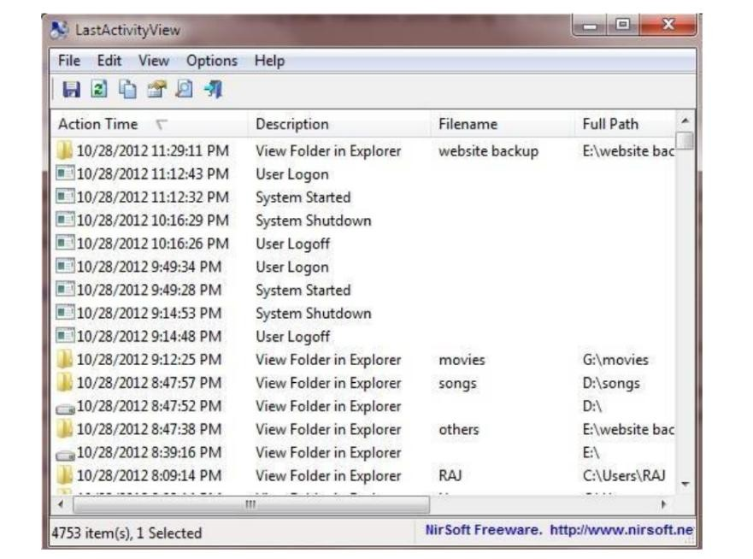
Fig. 5.1 – LastActivityView – activity log
- Read the columns: Action Time, Description, Filename, Full Path.
- Note the logged events:
- System Started / System Shutdown
- User Logon / User Logoff
- View Folder in Explorer, programs run, files opened
- Sort by Action Time to follow the latest activity first.
- Double-click an entry to view its details.

Output Screenshots
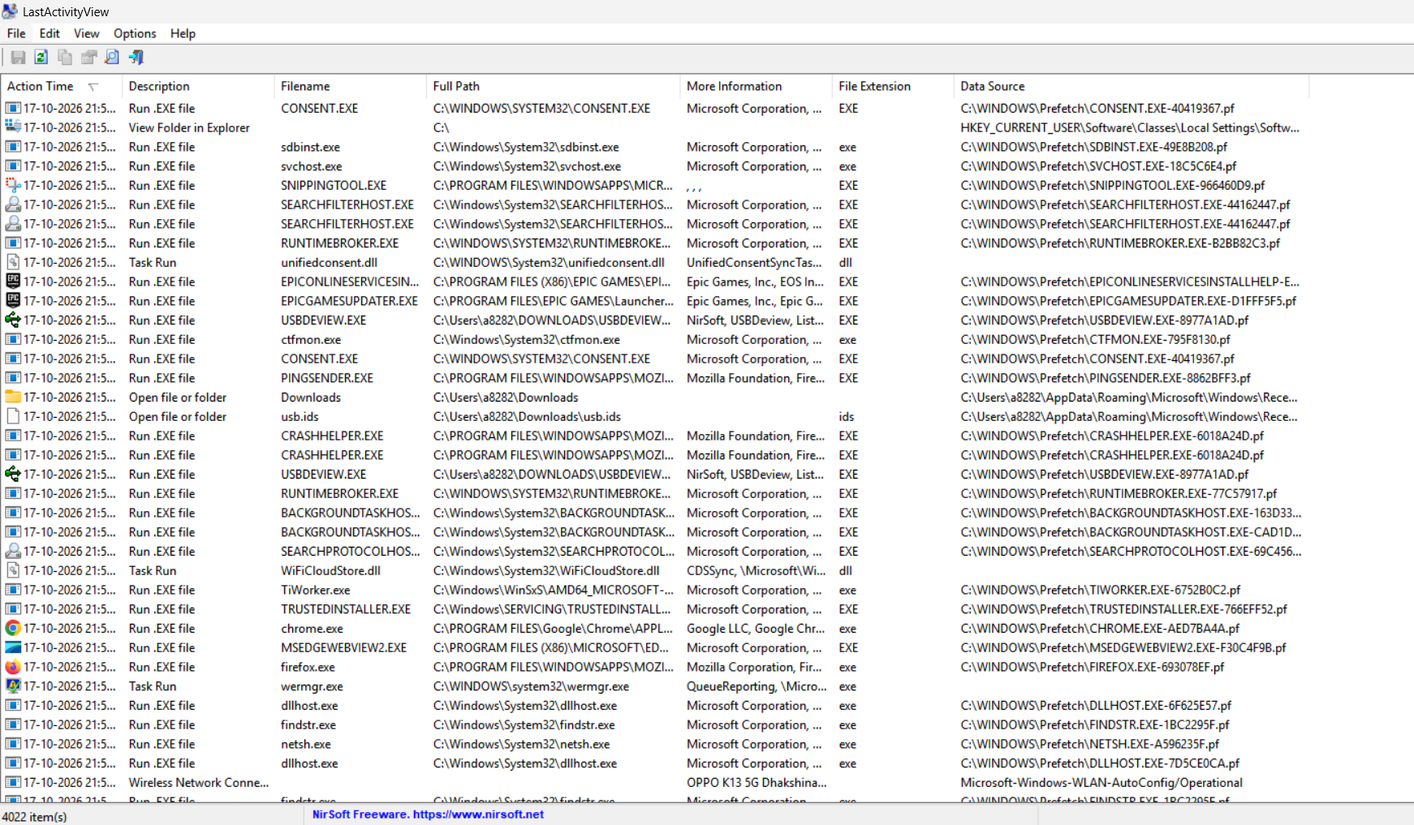
Fig. 5.2 – LastActivityView – activity list
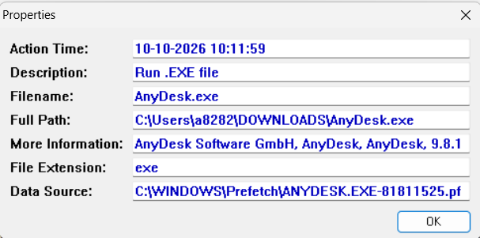
Fig. 5.3 – Properties of an activity entry

Result
The recent activity of the PC was listed in time order using LastActivityView.

