CR23532 – Cyber and Digital Forensics Lab

Experiment 6

Aim
To extract browser artifacts (history and cache) from Chrome and Internet Explorer.

Tools Used
ChromeHistoryView, ChromeCacheView, IEHistoryView, IECacheView (NirSoft)

Procedure
- Run ChromeHistoryView; it reads Chrome’s history file and lists visited pages.
- URL, Title, Visit date/time
- Visit count, Typed count, Referrer, Visit ID
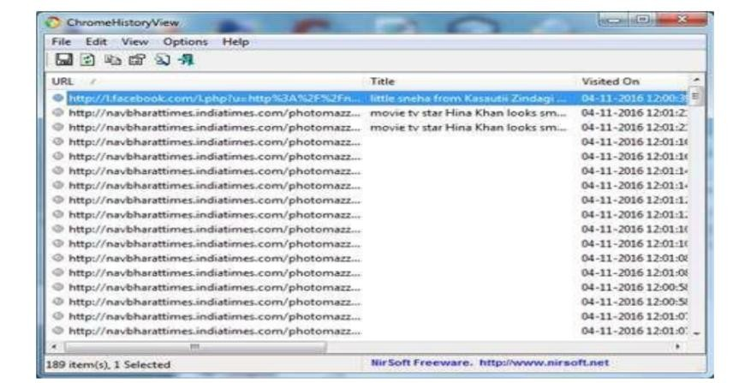
Fig. 6.1 – ChromeHistoryView
- Run ChromeCacheView; it reads Chrome’s cache folder.
- URL, Content type, File size
- Last accessed time, Expiration time, Server name, Server response
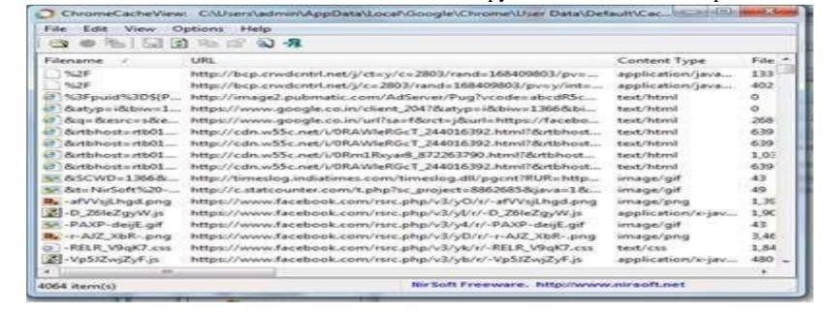
Fig. 6.2 – ChromeCacheView
- Run IEHistoryView; it lists URLs visited in Internet Explorer.
- Select URLs to save as text, HTML or XML
- Or remove them from the history file
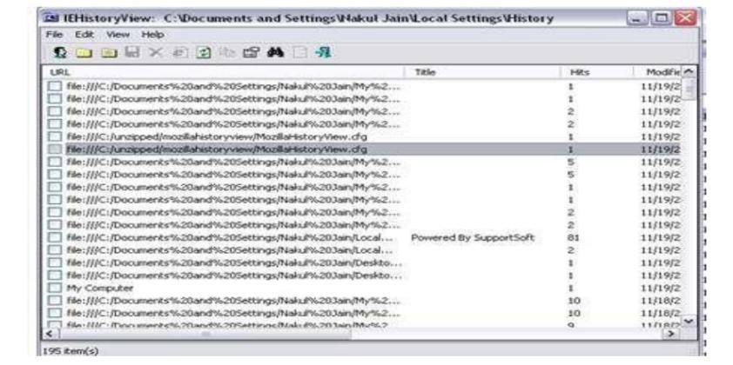
Fig. 6.3 – IEHistoryView
- Run IECacheView; it lists files stored in the IE cache.
- Filename, Content type, URL
- Last accessed / modified, Expiration, Hits, File size, Folder, Full path
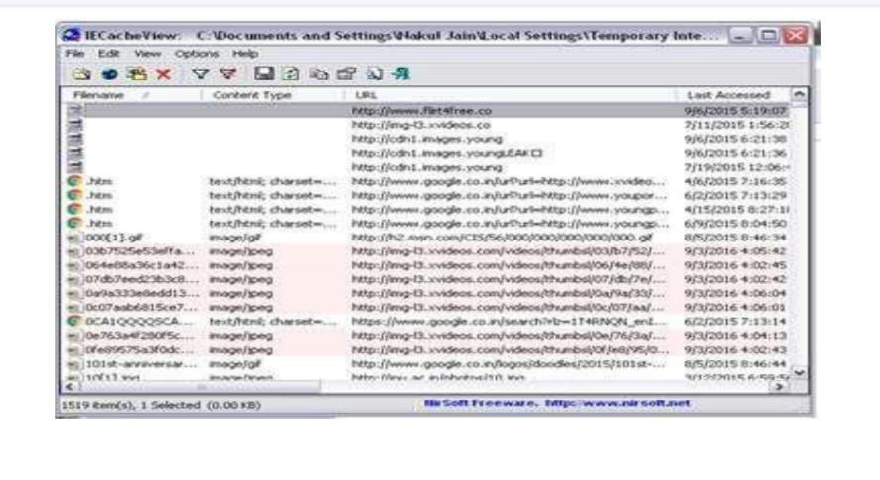
Fig. 6.4 – IECacheView

Output Screenshots
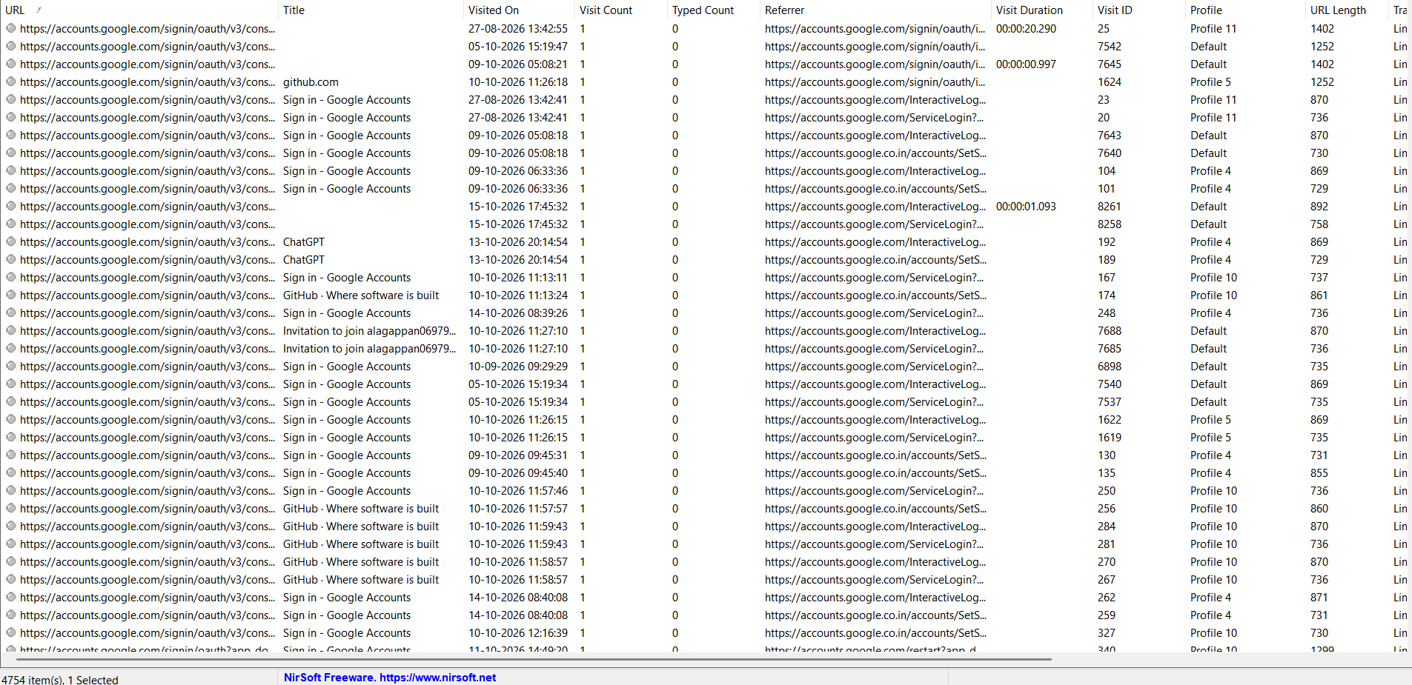
Fig. 6.5 – Browser history entries
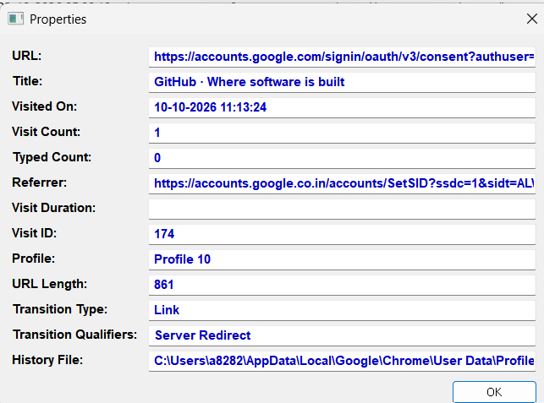
Fig. 6.6 – Properties of a history entry
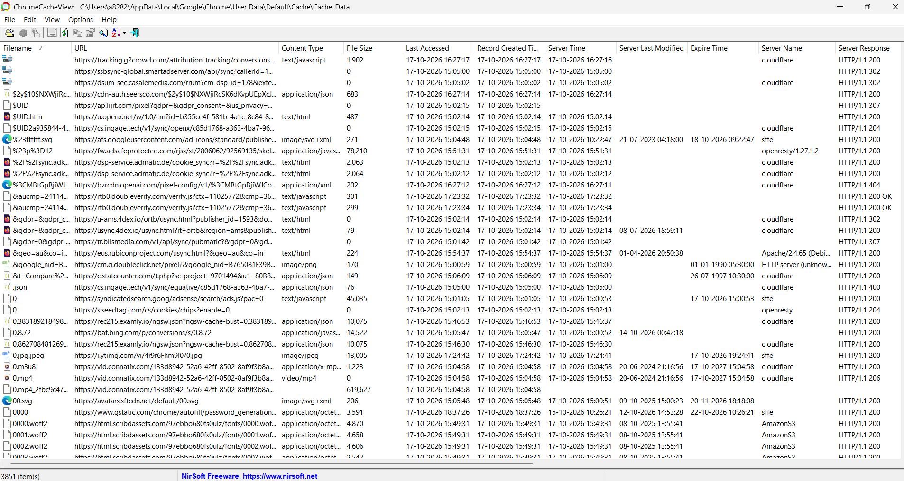
Fig. 6.7 – Browser cache entries

Result
Browsing history and cache artifacts were extracted from Chrome and Internet Explorer.

