CR23532 – Cyber and Digital Forensics Lab

Experiment 7

Aim
To compare two files for a forensic investigation using Compare IT.

Tools Used
Compare It! 4.2

Procedure
- Install and open Compare It!.
- Select the first file and click Open.
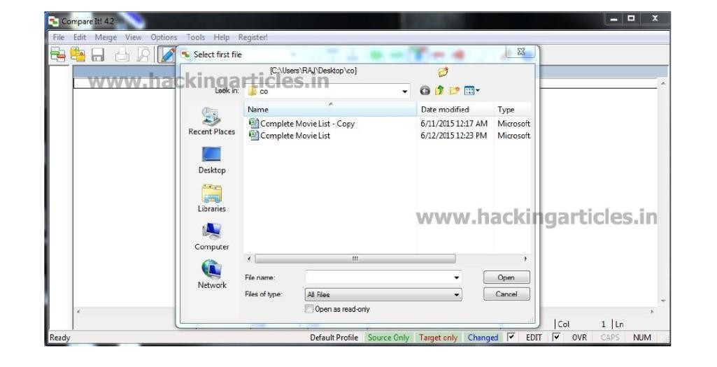
Fig. 7.1 – Selecting the first file
- Select the second file and click Open.
- Both files appear side by side with differences colour-coded (Source only, Target only, Changed).
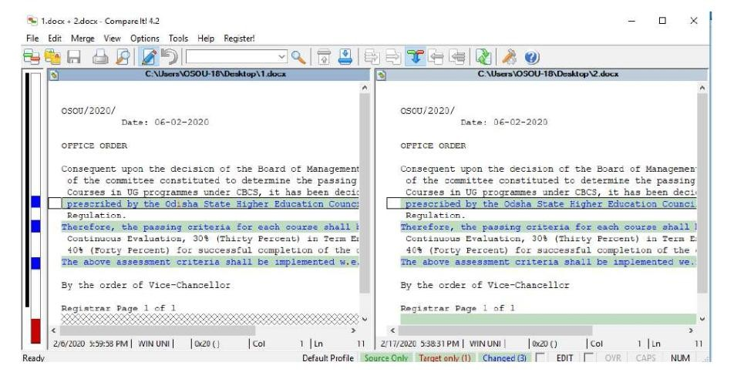
Fig. 7.2 – Side-by-side comparison with highlighted differences
- Check the highlighted bar and status bar for the number of changes (Changed: 3, Target only: 1).
- Print or save the difference report.
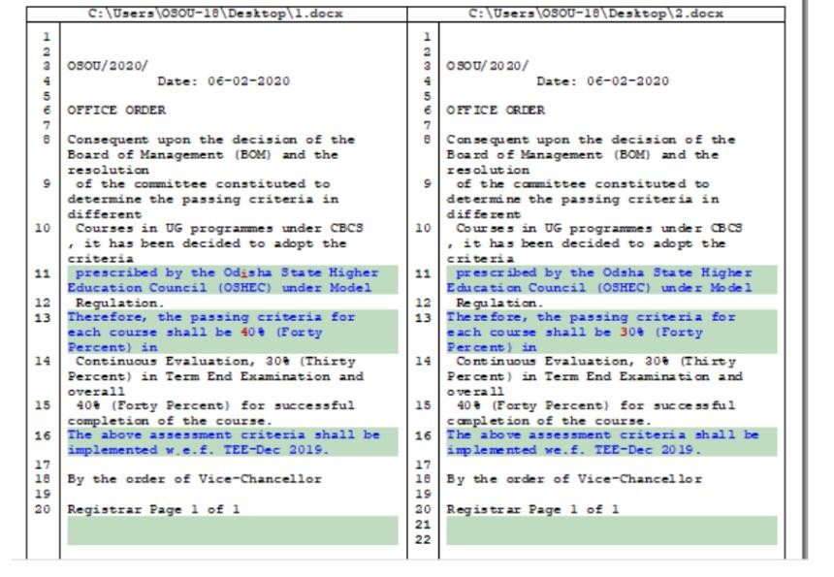
Fig. 7.3 – Printed difference report

Output Screenshots
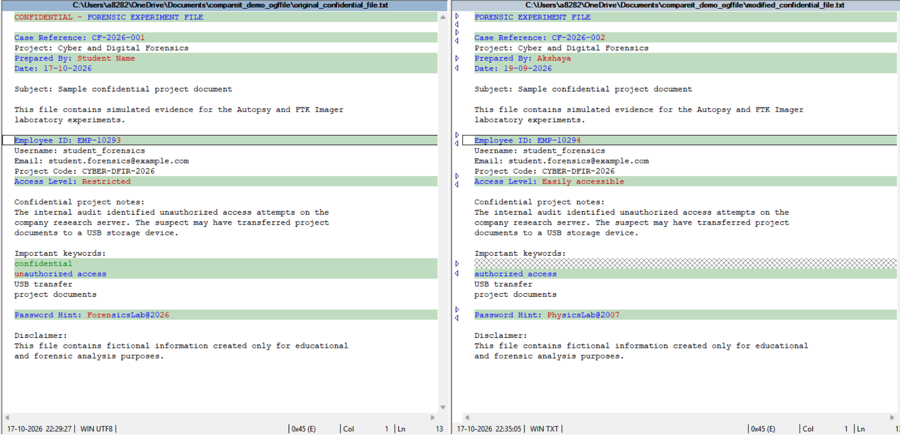
Fig. 7.4 – Comparison of the two files
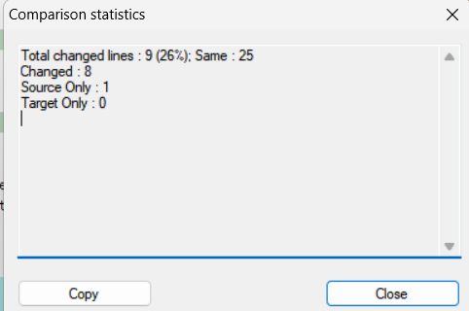
Fig. 7.5 – Comparison statistics
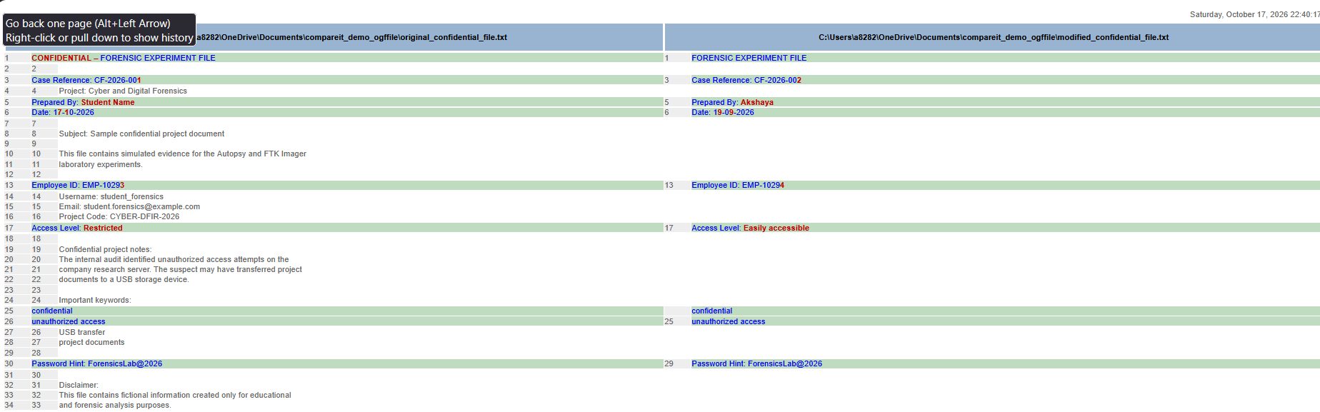
Fig. 7.6 – Difference report

Result
The differences between the two files were identified and a difference report was generated.

