CR23532 – Cyber and Digital Forensics Lab

Experiment 8

Aim
To collect email evidence from a victim PC by capturing its RAM and analysing it.

Tools Used
DumpIt, Bulk Extractor Viewer

Procedure
- Copy DumpIt to the victim PC (works on 32-bit and 64-bit Windows; can run from a USB key).
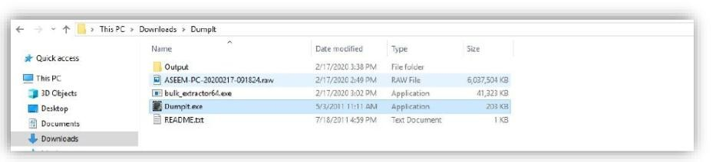
Fig. 8.1 – DumpIt folder
- Run Dumpit.exe; it shows the memory size and destination file.
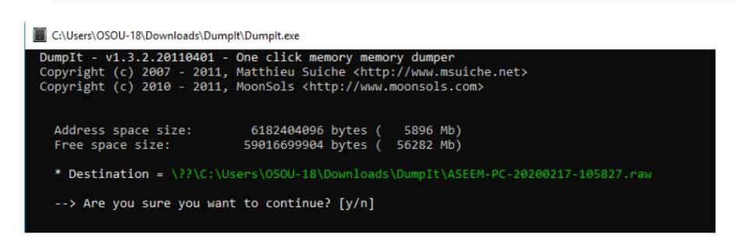
Fig. 8.2 – DumpIt confirmation prompt
- Type Y to start processing.
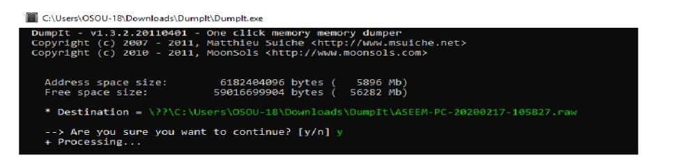
Fig. 8.3 – DumpIt processing
- The raw memory dump (.raw) is saved in the same folder.
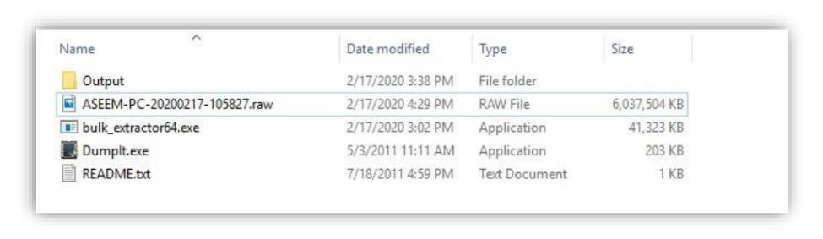
Fig. 8.4 – Raw memory dump created
- Download and open Bulk Extractor Viewer.
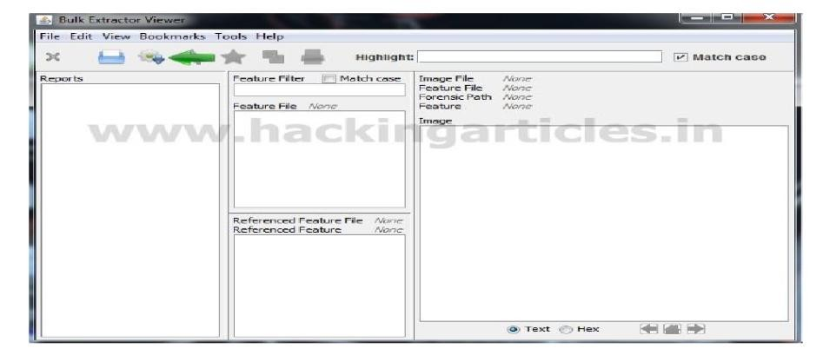
Fig. 8.5 – Bulk Extractor Viewer
- Generate a report: select the .raw image file and an output folder, click Start bulk_extractor.
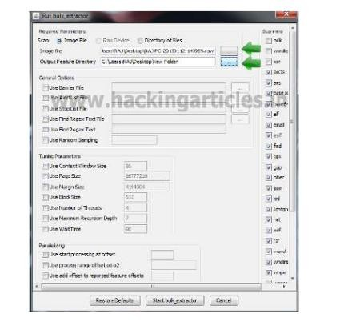
Fig. 8.6 – Run bulk_extractor
- Open email.txt in the report to see the email IDs found in memory.
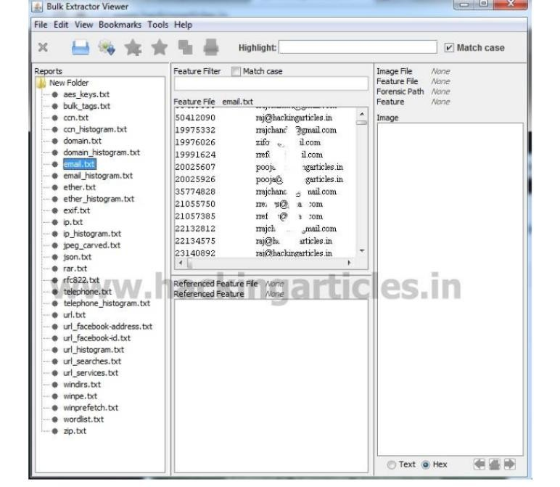
Fig. 8.7 – email.txt – recovered email addresses
- Open email_histogram.txt to see how many times each email ID occurs.
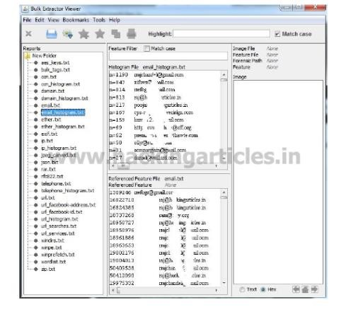
Fig. 8.8 – email_histogram.txt

Result
Email addresses were recovered from the victim PC’s memory dump using Bulk Extractor.

