CR23532 – Cyber and Digital Forensics Lab

Experiment 9

Aim
To hide a text file behind an image or audio file using Command Prompt and extract it again.

Tools Used
Windows Command Prompt, Notepad, WinRAR

Procedure
- Place the file to hide (A.txt) and the cover image (B.jpg) in one folder.
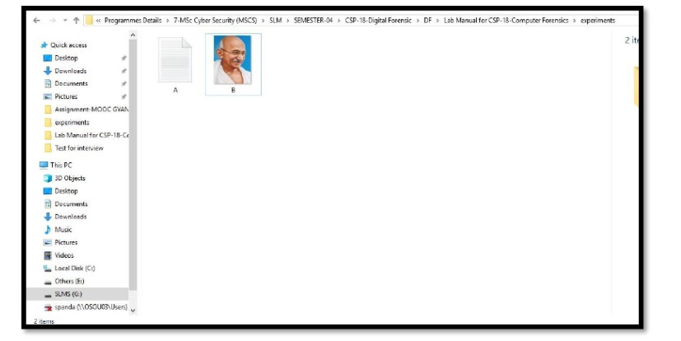
Fig. 9.1 – A.txt and B.jpg in the folder
- Press Win + R, type cmd and press OK.
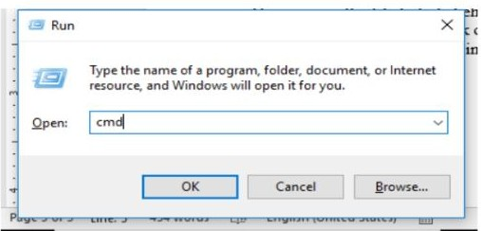
Fig. 9.2 – Run dialog – cmd
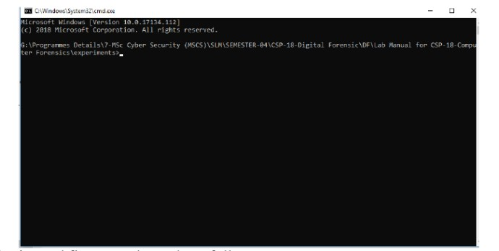
Fig. 9.3 – Command Prompt window
- Go to the folder: cd <folder path>.
- Merge the files in binary mode: copy /b B.jpg + A.txt C.jpg
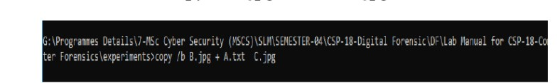
Fig. 9.4 – copy command entered
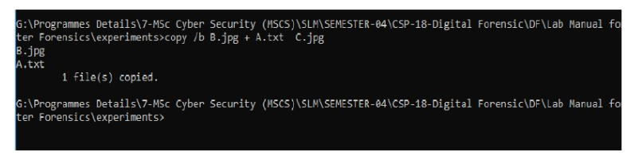
Fig. 9.5 – File copied – C.jpg created
- C.jpg looks the same as B.jpg; the text is hidden inside it.
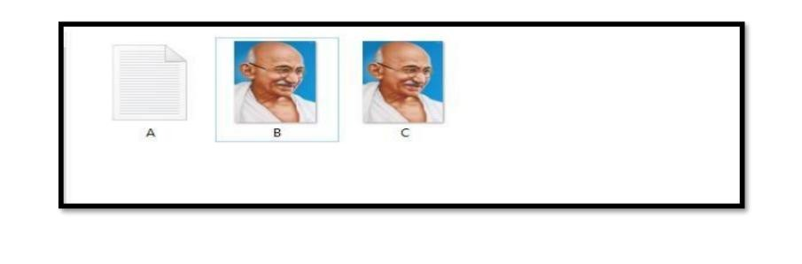
Fig. 9.6 – A.txt, B.jpg and C.jpg
- To retrieve: right-click C.jpg > Open with > Notepad.
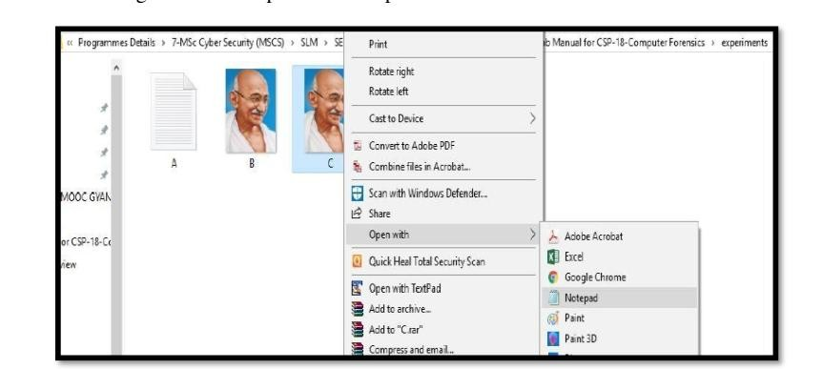
Fig. 9.7 – Open C.jpg with Notepad
- Scroll to the end of the file; the hidden text is visible.
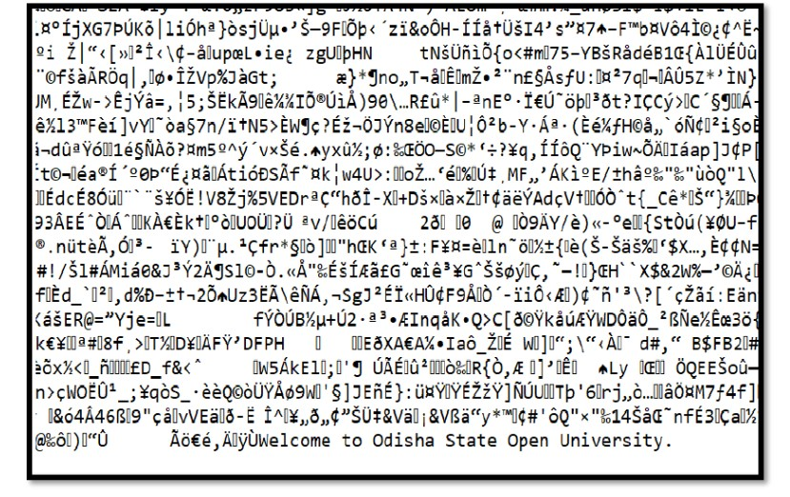
Fig. 9.8 – Hidden text at the end of the image data
- Alternative: hide a message directly with echo "Your Message">>"image.jpg" and view it the same way in Notepad.
- To hide a RAR: copy /b B.jpg + A.rar C.jpg, then open C.jpg with WinRAR.
- To hide in audio: zip the files as secret.zip and keep a cover file sound.mp3.

Fig. 9.9 – secret.zip and sound.mp3
- Merge them: copy /b sound.mp3+secret.zip newfile.mp3 (Linux: cat sound.mp3 secret.zip > newfile.mp3).
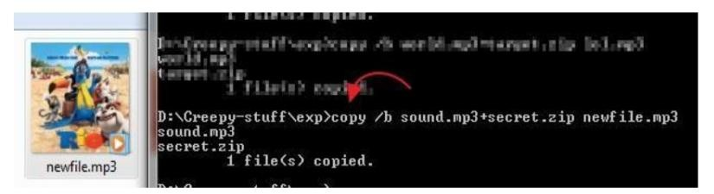
Fig. 9.10 – newfile.mp3 created
- Extract: rename newfile.mp3 to newfile.zip (or open it in WinRAR); the original files appear. Rename back to .mp3 to hide again.
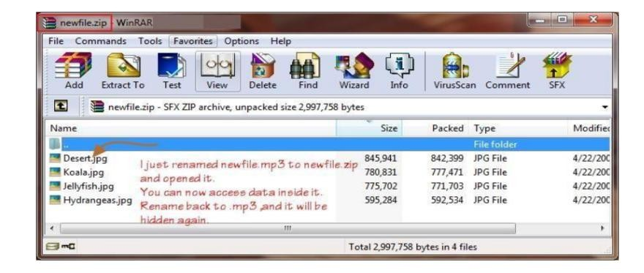
Fig. 9.11 – Hidden files opened in WinRAR

Output Screenshots
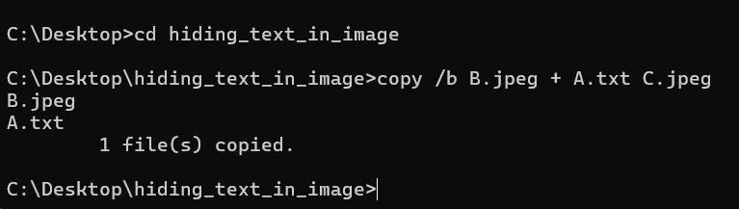
Fig. 9.12 – Merge command executed
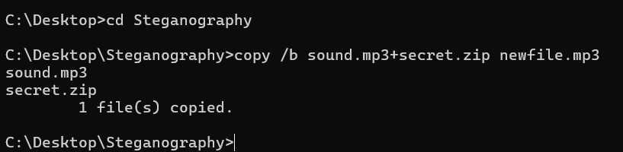
Fig. 9.13 – Audio + ZIP merge command
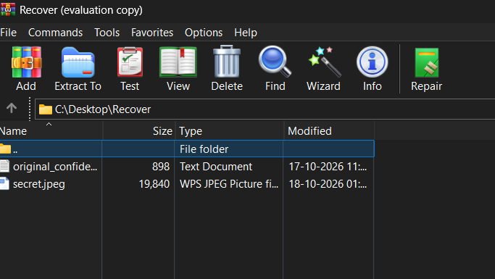
Fig. 9.14 – Hidden file recovered in WinRAR

Result
A file was hidden behind an image/audio file using Command Prompt and extracted successfully.

