CR23532 – Cyber and Digital Forensics Lab

Experiment 10

Aim
To extract Exchangeable Image File Format (EXIF) data from image files using ExifReader.

Tools Used
ExifReader (ExifRead.exe)

Procedure
- Download ExifReader and run ExifRead.exe.
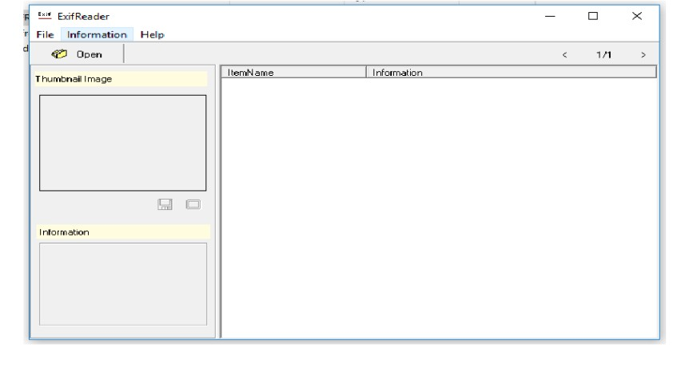
Fig. 10.1 – ExifReader window
- Click Open and browse to a JPEG/JPG image (these hold the most EXIF data).
- The image thumbnail loads on the left and the EXIF data is listed on the right.
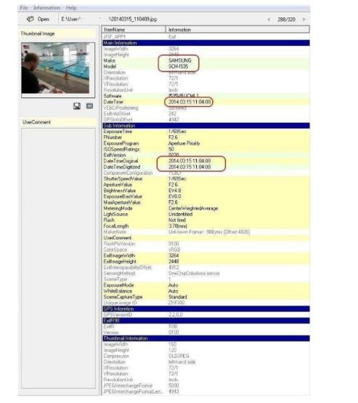
Fig. 10.2 – EXIF data of the selected image
- Note the key details:
- Make and Model of the camera (SAMSUNG, SCH-I535)
- Date/time taken (2014:03:15 11:04:08)
- Exposure, ISO, flash, focal length, image size, GPS (if present)

Output Screenshots
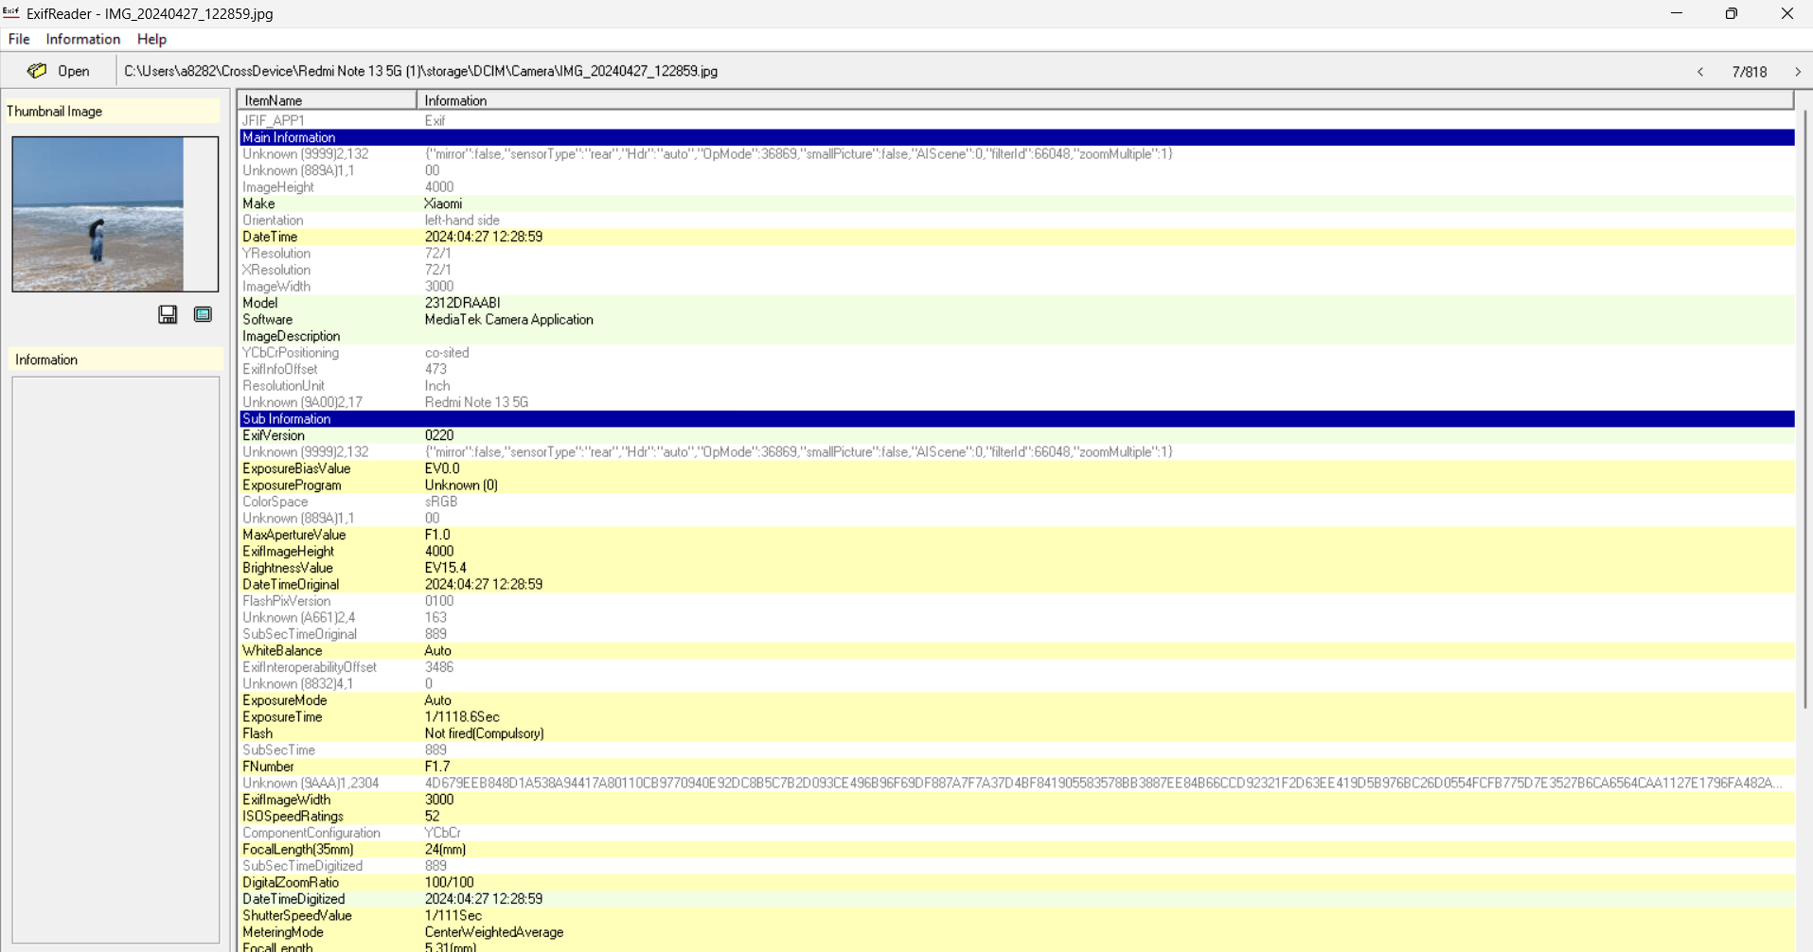
Fig. 10.3 – EXIF details extracted from an image

Result
EXIF metadata (camera make/model and date/time taken) was extracted from the image file.

