RULE-BASED INTRUSION DETECTION SYSTEM USING FORWARD AND BACKWARD CHAINING

A PROJECT REPORT

Submitted by

MOHIT JHA (241901056)
PRANAV TANIKAIVELAN (241901079)

in partial fulfillment for the award of the degree of

BACHELOR OF ENGINEERING
in

COMPUTER SCIENCE AND ENGINEERING (CYBER SECURITY)



RAJALAKSHMI ENGINEERING COLLEGE

ANNA UNIVERSITY: CHENNAI 600 025

NOVEMBER 2026

RAJALAKSHMI ENGINEERING COLLEGE CHENNAI

BONAFIDE CERTIFICATE

Certified that this Project report titled “Rule-Based Intrusion Detection System using Forward and Backward Chaining” is the bonafide work of “MOHIT JHA (241901056), PRANAV TANIKAIVELAN (241901079)”
who carried out the work under my supervision. Certified further that to the best of my knowledge the work reported herein does not form part of any other project report or dissertation on the basis of which a degree or award was conferred on an earlier occasion on this or any other candidate.

SIGNATURE
Divya R

Assistant Professor
Department of Computer Science and Engineering (Cyber Security)
Rajalakshmi Engineering College Chennai – 602 105

Submitted to Project Viva-Voce Examination held on

Internal Examiner

ii

ABSTRACT

Most intrusion detection systems rely on machine learning. They need large labelled datasets and act as black boxes, so an analyst cannot tell why an alert fired. This project builds a Rule-Based Intrusion Detection System using only classical Artificial Intelligence: hand-written IF-THEN rules and a logical inference engine, with no machine learning and no generative AI. Log events such as failed logins, connection attempts and privilege changes become facts. Six rules detect brute-force login, account compromise, port scanning and privilege escalation, and raise an overall intrusion flag. Forward chaining starts from the log and fires rules until nothing new appears, so it finds every alert. Backward chaining starts from a question such as is_intrusion(carol) and returns a proof tree or a "why not" explanation. The system is a single-page website that runs entirely in the browser. On a demonstration log of 99 events it derives 7 conclusions in 2 rounds, catches four attacks, correctly ignores four benign look-alikes, and traces every alert to exact rules and facts.

iii

ACKNOWLEDGEMENT

First, we thank the almighty God for the successful completion of the project. Our sincere thanks to our Chairman Mr. S. Meganathan B.E., F.I.E., for his sincere endeavor in educating us in his premier institution. We would like to express our deep gratitude to our beloved Chairperson Dr. Thangam Meganathan Ph.D., for her enthusiastic motivation which inspired us a lot in completing this project and Vice Chairman Mr. Abhay Shankar Meganathan B.E., M.S., for providing us with the requisite infrastructure.
We also express our sincere gratitude to our college Principal Dr. S.N. Murugesan M.E., Ph.D., and Dr. P. Tamilselvi Ph.D., Professor and Head, Department of Computer Science and Engineering (Cyber Security) and our project guide Divya R., Assistant Professor, for her encouragement and guiding us throughout the project. We would also like to thank our parents, friends, all faculty members and supporting staffs for their direct and indirect involvement in successful completion of the project for their encouragement and support.

MOHIT JHA (241901056)
PRANAV TANIKAIVELAN (241901079)

iv

TABLE OF CONTENTS

CHAPTER NO. | TITLE | PAGE NO.
 | ABSTRACT | iii
 | LIST OF TABLES | vii
 | LIST OF FIGURES | viii
1 | INTRODUCTION | 1
 | 1.1 BACKGROUND | 1
 | 1.2 PROBLEM STATEMENT | 3
 | 1.3 OBJECTIVES | 3
 | 1.4 SCOPE | 4
 | 1.5 SECURITY REQUIREMENTS/ SECURITY CONSIDERATIONS | 4
 | 1.6 SDG ALIGNMENT | 5
2 | LITERATURE REVIEW | 6
 | 2.1 EXISTING SYSTEM WITH SECURITY APPROACHES | 6
 | 2.2 RESEARCH GAPS | 8
 | 2.3 PROPOSED SYSTEM | 8
 | 2.3.1 OVERVIEW OF THE PROPOSED SYSTEM | 8
 | 2.3.2 OBJECTIVES OF THE PROPOSED SYSTEM | 8
 | 2.3.3 ADVANTAGES OF PROPOSED SYSTEM | 9
3 | SYSTEM DESIGN | 11
 | 3.1 SYSTEM ARCHITECTURE | 11
 | 3.2 MODULE DESIGN | 11
 | 3.3 DATA FLOW/UML DIAGRAMS | 14
 | 3.4 THREAT MODEL AND ATTACK SURFACE | 17
 | 3.5 SECURITY CONTROLS | 19

v

4 | SYSTEM DESCRIPTION | 21
 | 4.1 DATA COLLECTION | 21
 | 4.2 DATA PREPROCESSING | 23
 | 4.2.1 ALGORITHMS / METHODOLOGY | 23
 | 4.2.2 RESULTS AND DISCUSSION | 25
5 | CONCLUSION | 29
 | REFERENCES | 31
 | APPENDIX | 32

vi

LIST OF TABLES

TABLE NO. | TITLE | PAGE NO.
1.1 | SDG ALIGNMENT OF THE PROJECT | 5
2.1 | MACHINE LEARNING IDS VS RULE-BASED IDS | 6
3.1 | RULE BASE OF THE IDS | 14
3.2 | FORWARD CHAINING VS BACKWARD CHAINING | 16
3.3 | THREATS DETECTED BY THE RULE BASE | 17
4.1 | LOG FORMAT AND FACTS | 21
4.2 | RESULTS ON THE DEMONSTRATION LOG | 27
4.3 | CAUGHT PATTERNS AND CORRECTLY IGNORED PATTERNS | 27

vii

LIST OF FIGURES

FIGURE | TITLE | PAGE NO.
3.1 | SYSTEM ARCHITECTURE | 11
3.2 | DATA FLOW OF FORWARD CHAINING | 16
3.3 | INFERENCE CHAIN FOR ONE ATTACK | 16
4.1 | LOG EVENTS AND RULES PANELS OF THE WEBSITE | 23
4.2 | DEPLOYMENT OF THE WEBSITE | 25
4.3 | INFERENCE PANEL: BACKWARD  CHAINING TRACE FOR is_intrusion(carol) | 27

viii

CHAPTER 1 INTRODUCTION

BACKGROUND
Computer networks and online services are attacked every day. Attackers guess passwords, scan for open ports and try to gain administrator rights. An Intrusion Detection System (IDS) watches system and network logs and raises an alert when the recorded behaviour looks like an attack. IDS tools are a basic part of any security monitoring set-up.
Most recent IDS research uses machine learning. These systems learn from large labelled datasets and can find unusual patterns, but they have two practical problems. They need a lot of training data, and they usually cannot explain an alert in terms an analyst can check. A security analyst who must decide whether to block an IP address or lock an account needs to know exactly why the system raised the alarm.
Classical Artificial Intelligence offers another approach. In a rule-based expert system, human knowledge is written as IF-THEN rules, and an inference engine applies those rules to a set of known facts. Two standard reasoning strategies are used. Forward chaining is data-driven: it starts with the facts and fires rules to derive new facts. Backward chaining is goal-driven: it starts with a claim and searches for the rules and facts that prove it. Because every conclusion is built from named rules and named facts, a rule-based system can always show its reasoning.
This project applies these ideas to intrusion detection. It builds a working rule-based IDS and a website that shows the reasoning step by step, so that a user can watch how log events become facts, how facts fire rules and how rules finally produce an alert.
The idea of detecting intrusions automatically from audit records is not new. Early research in the 1980s, such as the intrusion-detection model proposed by Denning, described a system that reads audit records, compares them with stored profiles and rules, and reports activity that looks abnormal or that matches a known misuse pattern. Rule-based reasoning was therefore one of the first techniques used in intrusion detection, long before machine learning became popular, and it remains the basis of many signature and correlation engines used today.
The evidence on which an IDS works is the log. An authentication log records every successful and failed login. A network or firewall log records every connection attempt with its source address and destination port. A system log records administrative actions such as a change of user privilege. Each attack leaves a recognisable pattern in these logs. A password-guessing attack shows as a burst of failed logins from one address. A port scan shows as many connection attempts to different ports within a few seconds. A successful takeover shows as a login that follows a burst of failures. A privilege escalation shows as an administrator grant that follows a login almost immediately. These patterns are simple enough to be written down as rules by a human expert, and this is the property that the project uses.
A rule-based IDS has one more advantage that matters in a teaching and review setting: its reasoning can be shown. When the system concludes that a user account has been compromised, it can display the failed logins that were counted, the time window that was checked, the successful login that followed and the rule that joined these facts. This is the reason why the project is built around a website that displays the reasoning, and not only a program that prints the final alerts.
The project follows the Foundations of AI course closely. The log is the knowledge about the world, the facts are a logical representation of that log, the rules are the expert knowledge, and the inference engine is the reasoning component that uses forward chaining and backward chaining. Because only these classical concepts are used, the behaviour of the whole system can be explained from the course material alone, without any statistical model or training step.

PROBLEM STATEMENT
Existing machine-learning IDS tools are hard to trust and hard to explain. They require large labelled datasets, they act as black boxes, and a wrongly raised or missed alert cannot be traced to a cause. There is a need for an intrusion detector that (i) needs no training data, (ii) lets the analyst read and change the detection knowledge directly, and (iii) justifies each alert with a complete chain of evidence. The challenge is to build such a detector using only concepts from the Foundations of AI course, which means classical AI techniques (logic, rules and inference) and no machine learning or generative AI.

OBJECTIVES
    - To represent log events as logical facts such as failed_login(IP, user), successful_login(IP, user), connection_attempt(IP, port) and privilege_change(user, role).
    - To encode attack knowledge as a small base of IF-THEN rules with time windows and editable thresholds.
    - To implement a forward chaining engine that finds every alert and records a proof for each one.
    - To implement a backward chaining engine that answers queries such as is_intrusion(carol) with a proof tree, and explains near-misses with "why not" queries.
    - To build a single-page website that shows the log, the rules and the inference step by step, with a plain-English explanation beside the engine trace.
    - To test the system on a demonstration log that contains both real attacks and benign look-alike patterns, and to check that forward and backward chaining reach the same conclusions.

SCOPE
The system works on log events that arrive as a table with five fields: timestamp, event, user, source IP and detail. It detects four attack patterns: brute-force login, account compromise after a brute force, port scanning and privilege escalation. It also derives one overall flag, is_intrusion, for a user. The log can be built from scenario cards or imported as a CSV file. The whole engine runs in the user's browser and no log data is sent to any server.
The following are outside the scope of this work: learning from data, detection of unknown (zero-day) attacks, deep packet inspection, and live streaming of logs. The rule base uses fixed, known patterns, so an attacker who stays below the thresholds can avoid a rule. This limit is discussed in Chapter 5.

SECURITY REQUIREMENTS/ SECURITY CONSIDERATIONS
An intrusion detector is itself a security tool, so it must satisfy its own security requirements. The requirements considered in this project are listed below.
    - Explainability and accountability: every alert must trace back to exact rules and exact log rows.
    - Integrity of detection logic: rules are plain, readable definitions with visible thresholds, so unauthorised or accidental changes can be noticed. A built-in test confirms that forward and backward chaining agree.
    - Confidentiality of logs: logs and CSV files that a user adds are processed only in the browser and never leave the device.
    - Low false-positive rate: near-miss behaviour (for example only 3 failed logins, or 15 connections in 8 seconds) must not raise an alert.
    - Availability and low attack surface: the site is a static page with no server-side code, no database and no third-party libraries, which removes many common web attack paths.

    - Input robustness: malformed CSV rows must be handled without breaking the page.

SDG ALIGNMENT
The project contributes to the United Nations Sustainable Development Goals as shown in the table below.
Table 1.1 SDG ALIGNMENT OF THE PROJECT

S.  No. | SDG No. &  Goal | Relevant SDG Target | Project Contribution / Alignment
1 | SDG 9:  Industry, Innovation and Infrastructure | Target 9.1: Develop reliable, sustainable and resilient  infrastructure | Detects attacks on login and network services, which helps keep digital infrastructure reliable and resilient.
2 | SDG 16: Peace, Justice and Strong Institutions | Target 16.6: Develop effective, accountable and  transparent institutions | Every alert comes with a proof of exact rules and facts, so security decisions are transparent and accountable.
3 | SDG 4: Quality Education | Target 4.4: Increase the number of people with relevant  technical skills | The step-by-step trace and plain-English text teach forward and backward chaining and intrusion detection.
4 | SDG 10:  Reduced Inequalities | Target 10.2: Promote the inclusion of all | A free, no-install, single-page tool that needs no dataset or server can be used by small organisations and students with  limited resources.

CHAPTER 2 LITERATURE REVIEW

EXISTING SYSTEM WITH SECURITY APPROACHES
Intrusion detection approaches are usually grouped into three families. Signature-based detectors, such as classic network IDS tools, compare traffic and logs against a database of known attack patterns. They are fast and easy to understand, but they miss attacks that are not in the database. Anomaly-based detectors build a model of normal behaviour and flag deviations; most recent systems of this kind use machine learning or deep learning. Hybrid detectors combine both.
Machine-learning detectors can generalise to new attacks, but they depend on large labelled datasets, need re-training when behaviour changes, and give limited insight into why a particular event was flagged. Rule-based expert systems are the older approach. They were popular because their conclusions can be inspected, but many implementations are command-line tools with text output, which hides the reasoning from non-experts. Table 2.1 compares the two approaches.
Table 2.1 MACHINE LEARNING IDS VS RULE-BASED IDS

Aspect | Machine-learning IDS | Rule-based IDS (this project)
Training data | Large labelled datasets needed | None needed (0 samples)
Explanation of alerts | Often a black box | Full proof from rules and facts
Changing behaviour | Re-train the model | Edit a rule or a threshold
Unknown attacks | Can sometimes generalise | Only known patterns
False-positive control | Tuned statistically | Visible thresholds, easy to inspect
Run-time cost | Heavy compute at training | Very light, runs in a browser
Practical signature-based tools, such as the open-source Snort and Suricata network detectors, match packets and streams against large collections of rules written by experts. Log-oriented tools and event-based network analysers apply a similar idea to log events and to scripted event handlers. These tools show that rules are an accepted way to describe attacks in real deployments. However, their rule languages are designed for experts and for high-volume operation. They report an alert and the rule that matched, but they do not usually show the intermediate steps by which one derived fact led to another, and they are not designed to be explored interactively by a student.
Classical expert-system shells provide the reasoning methods used in this project. Forward chaining is the control strategy of production systems such as CLIPS and the OPS family: the engine repeatedly matches rules against the working memory and fires those that apply. Backward chaining is the strategy of logic programming languages such as Prolog and of classic diagnostic expert systems such as MYCIN: the engine starts from a goal and looks for rules and facts that prove it. Expert systems also introduced the explanation facility. A "how" explanation shows the chain of rules that led to a conclusion, and a "why" explanation shows why a piece of information is needed. The proof tree produced by backward chaining in this project plays the role of the "how" explanation, and the "why not" query extends the idea to conclusions that were not reached.
Rule-based methods also have well-known weaknesses. Writing and maintaining the rules requires expert knowledge. Rules are brittle, because a pattern that only slightly differs from the written one is missed. Thresholds are easy for an attacker to learn and to stay below. Large rule bases can contain rules that interact in ways that are hard to predict. The proposed system keeps these weaknesses in view. The rule base is deliberately small (six rules), every threshold is visible and editable on the rule card, and dependencies between rules are shown on screen, for example the warning that rule R2 needs R1 to be active. The benign look-alike scenarios are included in the demonstration log precisely to test how the thresholds behave when behaviour is close to, but not inside, an attack pattern.

RESEARCH GAPS
From the review of existing approaches, the following gaps were identified.
- Learning-based detectors give little or no justification for an alert, which reduces analyst trust.
- Rule-based tools usually show only final output, not the intermediate steps of forward and backward chaining, so they are poor teaching and review tools.
- Few tools let a user answer a "why not" question, that is, explain why an almost-attack did not raise an alert.
- Many tools need installation, a server, or a dataset before a user can try them.
- Rules in most tools cannot be switched on and off or re-tuned interactively while watching the effect on the result.

PROPOSED SYSTEM
    - OVERVIEW OF THE PROPOSED SYSTEM
The proposed system is a Rule-Based IDS with a visual website. Log events are turned into facts. Six IF-THEN rules describe the attacks. A logical inference engine applies the rules in two modes: forward chaining (automatic alerts) and backward chaining (user queries). The website is organised in three panels: Log events (what the system sees), Rules (what the system knows) and Inference (what the system concludes). Everything is inside one HTML file that runs in the browser.

OBJECTIVES OF THE PROPOSED SYSTEM
      - Detect brute force, account compromise, port scan and privilege escalation using rules only.

      - Make the reasoning visible with a step-by-step engine trace, yellow evidence rows and plain-English text.
      - Let the user change the log and the rules by drag and drop, and re-tune thresholds on the rule cards.
      - Keep the system simple to deploy: one static file, no server code and no installation.

ADVANTAGES OF PROPOSED SYSTEM
      - No training data and no machine learning: 0 labelled samples are needed.
      - 100% of alerts trace back to exact rules and facts.
      - Two inference modes on the same rule base: forward (all alerts) and backward (one claim, with a proof or a why-not).
      - Privacy friendly: logs never leave the user's browser.
      - Easy to extend: a new attack type needs only a new entry in the rule list.
      - Works on phones and desktops, in light and dark themes.
Several design principles guided the proposed system. The first is transparency: nothing is hidden inside the engine, and each conclusion carries the rule and the facts that produced it. The second is determinism: for the same log and the same active rules, the engine always gives the same result, and a built-in test checks that forward chaining and backward chaining agree. The third is locality: all processing is done in the user's browser, so that sensitive log data is not uploaded. The fourth is minimality: the whole system is one HTML file with no framework, no library and no server code. The fifth is extensibility: a new attack type needs only a new entry in the rule list.
The proposed system answers the research gaps identified in Section 2.2 one by one. The gap of unexplained alerts is answered by the proof tree and by the engine trace shown beside a plain-English description. The gap of hidden intermediate steps is answered by the Step, Play and Show all controls, which let the user move through the inference one line at a time. The gap of unanswered "why not" questions is answered by the backward chaining mode, which reports the closest miss for a claim that cannot be proved. The gap of installation effort is answered by delivering the system as one static web page. The gap of fixed, non-interactive rules is answered by the rule cards, on which a rule can be activated, deactivated, reordered and re-tuned while the result is observed.
In summary, the proposed system does not try to replace machine-learning detectors. It addresses a different need: a detector whose knowledge can be read, whose decisions can be justified, and whose behaviour can be inspected step by step. For the known attack patterns that it covers, it gives analysts and students a complete and checkable explanation of every alert.

CHAPTER 3 SYSTEM DESIGN

SYSTEM ARCHITECTURE
The architecture, shown in Figure 3.1, has six parts. The Log Input accepts scenario cards or a CSV file. The Fact Builder converts every log row into a fact. The Rule Base holds the active rules. Working Memory holds the log facts and every fact derived from them. The two inference engines, forward chaining and backward chaining, read the rules and the working memory. The Explanation Layer shows the engine trace, the proof tree and a plain-English description, and highlights the log rows that act as evidence. All parts run inside the browser.
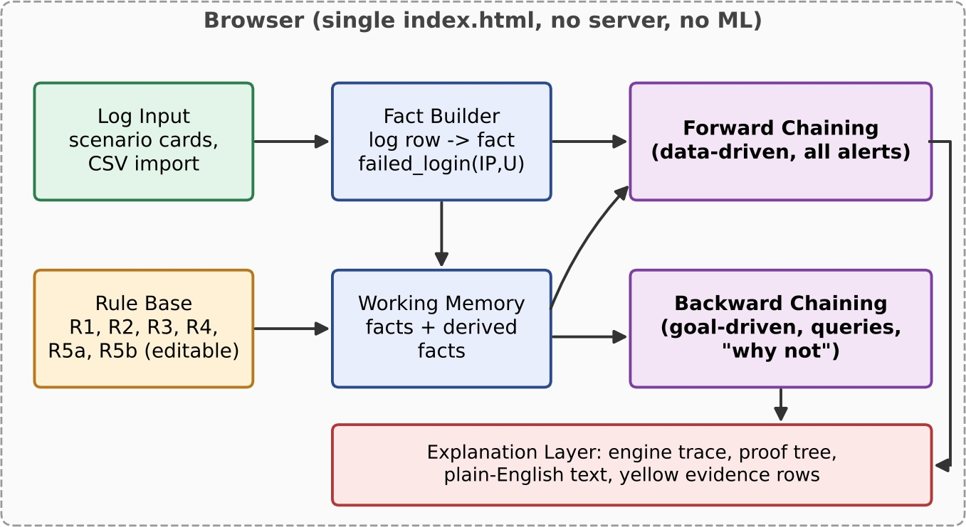

Figure 3.1 SYSTEM ARCHITECTURE

MODULE DESIGN
The system is divided into the modules described below.
    - Log module: holds the table of events (time, event, user, ip, detail). Rows come from six scenario cards (normal traffic, benign look-alikes, brute

force to takeover, brute force without entry, port scan, privilege escalation) or from a CSV import. The user can remove scenarios or clear the log.
    - Fact module: turns each row into a fact. LOGIN_FAILED becomes failed_login(IP, user), LOGIN_SUCCESS becomes successful_login(IP, user) and login(user), CONNECTION becomes connection_attempt(IP, port) and PRIV_CHANGE becomes privilege_change(user, role). Each fact keeps its time stamp and its log row number.
    - Rule module: stores the rules, their thresholds and their time windows. Rules can be activated, deactivated, reordered and edited. The page warns when a rule depends on another one that is switched off (for example R2 needs R1).
    - Forward chaining module: repeatedly applies every active rule to the facts. New facts are added with a proof node, and the loop stops when a full pass finds nothing new.
    - Backward chaining module: takes a goal, finds rules whose THEN-part matches it, tries to prove their IF-part recursively, and returns a proof tree. For a failed goal it reports the closest miss.
    - Explanation module: records each step of the engine as a trace line, writes a plain-English sentence for it, and highlights the supporting log rows in yellow. Step, Play and Show all controls set the pace.
    - Test module: a built-in check confirms that forward and backward chaining give the same conclusions on the demonstration log.

Rule base
The rule base contains six rules. Table 3.1 lists them with their thresholds.
Each rule is described below together with the part of the demonstration log that exercises it.
Rule R1 (brute-force login) counts failed logins per source IP address. It slides a time window over the failed logins of one IP and fires when 5 or more fall inside 60 seconds. In the demonstration log the IP 198.51.100.23 produces 7 failed logins for user carol at 3-second intervals, so 5 of them fall inside 12 seconds and the rule fires. The IP 203.0.113.9 produces 6 failed logins for user admin within 10 seconds and the rule fires as well. In contrast, user bob has only 3 failed logins from 10.0.0.22, and the IP 192.0.2.50 has 5 failed logins spread over 2 minutes, of which at most 3 fall inside any 60-second window, so the rule correctly does not fire.
Rule R2 (compromised account) joins two facts. It needs a brute_force(IP) fact and then a successful login from the same IP within 300 seconds. For carol, the successful login at 09:20:30 comes 18 seconds after the burst that triggered R1, so R2 derives account_compromised(carol). The brute force on admin is not followed by any successful login from 203.0.113.9, so R2 does not fire for it, and this is why that attack is flagged as a brute force but not as an intrusion.
Rule R3 (port scan) counts connection attempts per source IP. It fires when 21 or more attempts fall inside 10 seconds. The IP 203.0.113.77 makes 30 attempts, to ports 20 to 49, within 5 seconds, and the rule fires. The IP 10.0.0.30 makes 15 attempts, to ports 1000 to 1014, within about 8 seconds, which is below the limit of 21, so the rule correctly stays silent.
Rule R4 (privilege escalation) joins a login with an administrator grant. It fires when privilege_change(U, admin) follows login(U) within 5 seconds. User dave logs in at 10:20:00 and receives admin at 10:20:03, so the rule fires. User alice receives admin at 11:30:00, which is 55 minutes after her login at 10:35:00, so the rule does not fire.
Rules R5a and R5b are the overall intrusion rules. Each states that a derived condition makes the user an intrusion: R5a uses account_compromised(U) and R5b uses privilege_escalation(U). Notice that no rule derives is_intrusion from port_scan or from brute_force alone. These two are reported as findings in their own right, and an intrusion is declared only when an account is compromised or a privilege is escalated.

Table 3.1 RULE BASE OF THE IDS

Rule | IF | THEN | Detects
R1 | 5+ failed_login(IP, _) within 60 s | brute_force(IP) | Brute-force login
R2 | brute_force(IP), then successful_login(IP, U) within 300 s | account_compromis ed(U) | Compromised account
R3 | 21+ connection_attempt(IP,  _) within 10 s | port_scan(IP) | Port scanning
R4 | login(U), then privilege_change(U, admin) within 5 s | privilege_escalation (U) | Privilege escalation
R5a | account_compromised(U) | is_intrusion(U) | Overall intrusion flag
R5b | privilege_escalation(U) | is_intrusion(U) | Overall intrusion flag

Three small design choices were added to the rule table of the first review. R2 has a 300 s window, R3 means "more than 20" attempts (21 or more), and R5 is split into R5a and R5b because a logical OR is written as two separate rules. All thresholds can be edited on the rule cards.

DATA FLOW/UML DIAGRAMS
Figure 3.2 shows the data flow of forward chaining. The log rows are converted into facts. In each round the engine matches the IF-part of every active rule against the facts. If a rule fires and its conclusion is new, the new fact is added together with its proof and another round starts. When a full round derives nothing new, the engine has reached a fixpoint and stops.
The rules depend on each other as follows. R1 feeds R2, and R2 feeds R5a. R4 feeds R5b. R3 stands alone. This dependency structure explains why forward chaining needs more than one round: a conclusion such as is_intrusion(carol) can only be derived after brute_force and account_compromised have been derived. It also explains why switching a rule off changes the result of other rules, as seen when R1 is dragged out and carol is no longer flagged.
Forward chaining always terminates. Every derived fact is built from values that already occur in the log, such as IP addresses and user names, and the six rules can only produce five kinds of fact: brute_force, account_compromised, port_scan, privilege_escalation and is_intrusion. The engine adds a fact only when it is not already present, so the set of facts can grow only a limited number of times. When a full round adds nothing, the engine stops. For each derived fact the engine stores a proof node that lists the rule and the supporting facts, and each supporting fact stores the number of the log row it came from. This is what allows the website to highlight the evidence rows in yellow.

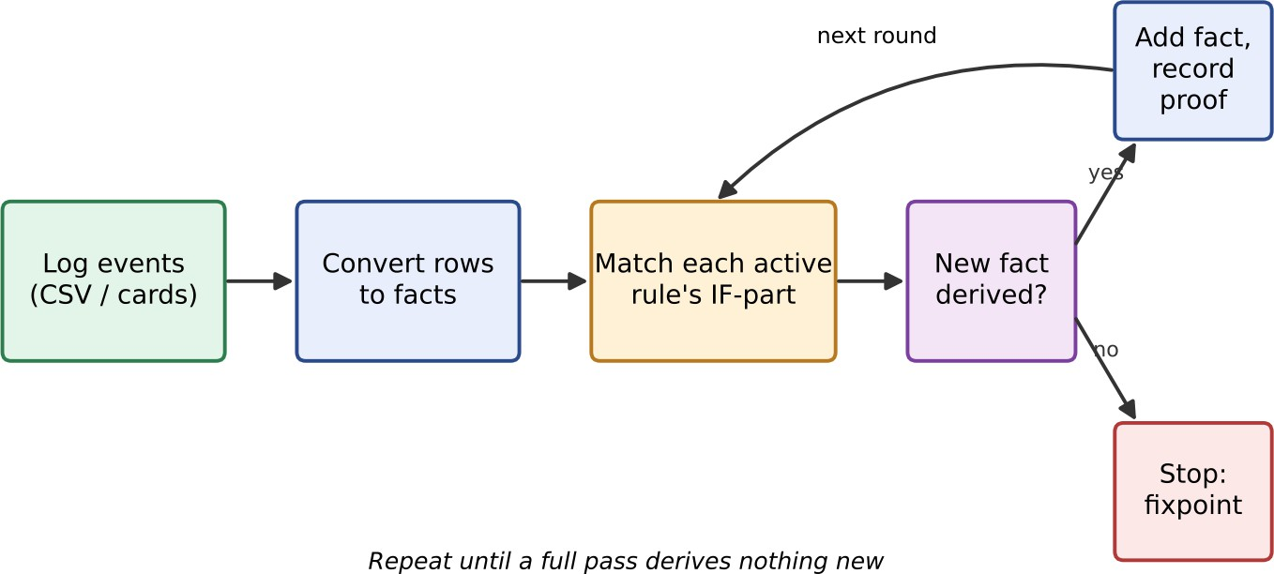

Figure 3.2 DATA FLOW OF FORWARD CHAINING
Figure 3.3 follows one attack through the engine. Seven LOGIN_FAILED rows for user carol come from the IP 198.51.100.23, and five of them fall within 12 seconds. Rule R1 fires and derives brute_force(IP). A successful login from the same IP 18 seconds later makes rule R2 fire and derive account_compromised(carol). Rule R5a then derives is_intrusion(carol). The whole chain is the proof of the alert.

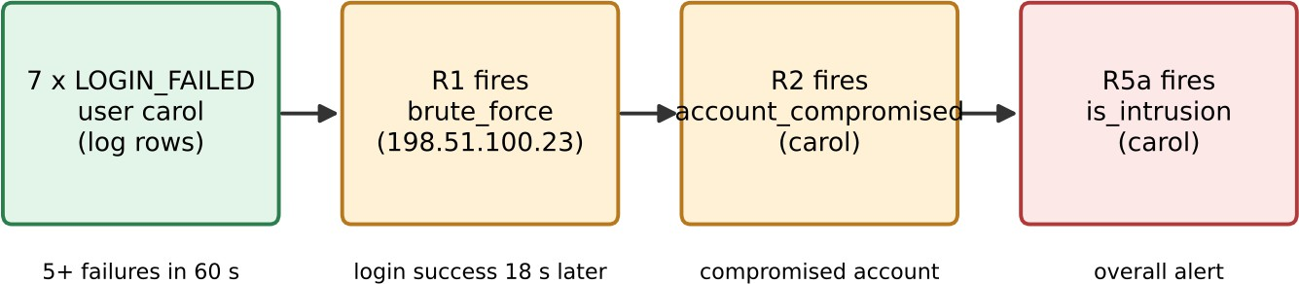

Figure 3.3 INFERENCE CHAIN FOR ONE ATTACK

Forward chaining and backward chaining
Table 3.2 FORWARD CHAINING VS BACKWARD CHAINING

Aspect | Forward chaining | Backward chaining

Aspect | Forward chaining | Backward chaining
Analogy | Detective: from evidence to conclusions | Lawyer: from a claim to its proof
Starting point | The log facts | A question typed by the user
Method | Fires every rule that applies, again and again | Works back through the rules to the log
Stops when | A full pass finds nothing new | The goal is proved or cannot be proved
Result | Every alert, each with its proof | YES with a proof tree, or NO with the closest miss
On the site | Run forward chaining | is_intrusion(carol), why not alice?

THREAT MODEL AND ATTACK SURFACE
The threat model has two parts: the attacks the IDS is meant to detect, and the threats to the IDS itself.
Table 3.3 THREATS DETECTED BY THE RULE BASE

Threat | Behaviour seen in the log | Rule that responds
Brute-force login | 5+ failed logins from one IP within 60 s | R1
Account takeover | Brute force followed by a successful login from the same IP within 300 s | R2, then R5a
Port scan | 21+ connection attempts from one IP within 10 s | R3
Privilege escalation | Login followed by an admin grant within 5 s | R4, then R5b

For the IDS itself, the attack surface is small. The site is one static file served over HTTPS, with no back-end, no database, no user accounts and no third-party libraries. The only input a user supplies is a CSV file or scenario cards, and these are parsed in the browser. The main residual threats are an attacker who stays just below a threshold (evasion), tampering with a locally edited rule set, and malformed CSV input.
The assets of the system are the log data that the user loads, the rule base with its thresholds, and the alerts and proofs that are produced. The first kind of adversary is the external attacker whose behaviour the IDS is meant to detect: the password guesser, the scanner and the user who obtains administrator rights. The second kind is an attacker who knows that a rule-based detector is in use and tries to evade it. The third is a careless or malicious editor of the rules, who could weaken a threshold so that real attacks no longer fire.
The entry points of the page are few. A user can drop scenario cards, import or drop a CSV file, edit the numeric thresholds on a rule card, and type a query into the question box. All of these are data given to a program that runs in the user's own browser, and none of them is sent to a server. File content must be treated as data only and never as code, and a malformed row must be skipped or reported without stopping the page. The hosting side is a static file on Cloudflare, so the main exposure there is the integrity of the file itself, which is protected by HTTPS delivery.
Evasion is the main residual threat. An attacker who tries 4 passwords per minute never reaches 5 failures in 60 seconds and stays below rule R1. An attacker who scans 20 ports in 10 seconds stays below rule R3. This is a limitation of every threshold rule and not a defect of this implementation. It is reduced by editing the thresholds and windows on the rule cards, by adding rules with longer windows, and by combining rules, but it cannot be removed completely. The report states this limit openly in Chapter 5.

SECURITY CONTROLS
    - Local processing: logs and CSV files never leave the browser, which protects confidentiality.
    - HTTPS delivery: Cloudflare serves the static file over HTTPS so the page cannot be altered in transit.
    - No back-end and no external libraries: the page has no server to compromise and no dependency supply chain.
    - Transparent rules: all rules and thresholds are visible and editable on the rule cards, and the page shows dependency warnings such as "needs R1 active".
    - Proof for every alert: each conclusion lists the rule and the facts that produced it, which supports review and accountability.
    - Reset and consistency: changing the log or the rules resets the inference, so the displayed result always matches what is on screen.
    - Self-check: a built-in test compares forward and backward chaining on the demonstration log.
The controls above map directly to the security requirements listed in Section 1.5. Explainability and accountability are met by the proof attached to every alert and by the plain-English explanation. The integrity of the detection logic is supported by visible rules and thresholds and by the self-check that compares forward and backward chaining. Confidentiality of logs is met by local processing. A low false-positive rate is supported by the benign look-alike scenarios, which are used to check that near-miss behaviour does not alert. Availability and a small attack surface follow from the choice of a static page without a back-end or external libraries.
Some controls depend on how the system is used. The thresholds in a rule set should be chosen with knowledge of the normal behaviour of the environment, for example how many failed logins a typical user produces. Changes to the rule set should be recorded by the user, so that it is always known which thresholds produced a given result. The site should be served only over HTTPS. When real logs are used, they should be exported from the source system in the five-column format and checked before import.
The remaining risks are accepted and documented. The system detects only the patterns that its rules describe, it can be evaded by an attacker who stays below the thresholds, and it works on a log file that the user supplies, not on a live stream. These risks are acceptable for the aim of the project, which is to show clearly how rule-based reasoning detects intrusions and explains its decisions.

CHAPTER 4 SYSTEM DESCRIPTION

DATA COLLECTION
The IDS does not learn from data, so no training set was collected. Instead, a sample log was written to exercise every rule. The log is a CSV table with five columns: timestamp, event, user, src_ip and detail. The event column takes one of four values: LOGIN_FAILED, LOGIN_SUCCESS, CONNECTION and PRIV_CHANGE. For CONNECTION rows the detail column holds the port, and for PRIV_CHANGE rows it holds the new role.
Table 4.1 LOG FORMAT AND FACTS

Log event | Fact produced | Meaning
LOGIN_FAILE D | failed_login(IP, user) | A wrong password was tried from an IP
LOGIN_SUCCE SS | successful_login(IP, user) and login(user) | A user logged in successfully
CONNECTION | connection_attempt(IP, port) | An IP tried to connect to a port
PRIV_CHANGE | privilege_change(user, role) | A user received a new role, e.g. admin

The demonstration log has 99 events. It is built from six scenario cards. Normal traffic gives everyday logins and connections plus one harmless typo. Four cards contain real attacks: brute force followed by takeover (7 failed logins on carol from 198.51.100.23, then a successful login), brute force without entry (6 failed logins on admin from 203.0.113.9), a port scan (30 connection attempts in 5 seconds from 203.0.113.77) and a privilege escalation (dave logs in and becomes admin 3 seconds later). One card, Benign look-alikes, holds patterns that must not alert: 3 failed logins from one IP, 5 failed logins spread over 2 minutes, 15 connections in 8 seconds, and an admin grant to alice 55 minutes after her login.
The six scenario cards hold different numbers of log rows. Normal traffic contributes 27 rows, Benign look-alikes 26 rows, Brute force to takeover 8 rows, Brute force with no entry 6 rows, Port scan 30 rows and Privilege escalation 2 rows. The cards do not overlap, so together they make exactly the 99 events of the demonstration log. Each card can also be used on its own: a single attack card, for example, can be dropped into an empty log to watch one attack move through the engine without any other traffic.
The cards are designed in pairs of attack and look-alike. The brute-force card (7 failures, then a login) is matched by the look-alike of 3 failures followed by a login. The port-scan card (30 attempts in 5 seconds) is matched by 15 attempts in about 8 seconds. The privilege card (an admin grant 3 seconds after a login) is matched by an admin grant 55 minutes after a login. Testing both sides of each threshold is the reason for this design: a detector that only fires on attacks has not been shown to be selective.
Users are not limited to the supplied cards. A CSV file with the columns timestamp, event, user, src_ip and detail can be imported with the Import CSV button or dropped onto the log. The rows then become part of the log and are turned into facts in the same way as the scenario rows. This makes it possible to test the rules on other data without changing the program.

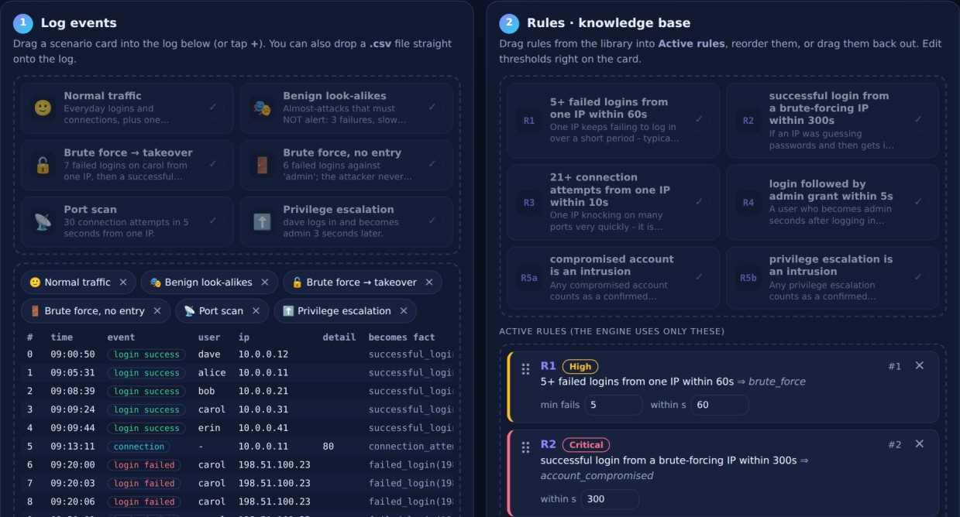
Figure 4.1 LOG EVENTS AND RULES PANELS OF THE WEBSITE

DATA PREPROCESSING
Before inference, every log row is parsed and turned into one or more facts. The time stamp is converted to seconds so that time windows can be checked by simple subtraction. Each fact keeps its row number, which is later used to highlight the evidence rows. The demonstration log of 99 events produces 109 facts, because each successful login gives two facts: successful_login(IP, user) and login(user).

ALGORITHMS / METHODOLOGY
Forward chaining. The engine keeps a working memory of facts. In each round it takes every active rule in order. For a rule with a count and a window, such as R1, it groups matching facts by their variables (for example by IP) and slides a window over them in time order. If 5 or more facts fall within 60 seconds, the rule fires. For a rule with a sequence, such as R2, it checks that the second event comes after the first within the given window. A fired rule adds its conclusion as a new fact, with the matching facts as its children in a proof tree. The loop ends when a full round adds no new fact.
facts <- facts_from_log(log)

repeat
new <- empty
for each active rule R in order:
for each binding B where IF-part of R matches facts: f <- THEN-part of R under B
if f not in facts: add f with proof(R, matching facts) to new facts <- facts + new
until new is empty

Backward chaining. The engine receives a goal such as is_intrusion(carol). It first looks for a log fact that matches the goal directly. If none is found, it looks for a rule whose THEN-part unifies with the goal. The variables of the rule are bound to the values in the goal, and the engine tries to prove each condition in the IF-part as a new sub-goal. If all sub-goals are proved the answer is YES and the proof tree is returned. If no rule works, the answer is NO. The "why not" mode searches for the closest miss, for example "only 5 x failed_login within 120 s, needs 5 within 60 s".
prove(goal):
if a log fact matches goal: return proof(fact)
for each active rule R whose THEN-part unifies with goal: bind variables of R from goal
if every condition in IF-part of R can be proved (recursively): return proof(R, sub-proofs)
return NO, with the closest miss

Concepts used. The project uses only ideas from the Foundations of AI course: knowledge representation with facts and rules, propositional and first-order style predicates, unification, forward chaining, backward chaining and proof trees.
Implementation. The page is written in plain HTML, CSS and JavaScript inside one file, index.html (about 71 KB), with no framework and no external library. HTML gives the structure (three panels, tables, buttons and drop zones). CSS gives the light and dark themes and the phone-friendly layout. JavaScript holds the engine (facts, rules, forward and backward chaining) and the page logic. The engine is a line-for-line port of an earlier Python version of the same rule

engine. Figure 4.2 shows the deployment: the file is uploaded as a static site, Cloudflare serves it over HTTPS, and the user's browser runs the entire engine.

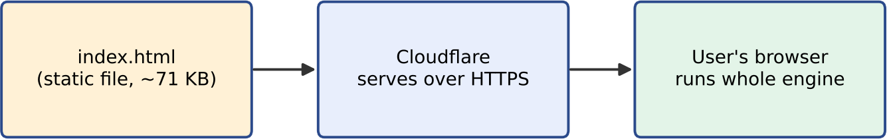

Figure 4.2 DEPLOYMENT OF THE WEBSITE
User interaction. A user can: (1) drag scenario cards into the log or remove them; (2) import or drop a CSV file; (3) drag rules in and out of the Active rules area, reorder them and edit thresholds; (4) press Run forward chaining or type a query; (5) use Step, Play and Show all to control the pace; and (6) read the plain-English explanation beside the code output. On touch screens the plus and cross buttons on each card replace dragging.

RESULTS AND DISCUSSION
A two-minute test was used to check the system. Pressing Run forward chaining on the demonstration log gives 7 conclusions in 2 rounds: brute_force for two IPs (198.51.100.23 and 203.0.113.9), account_compromised(carol), port_scan(203.0.113.77), privilege_escalation(dave), and is_intrusion for carol and dave. Asking is_intrusion(carol) by backward chaining returns the same proof chain as the worked example. Asking "why not alice?" shows that an admin grant given long after the login is not an escalation. Dragging rule R1 out and running again removes the account_compromised result, because R2 loses its input; the site displays the warning "needs R1 active" on R2.
The proof of is_intrusion(carol) can be read directly from the trace shown in Figure 4.3. The engine starts with the goal and tries rule R5a, whose IF-part is account_compromised(carol). To prove this sub-goal it tries rule R2, which needs a brute_force fact for an IP and a successful login of carol from the same IP. Rule R1 supplies brute_force(198.51.100.23) from the failed logins. The timing check then confirms that the login at 09:20:30 comes 18 seconds after the burst at 09:20:12, which is within the 300-second limit. The engine also tries the second brute-forcing IP, 203.0.113.9, and reports that no successful login of carol from it can be established, which shows that the engine searches among the candidate bindings and keeps the one that works.
After R5a succeeds, the engine still lists the alternative R5b. It needs privilege_escalation(carol), which in turn needs a login followed by an admin grant within 5 seconds. The log has two login events for carol, but no admin grant for her, so this branch fails. One successful branch is enough to prove the goal, but the trace shows both, so that the user can see that the claim is supported by exactly one path.
The "why not" queries give the closest miss in each case. For 192.0.2.50 the engine reports that 5 failed logins exist in total but at most 3 fall inside any 60-second window, while rule R1 needs 5. For 10.0.0.30 it reports that only 15 connection attempts exist, while rule R3 needs 21 within 10 seconds. For alice it explains that the admin grant did not follow a login within 5 seconds. These answers show the user not only that an alert was not raised but also how far the behaviour was from raising it.

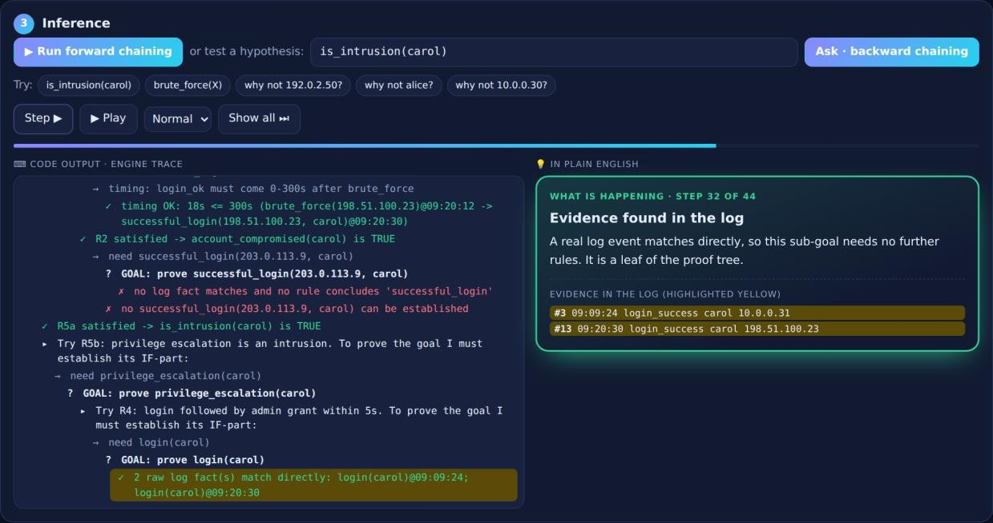
Figure 4.3 INFERENCE PANEL: BACKWARD CHAINING TRACE FOR
is_intrusion(carol)
Table 4.2 RESULTS ON THE DEMONSTRATION LOG

Measure | Value
Log events | 99
Facts derived from the log | 109
Conclusions reached | 7
Rounds of forward chaining | 2
Training samples needed | 0
Alerts that trace to exact rules and facts | 100%

Table 4.3 CAUGHT PATTERNS AND CORRECTLY IGNORED PATTERNS

Caught (alert raised) | Correctly ignored (no alert)
Brute force on carol, then a login: takeover and intrusion | Only 3 failed logins from one IP
Brute force on admin: flagged, but no intrusion (no login) | 5 failed logins spread over 2 minutes
Port scan from one IP: 30 attempts in 5 s | 15 connections in 8 s (needs 21)
dave becomes admin 3 s after login: escalation | Admin grant hours after login

Discussion. The look-alike cases show that the thresholds work as intended: patterns that come close to an attack but miss its numbers do not raise an alert. The brute force on admin is flagged by R1 but does not become an intrusion because no successful login follows, so R2 cannot fire. A built-in test confirms that forward and backward chaining reach the same conclusions on the demonstration log. The main strength of the approach is that every result can be explained; the main limit is that only known patterns with fixed thresholds are detected.
The behaviour of the system depends strongly on the thresholds, and the demonstration shows the trade-off. A lower threshold detects more attacks, but it also starts to alert on normal behaviour. For example, if the number of failures required by R1 is lowered from 5 to 3, the harmless typos of bob would start to raise brute-force alerts. A higher threshold removes such false alarms, but it lets a slower attacker through. Because the thresholds are editable on the rule cards, a user can try both directions and watch the effect on the result, which is a useful way to understand why thresholds must be chosen with the normal behaviour in mind.
The dependency between rules is also visible in practice. When R1 is removed from the active rules, R2 loses its input and carol is no longer reported as compromised, although all her failed and successful logins are still in the log. This shows that the engine reasons from the active rule set only and that the final alerts are exactly the logical consequences of the facts and the rules, which is the main property expected of a rule-based system.
The evaluation has limits that should be stated clearly. The demonstration log is written by the authors to cover each rule and its near-misses, so it shows that the rules behave as designed, but it does not measure how often the rules would give false alarms or miss attacks on real traffic. Such a measurement would need real logs with known labels, and it is listed as future work.

CHAPTER 5 CONCLUSION
This project built a Rule-Based Intrusion Detection System using only classical AI. Log events become facts, six IF-THEN rules describe the attacks, and an inference engine applies them by forward chaining (to find all alerts) and backward chaining (to prove or explain one claim). No machine learning and no generative AI is used. The system is delivered as one static web page that runs entirely in the browser, so no installation, server or dataset is needed, and no log data leaves the user's device.
On the demonstration log of 99 events, the system derived 109 facts and 7 conclusions in 2 rounds, caught brute force, account takeover, a port scan and a privilege escalation, and correctly ignored four benign look-alikes. Each alert comes with a proof built from exact rules and facts, and the step-by-step trace, yellow evidence rows and plain-English text make the reasoning visible.
Limitations. The rules use fixed thresholds and known patterns, so a slow attacker can slip under a rule, and unknown attack types are not detected. Logs are supplied as a file, not as a live stream.
Future work. More rules can be added, for example for data exfiltration, because a new rule only needs a new entry in the rule list. The engine can be connected to live logs instead of a CSV file, and rule thresholds can be tuned against larger real-world logs.
The project also met its learning aims. Building the system required representing knowledge as facts and rules, writing a matching procedure with unification, implementing forward chaining with a stopping condition, implementing backward chaining with recursion and proof trees, and presenting the reasoning to a human reader. These are the central techniques of classical AI, and the project shows that they are enough to build a useful and explainable security tool.
Several extensions are possible. New rules can be added for other attack types, for example data exfiltration, where a large transfer follows an account compromise. Rules can be given a severity, as the rule cards already label R1 as High and R2 as Critical, and alerts can then be ranked by severity. The rule set and the alerts can be exported so that a rule set is not lost when the page is closed. The engine can read a live log stream instead of a file. Finally, the rules can be evaluated on larger labelled logs to measure false alarms and missed attacks, and the thresholds can be tuned with the results.

REFERENCES

- S. Russell and P. Norvig, Artificial Intelligence: A Modern Approach, 4th ed. Pearson, 2020.
- E. Rich, K. Knight and S. B. Nair, Artificial Intelligence, 3rd ed. McGraw-Hill, 2009.
- D. E. Denning, "An intrusion-detection model," IEEE Transactions on Software Engineering, vol. SE-13, no. 2, pp. 222-232, 1987.
- K. Scarfone and P. Mell, Guide to Intrusion Detection and Prevention Systems (IDPS), NIST Special Publication 800-94, 2007.
- R. Sommer and V. Paxson, "Outside the closed world: On using machine learning for network intrusion detection," in Proc. IEEE Symposium on Security and Privacy, 2010, pp. 305-316.
- United Nations, Transforming Our World: The 2030 Agenda for Sustainable Development, 2015.

APPENDIX

Sample log format (CSV)
timestamp,event,user,src_ip,detail
2026-10-13 | 09:20:00,LOGIN_FAILED,carol,198.51.100.23,
2026-10-13 | 09:20:18,LOGIN_FAILED,carol,198.51.100.23,
2026-10-13 | 09:20:30,LOGIN_SUCCESS,carol,198.51.100.23,
2026-10-13 | 09:33:20,CONNECTION,-,203.0.113.77,20
2026-10-13 | 10:20:00,LOGIN_SUCCESS,dave,10.0.0.12,
2026-10-13 | 10:20:03,PRIV_CHANGE,dave,10.0.0.12,admin

Demonstration steps
  - Open the site and look at the three panels: log, rules and inference.
  - Click "Run forward chaining", press Play and follow the trace and the plain-English box. The expected result is 7 conclusions in 2 rounds.
  - Click is_intrusion(carol) to see the proof tree.
  - Click "why not alice?" to see why a late admin grant is not an escalation.
  - Drag rule R1 out and run again: R2 loses its input and carol is no longer flagged.

Website sections
The site has three numbered panels. Panel 1 (Log events) holds scenario cards and the log table. Panel 2 (Rules, knowledge base) holds the rule library and the Active rules list with editable thresholds. Panel 3 (Inference) holds the forward chaining button, the query box with ready-made queries (is_intrusion(carol), brute_force(X), why not 192.0.2.50?, why not alice?, why not 10.0.0.30?), the Step, Play and Show all controls, the code output and the plain-English box.

