PRACTICAL – 01

AIM: Practical of Data Collection, Data Curation and Management for large scale data system (such as MongoDB).

PROCEDURE:

Install MongoDB

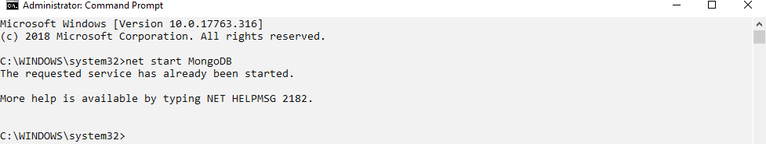Run CMD as administrator Start MongoDB via cmd

Enter the MongoDB bin folder via the cmd. Type Mongo

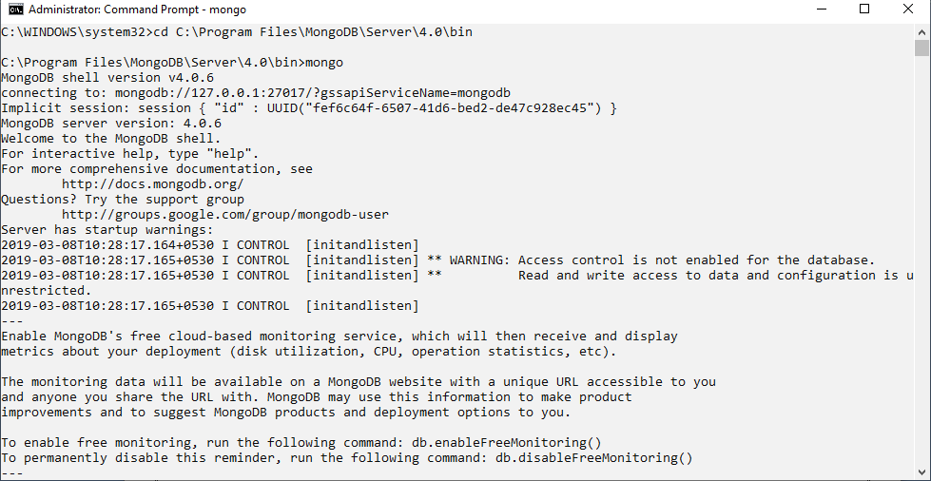

Check Current Database

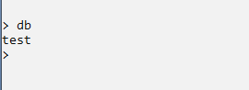

Use database library



Create Collection(table)



Insert document (records) in collection

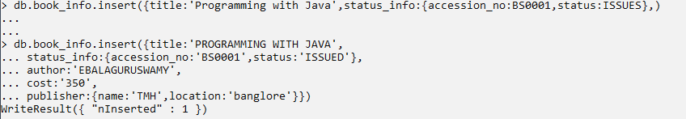

To insert multiple records in one column



To view records of a specific document:



To view all records:

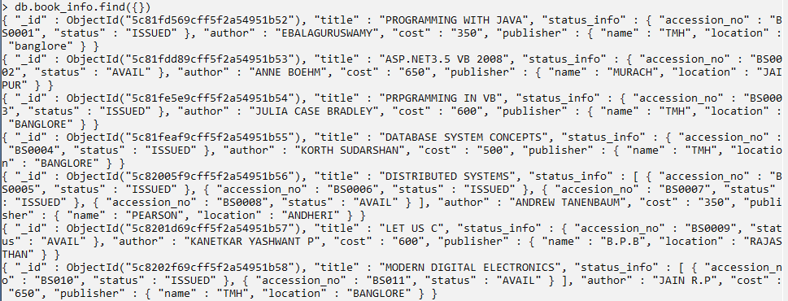

To view accession numbers:

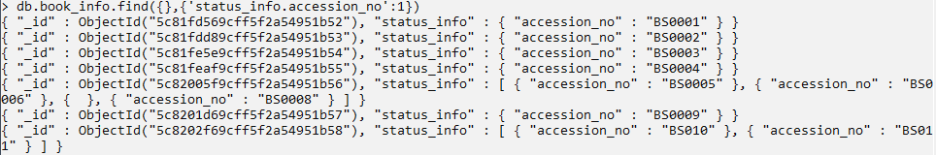

To print records with accession no “BS0001”



To print data in JSON format

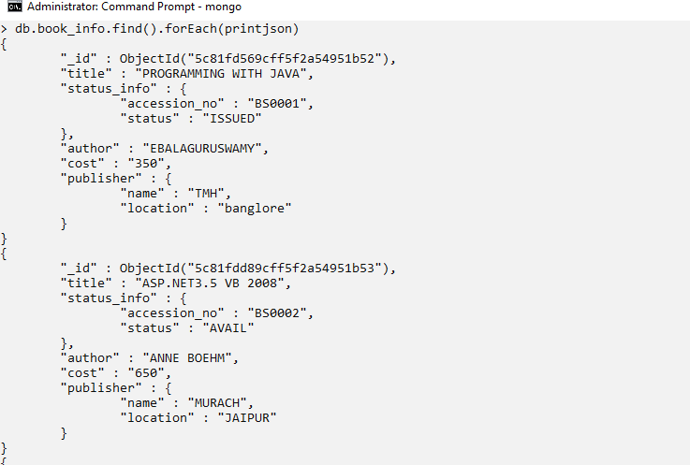

To print the details of book where cost is more than 500

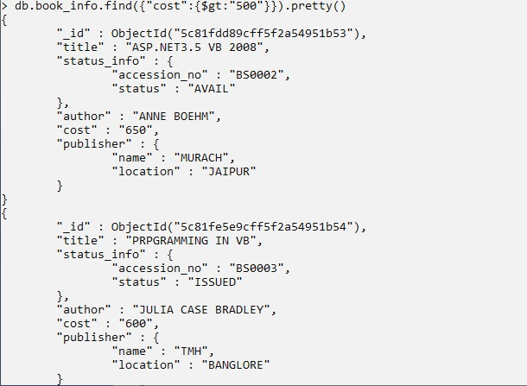

**Conclusion:** We have successfully executed Data Collection, Data Curation and Management for large scale data system (such as MongoDB).