**1)Write a PHP program to create a simple calculator calculator that can accept two numbers numbers and perform perform operation operations like add, subtract, subtract, multiplication multiplication and divide (using Self Processing accessing form)**

<HTML>

<BODY>

<form method="post" action="<?php echo $_SERVER['PHP_SELF']?>">

<B>First Number:</b><input type="text" name="num1">

<B>Second Number:</b><input type="text" name="num2">

<input type="radio" name="cal" value="add"> Add

<input type="radio" name="cal" value="sub"> Sub

<input type="radio" name="cal" value="mult"> Multy

<input type="radio" name="cal" value="div"> Division

<input type="submit" name="submit">

</form>

<?php

if(isset($_POST['submit']))

{

$n1=(int)$_POST['num1'];

$n2=(int)$_POST['num2'];

$c=trim($_POST['cal']);

if(strcmp($c,"add") == 0){$result=$n1+$n2; echo"$n1+$n2=$result";}

if(strcmp($c,"sub")== 0){$result=$n1-$n2; echo"$n1-$n2=$result";}

if(strcmp($c,"mult")== 0){$result=$n1*$n2; echo"$n1*$n2=$result";}

if(strcmp($c,"div")== 0){$result=$n1/$n2; echo"$n1/$n2=$result";}

}

?>

</body>

</html>

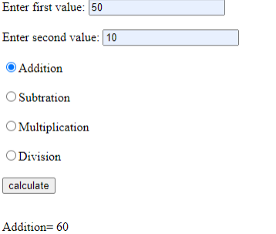

**2)Create a login form with a username and password. Once the user logs in, the second form should be displayed to accept user details (name, city, phone no). If the user doesn’t enter information within a specified time limit, expire his session and give a warning otherwise Display Details($_SESSION).**

**Login.html**

<html>

<form method="POST" action="login.php" >

<p>User Name: <input type="text" name="user"><br>

<p>Password :<input type="password"><br><br>

<input type="submit" value="Login"><br>

</form>

</html>

**Login.php**

<?php

$auth_yes=0;

session_start();

session_register();

#tm=time();

?>

<form method="GET" action="new.php">

<fieldset>

<legend>Enter username and password</legend>

<p>Roll_No:&nbsp&nbsp&nbsp<input type="text" name="rno"><br>

<p>Name:&nbsp&nbsp&nbsp<input type="text" name="nm"><br>

<p>City:&nbsp&nbsp&nbsp:&nbsp&nbsp&nbsp<input type="text" name="ct"><br><br>

<input type="submit" value=Submit>

</form>

**New.php**

<?php

$a=$_GET['rno'];

$b=$_GET['nm'];

$c=$_GET['ct'];

session_start();

$newt = $tm+60;

if($newt > time())

echo"time out";

else

{

echo"Roll_No=$a"."<br>";

echo"Name=$b"."<br>";

echo"City=$c"."<br>";

}

session_destroy();

?>

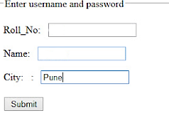

abc

123

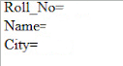

123

abc

Pune

**3)Write a PHP Script create login form and validate it (Use database and Sticky form concept)**

<html>

<head>

<title>Sticky Form</title><

</head>

<body>

<form action="<?php echo $_SERVER['PHP_SELF']?>" method=post> <input type=text name=txtuname value="<?php if(isset($_POST['txtuname']))echo $_POST['txtuname'];?>" >

<input type=password name=txtupass value="<?php if(isset($_POST['txtupass']))echo $_POST['txtupass'];?>" >

<input type=submit value="Login" name=submit>

<?php

if(isset($_POST['submit']))

$nm=$_POST['txtuname'];

$ps=$_POST['txtupass'];

$con=mysql_connect("localhost","root","rsb");

mysql_elect_db("slip6db",$con);

$result=mysql_query("select * from login where uname='$nm' and upass='$ps'");

$flag=0;

while($row=mysql_fetch_array($result))

{

$flag++;

}

if($flag==1)

echo "Login validated";

else

echo "username or password invalid";

?>

</body>

</html>

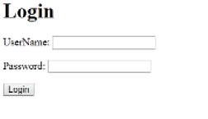

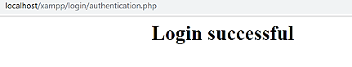

**4) Create a form to accept employee details like name, address and mobile number. Once the employee information is accepted, then accept LIC information like policy_no, name, premium. Display employee details and LIC details on next form.(use COOKIE)**

**Emp.html**

<html>

<body>

<form method="POST" action="Lic.php">

Enter EMP No : <input type=text name="eno"><br>

Enter EMP Name : <input type=text name="name"><br>

Enter Address : <input type=text name="addr"><br>

<input type=submit value=Submit>

</form>

</body>

</html>

**LIC.php**

<?php

session_start();

$_SESSION['eno']=$_POST['eno'];

$_SESSION['name']=$_POST['name'];

$_SESSION['addr']=$_POST['addr'];

echo"Hello ".$_SESSION['name']." enter LIC details<br>";

?>

<form method="POST" action="Display.php">

Plan No:<input type="text" name="pno"><br>

Plan Name :<input type="text" name="pname"><br>

Premium :<input type="text" name="pre"><br>

<input type=submit value=Display>

</form>

**Display.php**

<?php

    session_start();

            echo"<Center>"."<b>Employee Details</b>"."<br>";

            echo"Emp No:".$_SESSION['eno']."<br>";

            echo"Emp name:".$_SESSION['name']."<br>";

            echo"Address:".$_SESSION['addr']."<br>"."<hr>";

            echo"<b>LIC Plan Details:</b>"."<br>";

            echo"Plan No:".$_REQUEST['pno']."<br>";

            echo"Plan Name:".$_REQUEST['pname']."<br>";

            echo"Premium:".$_REQUEST['pre']."<br>"."<hr>";

 ?>

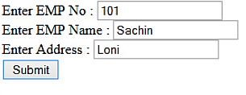

Xyz town

Abc

s

**Hello abc Enter your LIC details**

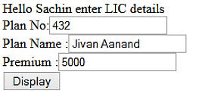

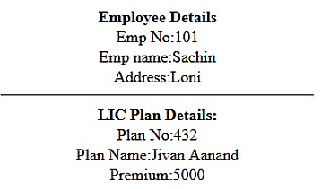

**Xyz town**

**Abc**

Xyz town

**5) Write a script to keep track of number of times the web page has been accessed (use $_COOKIE)**

<html>

<body>

<SCRIPT>

function GetCookie (name)

{

var arg = name + "=";

var alen = arg.length;

var clen = document.cookie.length;

var i = 0;

while (i < clen)

{

var j = i + alen;

if (document.cookie.substring(i, j) == arg)

return getCookieVal (j);

i = document.cookie.indexOf(" ", i) + 1;

if (i == 0) break;

}

return null;

}

function SetCookie (name, value)

{

var argv = SetCookie.arguments;

var argc = SetCookie.arguments.length;

var expires = (argc > 2) ? argv[2] : null;

var path = (argc > 3) ? argv[3] : null;

var domain = (argc > 4) ? argv[4] : null;

var secure = (argc > 5) ? argv[5] : false;

document.cookie = name + "=" + escape (value) +

((expires == null) ? "" : ("; expires=" + expires.toGMTString())) +

((path == null) ? "" : ("; path=" + path)) +

((domain == null) ? "" : ("; domain=" + domain)) +

((secure == true) ? "; secure" : "");

}

function DeleteCookie (name)

{

var exp = new Date();

exp.setTime (exp.getTime() - 1);

var cval = GetCookie (name);

document.cookie = name + "=" + cval + "; expires=" + exp.toGMTString();

}

var expDays = 30;

var exp = new Date();

exp.setTime(exp.getTime() + (expDays*24*60*60*1000));

function amt()

{

var count = GetCookie('count')

if(count == null)

{

SetCookie('count','1')

return 1

}

else

{

var newcount = parseInt(count) + 1;

DeleteCookie('count')

SetCookie('count',newcount,exp)

return count

}

}

function getCookieVal(offset)

{

var endstr = document.cookie.indexOf (";", offset);

if (endstr == -1)

endstr = document.cookie.length;

return unescape(document.cookie.substring(offset, endstr));

}

</SCRIPT>

<SCRIPT>

document.write("You've been here <b>" + amt() + "</b> times.")

</SCRIPT>

</body>

</html>

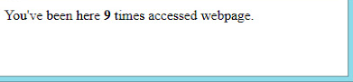

**6) Write a PHP script to accept username and password. If in the first three chances, username and password entered is correct then display second form with ‘welcome message’ otherwise display error message. [ Use Session]**

HTML file :

<html>

<head>

<script>

function getans()

{

st1=document.getElementById('txtname').value;

st2=document.getElementById('txtpass').value;

ob=new XMLHttpRequest();

ob.onreadystatechange=function()

{

if(ob.readyState==4 && ob.status==200)

{

if(ob.responseText==3)

{

alert("no chances left to login");

location="error.html";

}

else if(ob.responseText=="correct")

{

alert("login successful");

}

else alert(ob.responseText);

}

}

ob.open("GET","slip8_Q2.php?n="+st1+"&p="+st2);

ob.send();

}

</script>

</head>

<body>

<input type=text id=txtname placeholder="username"></br>

<input type=password id=txtpass placeholder="password"></br>

<input type="button" onclick="getans()" value="Login">

</body>

</html>

HTML file : error.html

<html>

<body>

<h1> no chances left to login </h1>

</body>

</html>

PHP file :

<?php

session_start();

$nm=$_GET['n'];

$ps=$_GET['p'];

if($nm==$ps)

{

echo "correct";

}

else if(isset($_SESSION['cnt']))

{

$x=$_SESSION['cnt'];

$x=$x+1;

$_SESSION['cnt']=$x;

echo $_SESSION['cnt'];

if($_SESSION['cnt']>=3)

$_SESSION['cnt']=1;

}

else

{

$_SESSION['cnt']=1;

echo "1";

}

?>

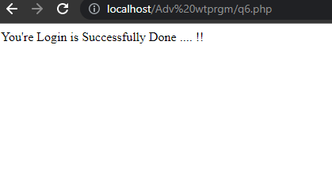

**Login Successful!**

7) **Create a form to accept student information (name, class, address). Once the student information is accepted, accept marks in next form (Java, PHP, ST, IT, pract1, and project).Display the mark sheet for the student in the next form containing name, class, marks of thesubject, total and percentage(Use $_COOKIE).**

**Html file :**

<html>

<body>

<form action="slip_10-1.php" method="post">

<center>

<h2>Enter Students information :</h2>

<table>

<tr><td>Name : </td><td><input type="text" name="name"></td><tr>

<tr><td>Address : </td><td><input type="text" name="addr"></td></tr>

<tr><td>Class : </td><td><input type="text" name="class"></td></tr>

<tr><td></td><td><input type="submit" value=Next></td></tr>

</table>

</center>

</form>

</body>

</html>

**Php file :**

Student-1.php :

<html>

<body>

<form action="slip_10-2.php" method="post">

<center>

<h2>Enter Marks for Student:</h2>

<table>

<tr><td>Java : </td><td><input type="text" name="m1"></td><tr>

<tr><td>PHP : </td><td><input type="text" name="m2"></td></tr>

<tr><td>ST : </td><td><input type="text" name="m3"></td></tr>

<tr><td>IT : </td><td><input type="text" name="m4"></td></tr>

<tr><td>Practical : </td><td><input type="text" name="m5"></td></tr>

<tr><td>Project : </td><td><input type="text" name="m6"></td></tr>

<tr><td></td><td><input type="submit" value=Next></td></tr>

</table>

</center>

</form>

</body>

</html>

<?php

setcookie("stud1",$_POST['name'],time()+3600);

setcookie("stud2",$_POST['addr'],time()+3600);

setcookie("stud3",$_POST['class'],time()+3600);

?>

Student-2.php :

<?php

echo "<h3>Marksheet</h3> ";

echo "Name : ".$_COOKIE['stud1']."<br>";

echo "Address : ".$_COOKIE['stud2']."\n";

echo "Class : ".$_COOKIE['stud3']."\n";

echo "Java : ".$_POST['m1']."\n";

echo "PHP : ".$_POST['m2']."\n";

echo "ST : ".$_POST['m3']."\n";

echo "IT : ".$_POST['m3']."\n";

echo "Practical : ".$_POST['m3']."\n";

echo "Project : ".$_POST['m3']."\n";

>?

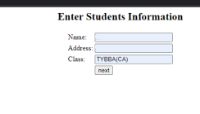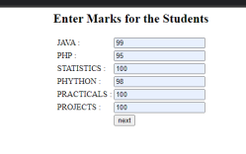

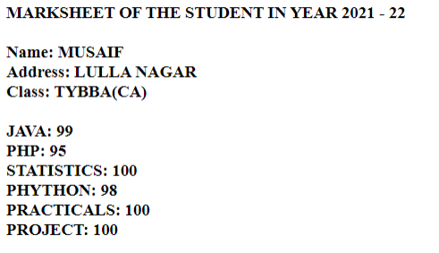

**NAME: ABC**

**ADDRESS: XYZ TOWN**

**CLASS: TY BBA(CA)**

**8)Write a program to create a shopping mall. User must be allowed to do purchase from three pages. Each page should have a page total. The fourth page should display a bill, which consists of a page total of whatever the purchase has been done and print the total. (Use $_SESSION).**

1.php-

<?php

session_start();

if(!isset($_SESSION['total']))

{

$_SESSION['total']=0;

}

if(isset($_POST['submit']))

{

$_SESSION['pname']="KACHI GHANI MUSTARD OIL (L)";

$_SESSION['amt']="100";

$_SESSION['total']=$_SESSION['total']+100;

}

?>

<html>

<head>

</head>

<body>

<h1<center>shopping mall</center> Total :<span style="color:red<?php if(isset($_SESSION['total'])){echo $_SESSION['total'];}?></span</h1>

<table style="width:100%">

<tr>

<th><a href="1.php">1</a></th>

<th><a href="2.php">2</a></th>

<th><a href="3.php">3</a></th>

<th><a href="Final.php">Final</a></th>

</tr>

</table>

Product 1:

<FORM ACTION="<?php $_SERVER['PHP_SELF']; ?>" method="POST">

<table style="width:100%" border=1>

<tr>

<th>Product Image</th>

<th>Product Name</th>

<th>Price </th>

<th>action</th>

</tr>

<tr>

<th><img src="img/1.png"height="200" Width="200"> </th>

<th>KACHI GHANI MUSTARD OIL (L)</th>

<th>100</th>

<th>

<input type=submit name=submit value="buy">

</form></th>

</tr>

</table>

</body>

</html>

2.php-

<?php

session_start();

if(!isset($_SESSION['total']))

{

$_SESSION['total']=0;

}

if(isset($_POST['submit']))

{

$_SESSION['pname']=$_SESSION['pname'].","."Patanjali Saundarya Face WashOIL (L)";

$_SESSION['amt']=$_SESSION['amt'].","."50";

$_SESSION['total']=$_SESSION['total']+50;

}

?>

<html>

<head>

</head>

<body>

<h1<center>shopping mall</center> Total :<span style="color:red;"><?php if(isset($_SESSION['total'])){echo $_SESSION['total'];}?></span></h1>

<table style="width:100%">

<tr<br> <th<a href="1.php">1</a</th>

<th<a href="2.php">2</a</th>

<th><a href="3.php">3</a></th>

<th<a href="Final.php">Final</th>

</tr>

</table>

Product 2:

<FORM ACTION="<?php $_SERVER['PHP_SELF']; ?>" method="POST">

<table style="width:100%" border=1>

<tr>

<th>Product Image</th>

<th>Product Name</th>

<th>Price </th>

<th>action</th>

</tr>

<tr>

<th><img src="img/2.jpg"height="200" Width="200"> </th>

<th>Patanjali Saundarya Face Wash</th>

<th>50</th>

<th>

<input type=submit name=submit value="buy">

</form></th>

</tr>

</table>

</body>

</html>

3.php-

<?php

session_start();

if(!isset($_SESSION['total']))

{

$_SESSION['total']=0;

}

if(isset($_POST['submit']))

{

$_SESSION['pname']=$_SESSION['pname'].","."Patanjali mango juices";

$_SESSION['amt']=$_SESSION['amt'].","."70";

$_SESSION['total']=$_SESSION['total']+70;

}

?> <html>

<head>

</head>

body>

<h1><center>shopping mall<</center> Total <span style="color:red;"><?php if(isset($_SESSION['total'])){echo $_SESSION['total'];}?></span></h1>

<table style="width:100%">

<tr>

<th><a href="1.php">1</a></th>

<th><a href="2.php">2</a></th>

<th><a href="3.php">3</a></th>

<th><a href="Final.php">Final</a></th>

</tr>

</table>

Product 3:

<FORM ACTION="<?php $_SERVER['PHP_SELF']; ?>" method="POST">

<table style="width:100%" border=1>

<tr> <th>Product Imag</th>

<th>Product Name</th>

<th>Price </th>

<th>action</th>

</tr<br> <tr>

<th<img src="img/3.jpg"height="200" Width="200"> </th>

<th>Patanjali mango juices</th>

<th>70<</th>

<th>

<input type=submit name=submit value="buy" >

</form>

</tr>

</table>

</body>

</html>

final.php

<?php

session_start();

?>

<html>

<head>

<script>

function myFunction()

{

window.print();

}

</script>

</head>

<body>

<h1><center>shopping mall</center> Total :<span style="color:red<?php if(isset($_SESSION['total'])){echo $_SESSION['total'];}?></span> <table style="width:100%">

<tr>

<th<a href="1.php">1</a></th>

<th<a href="2.php">2</a</th>

<th<a href="3.php">3</a></th>

<th><a href="Final.php">Final</a></th>

</tr>

</table>

<br>

<br>

<h2><center>Final Bill</center> Total :</h2>

<table style="width:100%" border=1>

<tr>br> <th>Product Name</th>

<th>AMount /th>

<th>Total</th>

<th>Print</th>

</tr>

<tr>

<th><?php if(isset($_SESSION['pname'])){echo $_SESSION['pname'];}?></th>

<th><?php if(isset($_SESSION['amt'])){echo $_SESSION['amt'];}?></th>

<th><span style="color:red;"><?php if(isset($_SESSION['total'])){echo $_SESSION['total'];}?></span></th>

<th><button onclick="myFunction()">Print </button>

</tr>

</table>

</body>

</html>

**9) Write a PHP script for the following: Design a form to accept a number from the user. Perform the operations and show the results.**

**1) Factorial of a number using Recursion.**

**2) Add the digits of that number to reduce it to single digit.  
 (use the concept of self-processing page.)**

<html>

<head>

<title>slip12</title>

</head>

<body>

<?php

if($_SERVER['REQUEST_METHOD']=="GET")

{

?>

<form action="<?php echo $_SERVER['PHP_SELF']?>" method=POST>

<input type name=txtnumber placeholder="Enter a number ">

<input type=submit value="calculate">

</form>

<?php

}

else if($_SERVER['REQUEST_METHOD']=="POST")

{

              function fact($n)

              {

                          if($n==1)

                          {

                                                  return 1;

                                      }

                                      else {   return($n*fact($n-1));

              }

              }

              function singleval($n)

              {

                          while($n>9)

                          {$sum=0;

                                      while($n)

                                      {

                                                  $r=$n%10;

                                                  $sum=$sum+$r;

                                                  $n=$n/10;

                                      }

                                      $n=$sum;

                          }

                          return $n;

              }

              echo fact($_POST['txtnumber']);

              echo "</br>";

              echo singleval($_POST['txtnumber']);

}

?>

</body>

</html>

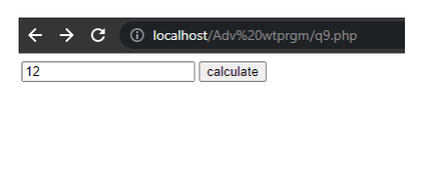

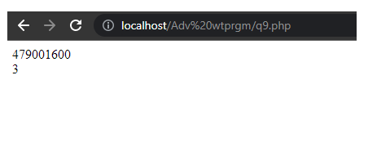

**10)Create student registration form and display details in the next page. (Use sticky form concept).**

<html>  
<body>  
<table border=1>  
<tr><th colspan=2>  
<form action="<?php echo $_SERVER['PHP_SELF']?>" method=post>  
<tr><td>Enter Name</td><td><input type="text" name="nm" value="<?php if(isset($_POST['nm']))echo $_POST['nm']?>"<td></tr>  
<tr><td>Enter Roll No</td><td><input type="text" name="rno" value="<?php if(isset($_POST['rno']))echo $_POST['rno']?>"</td></tr>  
<tr><td>Enter State</td><td><input type="text" name="st" value="<?php if(isset($_POST['st']))echo $_POST['st']?>" </td></tr>  
<tr><td>Enter City</td><td><input type="text" name="ct" value="<?php if(isset($_POST['ct']))echo $_POST['ct']?>"</td></tr>  
<tr><td>Enter Percentage</td><td><input type="text" name="per" value="<?php if(isset($_POST['per']))echo $_POST['per']?>"</td></tr>  
<tr><td><input type="submit" value="Submit" name="submit"></td>  
<td><nput type="reset" value="Reset"></td></tr>  
</form>  
</table>  
<?php  
if(isset($_POST['submit']))  
{  
$nm=$_POST['nm'];  
$rno=$_POST['rno'];  
$st=$_POST['st'];  
$ct=$_POST['ct'];  
$perc=$_POST['per'];  
}  
if((!empty($nm)) && (!empty($rno)) && (!empty($st)) && (!empty($ct)) && (!empty($perc)))  
{  
setcookie('nm',$nm);  
setcookie('rno',$rno);  
setcookie('st',$st);  
setcookie('ct',$ct);  
setcookie('perc',$perc);  
echo "U r Value is set";  
}  
?>  
<a href="slip14_1.php">show  
</body>  
</html>  
  
slip10_1.php-  
<?php  
echo "Your name is $_COOKIE[nm] </br>";  
echo "Your Roll No Is : $_COOKIE[rno]</br>";  
echo "Your State Is : $_COOKIE[st]</br>";  
echo "Your City Is : $_COOKIE[ct]</br>";  
echo "Your Percentage Is : $_COOKIE[perc]</br>";  
?>

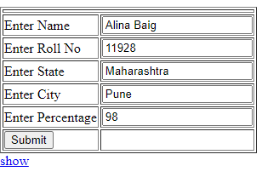

Pune

95

Maharashtra

101

abc

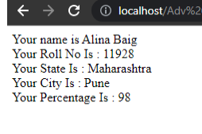

Your Name is **abc**

Your Roll no. is **101**

Your State is **Maharashtra**

Your City is **Pune**

Your percentage is **95**