**Title:**

Asset Performance Management

**Team:**

Mohit Kumar Agrahari-Developer/Project Owner

**Objective of the Application:**

* To provide an application to manage and monitor assets in real-time.
* To provide an application that helps to make strategic planning and decisions.
* To provide early knowledge about asset outage.
* To provide real time view of the target output specified.
* To Provide a platform for analytic deployment and execution which gives real time asset performance.

**Target Industry:**

* Power Industry
* Aviation Industry
* Shipping Industry
* Refinery Industry

**Tools and software:**

|  |
| --- |
| 1. Java JDK 1.8 |
| 2. Python 2.7 |
| 3. PostgreSQL |
| 4. Proficy Historian |
| 5.Eclipse |
| 6. Git |
| 7. Apache Maven 3.4 or above |
| 8. NodeJS v6.11.3 |
| 9. npm |
| 10.Cassandra 2.2.8 |
| 11. Grafana 4.5.2 |
| 12. Kairos DB 0.9.3 |

**Technical** **Architecture:**

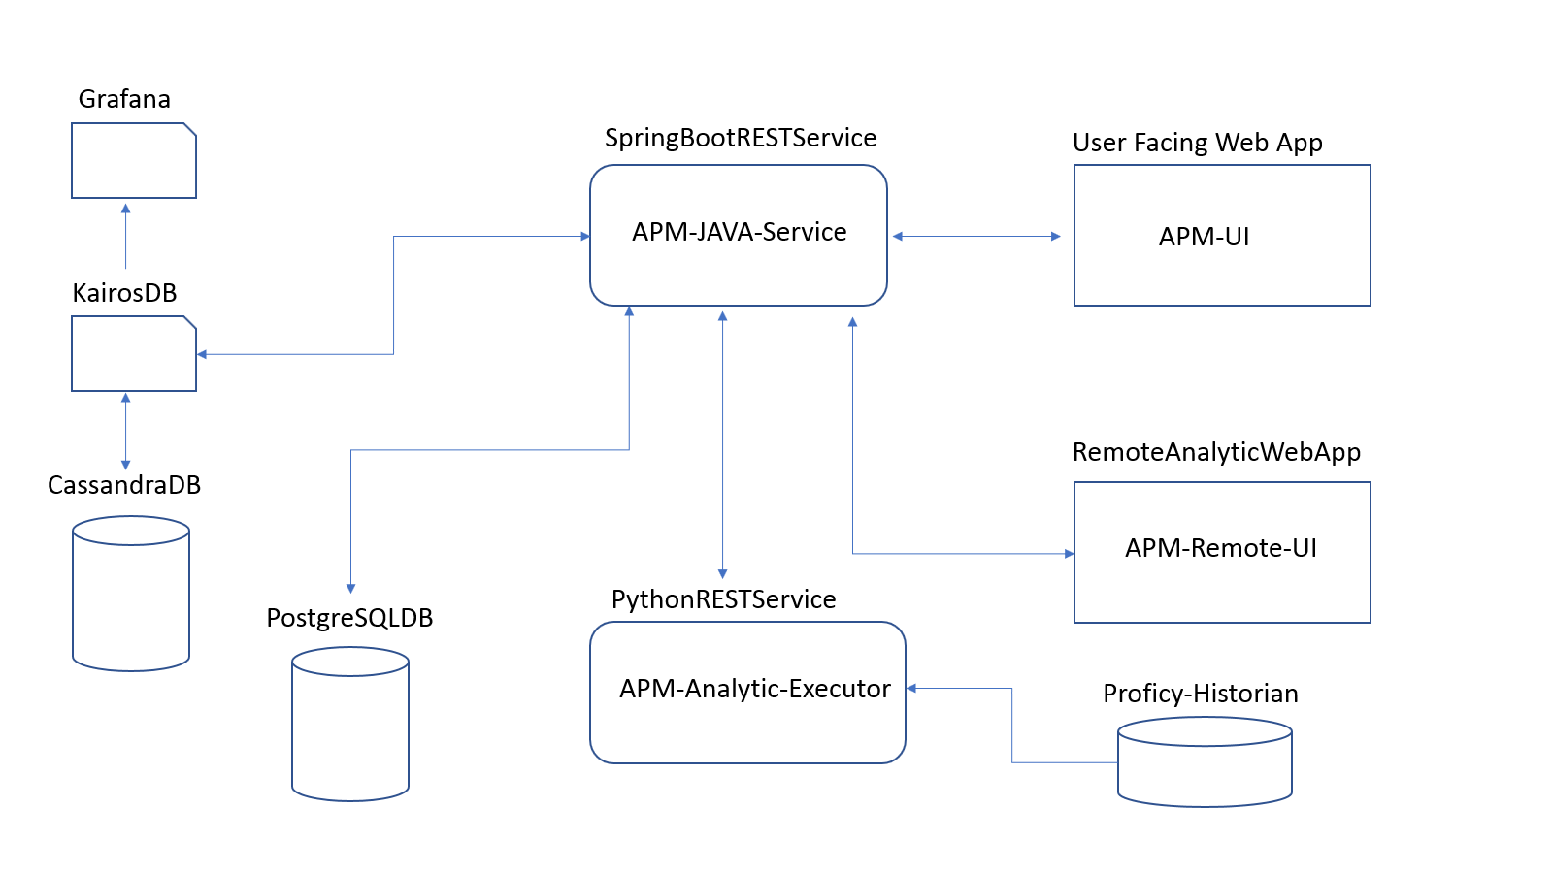

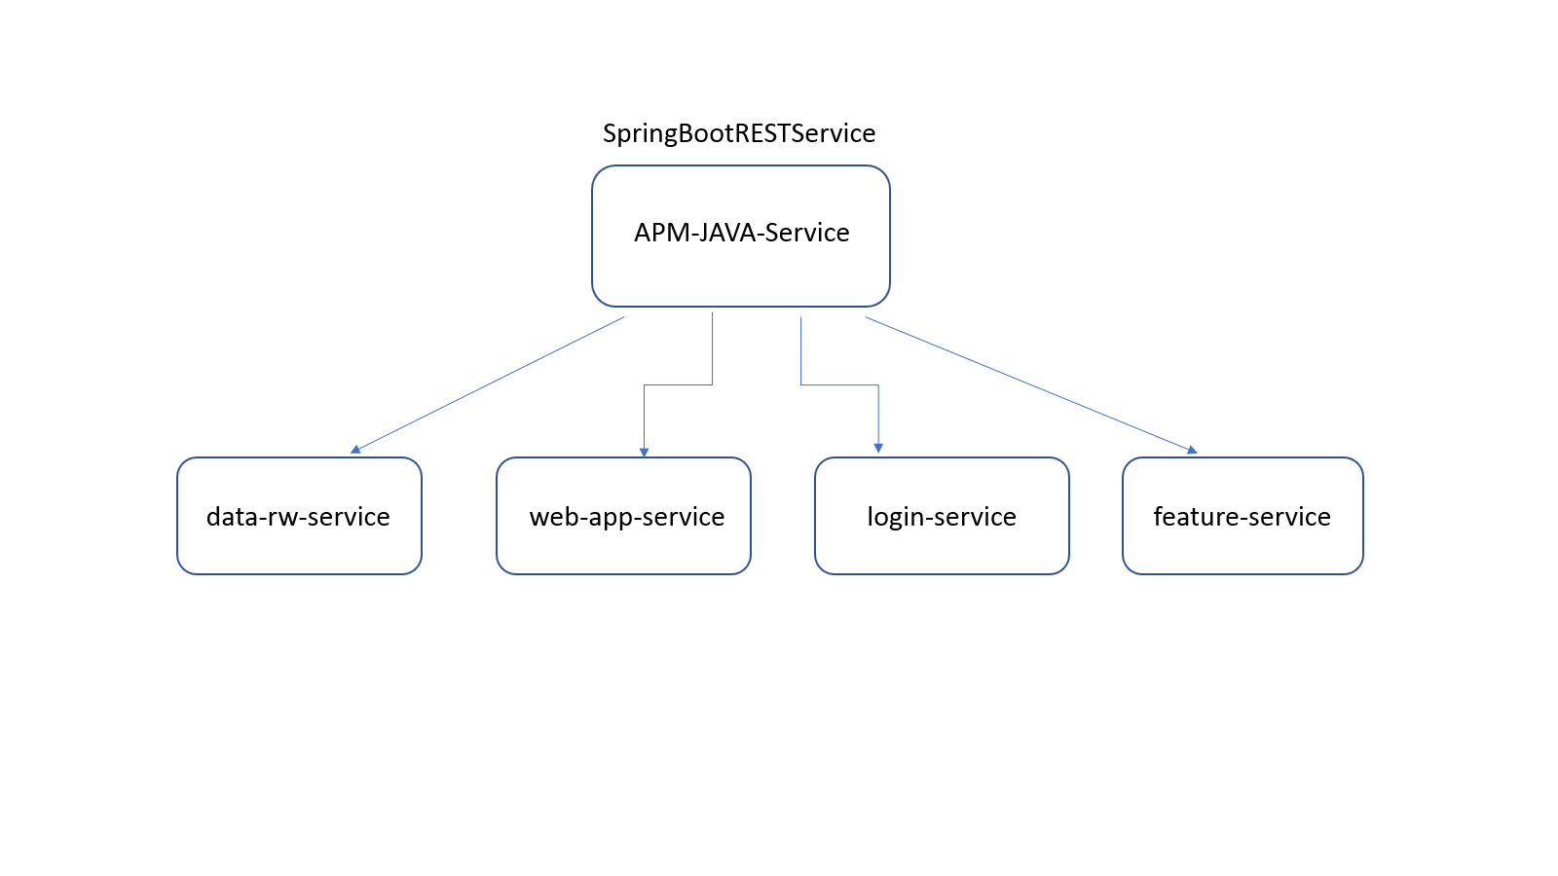

**Technical Component and Services**

**APM-JAVA-Service:**

A Java SpringBoot REST service which will be having below sub-service.

**data-rw-service:**

A Java SpringBoot REST Service which will be responsible for exposing APIs for read and write data from and to python REST service.

**web-app-service:**

A Java SpringBoot REST Service which will be responsible for exposing APIs for data visualization on APM-UI.

**login-service:**

A Java SpringBoot REST Service which will be responsible for exposing APIs for authentication and authorization of users.

**features-service:**

A Java SpringBoot REST Service which will be responsible for exposing APIs for role based access to application features.

**APM-Analytic-Executor:**

A python REST service responsible for exposing APIs for analytic execution and data flow between Java and Python REST services.

**APM-UI:**

A web application for data visualization.

**APM-Remote-UI:**

A web application for deploying analytics.

**PostgreSQL DB:**

A relational database for storing and manipulating transactional and configuration data related to APM application.

**Cassandra DB:**

A NoSQL database use to store time-series data returned from Analytics.

**KairosDB:**

A time-series database working as an interface for CassandraDB to store and retrieve time-series data, also useful for interpolation of time-series data.

**Proficy-Historian:**

A type of data storage which stores real time sensor data and provide this data to analytic on demand.

**Grafana:**

An intelligent tool for visualization of data in various formats, Can be easily used by non-technical management leaders and managers.