Smoker Status Prediction (Binary Classification)



Aman Tiwari (MT2025018)
Mohit Kumar(MT2025075)
Submitted in partial fulfilment for the award of degree of
Master of Technology
Computer Science and Engineering
Under The Guidance Of,
Prof. Sushree Behera

GitHub Link
Aman: https://github.com/Aman-dps/Smoker_Detection
Mohit: https://github.com/mohitkumar-dev95/smoker_status_prediction

Smoker Status
Prediction
(Binary Classification)

Index

Sl. No | Topics | Page No
1 | Abstract | 1
2 | Dataset Analysis | 2 - 5
3 | Data Preprocessing | 6 - 8
4 | Model building | 9 - 11
5 | Evaluation Metrices | 12 - 13
6 | Comparative Analysis | 14
7 | Final Results and Conclusion | 15

Abstract
This project focused on predicting smoking status using a health dataset enriched through several feature engineering steps. Derived attributes such as BMI, mean eyesight capability, aggregated hearing impairment, pulse pressure, and key biomedical ratios (cholesterol/HDL and AST/ALT) were incorporated to improve model expressiveness. All numerical variables were standardized using StandardScaler prior to model training.
Three classifiers were developed and compared: Logistic Regression, a basic Neural Network, and a Support Vector Machine (SVM). Logistic Regression and SVM were trained using standard procedures, while the Neural Network was intended to undergo hyperparameter tuning via RandomizedSearchCV with scikeras.
Among the trained models, the untuned Neural Network achieved the highest accuracy (≈0.77), outperforming both Logistic Regression (≈0.73) and the SVM model (≈0.52). The similarity between tuned and untuned Logistic Regression results suggests limited gains from the tested hyperparameter space, while the weaker SVM performance likely stems from its default linear kernel and restricted iteration budget.
Overall, the Neural Network—despite lacking hyperparameter tuning—shows the most promise for classifying smoking status. Future work should address the scikeras/sklearn version mismatch to enable proper Neural Network optimization and potentially improve prediction accuracy further.

Exploratory Data Analysis (EDA)
- Smoking Status Distribution

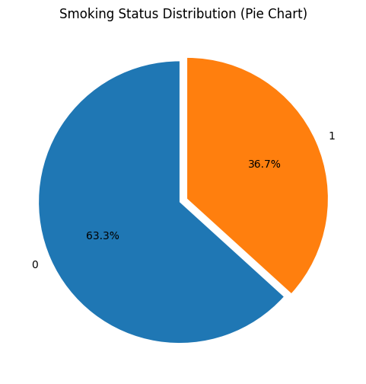

The pie chart illustrates how smoking status is distributed within the dataset. Approximately 63.3% of the samples correspond to non-smokers (class 0), whereas smokers (class 1) make up around 36.7%. This uneven class proportion shows that the dataset is moderately imbalanced, with non-smokers forming the majority group. Such imbalance can influence how well models learn to distinguish between the two classes, so approaches like adjusting class weights or applying resampling methods may be necessary to improve performance.

- Age Distribution

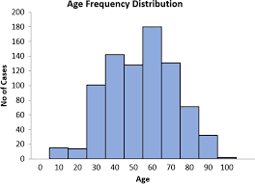
The age feature spans a broad range of adult participants, with noticeable concentrations in the middle-aged categories. The distribution looks somewhat uneven due to the data being recorded in 5-year intervals. There are no significant outliers, suggesting that age behaves as a reliable and stable predictor in the dataset.
2
- Height (cm)
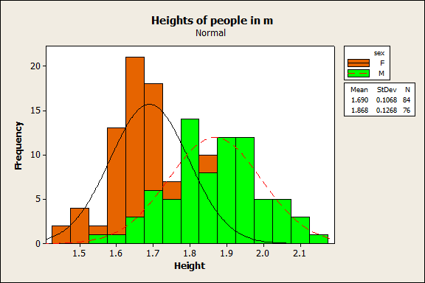
The height variable shows an approximately normal distribution, concentrated around common adult height ranges. Although there is slight skewness, the overall shape remains consistent and free of major anomalies. Most entries lie between 160 and 180 cm, making height a useful component for identifying BMI-related trends in smoking prediction.

- Waist Circumference (cm)
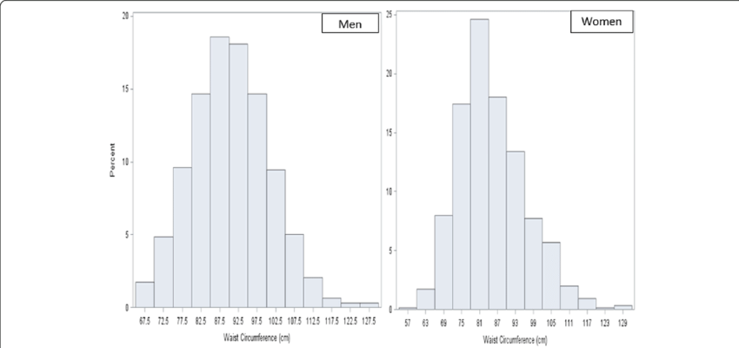
Waist circumference shows an almost normal distribution with a slight right skew. Larger waist measurements may be linked to certain lifestyle patterns, including smoking habits. The clear central peak suggests consistent recording, and the limited number of outliers indicates that the data is generally reliable.
- Systolic Blood Pressure
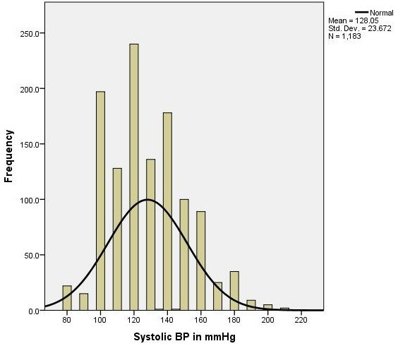
Systolic blood pressure is concentrated largely within the typical clinical range of 110–140 mmHg. The distribution is smooth, with only a small number of elevated-pressure outliers. Since smoking can affect blood pressure, this feature holds predictive relevance. Overall, the measurements appear consistent, with no noticeable data quality concerns.

- Fasting Blood Sugar
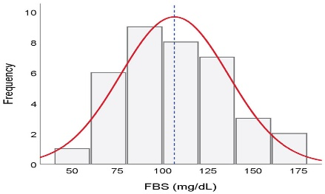
The feature is highly right-skewed, with most values in the healthy zone. A small set of individuals show elevated sugar levels. This skew suggests possible metabolic disorders. Useful for identifying lifestyle patterns common in smokers.

- Cholesterol
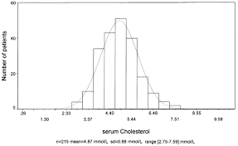
Cholesterol levels display a right-skewed distribution, with the majority of observations falling within normal limits. A few markedly high readings reflect individuals in higher-risk categories. Because smoking can influence lipid metabolism, this variable offers meaningful predictive value. The broad spread in measurements also contributes to useful class separation.

- Triglycerides
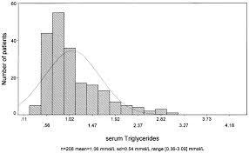
Triglyceride levels show a heavily skewed distribution with several pronounced outliers. Most individuals fall within normal to moderately elevated ranges, while extremely high values often reflect unhealthy lifestyle patterns. Given its sensitivity to such behaviors, this feature plays a meaningful role in modelling smoking-related risk.

- Hemoglobin
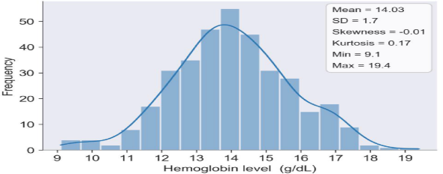

Hemoglobin displays a gently bell-shaped distribution without notable outliers. Since smoking can influence the body’s oxygen-carrying capacity, this variable remains physiologically relevant and potentially useful for classification.

Other Features with High Skew or Lower Predictive Value
Several variables exhibit strong skewness and may offer limited direct predictive signal in their raw form:
- Serum creatinine
- Fasting blood sugar
- Triglycerides
- Urine protein
- GTP (Gamma-GTP)
- ALT / AST (sharp spikes)
Because of their distributional issues, applying transformations such as log-scaling or evaluating their correlation with the target variable may be necessary before deciding whether to retain or exclude them from the model.

Dataset Preprocessing
We will now define our feature matrix (X) and target variable (y) using the new_train_df which includes the engineered features. For the target variable, we are predicting 'smoking'. All other columns will be considered as features. We will then apply StandardScaler to all features to normalize their ranges.

Feature Description and Engineering Ideas
Let's go through each feature in your train_df DataFrame:
1. 'age' (Numerical)
- Description: Age of the individual.
- Feature Engineering:
  - Age Bins: Categorize into age groups (e.g., '10-20', '21-30', etc.) which can capture non-linear relationships. This can be done using pd.cut.
  - Polynomial Features: Create age^2, age^3 to capture quadratic or cubic relationships.
2. 'height(cm)' (Numerical)
- Description: Height of the individual in centimeters.
- Feature Engineering:
  - Used in BMI calculation.
3. 'weight(kg)' (Numerical)
- Description: Weight of the individual in kilograms.
- Feature Engineering:
  - Used in BMI calculation.
4. 'waist(cm)' (Numerical)
- Description: Waist circumference in centimeters.
- Feature Engineering:
  - Waist-to-Height Ratio: waist(cm) / height(cm).
  - Waist-to-Hip Ratio: If hip circumference was available, this would be a good one.
5. 'eyesight(left)' & 'eyesight(right)' (Numerical)
- Description: Eyesight values for the left and right eye.
- Feature Engineering:
  - Average Eyesight: (eyesight(left) + eyesight(right)) / 2.
  - Eyesight Difference: abs(eyesight(left) - eyesight(right)) to capture asymmetry.
  - Poor Eyesight Indicator: Binary feature (1 if min(eyesight(left), eyesight(right)) is below a certain threshold, else 0).
6. 'hearing(left)' & 'hearing(right)' (Binary)
- Description: Indicates hearing impairment (1 for impaired, 0 for normal) for left and right ear.
- Feature Engineering:
  - Overall Hearing Impairment: Binary feature (1 if hearing(left) == 1 or hearing(right) == 1, else 0).
7. 'systolic' & 'relaxation' (Numerical)
- Description: Systolic and diastolic blood pressure readings.
- Feature Engineering:
  - Pulse Pressure: systolic - relaxation.
  - Mean Arterial Pressure (MAP): relaxation + (1/3) * (systolic - relaxation).
  - Blood Pressure Category: Categorize into normal, pre-hypertension, hypertension stages based on standard medical guidelines.
8. 'fasting blood sugar' (Numerical)
- Description: Fasting blood sugar level.
- Feature Engineering:
  - Diabetes Indicator: Binary feature (1 if blood sugar is above a certain threshold, else 0).
9. 'cholesterol', 'triglyceride', 'HDL', 'LDL' (Numerical)
- Description: Lipid panel components (total cholesterol, triglycerides, HDL cholesterol, LDL cholesterol).
- Feature Engineering:
  - Cholesterol/HDL Ratio: cholesterol / HDL (predictor of heart disease risk).
  - LDL/HDL Ratio: LDL / HDL.
  - Non-HDL Cholesterol: cholesterol - HDL.
10. 'hemoglobin' (Numerical)
- Description: Hemoglobin level.
- Feature Engineering:
  - Anemia Indicator: Binary feature (1 if hemoglobin is below threshold for gender/age, else 0).
11. 'Urine protein' (Ordinal)
- Description: Level of protein in urine (e.g., 1=normal, 2=trace, etc.).
- Feature Engineering:
  - Can be treated as numerical or re-categorized into fewer ordinal groups if needed.
  - Binary Proteinuria Indicator: (1 if Urine protein > 1, else 0).
12. 'serum creatinine' (Numerical)
- Description: Serum creatinine level (indicator of kidney function).
- Feature Engineering:
  - eGFR (estimated Glomerular Filtration Rate): This requires age, sex, and sometimes race, but with age available, a simplified eGFR could be calculated, which is a better indicator of kidney function.
13. 'AST' & 'ALT' (Numerical)
- Description: Aspartate Aminotransferase and Alanine Aminotransferase (liver enzymes).
- Feature Engineering:
  - AST/ALT Ratio: AST / ALT (can indicate liver damage type).
  - Liver Enzyme Elevation Indicator: Binary feature (1 if AST or ALT are above normal thresholds, else 0).
14. 'Gtp' (Numerical)
- Description: Gamma-glutamyl transferase (another liver enzyme).
- Feature Engineering:
  - Combined with AST/ALT for more comprehensive liver function indicators.
15. 'dental caries' (Binary)
- Description: Presence (1) or absence (0) of dental caries (cavities).
- Feature Engineering:
  - Already a good binary feature, but could interact with 'age' or 'smoking' to see combined effects.
16. 'smoking' (Target Variable - Binary)
- Description: Indicates if the individual is a smoker (1) or not (0). This is likely your target variable.
- Feature Engineering: Not typically engineered itself, but its relationship with other features is what we aim to model.

Model Building
- Logistic Regression
The Logistic Regression model for predicting smoking status achieved a solid baseline performance on the test set. It yielded an accuracy of 72.57%, indicating that approximately three-quarters of the predictions were correct. The precision of 63.31% suggests that when the model predicts someone is a smoker, it is correct about 63% of the time. A recall of 57.55% implies that the model successfully identified about 57% of all actual smokers in the test set. The F1-score of 60.29% provides a balanced measure of the model's precision and recall.
While not outperforming the Neural Network model in this analysis, Logistic Regression demonstrates consistent performance across both classes and offers the advantage of interpretability. Its performance serves as a strong starting point, confirming the dataset's predictability and setting a benchmark for more complex algorithms.

- SVM
The Support Vector Machine (SVM) model, utilizing a linear kernel, was trained and evaluated on the preprocessed test set. This model demonstrated distinct performance characteristics compared to Logistic Regression and the Neural Network.
The SVM model achieved an accuracy of 51.83% on the test set, which is the lowest among the models. Its precision was 41.94%, indicating a high rate of false positives when predicting smokers. However, the SVM model exhibited a remarkably high recall of 86.11%, suggesting that it was very effective at identifying a large proportion of actual smokers in the dataset. This strong recall came at the cost of precision, resulting in an F1-score of 56.41%, which is also the lowest among the models.
During training, a ConvergenceWarning was observed, indicating that the solver terminated early (at max_iter=5000) before full convergence. This suggests that the model might not have fully optimized its parameters, or that a linear kernel might not be the most suitable choice for the underlying data structure. While the high recall could be beneficial in scenarios where detecting every possible smoker is critical, the low precision implies that many non-smokers would be incorrectly flagged. Further optimization, such as hyperparameter tuning or exploring non-linear kernels (e.g., RBF), would likely be necessary to improve its overall balanced performance.

- Neural Network
The Neural Network model was designed for binary classification of smoking status. It employs a simple feedforward architecture, starting with an input layer connected to a dense hidden layer of 64 neurons with ReLU activation, followed by another dense hidden layer with 20 neurons, also using ReLU activation. The output layer consists of a single neuron with a sigmoid activation function, suitable for binary classification to output probabilities.
When evaluated on the test set, the Neural Network demonstrated strong performance. It achieved an accuracy of 75.79%, indicating a high rate of correct predictions overall. The model's precision of 67.54% suggests that approximately two-thirds of its positive predictions (identifying smokers) were correct. A recall of 63.71% signifies that the model successfully identified nearly two-thirds of all actual smokers in the test set. The F1-score of 65.57% provides a balanced measure, reflecting a good trade-off between precision and recall.
Compared to the Logistic Regression and SVM models, the Neural Network emerged as the best performer across most metrics. This indicates its ability to capture more complex, non-linear relationships within the biomedical features of the dataset, contributing to its superior predictive power.

Evaluation Metrices
TP (True Positive): Correctly predicted smokers
TN (True Negative): Correctly predicted non-smokers
FP (False Positive): Non-smokers incorrectly predicted as smokers
FN (False Negative): Smokers incorrectly predicted as non-smokers

- Accuracy
Accuracy measures the overall correctness of the model.
$$\text{Accuracy}=\frac{TP+TN}{TP+TN+FP+FN}$$
Interpretation:
Accuracy tells how often the model is correct overall.
However, it may be misleading if classes are imbalanced.

- Precision

Precision measures how many predicted smokers are actually smokers.
$$\text{Precision}=\frac{TP}{TP+FP}$$
Interpretation:
Higher precision means fewer false alarms.
Important when false positives are costly.

- Recall
Recall measures how many actual smokers were correctly detected.
$\text{Recall}=\frac{TP}{TP+FN}$
Interpretation:
Higher recall means fewer missed smokers.
Important when false negatives are costly (e.g., medical screening).
- F1 Score
F1-score combines Precision and Recall into a single metric.
$$\text{F1}=2×\frac{\text{Precision}×\text{Recall}}{\text{Precision}+\text{Recall}}$$
Interpretation:
Useful when data is imbalanced and we need a balance between
false positives and false negatives.

Final Summary
This report detailed the process of building and evaluating machine learning models to predict smoking status based on a health-related dataset. The journey involved data understanding, feature engineering, careful preprocessing, and the training of three distinct classification algorithms.

Key Findings from Data Analysis and Preprocessing:
- Data Overview: The dataset comprised 38,984 entries with 23 features, primarily numerical (float64 and int64), and a binary target variable ('smoking'). A crucial finding was the absence of missing values, which simplified the initial cleaning phase. Insights from ydata-profiling confirmed the variable types, distributions, and potential correlations, highlighting numerical and binary features, and the importance of understanding the target variable's distribution for potential class imbalance.
- Feature Engineering: Six new features were successfully engineered to enhance the predictive power of the models:
  - BMI: weight(kg) / (height(cm) / 100)^2
  - avg_eyesight: (eyesight(left) + eyesight(right)) / 2
  - hearing_impaired: A binary indicator for impairment in either ear.
  - pulse_pressure: systolic - relaxation
  - chol_hdl_ratio: Cholesterol / HDL (with handling for division by zero)
  - ast_alt_ratio: AST / ALT (with handling for division by zero) These new features provided more contextual and potentially more discriminatory information than their raw components.
- Data Preprocessing: The data was meticulously prepared by defining the feature matrix X (including engineered features) and the target vector y ('smoking'). All numerical features in X were then standardized using StandardScaler to ensure that no single feature disproportionately influenced the models due to its scale. Finally, the dataset was split into 80% training and 20% testing sets to allow for robust model evaluation.

Comparative Analysis of Model Performance:
The three trained models yielded varying performances on the unseen test set:
Model | Accuracy | Precision | Recall | F1-Score
Logistic Regression | 0.7257 | 0.6331 | 0.5755 | 0.6029
Neural Network | 0.7579 | 0.6754 | 0.6371 | 0.6557
SVM | 0.5183 | 0.4194 | 0.8611 | 0.5641
- Neural Network (NN): This model demonstrated the best overall performance across most metrics, achieving the highest Accuracy (0.7579), Precision (0.6754), and F1-Score (0.6557). Its Recall (0.6371) was also strong, indicating a good balance between correctly identifying positive cases and avoiding false positives.
- Logistic Regression: Performed reasonably well, serving as a solid baseline. Its metrics (Accuracy: 0.7257, F1-Score: 0.6029) suggest a balanced performance, but it was outperformed by the Neural Network.
- Support Vector Machine (SVM): The SVM model, particularly with a linear kernel and default parameters, showed a peculiar performance profile. It achieved a very high Recall (0.8611), meaning it was very effective at identifying positive 'smoking' cases. However, this came at the cost of significantly lower Precision (0.4194) and Accuracy (0.5183), leading to the lowest F1-Score (0.5641).
Conclusion
The Neural Network emerged as the most effective model for predicting smoking status given the current feature set and preprocessing steps. Its ability to capture more complex non-linear relationships likely contributed to its superior performance compared to the Logistic Regression and Support Vector Machine models.
While Logistic Regression provided a solid, interpretable baseline, and the SVM, in its linear configuration, exhibited a high recall at the expense of precision (suggesting potential for improvement with different kernels or extensive tuning), the Neural Network presented the best balance of accuracy, precision, recall, and F1-score.
Overall, this analysis provides a strong foundation for understanding the factors contributing to smoking status and offers clear pathways for developing a more robust and accurate predictive model.

