A

MINI PROJECT REPORT
On

“56 BHOG”

Submitted by
Jancy Mittal (21722)
Priyanka (21743)
Rashika Gupta (21750)
Utkarsh Kumar (21762)

Submitted to Mrs. Mekhla Rai (Assistant Professor)

Miss Neetika Gond
(Assistant Professor)


Department of Computer Science & Engineering KAMLA NEHRU INSTITUTE OF TECHNOLOGY, Sultanpur (2022-23)

DECLARATION

We hereby declare that this submission is our own work and that, to the best of our knowledge and belief, it contains no material previously published or written by another person or material which to a substantial extent has been accepted for the award of any other degree or diploma of the University or other institute of higher education, except where due acknowledgement has been made in the text.

Signature Jancy Mittal (21722)

Priyanka (21743)

Rashika Gupta (21750)

Utkarsh Kumar (21762)

CERTIFICATE

Certified that Jancy Mittal (Roll No. 21722), Priyanka (Roll No. 21743), Rashika Gupta (Roll No. 21750) and Utkarsh Kumar (Roll No. 21762) have carried out the project work presented in this project report entitled “56 BHOG” for the award of Master’s in Computer Application from Department of Computer Science and Engineering, Kamla Nehru Institute of Technology, Sultanpur under my guidance. The project report embodies results of original work, and studies are carried out by the students themselves and the contents of the project report do not form the basis for the award of any other degree to the candidates or to anybody else from this or any other University/Institution.

Signature
Miss Neetika Gond

Mrs. Mekhla Rai

ACKNOWLEDGMENT

At the very beginning, I would like to express my gratitude for being supervised by Mrs. Mekhla Rai and Ms. Neetika Gond and being guided by their instructions all along the semester. In fact, their continuous supervision and tracking allowed me to work on a regular basis and so I could so far learn a lot about the fascinating world of Web Application Development and Software Engineering.

ABSTRACT

There are a number of websites on Internet for searching recipes but none of them support interface for creating, searching, saving, and sharing recipes all at once. 56 Bhog is a Web application with image-based UI for searching, sharing, creating, and saving recipes. This website provides flexibility to user to search variety of recipes from available recipes in the forum. In addition, the app provides the users with two distinct features such as Blogging where the users can read and write blogs that need to be added. The second feature is about the community section, where the users can be part of our community. Also, this is very user-friendly web application, which every user can search for recipes, save recipe as favorite, share recipe with friends on social media Facebook. This app is time saver providing recipes in few clicks. Through title search, 56Bhog website makes finding recipes easy. With recipes being added daily there will always be something new for user to crave. The project has been implemented using HTML, CSS, Javascript and PHP.

LIST OF FIGURES

Figure 4.(a) – ER Diagram 12
Figure 4.(b) – 0 Level DFD 12
Figure 4.(c) – 1 Level DFD 13
Figure 5.(a) – Dashboard 14
Figure 5.(b) – Sign up Module 15
Figure 5.(c) – Login Module 15
Figure 5.(d) – Recipe Module 16
Figure 5.(e) – Blogging Module 17
Figure 5.(f) – FAQ Module 17
Figure 7.(a) – Use Case 25

 | TABLE OF CONTENTS
DECLARATION |  | ii
CERTIFICATE |  | iii
ABSTRACT |  | iv
ACKNOWLEDGMENT |  | v
LIST OF FIGURES |  | vi

- Introduction 1
  - Overview 1
  - Objectives 2
- Literature Survey… 3
- System Analysis 7
  - Requirement analysis 7
  - Risk analysis 11
- System Design 12
- Project Module 14
- Screenshots 18
  - Homepage 18
  - Blogs 19
  - User Registration/Login 20
  - Recipe Dashboard 20
  - Recipe Section 21
  - Competitions 22
  - FAQs 22
  - About Us 23
  - Contact Us… 23
- Implementation and Maintenance 24
  - Implementation 24

  - Testing 26
  - Maintenance 26
  - System security measures 26
- Future Scope of the Project 28
- References 29

Introduction

Nowadays, it is safe to admit that the world has attained the form of a global village, where everything is accessible through technology. The advent of the mobile phone has shaped the life of many people. It is hard to pass a day by without checking and rechecking your social network accounts. This can merely assert that mobile applications have already made their way to our lives. According to Butler (2011), “In recent years, the emergence of smart phones has changed the definition of mobile phones. Phone is no longer just a communication tool, but also an essential part of the people's communication and daily life. Various applications added unlimited fun for people's lives. It is certain that the future of the network will be the mobile terminal.” Whether people love to cook or just love to eat, they have a collection of dishes and recipes they'd like to try. Maybe they have a bunch handed down from a loved one. In either case, they certainly need a better method to keep them organized for the long haul than a bunch of index cards in a file folder, which old and tedious. Therefore, cooking with your phone is a lot tastier when you have the right recipes. The objective of this capstone is to develop a “56BHOG” web application to be used to elevate user kitchen skills and streamline blogging, instead of using index cards in a file folder. In other words, 56Bhog will turn your phone into a pocket sous chef. 56Bhog website is a very useful app for people who love to cook and try out new recipes. It provides user flexibility to search, share, save recipes from a database with an additional capability to maintain personal cookbook for creating new recipes, deleting recipe that are no longer required. This website is a time saver providing recipes in few clicks. The user is given choice to create personal cookbook, where user can create recipe, view recipe, and delete recipe. The interface is clean and simple. The user can search recipes, view added favorite recipe list and access personal cookbook all after successfully login.

OVERVIEW

It is acceptable to say that, in the modern world, everything is available via technology, creating a kind of global community. Many people's lives have been impacted by the invention of the mobile phone. It is challenging to get through the day without repeatedly checking your social media accounts. This can only serve to confirm that mobile applications have already entered our lives.

The mobile terminal will undoubtedly be the network's future. People have a collection of foods and recipes they'd like to try, regardless of whether they enjoy cooking or just eating. They may have received a number from a loved one. In either scenario, they unquestionably require a more effective system than a collection of index cards in a file folder, which is antiquated and tiresome, to keep them organized over the long term. Therefore, when you have the correct recipes, cooking on your phone is much more delicious. Instead of using index cards in a file folder, the goal of this capstone is to create a "56BHOG" online application that will improve user cooking abilities and ease blogging.

There are many places on the Internet where you can search for recipes, but none of them offer an interface where you can simultaneously create, search for, save, and share recipes. A web program called 56 Bhog has an image-based user interface for searching, sharing, generating, and saving recipes. This website gives users the freedom to browse a wide selection of recipes from those that are posted in the forum. The software offers users two more services that are separate, such as blogging, where users can read and write blogs that need to be added. The community section, where people can join our community, is the subject of the second feature.

OBJECTIVES

A flexible web-based learning experience allows you to go through a guided curriculum or choose recipes on an as-needed basis. Following are the main objectives: -

- The objective is to elevate user kitchen skills and streamline blogging, instead of using index cards in a file folder.
- It will turn your phone into a pocket sous chef.
- It is useful for people who love to cook and try out new recipes.
- It provides user flexibility to search, share, save recipes from a database with an additional capability to maintain personal cookbook for creating new recipe, deleting recipe that are no longer required.
- The user can search recipes, view added favorite recipe list and access personal cookbook all after successfully login.
- The user can connect to other professionals around the world and have access to their cookbook.

Literature Survey

OVERVIEW

In this chapter, three food-related applications are reviewed: Yummly, FoodTribe and I’m Hungry. Yummly and I’m Hungry are more emphasized on recipe feature while FoodTribe is emphasized more on sharing daily food-related post. For each of them, an account is registered to test the major features to point out the strengths and weaknesses.

YUMMLY

Yummly is a very popular recipe mobile app that provides recipe recommendations based on individual’s taste. Users are not allowed to publish or share personal recipes in this app. It acts like a recipe library on hand as many recipes can be found in this app. It also supports creating a shopping a list and one hour grocery delivery service within a particular country. In 2014, Yummly had 15 million active users in the US.

Strengths of Yummly

- Rich recipes library, up to 2 million recipes
- Up to 12 categories of recipes is sorted.
- User can save recipe into collections.
- Few steps to register an account.
- The quality of recipe is high as all recipes is qualified before listed.
- Does not support search recipes by serve size and preparation time.

Weaknesses of Yummly

- User cannot publish personal recipe on this platform which means sharing of personal recipe is not allowed.
- Profile only consist of name and profile image, which is not enough to reflect personal characteristic.
- Does not support multilingual.
- The ingredient shopping feature only supported in some countries.

FOODTRIBE

FoodTribe is a social media site that is designed for food lovers. It is downloadable from google play store and it is totally free for use. The major feature of this application is allowing the user to share food-related status and information. Users are prompted to select the interest tribes when a new registration is done. There are many tribes available for user to follow such as Home Cooking,

Sweet Treats, Meat, Vegan, Street Food etc. The tribes are divided into 49 categories and at least one of them should be chosen by users. After following the tribe, the tribe-related post published by others are shown on user’s timeline. Moreover, tribes followed by the user is going to display in user profile page hence users can know the interested tribes of each other. Users can also modify the interest tribes whenever needed.

Moreover, there is another attractive feature in FoodTribe which is the quizzes feature. User can create quiz base on a particular tribe, the questions can be set by publisher and answer type can also be define as checkbox, radio button, short answer when needed. At the bottom of each quiz, the participants can comment to share their opinion against the quiz question. The quiz feature in FoodTribe can help to spread knowledges and enhance the interactivity level among the users.

Strengths of FoodTribe

- User can publish food-related post and categorize it into corresponding tribe easily.
- Up to 49 tribes that can be subscribed by users.
- Few steps to set up an account.
- The overall design of the user interface is neat and easy to view.
- Quiz can be conduct by users to share food knowledges and ideas.
- Completed social features such as like, comment and chat are available.

Weaknesses of FoodTribe

- Does not support recipe sharing
- Does not support multilingual feature.
- The random advertisements that showed in application affects the user’s experience.
- Not friendly for new user as it is lack of tutorial and documentation, new user may not know how to perform some feature such as create new quiz.
- Every post needs to attach at least one photo or video, it may cause problem when there is no suitable photo for use.
- Text alignment of post is not neat.

I’M HUNGRY

I’m Hungry is an android app that helps people in discovering food recipes. User can quickly sign up an account by using google account sign up option. After registered, user is directed to the home page that displayed random food recipes. In this application, users are not allowed to create and share personal recipes. Every recipe displayed in this application is basically from website source. For each recipe, the website domain name is shown under the food recipe title, means that the food recipe is getting from this website. When user click into interested recipe, user is directed to a recipe page that contains all recipe data such as recipe title, website source, category, preparation

time, and ingredient list. At the bottom of the recipe page, user can click on view full recipe button and user is directed to the website that contain step by step direction tutorial. The application also provided search recipe feature. User can search recipes base on keyword or directly select the food category provided. In addition, this recipe has supported meal plan feature. User can attach recipe to a particular day to have a more appropriate diet plan. This meal plan feature can help user organize the diet habit more easily as it can remind user of what should eat in the coming days. Moreover, this application is also vegan-friendly. User can choose to disable all meat recipes and allow only vegetarian recipes display in home screen by adjust the setting in profile page.

Strengths of I’m Hungry

- Vegan-friendly, can disable all meat recipes from being displayed.
- Number of recipes is large as most of the recipes are from internet source.
- Search recipe by category can help user filter recipes more quickly.
- Support meal plan feature.

Weaknesses of I’m Hungry

- Lack of social functionality such as user profile, chat and search user are not available.
- User cannot share personal recipe on this platform.
- Rough application user interface design
- Does not provide search recipes by serve size and preparation time.

COMPARISON

PROPERTIES | YUMMLY | FOODTRIBE | I’M HUNGRY
Recipe Book Feature | Available | Not available | Available
Sharing of Personal Recipes | Not available | Not available | Not available
Save recipe post | Available | Not available | Not available
Sharing of personal post | Not available | Available | Not available
Comment Feature | Available | Available | Available
Recipe Template | Not available | Not available | Not available
Search Recipe by attribute | Available | Not available | Available
Content subscription | Not available | Available | Not available
Support multilingual | Not available | Not available | Not available
Food tracker | Not available | Not available | Not available

The comparison table shows us the strengths and weaknesses of each website, and their most powerful and least supportive features. Our team has gone through thorough investigation and has tried to include every feature that is possible. Moreover, we have tried to improve on what was already present on the internet.

System Analysis

REQUIREMENT ANALYSIS

Some of the requirement gathered are as follows-

    - Administrative activity must be performed by the authenticated administrator.
    - Only Admin can delete a user, with different privileges to use the system.
    - Only the registered user can access website’s exclusive tools.
    - All the accurate information must be provided, in the user registration.
    - A cook can only edit details of his/her published blog only.
    - The administrator must be able to view all the information about users and authenticate, edit as per the need.

LANGUAGE REQUIREMENTS

      - PHP

PHP (recursive acronym for PHP: Hypertext Preprocessor) is a widely used open-source general-purpose scripting language that is especially suited for web development and can be embedded into HTML.

What distinguishes PHP from something like client-side JavaScript is that the code is executed on the server, generating HTML which is then sent to the client. The client would receive the results of running that script but would not know what the underlying code was.

The best part about using PHP is that it is extremely simple for a newcomer but offers many advanced features for a professional programmer.

Database Server: MySQL

MySQL is a relational database server, it is a software product whose primary function is to store and retrieve data as requested by other software applications, be it those on the same computer or those running on another computer across a network (including the Internet). There are at least a dozen different editions of MySQL aimed at different audiences and for different workloads (ranging from small applications that store and retrieve data on the same computer, to millions of users and computers that access huge amounts of data from the Internet at the same time).

HTML

HTML (Hypertext Markup Language) is a text-based approach to describing how content contained within an HTML file is structured. This markup tells a web browser how to display text, images and other forms of multimedia on a webpage.

HTML is a formal recommendation by the World Wide Web Consortium (W3C) and is generally adhered to by all major web browsers, including both desktop and mobile web browsers. HTML5 is the latest version of the specification.

How HTML works-

HTML is a text file containing specific syntax, file and naming conventions that show the computer and the web server that it is in HTML and should be read as such. By applying these HTML conventions to a text file in virtually any text editor, a user can write and design a basic webpage, and then upload it to the internet.

The most basic of HTML conventions is the inclusion of a document type declaration at the beginning of the text file. This always comes first in the document, because it is the piece that affirmatively informs a computer that this is an HTML file. The document header typically looks like this: <!DOCTYPE html>. It should always be written that way, without any content inside it or breaking it up. Any content that comes before this declaration will not be recognized as HTML by a computer.

CSS

CSS stands for Cascading Style Sheets. It is a style sheet language which is used to describe the look and formatting of a document written in markup language. It provides an additional feature to HTML. It is generally used with HTML to change the style of web pages and user interfaces. It can also be used with any kind of XML documents including plain XML, SVG and XUL.

CSS is used along with HTML and JavaScript in most websites to create user interfaces for web applications and user interfaces for many mobile applications.

CSS helps Web developers create a uniform look across several pages of a Web site. Instead of defining the style of each table and each block of text within a page's HTML, commonly used styles need to be defined only once in a CSS document.

JavaScript

JavaScript is a scripting or programming language that allows you to implement complex features on web pages — every time a web page does more than just sit there and display static information for you to look at — displaying timely content updates, interactive maps, animated 2D/3D graphics, scrolling video jukeboxes, etc. — you can bet that JavaScript is probably involved. It is the third layer of the layer cake of standard web technologies, after HTML and CSS.

SOFTWARE AND HARDWARE REQUIREMENTS

The system should have an OS capable enough to support XAMPP v3.3.0. The detailed requirements are given in the next section which specifies the minimum requirement to run the product.

Software requirements

Server

        - Browser : Chrome, Firefox, Edge

        - Database : MySQL

        - Operating System : Windows XP SP3/7/8/8.1/10
Client

        - Browser : Chrome, Firefox, Edge

        - Operating System : Window XP SP3 or above
Developer

        - Browser : Chrome, Firefox, Edge
        - Development Environment : Microsoft Visual Studio Code
        - Database : MySQL
        - Operating System : Windows 10

        - Documentation tool : MS Word, MS Power-point

Hardware requirements

Server (Recommended)

        - Processor : 2.9 (GHz)5th gen i3

        - RAM : 4 GB

        - HDD : 100 GB
Client (Recommended)

        - Processor : 1.8 (GHz) Intel dual

        - RAM : 1 GB

        - HDD : 10 GB
Developer

        - Processor : 2.9 (GHz)5th gen i3

        - RAM : 4 GB

        - HDD : 100 GB

FUNCTIONAL REQUIREMENTS

- Create your own recipe:
In this section users can filter ingredients that they want to include in their meal as per the nutritional requirement. Along with the nutrients, they can also specify the number of calories they want their meal to have. After selecting the nutrients and calorie intake, ingredients are displayed that users can use in their recipe. Users can either drag the ingredients that are displayed at the top of create your own recipe section or can select from the list displayed in the left navigation. Once the user has finalized his/her ingredients, he/she can hit the done button. After hitting the done button. After hitting the done button, user is provided with two options; viz. “Customize

recommended recipes” or “Create your own recipe”. Selecting the first option, the user will be provided with the recommended top recipes for the selected ingredients. User can select one of it and can further customize according to his/her needs. On the other hand, selecting the second option, the user can create his/her own recipe from start. After the user has created/customized the recipe, user can save that recipe to his/her own recipes.

- Share recipes with friends – My Wall:
In this section users can search and add their friends. They can also share the recipes that they have made with their friends. This section also acts as a profile page for the user where he/she can see her basic information that he/she will be sharing with his/her friends. Also, the list of recipes and videos that the user has saved/uploaded will be shown here. This is the section where user is given the option to upload the videos.

- “Read recipes” – Recipe Booking:
In this section user will be shown with the list of all recipes with their ingredients, method, time to cook, and rating and nutritional value. If the user is not signed in, he/she can read the recipes suggested by experts. If the user is signed, he/she can read his own recipes, friend's recipes, and expert's recipes.

3.2 RISK ANALYSIS

A risk assessment involves evaluating existing physical and environmental security and controls and accessing their adequacy relative to the potential threats of the organization. A business impact analysis involves identifying the critical business functions within the organization and determining the impact of not performing the business function beyond the maximum acceptable outage. Types of criteria that can be used to evaluate the impact include: customer service, internal operations, legal/statutory and financial.

A primary objective of business recovery planning is to protect the organization in the event that all or part of its operations and/or computer services is rendered unusable. Each functional area of the organization should be analyzed to determine the potential risk and impact related to various disaster threats.

Regardless of the prevention techniques employed, possible threats that could arise inside or outside the organization need to be assessed. Although the exact nature of potential disasters or their resulting consequences are difficult to determine, it is beneficial to perform a comprehensive risk assessment of all threats that can realistically occur to the organization. Regardless of the type of threat, the goals of business recovery planning are to ensure the safety of customers, employees and other personnel.

System Design

ER DIAGRAM

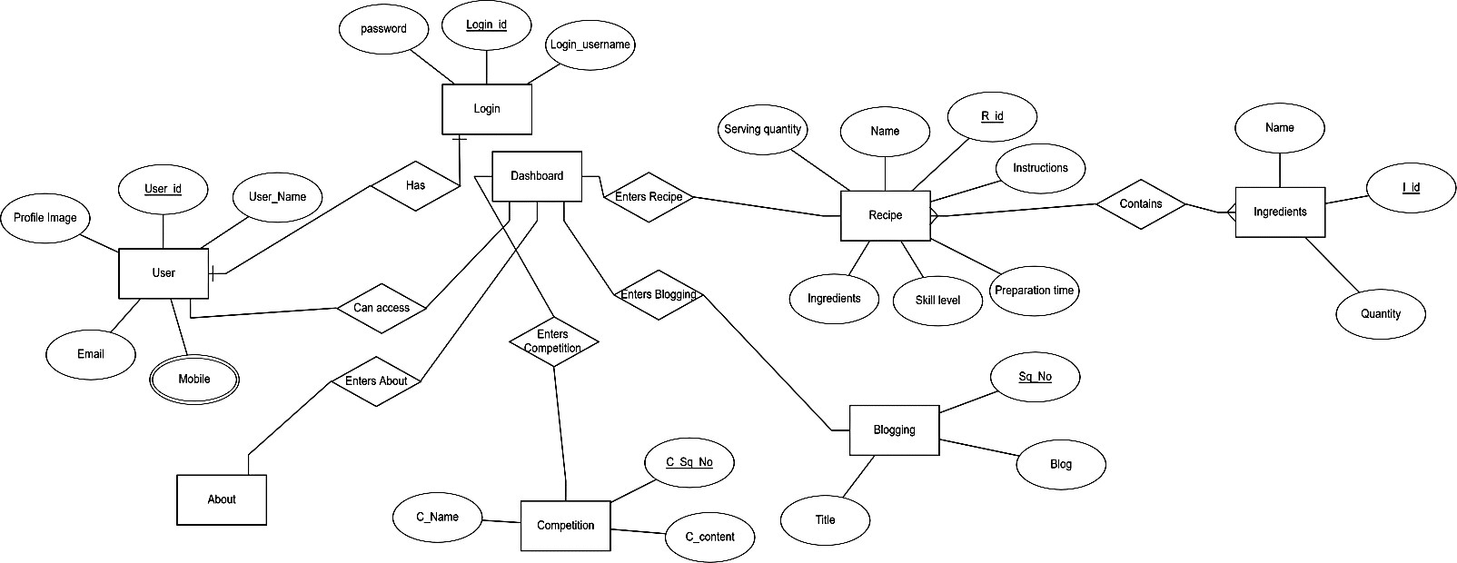

4.(a) ER Diagram for 56 BHOG

DATA FLOW DIAGRAM

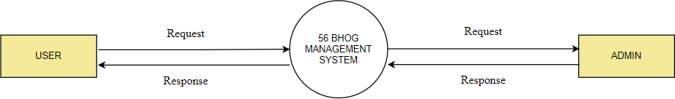

4.(b) 0 Level DFD for 56 BHOG

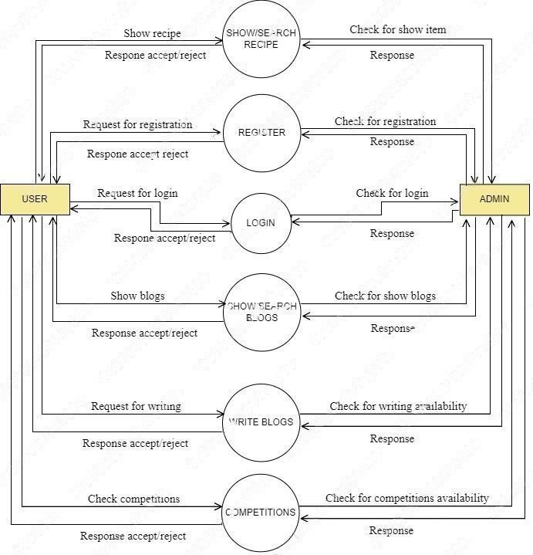

4.(c) 1 Level DFD for 56 BHOG

Project Module

MODULES

DASHBOARD

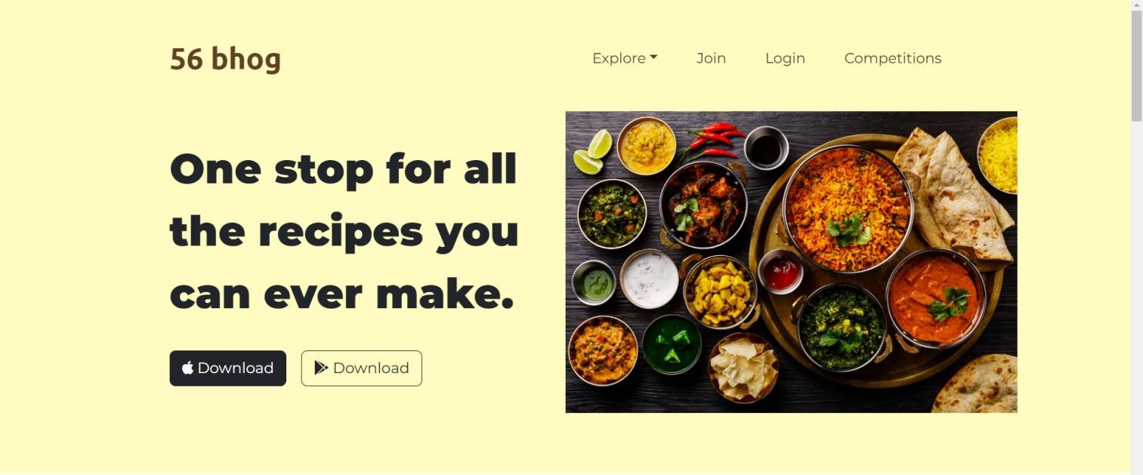

5.(a) Dashboard

Join: When the user clicks on this tab, it will display the sign-up page for new/first time users. Login: This is a login form. Users can use their own email and password to login into the panel. Explore: This is a dropdown menu with several options to select from.
Competitions: When the user clicks on this tab, it will display a separate cooking competition page.

SIGN UP MODULE

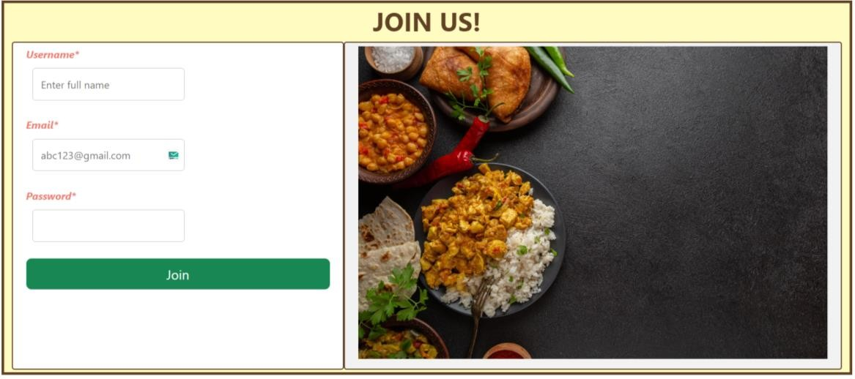
5.(b) Sign up Module

Username: The user will have to enter his/her full name.
Email: The user will enter his/her email id for verification.
Password: The user will enter his/her password for authentication.

LOGIN MODULE



5.(c) Login Module

Username: The username the user entered for the first time.
Password: The password created by the user.

RECIPE MODULE


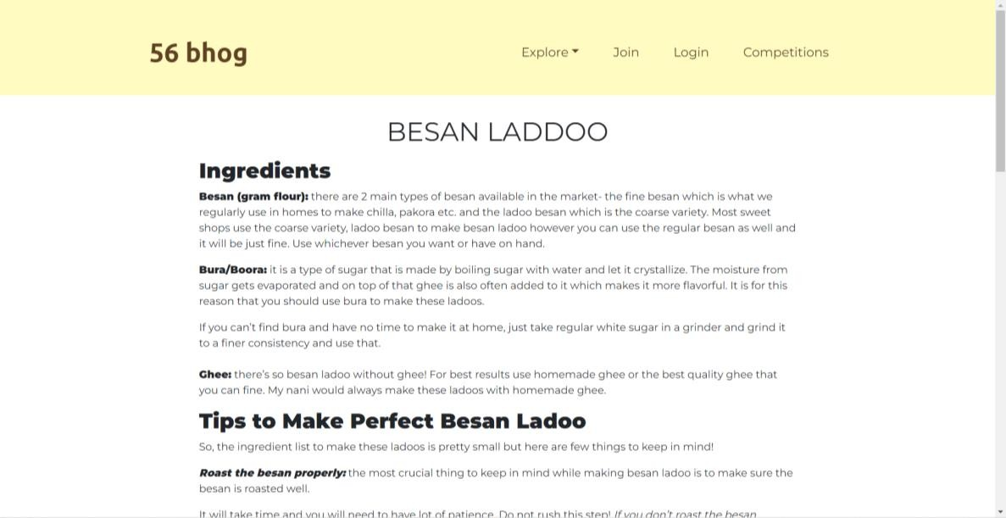
5.(d) Recipe Module

The recipe module showcases a particular recipe when clicked on. When the cursor is hovered over a particular recipe, it transitions and zooms in towards the user to show selection.

BLOGGING MODULE

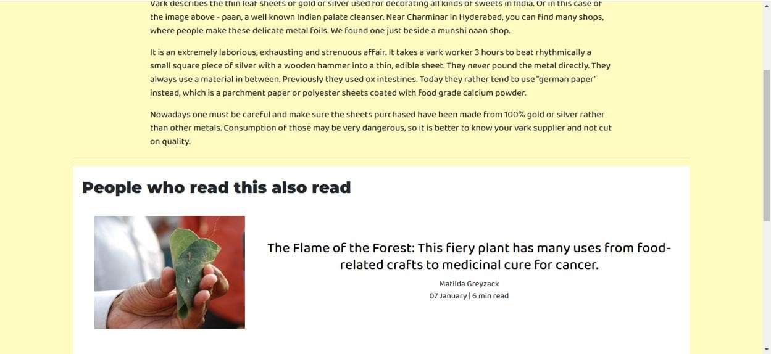
5.(e) Blogging Module

The blogging module gives the user the ability to be a part of the website. Each user, after registration, can become a part of this community by posting blog related to food or a particular ingredient. A User can also post a new recipe.

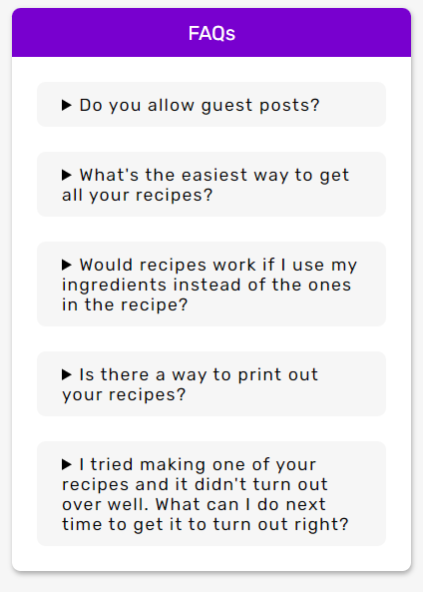
FAQ MODULE
5.(f) FAQ Module
For answering frequently asked questions related to the website.

Screenshots

HOMEPAGE

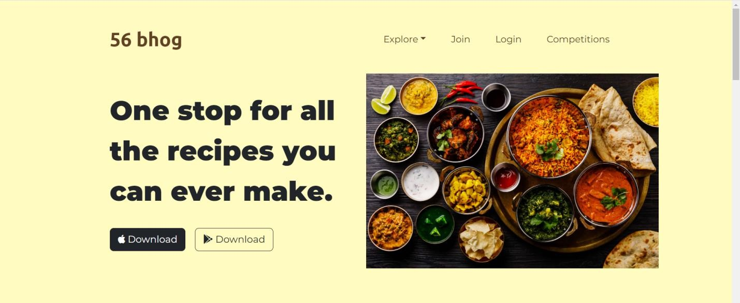

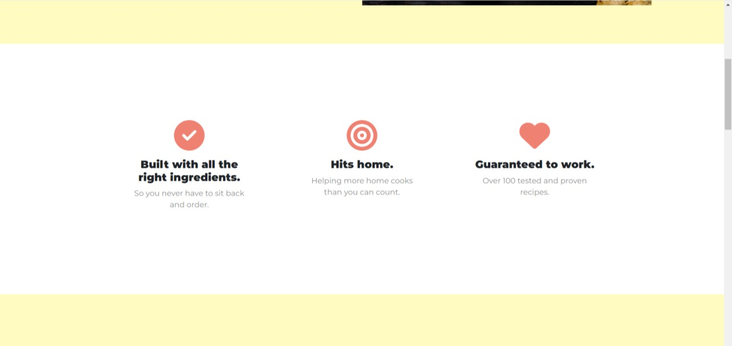

  - BLOGS
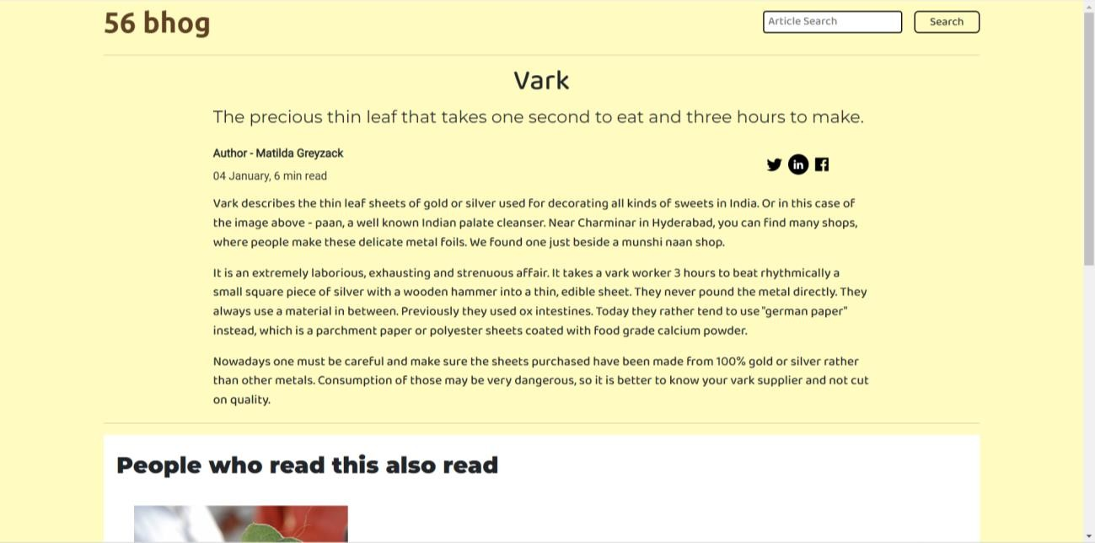

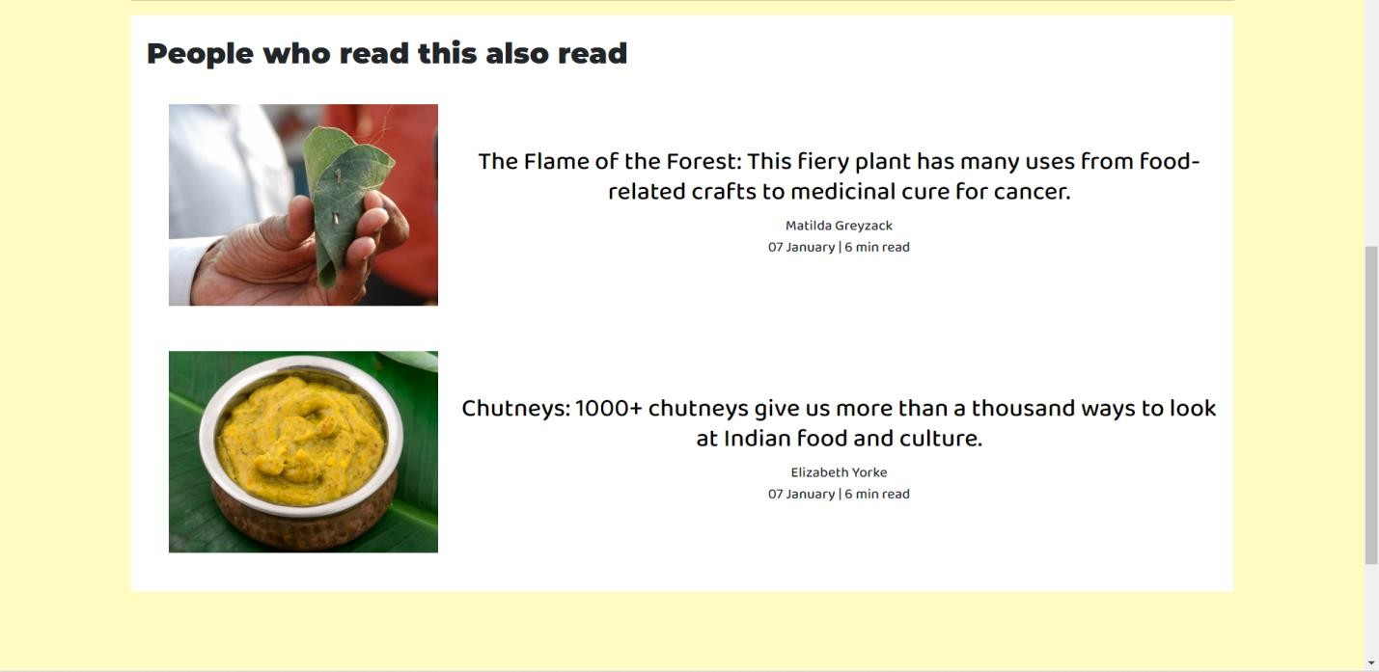

USER REGISTRATION / LOGIN





  - RECIPE DASHBOARD

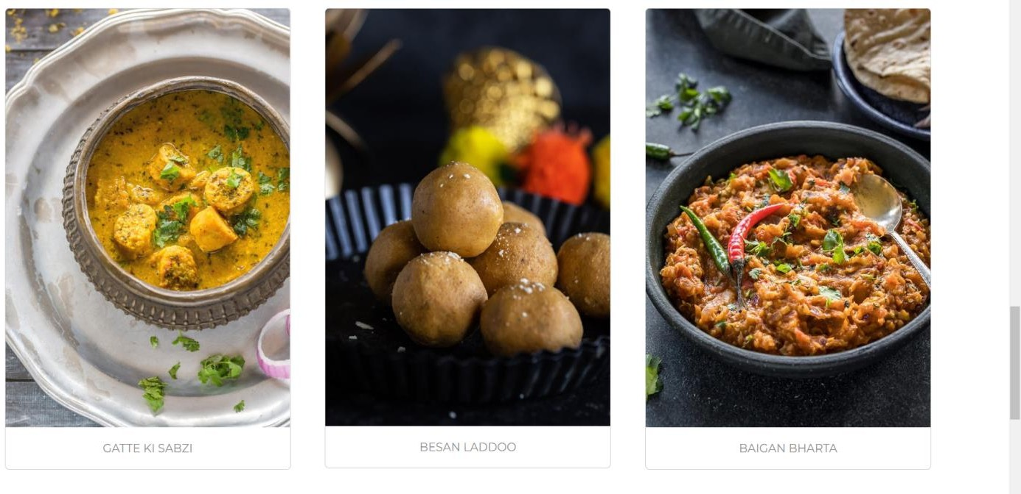

RECIPE SECTION



  - COMPETITIONS



FAQs



  - ABOUT US



  - CONTACT US


Implementation and Maintenance

IMPLEMENTATION

Implementation or execution in any project is done when the project planning is complete as detailed as possible. In this phase it monitors everything that could jeopardize the project or part of it in other words the theory is being tested by implementation to make sure the data in the system changes according to the plan. To keep track of project plan and keep ourselves in control all the tool and steps involved are applied by the project manager.

Steps in which all the tools are used:
    - Take action according to plan
    - Record and document all the work, changes & results
    - Analyze the result of action or changes made according to the plan

The steps involved here in this particular phase are:
    - Installation of Hardware and Software
    - Conversion of data
    - System Training
    - Documentation of the system

Installation of hardware and software:

Before implementation the hardware and the software required for debugging the system should be made fully operative so the translation can occur smoothly which is one of the most critical and costly activities in the system development life cycle.

Conversion of data:

As the old system is converted into a new system, the data from the old system should also be converted to run in the new system within new format. I this step the recovery procedures are needed to be fully defined and the database is configured with security.

System training:

All the programs of the system are loaded onto the computer systems of the user during this step. After loading the system, we check whether the project is under the control of the user and works according to the plan. To confirm the above sentence, we need to complete the following steps:
      - To execute the package
      - To pass the data
      - To process the data
      - To take out the reports/records

7.1.1 USE CASE DIAGRAM
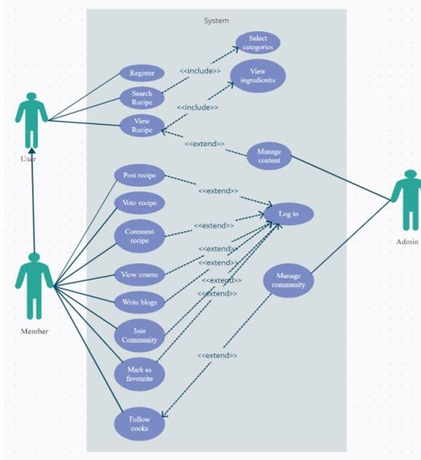
7.(a) Use Case Diagram for 56 BHOG

TESTING

Software testing is a process of verifying and validating a software application or program.

The main aim of the testing is to find out the bugs in the developed system before implementing it. It is an important phase of a successful system. After codifying the whole programs of the system, a test is being performed on the system so developed. The output of the testing phase should match the expected results.

I have used two types of testing:
- Black-Box testing: is a functional testing that targets only the interface to ensure that they work as expected. I make sure that every AlertDialog is shown if an input is missing.

- White-Box testing: is a clear-box one where the tester has access to the code. Since I have been the developer of my website, I have been practicing this type of testing on a daily basis.

MAINTENANCE

Maintenance is necessary to eliminate errors in the system during its working life and to tune the system to any variations in its working environments. It has been seen that there are always some errors found in the systems that must be noted and corrected. It also means the review of the system from time to time.

The review of the system is done for:

- knowing the full capabilities of the system
- knowing the required changes or the additional requirements Studying the performance.

SYSTEM SECURITY MEASURES

Some of the measures can be taken as follow: -

- Various validation checks are being applied on all the forms for authenticated management of data.

- As well as various validations are also applied on the form controls so as top have reliable entry of data.

- Backup of Database must be done at the regular interval by the administrator.
- Updating the password at regular interval.

Future Scope of the Project

As a future work, we’re planning to extend our website with many features like course provider
,meal planner, shopping of ingredients etc.

The course provider will give you learn all types of dishes at home along with competitions. You can learn from top chef's as well. The recorded session will be provided as well.

The meal planner will take care of diabetic patients, gym going persons, and all other infected patients as well.

The shopping of ingredients will make you shop all the kitchen ingredients at one place for the recipes.

References

We had benefited from the following sites which helped us throughout the development of this project:

- "STEEPLE Definition | Marketing Dictionary | MBA Skool-Study.Learn.Share.", MBA Skool-Study.Learn.Share., 2016. [Online]. Available: http://www.mbaskool.com/businessconcepts/marketing-and-strategy-terms/6814- steeple.html.
- M. Butler, “Android: Changing the Mobile Landscape”, Pervasive Computing, (2011), pp. 4-7.
- Ashwin Kumar. Mobile Application for News and Interactive Services. Department of Information Technology, JNTU, Hyderabad, India. VOL. 2, NO. 1, January 2012.
- Simply Recipes – Less Stress .More Joy "https://www.simplyrecipes.com"

