WEEK 5 INTERNSHIP REPORT
Data Analytics Impact Evaluation and Optimization Report
Prepared for: Mohit Kumar
Role focus: Data Analytics Strategist
Project type: Synthetic customer analytics case study
Date: 25 September 2026

1. Introduction
This report evaluates the performance and business impact of a customer analytics initiative using a reproducible Python workflow. The project focuses on customer revenue, conversion, satisfaction, delivery delays, support activity and churn. The objective is to convert operational data into measurable performance indicators, identify factors associated with weaker outcomes, segment customers for targeted intervention, and propose an optimization roadmap aligned with business goals.
Because no proprietary company dataset was supplied with the task, the analysis uses a clearly labeled synthetic dataset of 1,200 customer records. The dataset is for educational demonstration only and should not be interpreted as evidence about a real company or customer population. Baseline values are calculated from the synthetic records; optimization results are modeled scenarios rather than observed post-intervention outcomes.

2. Business Objectives and Evaluation Questions
- Measure baseline business KPIs: revenue, churn, conversion and customer satisfaction.
- Identify operational drivers associated with churn and customer satisfaction.
- Create a practical at-risk customer segment for targeted retention activity.
- Use statistical tests to assess whether delivery delays are associated with satisfaction differences.
- Develop an optimization scenario and quantify its assumptions.
- Recommend a measurement framework, experiment design and monitoring process.

3. Dataset and Methodology
The dataset contains 1,200 customer-level observations and 13 variables. Key variables include tenure, order frequency, average order value, sessions, support tickets, discount rate, delivery delay, satisfaction, churn, revenue and conversion rate. pandas and NumPy were used for preparation and KPI calculation, SciPy for statistical testing, and Matplotlib for visualization.
KPI / Variable | Baseline value | Interpretation
Total revenue | 4,018,348.82 | Aggregate synthetic customer revenue
Average revenue/customer | 3,348.62 | Average monetary contribution
Churn rate | 48.08% | Share of customers marked as churned
Average satisfaction | 3.99/5 | Customer experience indicator
Average conversion | 4.67% | Modeled conversion indicator
Average order value | 845.94 | Average order monetary value

4. Performance Measurement Framework
The evaluation framework combines outcome KPIs, driver metrics and operational controls. Outcome KPIs show whether the business objective is improving; driver metrics explain why; operational controls verify that the analytics process remains reliable.
- Revenue: total and per-customer revenue monthly.
- Churn: churn rate and retention by segment.
- Conversion: sessions-to-order behavior and intervention effects.
- Satisfaction: average score and low-score customer share.
- Service quality: delivery-delay rate and support-ticket volume.
- Analytics quality: missingness, duplicate rates, outliers and feature drift.

5. Exploratory and Statistical Analysis
The Pearson correlation between delivery delay and satisfaction is -0.586 (p=1.295e-111) in the synthetic sample. A Welch two-sample t-test comparing customers above versus at/below the median delivery delay gives t=-18.894, p=1.273e-69. This provides statistical evidence of a difference between the two simulated groups. It does not prove that delivery delay alone causes dissatisfaction; confounding factors and controlled experiments must be considered.
The churn outcome was also examined against order activity, delivery delay, support activity, satisfaction, tenure and revenue. These relationships are descriptive associations and should not be treated as causal estimates without experimental or quasi-experimental validation.
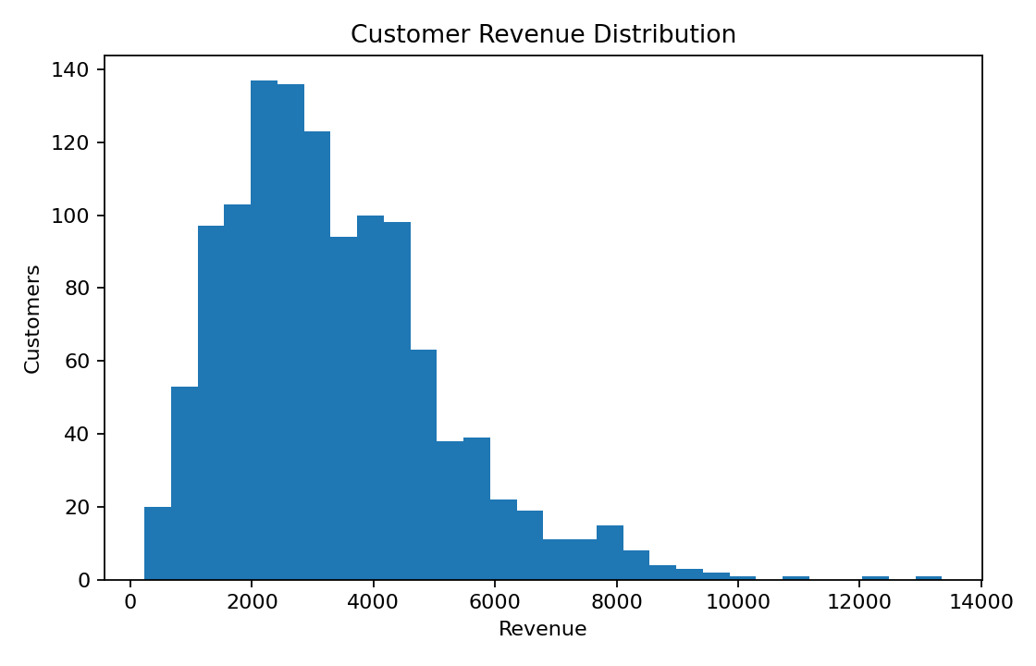
Figure 1. Distribution of synthetic customer revenue.
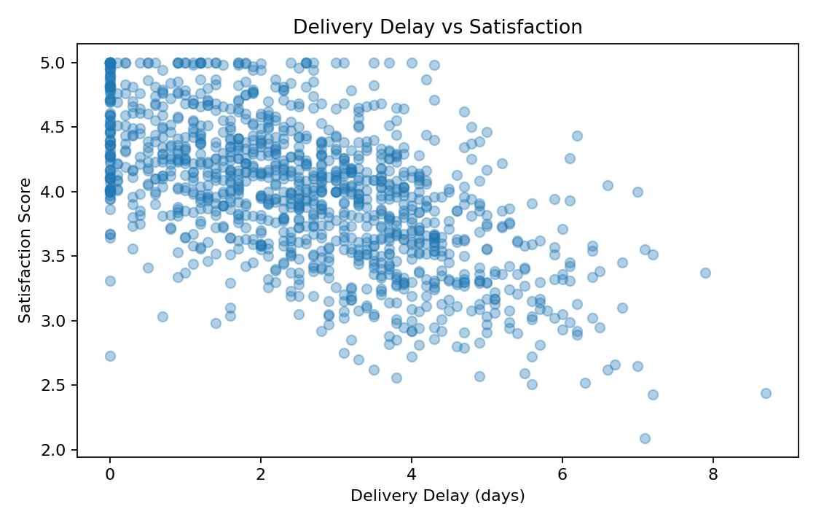
Figure 2. Relationship between delivery delay and satisfaction.

6. Customer Segmentation and Predictive Evaluation
A transparent risk score was constructed from normalized delivery delay, support-ticket volume, satisfaction and order frequency. The highest-risk 20% contains 240 customers. This is a prioritization score, not a production machine-learning model.
- High risk: prioritize service recovery, proactive communication and retention offers within cost limits.
- Medium risk: use automated education, delivery updates and personalized recommendations.
- Low risk: focus on loyalty, cross-sell and advocacy rather than expensive retention incentives.

7. Impact Evaluation and Optimization Scenario
To demonstrate impact evaluation, a modeled optimization scenario was created. It assumes a 15% relative reduction in churn, a 12% relative increase in conversion, a 0.25-point satisfaction improvement and an 8% revenue uplift. These are planning assumptions, not measured outcomes. A real organization should replace them with experimental estimates.
Metric | Baseline | Modeled optimized | Change
Churn rate | 48.08% | 40.87% | 15% relative reduction
Conversion rate | 4.67% | 5.23% | 12% relative increase
Satisfaction | 3.99 | 4.24 | +0.25 points
Revenue | 4,018,348.82 | 4,339,816.73 | 8% modeled uplift
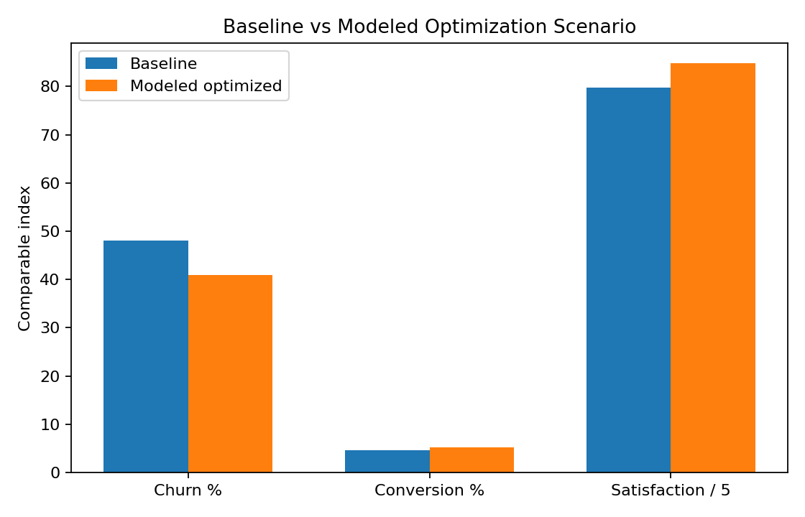
Figure 3. Baseline versus modeled optimization scenario.

8. Recommendations
Reduce delivery-related friction: Create service-level dashboards, proactive delivery communication and root-cause analysis of high-delay routes or partners.
Create a churn early-warning workflow: Refresh risk segments weekly and route high-risk customers to service recovery before churn occurs.
Use controlled experimentation: A/B test service recovery, personalized offers and messaging using treatment/control groups.
Optimize incentives: Measure retention lift against incentive cost and margin impact instead of discounting every at-risk customer.
Improve data quality: Automate checks for missing values, duplicates, outliers and inconsistent timestamps before KPI calculation.
Build an executive dashboard: Combine KPI trends, segment performance, intervention coverage, experiment results and data-quality status.

9. Challenges and How They Were Addressed
- No real company dataset was supplied, so a synthetic dataset was used and clearly labeled.
- Correlation was separated from causation; controlled experiments are recommended for causal impact.
- Different KPI scales were separated from the normalized visualization used for comparison.
- Risk scoring can produce false positives, so thresholds should be calibrated against observed outcomes.
- Optimization assumptions may overstate impact; the scenario must be validated before business claims are made.

10. Implementation Roadmap
Period | Action
Weeks 1–2 | Data-quality audit, KPI definitions, baseline dashboard and stakeholder sign-off.
Weeks 3–4 | Risk-segmentation pilot and service-recovery workflow.
Weeks 5–8 | A/B tests for interventions; monitor churn, conversion, satisfaction and cost.
Weeks 9–12 | Evaluate experiments, scale validated interventions and recalibrate thresholds.
Ongoing | Monthly KPI review, quarterly model validation and continuous data-quality monitoring.

11. Conclusion
The analysis demonstrates a complete impact-evaluation workflow: define business outcomes, establish measurable KPIs, inspect drivers, segment customers, apply statistical methods, visualize evidence, model optimization opportunities, and design a validation plan. In this synthetic case study, delivery delay is associated with lower satisfaction, and a transparent risk score identifies a subset of customers for targeted retention. The most important next step for a real analytics program is controlled measurement. Modeled improvements should not be treated as realized business impact until they are tested against a suitable control group and evaluated for statistical and financial significance.
The project provides a practical Python-based framework that can be transferred to real organizational data once approved data sources, KPI definitions, business costs and experimental controls are available.

12. Reproducibility and Project Files
The accompanying package contains the synthetic CSV dataset, Python analysis script, visualizations, requirements file, README and this final DOCX report. Generated dataset seed: 42, allowing the same synthetic records to be reproduced in a compatible Python environment.

