NOA RITES/MSM/NACP/13/2014/637_Cefixime was created on 1st May.

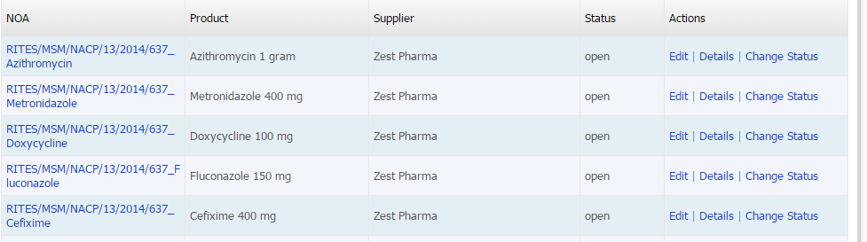

It is not visible in UI now

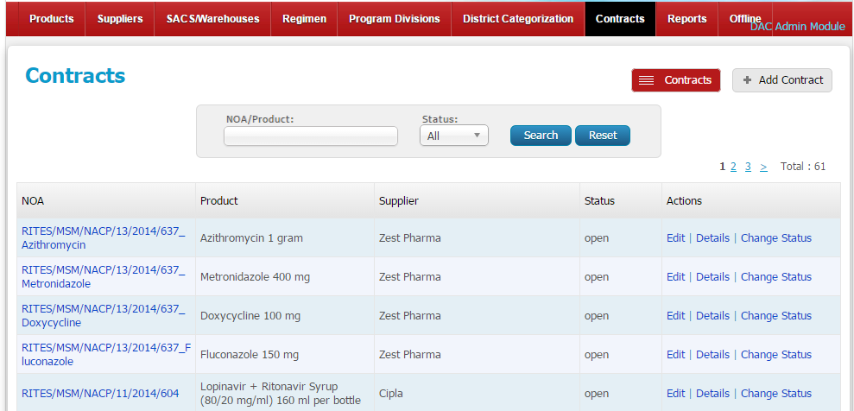

System is not letting us create again

