  ABC Medical Billing Statement
  Statement: ABC0000001
 | 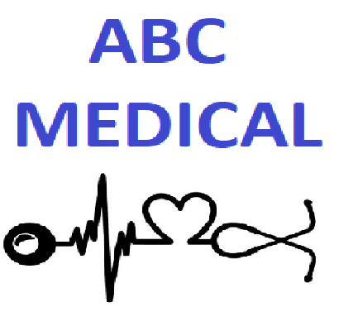
  Customer ID: C000000001
  MRN: 160-9-66984
  Billing Date:
  07/05/20
  Due Date:
  08/04/20
ABC Medical
1234 Get Better Blvd
St Petersburg, FL 33701
Phone: 727-123-4567
Fax: 727-123-4568
Email: Billing@ABCGetBetter.com

  Name: ALONSO AALDERINK
  Email: ALONSO.AALDERINK@sitametfaucibus.ca
Address: 160 CHAR NOR MANOR Boulevard
Las Vegas, NV 89101

Service Date | Description | ICD | Amount
2/24/2015 12:00:00 AM | Evaluation (simple) | Z04.9 | $110.00
2/24/2015 12:00:00 AM | Hospital Visit | Y74.0 | $76.00
2/24/2015 12:00:00 AM | Suction (level 2) | V97.33XA | $152.00
2/24/2015 12:00:00 AM | Percussion | Y93.J2 | $60.00
2/24/2015 12:00:00 AM | Vibration | T75.20XA | $38.00
2/24/2015 12:00:00 AM | Postural drainage | H04.221 | $38.00

  Total Due:
  $474.00
Information obtained by a nurse, physician or another member of your healthcare team will be recorded in your medical record and used to determine the course of treatment that should work best for you. Your physician will document his or her expectations of your healthcare team. Members of your healthcare team will then record the actions they took and their observations. In that way, the physician will know how you are responding to treatment.
We will also provide your physician or a subsequent healthcare provider with copies of various reports that should assist in treating you once you are discharged from this health center.
A bill may be sent to you or a third-party payer. The information on or accompanying the bill may include information that identifies you as well as your diagnosis, procedures and supplies used.
Members of the medical staff, the risk or quality-improvement manager, or members of the quality-improvement team may use information in your health record to assess the care and outcomes in your case and others like it. This information will then be used in an effort to continually improve the quality and effectiveness of the services we provide.
Business associates: There are some services provided in our organization through contacts with business associates. Examples include physician services in the emergency department and radiology, certain laboratory tests, and a copy service we may use when making copies of your health record. When these services are contracted, we may disclose your health information to our business associate so that they can perform the job we’ve asked them to do. To protect your health information, however, we require the business associate to appropriately safeguard your information.
Notification: We may use or disclose information to notify or assist in notifying a family member, personal representative, or another person responsible for your care, your location and general condition.
Research: We may disclose information to researchers when their research has been approved by an Institutional Review Board that has reviewed the research proposal and established protocols to ensure the privacy of your health information.
Funeral directors: We may disclose health information to funeral directors consistent with applicable law to carry out their duties.
Organ procurement organizations: Consistent with applicable law, we may disclose health information to organ procurement organizations or other entities engaged in the procurement, banking, or transplantation of organs for the purpose of tissue donation and transplant
Food and Drug Administration (FDA): We may disclose to the FDA health information relative to adverse events with respect to food, supplements, product and product defects, or post-marketing surveillance information to enable product recalls, repairs or replacement.
Worker’s Compensation: We may disclose health information to the extent authorized by and to the extent necessary to comply with laws relating to worker’s compensation or other similar programs established by law.
Public health: As required by law, we may disclose your health information to public health or legal authorities charged with preventing or controlling disease, injury or disability.
Law enforcement: We may disclose health information for law enforcement purposes as required by law or in response to a valid subpoena.
Abuse or neglect: We may disclose your protected health information to a public health authority that is authorized by law to receive a report of child abuse or neglect. We may also disclose this information if we believe you have been a victim of abuse, neglect or domestic violence.
Federal law makes provision for your health information to be released to an appropriate health oversight agency, public health authority or attorney, provided that a workforce member or business associate believes in good faith that we have engaged in unlawful conduct or have otherwise violated professional or clinical standards and are potentially endangering one or more patients, workers or the public.

