|  |  |
| --- | --- |
| **Topic :** | **CREDIT CARD DEFAULT PREDICTION** |
| **Document Type:** | **Wireframe** |
| **Author :** | **Mohit Maheshwari** |
| **Date: 29/7/2024** | **PW Skills: Full Stack Data Science Pro** |

**1.First Page Shows the form where you have to fill the form with details like:**

**Age(Integer), Marital Status (1: married, 2: Single, 3: Other), Pay_Bal (0: pay Duly, 1: Duly for 1 month and so on) , Pay_Amt and limit balance are Float data types.**

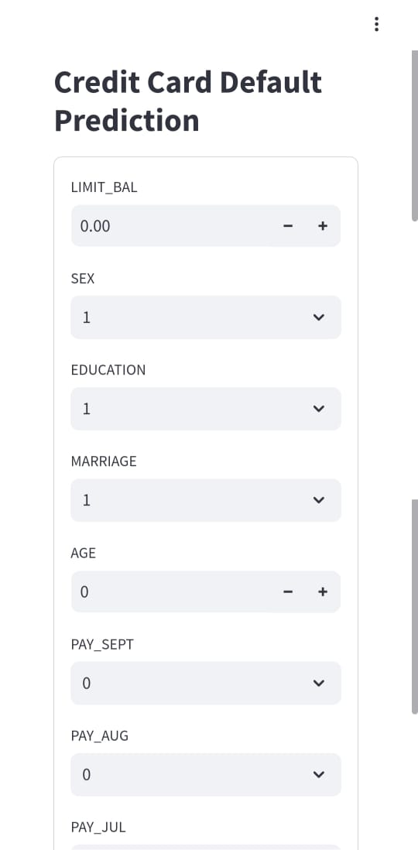

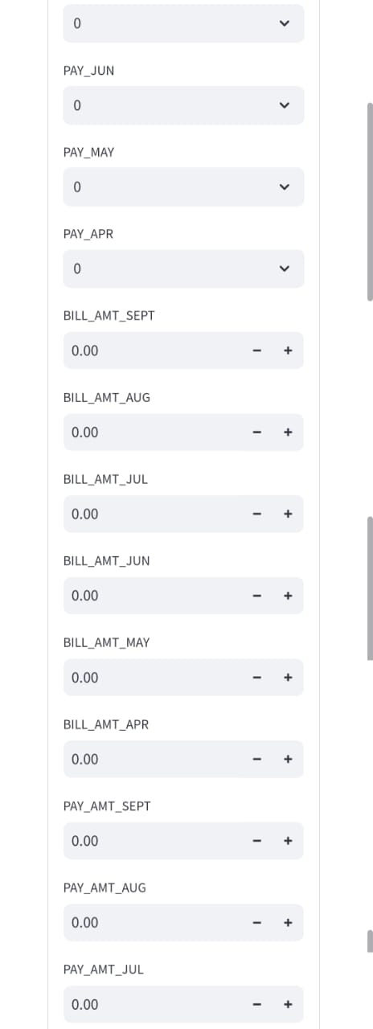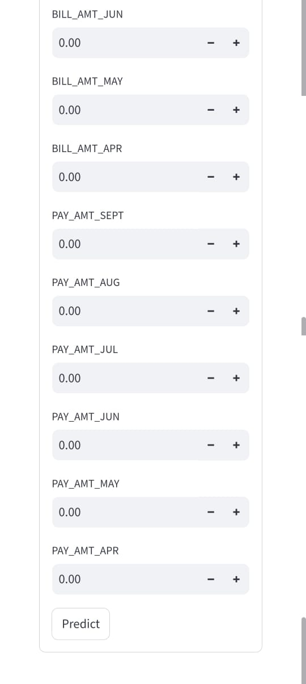

**2. As you fill all the detail it shows the result accordingly “Default” or “Not Default”, In case you forgot any box, it will take the default value for the category & will show result accordingly.**

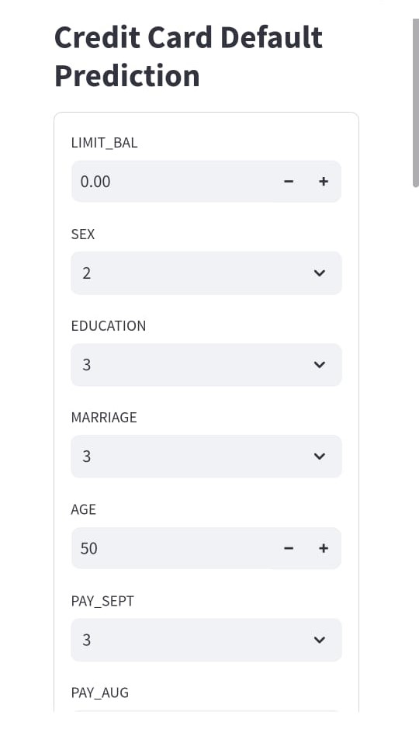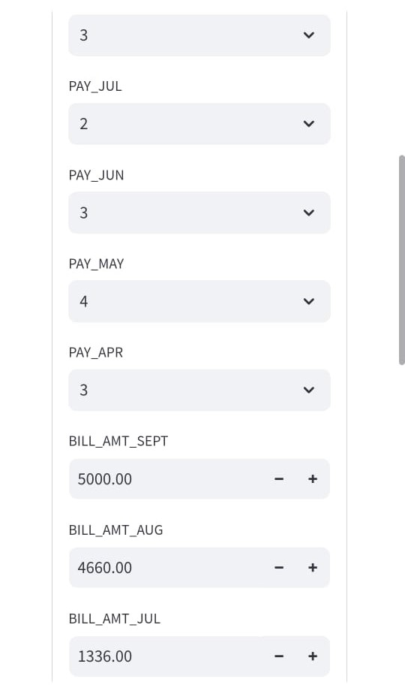

**3.After filling up all the fields when you click the Predict button show the message:**

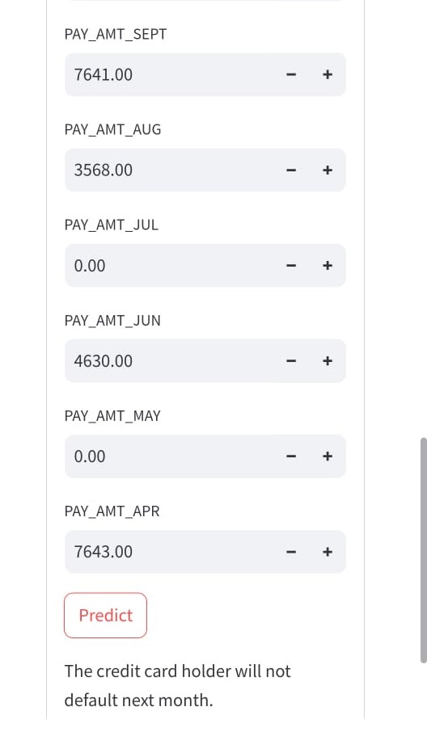

**4.In case the user is defaulter:**

