Core Java Task

1. Complete customer dashboard
2. Create customer table in database with following columns and all varchar  
   email, custname, city, phone, password;
3. Add some dummy customers in customer table
4. Add DbConnection class in CMS java project and make sure it is connected to Db

Hibernate

<https://docs.jboss.org/hibernate/orm/6.1/userguide/html_single/Hibernate_User_Guide.html#architecture>

1. ORM framework => object relational mapping
   1. Mapping of java objects to database table
   2. Mapping of data types -> automatic type conversion [ XXXDialect ]
   3. Mapping of different types of relationships
      1. Java -> isa hasa, equals
      2. DB -> PK, FK, CK, UK, Joins
   4. Creation of sql queries is taken care
   5. DB connection, loading driver and executing queries
   6. Handing exceptions
   7. By default commit false
2. Creating a simple hibernate maven project
   1. Create a quickstart Maven project
   2. Add dependencies in pom.xml file
      1. Hibernate-core
      2. MYSQL [ DB driver ]
   3. Hibernate configuration file => hibernate.cfg.xml [src/main/resources]
      1. Connection parameters
      2. Dialect
      3. Other DB related configurations
   4. Create entity classes
   5. To map java class with database tables
      1. XML based configuration
      2. Annotation based configurations  
         <mapping class=”” or resources=”.xml”>
   6. Load the configuration file
   7. Tables were created automatically by hibernate => No  
      DB first approach
   8. CRUD operations
      1. Save or persist [IMP] => insert
      2. Merge[IMP] or update => update
      3. Delete or remove [IMP] =>delete
      4. Get(<name of the class>, id) or load=> Select by id
      5. createQuery(<string>, return type) => Select all
   9. HQl queries => where, order by, group by, having or aggregate functions

Or palceholders :id

1. OneToOne => 1 User has 1 Vehicle
   1. Unidirectional
   2. Bidirectional => mappedBy
   3. Can change the column name : @JoinColumn
2. Embeddable (on the class) and Embedded (on the property)
3. ElementCollection => can be used on collections of type primitives
   1. @JoinTable => to specify the name of the joined table
4. OneToMany => can be used on collections of type user defined data types [ class ]
   1. By default it created a 3rd table
   2. @JoinColumn -> will not create the 3rd table
5. ManyToMany
6. Inheritance

**SPRING CORE**

1. 3 Core principles
   1. DI – Dependency Injection
   2. AOP – Aspect Oriented Programming
   3. Abstraction layer
2. Steps to create a spring project – Quickstart Maven
   1. Add dependencies => spring-context
   2. Create a class with getters/setters
   3. Create spring configuration file -> spring.xml
      1. Configure the beans using <bean>  
         id is optional -> when there is no ambiguity [ only 1 instance of the bean is configured ]
      2. By default all beans are eagerly loaded ->   
         lazy-init => to lazily load the beans
      3. For constructor injection  
         <constructor-args name=”propname” value=””> - for primitives value attribute   
         <constructor-args name=”propname” ref=””> - for object types use ref
      4. For setter injection  
         <property name=”propname” value=””> - for primitives value attribute   
         <property name=”propname” ref=””> - for object types use ref
      5. Scope =”singleton” prototype(for factory objects)
   4. Load the configuration file
      1. ApplicationContext context = new ClassPathXmlApplicationContext(“spring.xml”)
   5. To access the instances created by spring
      1. Context.getBean(“classname.class”)
      2. Context.getBean(“idvlaue”)
3. Annotation based configurations
   1. Property[setter]/ constructor/ field
      1. @Value – which injects values of type primitives
      2. @Autowired – which injects dependencies of reference type
   2. @Component – which is used on the class which tells spring to load this class and instantiate it
   3. @Primary – the class that is annotated with this annotation will be the default reference to be autowired
   4. @Qualifier – if there are more than 1 bean of same type then to resolve the ambiguity use this annotation and it takes precedence over @Primary  
      By default the ids of the classes/ beans are created with camel casing of the bean  
      you can override the default by specifying the name within @Component
   5. @Configuration – that provides java based configuration and it is annotated on the class that provides with configurations to your project  
      DB configuration  
      Web configuration

Security configuration

* 1. @ComponentScan – is used on the configuration class to tell spring to scan the classes with @Component annotation  
     It looks for the classes in the root package of the configuration class and the sub packages

1. Lifecycle of spring bean
   1. Beans are loaded
   2. Instantiated -> constructor is invoked
   3. ApplicationCOntext is set
   4. BeanNameAware -> that assigna an id to the bean
   5. BeanFactory -> where all the beans are registered
   6. Set some initial properties for the bean
      1. XML approach init-method, destroy-method
      2. Interfaces to implement
         1. DisposableBean
         2. InitializingBean
      3. Annotation based approach :  
         <dependency>

<groupId>javax.annotation</groupId>

<artifactId>javax.annotation-api</artifactId>

<version>1.3.2</version>

</dependency>

* + - 1. @PostConstruct
      2. @PreDestroy

1. Event handling in spring beans
   1. Event -> extends ApplicationEvent  
      the source i.e the publisher that raised the event and any other extra info
   2. Listener -> implements ApplicationListener or can use @EventListener on the method
   3. Publisher -> implements ApplicationEventPublisherAware or can autowire the ApplicationEventPublisher object using which an event can be published and listener handles the event

**SPRING JDBC**

1. Create a quickstart maven project
2. Add dependencies
3. Create a configuration class
   1. Create a DataSource object and provide DB connection parameters
   2. Create a JdbcTemplate object
4. Create a bean that is mapped with DB table
5. Create a CustomerDB class and inject the JdbcTemplate object using which sql queries can be executed

SPRING MVC

Tomcat setup for intellij

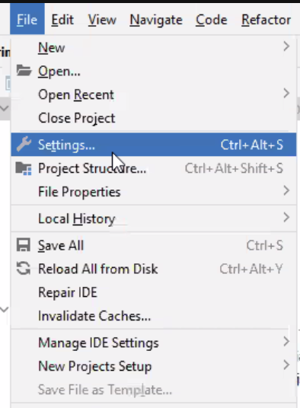 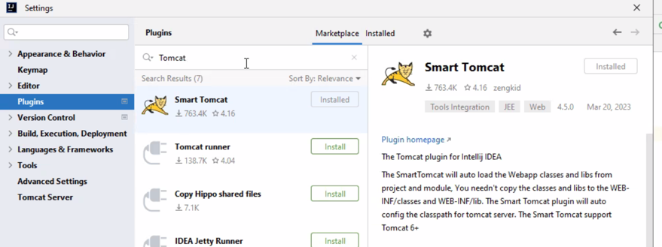

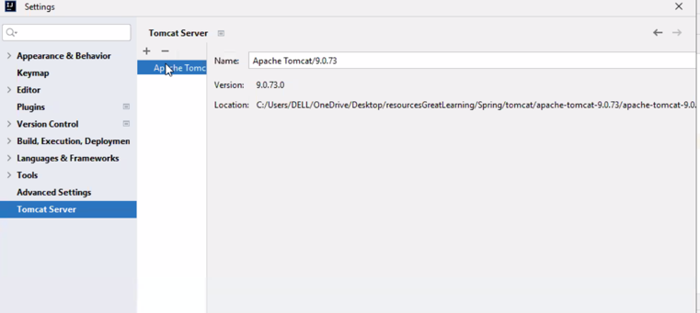

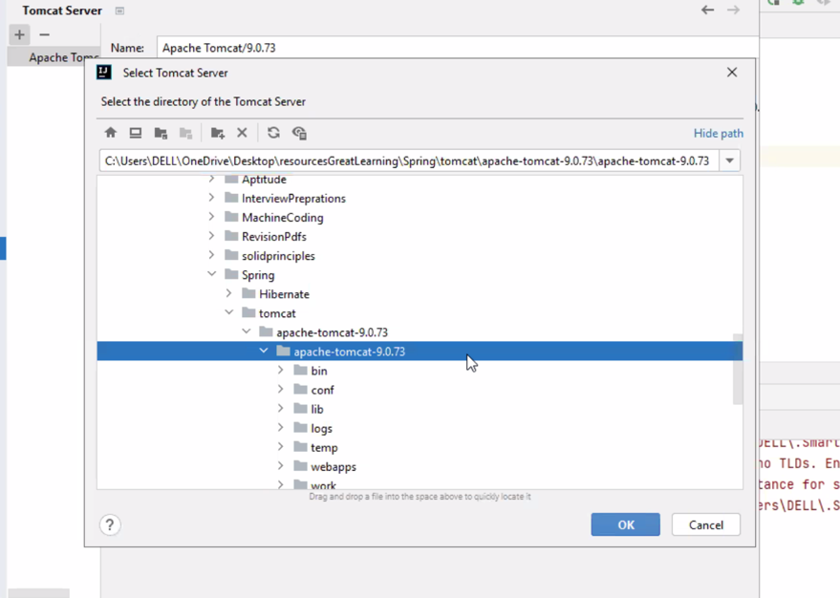

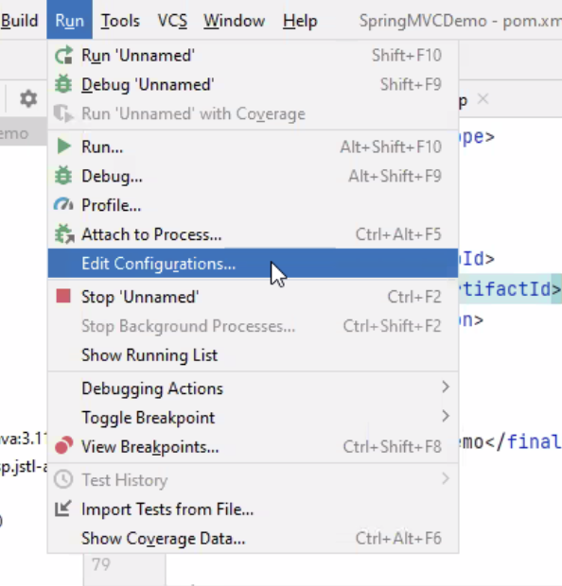

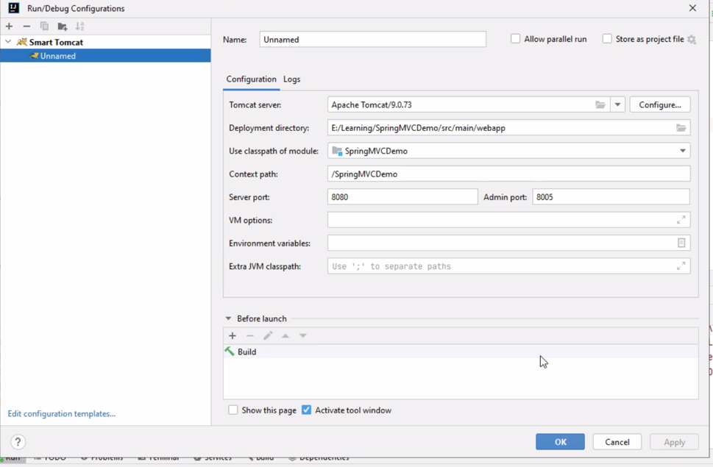

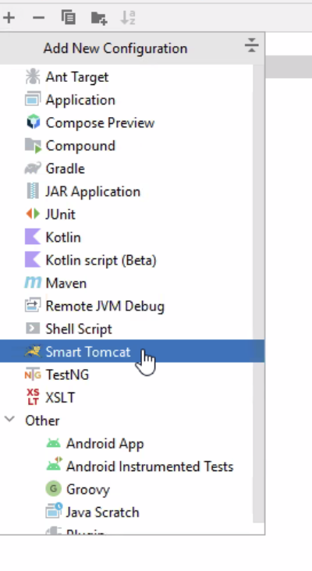

1. Create a maven webapp project
2. Add dependencies in pom.xml
3. Eclipse
   1. download tomcat server zip file and unzip it.
   2. Project Run As-> Run on server -> select tomcat and browse to the downloaded folder
4. Intellij : screenshots above
5. Create views folder under webapp/WEB-INF package and add hello.jsp within views folder
6. Create 2 configuration files to configure DispatcherServlet(ApplicationContextConfig.java) and ViewResolver(SpringWebAppInitializer)
7. Create a controller and configure it to return view
8. Add link in index.jsp page
9. TO ADD STATIC RESOURCES:
   1. Create resources folder under webapp/ folder
   2. Add images, css etc
   3. Create a configuration class MvcConfig and configure for path to static resources
   4. To access in JSP file : <img src=’resources/images/pic.jpg’/>
10. FOR DB configuration
    1. Add spring-orm and hibernate and mysql dependencies
    2. Create Users and Task entity with hibernate annotations
    3. Create src/main/resources folder if it does not exist and create db.properties file under this folder
    4. Add @PropertySource and give path to properties file on the ApplicationContextCOnfig class. Also add the db related configurations and for hibernate provide the package name to the entity
    5. Create UsersDatabase, USersService classes
    6. Update PostMapping for loginUser method in the controller