 | EUROPEAN TOPIC CENTRE ON WATER | 

EEA Activity 3.2.4 Task 18
Water account implementation:
Large Dam positioning
Administrators & Users guide

AUTHORS: F.-X. Prunayre, B.Fribourg-Blanc (IOW)

First Draft Version 0.1

Décembre 2005

Version History
FXP – François Xavier Prunayre (IOW)
BFB – Benoît Fribourg-Blanc (IOW)
DP – Dominique Preux (IOW)
SN – Steve Nixon (WRc)
TJL – Tim Lack (WRc)
PK – Peter Kristensen (NERI)
PC – Philippe Crouzet (EEA)
NT – Niels Thyssen (EEA)
BW – Beate WERNER (EEA)
HP – Hermann Peifer (EEA)
AB – Andreas Barkman (EEA)
AM – Andrus Meiner (EEA)
HP – Hermann Peifer (EEA)
CR – Cristian Romanescu (Eau De Web)

Version | Date | Author | Description | Distribution
0.1 | 12/12/2005 | FXP, BFB, DP | Draft version
0.2 | 19/12/2005 | FXP
0.3 | 20/03/2008 |  | Documented new features

Table of Contents

1. Introduction 5
2. Administrators’ guide 6
2.1. Architecture 6
2.2. Installation 7
Operating Systems on Servers (Linux) 7
Relational databases (postgresql) 7
2.3. SVN repository 8
2.4. Database backup 8
2.5. MS ACCESS database Export 8
2.6. (Optional) If user admin deleted by mistake 9
2.7. (Optional) Configuration of WMS services 9
2.8. (Optional) Configuration of a WMS for TeleAtlas data distribution 10
2.9. Standard compliance 10
3. User guide 11
3.1. User in charge of dam validation 11
3.1.1. Login & role 11
3.1.2. Dam validation process 11
3.1.3. Language and translation manager 14
3.2. Administrator 15
3.2.1. User manager 15
3.2.2. Link user with dams 16
4. Conclusion 17

LIST OF FIGURES AND TABLES

Figure 1 : Overall architecture for the system 6
Figure 2 : Dam positioning homepage 11
Figure 3 : Dam positioning validation process 12
Figure 4 : Home page for user 12
Figure 5 : Dam validation page 12
Figure 6 : Dam characteristics 13
Figure 7 : Large and small scale Image 2000 overviews 13
Figure 8 : Basic translation manager 15
Figure 9 : List of users allowed to work on the dam positioning 15
Figure 10 : Profile manager allowing to update user characteristics and select dams for user 16

Introduction
According to the International Commission On Large Dams (ICOLD), large dams are dams higher than 15 m (or higher than 10 m but with more than 500 m crest length, or more than 1 million m³ storage capacity, or more than 2 000 m³/s spilling capacity) (ICOLD, 2005)

The current number of large dams is about 6000 in the EEA area. The influence of these on the water cycle in the EEA area is thus important and needs to be taken into account. For that, it is first necessary to be able to correctly allocate the dams to the associated water systems.

However the dam position (expressed as geographical coordinates) registered in the available databases is generally inaccurate. A special process has then been developed by the EEA (AIR3) to locate as accurately as possible the dams listed in the ICOLD register on large dams. This process is divided in two steps as proposed in the methodology of pre-positioning and positioning dams developed by AIR3 :
- a pre-location task carried out by ETC/TE,
- a validation or correction by ICOLD national focal points.

Following agreement with ICOLD, the national focal points of ICOLD will be requested to accept / correct the proposed location. These organisations are based in countries and know accurately where dams are, even though they do not systematically have the coordinates at their disposal. To check / correct the position, it has been considered that an Internet tool, providing an image of the most likely position and the possibility to fix a new position by drag-and-drop a marker on the image would be the best solution from the point of view of minimizing the burden, avoiding copyright issues nevertheless ensuring security in transactions.

For this development the EEA agreed with the ETC/WTR that IOW will develop and provide this tool. It was further detailed in a taskplan agreed with the EEA.

To this end the present guide provides:
- installation and configuration tasks
- users guide

Administrators’ guide

Architecture
Architecture of the dam positioning module is based on 4 main components:

- A database based on ELDRED2
- Web interface
- GoogleMap API
- Webservices providing access to geographic dataset through OGC-WMS

Figure 1 : Overall architecture for the system
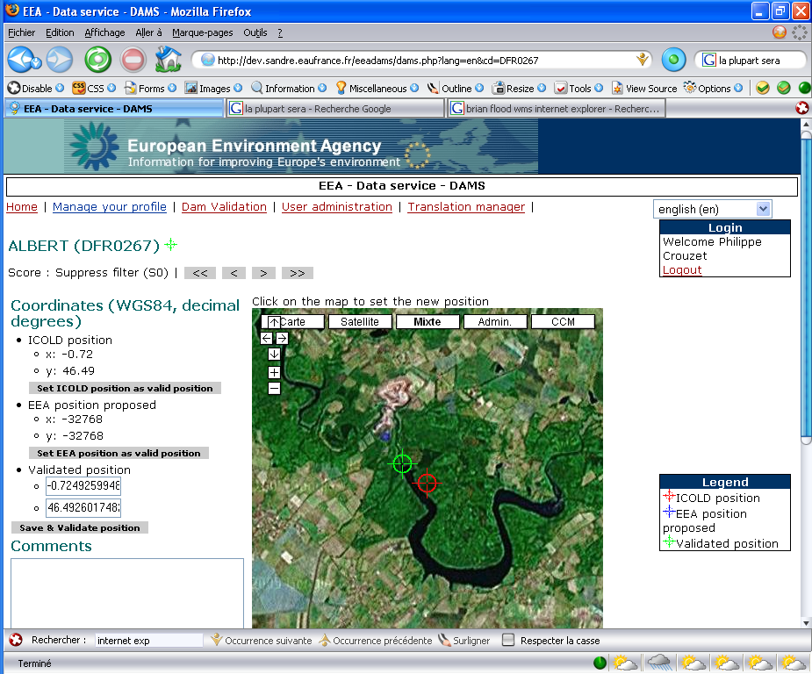
EEA-Webservice
Provide TeleAtlas data (layer : A7 and SM) using WMS
JRC-Webservice
Provide CCM data or Image 2000 using WMS

Due to the configuration, the dam positioning module is dependant on GoogleMap and WMS availability. Anyway, if none of these services are up and running, the web interface allows access to static overviews generated by EEA.

Security is defined through basic authentication (login/password) to access the web interface. WMS could also be secured based on web server IP filter.

Installation
System requirements:

Operating Systems on Servers (Linux)

Relational databases (postgresql)
- Webserver (apache)
- php 4.X or 5.X (http://www.php.net)
- pear (http://pear.php.net) with the following

Auth 1.2.3 stable
Config 1.10.4 stable
DB 1.7.6 stable
DB_DataObject 1.7.15 stable
Date 1.4.5 stable
Log 1.9.2 stable
PEAR 1.3.5 stable
Translation2 2.0.0beta8 beta

If one of these packages is missing, they could be installed using “pear install packageName” on the server.
- smarty (http://smarty.php.net)

Note: Using TRANSLATION2-2.0.0RC4 internationalization no longer works. A quick patch to see at least english is to replace in config.php in function iniI18n:
$smarty->assign($do->id, $i18n->get($do->id, $i18nPage));
with
$smarty->assign($do->id, $do->en);

Installation steps:

      - Install Linux, Apache, postgres, php, pear and smarty.

      - Due to a bug on PHP5 and PEAR::Config (http://pear.php.net/bugs/bug.php?id=5835 ), update the file PEAR/Config/Container/iniFile.php line 89 by :

$result = true;
return $result;
}
// end func parseDatasrc
Update: bug closed in version 5_1 CVS-2005-10-31
      - Copy the dam positioning module to your web server directory

      - Set permission for this directory according to your system (eg. chown -fR apache:apache eeadams)

      - Update [your_installation_dir]/commons/inc-config.conf and update options to fit your installation

Available options are :
[SETTINGS]
TITLE=EEA - Data service - DAMS
[PATH]
BASEDIR=/home/www/html/eeadams/
WWWDIR=/eeadams/
TPLDIR=templates/
SCHEMADIR=DataObjects/
[DB]
DB_TYPE=pgsql
DB_USER=postgres
DB_PASS=postgres
DB_NAME=eeadams
DB_SERVER=localhost
[MAP]
TOPOPATH=img/topo/
SPUDPATH=img/spud/
SPANPATH=img/span/
GOOGLEKEY=ABQIAAAAOiv5YlmaLzgjKukiZ3CcWhQSLWdk4ZF39yGhlmkL3uwf2PqFQhTBAVuc7Yrz14WR5V-sOv1sRv1Qbg
ICOLDICON=http://dev.sandre.eaufrance.fr/eeadams/img/icon/red.png
VALIDICON=http://dev.sandre.eaufrance.fr/eeadams/img/icon/green.png
EEAICON=http://dev.sandre.eaufrance.fr/eeadams/img/icon/blue.png
If you don’t have a google key you need to ask for one on the Google website (http://www.google.com/apis/maps/signup.html ).

      - Check that [your_installation_dir]/DataObject/*.ini files are correctly named (according to the database name, file names are case sensitive).

      - Create database structures using the eeadams.sql script.

      - (optional) Import data from the latest ELDRED2 Database (see 2.5. ).

SVN repository
SVN repository has been set up at the following URL:
https://svn.eionet.europa.eu/repositories/IOWater/trunk

Database backup
To do a database backup run the command below:

pg_dump –U postgres –p EEADAMS –f filename.sql EEADAMS

MS ACCESS database Export
To update database for the dam positioning module you need to export data from ELDRED2 database. You can use the following query LOADDAM2PGSQL :

SELECT
Dams2.NOEEA, Dams2.ic_Dam_Name,
Dams2.X_0DD, Dams2.Y_0DD, 0 AS Expr8,
Dams2.X_FDD, Dams2.Y_FDD, Null AS Expr1, Null AS Expr2,
Dams2_tech.ic_Area1000m2, Dams2_tech.ic_Capacity1000m3,
Dams2.ic_City, Dams2.CT, Null AS Expr3, Dams2.River_ID,
Null AS Expr4, Dams2.year_first, Dams2.year_dead, Null AS
Expr7, Null AS Expr5, Null AS Expr6, Dams2.Is_main,
Dams2.NOEEA_M, Dams2.is_Icold, Dams2.Alias_dam_name,
Dams2.ic_Year, Dams2.ic_State, Dams2.[ic_High_ m],
Dams2.is_GuessedH, Dams2.ic_length_m, Dams2.is_GuessedL,
Dams2.ic_Vol_1000m3, Dams2.ic_Purpose, Dams2.ic_Owner,
Dams2.ic_Note, Dams2_tech.ic_Particular,
Dams2_tech.ic_International, Dams2_tech.ic_Sealing,
Dams2_tech.ic_foundation, Dams2_tech.ic_Capacity1000m3,
Dams2_tech.ic_Area1000m2, Dams2_tech.ic_Spill_m3ps,
Dams2_tech.[ic_Type Spill], Dams2_tech.ic_Engineer,
Dams2_tech.ic_Contractor, Dams2_tech.ic_P_MW,
Dams2_tech.ic_E_WhpYear, Dams2_tech.ic_Irrigation_km2,
Dams2_tech.ic_Floodstock_hm3, Dams2_tech.ic_Resettlement
FROM Dams2_tech
INNER JOIN Dams2 ON Dams2_tech.NOEEA = Dams2.NOEEA;

Then export data to a CSV text file and import it into Postgres database using psql.

Psql –U postgres –p EEADAMS
EEADAMS=# DELETE FROM USER_DAMS;
EEADAMS=# DELETE FROM DAMS;
EEADAMS=# COPY DAMS FROM '/tmp/eldred2/eldred2dams.csv' WITH CSV;
COPY

You have to save the validation status and X, Y coordinate of the dams before updating the DAMS tables. If you plan to maintain both Postgres database and MSAccess database, import and export has to be carefully made to not remove data.

(Optional) If user admin deleted by mistake
If all admin users are deleted using the web interface, use psql to add a new one:
psql –U postgres –p EEADAMS
EEADAMS=# Insert into USERS (id, login, password, roleadm) values (99, ‘mylogin’, md5(‘mypassword’), true);

(Optional) Configuration of WMS services
Google map interface are able to contact WMS services. To set up new services 2 files could be changed:
- commons/config.php
- DataObjects/Public_dams.php

Configuration is made via javascript:
- set the URL
- set the layer(s) to be called
- optionally overlay 2 or more layers
- create a button on the google map interface for this new layer(s)

(Optional) Configuration of a WMS for TeleAtlas data distribution
TeleAtlas data are available through a web service. This web service is installed on possum and is accessible using the following URL: http://dampos.eea.eu.int/cgi-bin/wseea?

This web service can only be accessed through WMS (no WFS access). An IP filter could be set up to restrict access to only EEA servers.

For example, the installation process of the web service is described below:

- Install Mapserver (http://ms.gis.umn.edu ) and compile with standard options (ie. ESRI shapefile read and WMS server on)

- Create mapfile (see Annexe 1)

- Create Index on ESRI shapefile. On a command shell use:

/shptree A7
/shptree SM

- Configure your web server. In your cgi directory copy the mapserv file. Then create a shell script to hide the mapfile path.

#! /bin/sh

export MS_MAPFILE=/home/www/data/eea/map.map
/home/www/cgi-bin/mapservdev

- Call http://yourwebserver/cgi-bin/yourshellscript. (This should return the message “No query string information to decode”)

Standard compliance
For information, the module is not 100% compliant with W3C standard. XHTML 1.0 Transitional is respected in almost all web pages. Due to a bug in Internet Explorer GoogleMap script has to be after the last </html> tag of a web page. This is not allowed in XHTML 1.0.

User guide
2 roles exist in the application:
- User in charge of dam validation
- administrator

User in charge of dam validation

Login & role
Login is accessible through the home page You must provide login and password to log on to the site as described in Figure 2.
Figure 2 : Dam positioning homepage
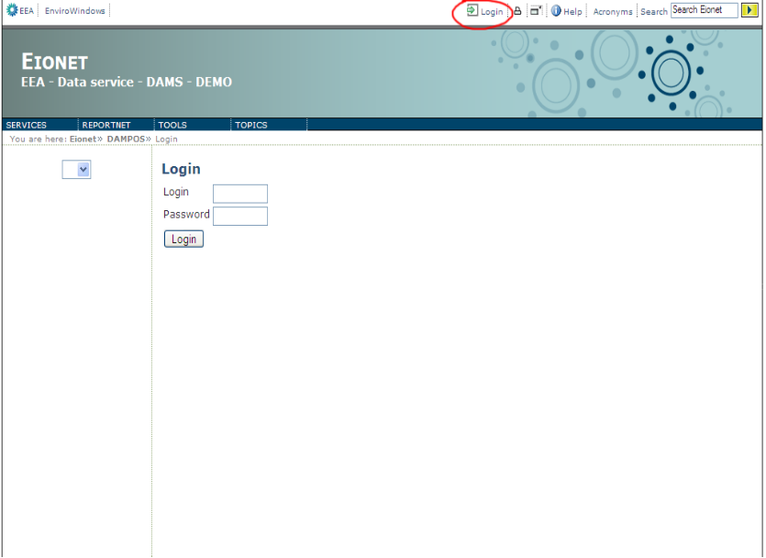

Dam validation process
The process to use as described in is the following :

- User log in through the homepage,
- Click on the map access or dam list to access one dam (see Figure 4),
- View dam characteristics (see Figure 5),
- Validation of the position:
  - Click on the Google map to propose a position or,
  - Set ICOLD coordinates as valid or,
  - Set EEA coordinates as valid (see example on Error: Reference source not found),
- Update comments if necessary and save position,
Move to the next dam.
Figure 3 : Dam positioning validation process


Click on an ICON to access the dam
Map access
Dam positioning
module

Identification
Dam list
Dam page
Save and valid position

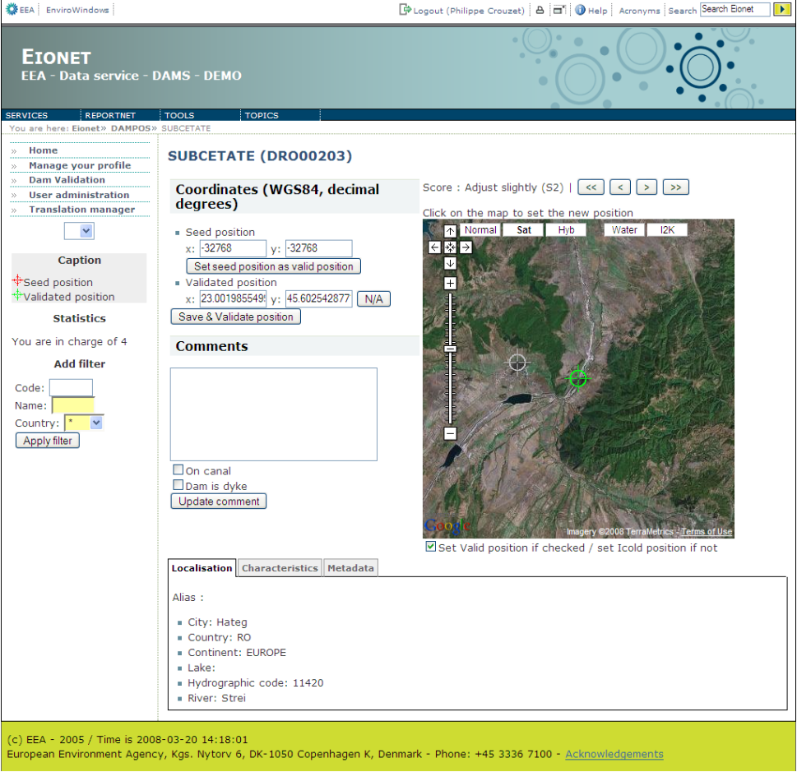
Figure 4 : Home page for user

Select the type of map (Satellite, Administrative area)

Figure 5 : Dam validation page
Click on the map to set the new position and save or move the marker
Add your comments
Click the button to set ICOLD position as valid and save
Click the button to set EEA position as valid and save
Click on the additional layer you want to see (Water or Image2000)
Save position and comment your add

Dam characteristics are presented at the bottom of the Dam validation page (see Error: Reference source not found). Grouped in tabs, information is:
- Localisation (city, rivers, lake, …),
- Characteristics (area, vol, …),
- Metadata (date, purpose, origin, …),
- Image 2000 overviews (large and small scale),
- Optionally topographic map if provided by member countries.

User could cancel validation. Define validated position as blank and save. Then the dam is no more valid.

Search function: You may search a dam using the following criteria:
- its name or parts of its name;
- its code or parts of its code (codes are: [D][COUNTRY 2L CODE][ID], for example DIT000158 – located in IT – Italy
- Its country (you may filter by all countries or a specific country). Administrators may see all the dams for all the countries while regular users may only investigate assigned dams.

Language and translation manager
The tool will be used for dams in the whole EEA area; however, the working language is English. To allow correct wording in the original language, as well as other uses for the database, a language interface is provided.

It manages as well language issues related to information attached to the dams (name and description using national alphabets) and in giving to local administrators the possibility to translate the texts and messages of the forms as decribed in the following figure.
Figure 6 : Basic translation manager
Select interface language
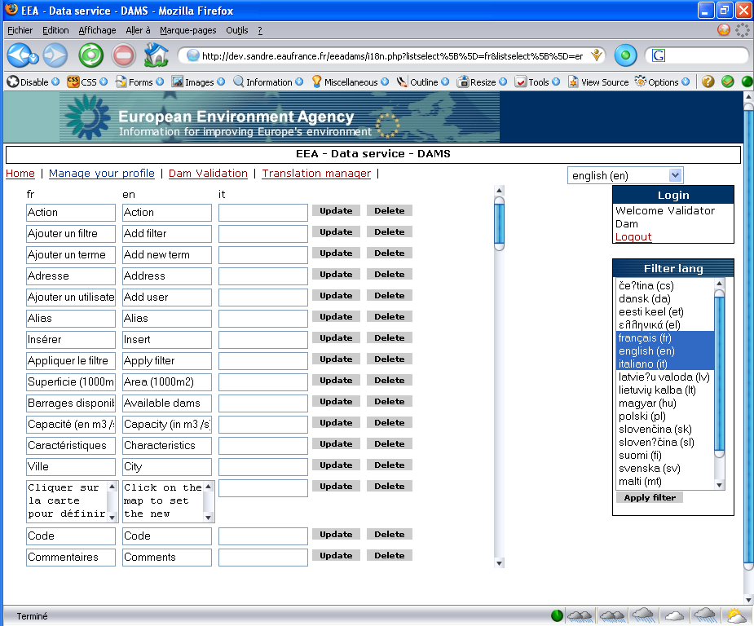
Select language to be updated
Update term
Term in selected language

If terms are not available in a language, fallback language is set to English.

Administrator
If user is administrator, he has 2 kinds of privileges:
- view and validate all dams (as describe in the previous section)
- user administration

The application allows the administration of users rights as detailed in the following.

User manager
Administrator's module, that manages authorisations for connecting authorised operators (in principle one or several ICOLD national representatives, or persons agreed by EEA). The authorisation procedure gives access to a series of items that can be a whole country, a part of a country or several countries. There is no crucial confidential issue and no system of encryption is needed.

The user manager allows removing, updating and adding users and managing their access rights.

Figure 7 : List of users allowed to work on the dam positioning
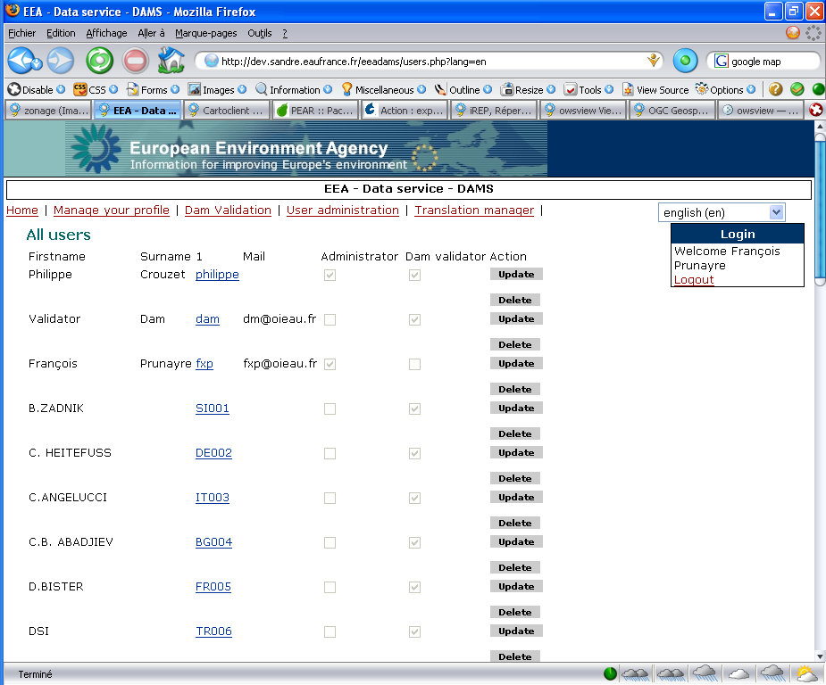
Click the button (or name) to update user profile
Click the button to delete

Once user has been created, administrator could link user and dams.

Link user with dams
User has to be dam validator for the dam list to be displayed.
User has to be administrator to link user and dams.

The form on the left (see Figure 8) allows to filter the whole dam list. Filters are:
- by code
- by name
- by country

Button “apply filter” search the data and update the “available dams” list. Then dams could be transferred to the ‘selected dam’ list. Then click save for the changed to be saved.

Figure 8 : Profile manager allowing to update user characteristics and select dams for user
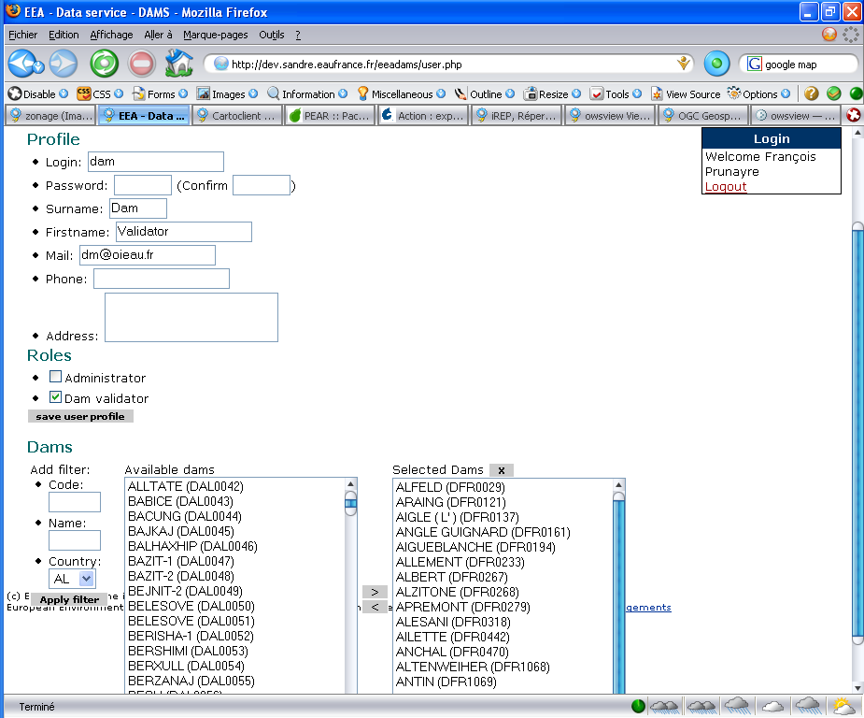
Filter form (Code, Name, Country)
List of available dams on the database
Remove all selected dams
Dams linked with current user

Conclusion
This tool allows quick access to position on a pan-European web mapping interface.

It is based, and depends on Google map API and OGC web services, as well as on availability of original datasets to position.

The user friendly interface should allow an easy implementation by national focal points and other users of the tool.

Being developed on widely used services, it could be applied to other datasets providing adaptation to their specificities.

REFERENCES

ICOLD, 2005, Position paper on dams and the Environment, http://www.icold-cigb.net/chartean.html#section1 (consulted 15/11/05)

ABBREVIATIONS

Organisations :

EEA | European Environment Agency
ETC/TE | European Topic Centre on Terrestrial Environment
ETC/WTR | European Topic Centre on Water
IOW | International Office of Water
ICOLD | International COmmission On Large Dams
OGC | Open Geospatial Consortium

- Mapfile

NAME EEA
STATUS ON
FONTSET "/home/www/data/common/etc/fonts.list"

# Map image size. Change size as desired
SIZE 400 300
#
# Start of web interface definition. Only the TEMPLATE parameter
# must be specified to display a map. See Mapserver documentation
#
WEB
IMAGEPATH '/home/www/html/tmp/'
IMAGEURL '/tmp/'

METADATA
"original_projection" "init=epsg:4326"
"ows_extent" "-12 34 36 74"
"ows_schemas_location" "http://schemas.opengeospatial.net"
"ows_title" "IOW - EEA - For internal only"
"ows_abstract" ""
"ows_keywordlist" ""
"ows_onlineresource" "http://dev.sandre.eaufrance.fr/eeadamsgeo"
"ows_fees" "none"
"ows_accessconstraints" "none"
"ows_contactperson" "Francois-Xavier Prunayre"
"ows_contactorganization" "Office International de l'eau / SANDRE"
"ows_contactposition" "Ingenieur SIG"
"ows_addresstype" "postal"
"ows_address" "15 rue Edouard Chamberland"
"ows_city" "LIMOGES"
"ows_stateorprovince" "HAUTE-VIENNE"
"ows_postcode" "87000"
"ows_country" "FRANCE"
"ows_contactvoicetelephone" "+33555114795"
"ows_contactfacsimiletelephone" "+33555114795"
"ows_electronicmailaddress" "fx.prunayre@oieau.fr"
"ows_srs" "EPSG:4326 EPSG:3035"
"ows_namespace_uri" "http://sandre.eaufrance.fr/eea"
"ows_namespace_prefix" "eea"
"wms_encoding" "UTF-8"
"wms_context_version" "1.1.1"
"wms_connectiontimeout" "3000"
END

END

OUTPUTFORMAT
NAME "PNG-24"
DRIVER "GD/PNG"
MIMETYPE "image/png"
IMAGEMODE RGB
EXTENSION "png"
END

# Extent based on full extent of QGIS view
EXTENT -12 34 36 74
UNITS dd
IMAGECOLOR 255 255 255
IMAGETYPE png

PROJECTION
"init=epsg:4326"
END

LAYER
NAME A7
GROUP "EEA"
TYPE POLYGON

STATUS ON
DUMP FALSE
TOLERANCEUNITS PIXELS
TOLERANCE 5
TEMPLATE "queryable"

DATA /home/www/data/eea/A7.shp

METADATA
"ows_title" "A7"
"ows_srs" "EPSG:4326"
"ows_group_title" "EEA"
"ows_extent" "-12 34 36 74"
"ows_metadataurl_href" ""
"ows_metadataurl_format" "text/plain"
"ows_metadataurl_type" "TC211"
#"gml_include_items" "all"
END

PROJECTION
"init=epsg:4326"
END

CLASS
NAME ""
COLOR -1 -1 -1
OUTLINECOLOR 73 189 164
END
END

LAYER
NAME SM
GROUP "EEA"
TYPE POINT

STATUS ON
DUMP FALSE
TOLERANCEUNITS PIXELS
TOLERANCE 5
TEMPLATE "queryable"

DATA /home/www/data/eea/SM.shp
CLASS
NAME ""
STYLE
SYMBOL "circle"
OUTLINECOLOR 255 138 126
COLOR 255 138 126
SIZE 8
MINSIZE 1
END
END
METADATA
"ows_title" "SM"
"ows_srs" "EPSG:4326"
"ows_group_title" "EEA"
"ows_extent" "-12 34 36 74"
#"gml_include_items" "all"
END

PROJECTION

"init=epsg:4326"
END
END

END # Map File

Open Geospatial Consortium – Web Map Service specification - http://portal.opengeospatial.org/files/?artifact_id=1081&version=1&format=pdf
Web Feature Service - https://portal.opengeospatial.org/files/?artifact_id=8339

