A Data Analysis Report On

**“SHOPNEST STORE”**

**(POWER BI)**

**CAPSTONE PROJECT**

**Submitted By:**

**MOHIT MISHRA**

**Batch No.: DA-202403-1**

**Submitted to:**



**Q1.** Identify the rating distribution in the ShopNest dataset, showcasing ratings categorized as Excellent, Very Good, Good, Bad, and Very Bad, along with corresponding orders.

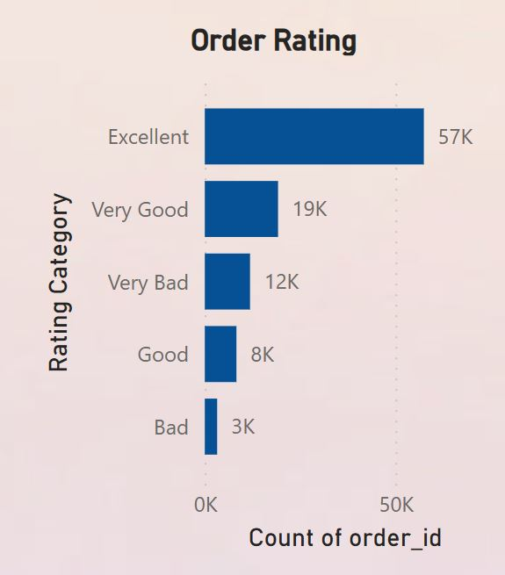

* **Visual Type**: Clustered Bar Chart
* **Excellent:** The highest number of orders, with 57K ratings.
* **Very Good:** Received 19K ratings.
* **Very Bad:** Got 12K ratings.
* **Good:** Had 8K ratings.
* **Bad:** The lowest, with 3K ratings.

This chart indicates that the majority of customers rated their orders positively, with “Excellent” being the most common rating. This suggests a high level of customer satisfaction overall. However, there are still areas for improvement, as indicated by the “Bad” and “Very Bad” ratings.

**Q2.** What are the top 10 and bottom 18 most popular product categories in the ShopNest dataset? Please list them based on the number of orders.

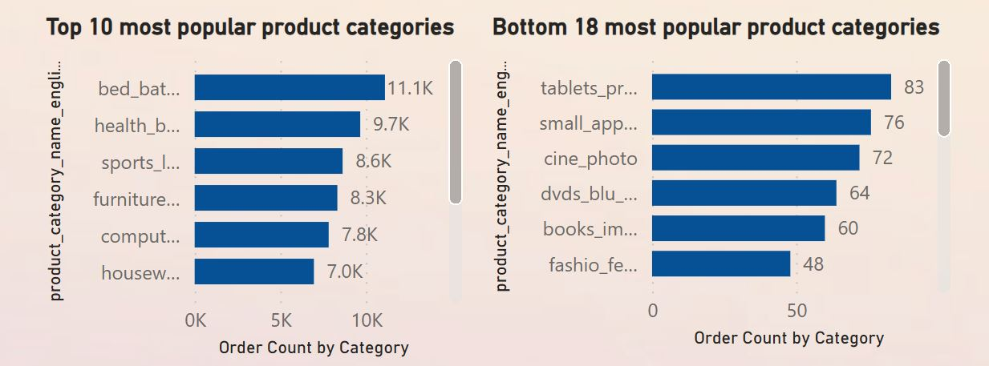

**Top 10 Most Popular Product Categories**

* **Visual Type :** Clustered Bar Chart
* **Insight** :
  + **Top Categories** :
    - **Bed Bath Table**: This category is the most popular with 11.1K orders, indicating strong demand.
    - **Health Beauty**: 9.7K orders, suggesting that health and beauty products are in high demand.
    - **Sports Leisure**: 8.6K orders, making it a significant contributor to overall sales.
  + **Other Categories**: Categories like "Housewares" and "Furniture Decorations" are also popular but have slightly fewer orders, still indicating significant consumer interest.

**Bottom 18 Most Popular Product Categories**

* **Visual Type**: Horizontal Bar Chart
* **Insight**:
  + **Least Popular Categories**:
    - **Tablets Printers**: With only 83 orders, this category is the least popular, possibly due to market saturation or lack of consumer interest.
    - **Small Appliances**: 76 orders, indicating low consumer demand.
    - **Cine Photo**: 72 orders, suggesting that this category does not perform well, possibly due to niche interest.

**Other Categories**: Categories like "Books Imported" and "Fashion Female" also have very few orders, indicating they are not primary revenue drivers.

**Q4.** Which payment methods are most commonly used by ShopNest customers.

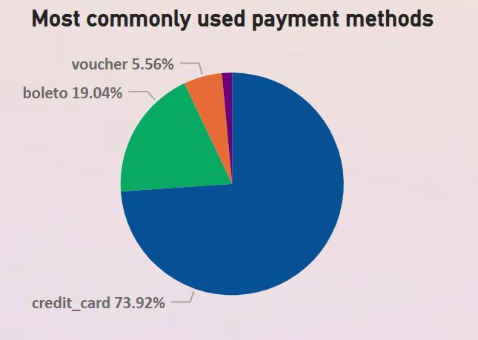

* **Visual Type** **:** Pie Chart
* **Insight** **:**
  + **Credit Card** **:** 73.92% of transactions are made using credit cards, showing that this is the preferred payment method for customers.
  + **Boleto** **:** 19.04% usage, indicating it's the second most popular method, likely due to its convenience in certain regions.
  + **Voucher :** 5.56%, a smaller percentage, indicating limited use, perhaps for promotions or discounts.
  + **Debit Card :** It’s the least used payment method.

**Q5**. Identify the product category. wise profit margin using the formula:

Hint: (Payment value -price + Freight_value)/payment_value*100 (Rounded to two decimal points).

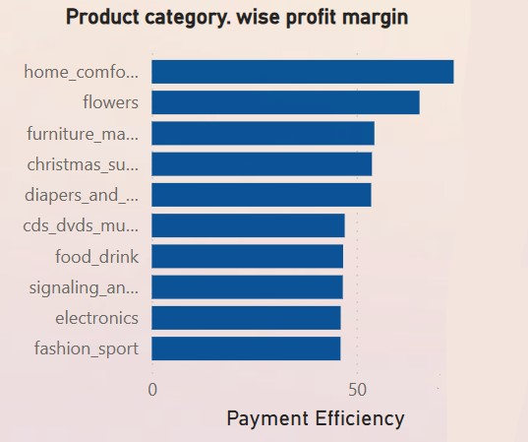

* **Visual Type:** Horizontal Bar Chart
* **Insights:**
  + **Top Categories by Payment Efficiency:**
    - **Home Comfort:** This category shows the highest payment efficiency, indicating it is highly profitable and customers are more likely to pay promptly or use preferred payment methods.
    - **Flowers:** This category also shows strong payment efficiency, potentially due to the high demand for flowers and lower return rates.
    - **Furniture Materials:** This category ranks third in payment efficiency, indicating it is a solid contributor to overall profit margins.

**Other Categories:** The chart shows that categories like "Computers" and "Small Appliances like Oven and Coffee" have lowest Profit Margin, indicating possible areas for improvement or different strategies.

**Q6.** Determine the monthly payments made by customers using credit cards.

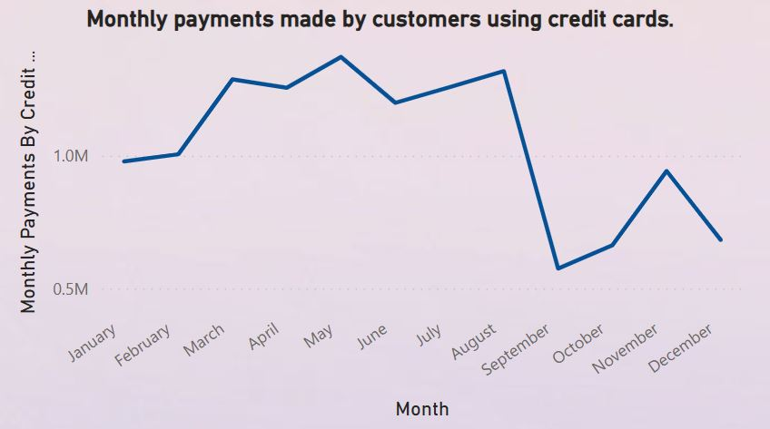

**NOTE:** Year Slicer is added in the top right of the dashboard to

navigate through months for every year.

* **Visual Type:** Line Chart
* **Insights:**
* In year 2016 most of the payments are made in the month of October only.
* In the year 2017, the trend of credit card payments exhibited a notable seasonal pattern. Our analysis reveals that **November** was the peak month for credit card transactions, with the highest payment volume recorded. This surge in payments could be attributed to end-of-year events, holiday shopping, or special promotions that drive increased consumer spending.

Conversely, the first part of the year, spanning from **January to April**, saw the lowest levels of credit card payments. This decline in payments during these months could be linked to post-holiday financial recovery or a seasonal dip in consumer spending.

This seasonal variation in payment trends highlights the impact of annual events and economic factors on credit card usage patterns. Understanding these trends can help in planning marketing strategies and managing financial resources more effectively.

* The year 2018 displayed a distinct pattern in credit card payment behavior. During the months of **April, May, and June**, payments remained relatively stable, indicating a period of consistent consumer spending. This steady trend suggests that these months did not experience significant fluctuations in payment volumes, potentially due to a balanced consumer spending pattern or the absence of major financial events.

In contrast, **February** and **August** saw noticeable declines in credit card payments. The decrease in February might be attributed to post-holiday financial adjustments or the natural dip in consumer spending after the festive season. Similarly, the drop in August could be related to the summer vacation period, during which spending patterns often change.

These insights into the payment trends for 2018 can provide valuable information for adjusting financial strategies and anticipating periods of higher or lower spending.

**Q7.** Identify sellers categorized by city, excluding cities starting with the letters S and B.

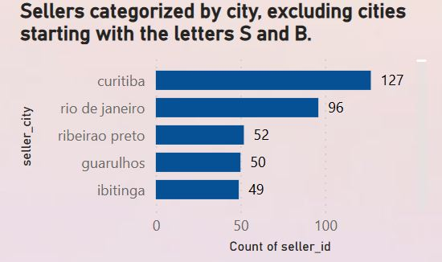

* **Visual Type:** Horizontal Bar Chart
* **Insight:**

**Curitiba**: This city has the highest number of sellers, indicating a strong seller base and possibly a large market.

**Rio de Janeiro**: Also shows a significant number of sellers, highlighting it as a major hub for the marketplace.

**Other Cities**: Cities like "Ribeirao Preto," "Guarulhos," and "Ibitinga" have fewer sellers but are still important for regional sales.

**Q8.** Create a dynamic visual that compares the number of delayed orders to the number of orders received earlier for each month. Utilize the drill through the cross-report feature to provide a detailed analysis of late and on-time deliveries.

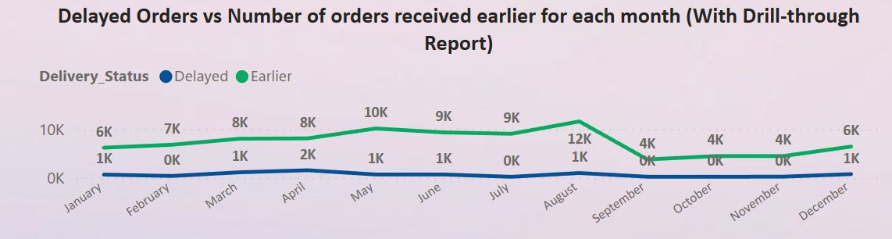

* **Visual Type:** Line Chart
* **Insight:**

1. **Delayed Orders:**

The ‘Delayed’ line consistently remains above the ‘Earlier’ line, indicating a higher number of delayed orders each month.

Peak in August: There is a significant peak in delayed orders in August, reaching 12K. This could indicate a seasonal issue or a specific event causing delays.

1. **Earlier Orders:**

The ‘Earlier’ line is consistently lower, suggesting fewer orders are delivered earlier than expected.

The trend remains relatively stable throughout the year, with no significant peaks or drops.

**Insights:**

**1. High Delays:** The consistently higher number of delayed orders suggests potential issues in the supply chain or delivery process that need addressing.

**2. August Spike:** The peak in August could be due to increased demand, logistical challenges, or other factors that should be investigated further.

Stable Early Deliveries: The stable trend in earlier deliveries indicates that while some orders are delivered ahead of time, it is not a common occurrence.

**Drill-Through Feature**

The drill-through feature allows for deeper analysis. By drilling through, you can access more detailed data for each month, such as specific reasons for delays, affected product categories, or regional performance.