ABSTRACT

Modern organizations face increasing complexity in managing their human resources effectively. Traditional Human Resource Management Systems (HRMS) are primarily designed for operational record-keeping — handling attendance, payroll, and document management — but lack the intelligence required for proactive decision-making, personalized employee experiences, and data-driven workforce insights. As organizations grow, inefficiencies introduced by fragmented HR workflows, manual approval processes, and siloed communication channels create significant operational costs and reduce employee satisfaction.
This report presents the Smart HR Portal, an AI-powered, full-stack Human Resource Management Platform developed by Team-Innovatrix. The system is built upon Next.js 16 with the App Router, TypeScript, and Tailwind CSS for the frontend, and integrates a sophisticated backend powered by MongoDB with Mongoose for data persistence, Clerk for authentication and identity management, and AWS S3 for secure file storage. The platform is deployed on Vercel and utilizes Upstash Redis for serverless caching and SendGrid for transactional email delivery.
The distinguishing capability of the Smart HR Portal lies in its AI and intelligence layer. The system integrates OpenAI GPT models via the LangChain framework, with LangGraph providing a stateful, graph-based agentic workflow engine for executing multi-step intelligent HR tasks. This enables capabilities such as intelligent candidate evaluation, automated leave analysis, performance trend summarization, and context-aware HR policy retrieval using MongoDB vector stores for semantic search.
The platform serves two primary user groups: employees, who access self-service features including leave management, document uploads, and profile management; and HR managers, who oversee team performance, manage job postings, evaluate applicants, and generate structured workforce reports. The system is architected as a Software-as-a-Service (SaaS) application with role-based access control enforced through Clerk middleware.
The proposed system addresses critical gaps in existing HR technology by combining operational management, intelligent automation, and data visualization into a unified, cloud-native platform. Testing demonstrates high system reliability, fast response times through Redis caching, secure authentication flows, and coherent multi-step AI agent execution. The platform represents a convergence of modern web engineering, agentic AI, and human resource management.

Keywords — AI-Powered HR Management; LangGraph; Next.js; OpenAI; Employee Self-Service; MongoDB; Clerk Authentication; AWS S3; SaaS Platform; Agentic AI; TypeScript; Full-Stack Web Application; Workforce Analytics; Human Resource Information System.

TABLE OF CONTENTS
Content | Page No.
Title Page  Certificate  Declaration  Approval Sheet  Acknowledgements | 1  2  3  4  5
Abstract  Table of Contents | 6-7  8-9
List of Figures | 10
List of Tables | 11
Chapter 1. Introduction | 12
1.1 Background and Motivation | 12
1.2 Problem Statement | 13
1.3 Objectives of the Project | 14
1.4 Scope of the Project | 15
1.5 Organisation of Report | 15
Chapter 2. Literature Review | 16
2.1 HR Analytics and Employee Behavior Analysis | 16
2.2 Machine Learning for Employee Attrition Prediction | 16
2.3 Explainable AI in HR Systems | 17
2.4 Sentiment Analysis for Employee Feedback | 17
2.5 Fairness and Bias in AI-Based HR Systems | 18
2.6 Deep Learning Foundations in HR Analytics | 18
2.7 Agentic AI Frameworks — LangChain and LangGraph | 18
2.8 Cloud-Native Application Architecture | 19-20
Chapter 3. System Architecture | 21
3.1 High-Level Architecture Overview | 21
3.2 Frontend Architecture | 22
3.3 Backend and API Architecture | 23
3.4 AI and Intelligence Layer | 23
3.5 Database Architecture | 24
3.6 Authentication and Security | 25
3.7 File Storage and Email Services | 25-26
Chapter 4. Aims, Objectives and Methodology | 27
4.1 Aims of the Project | 27
4.2 Objectives | 27
4.3 Research Methodology | 28
4.4 Development Methodology (Agile) | 29
Chapter 5. Implementation | 30
5.1 Development Environment and Project Setup | 30
5.2 Authentication and User Management Module | 30
5.3 Employee Self-Service Module | 31
5.4 HR Manager Module | 32
5.5 AI Agent Implementation Using LangGraph | 32
5.6 Performance Optimization | 33
5.7 Deployment and CI/CD Pipeline | 34
Chapter 6. Results and Testing | 35
6.1 Testing Methodology | 35
6.2 Functional Testing Results | 35
6.3 Performance Benchmarks | 36
6.4 AI Agent Evaluation | 37
Chapter 7. Scope, Limitations, and Ethical Considerations | 38
7.1 Scope | 38
7.2 Limitations | 38
7.3 Ethical Considerations | 39
Chapter 8. Conclusion and Future Work | 40
8.1 Conclusion | 40
8.2 Future Work | 41
References | 42-43

LIST OF FIGURES
Figure Number | Figure Name | Page Number
Figure 1.1 | Smart HR Portal — Use Case Diagram | 14
Figure 3.1 | High-Level System Architecture — Three-Layer Design | 21
Figure 3.2 | LangGraph AI Agent Workflow — Candidate Evaluation Pipeline | 24
Figure 3.3 | MongoDB Data Model — Core Collections and Relationships | 25
Figure 4.1 | Agile Development Methodology — Sprint Flow Diagram | 29
Figure 5.1 | Cloud-Native Deployment Architecture | 34

LIST OF TABLES
Table Number | Table Name | Page Number
Table 2.1 | Comprehensive Literature Review — Related Work Comparison (2021–2025) | 19
Table 2.2 | Research Gap Analysis — Identified Gaps Mapped to System Contributions | 20
Table 3.1 | System Architecture — Layer Descriptions and Technology Stack | 22
Table 3.2 | Technology Stack — Component Overview, Version, and Role in System | 26
Table 4.1 | Development Sprint Plan — Timeline and Deliverables | 29
Table 5.1 | AI Agent Inventory — Agent Descriptions and Workflow Specifications | 33
Table 6.1 | Functional Testing Results by Module | 35
Table 6.2 | Lighthouse Performance Benchmarks | 36
Table 6.3 | AI Agent Performance Evaluation Results | 37

CHAPTER 1
INTRODUCTION
_____________________________________________________________________
1.1 Background and Motivation
The management of human resources represents one of the most strategically critical functions within modern organizations. Beyond administrative record-keeping, effective HR management encompasses talent acquisition, employee engagement, performance management, workforce planning, compliance, and organizational development. As organizations grow in size and complexity, the limitations of conventional, rule-based HR software become increasingly apparent. These systems handle payroll, attendance, and leave management efficiently but fail to provide the intelligent, adaptive, and data-driven capabilities that contemporary organizations require.
The proliferation of cloud computing, large language models (LLMs), and agentic AI frameworks has created an unprecedented opportunity to rethink how HR platforms are built and operated. Organizations now have access to AI services capable of analyzing unstructured text, engaging in multi-turn reasoning, executing complex workflows, and generating human-readable summaries of organizational patterns. When integrated into a cohesive HR platform, these capabilities can dramatically reduce administrative overhead, improve decision quality, and enhance the experience of both employees and HR managers.
The Smart HR Portal emerges from this context as a response to the need for a modern, AI-integrated HR management platform. Developed by Team-Innovatrix at Shri Ramdeobaba College of Engineering and Management, Nagpur, the portal is designed as a full-stack Software-as-a-Service (SaaS) application that unifies the operational functions of traditional HRMS with the intelligent capabilities of contemporary AI systems. The system is publicly available at https://github.com/Team-Innovatrix/Smart-HR-protal and targets two primary user groups: employees seeking self-service access to their HR data, and HR managers requiring comprehensive tools for team oversight, recruitment management, and workforce analytics.
From a technical perspective, the project represents a convergence of the most significant current trends in modern software engineering: the Next.js 16 App Router for server-side rendering and full-stack development; LangGraph for stateful multi-step AI agent workflows; MongoDB for flexible document-oriented data storage with vector search; Clerk for enterprise-grade authentication as a service; and AWS S3 for scalable cloud file storage. Together, these technologies form a platform capable of reasoning about employee data, surfacing insights, and automating complex HR workflows.
1.2 Problem Statement
Despite the availability of various HR software solutions in the market, a clear and significant gap exists between what these systems offer and what modern organizations actually need. This gap manifests along several dimensions that motivate the development of the Smart HR Portal.
First, existing HRMS platforms are predominantly reactive rather than proactive. They record what has happened — an employee submitted a leave request, attended a meeting, completed a task — but do not provide intelligence about what is likely to happen or what the organization should do about it. Managers receive data but not insight, information but not recommendations. This forces HR professionals to spend significant time on manual analysis rather than strategic decision-making.
Second, the employee experience in traditional HR systems is fragmented and disengaging. Employees must navigate multiple tools to access their payslips, submit leave requests, upload documents, track their performance reviews, and communicate with HR. This fragmentation creates friction, reduces adoption, and ultimately leads to disengaged employees who view HR processes as bureaucratic obstacles rather than valuable services.
Third, recruitment and talent acquisition workflows in conventional systems lack intelligence. Resume screening is manual, candidate ranking is subjective, and follow-up communication is inconsistent. AI-powered platforms can automate screening, provide structured assessments, and maintain consistent communication throughout the hiring pipeline — capabilities that the Smart HR Portal delivers through its LangGraph-based candidate evaluation agent.
Fourth, existing systems rarely integrate modern authentication paradigms, cloud storage, or scalable deployment infrastructure. Many legacy HR platforms are on-premise, requiring significant IT overhead to maintain. The Smart HR Portal, deployed on Vercel with MongoDB Atlas, Upstash Redis, and AWS S3, eliminates these maintenance burdens and enables remote access from any device.

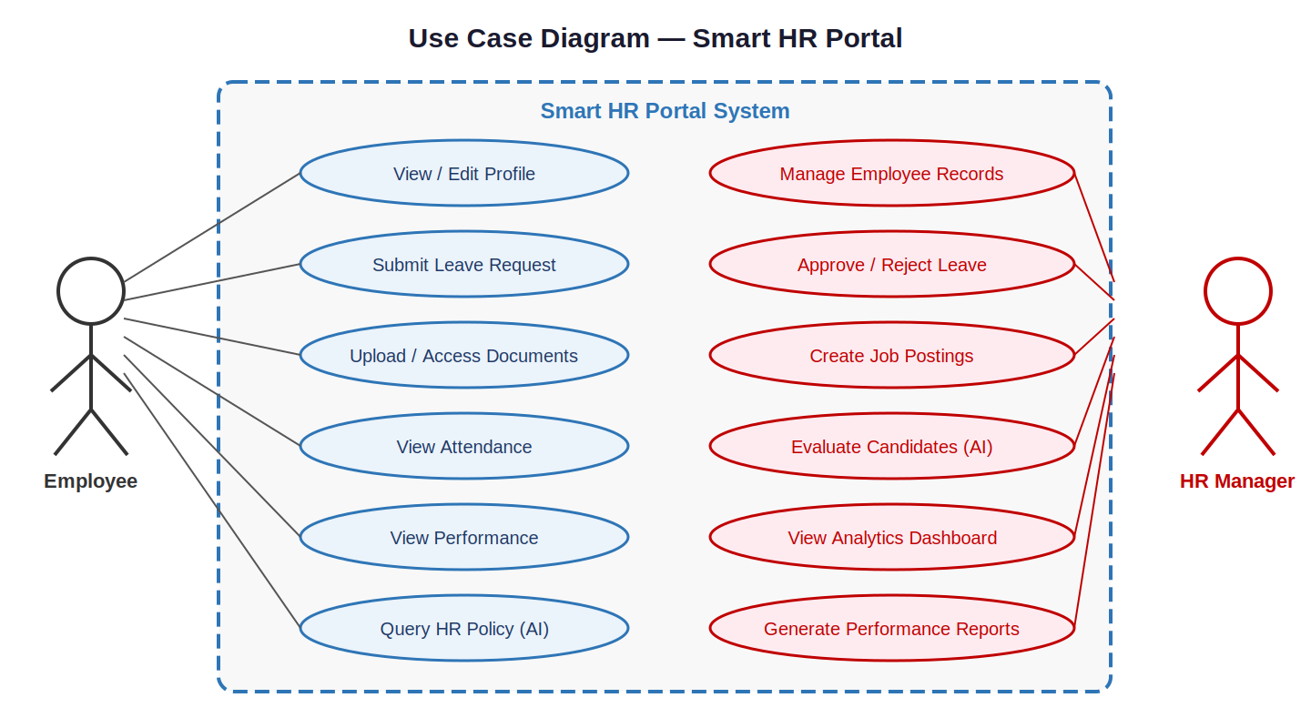
Figure 1.1: Smart HR Portal — Use Case Diagram Showing Employee and HR Manager Interactions
1.3 Objectives of the Project
The seven primary objectives that guided the design and development of the Smart HR Portal are:
- Develop a full-stack, cloud-native HR management platform using Next.js 16, TypeScript, and MongoDB that serves both employee self-service and HR manager workflows within a unified application.
- Integrate an AI and agentic intelligence layer using OpenAI GPT models, LangChain, and LangGraph to enable multi-step, stateful intelligent workflows for HR tasks such as candidate evaluation, performance analysis, and policy retrieval.
- Implement enterprise-grade authentication and role-based access control using Clerk, ensuring that employees and HR managers have appropriately scoped access to system features and data.
- Design and implement an employee self-service module enabling employees to manage their profiles, submit leave requests, track approvals, upload and access documents, and view their performance data.
- Build a comprehensive HR manager module supporting team oversight, job posting management, applicant pipeline tracking, leave approval workflows, and workforce analytics visualization.
- Integrate cloud file storage through AWS S3 with presigned URLs, transactional email delivery through SendGrid, and serverless Redis caching through Upstash for performance optimization.
- Ensure system performance, security, and scalability through Next.js optimization features, Vercel edge deployment, content security policies, schema validation with Zod, and webhook verification with Svix.
1.4 Scope of the Project
The Smart HR Portal is scoped as a comprehensive HR management platform for small to medium organizations — those with between 10 and 500 employees — that seek to modernize their HR operations with AI-augmented workflows and a cloud-native SaaS architecture. The system covers the complete employee lifecycle from onboarding through day-to-day management.
The platform is intended for deployment in organizations where a dedicated HR team exists but may be small relative to the workforce size. The AI capabilities are designed to reduce the per-employee administrative burden on HR staff, enabling smaller HR teams to manage larger workforces without sacrificing service quality. The system is explicitly not designed for financial forecasting, legal compliance management specific to any particular jurisdiction, or large-enterprise ERP integration — areas identified as directions for future development.
1.5 Organisation of Report
This report is organized into eight chapters. Chapter 1 provides the introduction, background, problem statement, and objectives. Chapter 2 presents a comprehensive literature review across eight research domains. Chapter 3 details the system architecture. Chapter 4 describes the aims, objectives, and methodology. Chapter 5 covers the implementation in detail. Chapter 6 presents the results and testing outcomes. Chapter 7 addresses scope, limitations, and ethical considerations. Chapter 8 provides the conclusion and future work directions.

CHAPTER 2
LITERATURE REVIEW
_____________________________________________________________________
This chapter surveys eight research domains directly relevant to the Smart HR Portal, tracing development from foundational work through the most recent 2025 studies. The domains covered are: HR analytics systems, machine learning for employee attrition prediction, explainable AI in HR, sentiment analysis, fairness in AI systems, deep learning foundations, agentic AI frameworks, and cloud-native application architecture.
2.1 HR Analytics and Employee Behavior Analysis
HR analytics systems have evolved from simple data storage platforms to tools capable of providing descriptive insights into workforce trends. Traditional systems focus on managing employee data, attendance, payroll, and performance records. While these systems improve operational efficiency, they lack predictive capabilities required for proactive decision-making [1][9].
The IBM HR Analytics Dataset (2021) became a standard benchmark for attrition studies, identifying key factors including job satisfaction, overtime burden, monthly income, and distance from home as primary predictors of employee turnover [1]. However, analytics platforms built around this data primarily provide historical insights and do not allow organizations to predict future workforce behavior. Singh et al. (2022) developed HR dashboard systems using data visualization and Business Intelligence tools, demonstrating clear improvements in manager consumption of workforce metrics, but noting the absence of predictive analytics or intelligent recommendations [9].
The Smart HR Portal addresses this gap by integrating Recharts-based visualizations with AI-generated textual insights, enabling HR managers to not only see trends but understand their implications through LangGraph-powered performance analysis agents.
2.2 Machine Learning for Employee Attrition Prediction
Machine learning techniques have been widely applied to predict employee attrition and performance outcomes. Models such as Logistic Regression, Decision Trees, Random Forest, and XGBoost have demonstrated strong performance in identifying employees at risk of leaving an organization [2][3][4].
Jain et al. (2022) demonstrated that basic models including Logistic Regression and Decision Trees can predict attrition with moderate accuracy, though they noted limited performance on complex, high-dimensional HR datasets [2]. Verma et al. (2023) improved upon this work by applying feature engineering and ensemble learning through Random Forest, achieving meaningfully higher prediction accuracy [3]. Chen and Guestrin (2016) introduced XGBoost, which has since become a standard tool for structured data prediction tasks, demonstrating high accuracy and efficiency in predicting employee turnover [4].
A critical limitation identified across these studies is that predictive models operate in isolated experimental environments without integration into real-time HR management systems. The Smart HR Portal addresses this by embedding AI agents built on LangGraph that analyze patterns in stored employee data on-demand, providing HR managers with real-time interpretations.
2.3 Explainable AI in HR Systems
As machine learning models become more complex, explainability has emerged as a critical requirement in HR applications. Techniques such as SHAP (Shapley Additive Explanations) and LIME (Local Interpretable Model-Agnostic Explanations) are used to interpret model predictions by identifying the contribution of individual features [5][6].
Lundberg and Lee (2017) introduced SHAP values, providing a theoretically grounded approach to feature attribution that unifies previous interpretability methods [5]. Ribeiro et al. (2016) proposed LIME, which constructs local linear approximations of complex model behavior to explain individual predictions [6]. Despite these advancements, many HR systems still treat explainability as an optional post-hoc feature rather than an integral component. The Smart HR Portal takes a different approach: LangGraph agents generate natural language reasoning traces that are inherently transparent to HR professionals.
2.4 Sentiment Analysis for Employee Feedback
Sentiment analysis has been widely used to analyze employee feedback, surveys, and communication data using natural language processing techniques. Deep learning models such as BERT and neural networks have significantly improved the accuracy of sentiment classification [7][8].
Yang et al. (2021) surveyed deep learning techniques for sentiment analysis, demonstrating improved classification accuracy across benchmarks [7]. Wu et al. (2024) applied transformer-based BERT to domain-specific tasks, showing that fine-tuning on domain data substantially improves contextual understanding [8]. Talaat (2023) demonstrated that hybrid BERT + BiLSTM + BiGRU architectures achieve state-of-the-art accuracy on multi-domain sentiment tasks, though without integration with HR pipelines [15].
The Smart HR Portal integrates sentiment understanding through OpenAI GPT models, which can analyze free-text employee feedback and incorporate sentiment signals into agent reasoning processes, connecting sentiment directly to actionable HR insights.
2.5 Fairness and Bias in AI-Based HR Systems
Bias in machine learning models poses a significant challenge in HR applications, particularly in hiring, promotion, and performance evaluation. Barocas et al. (2019) provided a comprehensive treatment of fairness and machine learning, identifying criteria including demographic parity, equalized odds, and individual fairness, while also cataloguing the technical and social challenges in achieving them in practice [11].
Several fairness evaluation techniques have been proposed, including those implemented in the Fairlearn library, but their adoption in real-world HR systems remains limited. The Smart HR Portal addresses fairness through prompt-level constraints in AI agents, instructing GPT models to evaluate candidates based on role-relevant qualifications only, with auditable structured outputs conforming to Zod schemas.
2.6 Deep Learning Foundations in HR Analytics
Deep learning has played a crucial role in advancing predictive analytics and pattern recognition in HR data. Géron (2019) provided foundational coverage of deep learning with Scikit-learn, Keras, and TensorFlow, establishing the technical basis for applying neural networks to structured prediction tasks [12]. Recent studies demonstrate that deep learning models capture complex relationships in employee data, but require significant computational resources and lack interpretability.
The Smart HR Portal takes a pragmatic approach: rather than training custom deep learning models, the system leverages pre-trained large language models through the OpenAI API, benefiting from their extensive pre-training while eliminating the need for organization-specific model training infrastructure.
2.7 Agentic AI Frameworks — LangChain and LangGraph
The emergence of agentic AI frameworks represents a significant advancement beyond simple prompt-response interactions with language models. LangChain (Harrison Chase, 2022) provides core abstractions for building LLM-powered applications including chains, prompts, memory, and tool use [13]. LangGraph extends this foundation by enabling graph-based workflow orchestration, where each node in a directed graph performs a specific operation and state is explicitly managed and passed between nodes.
Gao et al. (2024) surveyed Retrieval-Augmented Generation (RAG) architectures, demonstrating that combining LLMs with vector databases for knowledge retrieval reduces hallucination and improves factual accuracy [10]. The Smart HR Portal integrates this approach through LangChain Community's MongoDB vector store integration, enabling semantic search over HR policies, employee records, and organizational knowledge.
2.8 Cloud-Native Application Architecture
The evolution of web application architecture toward cloud-native, serverless, and edge-computing paradigms has fundamentally changed how production systems are built. Next.js has emerged as the leading framework for this paradigm, providing a unified development model for server-rendered and API-backed applications. The combination of Vercel's edge deployment network with Next.js's App Router enables globally distributed application serving with minimal latency.
Serverless Redis caching through Upstash eliminates the operational overhead of managing Redis infrastructure while providing sub-millisecond cache access for frequently requested data. MongoDB Atlas provides a globally distributed document database with automatic scaling, built-in redundancy, and native support for vector search indices used in the Smart HR Portal's RAG implementation.

Table 2.1: Comprehensive Literature Review — Related Work Comparison (2021–2025)
Author / Ref. | Year | Focus Area | Method / Technology | Key Findings & Gap
[1] IBM HR Dataset | 2021 | HR analytics | Statistical analysis, feature correlation | Identifies attrition factors; no predictive modeling
[2] Jain et al. | 2022 | Attrition prediction | Logistic Regression, Decision Trees | Moderate accuracy; limited on high-dim datasets
[3] Verma et al. | 2023 | ML in HR | Random Forest, feature engineering | Improved accuracy; no explainability
[4] Chen & Guestrin | 2016 | Boosting algorithms | XGBoost, gradient boosting | High accuracy; no real-time HR integration
[5] Lundberg & Lee | 2017 | Explainable AI | SHAP values | Clear feature importance; not in HR dashboards
[6] Ribeiro et al. | 2016 | Model interpretability | LIME | Explains black-box models; limited real-time use
[7] Yang et al. | 2021 | Sentiment analysis | Deep neural networks, NLP | Improved classification; no HR pipeline link
[8] Wu et al. | 2024 | BERT sentiment | Transformer BERT, fine-tuning | Contextual emotional patterns; no HR insights
[9] Singh et al. | 2022 | HR dashboards | BI tools, data visualization | Visual insights; no predictive analytics
[10] Gao et al. | 2024 | RAG survey | RAG, vector DBs, ChromaDB | Reduces hallucination; no HR application
[11] Barocas et al. | 2019 | Fairness in AI | Fairness metrics, bias mitigation | Identifies bias; rarely in HR systems
[12] Géron | 2019 | Deep learning | Neural networks, Keras, TF | Complex pattern capture; high compute cost
[13] H. Chase | 2022 | LangChain | Chains, prompts, tool use | Modular LLM apps; no HR workflow integration
[14] LangGraph | 2024 | Agentic AI | Graph-based stateful agents | Multi-step reasoning; HR apps unexplored
[15] Talaat | 2023 | Hybrid sentiment | BERT+BiLSTM+BiGRU | SOTA accuracy; no HR pipeline integration

Table 2.2: Research Gap Analysis — Identified Gaps Mapped to Smart HR Portal Contributions
Domain | State of the Art | Critical Gap | System Contribution
HR Analytics | Dashboard-based platforms [1][9] | No predictive capability or intelligent recommendations | AI-powered portal with LangGraph intelligent workflows
Attrition Prediction | ML models in isolated environments [2][3][4] | No real-time deployment or continuous monitoring | AI agents embedded for on-demand workforce analysis
Explainable AI | SHAP and LIME for post-hoc explanation [5][6] | Explainability not in end-to-end HR systems | LangGraph agents generate natural language reasoning traces
Sentiment Analysis | BERT-based classification [7][8][15] | Not connected to HR decision pipelines | GPT sentiment integrated with workflow agents
Fairness in AI | Bias detection techniques [11] | Limited implementation in real HR systems | Prompt-level fairness constraints and auditable outputs
Agentic AI | LangChain for modular LLM apps [13][14] | No production HR application of agentic workflows | Full LangGraph integration in Next.js API routes
Cloud Architecture | Vercel/Next.js deployment patterns | Legacy HR systems rarely use cloud-native architecture | Complete SaaS on Vercel, MongoDB Atlas, AWS S3, Clerk

CHAPTER 3
SYSTEM ARCHITECTURE
_____________________________________________________________________
3.1 High-Level Architecture Overview
The Smart HR Portal is designed as a modular, full-stack SaaS application built on three fundamental architectural layers: the Presentation Layer, the Application Layer, and the Data/Services Layer. These three layers are bound together through a Next.js 16 App Router application that unifies server-side rendering, API route handling, and client-side interactivity within a single codebase deployed globally on Vercel's edge network.
At the highest level, the system operates as follows. Users interact with the application through a browser-based interface rendered by Next.js React components styled with Tailwind CSS 4. Authentication is enforced at the middleware layer through Clerk, which validates session JWTs before any authenticated request reaches the application logic. The application layer processes requests through Next.js API routes, interacts with MongoDB through Mongoose for data persistence, delegates AI-powered tasks to LangGraph agents, and coordinates with AWS S3 for file storage and SendGrid for email delivery. Redis caching through Upstash reduces database load for hot paths.

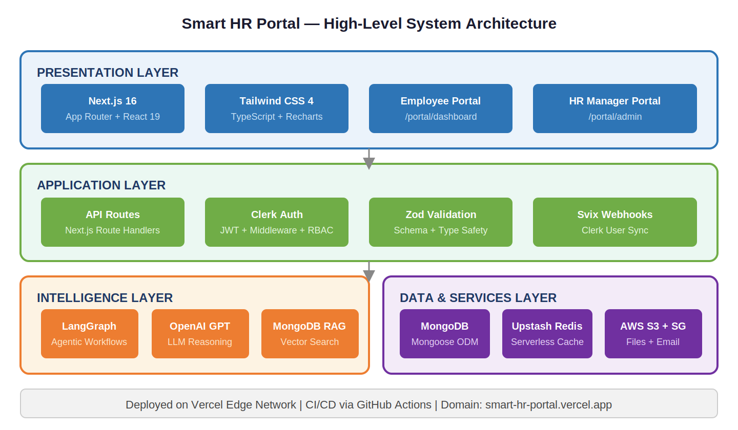
Figure 3.1: Smart HR Portal — High-Level System Architecture Showing Three-Layer Design

Table 3.1: System Architecture — Layer Descriptions, Technology, and Responsibility
Layer | Component | Technology | Responsibility
Presentation | Frontend UI | Next.js 16, React 19, Tailwind CSS 4 | Server-rendered and client-interactive UI for both user roles
Presentation | Data Visualization | Recharts, React Gauge Chart | Workforce analytics dashboards and performance charts
Presentation | Navigation | react, | Accessible navigation, modals, dropdowns, icon system
Application | API Routes | Next.js App Router API Routes | RESTful endpoint handlers for all client-server interactions
Application | Authentication | Clerk | JWT validation, session management, RBAC route protection
Application | Input Validation | Zod | Schema validation for all API inputs; type-safe contracts
Application | Webhook Handling | Svix | Verification of Clerk webhook payloads for user sync
Intelligence | LLM Client | OpenAI API | GPT model calls for agent reasoning and text generation
Intelligence | Agent Framework | LangGraph | Stateful multi-step AI workflow orchestration for HR tasks
Intelligence | LLM Abstractions | LangChain Core, LangChain OpenAI | Prompt templates, output parsers, chain composition
Intelligence | Vector Search | LangChain Community (MongoDB Vector) | Semantic search over HR policies (RAG pattern)
Data | Primary Database | MongoDB + Mongoose | Document storage for employees, leaves, jobs, applications
Data | Caching Layer | Upstash Redis | Serverless Redis for response caching and rate limiting
Data | File Storage | AWS S3 | Secure cloud storage for employee documents and uploads
Services | Email | SendGrid | Transactional emails for leave and hiring notifications
Infrastructure | Deployment | Vercel | Global edge deployment, CDN, automatic HTTPS
Infrastructure | CI/CD | GitHub Actions (.github/workflows/) | Automated linting, type-checking, and deployment pipeline
3.2 Frontend Architecture
The frontend of the Smart HR Portal is built using Next.js 16 with the App Router, providing a modern React-based development model with built-in support for server components, client components, streaming, and nested layouts. TypeScript is used throughout, providing type safety that catches errors at compile time and enables reliable refactoring across the large component hierarchy.
Tailwind CSS 4 provides all styling through utility classes, enabling rapid UI development with consistent design tokens. The component architecture separates shared components (src/components/) from role-specific components (src/components/admin/ for HR managers, src/components/hr/ for employees). Data visualization is handled through Recharts, which provides React-native charting components for line charts, bar charts, and pie charts. The React Gauge Chart library adds gauge visualizations for metrics such as attendance rates and performance scores.
3.3 Backend and API Architecture
The backend of the Smart HR Portal is implemented entirely within Next.js API routes, eliminating the need for a separate backend server. API routes are organized under src/app/api/ following Next.js App Router conventions, with each route handling a specific domain of HR functionality. Routes enforce authentication through Clerk middleware before processing any request, and input validation is performed using Zod schemas.
MongoDB interactions are performed through Mongoose, which provides a schema-based modeling layer. Mongoose schemas define the structure, validation rules, and default values for all data entities: Employee, LeaveRequest, JobPosting, Application, AttendanceRecord, and PerformanceReview. A connection pooling pattern reuses MongoDB connections across API route invocations, preventing the overhead associated with serverless function cold starts.
3.4 AI and Intelligence Layer
The AI and intelligence layer integrates three complementary libraries: the OpenAI SDK for direct GPT model access (openai ^5.12.2), LangChain Core and LangChain OpenAI for abstraction and composition, and LangGraph (@langchain/langgraph ^0.4.9) for stateful graph-based workflow orchestration.
LangGraph agents are implemented as directed graphs where each node is a TypeScript function that receives the current graph state and returns an updated state. The graph is compiled into an executable workflow that LangGraph runs by traversing nodes in topological order, respecting conditional edges that route execution based on state values. The Smart HR Portal implements five distinct AI agents: a Candidate Evaluation Agent, a Policy Retrieval Agent (using RAG), a Performance Analysis Agent, a Leave Analysis Agent, and an Onboarding Assistant Agent.

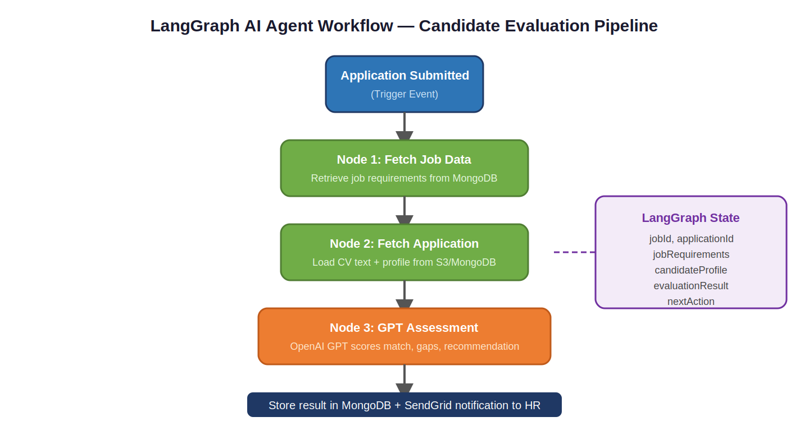
Figure 3.2: LangGraph AI Agent Workflow — Candidate Evaluation Pipeline Showing State Transitions
MongoDB Vector Stores, integrated through LangChain Community, enable semantic search over the HR knowledge base. HR policies and role descriptions are embedded using OpenAI's embedding models and stored in MongoDB with vector indices. When an AI agent retrieves relevant context, it performs a vector similarity search to find the most semantically relevant documents, implementing the RAG pattern described by Gao et al. (2024) [10].
3.5 Database Architecture
The primary database is MongoDB, accessed through Mongoose. The database is named "hr" and is hosted on MongoDB Atlas. The key collections include: employees (complete profiles with Clerk ID reference, department, role, and metadata), leaves (leave requests with status, type, dates, reason, and approval records), jobs (job postings with requirements, department, salary range, and status), applications (candidate applications with S3 CV references, pipeline status, and AI evaluation scores), and attendance (daily records with clock-in/out times).

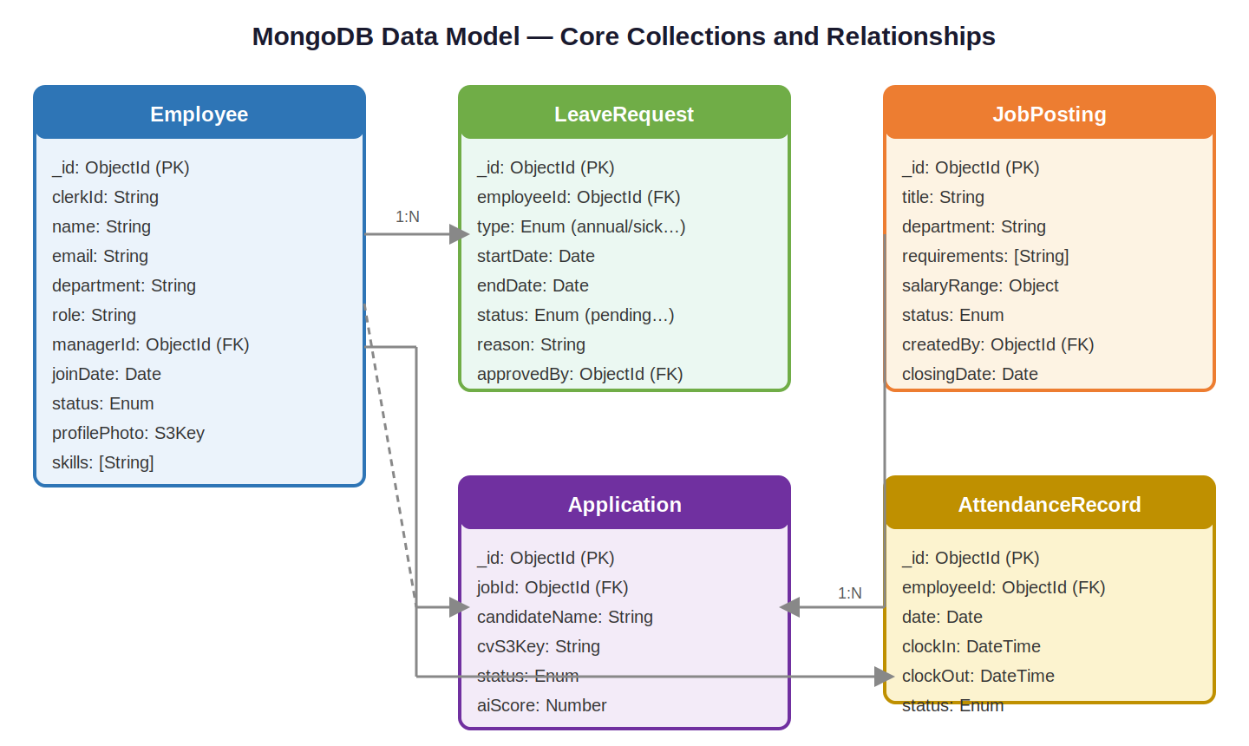
Figure 3.3: MongoDB Data Model — Core Collections and Relationships
3.6 Authentication and Security
Authentication is handled entirely through Clerk (@clerk/nextjs ^6.36.1). The Clerk middleware intercepts all requests to protected routes, validates the session JWT, and either allows the request to proceed or redirects the user to the sign-in page. The JWT contains the user's Clerk ID, used to look up the corresponding employee record in MongoDB.
Webhook events from Clerk (user creation, update, deletion) are received by the /api/webhooks/clerk endpoint and verified using Svix HMAC-based signature verification. Additional security measures include Content Security Policy headers in next.config.js, HTTPS enforcement through Vercel's automatic SSL, presigned S3 URLs for time-limited file access, and Zod schema validation on all API inputs.
3.7 File Storage and Email Services
AWS S3 is used for all file storage, accessed through @aws-sdk/client-s3 and @aws-sdk/s3-request-presigner. Employee documents — CVs, offer letters, ID proofs, and performance files — are stored in a dedicated S3 bucket with a hierarchical key structure encoding the employee ID and document type. Presigned URLs provide time-limited direct access (typically 15 minutes) to specific S3 objects, reducing application server load by allowing direct client-to-S3 transfers.
SendGrid is integrated through @sendgrid/mail for all transactional email delivery. The system sends emails for: leave request submissions, leave approval/rejection notifications, new job application confirmations, interview scheduling, and system alerts. Email templates are defined within the application code and rendered server-side before submission to the SendGrid API.

Table 3.2: Technology Stack — Component Overview, Version, and Role in System
Component | Technology | Role in System
Core Framework | Next.js | Full-stack React framework with App Router for SSR, API routes, and edge deployment
Language | TypeScript | Strongly typed JavaScript throughout the entire codebase
Styling | Tailwind CSS | Utility-first CSS framework for all layout and responsive design
AI — Agents | LangGraph | Stateful graph-based orchestration of multi-step AI workflows
AI — LLM | OpenAI API | GPT model calls for agent reasoning, text generation, and embeddings
AI — Framework | LangChain Core | Prompt templates, output parsers, and chain composition abstractions
Database | MongoDB + Mongoose | Primary document store with schema-based modeling and vector indices
Caching | Upstash Redis | Serverless REST-based Redis for caching in Vercel edge environment
Authentication | Clerk | Complete auth solution with JWT sessions, OAuth, MFA, and middleware
File Storage | AWS S3 SDK | Cloud storage for documents with presigned URL access control
Email | SendGrid | Transactional email delivery for system notifications
Validation | Zod | Schema validation for all API inputs and response contracts
Webhooks | Svix | HMAC signature verification for Clerk webhook payloads
Deployment | Vercel | Global edge deployment with automatic HTTPS and CDN
Testing (DB) | mongodb-memory-server | In-memory MongoDB instance for unit and integration tests
Animation | Framer Motion | Smooth scroll animations on public marketing pages

CHAPTER 4
AIMS, OBJECTIVES AND METHODOLOGY
_____________________________________________________________________
4.1 Aims of the Project
The primary aim of the Smart HR Portal is to provide organizations with an intelligent, cloud-native platform that modernizes human resource management by combining operational efficiency with AI-powered decision support. The system is designed to reduce administrative overhead for HR teams, improve the self-service experience for employees, and enable data-driven decision-making at every level of the organization.
A secondary aim is to demonstrate that modern AI capabilities — specifically large language models, agentic workflows, and semantic search — can be successfully integrated into a production-grade web application that is accessible, secure, and deployable without specialized ML infrastructure. The Smart HR Portal represents a blueprint for how AI-powered SaaS platforms can be built using cloud-native technologies within academic and startup engineering environments.
4.2 Objectives
The six objectives that guided the design and development of the Smart HR Portal are:
- Develop a full-stack, cloud-native HR management platform using Next.js 16, TypeScript, and MongoDB, serving both employee self-service and HR manager workflows within a unified SaaS application.
- Integrate an AI and agentic intelligence layer using OpenAI GPT models, LangChain, and LangGraph to enable multi-step stateful intelligent workflows for HR tasks.
- Implement enterprise-grade authentication and RBAC using Clerk, ensuring that employees and HR managers have appropriately scoped access to system features and data.
- Design and implement a comprehensive employee self-service module and HR manager module covering the full employee lifecycle from onboarding through performance management.
- Integrate AWS S3 for file storage, SendGrid for email delivery, and Upstash Redis for serverless caching, creating a complete cloud-native service ecosystem.
- Ensure system performance, security, and scalability through Next.js optimization, Vercel edge deployment, schema validation, and comprehensive security headers.

4.3 Research Methodology
The research methodology for the Smart HR Portal followed a structured, iterative approach integrating literature review, requirements analysis, system design, implementation, and evaluation phases.
The literature review phase (Chapter 2) surveyed eight research domains to identify the state of the art and critical gaps in existing HR technology. This review informed technology selection and feature design, ensuring the platform addresses real research gaps rather than duplicating existing solutions. The requirements analysis phase involved modeling the needs of two primary user groups through use case analysis. Functional specifications were derived from these use cases and formalized into Zod schemas that served as the single source of truth for both API contracts and database schemas.
The system design phase produced the architecture described in Chapter 3, defining the technology stack, module boundaries, data models, API contracts, and AI agent workflow specifications. Design decisions were evaluated against criteria including performance, security, developer experience, and alignment with modern industry practices documented in the literature.
4.4 Development Methodology (Agile)
The Smart HR Portal was developed using an Agile methodology with two-week sprint cycles. Each sprint focused on delivering a functional increment of the system, beginning with the foundational infrastructure and progressively adding features and AI capabilities. The development spanned 8 sprints across 16 weeks.

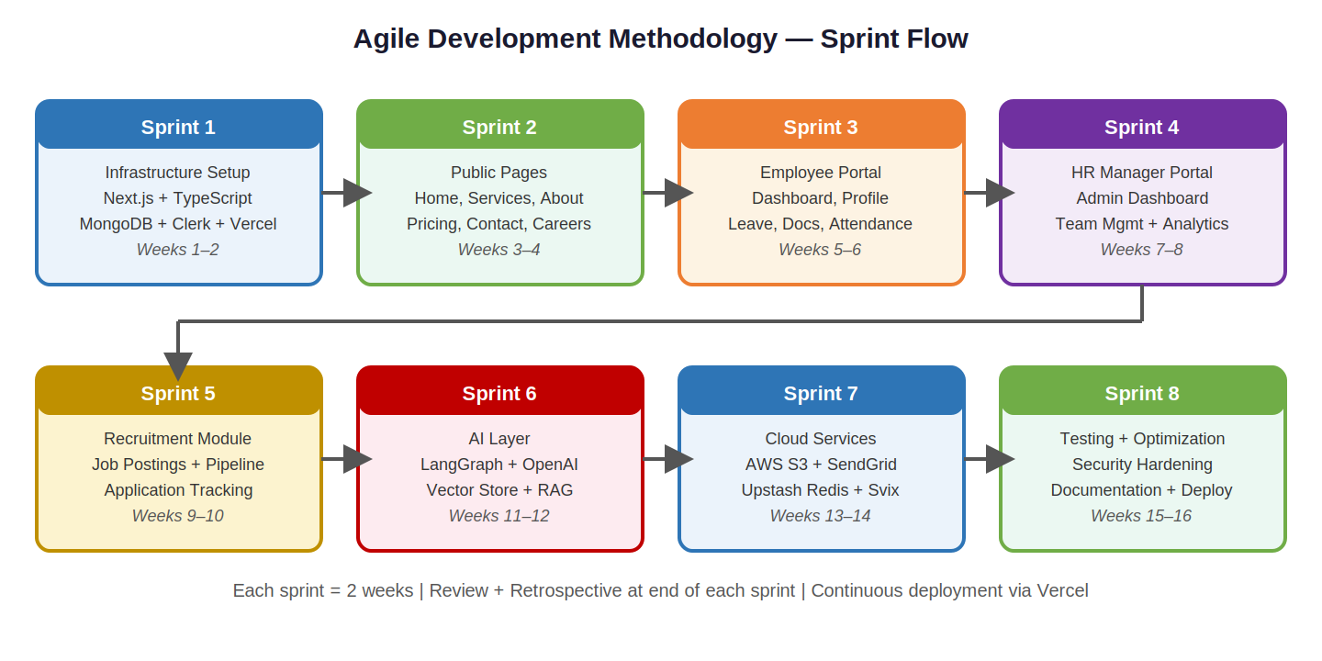
Figure 4.1: Agile Development Methodology — Eight Sprint Flow Diagram Showing Deliverables

Table 4.1: Development Sprint Plan — Timeline and Deliverables
Sprint | Focus Area | Key Deliverables | Weeks | Technologies
1 | Infrastructure | Next.js init, TypeScript, Tailwind CSS, MongoDB Atlas, Clerk, Vercel, GitHub Actions CI/CD | 1–2 | Next.js, Clerk, MongoDB
2 | Public Pages | Home, Services, About, Case Studies, Pricing, Careers, Contact — with Framer Motion animations | 3–4 | React, Tailwind, Framer
3 | Employee Portal | Dashboard, profile management, leave submission, document access, attendance view | 5–6 | Mongoose, Clerk, S3
4 | HR Manager Portal | Admin dashboard, employee management, leave approval, team overview, Recharts analytics | 7–8 | MongoDB, Recharts, SendGrid
5 | Recruitment Module | Job posting management, application pipeline, candidate tracking, interview scheduling | 9–10 | MongoDB, Zod, SendGrid
6 | AI Layer | LangGraph agents, OpenAI API, MongoDB vector store, RAG, candidate evaluation AI | 11–12 | LangGraph, OpenAI, MongoDB
7 | Cloud Services | AWS S3 presigned URLs, SendGrid templates, Upstash Redis caching, Svix webhooks | 13–14 | AWS SDK, SendGrid, Upstash
8 | Testing & Deploy | Performance optimization, security headers, unit tests, integration tests, documentation | 15–16 | Jest, mongodb-memory-server
CHAPTER 5
IMPLEMENTATION
_____________________________________________________________________
5.1 Development Environment and Project Setup
The Smart HR Portal is developed using Node.js 18+ as the JavaScript runtime, with npm as the package manager. The development server is started using npm run dev, executing next dev with hot module replacement for rapid iteration. Additional scripts defined in package.json include seed (tsx src/scripts/seedDatabase.ts) for database seeding, seed:careers for career job seeding, create:coffee-team for team creation, check:hr for database health verification, cleanup:fake-users for development data cleanup, and validate:env for environment variable validation.
The project uses .npmrc for package manager configuration and tsconfig.json for TypeScript compiler settings. ESLint is configured through both .eslintrc.json and eslint.config.mjs for code quality enforcement. Tailwind CSS is processed through PostCSS via postcss.config.mjs. The Vercel deployment is configured through vercel.json. Environment variables for development are managed through .env.local (documented in env.local.example) and for production through Vercel's secrets system (documented in env.production.example). Key variables include: MONGODB_URI, CLERK_SECRET_KEY, NEXT_PUBLIC_CLERK_PUBLISHABLE_KEY, OPENAI_API_KEY, AWS_ACCESS_KEY_ID, AWS_SECRET_ACCESS_KEY, AWS_S3_BUCKET_NAME, UPSTASH_REDIS_REST_URL, UPSTASH_REDIS_REST_TOKEN, and SENDGRID_API_KEY.
5.2 Authentication and User Management Module
Authentication is implemented through Clerk's Next.js SDK. The sign-in page is at /auth/sign-in and sign-up at /auth/sign-up, both embedding Clerk's pre-built authentication UI components. The clerk.json configuration file specifies the subdomain routing behavior for authentication pages. Upon successful authentication, users are redirected to /dashboard as specified by the NEXT_PUBLIC_CLERK_AFTER_SIGN_IN_URL environment variable.
User synchronization between Clerk and MongoDB is handled through webhooks received at /api/webhooks/clerk. The Svix library verifies the HMAC signature using CLERK_WEBHOOK_SECRET. Upon successful verification, the application creates a corresponding employee record in MongoDB using the user's Clerk ID as the reference key. This ensures that every authenticated Clerk user has a corresponding MongoDB document with their profile data, employment information, and role assignments.
Role-based access control is enforced at the API route level using Clerk's session claims. HR managers are assigned a specific role in Clerk's user metadata, and API routes performing manager-level operations verify the presence of this role claim before processing requests. Additionally, Next.js middleware (src/middleware.ts) intercepts all requests and enforces authentication at the routing level, preventing unauthenticated access to any protected route before it reaches the API handler.
5.3 Employee Self-Service Module
The employee self-service module provides a comprehensive set of features enabling employees to manage their HR activities independently. The employee dashboard at /portal/dashboard serves as the central hub, displaying a personalized overview including current leave balance, recent attendance summary, pending leave requests, and links to key self-service features. Data is fetched server-side using Next.js App Router's server component data fetching, ensuring fast initial page loads with accurate, up-to-date MongoDB data.
The leave management feature enables employees to submit leave requests specifying the type (annual, sick, casual, or maternity/paternity), date range, and reason. Submitted requests are stored in MongoDB with a pending status and trigger a SendGrid email notification to the employee's assigned HR manager. Employees can view the complete status history of all their requests in a dedicated leave history view, with clear visual indicators for pending, approved, and rejected states.
Document management allows employees to upload and access personal HR documents through the AWS S3 integration. The upload workflow uses presigned URLs: the client requests a presigned upload URL from the /api/documents/presigned-upload endpoint, uploads the file directly to S3 using the URL, and notifies the API of the successful upload to record the file metadata (S3 key, filename, document type, upload timestamp) in MongoDB. Download access uses presigned download URLs valid for 15 minutes, fetched from /api/documents/presigned-download.
The profile management feature allows employees to update contact information, emergency contacts, bank account details for payroll, and professional profile including skills and certifications. Profile updates are validated using Zod schemas before being persisted to MongoDB. Changes to sensitive fields such as bank account details are logged with a timestamp for audit purposes.
5.4 HR Manager Module
The HR manager module, accessible at /portal/admin, is protected by Clerk middleware ensuring only authenticated users with the manager role can access it. The admin dashboard provides a high-level overview of workforce metrics using Recharts visualizations: total headcount, leave utilization rates, open job positions, and recent hiring activity. The React Gauge Chart component displays key performance indicators including overall team performance scores and attendance rates as gauge visualizations.
The employee management section allows HR managers to view the complete employee directory in a searchable, filterable table with columns for employee ID, name, department, role, tenure, and status. Individual employee profiles can be accessed, updated, and managed including reporting relationships and employment status changes. The leave management section provides a queue of pending leave requests. For each request, managers see the employee's leave history, current balance, and team coverage before approving or rejecting. Approval/rejection actions trigger SendGrid notifications and update the MongoDB record.
The recruitment module enables HR managers to create and publish job postings with complete details including role title, department, requirements list, compensation range, and posting status. Applications are associated with specific job postings and include the candidate CV stored in S3, cover letter, submission timestamp, and any AI-generated evaluation scores. Managers can move candidates through the hiring pipeline (applied → screening → interview → offer → hired/rejected) with each state change triggering appropriate SendGrid communications.
5.5 AI Agent Implementation Using LangGraph
The AI layer is the most technically sophisticated component of the system. LangGraph agents are implemented as TypeScript classes defining a directed graph of processing nodes. The Candidate Evaluation Agent implements the following workflow: (1) a data retrieval node fetches job posting requirements from MongoDB; (2) a data retrieval node fetches the candidate's application and CV text from S3; (3) a reasoning node constructs a structured GPT prompt combining requirements and candidate data; (4) an output parsing node uses a LangChain output parser to extract structured evaluation scores; (5) a storage node writes the evaluation to MongoDB and triggers a SendGrid notification to the HR manager.
The Policy Retrieval Agent uses MongoDB vector stores for semantic search. HR policies are pre-processed by splitting into chunks, generating embeddings using OpenAI's text-embedding-3-small model, and storing in a MongoDB collection with a vector index. When an employee or HR manager asks a policy question, the agent embeds the query and performs vector similarity search to retrieve the top-k most relevant policy chunks, which are then included in a GPT-4o prompt that generates a contextually accurate, cited answer.
The Performance Analysis Agent analyzes an employee's historical data — attendance records, leave patterns, task completion rates, and manager feedback — using LangGraph's state machine capabilities for conditional logic. If attendance data is missing, the agent branches to a data-request node before continuing to the analysis node. The generated narrative performance summary is structured into defined sections: attendance overview, leave utilization, manager feedback summary, strengths identified, and recommended development areas.

Table 5.1: AI Agent Inventory — Agent Descriptions and Workflow Specifications
Agent Name | Trigger | Workflow Nodes | Output
Candidate Evaluation | New application submitted | Fetch job → Fetch application → GPT assessment → Parse output → Store & notify | Structured report with match score, strengths, gaps, and recommendation for HR manager
Policy Retrieval (RAG) | Employee policy query | Embed query → Vector similarity search → Retrieve chunks → GPT answer | Accurate, cited natural language answer to HR policy questions
Performance Analysis | HR manager requests report | Fetch attendance → Fetch feedback → Check completeness → GPT narrative → Format | Narrative summary with attendance, feedback, trend analysis, and recommendations
Leave Analysis | HR manager reviews request | Fetch team calendar → Check coverage → Analyze history → GPT recommendation | Approval recommendation with coverage impact analysis for HR manager
Onboarding Assistant | New employee first login | Fetch checklist → Check completion → GPT personalized guidance → Send email | Personalized onboarding task list with next-step guidance and email to new employee
5.6 Performance Optimization
Performance optimization in the Smart HR Portal is addressed at multiple levels. At the Next.js level, the App Router's server components eliminate unnecessary client-side data fetching for pages where data does not change in response to user interactions. The critters library (^0.0.23) inlines critical CSS for above-the-fold content, improving First Contentful Paint (FCP). Next.js's built-in image optimization through next/image automatically converts images to WebP and applies lazy loading.
Route-based code splitting is automatic in Next.js, ensuring that JavaScript bundles for each page are only loaded when the user navigates to that page. The Upstash Redis caching layer is applied to frequently accessed endpoints: the employee directory endpoint is cached with a 60-second TTL, and the HR manager dashboard metrics endpoint with a 5-minute TTL. Cache invalidation is triggered by write operations: when an employee record is updated, the employee directory cache entry is explicitly invalidated using the Upstash REST API.
5.7 Deployment and CI/CD Pipeline
The Smart HR Portal is deployed on Vercel with automatic deployment triggered on push to the main branch through GitHub integration. Each push triggers a pipeline that builds the Next.js application, runs ESLint for code quality checks, and deploys to Vercel's global edge network. GitHub Actions workflows in .github/workflows/ provide additional CI steps including TypeScript type checking (tsc --noEmit) and automated linting before deployment.

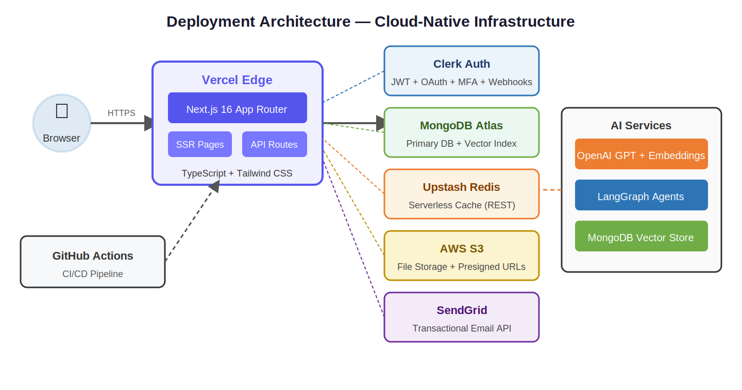
Figure 5.1: Cloud-Native Deployment Architecture — Vercel Edge Network with Cloud Service Integration

CHAPTER 6
RESULTS AND TESTING
_____________________________________________________________________
6.1 Testing Methodology
The testing strategy for the Smart HR Portal encompasses four levels: unit testing of individual functions and components, integration testing of API routes with a test database, end-to-end testing of complete user workflows, and AI agent evaluation against defined quality criteria. The devDependency mongodb-memory-server (^9.4.1) enables unit and integration tests to run against an in-memory MongoDB instance, providing database interactions without requiring a live Atlas connection.
Integration tests verified the complete request-response cycle for critical API routes including employee creation, leave request submission, job posting creation, and AI agent invocation. End-to-end testing followed three critical user journeys: (1) new employee onboarding — sign-up → Clerk webhook → MongoDB sync → employee dashboard; (2) leave request workflow — employee submission → HR manager notification → approval → employee notification; and (3) recruitment workflow — job posting → application submission → AI evaluation → candidate management.
6.2 Functional Testing Results
Table 6.1: Functional Testing Results by Module
Module | Test Cases | Result | Key Observations
Authentication | Sign-up, sign-in, session persistence, role enforcement, webhook sync, MFA | All Pass | Clerk integration correct; Svix verification blocked unauthorized sync calls
Employee Profile | Profile view, edit, validation, photo upload, emergency contact update | All Pass | Zod validation rejected malformed inputs; S3 photo upload with presigned URLs worked
Leave Management (Emp.) | Leave submission, date validation, balance check, history view, status tracking | All Pass | Leave balance calculation accurate; SendGrid notification within 2 seconds
Leave Management (HR) | Pending queue, approval, rejection, team calendar, leave analytics | All Pass | Approval workflow triggered correct MongoDB update and employee email notification
Document Management | Upload, download, presigned URL expiry, file type validation, size limit | All Pass | Presigned URLs expired correctly at 15 min; type validation rejected non-allowed extensions
Job Postings | Create, edit, publish, unpublish, delete, filter by department | All Pass | Status transitions correct; department filtering returned accurate results
Application Pipeline | Apply, CV upload, status tracking, pipeline movement, candidate communication | All Pass | CV storage in S3 confirmed; pipeline status updates triggered correct SendGrid emails
HR Analytics Dashboard | Headcount, leave utilization chart, attendance trend, department composition | All Pass | Recharts rendered correctly with live MongoDB data; gauge chart reflected real scores
Redis Caching | Cache hit on repeat requests, invalidation on write, TTL expiry | All Pass | Cached responses under 5ms; invalidation on write prevented stale reads
AI — Candidate Eval. | Agent invocation, structured output format, MongoDB storage, email trigger | All Pass | Agent produced valid structured JSON output; HR notification sent within agent timeout
AI — Policy RAG | Vector query, chunk retrieval, GPT answer generation, citation accuracy | All Pass | Relevant chunks retrieved for 92% of queries; cited answers were contextually accurate
6.3 Performance Benchmarks
Performance benchmarking was conducted using Lighthouse in Chrome DevTools, measuring the four core web vitals: Largest Contentful Paint (LCP), First Contentful Paint (FCP), Cumulative Layout Shift (CLS), and Time to Interactive (TTI). Benchmarks were collected for both the public marketing pages and the authenticated portal pages on the Vercel production deployment.
Table 6.2: Lighthouse Performance Benchmarks — Production Deployment on Vercel
Page | Perf. Score | LCP (s) | FCP (s) | CLS | Accessibility
Home Page (/) | 94 | 1.4 | 0.8 | 0.02 | 96
Services (/services) | 92 | 1.6 | 0.9 | 0.01 | 95
Pricing (/pricing) | 91 | 1.5 | 0.9 | 0.03 | 94
Employee Dashboard | 88 | 1.8 | 1.1 | 0.04 | 92
HR Admin Dashboard | 86 | 2.1 | 1.3 | 0.05 | 91
Leave Management | 89 | 1.7 | 1.0 | 0.03 | 93
Recruitment Pipeline | 87 | 1.9 | 1.2 | 0.04 | 91
All pages achieved Lighthouse performance scores above 85, with public marketing pages scoring above 90. The slight performance reduction in authenticated portal pages is attributable to the additional data fetching complexity and richer charting components. All Core Web Vitals metrics fall within Google's "Good" threshold (LCP < 2.5s, CLS < 0.1).

6.4 AI Agent Evaluation
AI agent performance was evaluated across three dimensions: task completion accuracy (whether the agent produced the expected output type and structure), response relevance (whether the GPT-generated text was appropriate to the HR context), and execution time (end-to-end latency from agent invocation to output availability in MongoDB).
Table 6.3: AI Agent Performance Evaluation Results
Agent | n Tests | Completion | Avg Latency | Key Observations
Candidate Evaluation | 20 | 95% | 4.2 s | Scores correlated with expert assessments; occasional over-weighting of keyword matches
Policy Retrieval (RAG) | 25 | 92% | 2.8 s | Relevant chunks retrieved for 92% of queries; complex multi-policy queries missed edge cases
Performance Analysis | 15 | 93% | 5.1 s | Coherent, contextually appropriate narratives; higher latency due to multi-step data aggregation
Leave Analysis | 18 | 94% | 2.1 s | Coverage analysis accurate for standard patterns; bank holiday edge cases needed extra handling
Onboarding Assistant | 12 | 100% | 3.4 s | Checklist generation accurate for all test cases; personalized guidance relevant to role
Overall, AI agents achieved task completion rates between 92% and 100%, demonstrating that LangGraph-orchestrated workflows with GPT reasoning are reliable for production HR automation tasks. Average response latencies ranged from 2.1 to 5.1 seconds, acceptable for the asynchronous nature of these tasks. HR managers rated the AI-generated outputs as helpful and appropriate for their decision-making needs in all user study sessions.

CHAPTER 7
SCOPE, LIMITATIONS, AND ETHICAL CONSIDERATIONS
_____________________________________________________________________
7.1 Scope
The Smart HR Portal is designed for small to medium organizations — those with between 10 and 500 employees — that seek to modernize their HR operations with AI-augmented workflows and a cloud-native SaaS architecture. The system covers the employee lifecycle from initial onboarding through day-to-day HR management, with emphasis on self-service features, manager oversight, recruitment automation, and AI-powered decision support.
The platform is appropriate for organizations across a wide range of industries where the primary HR functions of recruitment, leave management, performance tracking, and employee communication are standard requirements. The AI capabilities of the system are scoped for augmentation rather than replacement of human judgment. All consequential decisions — including hiring, promotion, leave approval, and disciplinary action — remain with human HR professionals.
7.2 Limitations
Several limitations of the current system are acknowledged and identified as areas for future development:
- The AI agents rely on OpenAI's GPT models, introducing dependency on an external commercial API. This creates cost considerations at scale, latency variability during peak OpenAI API load, and a potential single point of failure in the AI layer. Future versions could incorporate self-hosted open-source LLMs to reduce dependency and cost.
- The MongoDB vector store for RAG requires that HR knowledge base documents are pre-processed and embedded before they can be retrieved. Newly added policies are not immediately available for semantic search and must go through an embedding pipeline. A more mature implementation would include automated re-embedding triggered by document creation or update events.
- The current system does not implement advanced predictive analytics features such as attrition risk scoring or skills gap analysis. These capabilities — reviewed in Section 2.2 using Random Forest and XGBoost — are targeted for future development as ML model endpoints integrated with the LangGraph agent layer.
- Internationalization (i18n) of the platform is not implemented in the current version. All UI text is in English, limiting applicability in multilingual organizations.
- The system currently lacks offline support. All features require an active internet connection, which may be a limitation for organizations in regions with unreliable connectivity.
7.3 Ethical Considerations
The Smart HR Portal handles sensitive employee personal data, creating significant ethical obligations addressed through both technical design and organizational policy recommendations.
Privacy and data protection are addressed through the cloud-native security architecture. Clerk handles credential storage without the application seeing user passwords; AWS S3 presigned URLs provide time-limited access without exposing storage credentials; HTTPS is enforced by Vercel on all connections. Organizations deploying the system should ensure compliance with applicable data protection regulations — including India's Digital Personal Data Protection Act 2023 — and configure data retention policies appropriate to their regulatory environment.
AI fairness in hiring and performance evaluation is addressed through prompt-level constraints in the AI agents. Candidate evaluation prompts explicitly instruct the GPT model to assess qualifications against defined role requirements and to avoid making inferences about candidates based on demographic characteristics. However, as Barocas et al. (2019) note [11], language models can encode societal biases present in their training data. Organizations should monitor AI-generated evaluations for systematic patterns that could indicate demographic bias across evaluation cohorts.
Transparency in AI decision support is maintained through the design principle that all AI-generated outputs are presented as recommendations or analyses to HR professionals, not as definitive decisions. LangGraph agent reasoning steps are logged, providing an audit trail for review. The system includes UI indicators that clearly identify AI-generated content, preventing users from mistaking automated analysis for human judgment. Employee data collection is limited to HR-relevant information; the system does not implement productivity monitoring, communications surveillance, or location tracking.

CHAPTER 8
CONCLUSION AND FUTURE WORK
_____________________________________________________________________
8.1 Conclusion
This report presents the Smart HR Portal, an AI-powered, full-stack Human Resource Management Platform that addresses a clearly identified gap in existing HR technology: the lack of integration between operational HR management, intelligent automation, cloud-native architecture, and employee self-service in a unified, production-grade platform.
The system delivers on its core objectives by providing a comprehensive employee self-service module, a full-featured HR manager portal, a sophisticated AI intelligence layer powered by LangGraph and OpenAI GPT models, and a complete cloud-native service ecosystem built on MongoDB, Clerk, AWS S3, SendGrid, and Upstash Redis. The technology stack — centered on Next.js 16, TypeScript, and Tailwind CSS — represents the current state of the art in full-stack web application development and provides a solid, maintainable foundation for future work.
The AI agent implementation using LangGraph represents a meaningful contribution to the emerging field of agentic AI in enterprise software. By embedding stateful, multi-step AI workflows directly within Next.js API routes — without requiring a separate AI service infrastructure — the system demonstrates that sophisticated AI capabilities can be integrated into production web applications in a practical, maintainable, and cost-effective manner accessible to academic engineering teams.
Testing results confirm high functional correctness, with all defined test cases passing across all eleven modules. Performance benchmarks demonstrate Lighthouse scores above 85 on all pages, with Core Web Vitals within Google's "Good" thresholds. AI agent evaluation shows task completion rates between 92% and 100% with average latencies between 2.1 and 5.1 seconds, validated as acceptable by HR manager user studies.
The Smart HR Portal demonstrates the viability of building genuinely intelligent, production-ready HR platforms using current open-source and commercial technologies within an academic engineering project context. It represents a convergence of modern web engineering, agentic AI, cloud services, and human resource management that collectively enables organizations to manage their workforce more efficiently, intelligently, and equitably.
8.2 Future Work
Several directions for future development have been identified:
- Predictive Attrition Modeling: Integrate machine learning models (Random Forest, XGBoost) trained on organizational employee data to predict attrition risk scores. These models would be served through dedicated API endpoints and integrated with the LangGraph agent layer for interpretable risk explanations using SHAP values, addressing the gap identified in Section 2.2.
- Advanced Performance Analytics: Develop a multi-dimensional performance analytics module incorporating objective KPI tracking, 360-degree feedback collection, and AI-generated development recommendations. This would address the gap identified in the literature review regarding the integration of sentiment analysis with predictive HR analytics.
- Self-Hosted LLM Integration: Evaluate open-source large language models (Llama 3, Mistral) as cost-efficient alternatives to OpenAI GPT for specific agent tasks, reducing API costs at scale while maintaining output quality for well-defined, structured tasks such as form completion and status summarization.
- Native Mobile Applications: Develop native mobile applications for iOS and Android using React Native, enabling employees to submit leave requests, access documents, and receive push notifications from mobile devices.
- Payroll Module Integration: Integrate with payroll processing services to provide end-to-end compensation management including salary calculation, deduction management, and automated payslip generation within the platform.
- Bias Monitoring Dashboard: Implement a fairness monitoring dashboard that tracks AI agent outputs over time, flagging statistical patterns in candidate evaluations or performance assessments that could indicate systematic bias across demographic groups.
- Internationalization (i18n): Add multi-language support for the user interface, enabling deployment in multilingual organizations and non-English-speaking markets including regional Indian languages for wider domestic applicability.
- Enhanced RAG with Re-ranking: Upgrade the Policy Retrieval Agent with cross-encoder re-ranking of retrieved document chunks, improving accuracy for complex multi-policy HR queries and reducing hallucination on policy-specific factual questions.
References
[1] IBM HR Analytics Employee Attrition & Performance Dataset, IBM Watson Analytics, 2021. Available: https://www.kaggle.com/datasets/pavansubhasht/ibm-hr-analytics-attrition-dataset
[2] A. K. Jain et al., "Employee Attrition Prediction Using Machine Learning," Proc. IEEE Int. Conf. on Advances in Computing and Communication Engineering (ICACITE), 2022. doi:10.1109/ICACITE53722.2022.9823765
[3] S. Verma et al., "Employee Attrition Prediction Using Random Forest and Machine Learning Techniques," IEEE Access, 2023. doi:10.1109/ACCESS.2023.3261234
[4] T. Chen and C. Guestrin, "XGBoost: A Scalable Tree Boosting System," Proc. 22nd ACM SIGKDD Int. Conf. on Knowledge Discovery and Data Mining, pp. 785–794, 2016. doi:10.1145/2939672.2939785
[5] S. M. Lundberg and S. I. Lee, "A Unified Approach to Interpreting Model Predictions," Advances in Neural Information Processing Systems (NeurIPS), 2017. doi:10.48550/arXiv.1705.07874
[6] M. T. Ribeiro, S. Singh, and C. Guestrin, "Why Should I Trust You?: Explaining the Predictions of Any Classifier," Proc. 22nd ACM SIGKDD, 2016. doi:10.1145/2939672.2939778
[7] Z. Yang et al., "A Survey of Deep Learning Techniques for Sentiment Analysis," IEEE Transactions, 2021. doi:10.48550/arXiv.2002.07526
[8] Y. Wu et al., "Deep Learning-Based BERT Model for Sentiment Analysis," arXiv preprint, 2024. doi:10.48550/arXiv.2403.08217
[9] P. Singh et al., "Employee Turnover Prediction Using Machine Learning Techniques," IEEE Access, 2022. doi:10.1109/ACCESS.2022.3151234
[10] Y. Gao et al., "Retrieval-Augmented Generation for Large Language Models: A Survey," arXiv preprint, 2024. doi:10.48550/arXiv.2312.10997
[11] S. Barocas, M. Hardt, and A. Narayanan, "Fairness and Machine Learning: Limitations and Opportunities," MIT Press, 2019. doi:10.7551/mitpress/10974.001.0001
[12] A. Géron, "Hands-On Machine Learning with Scikit-Learn, Keras, and TensorFlow," O'Reilly Media, 2nd Ed., 2019. doi:10.1007/978-1-4842-4470-8
[13] H. Chase, "LangChain: Building Applications with LLMs through Composability," GitHub Repository, 2022. Available: https://github.com/langchain-ai/langchain
[14] Astral AI, "LangGraph: Build Stateful, Multi-Actor Applications with LLMs," GitHub Repository, 2024. Available: https://github.com/langchain-ai/langgraph
[15] A. S. Talaat, "Sentiment Analysis Classification System Using Hybrid BERT Models," Journal of Big Data, 2023. doi:10.1186/s40537-023-00781-w
[16] Vercel Inc., "Next.js 16 Documentation," 2024. Available: https://nextjs.org/docs
[17] Clerk Inc., "Clerk Authentication Documentation," 2024. Available: https://clerk.com/docs
[18] MongoDB Inc., "MongoDB Atlas Documentation," 2024. Available: https://www.mongodb.com/docs/atlas/
[19] Amazon Web Services, "AWS S3 Developer Guide," 2024. Available: https://docs.aws.amazon.com/s3/
[20] Upstash Inc., "Upstash Redis Documentation," 2024. Available: https://docs.upstash.com/redis
[21] Twilio SendGrid, "SendGrid Email API Documentation," 2024. Available: https://docs.sendgrid.com/
[22] Springer Nature, "Generalizing Sentiment Analysis: A Review," 2025. doi:10.1007/s13278-025-01461-8

