**Business Strategy of Patanjali**

**About Patanjali**

* **What is Patanjali?**

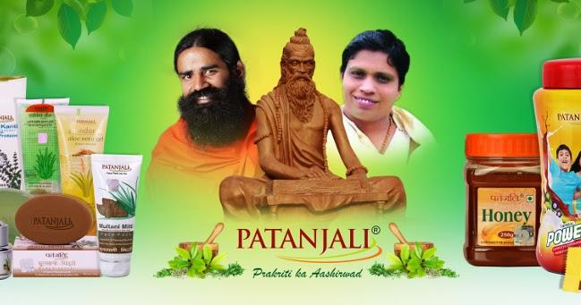

Patanjali is known by its headquarters in Haridwar (Uttarakhand, India to be India’s multinational consumer products manufacturer. This company was formed in 2006 by Baba Ramdev and Acharya Balkrishna. In 2006. Patanjali manufactures several household products, including cosmetics, medicines for ayurvedic, and foods. In other countries, Patanjali serves, mainly in the Middle East and other subcontinents of the Indian region.

Patanjali was an ancient Indian sage and an incarnation of Sheshnag, the king of snakes, who is considered the author of many important Sanskrit texts. Of these, Yogasutra is his greatest work, which is the original book of Yoga philosophy. There are 3 main texts composed by Patanjali in Indian literature. Yoga Sutras, commentaries on Ashtadhyayi and treatises on Ayurveda. Some scholars are of the opinion that these three books were written by the same person, others believe that these are the creations of different persons. Patanjali wrote his commentary on Panini's Ashtadhyayi which was named Mahabhashya. There is no clear evidence about when Patanjali was born, but most scholars believe that he was born around the second century.

* **Company size (Financial, Employees, Stakeholders and Investors etc.)**

**Financial:**

According to CLSA and HSBC, Patanjali was one of the fastest-growing FMCG companies in India in 2016. It was valued at ₹3,000 crore (equivalent to ₹ 37 billion or US$460 million in 2020). Patanjali estimated its annual turnover for the 2016–17 fiscal year at ₹10,216 crore (US$1.3 billion).

**Employees:**

Patanjali has**25,000 employees**

**Stakeholders:**

| **NAME** | **DIN/PAN** | **DESIGNATION** | **DATE OF APPOINTMENT** |
| --- | --- | --- | --- |
| ACHARYA BALKRISHNA | 1778007 | Managing Director | 13 January, 2006 |
| SWAMI MUKTA NANDA | 1778508 | Director | 13 January, 2006 |
| AJAI KUMAR ARYA | 2013411 | Director | 30 April, 2007 |
| RAKESH MITTAL | 6759857 | Director | 11 December, 2013 |
| SUMEDHA | 6974737 | Director | 15 September, 2014 |
| RAM BHARAT | 1651754 | Director | 01 October, 2017 |

**Investors:**

Patanjali Shareholders NRI Couple Sunita and sarwan Poddar, a follower of Ramdev, gave the Balakrishnan the first loans to kickstart the business. They have 3 % shareholding in the Ayurveda business whereas Balakrishnan holds the 94% stake in Patanjali.

* **What was their revenue model?**

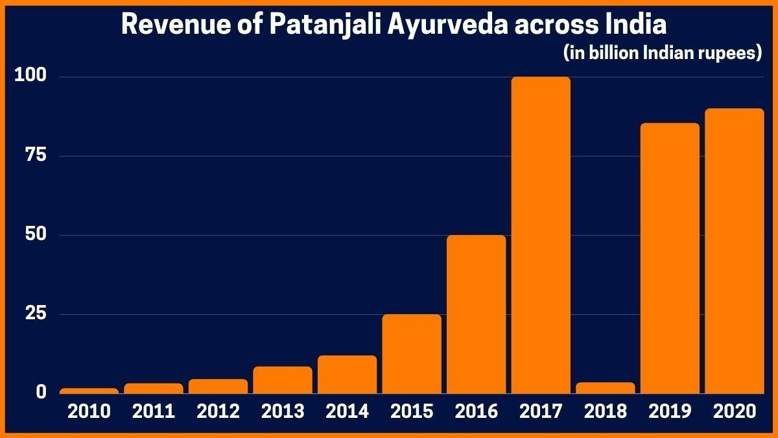

As being an FMCG company, Patanjali also manufactures the product and sells them. But aside from this, Patanjali has a huge loyal customer base with great marketing strategies in hand.

Patanjali increases its sales and revenue through the means of credible existence in the target base. Patanjali sells its products at some pretty low prices that bring out more reach and sales for the company.

Patanjali holds a very effective revenue generation method through its huge loyal customers base along with an absolutely affordable cost structure, obtaining various marketing tactics. Moreover, the company includes several distribution strategies including:

**1. Patanjali Chikitsalaya:** Doctors checkup the health of patients without any charge and recommend Patanjali's Ayurvedic medicine.

**2. Swadeshi Kendra:** The outlets of Patanjali where you can find all the household and non-medicine products.

**3. Patanjali Arogya Kendra:** Yoga experts guides for yoga exercises and fitness tips and training for the customers. Also, they suggest various Ayurvedic medicines.

* **Marketing strategy**

There are the marketing strategy:-

1) Price

The objective of the company is Upkar and not Vyapar. So the company provides the right quality products at affordable prices. Prices of Patanjali products are much lower than that of other FMCG companies. It is because of several factors:

* Patanjali acquired lands at a discounted rate.
* Patanjali enjoys tax exemption which other companies do not enjoy.
* Patanjali procures raw materials directly from the farmers, which substantially reduces the production cost.

The margin of profit for distributors and retailers is much less in Patanjali products as compared to other FMCG products. It may be the reason for Patanjali having its retail outlets.

2) Branded house model

In this model, various products are produced, sold, and promoted under one brand. In this case, Patanjali is a brand that is developed for the sale of products. There is no need to promote products separately. It reduces the promotion and advertising costs.

3) Promotion

The promotion strategy is rather simple. Since Patanjali produces herbal and organic products, it encourages people to use them. Not only this, Patanjali says money you spend on Patanjali products stays in India (no black money) because everything from procuring raw materials to the sale of products is taking place in India.

Also, Baba Ramdev himself is a great personality, so they don’t need anyone else to promote their products. In short, the Business Model of Patanjali supports the company.

4) Distribution

As said earlier, Patanjali has its network to distribute products. They do it in three ways:

* Swadeshi Kendra: They have several retail outlets in India to sell their products.
* Patanjali Arogya Kendra: There are the health and wellness centers of Patanjali.
* Patanjali Chikitshalya: These are the clinics with doctors. They treat the patients for free and ask them to buy medicine from their stores.
* Reliance retails stores: Their products are also available in Reliance retail stores.
* Future Group outlets: Patanjali has also entered into a partnership with Future Group to sell its products in their outlets.
* **Customer analysis**

Patanjali entirely focuses on targeting an immense Indian audience. The company provides goods at very low pricing and the influence of Baba Ramdev over the general public, promotes the Patanjali brand more vibrantly. Patanjali [targets its audience](https://startuptalky.com/how-to-find-target-market-for-your-startup/) entirely, without any sub-categories.

* **Product/Service Analysis**

Different varieties of products that Patanjali business model deals with are-

* 1. Foods
  2. Beverages
  3. Cleaning agents
  4. Personal care products
  5. Ayurvedic medicines etc

**About Market**

* **Key competitors in that period**

Below are the top 6 competitors of Patanjali:

1. Dabur India

2. Procter and Gamble

3. Marico

4. Nestle Ltd

5. HUL (Hindustan Unilever Limited)

6. Himalaya Herbal Healthcare

* **Socioeconomic factors faced by Patanjali**

economic factors:

The economic factors in Pestel's analysis of Patanjali are given below:

The rising inflation rate in India is the main reason why the Indian population is looking for cheaper alternatives to the products.

Patanjali has fulfilled this need very well. Increase in taxes and interest rates affect the cost of production of products. Patanjali is recognized as an affordable brand in the lower middle class and middle class segment and would like to remain the same. Currency exchange rates have little impact for Patanjali as it procures its raw materials internally within India. It has nothing to do with imports from abroad. The GST introduced in India has been a great boon for Patanjali. The increased income potential of the middle class in India has been an advantage for Patanjali.

social factors:

Following are the social factors affecting Patanjali Pestel analysis:

Populations around the world, as a whole, are becoming more health conscious. Patanjali as a brand is Ayurvedic and hence side effect free. The products are considered healthy as they are mineral and herbal. Another reason for people preferring Patanjali products is the increase in lifestyle related health issues. Wrong work life culture is the main reason for body pain, weak bones etc. Baba Ramdev also has a very strong and devoted following thanks to his yoga training. He has conducted camps all over India and he is a very well known and established face in India. From time to time he has also expressed his nationalist sentiments through the media and this is the reason why people want to believe in his brand.

* **Position of Patanjali in market compared to other competitors**

Patanjali Ayurveda Limited, although established in 2006(with only ayurvedic products). Later the company decided to expand its portfolio and entered the Indian market with a boom. In this article we look at the aspects as to how the brand rose to the top and how it failed.

With the brand face of Baba Ramdev, the vast variety of herbal and ayurvedic products (approx. 900 products as now) and on the back of patriotism Patanjali entered the market with a boom. Competitors of Ptanjali were shocked from the initial success of the brand as they didn't acknowledge the competition and constantly underestimated the Patanjali brand, which proved to be very costly for them. Patanjali hampered the sales of various big brands like Colgate Palmolive, HUL, P&G, Dabur etc. Its toothpaste brand “Dant Kanti '' gave strong fight to Colgate’s toothpaste, Patanjali honey got into a straight fight with Dabur honey, its ghee gave fight to the Amul ghee and various other products started to capture the market. In 2013-14 year Patanjali had revenue of about Rs. 1,184 Cr which it nearly doubled to Rs. 2006 Cr in 2014-15. Most successful year of the company was the year 2016-17 in which the company garnered a staggering revenue of about Rs.10,561 Cr which is more than double of its previous year revenue. Company entered the Rs.10,000 Cr club in just six years, while companies like HUL, Amul,etc. took decades to reach this feat. It is no surprise that American business magazine Fast Company ranked Baba Ramdev 27th in its list of “Most Creative Business People of 2016” while his close associate and CEO of PAL Acharya Balkrishna has made his debut on the Forbes list of India’s 100 Richest People at 48th position; given the fact that he owns 94% of the company. So, here we look into the factors behind the dramatic rise of the company and we look at how ancient Ayurveda and modern technology go hand in hand to create success in this fast moving world and gave  big companies a run for their money.

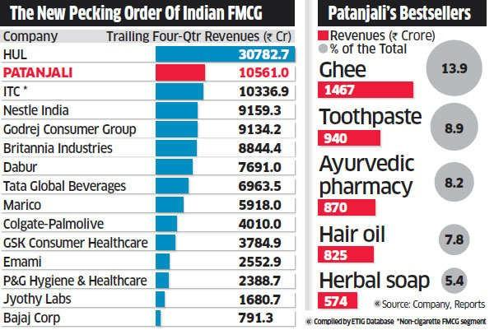

* **PR** (Public relations) **and Media**

1. Public relations: Baba Ramdev has excellent public relations and media skills. He is an often featured personality along with his products in the media.
2. Patanjali ayurved has its channel on youtube which features more than 200 videos on Yoga and product information.
3. Baba Ramdev’s books and videos are not only an excellent information disbursal tool but also a subtle promotion tool.

**Failure Cause and Effect Analysis**

* **What are the possible causes of failure and how could they affect the business?**

**Logistics**:

Since Patanjali doesn't have any long-term deals with transporters the company’s planning got complicated and their cost got increased too.

**Declining Revenue:**

The company’s standalone consumer goods revenue declined more than 10 per cent in the year ended March 2018 for the first time since 2013. Their strategy of high volume and low pricing has started to hurt them.

**Lack of International Clientele**

Patanjali products dominate the local markets but it does not have clients in ASEAN and European markets like its competitor Dabur does. Patanjali only enjoys an audience in India due to its low pricing and Baba Ramdev’s influence. They need to expand to other countries to diversify their business.

* **New competitor in Market**

Threats in the SWOT ANALYSIS OF PATANJALI :

Increasing Competition: FMCG majors such as HUL, Marico, etc. and new entrants such as Sri Ayurveda are also entering the organic market after the awareness created by Patanjali which increases the competition in the market.

* **PR or Media reputation damage**

Public relation:

1. Ramdev has had 100 cases filed against him by the Government of Uttarakhand for a number of offenses.Of these, 81 cases against Patanjali Yogpeeth and its sister concerns in Haridwar were registered for violations of the Zamindari Abolition and Land Reforms (ZALR) Act and the Indian Stamps Act.
2. Patanjali has been cited for its working conditions; Ramdev and Balkrishna are treated as gurus whose feet must be touched each time they enter an area. Workers are paid ₹6,000 (US$75) per month, working 12-hour shifts, six days a week. They are also discouraged from asking for a raise, with the rationale that working at the factory is considered "seva" (voluntary service) to the cause and is a payment in itself.

Media:

1. One of the products manufactured by Ramdev's Divya pharmacy and sold by the Patanjali Pharmacy chain was Divya Putrajeevak Seed, described in its catalog as a natural herb which (according to the company) could treat infertility. However, doctors pointed out the misleading name of the drug: the word *"putrajeevak"* (lit. transl. "son's life" ). Some Patanjali Pharmacy stores sold the drug with the claim that it would ensure the birth of a boy, reportedly leading to an increase in sales. In 2016, the Uttarakhand health department said that the drug violated the Pre-Conception and Pre-Natal Diagnostic Techniques Act, 1994 The Maharashtra government ordered a probe of whether the drug had violated laws in 2018, and Congress leaders in the state demanded a ban on the drug.
2. Covid-19 cure: Laboratory tests showed that the drug did not contain any ingredients which could treat or prevent coronavirus infections. The Indian government allowed Patanjali Ayurved to market Coronil as an immunity booster (not a cure),but the Government of Maharashtra has banned the sale of Coronil in the state. First information reports were filed in Bihar and Rajasthan against Ramdev, Balkrishna and others, accusing them of dishonesty and selling fake medicines. The government of Maharashtra banned Coronil in the state in June 2020, with home minister Anil Deshmukh threatening the company with legal action if they did not observe the ban.

* **Socioeconomic causes**

Baba Ramdev’s Patanjali is in a free-fall & it can’t be blamed on the slowdown alone. Unplanned expansion, a poor supply chain, inconsistent product quality and business practices, combined with the slowdown, have badly hurt Patanjali's revenues.

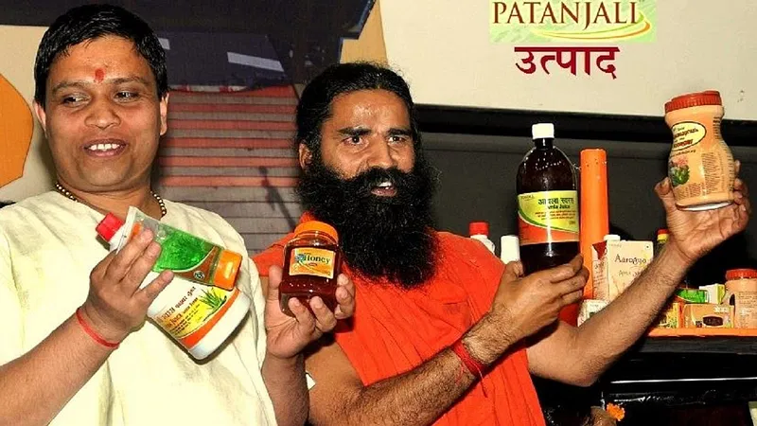

* **Supplier and Customer bargaining power**

Bargaining power of suppliers in the Porter 5 force model reflects the pressure exerted by suppliers on business organizations by adopting different tactics like reducing the product availability, reducing the quality or increasing the prices. When suppliers have strong bargaining power, it costs the buyers- (business organizations). Moreover, high supplier bargaining power can increase the competition in the industry and lower the profit and growth potential for Patanjali Takes On Industry Giants Similarly, weak supplier power can make the industry more attractive due to high profitability and growth potential.

Bargaining power of suppliers will be high for Patanjali Takes On Industry Giants if:

* Suppliers have concentrated into a specific region, and their concentration is higher than their buyers.
* This force is particularly strong when the cost to switch from one supplier to another is high for buyers (for example, due to contractual relationships).
* When suppliers are few and demand for their offered product is high, it strengthens the suppliers’ position against Patanjali Takes On Industry Giants
* Suppliers’ forward integration weakens the Patanjali Takes On Industry Giants’s position as they also become the competitors in that area.
* If Patanjali Takes On Industry Giants is not well educated, does not have adequate market knowledge and lacks the price sensitivity, it automatically strengthens the suppliers' position against the organization.
* Other factors that increase the suppliers’ bargaining power include-high product differentiation offered by suppliers, Patanjali Takes On Industry Giants making only a small proportion of suppliers’ overall sales and unavailability of the substitute products.

Contrarily, the bargaining power of suppliers will be low for Patanjali Takes On Industry Giants if:

* Suppliers are not concentrated
* Switching costs are low
* Product lacks differentiation
* Substitute products are available
* Patanjali Takes On Industry Giants is highly price sensitive and has adequate market knowledge
* There is no threat of forward integration by suppliers.

**What could go wrong?**

* Less Promotions – Though this looks like a benefit today, low promotions will cause harm to the company’s Marketing in the long run. It’s high time that Patanjali starts considering increasing their promotional activities because these activities are very important to capture the market.
* Concept of Sub-brand- Every product of the company is under the umbrella (ie. Patanjali atta, Patanjali shuddhi, Patanjali biscuits etc). So we need to think like parle as it entered in the market as a snack company and launched parle-g but after some time parle launched it’s sub-brand hide & seek as a chocolate biscuit. So there should be a sub-brand for Patanjali too to gain some new customer base.
* Brand Expansion- Patanjali launches Patanjali paridhan as a new apparel shop for all type of category as- shoe, clothes etc. this expansion can make customers confuse about the motive of the Patanjali because the main motive of Patanjali was to promote the ayurveda and to provide the purity in their product.
* Not clinically approved- Patanjali products are not clinically approved by WHO, since they are tested only in their personal labs. This can cause the downfall of the company later, if any rival gave too much air to it.
* Political Indulgence – Baba Ramdev is often seen on many political platforms, giving speeches. Though not actively involved in Politics, this indirect indulgence can also affect Patanjali. One wrong or controversial statement can hamper the image & reputation of the brand.

**Growth Opportunities in Current Scenario**

* **Understand the possible growth opportunities for**

International Markets:

Patanjali can capitalize on India’s massive expat audience. According to one case study, Patanjali enjoys its second-biggest market in the USA, where the NRI audience are attracted to its nationalist and heritage driven brand image. They can extend this into a proper international marketing and sales strategy.

Targeting the luxury market:

Patanjali till now has only focused on low priced and mass-consumed products. It can capitalize on its natural and heritage driven brand to market more expensive and higher quality products to appeal to and compete against better products.

* **Customer acquisition**

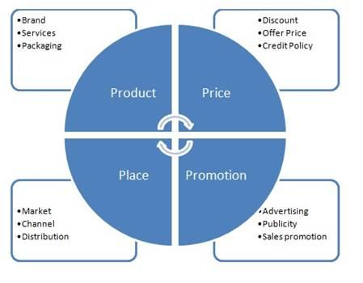

* **Entry to new market**

1. In Nepal, Patanjali operates a manufacturing facility. This well-established commercial relationship is allowing Patanjali to expand rapidly in Nepal.This will undoubtedly attempt to overtake the market in a number of other nations and the popularity grows in India and Nepal.
2. Patanjali is poised to have enough funds for expansion and growth, thanks to its remarkable turnover of Rs. 30,000 crores.
3. Patanjali does great research on its target demographic to understand the message it should convey through its advertising campaigns. It also helps the company understand which marketing platform would be most effective for its strategy.
4. Its marketing strategy emphasizes its herbal goods, in particular, focusing on the advantages of natural and organic materials. Patanjali’s Swadeshi products are well-liked and widely consumed by the Indian public. The brand’s inclusion of natural elements in its product lines has given it a competitive advantage over its competitors.

* **New venture in same business line**

1. For a company like Patanjali, global markets provide fertile ground for expansion. Spirituality and anything associated with mysticism is popular among Africans, Asians, and Middle Easterners. The company has a direct connection to yoga, thanks to Baba Ramdev. Therefore, it has the ability to develop in other countries where yoga is a common practice.
2. The company has targeted one of the most important necessities, clothing, in response to increased worries about dependence on other countries for clothing essentials.
3. The products are about 20%-30% less expensive than those of its competitors. Budget-friendly products are readily available and preferred by consumers with limited financial resources. Patanjali’s rivals find it difficult to keep up with such a favorable pricing plan.
4. In addition, the company intends to provide urea-free calf feed as well as solar energy production.

* **New product opportunities**

1. Patanjali has launched a slew of new products. Cow milk, flavored milk, curd, buttermilk, and cheese are now available from the company’s dairy division.
2. Patanjali has also launched a clothing brand called Paridhan, making inroads into the apparel industry after attaining remarkable success in the FMCG sector.
3. Patanjali now sells frozen veggies, such as peas, sweet corn, and mixed vegetables. It is also now in direct competition with McCain Foods.
4. Patanjali has also launched Divya Jal, a brand of packaged drinking water. A growing number of consumers are opting for organic and natural products.
5. Patanjali should invest more in its organic agricultural industry now, especially in terms of creating awareness about the health benefits and danger-prevention capabilities of its products.