CUSTOMER TRANSFER REDUCTION DIAGNOSTIC

San Juan Oaks
  - Why calls are reaching the pro shop - and how to reduce avoidable transfers
Review period | Calls reviewed | Prepared
21 July-4 August 2026 | 523 | 4 August 2026

Bottom line: the client’s perception is supported by the data.
The AI forwarded 361 calls (69.0%). Of these, 267 went specifically to the golf shop/pro shop - 51.1% of all calls. The golf-shop transfer rate was essentially flat across the two complete seven-day periods (51.5% then 50.8%), so staff would not yet feel a tangible reduction.
523  calls reviewed | 361  all forwards | 267  to golf shop | 51.1%  of all calls

The central finding
There is no single cause. Nearly half of golf-shop transfers are driven by callers asking for a person before stating a need; the remainder is concentrated in booking-service gaps, live information gaps, and avoidable interaction friction. The reduction plan therefore needs coordinated work across product, prompt/experience design, and course-supplied operational knowledge.
This report is designed for joint review by SpeakSport and San Juan Oaks. It distinguishes transfers that are addressable from transfers that should remain human.

Executive summary
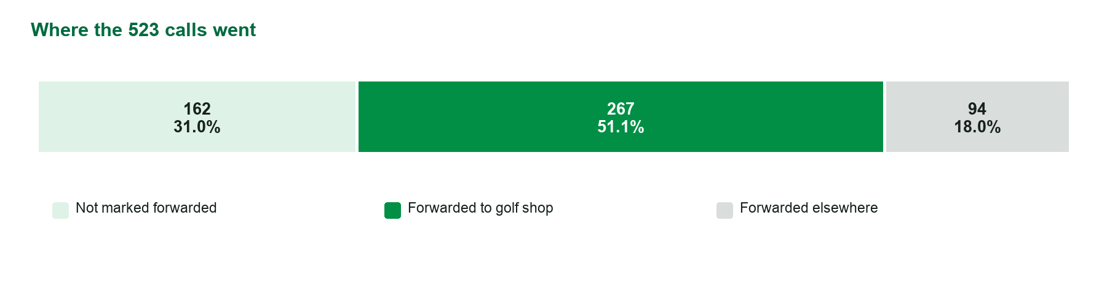
Source: SpeakSport call export; a “forward” is identified from ended_reason = assistant-forwarded-call.

What the numbers say
- 361 of 523 calls were forwarded (69.0%); 162 calls (31.0%) were not marked as forwarded. “Not forwarded” is not automatically equivalent to successfully resolved.
- 267 calls reached the golf shop/pro shop - 74.0% of all forwards and 51.1% of every call in the sample.
- 94 forwards (18.0% of all calls) went elsewhere, primarily to restaurants and events. These do not contribute directly to golf-shop load, but they explain why the overall forward rate is higher than the pro-shop rate.
- 153 of the 267 golf-shop transfers (57.3%) began with an immediate caller request for a person or destination. 103 (38.6%) were initiated by the AI because of a gap/routing rule; 11 (4.1%) followed an attempted self-service interaction.
- The largest product-shaped cluster is booking servicing: 25 cancellations, 32 modifications/confirmations, and 9 group/multiple-tee-time requests reached the golf shop.
Priority signal: the prior 31 July update states that on-call cancellations and upcoming-booking confirmations had been rolled out. Yet the reviewed calls still include 25 cancellation transfers and 32 modification/confirmation transfers, including a cancellation on 3 August. This should be treated first as a production/configuration/prompt consistency issue, not as a request for a brand-new capability.

1. Transfer landscape
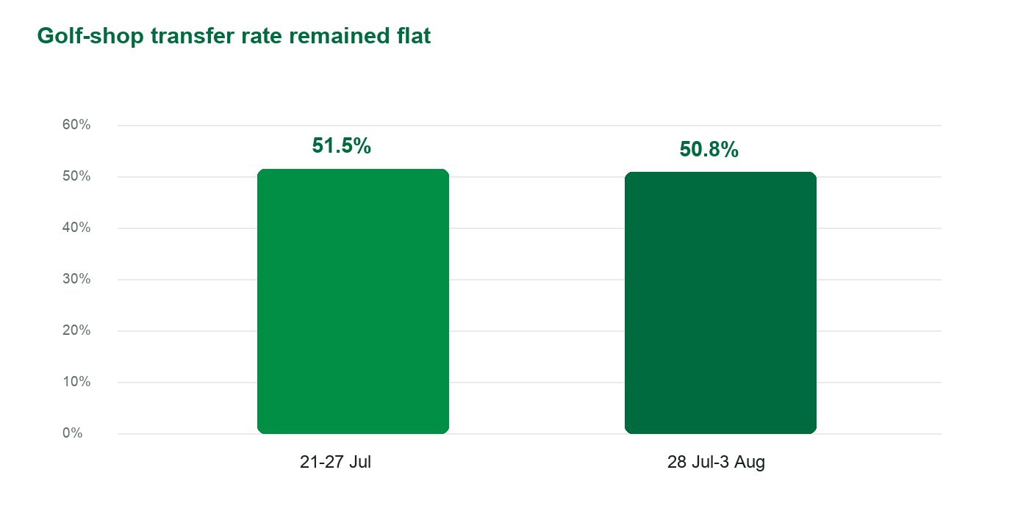
Two complete seven-day periods; 4 August is excluded because it is a partial day in the export.
Golf-shop transfer volume did not materially improve week over week. The overall forward rate rose from 66.5% to 71.8%, while the rate specifically reaching the golf shop stayed nearly unchanged: 51.5% versus 50.8%. Daily rates were volatile, so the two-week sample should be treated as a baseline rather than a long-term trend.

Where forwarded calls went
Destination | Calls | % of forwards | % of all calls
Golf shop / pro shop | 267 | 74.0% | 51.1%
36 Degrees North | 36 | 10.0% | 6.9%
McCann’s Bar & Grill | 23 | 6.4% | 4.4%
Events / group sales | 17 | 4.7% | 3.3%
Other or named destinations | 18 | 5.0% | 3.4%

Interpretation: the customer’s operational concern is narrower than the overall 69.0% headline. The most relevant baseline is 51.1% of all calls reaching the golf shop.

2. Why calls reach the golf shop
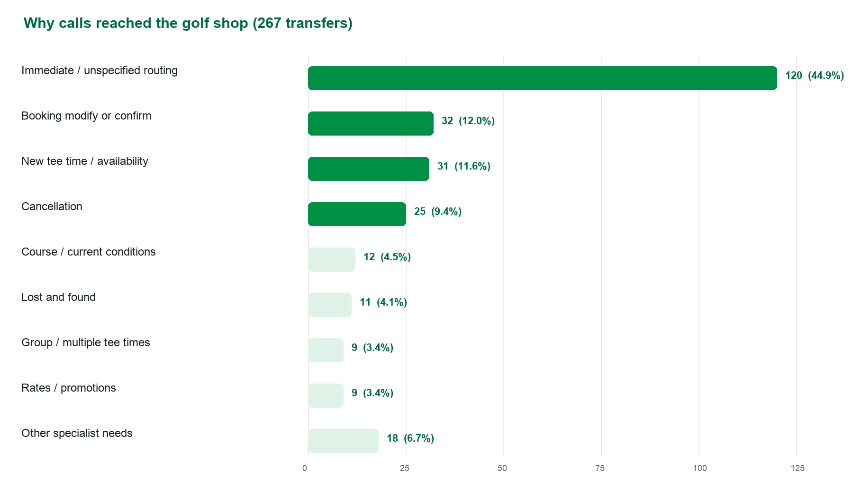
The 267 golf-shop transfers were assigned one primary intent. “Immediate / unspecified routing” means the caller asked for the golf shop, an operator, or a representative without revealing a resolvable task. “Other specialist needs” combines dining, administration, lessons, and events that happened to route to the golf shop.

Who initiated the transfer?
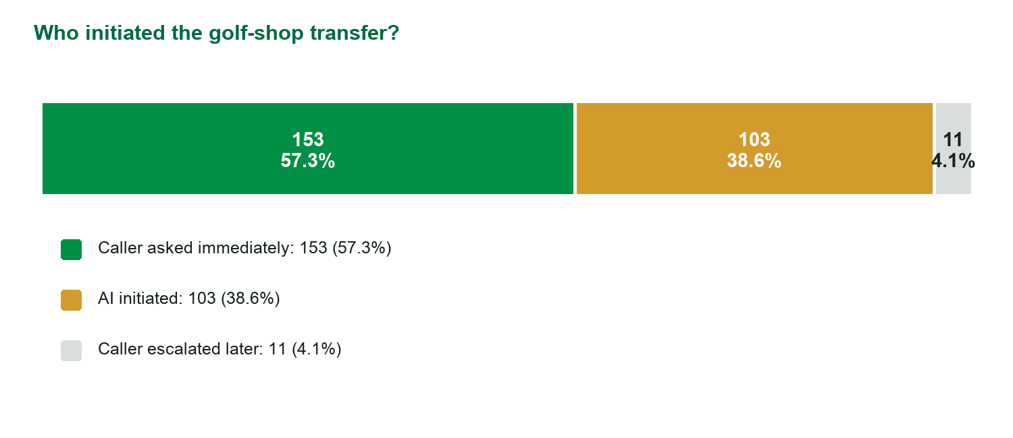

3. Root cause A - callers ask for a person immediately
153 golf-shop transfers (57.3%) were caller-led from the outset. Within the full golf-shop set, 120 calls (44.9%) contained no substantive need beyond “pro shop,” “golf shop,” “operator,” or an equivalent request.

What is happening
- The caller arrives with a routing habit: they dial the main number expecting the pro shop, not an automated service.
- The assistant typically confirms the destination and transfers immediately. It does not consistently make a short, task-specific attempt to surface whether the need is one it can resolve.
- Some callers reveal a tee-time need only after asking for a person. These are the best candidates for a brief AI-first rescue; callers seeking a named staff member should still be routed promptly.

Recommended treatment
Use a one-question soft gate, never a hard barrier:
“I can usually book, change, cancel, confirm, or price a tee time right here. Tell me what you need, or say ‘transfer’ and I’ll connect you.”
- If the caller repeats the request, transfer immediately. Do not interrogate or require multiple confirmations.
- If the caller names a person, department, restaurant, emergency, or on-course issue, route without attempting containment.
- Measure the “rescue acceptance rate”: the share of immediate golf-shop requests that become a completed AI task after one prompt.
Opportunity sizing: this lever is large but uncertain. Even a 10%-20% acceptance rate across the 131 golf-shop calls assigned to caller-adoption framing would avoid roughly 13-26 transfers in a comparable two-week period.

4. Root cause B - booking-service capability is not consistently reaching callers
Booking servicing accounts for 66 golf-shop transfers: 25 cancellations, 32 modification/confirmation requests, and 9 group/multiple-tee-time requests. Lost-and-found adds another 11 calls that could be handled through a structured intake workflow rather than synchronous transfer.

The cancellation and confirmation inconsistency
The 31 July performance update says on-call cancellations and upcoming-booking confirmations are live. The transcripts nevertheless contain repeated statements such as “I am not able to process tee-time cancellations” followed by transfer. This pattern appears throughout the review window and as late as 3 August.
- Audit tenant feature flags, prompt versions, integration permissions, eligibility rules, and fallback branches for San Juan Oaks.
- Run scripted regression calls for cancel, confirm, change player count, change date/time, no-email confirmation, and duplicate booking scenarios.
- Log the exact reason every servicing attempt falls back: no matching reservation, identity mismatch, ineligible booking, API error, unsupported mutation, or prompt-only refusal.

Capability roadmap
Priority | Capability | Action | Observed pool
P0 | Cancel and confirm | Restore/verify the capability already described as live; remove stale “cannot cancel” branches. | 25 cancels + part of 32 confirm/modify
P0 | Modify a booking | Support player-count, date, and time changes with eligibility checks and clear confirmation. | 32 modify/confirm
P1 | Group requests | Capture group size/date/time and either book adjacent inventory or send a structured request to the correct owner. | 9 group/multiple
P1 | Lost and found intake | Capture item, location, date/time, contact details, and asynchronously notify staff; transfer only for urgent same-day retrieval. | 11 lost/found

5. Root cause C - live knowledge and interaction friction
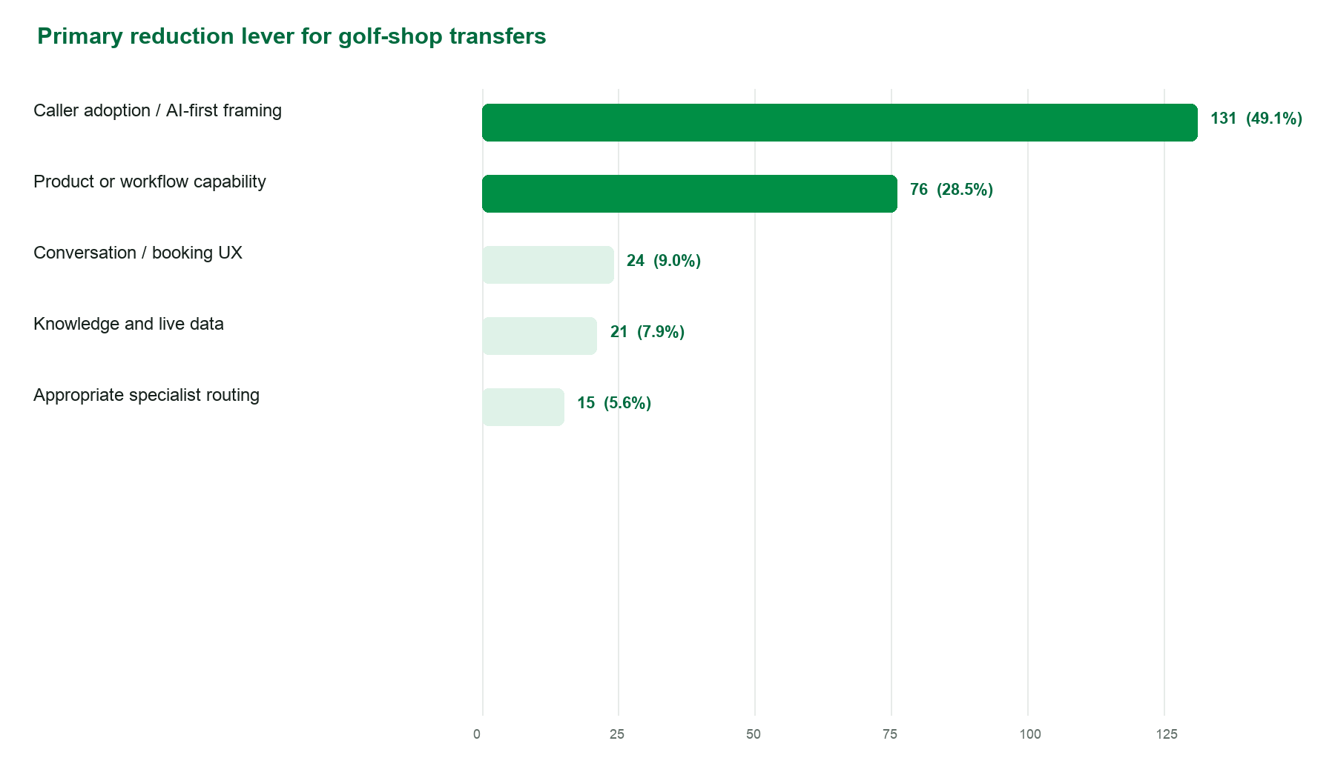

Knowledge and live-data gaps
21 golf-shop transfers were assigned primarily to knowledge/data integration. Common themes were exact green-fee pricing, replay or association rates, range closing times, maintenance/punching dates, twilight definitions, dress code, and current course conditions.
- Return the exact price alongside every available tee time. Avoid finding inventory and then transferring for the rate.
- Add a time-stamped operational feed for range closures, maintenance, frost/cart-path status, and same-day exceptions.
- For policies and promotions, store an answer plus an effective date, owner, and expiry/review date.

Conversation and booking UX friction
24 golf-shop transfers were assigned primarily to conversation/UX improvement. The most visible friction appears in name/email capture, repeated clarification loops, silence/filler behavior, and booking flows that reach an available tee time but do not complete.
- Stop requiring NATO-phonetic spelling for routine names and email addresses. Confirm naturally, use the caller’s known profile/ANI when permitted, or send an SMS form/link for correction.
- Remove stray system utterances such as “I lost track,” “I’ll proceed with scheduling,” or repeated hold language that make the assistant feel unreliable.
- When confidence is low, summarize what was understood once and offer two choices. Do not keep asking open-ended clarification questions.
- Instrument booking drop-off by step: date, players, time, name, email, lookup, price, confirmation, payment/eligibility, and API completion.

6. What callers experienced - representative patterns
Pattern | Observed experience | Reduction approach
Immediate routing habit | Caller opens with “pro shop” or “operator”; the AI confirms and transfers without learning the task. | Introduce the one-question soft gate; honor a repeated transfer request.
Cancellation refusal | Caller asks to cancel; the AI says it cannot process cancellations and routes to the golf shop. | Verify the already-announced cancellation capability and eliminate stale refusal paths.
Confirmation / modification gap | Caller asks to confirm, add/remove a player, or change a time; the AI routes rather than servicing the reservation. | Add or restore authenticated lookup and mutation flows with explicit fallback reasons.
Exact-price handoff | AI finds an available time but cannot state the exact fee, so it offers the golf shop. | Expose the booked-time rate in the same availability response.
Identity capture frustration | A booking advances to spelling a name/email; repeated correction or phonetic requests lead the caller to ask for a person. | Use profile/ANI, natural confirmation, and SMS correction.
Current-operations uncertainty | The AI knows normal range hours but transfers for a Monday or same-day exception. | Publish a time-stamped daily operations feed.
Lost and found | The assistant has no record/workflow and transfers every inquiry. | Create structured intake and asynchronous staff notification.

Examples are paraphrased from reviewed transcripts and exclude caller names, phone numbers, and email addresses.

7. Recommended joint action plan

First 14 days - stabilize and prove the basics
Owner | Action | Definition of done
SpeakSport | Audit cancellation and confirmation production paths; publish failure-reason logging. | Owner assigned; regression suite passes; no stale “cannot cancel” prompt when eligible.
SpeakSport | Deploy the one-question soft gate for immediate golf-shop requests with instant opt-out. | Rescue acceptance and repeat-transfer rates visible by day.
SpeakSport | Remove phonetic-email requirement and stray filler/system utterances. | Lower transfer/drop-off after identity capture.
San Juan Oaks | Provide the high-priority knowledge pack and named routing owners. | All P0 knowledge items have owner, effective date, and review cadence.
Joint | Review 30 transferred calls after changes, using the taxonomy in this report. | Shared avoidable/appropriate labels; disputed calls resolved.

Days 15-45 - expand self-service
- Enable exact tee-time pricing, booking modification, and richer reservation confirmation.
- Launch lost-and-found structured intake and group-booking intake with asynchronous routing.
- Add a daily operations feed for range hours, maintenance, course status, and temporary exceptions.
- Create transfer analytics by destination, initiating party, caller intent, fallback reason, and successful human connection.

Days 46-90 - optimize and govern
- Run controlled prompt experiments on the soft gate and booking recovery language.
- Set a monthly knowledge review with named San Juan Oaks owners and expiry alerts.
- Expand self-service only where the human workflow is stable, safe, and auditable; preserve direct transfer for emergencies, named staff, and specialist judgment.

8. San Juan Oaks knowledge and workflow pack
The course can materially improve containment by supplying a small, governed set of information. Each item should include an owner, “last updated” date, and expiry/review cadence.
Knowledge domain | Required content | Cadence
Daily operations | Range opening/closing by day; Monday maintenance cutoff; frost/cart-path status; course closures; aeration/punching schedule; twilight start definition. | Daily or event-driven
Pricing | Exact rate source; replay specials; NCGA/youth/ride-along policies; spectator/cart fees; range access; club rental; promotions and expiry. | Live feed or weekly
Booking policy | Booking window; single-player rules; group threshold; multiple tee times; cancellation/change windows; no-show policy; late-arrival process. | Monthly / on change
Facilities | Dress code; practice facilities; showers/locker rooms; accessibility; GPS/cart assistance; course amenities and hours. | Quarterly / on change
Retail/admin | Gift card purchase and balance; merchandise; club fitting; receipts/refunds; membership contacts; donation/sponsorship/vendor requests. | Monthly
Dining/events | Restaurant hours, menus and ordering routes; reservation platforms; patio/corkage policies; live music; banquets, weddings and tournaments. | Weekly / event-driven
Lost and found | Who owns it; intake fields; response SLA; urgent vs non-urgent; where recovered items are stored; caller update method. | Quarterly / on change
Routing map | Named staff/roles, extensions, hours, overflow destination, voicemail behavior, and which intents must bypass AI. | Monthly / staffing change

Recommended operating rule: when information is volatile, the AI should state when it was last updated. If data is stale or unavailable, it should offer a structured callback/request before defaulting to a synchronous transfer.

9. Reduction scenarios and measurement plan
The scenarios below are planning models, not forecasts. They apply different “capture rates” to the observed golf-shop opportunity levers while leaving the 15 transfers judged appropriate for specialist routing unchanged.
Scenario | Assumed capture by lever | Fewer golf-shop transfers | Remaining calls | Rate / all calls | Relative reduction
Current baseline | - | 0 | 267 | 51.1% | -
Conservative | Adoption 10%; product 35%; UX 35%; knowledge 50% | 59 | 208 | 39.8% | 22%
Target | Adoption 20%; product 60%; UX 60%; knowledge 75% | 102 | 165 | 31.5% | 38%
Stretch | Adoption 30%; product 80%; UX 75%; knowledge 90% | 137 | 130 | 24.9% | 51%

A sensible near-term operating target is below 40 golf-shop transfers per 100 calls, followed by a 60-90 day target around 32 per 100 calls if capability and data work land successfully.

Weekly scorecard
Metric | Definition | Baseline | Target / use
Golf-shop transfer rate | Golf-shop forwards / all calls | 51.1% | <40% first; ~32% target
Overall forward rate | All forwards / all calls | 69.0% | Context only; destination matters
Immediate human-request rate | Immediate caller-led golf-shop forwards / all calls | 29.3% | Track; improve rescue acceptance
AI-initiated golf-shop rate | AI-led golf-shop forwards / all calls | 19.7% | Primary product/knowledge signal
Servicing fallback rate | Cancel/modify/confirm forwards / relevant servicing requests | Not derivable from export | Instrument denominator and reason
Rescue acceptance | Immediate human requests resolved after one soft gate / eligible requests | Not instrumented | 10%-20% initial target
Transfer connection success | Transfers answered / attempted | Not in export | Instrument by destination

Appendix A - methodology and caveats

Data and classification
- Source file: calls-2026-07-21-to-2026-08-04.csv, containing 523 calls and transcript text.
- A transfer is defined strictly as ended_reason = assistant-forwarded-call. Destination is inferred from the final transfer statement in the transcript.
- Each forwarded call was reviewed using caller utterances and transfer context, then assigned one primary initiation type, intent, destination, and reduction lever. Categories are mutually exclusive for counting, even when a call contained more than one topic.
- The 4 August data is partial. Week-over-week comparison uses 21-27 July and 28 July-3 August only.
- Speech-to-text errors are visible (for example “tea time,” “key time,” or “Photoshop” for tee time/pro shop). Classification uses context, but isolated ambiguous calls remain possible.
- A call not marked forwarded may still be abandoned or unresolved. Resolution/containment should be measured separately once explicit outcome data is available.

All forwarded calls by primary intent
Primary intent | Calls | % of forwards | % of all calls
Immediate/unspecified routing | 125 | 34.6% | 23.9%
Dining/food service | 68 | 18.8% | 13.0%
New tee time/availability | 33 | 9.1% | 6.3%
Booking modification/confirmation | 32 | 8.9% | 6.1%
Cancellation | 25 | 6.9% | 4.8%
Membership/billing/retail/admin | 17 | 4.7% | 3.3%
Group/multiple tee times | 13 | 3.6% | 2.5%
Lost and found | 13 | 3.6% | 2.5%
Course/current conditions | 12 | 3.3% | 2.3%
Rates/promotions | 10 | 2.8% | 1.9%
Events/tournaments | 10 | 2.8% | 1.9%
Lessons/other | 3 | 0.8% | 0.6%

Sources
1. SpeakSport call export for San Juan Oaks, 21 July-4 August 2026 (523 calls).
2. SpeakSport Customer Performance Update - San Juan Oaks, prepared 31 July 2026.
3. SpeakSport logo supplied 4 August 2026.

