# Software Requirements Specification

# for

# “Medical Representative”

Version 1.0 approved

Prepared by:-

Sahil Patil (TI24)

Mohit Patil (TI23)

Organization: Marathwada Mitra Mandal’s College Of Engineering, Karvenagar, Pune-52

Date:-13/10/2017

………………………………………**Table of Contents**

Revision History 2

1. Introduction 3

1.1 Purpose 3

1.2 Intended Audience and Reading Suggestions 3

1.3 Project Scope 3

2. Overall Description 3

2.1 Product Perspective 3

2.2 Product Features 4

2.3 Operating Environment 4

2.4 Design and Implementation Constraints 4

2.5 User Documentation 4

2.6 Assumptions and Dependencies 4

3. System Features 4

3.1 System Feature 1 4

3.2 System Feature 2 5

3.3 System Feature 3 5

3.4 System Feature 4 5

3.5 System Feature 5 5

4. External Interface Requirements 5

4.1 User Interfaces 5

4.2 Hardware Interfaces 5

4.3 Software Interfaces 5

4.4 Communications Interfaces 6

5. Other Nonfunctional Requirements 6

5.1 Performance Requirements 6

5.2 Safety Requirements 8

5.3 Security Requirements 8

5.4 Software Quality Attributes 8

# Revision History:-

|  |  |  |  |
| --- | --- | --- | --- |
| **Sr. No** | **Date** | **Reason For Changes** | **Version** |
| 1 | 30/08/2017 | Changes for Responsive Site | 0.1 |
| 2 | 05/09/2017 | Changes for validation | 0.2 |
| 3 | 25/09/2017 | Back End changes | 0.3 |
| 4 | 30/09/2017 | Some Up gradation in back end | 0.4 |

## 1. Introduction

## 1.1 Purpose

This project is developed for Medical representative which enhances contact between pharmaceutical and **medical** companies and health-care professionals.

## 1.2 Intended Audience and Reading Suggestions

* Developers who can review project’s capabilities and more easily understand where their efforts should be targeted to improve or add more features to it (design and code the application it sets the guidelines for future development).
* End users of this application who wish to read about what this project can do.

## 1.3 Project Scope

This project is developed for medical representative to manage call to the customer that is physician and chemists . MR can track various sells team activities such as Daily Sells Reports, Daily Call Report, Paid holidays,.

**The area covered under this project :-**

Pharmaceutical Industry and Sales Teams:- This includes study of how business expansion between pharmaceuticals company and physicians and drug retailers.

**Objective:-**

Our product should be helpful for medical representative for managing his daily records. Hence we are reducing efforts by making product through excellence in quality.

**Goal:-**

To make user friendly site for accessing daily records for better business

## 2 Overall Description:-

## 2.1 Product Perspective

The product is supposed to be an license product End User License Agreement (EULA) . It is a web based system implementing client-server model. The login portal System provides simple mechanism for users to maintain their Work activity.

## 2.2 Product Features

The product helps users to see all their work activity and sales report and also holiday available to them of them through login provided by respective company the registration facility is not provided for security issue. All the things in the system once login are manage by the user.

## 2.3 Operating Environment

1.Client/Server system

2.Operating system: Any operating system

3.Database: MySQL database

4.Platform: HTML/CSS/PHP/Bootstrap

## 2.4 Design and Implementation Constraints

1.The global schema, fragmentation schema, and allocation schema.

2.MySQL commands for above queries/applications

3.Implement the database at least using a centralized database management system.

## 2.5 User Documentation

-We provide online help to user by email facility.

## 2.6 Assumptions and Dependencies

The logged in user is able to set his daily visit records and mange his daily sales report the no of visits for doctor and chemist are displayed.

## 3.System Features

The product is designed in such way that customer can see products of pharmaceutical company if customer needs any information then he/she will fill contact us form and we assist them for their needs. If there is any need from customer the medical representative arranges a visit for discussing products in detail. All the thing about company is also provided on the site.

## 3.1 System Feature 1:-

Home page - which gives detail about the pharmasutical company prisma they will understand the products and how business is spread over the all over the india .

## 3.2 System Feature 2:-

About us page-This will display about our organisation.

## 3.3 System Feature 3:-

Products page will display all available product from the company.

## 3.4 System Feature :-

Contact us form that will take information from customer for further communication.

## 3.5 System Feature :-

## 3.5.1Description and Priority:-

The medical Representative login is high priority of the application.

## 3.5.2 Stimulus/Response Sequences:-

Add daily visits in the database such as day,date,doctor name,timing.

1. Displays a detailed list of available visits and can make changes according to convenience like add,edit ,delete in the database.
2. User can add daily sales report to the at the end of day.

## 4 External Interface Requirements

## 4.1 USER INTERFACES:-

* Front-end software: HTML,CSS,BOOTSTRAP,PHP
* Back-end software: MySQL

## 4.2 HARDWARE INTERFACES:-

* Windows,Linux
* A web browser which supports HTML & JavaScript.
* Apache tomcat server.

## 4.3 Following are the software used for the medical representative online application:-

|  |  |
| --- | --- |
| **Software used** | **Description** |
| Operating system | choose Windows and Linux operating system for its best support and user-friendliness. |
| Database | To save the records of doctor and chemist visit we have chosen MySQL database. |
| PHP | To implement the project we have chosen PHP language for its more interactive support. |

## 4.4 COMMUNICATION INTERFACES:-

This project supports all types of web browsers. We are using forms for the login and arranging daily visit to doctor and chemist and generating daily sales report etc.

## 5. NONFUNCTIONAL REQUIREMENTS:-

## 5.1 PERFORMANCE REQUIREMENTS

The steps involved to perform the implementation of medical representative are as listed below.

## A) E-R DIAGRAM:-

The E-R Diagram constitutes a technique for representing the logical structure of a database in a pictorial manner. This analysis is then used to organize data as a relation, normalizing relation and finally obtaining a relation database.

**ENTITIES:** Which specify distinct real-world items in an application.

**PROPERTIES/ATTRIBUTES:** Which specify properties of an entity and relationships.

**RELATIONSHIPS:** Which connect entities and represent meaningful dependencies between them.

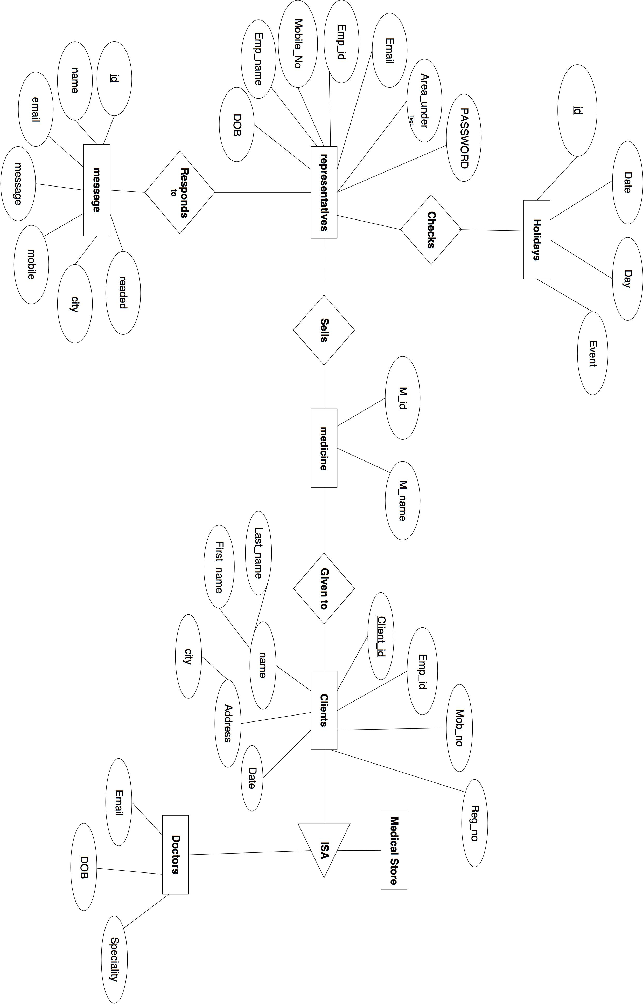

## B) NORMALIZATION:-

The basic objective of normalization is to reduce redundancy which means that information is to be stored only once. Storing information several times leads to wastage of storage space and increase in the total size of the data stored.

If a database is not properly designed it can give rise to modification anomalies. Modification anomalies arise when data is added to, changed or deleted from a database table. Similarly, in traditional databases as well as improperly designed relational databases, data redundancy can be a problem. These can be eliminated by normalizing a database.

Normalization is the process of breaking down a table into smaller tables. So that each table deals with a single theme. There are three different kinds of modifications of anomalies and formulated the first, second and third normal forms (3NF) is considered sufficient for most practical purposes. It should be considered only after a thorough analysis and complete understanding of its implications.

## 5.2 SAFETY REQUIREMENTS:-

If there is extensive damage to a wide portion of the database due to catastrophic failure, such as a disk crash, the recovery method restores a past copy of the database that was backed up to archival storage (typically tape) and reconstructs a more current state by reapplying or redoing the operations of committed transactions from the backed up log, up to the time of failure.

## 5.3 SECURITY REQUIREMENTS:-

Security systems need database storage just like many other applications. However, the special requirements of the security market mean that vendors must choose their database partner carefully.

## 5.4 Software Quality Attributes:-

Software Quality Attributes are it is Adaptable by any user there’s no difficult section where customer may

get confuse It has correctness and can be used by any Person.