**MINI PROJECT REPORT**

**ON**

# “ Medical Representative ”

# (Software Laboratory - I)

**SUBMITTED BY**

**Sahil Patil (TI24)**

**Mohit Patil (TI23)**

2017-18

T.E. (INFORMATION TECHNOLOGY)

Semester - I

Under the Guidance Of

Mrs. RUPALI CHOPADE / Mr. NIKHIL DHAVASE



DEPARTMENT OF INFORMATION TECHNOLOGY

MARATHWADA MITRA MANDAL’S COLLEGE OF ENGINEERING, KARVENAGAR, PUNE.



DEPARTMENT OF INFORMATION TECHNOLOGY

MARATHWADA MITRA MANDAL’S COLLEGE OF ENGINEERING, KARVENAGAR, PUNE.

**CERTIFICATE**

This is to certify that **Mohit Patil, Sahil Patil** having roll no **TI23, TI24** is studying in **TE INFORMATION TECHNOLOGY** course in **SEM I** and they have successfully completed and submitted the Mini Project Report under the subject **Software Laboratory - I** , entitled **“ Medical Representative”** .This study is a partial fulfillment of the degree of Bachelor of Engineering in Information Technology of Savitribai Phule Pune University, PUNE during the academic year 2017-2018.

Mrs. RUPALI CHOPADE / Mr. NIKHIL DHAVASE Mrs. RUPALI CHOPADE

Guide H.O.D.

**ABSTRACT**

This project “Medical Representative” provides us a simple interface for maintenance of visit information .It can be used by pharmaceutical company to maintain the records of Medical Representative easily. Achieving this objective is difficult using a manual system as the information is scattered, can be redundant and collecting relevant information may be very time consuming. All these problems are solved using this project. Throughout the project the focus has been on presenting information in an easy and intelligible manner. The project is very useful for those who want to know about the Medical Representative in detail . The project provides facilities like daily visits and profile creation of medical Representative thus reducing paperwork and automating the record generation process in an Login System. We have contact us form for those who want to join with us.

INDEX

TOPIC PAGE NO.

1.Introduction………………………………………………………………… 1.1 Literature Review………………………………………….

1.2 Scope of Project……………………………………………

* 1. 1.3 Application Of Project………………………………………..
  2. 2.Requirements
  3. 2.1 Software Requirements/SRS.…………………………………
  4. 2.2 Hardware Requirements………………………………………..
  5. 3. System Analysis and Design
  6. 3.1 ER Diagram / EER Diagram……………………………….....
  7. 3.2 Database Normalization………………………………………..
  8. 4. Source Code ………………………………………………………..
  9. 5. Persona .............................................................................................
  10. 6. Graphical User Interface ………………………………………….
  11. 7. Testing Document………..…………………………………………
  12. 8. Future Enhancement……………………………………………….
  13. 9. Conclusion…………………………………………………………..
  14. 10. References / Bibliography…………………………………………
  15. **1. INTRODUCTION**

The objective of medical representative project is to help medical representative to manage their daily work loads according to date .They can fill doctor and chemist detail regarding visit of respective physician and chemist.

**1.1 LITERATURE REVIEW:**

An online medical representative system streamlines the application and monitoring of medical representative detail.

Why Use Online login for medical representative?

## Bryan Glessan(medical representative):- I personally like this system as it reduces the amount of human errors that contribute to double bookings &amp; misplaced paper calendars.(source:http://rxtro.com)

* **Jane carpenter (medical representative):**I find the system fantastic, it's easy to use and allows for distinct instruction on holding a meeting within our centre and eliminates the booking calendar from the duties of my reception.(source:http://rxtro.com)

**1.2 SCOPE OF PROJECT :**

The representative login is enhanced to accommodate changes made by representative while arranging Daily Call Reports for arranging visit for doctors and chemist with add,delete,update facility.

They have facility for arranging Daily Sales Report for daily sales and holiday and profile management .The medical representative will increase product awareness, answer queries, provide advice and introduce new products. Representatives will get in constant touch with customer who have filled information through contact us form.

**1.3 APPLICATION OF PROJECT**

* 1. All medical representative of pharmaceutical company can fill-up their daily call report easily, where in company manual work get reduced and finally Representative database gets filled-up through form. Customer can click on links on home page and check from Prisma Pharmaceuticals site. Site manager can also manage large Representative data in an easy manner.
  2. 2**. REQUIREMENTS**

**2.1 SOFTWARE REQUIREMENTS**

1. Operating systems : Any OS
2. Languages : HTML, CSS, Java script, PHP
3. Database: MYSQL
4. Server: APACHE TOMCAT
5. Browser: Google Chrome, Firefox Web Browser

**2.2 HARDWARE REQUIREMENTS**

* Processor : Pentium IV and onwards
* Speed : 2.8 GHz
* RAM : Minimum 256 MB
* Hard Disk : Minimum 10 GB

# 3.System Analysis and Design:-

## 3.1 ER/EER DIAGRAM:-

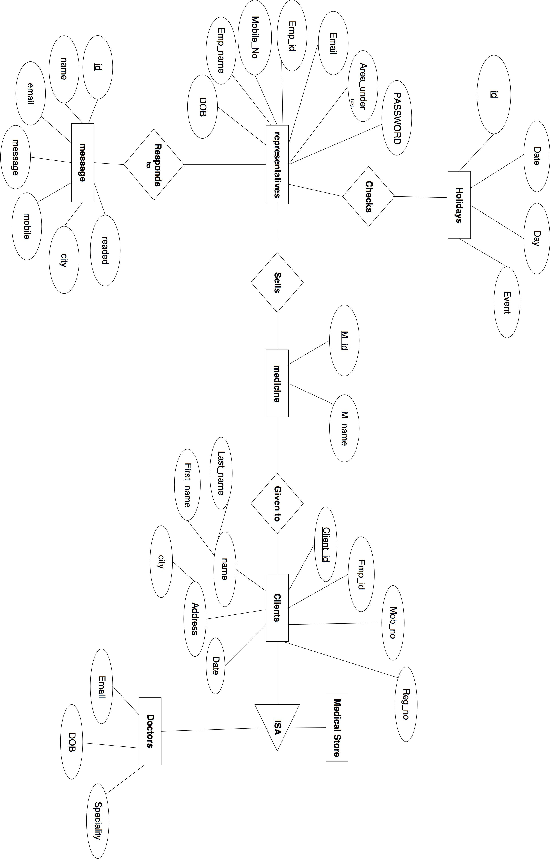

**3.2 Database Normalization:-**

The basic objective of normalization is to reduce redundancy which means that information is to be stored only once. Storing information several times leads to wastage of storage space and increase in the total size of the data stored.

If a database is not properly designed it can give rise to modification anomalies. Modification anomalies arise when data is added to, changed or deleted from a database table. Similarly, in traditional databases as well as improperly designed relational databases, data redundancy can be a problem. These can be eliminated by normalizing a database.

Normalization is the process of breaking down a table into smaller tables. So that each table deals with a single theme. There are three different kinds of modifications of anomalies and formulated the first, second and third normal forms (3NF) is considered sufficient for most practical purposes. It should be considered only after a thorough analysis and complete understanding of its implications.

**4.SOURCE CODE:-**

**dcrpage.php(view) data from table:-**

<?php

session_start();

if(!isset($_SESSION['login_user'])){

header("Location:index.php");

}

?>

<html>

<?php

//including the database connection file

include 'config.php';

$login_session=$_SESSION['user_name'];

$login_id=$_SESSION['login_user'];

$result = mysqli_query($conn, "SELECT * FROM doctor where Emp_id='$login_id' ORDER BY Date DESC"); // using mysqli_query instead

$m=mysqli_query($conn, "SELECT * FROM medical_store where Emp_id='$login_id' ORDER BY Date DESC");

?>

<table width='100%' border= px;>

<tr bgcolor='#CCCCCC'>

<td>Visit Date</td>

<td>Doctor Name</td>

<td>Registration No</td>

<td>Mobile No.</td>

<td>Speciality</td>

<td>Email</td>

<td>Change</td>

</tr>

<?php

while($res = mysqli_fetch_array($result)) {

echo "<tr>";

echo "<td>".$res['Date']."</td>";

echo "<td>".$res['First_name'].$res['Last_name']."</td>";

echo "<td>".$res['Reg_no']."</td>";

echo "<td>".$res['Mob_no']."</td>";

echo "<td>".$res['Speciality']."</td>";

echo "<td>".$res['Email']."</td>";

echo "<td><a href=\"edit.php?Client_id=$res[Client_id]\">Edit</a> | <a href=\"delete.php?Client_id=$res[Client_id]\" onClick=\"return confirm('Are you sure you want to delete?')\">Delete</a></td>";

}

?>

</table>

<h2 class="chem">Chemist visit</h2>

<hr/ style">

<table style="top:auto" width='100%' border= px;>

<tr bgcolor='#CCCCCC'>

<td>Visit Date</td>

<td>Doctor Name</td>

<td>Registration No</td>

<td>Mobile No.</td>

<td>address</td>

<td>Change</td>

</tr>

<?php

//while($res = mysqli_fetch_array($result)) { // mysqli_fetch_array is deprecated, we need to use mysqli_fetch_array

while($re = mysqli_fetch_array($m)) {

echo "<tr>";

echo "<td>".$re['Date']."</td>";

echo "<td>".$re['First_name'].$re['Last_name']."</td>";

echo "<td>".$re['Reg_no']."</td>";

echo "<td>".$re['Mob_no']."</td>";

echo "<td>".$re['Address']."</td>";

echo "<td><a href=\"cedit.php?Client_id=$re[Client_id]\">Edit</a> | <a href=\"cdelete.php?Client_id=$re[Client_id]\" onClick=\"return confirm('Are you sure you want to delete?')\">Delete</a></td>";

}

?>

**doctor_visit.php:-**

<html>

<head>

<?php include 'back_header.php';?>

</head>

<body>

<div class="col-md-6 col-md-push-2">

<div class="form">

<form action="doctor_valid.php" method="post" class="contactForm">

<div class="form-group">

<input type="date" class="form-control" name="DOB" id="DOB" placeholder="Date of birth No" data-rule="minlen:4" data-msg="" />

<div class="validation"></div>

</div>

<div class="form-group">

<input type="text" name="first" class="form-control" id="first" placeholder="First Name" data-rule="minlen:4" data-msg="" />

<div class="validation"></div>

</div>

<div class="form-group">

<input type="text" name="last" class="form-control" id="last" placeholder="Last Name" data-rule="minlen:4" data-msg="" />

<div class="validation"></div>

</div>

<div class="form-group">

<input type="email" class="form-control" name="email" id="email" placeholder="Email" data-rule="minlen:5" data-msg="" />

<div class="validation"></div>

</div>

<div class="form-group">

<input type="text" class="form-control" name="reg" id="reg" placeholder="Registration No" data-rule="minlen:4" data-msg="" />

<div class="validation"></div>

</div>

<div class="form-group">

<textarea class="form-control" name="address" rows="5" data-rule="required" data-msg="" placeholder="Address"></textarea>

<div class="validation"></div>

</div>

<div class="form-group">

<input type="text" class="form-control" name="speciality" id="reg" placeholder="Speciality" data-rule="minlen:4" data-msg="" />

<div class="validation"></div>

</div>

<div class="form-group">

<input type="text" class="form-control" name="mob" id="mob" placeholder="Mobile Number" data-rule="minlen:4" data-msg="" />

<div class="validation"></div>

</div>

<div class="text-center"><button type="submit" value="add" name="Submit">Submit</button></div>

</form>

</div>

</div>

</body>

</html>

**doctor_valid.php (Adding doctor visit database)**

<?php

session_start();

if(!isset($_SESSION['login_user'])){

header("Location:index.php");

}

?>

<?php

//including the database connection file

include 'config.php';

$login_id=$_SESSION['login_user'];

if(isset($_POST['Submit'])) {

$first = $_POST['first'];

$last = $_POST['last'];

$address = $_POST['address'];

$reg = $_POST['reg'];

$email = $_POST['email'];

$DOB = $_POST['DOB'];

$speciality = $_POST['speciality'];

$mob = $_POST['mob'];

$Emp_id=$_SESSION['login_user'];

// checking empty fields

if(empty($first) || empty($last) || empty($address)|| empty($reg)|| empty($email)|| empty($DOB)|| empty($speciality)|| empty($mob)) {

if(empty($first)) {

echo "<font color='red'>Please enter first name.</font><br/>";

}

if(empty($last)) {

echo "<font color='red'>Please enter last name.</font><br/>";

}

if(empty($address)) {

echo "<font color='red'>address places field is empty.</font><br/>";

}

if(empty($reg)) {

echo "<font color='red'>Please enter Registration no.</font><br/>";

}

if(empty($email)) {

echo "<font color='red'>Please enter email.</font><br/>";

}

if(empty($DOB)) {

echo "<font color='red'>Please enter date of birth.</font><br/>";

}

if(empty($speciality)) {

echo "<font color='red'>Please enter date of speciality.</font><br/>";

}

if(empty($mob)) {

echo "<font color='red'>Please enter date of Mobile number.</font><br/>";

}

//link to the previous page

echo "<br/><a href='javascript:self.history.back();'>Go Back</a>";

} else {

// if all the fields are filled (not empty)

//insert data to database

$result = mysqli_query($conn, "INSERT INTO doctor(First_name,Last_name,Address,Reg_no,Email,Date,Speciality,Mob_no,Emp_id) VALUES('$first','$last', '$address','$reg','$email','$DOB','$speciality','$mob','$Emp_id')");

//display success message

echo "<font color='green'>Data added successfully.";

echo "<br/><a href='dcrpage.php'>View Result</a>";

}

}

?>

**edit.php**

<?php

// including the database connection file

include_once("config.php");

if(isset($_POST['update']))

{

$Client_id = $_POST['Client_id'];

$first = $_POST['first'];

$last = $_POST['last'];

$address = $_POST['address'];

$reg = $_POST['reg'];

$email = $_POST['email'];

$DOB = $_POST['DOB'];

$speciality = $_POST['speciality'];

$mob = $_POST['mob'];

// checking empty fields

if(empty($first) || empty($last) || empty($address)|| empty($reg)|| empty($email)|| empty($DOB)|| empty($speciality)|| empty($mob)) {

if(empty($first)) {

echo "<font color='red'>Please enter first name.</font><br/>";

}

if(empty($last)) {

echo "<font color='red'>Please enter last name.</font><br/>";

}

if(empty($address)) {

echo "<font color='red'>address places field is empty.</font><br/>";

}

if(empty($reg)) {

echo "<font color='red'>Please enter Registration no.</font><br/>";

}

if(empty($email)) {

echo "<font color='red'>Please enter email.</font><br/>";

}

if(empty($DOB)) {

echo "<font color='red'>Please enter date of birth.</font><br/>";

}

if(empty($speciality)) {

echo "<font color='red'>Please enter date of speciality.</font><br/>";

}

if(empty($mob)) {

echo "<font color='red'>Please enter date of Mobile number.</font><br/>";

}

} else {

//updating the table

$result=mysqli_query($conn,"UPDATE doctor SET First_name='$first',Last_name='$last',Address='$address',Reg_no='$reg',Email='$email',Date='$DOB',Speciality='$Speciality',Mob_no='$mob' WHERE Client_id=$Client_id");

echo "";

//redirectig to the display page. In our case, it is dcrpage.php.php

header("Location: dcrpage.php");

}

}

?>

<?php

$Client_id = $_GET['Client_id'];

//selecting data associated with this particular id

$result = mysqli_query($conn, "SELECT * FROM doctor WHERE Client_id=$Client_id");

while($res= mysqli_fetch_array($result))

{

$Client_id = $res['Client_id'];

$first = $res['First_name'];

$last = $res['Last_name'];

$address = $res['Address'];

$reg = $res['Reg_no'];

$email = $res['Email'];

$DOB = $res['Date'];

$speciality = $res['Speciality'];

$mob = $res['Mob_no'];

}

?>

<html>

<head>

<title>Edit Data</title>

</head>

<body>

<a href="dcrpage.php">Home</a>

<br/><br/>

<form name="form1" method="post" action="edit.php">

<table border="0">

<div class="form-group">

<input type="date" class="form-control" name="DOB" id="DOB" placeholder="Date of birth No" data-rule="minlen:4" data-msg="" value="<?php echo $DOB;?>" />

<div class="validation"></div>

</div>

<div class="form-group">

<input type="text" name="first" class="form-control" id="first" placeholder="First Name" data-rule="minlen:4" data-msg="" value="<?php echo $first;?>"/>

<div class="validation"></div>

</div>

<div class="form-group">

<input type="text" name="last" class="form-control" id="last" placeholder="Last Name" data-rule="minlen:4" data-msg="" value="<?php echo $last;?>"/ >

<div class="validation"></div>

</div>

<div class="form-group">

<input type="email" class="form-control" name="email" id="email" placeholder="Email" data-rule="minlen:5" data-msg=""value="<?php echo $email;?>" />

<div class="validation"></div>

</div>

<div class="form-group">

<input type="text" class="form-control" name="reg" id="reg" placeholder="Registration No" data-rule="minlen:4" data-msg="" value="<?php echo $reg;?>"/>

<div class="validation"></div>

</div>

<div class="form-group">

<textarea class="form-control" name="address" rows="5" data-rule="required" data-msg="" value="<?php echo $address;?>" placeholder="Address" /></textarea>

<div class="validation"></div>

</div>

<div class="form-group">

<input type="text" class="form-control" name="speciality" id="reg" placeholder="Speciality" data-rule="minlen:4" data-msg="" value="<?php echo $speciality;?>"/>

<div class="validation"></div>

</div>

<div class="form-group">

<input type="text" class="form-control" name="mob" id="mob" placeholder="Mobile Number" data-rule="minlen:4" data-msg="" value="<?php echo $mob;?>"/>

<div class="validation"></div>

</div>

<tr>

<td><input type="hidden" name="Client_id" value=<?php echo $_GET['Client_id'];?>></td>

<td><input type="submit" name="update" value="Update"></td>

</tr>

</table>

</form>

</body>

</html>

**Delete.php**

<?php

include("config.php");

//getting id of the data from url

$Client_id = $_GET['Client_id'];

//deleting the row from table

$result = mysqli_query($conn, "DELETE FROM doctor WHERE Client_id=$Client_id");

//redirecting to the display page (index in our case)

header("Location:dcrpage.php");

?>

**5.Persona:-**

Vilesh Patil is 28 years old and works as a medical representative with company Prisma pharmaceutical private limited for last 5 years and knows it well.Many of younger representative ask him for his advice when they meet up in the workplace.  vilesh likes sharing his knowledge with the younger guys, as it makes him feel a valued part of the team.

Vilesh has seen many changes over the years with the company and tries his best to move with the time.however, he found new computer-based intra net software which is used for managing daily records of representatives.

Vilesh thinks the system is useful and helped him to manage his daily visits and record in an effective manner and has reduced hectic paperwork on the work field and saved their time for further attending more customer.he is in constant touch with their customer through inquiry details available and can do his job effectively for promoting products of the company.

**6.Graphical User Interface :-**



**Footer:-**





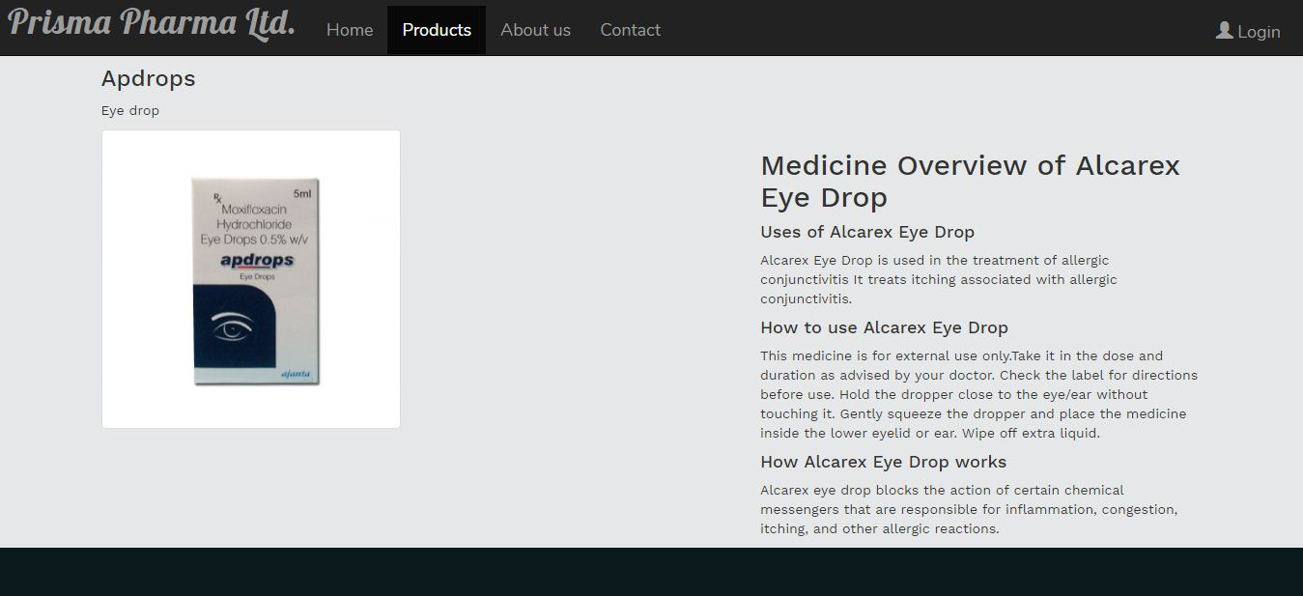

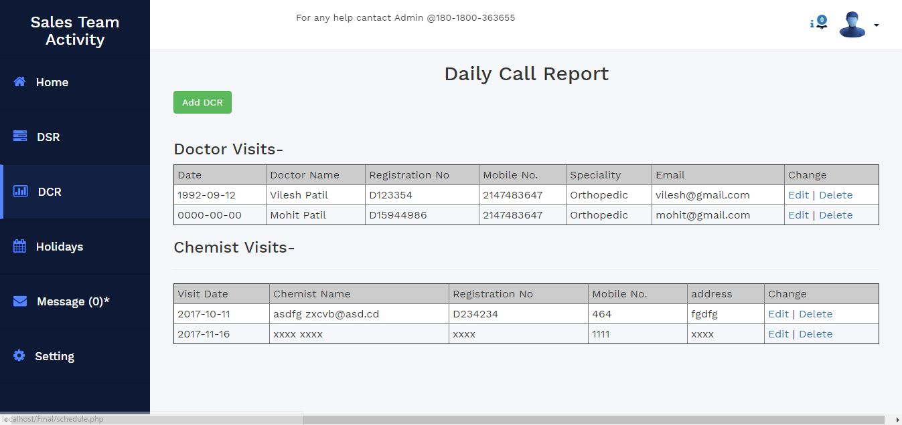

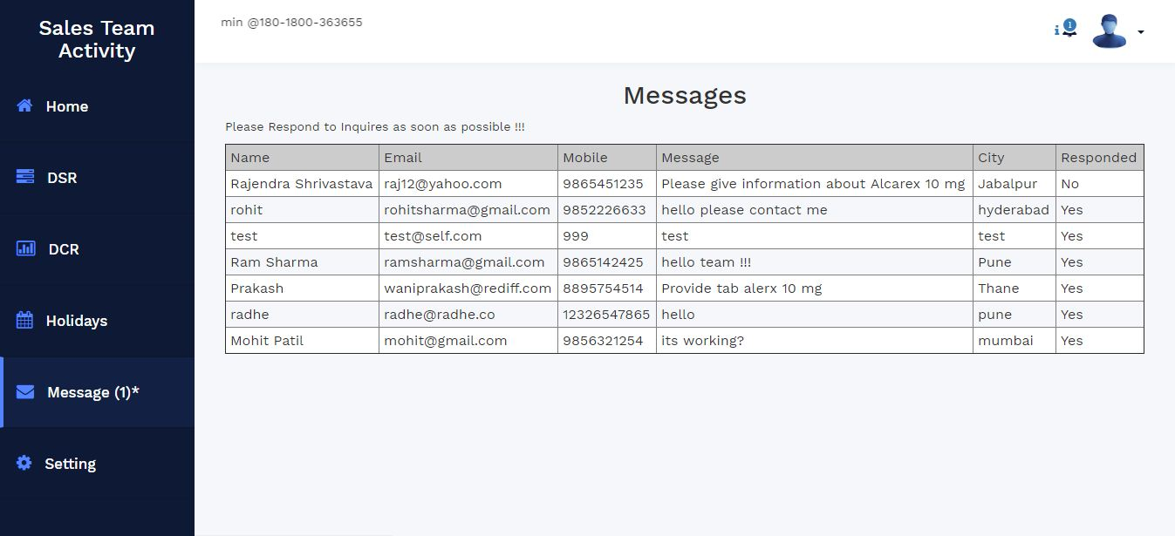

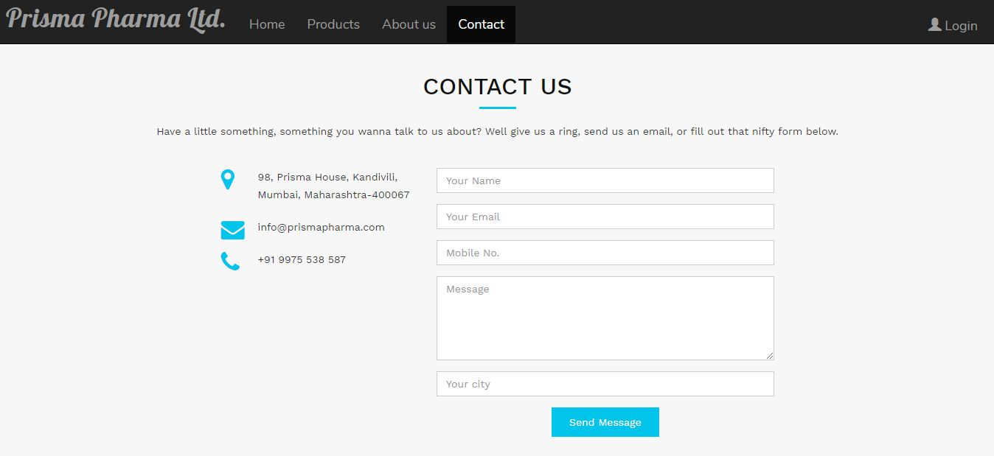



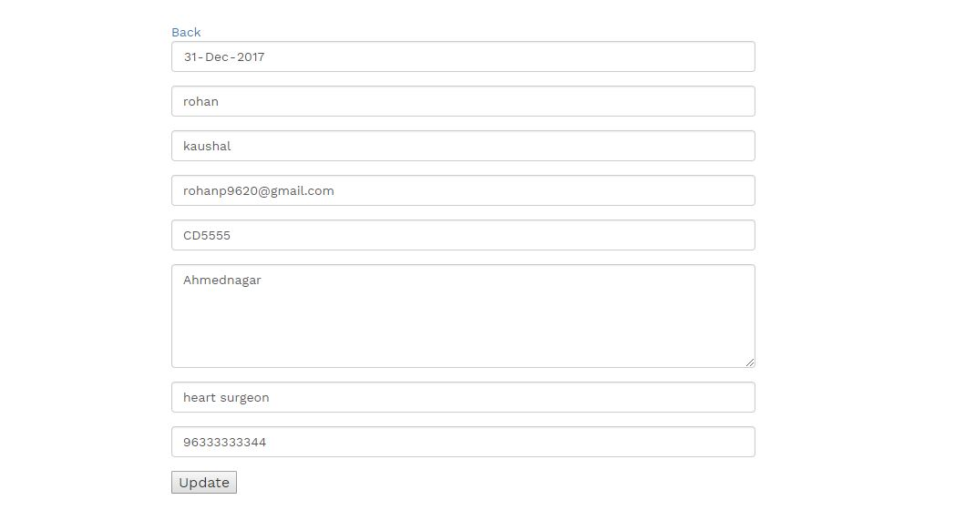

**7.TESTING DOCUMENT**

**INTRODUCTION**

“Software testing is the process used to assess the quality of computer software. Software testing is an empirical technical investigation conducted to provide stakeholders with information about the quality of the product or service under test, with respect to the context in which it is intended to operate.”

**TESTING PRINCIPLES:-**

**Principle 1: Definition**

To test a program is to try to make it fail.

**Principle 2: Tests versus specs**

Tests are no substitute for specifications.

**Principle 3: Regression testing**

Any failed execution must yield a test case, to remain a permanent part of the project’s test suite.

**Principle 4 (variant): Contracts as oracles**

Oracles should be part of the program text, as contracts. Determining test success or failure should be an automatic process consisting of monitoring contract satisfaction during execution

**Principle 5: Manual and automatic test cases**

An effective testing process must include both manually and automatically produced test cases.

**Principle 6: Empirical assessment of testing strategies**

Evaluate any testing strategy, however attractive in principle, through objective assessment using explicit criteria in a reproducible testing process.

**Principle 7: Assessment criteria**

A) Testing strategy’s most important property is the number of faults it uncovers as a function of time.

**7.TESTING :**

**1. Login:**

|  |  |  |  |
| --- | --- | --- | --- |
| **Test ID** | **Steps** | **Expected Result** | **Actual Result** |
| T1 | Emp_id Correct  Password Correct | PASS | PASS |
| T2 | Emp_id Correct  Password Wrong | FAIL | FAIL |
| T3 | Emp_id Wrong  Password Correct | FAIL | FAIL |
| T4 | Emp_id Wrong  Password Wrong | FAIL | FAIL |

**2. Insert:**

|  |  |  |  |
| --- | --- | --- | --- |
| **Test ID** | **Steps** | **Expected Result** | **Actual Result** |
| U1 | Insert Query:  Correct | Insert  SUCCESFUL | Insert  SUCCESFUL |
| U2 | Insert Query:  Wrong | Insert  UNSUCCESFUL | Insert  UNSUCCESFUL |

**3. Update :**

|  |  |  |  |
| --- | --- | --- | --- |
| **Test ID** | **Steps** | **Expected Result** | **Actual Result** |
| U1 | Update Query:  Correct | UPDATE  SUCCESFUL | UPDATE  SUCCESFUL |
| U2 | Update Query:  Wrong | UPDATE  UNSUCCESFUL | UPDATE  UNSUCCESFUL |

**4. Delete :**

|  |  |  |  |
| --- | --- | --- | --- |
| **Test ID** | **Steps** | **Expected Result** | **Actual Result** |
| D1 | Delete Query:  Correct | DELETE  SUCCESFUL | DELETE  SUCCESFUL |
| U2 | Delete Query:  Wrong | DELETE  UNSUCCESFUL | DELETE  UNSUCCESFUL |

**8.FUTURE ENHACEMENT:**

As future work some additional stuff could be implemented and integrated into the application code making it much more reliable and flexible especially what concerns medical representative system for instance

Apparently the role of such systems is basic and essential within each pharma company that wants to keep a really a good control and record concerning its personal data ,functionality and performance on all levels in its structure .Every Pharmaceutical company in now a days ,has the necessity of managing its representatives on really good level as the student has definitely the greatest merit of building up its future as such as it will be easier for representatives of companies for accessing specific Record of particular days from database that we have formed.

The well managed database of medical representative means keeping the appropriate records of each representative of company. Thus medical representative record can be analysis for companies appraisal. The companies can thereby look for specific representative records as per their requirement.

**9.Conclusion:**

Medical representative login management system lead to a better organization structure since the information management of the representative is well structured and also lead to better as well as efficent utilization of resources.

**10.REFERENCES / BIBLIOGRAPHY**

* <https://www.google.co.in/>
* <http://www.w3schools.com/>
* <https://www.wikipedia.org/>
* <https://www.tutorialspoint.com/>