
INTERNSHIP PROJECT REPORT
ON
ARCWELL LMS
A Web-Based Learning Management System
Submitted in partial fulfilment of the requirements for the degree of
Bachelor of Technology
in Computer Science & Engineering
Submitted by
[Student Name] | [Roll Number]
Under the guidance of
[Guide Name]
[Designation]
Department of Computer Science & Engineering
School of Engineering and Sciences
GD Goenka University, Gurugram, Haryana
Session 2026–2027 (ODD SEM)

Contents
Executive summary 3
1. Introduction 3
2. Problem statement and objectives 4
3. Literature review 4
4. Requirements and scope 5
5. Proposed methodology 6
6. System design 7
7. Implementation 8
8. Hardware and software requirements 8
9. Project work plan 9
10. Validation and limitations 10
11. Conclusion and future work 10
References 11

Executive summary
Arcwell LMS is a browser-based learning workspace that brings course videos, lesson resources, learner notes, and progress tracking into one interface. The project uses a React and Vite frontend, an Express API, and MongoDB persistence. Separate frontend and backend applications communicate through an API configured by environment variables.
The implemented learner workflow supports authenticated access, module and lesson navigation, video playback, lesson completion, playback resumption, timestamped video notes, private lesson notes, and links to learning resources. An administrator workflow supports course-structure and resource maintenance. Server-side sessions, role checks, password hashing, and per-user progress records provide the core access-control and persistence mechanisms.
This report presents the system as implemented in the supplied repository. It distinguishes existing features from quality targets and proposed enhancements; no performance measurements or formal test results are claimed.

Project profile
Item | Description
Project | Arcwell LMS: A Web-Based Learning Management System
Application type | Responsive browser-based learning workspace
Frontend | React 18 with Vite 6
Backend | Node.js 22 with Express 4
Database | MongoDB using the official Node.js driver
Primary users | Students and administrators
Deployment model | Separately deployable static frontend and API service

1. Introduction
Learning content is often distributed across video platforms, shared documents, assignment files, code repositories, and informal notes. Learners may need to switch between these services while also tracking which lessons they have completed and where they stopped watching. Arcwell LMS consolidates these activities around a structured course outline and a lesson workspace.
The application has a React single-page interface served as a static site and an Express API that persists course, account, and progress data in MongoDB. The repository documents local development and a deployment pattern with separate frontend and backend services. The interface provides distinct learner and administrator workflows, while authentication and authorization are enforced by the backend API.

1.1 Purpose and scope
The project scope covers course and module navigation, video-based lesson delivery, resource links, learner progress, personal note-taking, and administrator course-content management. The system is designed for web browsers and relies on external URLs for video and supplemental course materials. It does not implement video hosting, a payment system, a full assessment engine, or live classroom features.

1.2 Intended users
• Students use the learning workspace to open lessons, watch videos, follow resource links, record notes, and maintain course progress.
• Administrators maintain modules and lectures, update resource links, manage lesson order, and preview the learner experience.
• Course instructors provide learning content and resources through the course structure maintained in Arcwell LMS.

2. Problem statement and objectives

2.1 Problem statement
Learners need a consistent way to access course materials and keep track of their learning activity. When videos, notes, assignments, and repositories are disconnected, students must manage navigation and progress across multiple locations. Course administrators also need a controlled way to update lesson structure and resource links without changing application code for routine content updates.
The project addresses this need by providing a single authenticated interface for course navigation and lesson activity, backed by persistent course and learner-progress data. It also provides administrator-only operations for managing course content.

2.2 Objectives
1. Provide a clear course outline organized into modules and lectures.
2. Present lesson video and related external resources in a consistent workspace.
3. Persist lesson completion and playback position for each authenticated learner.
4. Allow learners to save timestamped video notes and private lesson notes.
5. Provide administrator controls for creating, renaming, moving, deleting, and updating course content.
6. Separate the frontend, API, and database concerns so that each application component can be configured and deployed independently.
7. Protect account and administrative operations with authenticated sessions, password hashing, and role-based authorization.

3. Literature review
The project combines established web application patterns rather than introducing a new learning-science model. The React documentation describes the component-oriented model used to structure interactive interfaces [1]. Arcwell applies this model through reusable interface components for authentication, lesson playback, resource panes, notes, and administrator forms.
Express routing provides a modular way to associate HTTP methods and URL paths with request handlers [2]. Arcwell uses separate authentication and course routers, with authentication middleware applied to course operations and administrator middleware applied to content-management routes. The application uses the official MongoDB Node.js driver to connect to MongoDB and perform collection operations [3].
Vite provides the frontend development server and production build command used by the project [4]. This lets the static frontend and API be built and deployed independently. The design follows a client-server separation: the browser handles presentation and interaction, the API validates requests and enforces access rules, and MongoDB stores application records. These technology references inform the implementation choices; they do not, by themselves, demonstrate measured learning outcomes or system performance.

4. Requirements and scope

4.1 Functional requirements
Table 1. Functional requirements
ID | Requirement | Primary role
FR-01 | Sign in and sign out using an authenticated server-side session. | Student / administrator
FR-02 | Retrieve the course outline and select a module lesson. | Student / administrator
FR-03 | Play supported lesson video links and access external notes, assignment, and repository links. | Student
FR-04 | Mark lesson completion and view course completion progress. | Student
FR-05 | Save, resume, and reset a lesson playback position. | Student
FR-06 | Create timestamped video notes and private lesson notes. | Student
FR-07 | Create and rename modules; create and rename lectures. | Administrator
FR-08 | Update lesson video and resource URLs; reorder or delete lectures. | Administrator
FR-09 | Preview the student learning experience from the administrator workspace. | Administrator

4.2 System modules
Table 2. Major application modules
Module | Responsibility | Implementation location
Authentication | Login, optional sign-up, logout, session restoration, role identity. | authRoutes.js; authController.js
Course catalogue | Read course data and present modules, lessons, and progress. | courseRoutes.js; courseController.js; App.jsx
Video learning | Embed supported videos, playback controls, resume position, timestamped notes. | Player component; progressModel.js
Resources and notes | Open lesson resources, save self-notes, export notes to PDF. | LectureResources; SelfNotesPane
Administrator console | Create/update/reorder/delete course modules, lectures, and resources. | adminController.js; AdminDashboard
Persistence and migration | Store course, user, progress, and session records; import seed data. | models/; config/database.js; scripts/

4.3 Non-functional requirements
The following are quality requirements and design goals. The repository does not include benchmark results or a formal service-level specification, so these qualities should be validated in the intended deployment environment.
Table 3. Non-functional requirements and evidence
Quality | Requirement or design measure | Status in supplied implementation
Usability | Keep lesson navigation, playback, resource access, and notes in one responsive workspace. | Responsive React interface and role-specific workflows are present.
Availability | Provide a health endpoint and deploy frontend/API separately. | Health route and deployment guidance are documented; uptime is not measured.
Efficiency | Avoid unnecessary API writes and use browser-local caching for playback recovery. | Playback writes are throttled and local playback state is cached.
Accuracy | Validate required fields, URLs, ownership, and lesson indices before updates. | Input and URL checks exist in content and progress handlers.
Performance | Keep API and UI responsive under expected cohort use. | No load or response-time benchmarks are supplied.
Reliability | Persist learning state and adjust completion keys when lessons move or are deleted. | MongoDB persistence and progress remapping logic are implemented.
Maintainability | Separate frontend, backend, routes, controllers, models, and services. | Repository follows a two-application structure with layered backend code.
Security | Hash passwords, use HTTP-only session cookies, restrict admin routes, and configure origins. | These controls are implemented; deployment secrets and production settings must be configured.

5. Proposed methodology
The project follows an iterative web-application workflow. Requirements are translated into learner and administrator tasks, then mapped to frontend views, API routes, and persistent data. The browser communicates with the Express API over HTTP; the API validates the request, checks the session and role where required, applies the requested operation, and reads or writes MongoDB records. The frontend updates the current view from the API response.

5.1 Development stages
1. Define users, core workflows, and course-content requirements.
2. Design the application boundary between the static frontend, API, and MongoDB.
3. Implement learner navigation, playback, resources, notes, and progress tracking.
4. Implement administrator operations and protect them with role checks.
5. Configure environment-based local and hosted deployment settings.
6. Review the implementation against the functional requirements and document validation still needed.

5.2 Data lifecycle
The course catalogue and user records are imported from bundled JSON migration data into MongoDB. The running application reads its course and user data from MongoDB. Authenticated learner actions update per-user progress, including completion, playback positions, video notes, and self-notes. The database uses separate collections for courses, users, progress, and sessions.

6. System design

6.1 Architecture
The frontend is a React application built by Vite and published as static assets. It calls the backend using the configured VITE_API_URL. The Express API uses CORS to permit the configured client origin and includes credentials so the browser can send the HTTP-only session cookie. The API reads and writes MongoDB through the official Node.js driver. Course videos and supplemental materials remain external resources referenced by validated URLs.
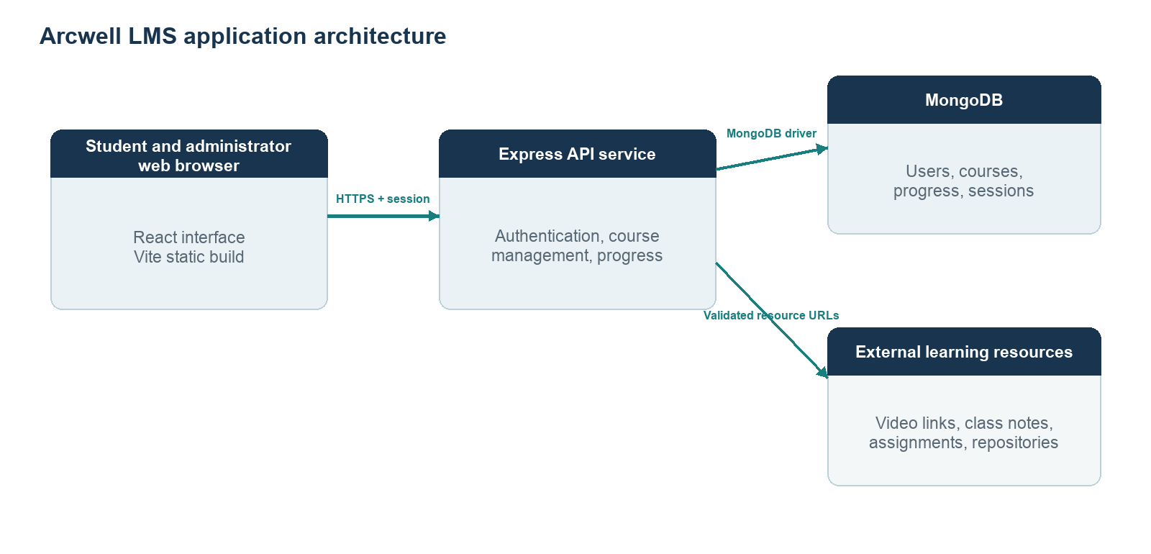
Figure 1. Arcwell LMS deployment and request flow

6.2 Data model
The database separates identity, course content, learner activity, and session state. User identity is referenced by progress records through userId. Course content is stored as a course document containing modules and lessons. Progress records contain per-user completion keys and lesson-specific playback and notes. Session records are managed by the MongoDB-backed session store.
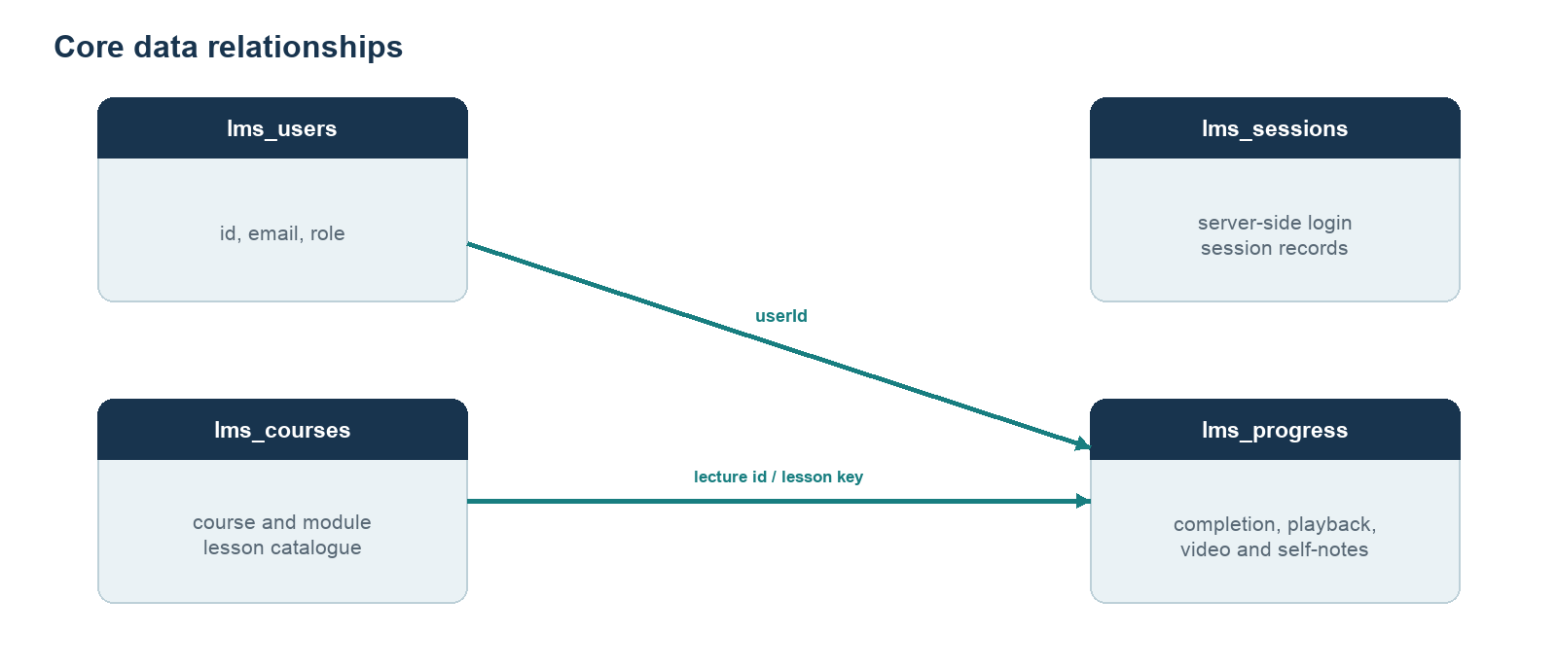
Figure 2. Core MongoDB collection relationships

6.3 Security design
• Passwords are stored as bcrypt hashes rather than plaintext values.
• Authentication uses express-session with a MongoDB session store and an HTTP-only cookie.
• Course routes require a valid session. Administrator mutations also require the administrator role.
• Cross-origin requests are restricted to the configured client origin; credentialed requests are enabled for session use.
• The README directs deployments to configure MongoDB URI, session secret, environment, and client origin as environment variables.
Production deployment must use a strong secret, HTTPS, an accurate client origin, and appropriately restricted database credentials. These are configuration responsibilities, not values embedded in the report.

7. Implementation

7.1 Frontend
The frontend is implemented with React 18 and Vite 6. The main application contains reusable views and components for authentication, the course rail, the video player, lecture resources, self-notes, and the administrator dashboard. Framer Motion supports interface transitions; Lucide React supplies interface icons. The player supports common controls, playback-speed selection, fullscreen operation, keyboard seeking, and a lock mode for playback controls.
Learner activity is connected to backend API methods through a small frontend API module. The player caches playback position in browser storage and synchronizes progress with the backend. Self-notes can be exported as PDF from the browser. Account sign-up is disabled by default and requires matching frontend and backend environment flags to enable.

7.2 Backend
The backend is a Node.js 22 and Express 4 application. Authentication endpoints handle account lookup, login, logout, and configurable sign-up. Authenticated course endpoints return course data and update completion, notes, and playback position. Administrator endpoints manage modules, lectures, resource URLs, and lecture order. Controllers validate user input and return status codes and JSON error messages.

7.3 Persistence and migration
The MongoDB database name defaults to corebase and can be overridden through MONGODB_DB. The application uses lms_courses, lms_users, lms_progress, and lms_sessions collections. Unique indexes protect user email and identifier fields and the per-user progress key. A migration script imports the bundled JSON seed data; the seed JSON files are migration inputs and are not read directly by the running application.

7.4 Deployment
The documented deployment separates the backend API application from the static frontend. The backend is configured with MongoDB connection settings, a session secret, the client origin, and a runtime port supplied by the host. The frontend is built with the backend base URL supplied as VITE_API_URL. The repository describes Sevalla hosting as the target setup and includes a health-check path for deployment verification.

8. Hardware and software requirements

8.1 Hardware requirements
• Developer workstation capable of running Node.js 22, npm, and a modern web browser.
• Internet connectivity for package installation, database access, hosted application access, and externally hosted video/resources.
• MongoDB deployment reachable from the backend service, either local or hosted.
• End-user computer, tablet, or smartphone with a modern browser and a stable network connection.

8.2 Software requirements
Table 4. Software stack
Layer | Technology | Role
Frontend framework | React 18.3 | Builds the interactive browser interface.
Frontend tooling | Vite 6 | Runs development server and creates production static assets.
Backend runtime | Node.js 22 | Executes the API service.
API framework | Express 4 | Defines routes, middleware, and request handling.
Database | MongoDB with Node.js driver 7.x | Stores course, user, progress, and session records.
Authentication | express-session, connect-mongo, bcryptjs | Manages session state and password hashing.
Supporting libraries | Framer Motion, Lucide React, jsPDF | Interface animation, icons, and PDF note export.
Development tools | npm, Git, modern browser | Package management, source control, and browser access.

9. Project work plan
The sequence below presents a practical implementation plan aligned to the system components. The repository does not provide dated internship milestones, so the phases are shown in sequence without assigning calendar dates or claiming completion status.
Table 5. Indicative project phase sequence
Workstream | 1 Requirements | 2 Design | 3 Build | 4 Integrate | 5 Review
Requirements and scope | ● | ●
Architecture and data model |  | ● | ●
Learner experience |  |  | ● | ●
Administrator workflows |  |  | ● | ●
Database and authentication |  | ● | ● | ●
Integration and deployment |  |  |  | ● | ●
Documentation and handover |  |  |  |  | ●

Phase key: the filled marker indicates where the workstream is expected to be active in the sequence. Exact calendar timing should be aligned with the internship schedule.

10. Validation and limitations

10.1 Validation approach
The implementation exposes a health route at /api/health and includes request validation, authentication middleware, authorization checks, and persistence operations. A complete acceptance review should cover sign-in and sign-out, learner navigation, playback resume, lesson completion, notes, resource links, administrator content changes, and the production health check. Performance, accessibility, cross-browser compatibility, backup recovery, and security configuration should be assessed in the deployment environment.
The supplied repository does not include automated test scripts or recorded test results. This report therefore describes implemented behavior and recommended validation areas; it does not present unverified pass rates, performance measurements, or user-study findings.

10.2 Current constraints
• Video media is externally hosted; availability and permissions depend on the source provider and sharing settings.
• Course content is managed by administrators, while the application does not provide a complete content-authoring or assessment platform.
• Signup is disabled by default; new-account availability depends on coordinated environment configuration.
• No benchmark, uptime, accessibility audit, or formal penetration-test evidence is supplied with the source repository.
• Progress completion keys are positional and must be remapped when lecture order changes; the backend contains logic for supported reorder and delete operations.

10.3 Future enhancements
• Add automated unit, API integration, and end-to-end tests for learner and administrator workflows.
• Introduce structured assessment submissions, grading, and feedback if required by the course model.
• Add administrative reporting for learner completion and engagement while applying appropriate privacy controls.
• Add monitoring, backups, audit logs, and deployment health alerts.
• Evaluate accessibility and mobile usability with representative users and assistive technology.
• Define and measure response-time and availability objectives under expected cohort load.

11. Conclusion and future work
Arcwell LMS provides a focused learning workspace that connects course structure, video lessons, resources, notes, and learner progress. Its implementation uses a React and Vite frontend, a role-protected Express API, and MongoDB persistence. The repository also documents separate deployment configuration for the static frontend and backend service.
The project meets its core implementation objective of organizing lesson activity and content administration in one browser-based application. The next stage should strengthen automated verification, evaluate accessibility and performance in the deployment environment, and extend assessment or reporting capabilities only where course requirements call for them.

References
[1] React Team. “Quick Start.” React Documentation. https://react.dev/learn (accessed 14 October 2026).
[2] OpenJS Foundation. “Express routing.” Express Documentation. https://expressjs.com/en/guide/routing/ (accessed 14 October 2026).
[3] MongoDB, Inc. “MongoDB Node.js Driver.” MongoDB Documentation. https://www.mongodb.com/docs/drivers/node/current/ (accessed 14 October 2026).
[4] Vite Contributors. “Getting Started.” Vite Documentation. https://vite.dev/guide/ (accessed 14 October 2026).
[5] Arcwell LMS project repository. README.md; frontend/src/App.jsx; frontend/src/api.js; frontend/src/styles.css; backend/server/app.js; backend/server/routes/; backend/server/controllers/; backend/server/models/; backend/server/services/courseService.js; backend/server/config/database.js; backend/scripts/. Source code and project configuration supplied for this report.

