
O-RAN.WG11.TR.OAuth2.0-Security.0-R005-v07.00

Technical Report

O-RAN Work Group 11 (Security Work Group)
OAuth 2.0 Security

Copyright © 2026 by the O-RAN ALLIANCE e.V.
The copying or incorporation into any other work of part or all of the material available in this specification in any form without the prior written permission of O-RAN ALLIANCE e.V. is prohibited, save that you may print or download extracts of the material of this specification for your personal use, or copy the material of this specification for the purpose of sending to individual third parties for their information provided that you acknowledge O-RAN ALLIANCE as the source of the material and that you inform the third party that these conditions apply to them and that they must comply with them.
O-RAN ALLIANCE e.V., Buschkauler Weg 27, 53347 Alfter, Germany
Register of Associations, Bonn VR 11238, VAT ID DE321720189

Contents
List of figures 4
List of tables 5
Foreword 6
Modal verbs terminology 6
1 Scope 7
2 References 7
2.1 Normative references 7
2.2 Informative references 7
3 Definition of terms, symbols and abbreviations 8
3.1 Terms 8
3.2 Symbols 10
3.3 Abbreviations 10
4 Study and recommendation for OAuth 2.0 10
4.1 General Consideration 10
4.2 IETF 6749 10
4.3 IETF 8705 10
4.4 3GPP TS 33.122 10
4.5 ETSI NFV SEC022 10
5 Threats 11
5.1 Assets 11
5.1.1 O-RAN Architecture Elements 11
5.1.2 O-RAN interfaces 11
5.2 Threats Template 11
5.3 Potential Threat and Exploits 12
5.4 OAuth 2.0 Threats 12
6 Threat Analysis 13
6.1 General OAuth 2.0 Threats 13
6.2 Authorization Server related Threats 20
7 Risk Assessment 23
7.1 Security Controls 23
7.2 OAuth 2.0 Risk Analysis 23
8 Void 36
9 OAuth 2.0 Authorization framework 36
9.1 Overview 36
9.2 Key Issues 37
9.2.1 Key Issue #1: Registration of O-RAN architecture elements 37
9.2.2 Key Issue #2: Provisioning of client_id and secrets to O-RAN architecture elements 37
9.2.3 Key Issue #3: Provisioning of authorization grants for O-RAN architecture elements 37
9.2.4 Key Issue #4: Revocation of client_id and secrets for O-RAN architecture elements 37
9.2.5 Key Issue #5: Revocation of authorization grants for O-RAN architecture elements 38
9.2.6 Key Issue #6: Unsecured transfer of client secrets 38
9.2.7 Key Issue #7: Unsecured transit and storage of access and refresh tokens 38
9.2.8 Key Issue #8: No expiration limit for access tokens and client secrets 38
9.2.9 Key Issue #9: No administration controls for client_id 38
9.2.10 Key Issue #10: Unrestricted access to O-RAN resource servers 39
9.2.11 Key Issue #11: Unauthorised access to the O-RAN resource servers 39
9.2.12 Key Issue #12: Unsecured transmission 39
9.2.13 Key Issue #13: Compromised access token 40
9.3 Solutions 40
9.3.1 Solution #1: Registration of rApp 40
9.3.2 Solution #2: Request access token for R1 services 42
9.3.3 Solution #3: R1 services request with access token 45
9.3.4 Solution #4: Secure transmission for client, authorization server and resource server for R1, A1 and O2 48
9.3.5 Solution #5: Support for RBAC 53
9.3.6 Solution #6: Profile for client credentials grant type clients 56
9.3.7 Solution #7: Resolution of authorization decision between authorization server and resource server 59
9.3.8 Solution #8: rApp certificate enrolment 62
10 Study and recommendation on O-RAN Authorization Server architecture 64
11 Conclusion 64
Annex:Change history/Change request (history) 65

List of figures
Figure 9.1-1 OAuth 2.0 framework for O-RAN Architecture elements and applications .………….36
Figure 9.3.1-1 rApp registration 42
Figure 9.3.2-1 Request access token for R1 services 44
Figure 9.3.3-1 R1 Service request using access token ….46
Figure 9.3.4-1 Transmission between client and authorization server…………………………………………………....49
Figure 9.3.4-2 Transmission between client and resource server…………………………………………………………50
Figure 9.3.4-3 Tls_client_OAuth method………………………………………………………………………….……...51
Figure 9.3.4-4 Private_key_JWT with JWE method……………………………………………………………………...51
Figure 9.3.4-5 Private_key_JWT method…………………………………………………………………………………51
Figure 9.3.4-6 Client_secret_JWT method………………………………………………………………………………..52
Figure 9.3.4-7 Client_secret_basic method………………………………………………………………………………..52
Figure 9.3.4-8 Client_secret_post method………………………………………………………………………………....52
Figure 9.3.4-9 Self_signed_tls_client_auth method…………………………………………………….…………………53
Figure 9.3.5-1 RBAC for client credentials……………………………………………………….……………………….55
Figure 9.3.6-1 Profile for confidential client………………………………………………………………………………58
Figure 9.3.7-1 Validation decision of roles and permissions………………………………………………………………59
Figure 9.3.7-2 Roles and permission resolution between the authorization server and resource server…………………...61
Figure 9.3.8-1 Initial certificate enrolment for rApp instance……………………………………………………………...63

List of tables
Table 5.4-1 OAuth2.0 threats………………………………………………………………………………..……….…...12
Table 7-2-1 OAuth 2.0 risk analysis………………………………………………………………………………….…..23
Table 9.3.1-1 rApp registration 41
Table 9.3.2-1 Request access token for R1 services use case 43
Table 9.3.3-1 R1 service request using access token use case ….45
Table 9.3.4-1 Use case of secure data transmission between client and authorization server…………………………....48
Table 9.3.4-2 Authentication methods……………………………………………………………………………………50
Table 9.3.4-3 Authentication method preferences..………………………………………………………………………53
Table 9.3.5-1 Use case of RBAC…………………………………………………………………………………….…...54
Table 9.3.6-1 Client credentials grant type client profile………………………………………………………………...56
Table 9.3.7-1 Use case of authorization decision between authorization server and resource server……………………60
Table 9.3.8-1 Initial certificate enrolment for rApp instance……………………………………….……………………62

Foreword
This Technical Report (TR) has been produced by WG11 of the O-RAN ALLIANCE.
The content of the present document is subject to continuing work within O-RAN and may change following formal O-RAN approval. Should the O-RAN Alliance modify the contents of the present document, it will be re-released by O-RAN with an identifying change of version date and an increase in version number as follows:
version xx.yy.zz
where:
xx: the first digit-group is incremented for all changes of substance, i.e. technical enhancements, corrections, updates, etc. (the initial approved document will have xx=01). Always 2 digits with leading zero if needed.
yy: the second digit-group is incremented when editorial only changes have been incorporated in the document. Always 2 digits with leading zero if needed.
zz: the third digit-group included only in working versions of the document indicating incremental changes during the editing process. External versions never include the third digit-group. Always 2 digits with leading zero if needed.

Modal verbs terminology
In the present document "shall", "shall not", "should", "should not", "may", "need not", "will", "will not", "can" and "cannot" are to be interpreted as described in clause 3.2 of the O-RAN Drafting Rules (Verbal forms for the expression of provisions).
"must" and "must not" are NOT allowed in O-RAN deliverables except when used in direct citation.

1 Scope
The technical report defines the authorization framework for O-RAN architecture elements using OAuth 2.0 and applies to the HTTP and Kafka based APIs [i.13] [i.18] used in the R1, O1, O2, A1, FH m-plane [i.17] and Y1 interfaces.
For this objective, the present document
- Defines the procedure flow for token registration process, token request process, token verification process and token authorization process. It will specify the token scope metadata for O-RAN.
- Analyses the existing specifications related to OAuth 2.0 such as O-RAN Security protocol specification, IETF RFC 8705 [i.6], IETF RFC 6749 [i.5], 3GPP TS29.501 [i.3], 3GPP TS 33.122 [i.4], 3GPP TS 28.319 [i.19] and ETSI NFV SEC-022 [i.7]. This is used as input to the present document.
- Analyses the security threat arising from the misuse of the access token and defines the security requirements associated to access token.
- Provides the study and recommendation of an authorization server architecture to overlay on the O-RAN architecture.

2 References

2.1 Normative references
Not applicable.

2.2 Informative references
References are either specific (identified by date of publication and/or edition number or version number) or non-specific. For specific references, only the cited version applies. For non-specific references, the latest version of the referenced document (including any amendments) applies. In the case of a reference to a 3GPP document, a non-specific reference implicitly refers to the latest version of that document in Release 18 or the latest 3GPP release prior to Release 18 that includes that document.
NOTE: While any hyperlinks included in this clause were valid at the time of publication, O-RAN cannot guarantee their long term validity.
The following referenced documents are not necessary for the application of the present document but they assist the user with regard to a particular subject area.
[i.1] O-RAN.WG11.TS.SecProtSpec: “O-RAN Security Protocols Specification”
[i.2] O-RAN.WG11.TS.SRCS: “O-RAN Security Requirements and Controls Specification”
[i.3] 3GPP TS 29.501:"5G System; Network Function Repository Services"
[i.4] 3GPP TS 33.122:"Security aspects of Common API Framework (CAPIF) for 3GPP northbound APIs"
[i.5] IETF RFC 6749: "The OAuth 2.0 Authorization Framework"
[i.6] IETF RFC 8705: "OAuth 2.0 Mutual-TLS Client Authentication and Certificate-Bound Access Tokens"
[i.7] ETSI GS NFV-SEC 022: "Network Functions Virtualisation (NFV) Release 2; Security; Access Token
Specification for API Access"
[i.8] IETF RFC 6819: “OAuth 2.0 Threat Model and Security Considerations”
[i.9] O-RAN.WG1.TS.OAD: “O-RAN Architecture Description”
[i.10]3GPP TS 23.222: "Common API Framework for 3GPP Northbound APIs"
[i.11]3GPP TS 29.222: "Common API Framework for 3GPP Northbound APIs"
[i.12] IETF RFC 2616: “Hypertext Transfer Protocol -- HTTP/1.1”
[i.13] O-RAN.WG2.TS.R1GAP: “R1 interface: General Aspects and Principles” ("R1GAP")
[i.14] O-RAN.WG2.Use-Case-Requirements: “Non-RT RIC & A1/R1 Interface: Use Cases and Requirements” ("UCR")
[i.15] O-RAN.WG1.TR.Decoupled-SMO-Architecture: “Decoupled SMO”
[i.16] O-RAN.WG11.TR.SMO-Security-Analysis: “SMO Security”
[i.17] O-RAN.WG4.TS.MP: “Management Plane Specification”
[i.18] Kafka Documentation https://kafka.apache.org/documentation.html
[i.19] 3GPP TS 29.319: “Management and orchestration; Access control for management services”
[i.20] O-RAN.WG11.TR.Threat-Modeling:“O-RAN Threat Modelling and Risk Assessment”
[i.21] Final: OpenID Connect Core 1.0 incorporating errata set 2
[i.22] IETF RFC 7591: OAuth 2.0 Dynamic Client Registration Protocol
[i.23] IETF RFC 8414: OAuth 2.0 Authorization Server Metadata
[i.24] ITU-T M.3050: https://www.kornev-online.net/ITIL/T-REC-M.3050-200405-I!Sup3!PDF-E.pdf
[i.25] Coarse-Grained vs Fine-Grained Authorization: Which to Use?
[i.26] O-RAN.WG1.TS.SMO-ARCH: “SMO Architecture”
[i.27] O-RAN.WG2.TS.Non-RT-RIC-ARCH: “Non-RT RIC: Architecture”
[i.28] IETF RFC 5280: “Internet X.509 Public Key Infrastructure Certificate and Certificate Revocation List (CRL)
Profile
[i.29] IETF RFC 8705: “OAuth 2.0 Mutual-TLS Client Authentication and Certificate-Bound Access Tokens”

3 Definition of terms, symbols and abbreviations

3.1 Terms
For the purposes of the present document, the following terms apply:
A1: Interface between non-RT RIC and Near-RT RIC to enable policy-driven guidance of Near-RT RIC applications/functions, and support AI/ML workflow.
Access Token: credentials used to obtain access. It is a string, usually opaque to the client, representing an authorization issued to the client. Tokens represent specific scopes and durations of access, granted by the resource owner, and enforced by the resource server and authorization server (see [i.5], clause 1.4).
Authorization code: The authorization code is obtained by using an authorization server as an intermediary between the client and resource owner. Instead of requesting authorization directly from the resource owner, the client directs the resource owner to an authorization server (via its user-agent as defined in [IETF RFC 2616]), which in turn directs the resource owner back to the client with the authorization code. ([i.5], clause 1.3.1)
Authorization Server: The server issuing access tokens to the client after successfully authenticating the resource owner and obtaining authorization. ([i.5], clause 1.1)
Client: An application making protected resource requests on behalf of the resource owner and with its authorization. The term "client" does not imply any particular implementation characteristics (e.g., whether the application executes on a server, a desktop, or other devices). ([i.5], clause 1.1)
Client Credentials: The client credentials (or other forms of client authentication) can be used as an authorization grant when the authorization scope is limited to the protected resources under the control of the client, or to protected resources previously arranged with the authorization server. Client credentials are used as an authorization grant typically when the client is acting on its own behalf (the client is also the resource owner) or is requesting access to protected resources based on an authorization previously arranged with the authorization server. ([i.5], clause 1.3.4)
Coarse-grained authorization (CGA): uses one attribute (like user roles), making access control simple for smaller setups (see [i.25]).
Confidential client: A client capable of maintaining the confidentiality of their credentials (e.g., client implemented on a secure server with restricted access to the client credentials), or capable of secure client authentication using other means as in clause 2.2 of [i.5].
CSRF: Cross-site request forgery (CSRF) is a web-based attack whereby HTTP requests are transmitted from a user that the web site trusts or has authenticated (e.g., via HTTP redirects or HTML forms). ([i.8], clause 4.4.1.8)
Fine-grained authorization (FGA): uses a combination of detailed attributes, offering precise control for larger, intricate environments (see [i.25]).
Near-Real-Time RAN Intelligent Controller: An O-RAN Network Function (NF) that enables near-real-time control and optimization of RAN elements and resources via fine-grained data collection and actions over E2 interface. It may include AI/ML (Artificial Intelligence / Machine Learning) workflow including model training, inference and updates.
Non-Real-Time RAN Intelligent Controller: A functionality within SMO that drives the content carried across the A1 interface. It is comprised of the Non-RT RIC Framework and the Non-RT RIC Applications (rApps) whose services are defined below.
Non-RT RIC Applications (rApps): Modular applications that leverage the functionality exposed via the Non-RT RIC Framework’s R1 interface to provide added value services relative to RAN operation, such as driving the A1 interface, recommending values and actions that may be subsequently applied over the O1/O2 interface and generating “enrichment information” for the use of other rApps. The rApp functionality within the Non-RT RIC enables non-real-time control and optimization of RAN elements and resources and policy-based guidance to the applications/features in Near-RT RIC.
O2: Interface between SMO framework as specified in clause 5.3.1 and the O-Cloud for supporting O-RAN virtual network functions. Please refer to [i.9] for more information.
Open Redirector: An open redirector is an endpoint using a parameter to automatically redirect a user-agent to the location specified by the parameter value without any validation. ([i.5], clause 10.15)
R1 Interface: Interface between rApps and Non-RT RIC Framework via which R1 Services can be produced and consumed.
Refresh token: Refresh tokens are credentials used to obtain access tokens. Refresh tokens are issued to the client by the authorization server and are used to obtain a new access token when the current access token becomes invalid or expires, or to obtain additional access tokens with identical or narrower scope (access tokens may have a shorter lifetime and fewer permissions than authorized by the resource owner). ([i.5], clause 1.5)
Resource Owner: An entity capable of granting access to a protected resource. When the resource owner is a person, it is referred to as an end-user. ([i.5], clause 1.1)
Resource Server: The server hosting the protected resources, capable of accepting and responding to protected resource requests using access tokens. ([i.5], clause 1.1)
SMO: A Service Management and Orchestration framework.
User-Agent: The User-Agent request-header field contains information about the user agent originating the request. This is for statistical purposes, the tracing of protocol violations, and automated recognition of user agents for the sake of tailoring responses to avoid particular user agent limitations. ([i.12], clause 14.43)
xApp: An application designed to run on the Near-RT RIC. Such an application is likely to consist of one or more microservices and at the point of on-boarding will identify which data it consumes and which data it provides. The application is independent of the Near-RT RIC and may be provided by any third party. The E2 enables a direct association between the xApp and the RAN functionality.
Y1: An interface over which RAN analytics services are exposed by the Near-RT RIC to be consumed by Y1 consumers.

3.2 Symbols
Void

3.3 Abbreviations
For the purposes of the present document, the following abbreviations apply:
3GPP 3rd Generation Partnership Project
Near-RT RIC Near-Real-Time RAN Intelligent Controller
rApp Non-RT RIC Application
SMO Service Management and Orchestration
xApp Near-RT RIC Application

4 Study and recommendation for OAuth 2.0

4.1 General Consideration
This Technical Report makes the following considerations:
- O-RAN Alliance WG1 has identified the key functions and interfaces [i.9] adopted in O-RAN and this will influence the set of assets to be protected for OAuth 2.0 framework.
- This TR will perform a detailed study of the OAuth 2.0 authorization server for O-RAN architecture elements and interfaces.
- Clause 4.7 in O-RAN Security Protocol Security specification [i.1] will be considered as the baseline text for the OAuth 2.0 framework.
- The recommended security requirements and controls provided in this report will be shared with the impacted O-RAN Alliance working group, such as WG1, WG2, WG3, WG6 and WG10 prior publishing them as normative.

4.2 IETF 6749
Editor’s note: This clause will do the study related to OAuth 2.0 framework from IETF RFC 6749

4.3 IETF 8705
Editor’s note: This clause will do the study related to OAuth 2.0 Mutual-TLS Client Authentication and Certificate-Bound Access Tokens from IETF RFC 8705

4.4 3GPP TS 33.122
Editor’s note: This clause will do the study related to OAuth 2.0 recommended from 3GPP specification (23.222, 29.222, 33.122, TS29.501)

4.5 ETSI NFV SEC022
Editor’s note: This clause will do the study related to OAuth 2.0 mechanism and definition from ETSI NFV SEC022

5 Threats

5.1 Assets
The following O-RAN architecture elements and interfaces should be considered for the security threat analysis:

5.1.1 O-RAN Architecture Elements
- ASSET-C-01: Service Management and Orchestration (SMO)
- ASSET-C-02: Near-RT RIC software
- ASSET-C-07: O-eNB
- ASSET-C-08: O-Cloud
- ASSET-C-09: xApps
- ASSET-C-10: rApps
- ASSET-C-11: Non-RT RIC
- ASSET-C-32: O-RU
- ASSET-C-34: O-DU
- ASSET-C-36: O-CU Host, includes O-CU-CP and O-CU-UP software

5.1.2 O-RAN interfaces
- ASSET-C-14: A1 interface
- ASSET-C-16: R1 interface
- ASSET-C-23: O2 interface
- ASSET-C-42: Y1 interface
- ASSET-C-63: Near RT RIC API’s

5.2 Threats Template
Template to present the threat characteristics:
Threat ID | O-RAN threat ID
Threat title | [Threat Title will include suitable reference of 3GPP/IETF/ETSI]
Threat description | Introduction about the threat
Threat type | Spoofing  Tampering  Repudiation  Information disclosure  Denial of Service  Elevation of Privilege
Vulnerability
Impact type | Authenticity  Integrity  Non-repudiation  Confidentiality  Availability  Authorization
Affected Assets | Asset identification

5.3 Potential Threat and Exploits

5.4 OAuth 2.0 Threats
The following threats to OAuth 2.0 have been identified and are analyzed in clause 6 Threat Analysis.

Table 5.4-1 – OAuth 2.0 threats
Threat-Id | Threat Description (Brief)
General OAuth 2.0 Threats
T-OAuth-G-01 | Obtaining client secrets
T-OAuth-G-02 | Obtaining refresh tokens
T-OAuth-G-03 | Obtaining access tokens
T-OAuth-G-04 | Eavesdropping access tokens
T-OAuth-G-05 | Disclosure of client credentials during transmission
T-OAuth-G-06 | Open redirectors on client
T-OAuth-G-07 | Obtain a deployment specific secret
T-OAuth-G-08 | Obtaining authorization by code substitution (OAuth Login)
T-OAuth-G-09 | Access token leak in transport/endpoints
T-OAuth-G-10 | Malicious client obtains existing authorization by fraud
T-OAuth-G-11 | Malicious client obtains authorization
T-OAuth-G-12 | Accidental exposure of passwords at client site
T-OAuth-G-13 | Client obtains scopes without end-user authorization and possible misconfigurations
T-OAuth-G-14 | Client obtains refresh token through automatic authorization
T-OAuth-G-15 | Eavesdropping refresh tokens from authorization server
T-OAuth-G-16 | Obtaining refresh token by online guessing
T-OAuth-G-17 | Refresh token phishing by counterfeit authorization server
T-OAuth-G-18 | Guessing access tokens
T-OAuth-G-19 | Access token phishing by counterfeit resource server
T-OAuth-G-20 | Abuse of token by legitimate resource server or client
T-OAuth-G-21 | Token leakage via log files and http referrers
T-OAuth-G-22 | User unintentionally grants too much access scope
T-OAuth-G-23 | Leak of confidential data in HTTP proxies
T-OAuth-G-24 | Replay of authorized resource server requests
Authorization Server related threats
T-OAuth-AS-01 | Password phishing by counterfeit authorization server
T-OAuth-AS-02 | Obtaining access tokens from authorization server database
T-OAuth-AS-03 | Obtaining client secret from authorization server database
T-OAuth-AS-04 | Online guessing of authorization codes
T-OAuth-AS-05 | DoS attacks that exhaust resources
T-OAuth-AS-06 | CSRF attack against redirect-uri
T-OAuth-AS-07 | Resource owner impersonation
T-OAuth-AS-08 | DoS using manufactured authorization "codes"
T-OAuth-AS-09 | Obtaining user passwords from authorization server database
T-OAuth-AS-10 | Obtaining the resource owner password credentials by online guessing
T-OAuth-AS-11 | Obtaining refresh token from authorization server database
Access Control related Threats
T-O-RAN-03 | Attacks from the internet exploit weak authentication and access control to penetrate O-RAN network boundary
T-O-RAN-06 | An attacker exploits insufficient/improper mechanisms for authentication and authorization to compromise O-RAN components
T-R1-01 | An attacker gains unauthorized access to R1 services
T-R1-05 | An attacker gains unauthorized access to data
T-AppLCM-04 | Attacker exploits missing or improperly defined elements of application’s SecurityDescriptor
T-GEN-02 | Malicious access to exposed services using valid accounts
T-SMO-10 | Sensitive data at rest is exposed to an internal attacker
NOTE: In above table 5.4-1, access control related threats are defined in [i.20]

6 Threat Analysis

6.1 General OAuth 2.0 Threats
Threat ID | T-OAuth-G-01
Threat title | Obtaining client secrets, IETF RFC 6819 [i.8], clause 4.1.1
Threat description | A malicious actor may access the secrets and token of O-RAN architecture elements and use them to replay its refresh tokens and authorization codes.
Threat type | Information disclosure  Elevation of privilege
Vulnerability | Unsecured tokens and secrets
Impact type | Confidentiality  Authorization
Affected Asset | ASSET-C-01, ASSET-C-02, ASSET-C-07, ASSET-C-08, ASSET-C-09, ASSET-C-10, ASSET-C-11, ASSET-C-32, ASSET-C-34, ASSET-C-36

Threat ID | T-OAuth-G-02
Threat title | Obtaining refresh tokens, IETF RFC 6819 [i.8], clause 4.1.2
Threat description | A malicious actor may get file system access of the local storage of O-RAN architecture elements and read the refresh tokens. A malicious actor may use the compromised refresh token for a malicious application.
Threat type | Information disclosure
Vulnerability | A new refresh token was not issued
Impact type | Confidentiality
Affected Asset | ASSET-C-01, ASSET-C-02, ASSET-C-07, ASSET-C-08, ASSET-C-09, ASSET-C-10, ASSET-C-11, ASSET-C-32, ASSET-C-34, ASSET-C-36

Threat ID | T-OAuth-G-03
Threat title | Obtaining access tokens, IETF RFC 6819 [i.8], clause 4.1.3
Threat description | Access tokens may be stolen by a malicious actor from the local storage if the O-RAN architecture elements store them in a local storage that is accessible to other O-RAN architecture elements or applications without restriction proper access control.
Threat type | Elevation of privilege
Vulnerability | Insufficient protection for credentials
Impact type | Authorization
Affected Asset | ASSET-C-01, ASSET-C-02, ASSET-C-07, ASSET-C-08, ASSET-C-09, ASSET-C-10, ASSET-C-11, ASSET-C-32, ASSET-C-34, ASSET-C-36

Threat ID | T-OAuth-G-04
Threat title | Eavesdropping access tokens, IETF RFC 6819 [i.8], clause 4.3.1
Threat description | A malicious actor may attempt to eavesdrop on access tokens in transit from the authorization server to the O-RAN architecture elements and applications
Threat type | Information disclosure
Vulnerability | Non authenticated, weakly or incorrectly authenticated communication channels
Impact type | Confidentiality
Affected Asset | ASSET-C-01, ASSET-C-02, ASSET-C-07, ASSET-C-08, ASSET-C-09, ASSET-C-10, ASSET-C-11, ASSET-C-32, ASSET-C-34, ASSET-C-36

Threat ID | T-OAuth-G-05
Threat title | Disclosure of client credentials during transmission, IETF RFC 6819 [i.8], clause 4.3.3
Threat description | A malicious actor may attempt to eavesdrop the transmission of O-RAN architecture elements credentials between the application and authorization server during the O-RAN architecture elements authentication process or during OAuth token requests.
Threat type | Information disclosure
Vulnerability | Non authenticated, weakly or incorrectly authenticated communication channels
Impact type | Confidentiality
Affected Asset | ASSET-C-01, ASSET-C-02, ASSET-C-07, ASSET-C-08, ASSET-C-09, ASSET-C-10, ASSET-C-11, ASSET-C-32, ASSET-C-34, ASSET-C-36

Threat ID | T-OAuth-G-06
Threat title | Open redirectors on client, IETF RFC 6819 [i.8], clause 4.1.5
Threat description | A malicious actor may use an open redirector operated by the O-RAN Applications to construct a redirect URI that will pass the authorization server validation but will send authorization code to an endpoint under the control of a malicious actor.
Threat type | Information disclosure
Vulnerability | Non authenticated, weakly or incorrectly authenticated communication channels
Impact type | Authenticity
Affected Asset | ASSET-C-01, ASSET-C-02, ASSET-C-07, ASSET-C-08, ASSET-C-09, ASSET-C-10, ASSET-C-11, ASSET-C-32, ASSET-C-34, ASSET-C-36

Threat ID | T-OAuth-G-07
Threat title | Obtain a deployment-specific secret, IETF RFC 6819 [i.8], clause 4.1.1
Threat description | An attacker may try to gain the secret for a O-RAN client installation, either from a resource server or O-RAN Applications.
Threat type | Spoofing
Vulnerability | Malicious applications, insufficient access control
Impact type | Authenticity
Affected Asset | ASSET-C-01, ASSET-C-02, ASSET-C-07, ASSET-C-08, ASSET-C-09, ASSET-C-10, ASSET-C-11, ASSET-C-32, ASSET-C-34, ASSET-C-36

Threat ID | T-OAuth-08
Threat title | Obtaining authorization by code substitution (OAuth Login), IETF RFC 6819 [i.8], clause 4.4.1.13
Threat description | An attacker could attempt to log into an application using a victim's identity. Applications relying on identity data provided by an OAuth protected service API to login users are vulnerable to this threat.
Threat type | Information disclosure
Vulnerability | Insufficient protection for credentials
Impact type | Authorization
Affected Asset | ASSET-C-01, ASSET-C-02, ASSET-C-07, ASSET-C-08, ASSET-C-09, ASSET-C-10, ASSET-C-11, ASSET-C-32, ASSET-C-34, ASSET-C-36

Threat ID | T-OAuth-G-09
Threat title | Access token leak in transport/endpoints, IETF RFC 6819 [i.8], clause 4.4.2.1
Threat description | A token may be eavesdropped by an attacker. The token is sent from the server to the client via a URI fragment of the redirect URI. If the communication is not secured or the endpoint is not secured, the token could be leaked by parsing the returned URI.
Threat type | Information disclosure
Vulnerability | Non authenticated, weakly or incorrectly authenticated URI
Impact type | Authorization
Affected Asset | ASSET-C-01, ASSET-C-02, ASSET-C-07, ASSET-C-08, ASSET-C-09, ASSET-C-10, ASSET-C-11, ASSET-C-32, ASSET-C-34, ASSET-C-36

Threat ID | T-OAuth-G-10
Threat title | Malicious client obtains existing authorization by fraud, IETF RFC 6819 [i.8], clause 4.2.3
Threat description | Authorization servers may wish to automatically process authorization requests from client that have been previously authorized by the user. When the user is redirected to the authorization server's end-user authorization endpoint to grant access, the authorization server detects that the user has already granted access to that particular client. Instead of prompting the user for approval, the authorization server automatically redirects the user back to the client.  A malicious client may exploit that feature and try to obtain such an authorization "code" instead of the legitimate client.
Threat type | Spoofing  Repudiation
Vulnerability | Improper authorization process and lack of re-validating the authorization requests
Impact type | Authorization  Non repudiation
Affected Asset | ASSET-C-01, ASSET-C-02, ASSET-C-07, ASSET-C-08, ASSET-C-09, ASSET-C-10, ASSET-C-11, ASSET-C-32, ASSET-C-34, ASSET-C-36

Threat ID | T-OAuth-G-11
Threat title | Malicious client obtains authorization, IETF RFC 6819 [i.8], clause 4.4.2.3
Threat description | A malicious client may attempt to obtain a token by fraud.
Threat type | Spoofing  Repudiation
Vulnerability | Insufficient protection for credentials
Impact type | Authorization  Non repudiation
Affected Asset | ASSET-C-01, ASSET-C-02, ASSET-C-07, ASSET-C-08, ASSET-C-09, ASSET-C-10, ASSET-C-11, ASSET-C-32, ASSET-C-34, ASSET-C-36

Threat ID | T-OAuth-G-12
Threat title | Accidental exposure of passwords at client site, IETF RFC 6819 [i.8], clause 4.4.3.1
Threat description | If the client does not provide enough protection, an attacker could retrieve the passwords for a user.
Threat type | Information Disclosure
Vulnerability | Insufficient protection for credentials
Impact type | Authorization
Affected Asset | ASSET-C-01, ASSET-C-02, ASSET-C-07, ASSET-C-08, ASSET-C-09, ASSET-C-10, ASSET-C-11, ASSET-C-32, ASSET-C-34, ASSET-C-36

Threat ID | T-OAuth-G-13
Threat title | Client obtains scopes without end-user authorization and possible misconfigurations, IETF RFC 6819 [i.8], clause 4.4.3.2
Threat description | An O-RAN Application like an rApp or xApp intentionally or unintentionally obtains a token with scope unknown for, or unintended by, the resource owner.
Threat type | Tampering  Elevation of privilege
Vulnerability | misconfiguration
Impact type | Confidentiality  Authorization
Affected Asset | ASSET-C-01, ASSET-C-02, ASSET-C-07, ASSET-C-08, ASSET-C-09, ASSET-C-10, ASSET-C-11, ASSET-C-32, ASSET-C-34, ASSET-C-36

Threat ID | T-OAuth-G-14
Threat title | Client obtains refresh token through automatic authorization, IETF RFC 6819 4.4.3.3 [i.8], clause 4.4.3.3
Threat description | An O-RAN application like an rApp or xApp obtains intentionally or unintentionally a long-term authorization represented by a refresh token even if the resource owner did not intend so
Threat type | Tampering  Elevation of privilege
Vulnerability | Improper authorization process and lack of re-validating the authorization requests
Impact type | Confidentiality  Authorization
Affected Asset | ASSET-C-01, ASSET-C-02, ASSET-C-07, ASSET-C-08, ASSET-C-09, ASSET-C-10, ASSET-C-11, ASSET-C-32, ASSET-C-34, ASSET-C-36

Threat ID | T-OAuth-G-15
Threat title | Eavesdropping refresh tokens from authorization server, IETF RFC 6819 [i.8], clause 4.5.1
Threat description | An O-RAN Application like an rApp or xApp may eavesdrop on refresh tokens when they are transmitted from the authorization server to the client.
Threat type | Tampering  Elevation of privilege
Vulnerability | Non authenticated, weakly or incorrectly authenticated communication channels
Impact type | Confidentiality  Authorization
Affected Asset | ASSET-C-01, ASSET-C-02, ASSET-C-07, ASSET-C-08, ASSET-C-09, ASSET-C-10, ASSET-C-11, ASSET-C-32, ASSET-C-34, ASSET-C-36

Threat ID | T-OAuth-G-16
Threat title | Obtaining refresh token by online guessing, IETF RFC 6819 [i.8], clause 4.5.3
Threat description | An O-RAN Application like an rApp or xApp may try to guess valid refresh token values and send it using the grant type "refresh_token" in order to obtain a valid access token.
Threat type | Tampering  Elevation of privilege
Vulnerability | Improper authorization process and lack of re-validating the authorization requests
Impact type | Confidentiality  Authorization
Affected Asset | ASSET-C-01, ASSET-C-02, ASSET-C-07, ASSET-C-08, ASSET-C-09, ASSET-C-10, ASSET-C-11, ASSET-C-32, ASSET-C-34, ASSET-C-36

Threat ID | T-OAuth-G-17
Threat title | Refresh token phishing by counterfeit authorization server, IETF RFC 6819 [i.8], clause 4.5.4
Threat description | An O-RAN Application like an rApp or xApp could obtain valid refresh tokens by proxying requests to the authorization server.
Threat type | Tampering  Spoofing  Elevation of privilege
Vulnerability | Non authenticated, weakly or incorrectly authenticated communication channels
Impact type | Confidentiality  Authorization
Affected Asset | ASSET-C-01, ASSET-C-02, ASSET-C-07, ASSET-C-08, ASSET-C-09, ASSET-C-10, ASSET-C-11, ASSET-C-32, ASSET-C-34, ASSET-C-36

Threat ID | T-OAuth-G-18
Threat title | Guessing access tokens, IETF RFC 6819 [i.8], clause 4.6.3
Threat description | Access to a single user’s data is possible where an attacker may place a malicious rApp or xApp and attempt to guess the access token values based on knowledge from other access tokens.
Threat type | Tampering  Elevation of privilege
Vulnerability | Insecure generation of access token
Impact type | Confidentiality  Authorization
Affected Asset | ASSET-C-01, ASSET-C-02, ASSET-C-07, ASSET-C-08, ASSET-C-09, ASSET-C-10, ASSET-C-11, ASSET-C-32, ASSET-C-34, ASSET-C-36

Threat ID | T-OAuth-G-19
Threat title | Access token phishing by counterfeit resource server, IETF RFC 6819 [i.8], clause 4.6.4
Threat description | An O-RAN Application like an rApp or xApp may send a valid access token to a counterfeit resource server where the server in turn uses that token to access other services on behalf of the resource owner.
Threat type | Tampering  Spoofing  Elevation of privilege
Vulnerability | Insufficient protection for credentials
Impact type | Confidentiality  Authorization
Affected Asset | ASSET-C-01, ASSET-C-02, ASSET-C-07, ASSET-C-08, ASSET-C-09, ASSET-C-10, ASSET-C-11, ASSET-C-32, ASSET-C-34, ASSET-C-36

Threat ID | T-OAuth-G-20
Threat title | Abuse of token by legitimate resource server or client, IETF RFC 6819 [i.8], clause 4.6.5
Threat description | An O-RAN legitimate resource server which protects the resources could use an access token to access another resource server.
Threat type | Tampering  Elevation of privilege
Vulnerability | insufficient protection for access control on resource server
Impact type | Confidentiality  Authorization
Affected Asset | ASSET-C-01, ASSET-C-02, ASSET-C-07, ASSET-C-08, ASSET-C-09, ASSET-C-10, ASSET-C-11, ASSET-C-32, ASSET-C-34, ASSET-C-36

Threat ID | T-OAuth-G-21
Threat title | Token leakage via log files and HTTP referrers, IETF RFC 6819 [i.8], clause 4.6.7
Threat description | An O-RAN Application such as an rApp or xApp may incorrectly send the access token in the URI query, allowing the access tokens to be leaked in log files and the HTTP “referer.”
Threat type | Tampering  Elevation of privilege
Vulnerability | Improper implementation of API request
Impact type | Confidentiality  Authorization
Affected Asset | ASSET-C-01, ASSET-C-02, ASSET-C-07, ASSET-C-08, ASSET-C-09, ASSET-C-10, ASSET-C-11, ASSET-C-32, ASSET-C-34, ASSET-C-36

Threat ID | T-OAuth-G-22
Threat title | User unintentionally grants too much access scope, IETF RFC 6819 [i.8], clause 4.2.2
Threat description | An O-RAN Application such as an rApp or xApp may incorrectly implement scoping and end-user authorization, allowing unauthorized access to resources.
Threat type | Elevation of privilege
Vulnerability | Misconfiguration, insufficient authorization access
Impact type | Authorization
Affected Asset | ASSET-C-01, ASSET-C-02, ASSET-C-07, ASSET-C-08, ASSET-C-09, ASSET-C-10, ASSET-C-11, ASSET-C-32, ASSET-C-34, ASSET-C-36

Threat ID | T-OAuth-G-23
Threat title | Leak of confidential data in HTTP proxies, IETF RFC 6819 [i.8], clause 4.6.6
Threat description | As specified in SPS clause 4.7, OAuth HTTP authentication scheme is optional. However, as per [IETF RFC 2616] it relies on the Authorization and WWW-Authenticate headers to distinguish authenticated content so that it can be protected. Proxies and caches, in particular, may fail to adequately protect requests by not using these headers.
Threat type | Information disclosure
Vulnerability | Non authenticated, weakly or incorrectly authenticated communication channels
Impact type | Confidentiality
Affected Asset | ASSET-C-01, ASSET-C-02, ASSET-C-07, ASSET-C-08, ASSET-C-09, ASSET-C-10, ASSET-C-11, ASSET-C-32, ASSET-C-34, ASSET-C-36

Threat ID | T-OAuth-G-24
Threat title | Replay of authorized resource server requests, IETF RFC 6819 [i.8], clause 4.6.2
Threat description | An attacker may attempt to replay valid requests to obtain or modify/delete the O-RAN application data.
Threat type | Tampering
Vulnerability | Inadequacy of request validation of Resource server
Impact type | Integrity
Affected Asset | ASSET-C-01, ASSET-C-02, ASSET-C-07, ASSET-C-08, ASSET-C-09, ASSET-C-10, ASSET-C-11, ASSET-C-32, ASSET-C-34, ASSET-C-36

6.2 Authorization Server related Threats
Threat ID | T-OAuth-AS-01
Threat title | Password phishing by counterfeit authorization server, IETF RFC 6819 [i.8], clause 4.2.1
Threat description | A malicious actor may steal confidential data (e.g., Password) by intercepting the O-RAN Application’s request and exploit the URL endpoints managed by authorization server.
Threat type | Information disclosure
Vulnerability | Non authenticated, weakly or incorrectly authenticated communication channels
Impact type | Authenticity
Affected Asset | OAuth authorization server

Threat ID | T-OAuth-AS-02
Threat title | Obtaining access tokens from authorization server database, IETF RFC 6819 [i.8], clause 4.3.2
Threat description | A malicious actor may obtain access tokens from the authorization server's database by gaining access to the database or launching a SQL injection attack.
Threat type | Elevation of privilege
Vulnerability | Unsecured database, Insufficient protection for credentials
Impact type | Authorization
Affected Asset | OAuth authorization server

Threat ID | T-OAuth-AS-03
Threat title | Obtaining client secret from authorization server database, IETF RFC 6819 [i.8], clause 4.3.4
Threat description | A malicious actor may obtain valid client_id/secrets combinations from the authorization server's database by gaining access to the database or launching a SQL injection attack.
Threat type | Elevation of privilege
Vulnerability | Unsecured database
Impact type | Authorization
Affected Asset | OAuth authorization server

Threat ID | T-OAuth-AS-04
Threat title | Online guessing of authorization codes, IETF RFC 6819 [i.8], clause 4.4.1.3
Threat description | A malicious actor may try to guess valid authorization code values and send the guessed code value using the grant type code in order to obtain a valid access token.
Threat type | Information disclosure
Vulnerability | Improper authorization process and lack of re-validating the authorization requests
Impact type | Confidentiality
Affected Asset | OAuth authorization server

Threat ID | T-OAuth-AS-05
Threat title | DoS attacks that exhaust resources, IETF RFC 6819 [i.8], clause 4.4.1.11
Threat description | A malicious actor may exhaust the pool of authorization codes of the authorization server by repeatedly directing the O-RAN Application to request the access tokens.
Threat type | Denial of Service
Vulnerability | Improper authorization process and lack of re-validating the authorization requests
Impact type | Availability
Affected Asset | OAuth authorization server

Threat ID | T-OAuth-AS-06
Threat title | CSRF attack against redirect-uri, IETF RFC 6819 [i.8], clause 4.4.1.8
Threat description | CSRF attacks on OAuth approvals may allow a malicious actor to obtain authorization to OAuth protected resources without the consent of the O-RAN Applications.
Threat type | Elevation of privilege
Vulnerability | Improper authorization process and lack of re-validating the authorization requests
Impact type | Authorization
Affected Asset | OAuth authorization server

Threat ID | T-OAuth-AS-07
Threat title | Resource owner impersonation, IETF RFC 6819 [i.8], clause 4.4.1.10
Threat description | A malicious actor could obtain unauthorized access to a resource by using an existing authenticated session that causes the OAuth 2.0 authorization server to improperly bypass resource owner consent.
Threat type | Elevation of privilege
Vulnerability | Improper authorization process and lack of re-validating the authorization requests
Impact type | Authorization
Affected Asset | OAuth authorization server

Threat ID | T-OAuth-AS-08
Threat title | DoS using manufactured authorization "codes", IETF RFC 6819 [i.8], clause 4.4.1.12
Threat description | An attacker who owns a botnet may locate the redirect URIs of client that listen on HTTP, access them with random authorization "codes", and cause a large number of HTTPS connections to be concentrated onto the authorization server. This can result in a denial-of-service (DoS) attack on the authorization server.
Threat type | Denial of Service
Vulnerability | Non authenticated, weakly or incorrectly authenticated communication channels
Impact type | Availability
Affected Asset | OAuth authorization server

Threat ID | T-OAuth-AS-09
Threat title | Obtaining user passwords from authorization server database, IETF RFC 6819 [i.8], clause 4.4.3.5
Threat description | An attacker may obtain valid username/password combinations from the authorization server's database by gaining access to the database or launching a SQL injection attack.
Threat type | Information disclosure
Vulnerability | Unsecured database, Insufficient protection for credentials
Impact type | Authorization  Information disclosure
Affected Asset | OAuth authorization server

Threat ID | T-OAuth-AS-10
Threat title | Obtaining the resource owner password credentials by online guessing, IETF RFC 6819 [i.8], clause 4.4.3.6
Threat description | An attacker may try to guess valid username/password combinations using the grant type "password".
Threat type | Information disclosure
Vulnerability | Unsecure credentials
Impact type | Authorization
Affected Asset | OAuth authorization server

Threat ID | T-OAuth-AS-11
Threat title | Obtaining refresh token from authorization server database, IETF RFC 6819 [i.8], clause 4.5.2
Threat description | This threat is applicable if the authorization server stores refresh tokens as handles in a database. An attacker may obtain refresh tokens from the authorization server's database by gaining access to the database or launching a SQL injection attack.
Threat type | Information disclosure
Vulnerability | Unsecured database
Impact type | Authorization
Affected Asset | OAuth authorization server

7 Risk Assessment

7.1 Security Controls
The following security controls should be considered for security threat and risk analysis:
- Control-1: OAuth 2.0
- Control-2: IAM (using RBAC)
- Control-3: Certificate Management
- Control-4: Encryption for Data at Rest
- Control-5: Encryption for Data in Motion (eg., TLS)

7.2 OAuth 2.0 Risk Analysis
This clause provides risk assessment tables for each of the identified assets. These tables list the assets, threats, impacts, and possible security controls. The following risk assessment matrix is used to assess the risk score as defined in [i.20].
Table 7-2-1 OAuth 2.0 risk analysis
Asset-Id | Asset Name | Threat-Id | Threat Description (Brief) | Impact/ Likelihood Raw Score | Possible Security Controls | Security Control-id
ASSET-C-01 | SMO | T-OAuth-G-01 | Obtaining client secrets | Impact = High Likelihood = Medium | Data encryption,  OAuth 2.0 | Control-1  Control-2  Control-4  Control-5
ASSET-C-02 | Near-RT RIC software
ASSET-C-07 | O-eNB
ASSET-C-08 | O-Cloud
ASSET-C-09 | xApps
ASSET-C-10 | rApps
ASSET-C-11 | Non-RT RIC
ASSET-C-32 | O-RU
ASSET-C-34 | O-DU
ASSET-C-36 | O-CU Host, includes O-CU-CP and O-CU-UP software
ASSET-C-01 | SMO | T-OAuth-G-02 | Obtaining refresh tokens | Impact = High Likelihood = Medium | Data encryption | Control-4  Control-5
ASSET-C-02 | Near-RT RIC software
ASSET-C-07 | O-eNB
ASSET-C-08 | O-Cloud
ASSET-C-09 | xApps
ASSET-C-10 | rApps
ASSET-C-11 | Non-RT RIC
ASSET-C-32 | O-RU
ASSET-C-34 | O-DU
ASSET-C-36 | O-CU Host, includes O-CU-CP and O-CU-UP software
ASSET-C-01 | SMO | T-OAuth-G-03 | Obtaining access tokens | Impact = High Likelihood = Medium | Data encryption, IAM | Control-2  Control-4
ASSET-C-02 | Near-RT RIC software
ASSET-C-07 | O-eNB
ASSET-C-08 | O-Cloud
ASSET-C-09 | xApps
ASSET-C-10 | rApps
ASSET-C-11 | Non-RT RIC
ASSET-C-32 | O-RU
ASSET-C-34 | O-DU
ASSET-C-36 | O-CU Host, includes O-CU-CP and O-CU-UP software
ASSET-C-01 | SMO | T-OAuth-G-04 | Eavesdropping access tokens | Impact = High Likelihood = Medium | Authentication  Data encryption | Control-5
ASSET-C-02 | Near-RT RIC software
ASSET-C-07 | O-eNB
ASSET-C-08 | O-Cloud
ASSET-C-09 | xApps
ASSET-C-10 | rApps
ASSET-C-11 | Non-RT RIC
ASSET-C-32 | O-RU
ASSET-C-34 | O-DU
ASSET-C-36 | O-CU Host, includes O-CU-CP and O-CU-UP software
ASSET-C-01 | SMO | T-OAuth-G-05 | Disclosure of client credentials during transmission | Impact = High Likelihood = Medium | Authentication  Data encryption | Control-5
ASSET-C-02 | Near-RT RIC software
ASSET-C-07 | O-eNB
ASSET-C-08 | O-Cloud
ASSET-C-09 | xApps
ASSET-C-10 | rApps
ASSET-C-11 | Non-RT RIC
ASSET-C-32 | O-RU
ASSET-C-34 | O-DU
ASSET-C-36 | O-CU Host, includes O-CU-CP and O-CU-UP software
ASSET-C-01 | SMO | T-OAuth-G-06 | Open redirectors on client | Impact = High Likelihood = Medium | Authentication, IAM | Control-1, Control-5
ASSET-C-02 | Near-RT RIC software
ASSET-C-07 | O-eNB
ASSET-C-08 | O-Cloud
ASSET-C-09 | xApps
ASSET-C-10 | rApps
ASSET-C-11 | Non-RT RIC
ASSET-C-32 | O-RU
ASSET-C-34 | O-DU
ASSET-C-36 | O-CU Host, includes O-CU-CP and O-CU-UP software
ASSET-C-01 | SMO | T-OAuth-G-07 | Obtain a deployment-specific secret | Impact = High Likelihood = Medium | Data encryption,  Access control | Control-2  Control-4
ASSET-C-02 | Near-RT RIC software
ASSET-C-07 | O-eNB
ASSET-C-08 | O-Cloud
ASSET-C-09 | xApps
ASSET-C-10 | rApps
ASSET-C-11 | Non-RT RIC
ASSET-C-32 | O-RU
ASSET-C-34 | O-DU
ASSET-C-36 | O-CU Host, includes O-CU-CP and O-CU-UP software
ASSET-C-01 | SMO | T-OAuth-G-08 | Obtaining authorization by code substitution (OAuth Login) | Impact = High Likelihood = Medium | Identity Management | Control-1  Control-2
ASSET-C-02 | Near-RT RIC software
ASSET-C-07 | O-eNB
ASSET-C-08 | O-Cloud
ASSET-C-09 | xApps
ASSET-C-10 | rApps
ASSET-C-11 | Non-RT RIC
ASSET-C-32 | O-RU
ASSET-C-34 | O-DU
ASSET-C-36 | O-CU Host, includes O-CU-CP and O-CU-UP software
ASSET-C-01 | SMO | T-OAuth-G-09 | Access token leak in transport/endpoints | Impact = High Likelihood = Medium | Authentication  Data encryption | Control-5
ASSET-C-02 | Near-RT RIC software
ASSET-C-07 | O-eNB
ASSET-C-08 | O-Cloud
ASSET-C-09 | xApps
ASSET-C-10 | rApps
ASSET-C-11 | Non-RT RIC
ASSET-C-32 | O-RU
ASSET-C-34 | O-DU
ASSET-C-36 | O-CU Host, includes O-CU-CP and O-CU-UP software
ASSET-C-01 | SMO | T-OAuth-G-10 | Malicious client obtains existing authorization by fraud | Impact = High Likelihood = Medium | Access control | Control-2
ASSET-C-02 | Near-RT RIC software
ASSET-C-07 | O-eNB
ASSET-C-08 | O-Cloud
ASSET-C-09 | xApps
ASSET-C-10 | rApps
ASSET-C-11 | Non-RT RIC
ASSET-C-32 | O-RU
ASSET-C-34 | O-DU
ASSET-C-36 | O-CU Host, includes O-CU-CP and O-CU-UP software
ASSET-C-01 | SMO | T-OAuth-G-11 | Malicious client obtains authorization | Impact = High Likelihood = Medium | Identity Management, Data Encryption | Control-1  Control-2  Control-4  Control-5
ASSET-C-02 | Near-RT RIC software
ASSET-C-07 | O-eNB
ASSET-C-08 | O-Cloud
ASSET-C-09 | xApps
ASSET-C-10 | rApps
ASSET-C-11 | Non-RT RIC
ASSET-C-32 | O-RU
ASSET-C-34 | O-DU
ASSET-C-36 | O-CU Host, includes O-CU-CP and O-CU-UP software
ASSET-C-01 | SMO | T-OAuth-G-12 | Accidental exposure of passwords at client site | Impact = High Likelihood = Medium | Data Encryption | Control-4  Control-5
ASSET-C-02 | Near-RT RIC software
ASSET-C-07 | O-eNB
ASSET-C-08 | O-Cloud
ASSET-C-09 | xApps
ASSET-C-10 | rApps
ASSET-C-11 | Non-RT RIC
ASSET-C-32 | O-RU
ASSET-C-34 | O-DU
ASSET-C-36 | O-CU Host, includes O-CU-CP and O-CU-UP software
ASSET-C-01 | SMO | T-OAuth-G-13 | Client obtains scopes without end-user authorization and possible misconfigurations | Impact = High Likelihood = Medium | Access control, Identity Management | Control-1  Control-2
ASSET-C-02 | Near-RT RIC software
ASSET-C-07 | O-eNB
ASSET-C-08 | O-Cloud
ASSET-C-09 | xApps
ASSET-C-10 | rApps
ASSET-C-11 | Non-RT RIC
ASSET-C-32 | O-RU
ASSET-C-34 | O-DU
ASSET-C-36 | O-CU Host, includes O-CU-CP and O-CU-UP software
ASSET-C-01 | SMO | T-OAuth-G-14 | Client obtains refresh token through automatic authorization | Impact = High Likelihood = Medium | Access control, Identity Management | Control-1  Control-2
ASSET-C-02 | Near-RT RIC software
ASSET-C-07 | O-eNB
ASSET-C-08 | O-Cloud
ASSET-C-09 | xApps
ASSET-C-10 | rApps
ASSET-C-11 | Non-RT RIC
ASSET-C-32 | O-RU
ASSET-C-34 | O-DU
ASSET-C-36 | O-CU Host, includes O-CU-CP and O-CU-UP software
ASSET-C-01 | SMO | T-OAuth-G-15 | Eavesdropping refresh tokens from authorization server | Impact = High Likelihood = Medium | Authentication  Data encryption | Control-5
ASSET-C-02 | Near-RT RIC software
ASSET-C-07 | O-eNB
ASSET-C-08 | O-Cloud
ASSET-C-09 | xApps
ASSET-C-10 | rApps
ASSET-C-11 | Non-RT RIC
ASSET-C-32 | O-RU
ASSET-C-34 | O-DU
ASSET-C-36 | O-CU Host, includes O-CU-CP and O-CU-UP software
ASSET-C-01 | SMO | T-OAuth-G-16 | Obtaining refresh token by online guessing | Impact = High Likelihood = Medium | Access control, Identity Management | Control-1  Control-2
ASSET-C-02 | Near-RT RIC software
ASSET-C-07 | O-eNB
ASSET-C-08 | O-Cloud
ASSET-C-09 | xApps
ASSET-C-10 | rApps
ASSET-C-11 | Non-RT RIC
ASSET-C-32 | O-RU
ASSET-C-34 | O-DU
ASSET-C-36 | O-CU Host, includes O-CU-CP and O-CU-UP software
ASSET-C-01 | SMO | T-OAuth-G-17 | Refresh token phishing by counterfeit authorization server | Impact = High Likelihood = Medium | Authentication,  Data encryption | Control-5
ASSET-C-02 | Near-RT RIC software
ASSET-C-07 | O-eNB
ASSET-C-08 | O-Cloud
ASSET-C-09 | xApps
ASSET-C-10 | rApps
ASSET-C-11 | Non-RT RIC
ASSET-C-32 | O-RU
ASSET-C-34 | O-DU
ASSET-C-36 | O-CU Host, includes O-CU-CP and O-CU-UP software
ASSET-C-01 | SMO | T-OAuth-G-18 | Guessing access tokens | Impact = High Likelihood = Medium | Access control, Identity Management | Control-1  Control-2
ASSET-C-02 | Near-RT RIC software
ASSET-C-07 | O-eNB
ASSET-C-08 | O-Cloud
ASSET-C-09 | xApps
ASSET-C-10 | rApps
ASSET-C-11 | Non-RT RIC
ASSET-C-32 | O-RU
ASSET-C-34 | O-DU
ASSET-C-36 | O-CU Host, includes O-CU-CP and O-CU-UP software
ASSET-C-01 | SMO | T-OAuth-G-19 | Access token phishing by counterfeit resource server | Impact = High Likelihood = Medium | Authentication,  Data encryption | Control-5
ASSET-C-02 | Near-RT RIC software
ASSET-C-07 | O-eNB
ASSET-C-08 | O-Cloud
ASSET-C-09 | xApps
ASSET-C-10 | rApps
ASSET-C-11 | Non-RT RIC
ASSET-C-32 | O-RU
ASSET-C-34 | O-DU
ASSET-C-36 | O-CU Host, includes O-CU-CP and O-CU-UP software
ASSET-C-01 | SMO | T-OAuth-G-20 | Abuse of token by legitimate resource server or client | Impact = High Likelihood = Medium | Access control, Identity Management | Control-1  Control-2
ASSET-C-02 | Near-RT RIC software
ASSET-C-07 | O-eNB
ASSET-C-08 | O-Cloud
ASSET-C-09 | xApps
ASSET-C-10 | rApps
ASSET-C-11 | Non-RT RIC
ASSET-C-32 | O-RU
ASSET-C-34 | O-DU
ASSET-C-36 | O-CU Host, includes O-CU-CP and O-CU-UP software
ASSET-C-01 | SMO | T-OAuth-G-21 | Token leakage via log files and HTTP referrers | Impact = High Likelihood = Medium | Access control, Identity Management,  Data encryption | Control-1  Control-2  Control-5
ASSET-C-02 | Near-RT RIC software
ASSET-C-07 | O-eNB
ASSET-C-08 | O-Cloud
ASSET-C-09 | xApps
ASSET-C-10 | rApps
ASSET-C-11 | Non-RT RIC
ASSET-C-32 | O-RU
ASSET-C-34 | O-DU
ASSET-C-36 | O-CU Host, includes O-CU-CP and O-CU-UP software
ASSET-C-01 | SMO | T-OAuth-G-22 | User unintentionally grants too much access scope | Impact = High Likelihood = Medium | Access control, Identity Management | Control-1  Control-2
ASSET-C-02 | Near-RT RIC software
ASSET-C-07 | O-eNB
ASSET-C-08 | O-Cloud
ASSET-C-09 | xApps
ASSET-C-10 | rApps
ASSET-C-11 | Non-RT RIC
ASSET-C-32 | O-RU
ASSET-C-34 | O-DU
ASSET-C-36 | O-CU Host, includes O-CU-CP and O-CU-UP software
ASSET-C-01 | SMO | T-OAuth-G-23 | Leak of confidential data in HTTP proxies | Impact = High Likelihood = Medium | Authentication,  Data encryption | Control-5
ASSET-C-02 | Near-RT RIC software
ASSET-C-07 | O-eNB
ASSET-C-08 | O-Cloud
ASSET-C-09 | xApps
ASSET-C-10 | rApps
ASSET-C-11 | Non-RT RIC
ASSET-C-32 | O-RU
ASSET-C-34 | O-DU
ASSET-C-36 | O-CU Host, includes O-CU-CP and O-CU-UP software
ASSET-C-01 | SMO | T-OAuth-G-24 | Replay of authorized resource server requests | Impact = High Likelihood = Medium | Authentication,  Data encryption, Identity Management | Control-2  Control-5
ASSET-C-02 | Near-RT RIC software
ASSET-C-07 | O-eNB
ASSET-C-08 | O-Cloud
ASSET-C-09 | xApps
ASSET-C-10 | rApps
ASSET-C-11 | Non-RT RIC
ASSET-C-32 | O-RU
ASSET-C-34 | O-DU
ASSET-C-36 | O-CU Host, includes O-CU-CP and O-CU-UP software

8 Void

9 OAuth 2.0 Authorization framework

9.1 Overview
Figure 9.1-1 depicts the basic OAuth 2.0 framework for O-RAN architecture elements and applications. This general authorization framework is generalized from clause 1 of IETF RFC 6749 [i.5].
[17
O-RAN OAuth 2.0 Framework
O-RAN Client
Resource Owner
Authorization
Server
Resource
Server
1.O-RAN Client Authorization Request
2. Resource Owner Authorization Grant
3. O-RAN Client Authorization Grant
6. Protected Resource
5. O-RAN Client Access Token
4. Authorization Server Access Token

Figure 9.1-1 OAuth 2.0 framework for O-RAN architecture elements and applications
O-RAN OAuth 2.0 framework defines four roles from clause 1 of IETF RFC 6749 [i.5]:
- O-RAN client: An O-RAN client is an O-RAN architecture element or application like an rApp or xApp acting as an OAuth client.
- Authorization server: The server issuing access tokens to the O-RAN client after successfully authenticating the resource owner and obtaining authorization.
- Resource owner: “An entity capable of granting access to a protected resource. When the resource owner is a person, it is referred to as an end-user.” ([i.5], clause 1.1)
- Resource server: “The server hosting the protected resources, capable of accepting and responding to protected resource requests using access tokens.” ([i.5], clause 1.1)

9.2 Key Issues

9.2.1 Key Issue #1: Registration of O-RAN architecture elements

9.2.1.1 Key issue detail
This clause discusses the key issue related to registration of O-RAN client (e.g., xApp, rApp) in the
authorization server.

9.2.1.2 Security threats
The security threats related to the above key issue are T-OAuth-G-05, T-OAuth-G-06, T-OAuth-G-12 as
defined in clause 6.1.

9.2.2 Key Issue #2: Provisioning of client_id and secrets to O-RAN architecture elements

9.2.2.1 Key issue detail
This clause discusses the key issue related to provisioning of the client_id and secrets for O-RAN client
(e.g., xApp, rApp).

9.2.2.2 Security threats
The security threats related to the above key issue are T-OAuth-G-01, T-OAuth-G-03, T-OAuth-G-04, T-
OAuth-G-05, T-OAuth-G-09, T-OAuth-G-18, T-OAuth-G-19, T-OAuth-G-20, T-OAuth-G-21, T-OAuth-AS-
10 as defined in clause 6.1 and clause 6.2.

9.2.3 Key Issue #3: Provisioning of authorization grants for O-RAN architecture elements

9.2.3.1 Key issue detail
This clause discusses the key issue related to provisioning of the authorization grants for O-RAN client
(e.g., xApp, rApp).

9.2.3.2 Security threats
The security threats related to the above key issue are T-OAuth-G-08, T-OAuth-G-10, T-OAuth-G-11, T-
OAuth-G-13 as defined in clause 6.1.

9.2.4 Key Issue #4: Revocation of client_id and secrets for O-RAN architecture elements

9.2.4.1 Key issue detail
This clause discusses the key issue related to revocation of client_id and secrets for O-RAN client
(e.g., xApp, rApp).

9.2.4.2 Security threats
The security threats related to the above key issue are T-OAuth-G-02, T-OAuth-G-14, T-OAuth-G-15, T-
OAuth-G-17, T-OAuth-AS-11 as defined in clause 6.1 and clause 6.2.

9.2.5 Key Issue #5: Revocation of authorization grants for O-RAN architecture elements

9.2.5.1 Key issue detail
This clause discusses the key issue related to revocation of authorization grants for O-RAN client (e.g., xApp,
rApp).

9.2.5.2 Security threats
The security threats related to the above key issue are T-OAuth-G-10, T-OAuth-AS-04, T-OAuth-AS-07 as
defined in clause 6.1 and clause 6.2.

9.2.6 Key Issue #6: Unsecured transfer of client secrets

9.2.6.1 Key issue detail
This clause discusses the key issue related to unsecure transfer of client secrets and the main purpose of
the key issue to identify,
    - How are the client secrets transferred to potential clients?
    - Whether the client secrets will be known at development time or runtime?

9.2.6.2 Security threats
The security threats related to the above key issue are T-OAuth-G-01, T-OAuth-G-05, T-OAuth-G-12,
T-OAuth-AS-01, T-OAuth-AS-03 as defined in clause 6.1 and clause 6.2.

9.2.7 Key Issue #7: Unsecured transit and storage of access and refresh tokens

9.2.7.1 Key issue detail
This clause discusses the key issue related to unsecure transit and storage of access and refresh tokens. The
main purpose of the key issue is to identify the possible mechanisms exist to ensure the integrity and
confidentiality of access and refresh tokens.

9.2.7.2 Security threats
The security threats related to the above key issue is T-OAuth-G-02, T-OAuth-G-03, T-OAuth-G-04, T-
OAuth-G-20, T-OAuth-G-15, T-OAuth-G-16, T-OAuth-G-18 as defined in clause 6.1.

9.2.8 Key Issue #8: No expiration limit for access tokens and client secrets
9.2.8.1 Key issue detail
This clause discusses the key issue related to no expiry limits for access token and client secrets. The
main purpose of the key issue is to identify if
- How the access tokens can be configured with the minimal expiration time?
- How are the client secrets revoked and refreshed at regular interval of time?

9.2.8.2 Security threats
The security threats related to the above key issue are T-OAuth-G-10, T-OAuth-AS-01, T-OAuth-AS-02, T-OAuth-AS-03 as defined in clause 6.1 and clause 6.2.

9.2.9 Key Issue #9: No administration controls for client_id

9.2.9.1 Key issue detail
This clause discusses the key issue related to unavailability of administration control for client_id and the
main purpose of the key issue is to identify,
- How does the administrator validate the consumers who are connected to the system?
- How dynamic clients are introduced and whether it is possible or not?

9.2.9.2 Security threats
The security threat related to the above key issue is T-OAuth-G-11 as defined in clause 6.1.

9.2.10 Key Issue #10: Unrestricted access to O-RAN resource servers

9.2.10.1 Key issue detail
This clause addresses the key issues related unrestricted access to O-RAN resource servers and the main
purpose of the key issue is to identify how scopes are designed, provisioned and enforced. Below are the key
topics such as,
- How are scopes designed by the resource servers including the clearance and access levels?
- How are scopes transferred to the authorization server?
- How are scopes requested by the client?
- How are scopes created in the authorization server?

9.2.10.2 Security threats
The security threats related to the above key issue are T-OAuth-G-11, T-OAuth-G-13 as defined in clause 6.1.

9.2.11 Key Issue #11: Unauthorised access to the O-RAN resource servers
This clause discusses the key issue related to unauthorised access to the O-RAN resource servers. The O-RAN
resource servers need to be accessed by only those users who are authorized to carry out the specific task.
Hence, we need a mechanism to design and map the O-RAN resource server to the users for access control.

9.2.11.1 Key issue detail
The main purpose of the key issue is to identify,
- How can access to resources to be limited to specified users (least privilege) and only for the intended task?
- How can access (assign users to permissions related to the resource servers) be managed in a fast and efficient manner?
- How can a role be retained a role only for the period of time required, and no longer?

9.2.11.2 Security threats
The security threats related to limited access control are below.
      - Malicious attacks with open access to the entire system of assets and data
      - Insider threats
      - Privilege stagnation over a period of time

NOTE: Some of the threats id’s such as T-O-RAN-03,T-O-RAN-06,T-R1-01,T-R1-05,T-AppLCM-04,T-GEN-02,T-SMO-10 in clause 5.4 of the present document are mapped and identified in the O-RAN Threat Modelling and Remediation Analysis document [i.20], need to be discussed further.

9.2.12 Key Issue #12: Unsecured transmission
The key issues address the need for secure transmission of request and response between client and authorization server, between client and resource server. The O-RAN related HTTP client (e.g.: R1, A1, O2) need to make a request to the authorization server and receive a response with respect to the access token. After that the access token has to be transferred from the client to the resource server.

9.2.12.1 Key issue detail
The main purpose of the key issue is to identify,
  - How can the client send the request that includes credentials related to client_id and client_secret to the authorization server?
  - How can the client receive the response from the authorization server?
  - How can the client send the access token to the resource server?

9.2.12.2 Security threats
The security threats related to insecure transmission of request and response are T-OAuth-G-01, T-OAuth-G-
03, T-OAuth-G-05 as defined in clause 6.1.

9.2.13 Key Issue #13: Compromised access token

9.2.13.1 Key issue detail
This key issue is addressing the need of token binding support for the authorization server when mutual TLS is used for connection establishment between authorization server and clients using client certificate.

9.2.13.2 Security threats
The security threats related to T-OAuth-G-11, T-OAuth-G-16, T-OAuth-AS-04.

9.3 Solutions

9.3.1 Solution #1: Registration of rApp
9.3.1.1 Background
This use case allows an rApp to register to the SMO as specified in R1GAP [i.13] [i.14]. The registration procedure is specified as part of Service Management and Exposure services in R1GAP [i.13] [i.14].
9.3.1.2 Solution description
Table 9.3.1-1 rApp registration
Use Case Stage | Evolution / Specification | <<Uses>>  Related use
Goal | Register the rApp to the SME SMOS Service Producer in SMO framework.
Actors and Roles | - The rApp management SMOS in the role of SMOS Service Consumer.  - The SME SMOS in the role of SMOS Service Producer.
Assumptions | Trust is established with rApp management SMOS and SME SMOS.
Preconditions | The rApp instance is ready for creation.
Begins when | The rApp management SMOS is ready for registration of the rApp.
Step 1 (M) | The rApp management SMOS sends a registration request to the SME SMOS by passing the relevant information (e.g., rApp name, vendor, software version, etc) as specified in clause 12.1 of Non-RT RIC & A1/R1 Interface UCR [i.14].
Step 1 (M) | The SME SMOS processes the rApp registration request that may include,  - performing authentication for rApp management SMOS,  - rAppId will be assigned to rApp.
Step 3 (M) | Response to the registration request along with the rAppId.
Ends when | The rApp is allocated with an rAppId along with a certificate by the rApp management SMOS.
Exceptions | n/a
Post Conditions | The rApp is registered.
Traceability | REQ-R1-SME-rAppreg-FUN1, REQ-R1-SME-rAppreg-FUN2.

@startuml
skinparam ParticipantPadding 5
skinparam BoxPadding 10
skinparam defaultFontSize 12
skinparam lifelineStrategy solid
autonumber
box “SMO“ #cadetBlue
participant "rApp Management SMOS" as rApp_M

participant “SME SMOS” as SME
rApp_M->SME:rApp management SMOS sends a registration request to the SME SMOS \n based on endpoint details and passing relevant information (e.g., rApp name, \n vendor, software version, etc) as specified in clause 12.1 of Non-RT RIC & \n A1/R1 Interface UCR[i.14]
SME-->SME:
note right
Validating the request and
assign rAppId using
Authorization service
end note
SME->rApp_M:Response to the registration request (rAppId)

Note Over rApp_M
rApp management SMOS assign rAppId along with a
certificate to rApp
end note
endbox

@enduml

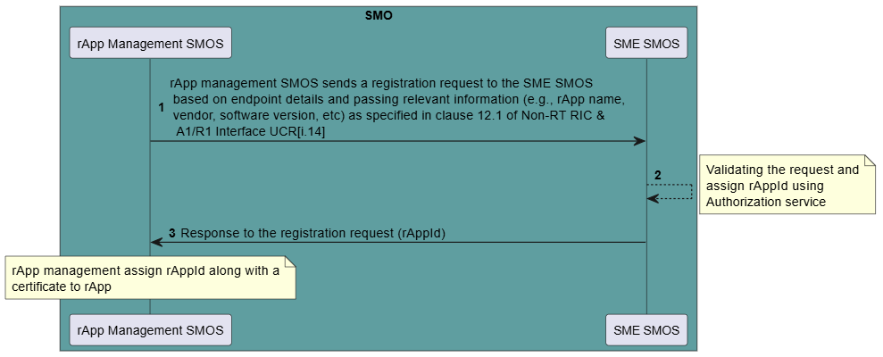
Figure 9.3.1-1 rApp registration
9.3.1.3 Impacts on existing O-RAN architecture elements and interfaces
- Service Management and Exposure (SME) SMOS as specified in [i.26].
- rApp Management (SMOS) as specified in [i.26].

9.3.1.4 Solution Evaluation
Key Issue #1: Registration of O-RAN architecture elements

9.3.1.5 Potential security recommendations
  - OAuth protection of the R1 interface is already mandatory in the O-RAN Security Requirements and Controls Specifications [i.2] SEC-CTL-R1-3.

9.3.2 Solution #2: Request access token for R1 services
9.3.2.1 Background
This use case allows an rApp to request an access token for access to R1 services as specified in R1GAP [i.13] [i.14]. The request access procedure is specified as part of Service Management and Exposure services in R1GAP [i.13] [i.14].
An rApp in the role of Service Consumer will be able to request the token and once the token is available, the rApp in the role of Service Consumer will be able access the R1 Services for which it has been authorized.
9.3.2.2 Solution description
Table 9.3.2-1 Request access token for R1 services
Use case stage | Evolution / specifiction | <<Uses>> Related use
Goal | To enable rApp to request an access token for access to R1 services.
Actors and Roles | rApp in the role of Service Consumer that requests token for access to R1 services.  SME as SMOS in the role of SME services Producer support authorization service
Assumptions | rAppId and credentials have been provisioned.
Pre-conditions | R1 interface is established
Begins when | rApp has determined need for an access token to access R1 services and resources.
Step 1 (M) | rApp sends Access token request containing the rAppId and optionally token scope. | SPS [i.1], clause 4.7.2.3
Step 2 (M) | SME authenticate the rApp and if the rApp token request is authorized, then an access token is generated. | SPS [i.1], clause 4.7.2.3
Step 3 (M) | SME respond with access token. | SPS [i.1], clause 4.7.2.3
Ends when | rApp has received an access token for access to R1 services.
Exceptions | n/a
Post-conditions | The rApp is authorized for accessing R1 services.
Traceability | REQ-R1-A-FUN1

@startuml
skinparam ParticipantPadding 5
skinparam BoxPadding 10
skinparam defaultFontSize 12
skinparam lifelineStrategy solid
autonumber
box "non-RT RIC" #whitesmoke
box #ivory
participant rApp as rApp
endbox
box "SMO" #cadetBlue
participant “SME (SMOS)" as SME
endbox
rApp -> SME: <<R1>> Access token request (rAppId)
SME->SME:
note right
Check Authorization
(Authenticate the rApp and
check if authorized, if
rApp is authorized,
generate an access token)
end note

SME -> rApp :<<R1>> Access token response (access token)
@enduml

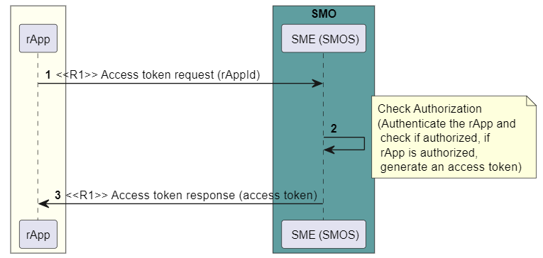
Figure 9.3.2-1 Request access token for R1 services

9.3.2.3 Impacts on existing O-RAN architecture elements and interfaces
R1 interface, rApp and SME are the O-RAN architecture elements and interfaces involved in the proposed use cases as specified in Decoupled SMO [i.15] [i.16].
1) Service Management and Exposure (SME) SMOS
The SME service is introduced in the [i.8] clause 3.1. While the SME was initially targeted for management and exposure of rApp services in the [i.8], its services are applicable to any entities within the SMO that fulfil the roles of Service Producer and/or Service Consumer.
In a decomposed service-based SMO architecture, the SME can be leveraged as a generic SMOS, handling service management and exposure for any SMOSs within SMO. The SME SMOS provides a set of common SMO capabilities that are needed for all SMO Services. Several of the SME services are applicable to any SMOSs:
- SMOS registration,
- SMOS discovery,
- Authentication and authorization to access a SMOS,
- Communication support between SMOS Service Producers and SMOS Service Consumers (SMOS Communication),
- Bootstrap of new SMOSs (optional),
- Heartbeat of SMOSs (optional).
2) SME functions in the role of SME services Producer
- supports the functionality of OAuth 2.0 authorization server,
- support authentication and authorization of an rApp to determine which R1 services an rApp can access,
- provide response of success or failure to access token request.
- rApp
- supports initiating the procedure to request access token,
- supports initiating service request with the available access token.

9.3.2.4 Solution evaluation
Key Issue #3: Provisioning of Authorization Grants for R1 services

9.3.2.5 Potential security recommendation
  - Use OAuth 2.0, as specified in O-RAN Security Protocols Specifications [i.1], clause 4.7 to implement authorization in the R1 interface.
  - Enable rApp to request OAuth 2.0 access tokens for R1 services.
  - Enable the SME to act as both an OAuth 2.0 resource and an OAuth 2.0 authorization server.

9.3.3 Solution #3: R1 services request with access token
9.3.3.1 Background
This use case discusses R1 service Producer to verify that rApp is authorized to access the R1 service as specified in R1GAP [i.13] [i.14]. The service request procedure is specified as part of Service Management and Exposure services in R1GAP [i.13][i.14].
9.3.3.2 Solution description
Table 9.3.3-1 R1 Service request using access token
Use case stage | Evolution / specification | <<Uses>> Related use
Goal | To enable R1 service Producer to verify that rApp is authorized to access the R1 service.
Actors and Roles | rApp in the role of Service Consumer that requests access to an R1 service with access token.  R1 service producer in the role of SME services Producer that supports the validation of the access token and provides access to the requested service.
Assumptions | rApp has requested and received an access token for the R1 service for which service access is requested.
Pre-conditions | R1 interface is established.
Begins when | rApp initiates a request for an R1 Service to R1 Service producer.
Step 1 (M) | rApp sends service request containing an access token to R1 service Producer
Step 2 (M) | R1 service Producer verifies integrity and claims in the access token. If successful, the requested service is executed. | SPS [i.1] clause 4.7.2.4]
Step 3 &4 (M) | R1 service Producer sends response to the service request if it has valid token
Step 5 & 6 (O) | The verification of integrity and claims in step 3 was unsuccessful due to invalid or expired token, the requested service is not executed, and R1 service Producer sends a response with appropriate error code.
Ends when | R1 service Producer has responded to the service request.
Post-conditions | -
Traceability | REQ-R1-SME-A-FUN2

@startuml
!pragma teoz true
skinparam ParticipantPadding 5
skinparam BoxPadding 10
skinparam defaultFontSize 12
skinparam lifelineStrategy solid
autonumber
box #whitesmoke
box #ivory
participant rApp as rApp
endbox
box "SMO" #cadetBlue
participant “ SME " as SME
participant “ R1 service Producer m" as SP

endbox
rApp ->SP: <<R1>> Service request (access token)
SP->SP
note right
Validate token
(Verify integrity and claims
in the access token.
If successful, execute
the requested service).
end note
alt
SP->SP: Valid Token
SP -> rApp :<<R1>> Service response (success)
SP->SP: Invalid or Expired Token
SP -> rApp :<<R1>> Service response (failure)
end ref
@enduml

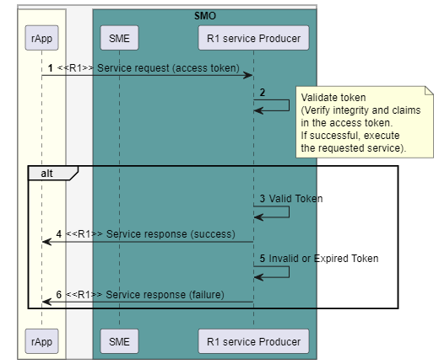
Figure 9.3.3-1 R1 Service request using access token
9.3.3.3 Impacts on existing O-RAN architecture elements and interfaces
R1 interface, rApp and SME are the O-RAN architecture elements and interfaces involved in the proposed use cases as specified in Decoupled SMO [i.15] [i.16].
1) Service Management and Exposure (SME) SMOS
The SME service is introduced in the [i.13] clause 3.1. While the SME was initially targeted for management and exposure of rApp services in the [i.13], its services are applicable to any entities within the SMO that fulfil the roles of Service Producer and/or Service Consumer.
In a decomposed service-based SMO architecture, the SME can be leveraged as a generic SMOS, handling service management and exposure for any SMOSs within SMO. The SME SMOS provides a set of common SMO capabilities that are needed for all SMO Services.
Several of the SME services are applicable to any SMOSs:
- SMOS registration,
- SMOS discovery,
- Authentication and authorization to access a SMOS,
- Communication support between SMOS Service Producers and SMOS Service Consumers (SMOS Communication),
- Bootstrap of new SMOSs (optional),
- Heartbeat of SMOSs (optional).

- SME in the role of SME services Producer
- supports the functionality of OAuth 2.0 authorization server,
- support authentication and authorization of an rApp to determine which R1 services an rApp can access,
- provide response of success or failure to access token requests
- rApp
- initiating the procedure to request access token,
- initiating service request with the available access token.
- R1 Service Producer
- provider of an R1 service.

9.3.3.4 Solution evaluation
Key issue #6: Provisioning of service access based on access token

9.3.3.5 Potential security recommendations
  - Use OAuth 2.0, as specified in O-RAN Security Protocols Specifications [i.1], clause 4.7 to implement authorization in the R1 interface.
  - Enable the SME to act as both an OAuth 2.0 resource and an OAuth 2.0 authorization server.

9.3.4 Solution #4: Secure transmission for client, authorization server and resource server for R1, A1 and O2
9.3.4.1 Background
This solution elaborates on the possibilities to ensure that data for the below flows is secure transmission of request and response between client to authorization server, between client and resource server for R1, A1 and O2.
- Between client and authorization server
  - The client needs to send the credentials and the authorization request details which need to be secured during transmission.
- Between client and resource server
  - The client needs to send the access token to the authentic resource server which needs to be secured during transmission.

9.3.4.2 Solution description
Table 9.3.4-1 use case of secure data transmission between client and authorization server
Use Case Stage | Evolution / Specification | <<Uses>>  Related use
Goal | - Transfer the data from client to authorization server securely
Actors and Roles | Below are examples of HTTP clients,  - rApp in the role of R1 Service Consumer  - SMO towards near RT RIC in the role of A1 consumer  - O-RAN assets towards O-cloud in the role of O2 consumer
Assumptions | TLS is the underlying secure protocol on which the below is built upon.
Preconditions | The consumer is registered with valid client_id and client_secret  The authorization server has a valid X.509 certificate  The consumer has the trust anchor for the authorization server’s X.509 certificate
Begins when | The consumer needs to contact the authorization server to send an authorization request
Step 1 (M) | The client authenticates the authorization server
Step 2 (M) | The client sends the request details to authorization server after successful authentication
Ends when | The consumer receives the access token from the authorization server
Exceptions | n/a
Post Conditions | The consumer is in possession of the access token securely
Traceability | n/a

@startuml
hide footbox
skinparam sequenceActorBackgroundColor White
skinparam sequenceActorBorderColor Black
skinparam sequenceParticipantBackgroundColor White
skinparam sequenceParticipantBorderColor Black
skinparam sequenceArrowColor Black
skinparam sequenceLifeLineBackgroundColor White
skinparam sequenceLifeLineBorderColor Black
skinparam shadowing false
skinparam NoteBackgroundColor White
skinparam NoteBorderColor Black

Title Secure transmission between client and authorization server
Actor "client" as client
participant "OAuth Authorization Server" as AS

client -> AS:authenticate with client_id and client_secret
client -> AS:send authorization Request
AS -> client: send access token

@enduml

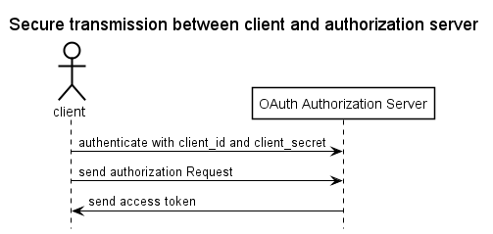
Figure 9.3.4-1 Transmission between client and authorization server
@startuml
hide footbox
skinparam sequenceActorBackgroundColor White
skinparam sequenceActorBorderColor Black
skinparam sequenceParticipantBackgroundColor White
skinparam sequenceParticipantBorderColor Black
skinparam sequenceArrowColor Black
skinparam sequenceLifeLineBackgroundColor White
skinparam sequenceLifeLineBorderColor Black
skinparam shadowing false
skinparam NoteBackgroundColor White
skinparam NoteBorderColor Black

Title Secure transmission between client and resource server
Actor "client" as client
participant "resource server" as RS

client <-> RS:mutual authentication
client -> RS:send access token as part of API operation

@enduml

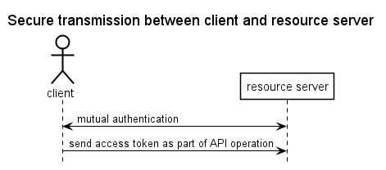
Figure 9.3.4-2 Transmission between client and resource server
9.3.4.2.1 Authentication methods between client, authorization server and resource server
The solutions below are various options to transfer information securely between the O-RAN OAuth clients and the various servers in the interaction including the authorization server and the various O-RAN resource servers. Below is a summary:
Table 9.3.4-2 Authentication methods
OAuth token end point authentication method | Reference | Short description
Tls_client_auth | RFC 8705 [i.6] | Usage of certificates for both client and server authentication. Usage of certificate hash for certificate bound access tokens
Private_key_JWT (with JWE) | RFC 8705 [i.6] | Usage of certificates for both integrity and confidentiality protection (encryption)
Private_key_JWT | OpenID foundation [i.21] | Usage of certificates for integrity protection
Client_secret_JWT | OpenID foundation [i.21] | Usage of shared secrets, for example client_secret for integrity protection
Client_secret_basic | RFC 7591 [i.22] | Client_id and client_secret transmission in the header
Client_secret_post | RFC 7591 [i.22] | Client_id and client_secret transmission in the payload
Self_signed_tls_client_auth | RFC 8705 [i.6] | Usage of client self-signed certificates in mutual authentication

Below are the details of the methods explained above
- Tls_client_auth
  - Part of RFC 8705.
  - Mutual authentication of both client and server. Here certificates are issued by a certificate authority. Also supports token binding.
  - For certificate bound access tokens every party proves that they are in possession of their private key.
  - Who is in possession of the private key used to establish the connection can use the access token (puts the hash of the certificate (cnf) that has been used).

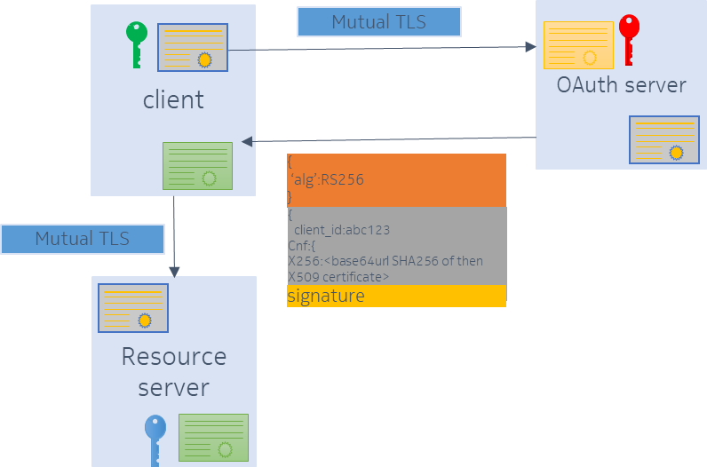
Figure 9.3.4-3 - Tls_client_OAuth method
- Private_key_JWT (with JWE)
  - Part of OpenID foundation specification.
  - Public and private key is used to sign and encrypt the JWT token using asymmetric cryptography.
  - Contents of the message cannot be seen as they are encrypted.
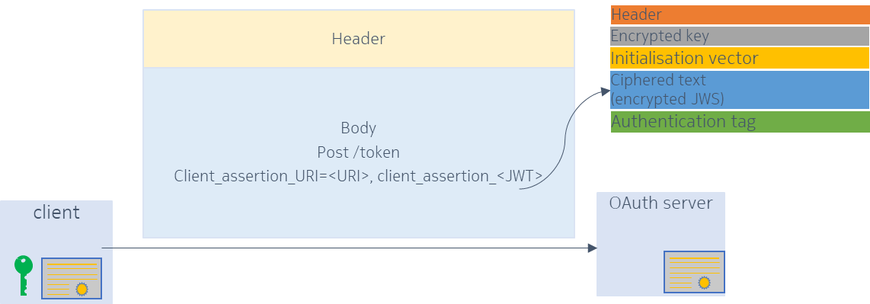
Figure 9.3.4-4 Private_key_JWT with JWE method
- Private_key_JWT
  - Part of OpenID foundation specification
  - The client_id and client_secret is part of the JWT token which is integrity protected. The JWT is a string which is attached as a client assertion. Here we AVOID putting the secret in message, instead in the JWT token.
  - Confidential client create JSON Web Token along with the public and private key. Hence structure of the JWT isthe header, body and the Signature. Hence JWS client has the private key and shares the public key to the authorization server for validation of the request. Hence the contents of the message can be seen but secure from manipulation.
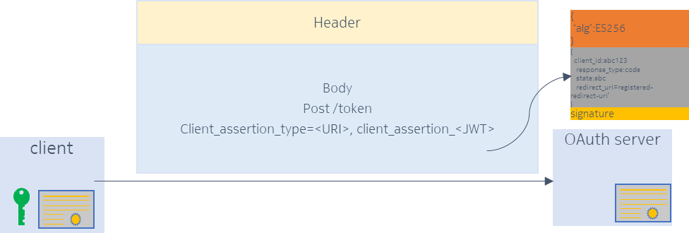
Figure 9.3.4-5 Private_key_JWT method
- Client_secret_JWT
  - Part of OpenID foundation specification.
  - Client_secret_JWT - client_id and client_secret in the JWT token which is integrity protected with a shared secret key (client_secret known to both parties) using HMAC. The JWT is a string which is attached as a client assertion. Here we AVOID putting the secret in message. Instead in the JWT token which is with a MAC (hash function+Secret).
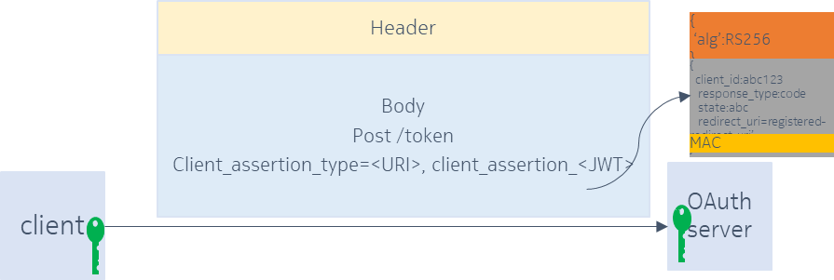
Figure 9.3.4-6 Client_secret_JWT method
- Client_secret_basic
  - client_id and client_secret in the header of the message.
  - Defined in RFC 7591.
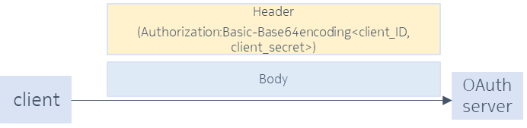
Figure 9.3.4-7 Client_secret_basic method
- Client_secret_post
  - client_id and client_secret in the body of the message.
  - Defined in RFC 7591.
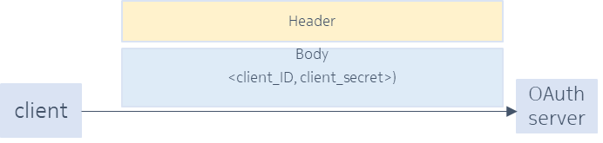
Figure 9.3.4-8 Client_secret_post method
- Self_signed_tls_client_auth
  - RFC 8705.
  - Mutual authentication using self signed certificates. Here certificate is created by self signing.

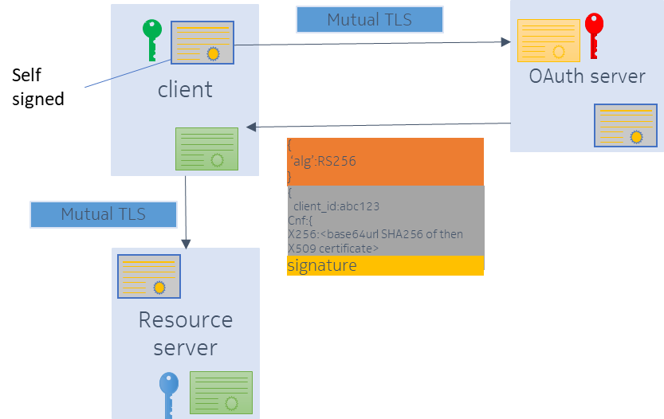
Figure 9.3.4-9 Self_signed_tls_client_auth method
9.3.4.3 Impacts on existing O-RAN architecture elements and interfaces
R1 client, A1 client and the O2 client needs to choose the authentication method from the options explained above depending on the client and authorization server capabilities:

9.3.4.4 Solution evaluation
There is a need to support secure transmission of requests and response between client and authorization server, between client to resource server. Below is the order of preference of various methods explained above in the order of most preferred to least preferred depending on the authorization server capabilities as well as the security level preferred.
Table 9.3.4-3 Authentication method preferences

OAuth token end point authentication method | Evaluation
Tls_client_auth | Highly preferred
Private_key_JWT (with JWE) | Preferred
Private_key_JWT | Preferred
Client_secret_JWT | Preferred
Client_secret_basic | Preferred
Client_secret_post | Preferred
Self_signed_tls_client_auth | Least preferred

9.3.4.5 Potential security recommendations
Editor’s note: The security recommendation will be left for future study.

9.3.5 Solution #5: Support for RBAC
9.3.5.1 Background
- Role based access control is an important concept for the authorization mechanism in O-RAN to support either coarse grained or fine-grained access.
- The protected resources expose various operations which can be protected by access rules are mapped to different roles in an operator setup. An operator should assign roles to users (human and non-human) using identity management workflows.
This solution elaborates on the possibilities to
  - Explain the association between the users, roles and the access rules (permissions) as defined in [i.19] clause 7.

NOTE: the reference of the 3GPP specification in [i.19] can be considered as an example and customised for the O-RAN interfaces.

9.3.5.2 Solution description
Table 9.3.5-1 use case of RBAC
Use Case Stage | Evolution / Specification | <<Uses>>  Related use
Goal | Design and deploy the role-based access model in an OAuth server for the O-RAN resources
Actors and Roles | Admin resource server – design of operations on resource server for access control  Admin – Network administrator for access control  Authorization server
Assumptions | Resources require coarse and fine grained permissions (access rules) to be designed  The solution considers the possibility of adding permissions manually. There is a possibility that this could also be automated
Preconditions | n/a
Begins when | Resource server needs to support access control
Step 1 (M) | Design coarse grained and fine-grained permissions
Step 2(M) | Express the permissions of a resource server
Step 3(M) | Deploy permissions
Step 4(M) | Deploy roles
Step 5(M) | Deploy client_ID and its client_secret
Ends when | Administration of RBAC is completed and resolved in the OAuth server
Exceptions | n/a
Post Conditions | n/a
Traceability | n/a

@startuml
hide footbox
skinparam sequenceActorBackgroundColor Whiteskinparam sequenceActorBorderColor Black
skinparam sequenceParticipantBackgroundColor White
skinparam sequenceParticipantBorderColor Black
skinparam sequenceArrowColor Black
skinparam sequenceLifeLineBackgroundColor White
skinparam sequenceLifeLineBorderColor Black
skinparam shadowing false
skinparam NoteBackgroundColor White
skinparam NoteBorderColor Black

Actor "Admin Resource server" as AR
Actor "Admin"
participant "Authorization Server" as AS

group Design of permissions \n(resources and operations)
AR-> AR: 1: Design coarse grained and fine grained permissions
AR-> Admin: 2: Express the permissions of a resource server
end

group Provisioning of RBAC model data
Admin -> AS: 3: Deploy permissions
Admin -> AS: 4: Deploy roles
Admin -> AS: 5: Deploy client_ID and its Client_secret
end

@enduml

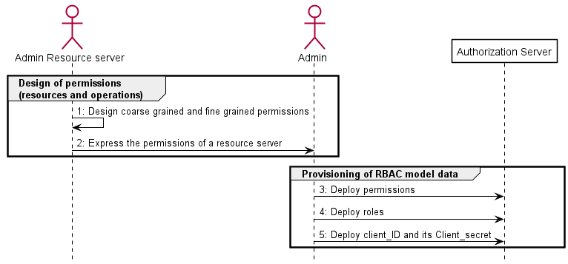
Figure 9.3.5-1 RBAC for client credentials
9.3.5.3 Impacts on existing O-RAN architecture elements and interfaces
- The O-RAN interfaces should factor in the permissions which should be used in the context of scope in the OAuth flows.
- The keyword scope is used both in an OAuth access token as well as in the OpenAPI to define what a particular interface is allowed to do.

9.3.5.4 Solution evaluation
- Permissions have to be considered by all the O-RAN APIs,
- For the OpenAPIs this should be expressed as scopes,
- The semantics of the permissions which should be evaluated and validated by the resource server need to be defined.

9.3.5.5 Potential security recommendations
Editor’s note: The security recommendation will be left for future study.

9.3.6 Solution #6: Profile for client credentials grant type clients
9.3.6.1 Background
- To ensure interoperability we propose the need for prescriptive profiles for a client which need to carry out access control when communicating from one machine to another machine which is the resource server.
- This solution considers the below aspects for the profile,
- Resource server which exposes the APIs.
- Authorization server client (confidential client). Example of confidential client is A1 client interacting with the Near RT RIC platform.
- Security options with certificate binding [i.6].

9.3.6.2 Solution description
Table 9.3.6-1 client credentials grant type client profile
Use Case Stage | Evolution / Specification | <<Uses>>  Related use
Goal | Derive an OAuth related profile for the machine-to-machine clients
Actors and Roles | Resource server – provider of the APIs for the client to access  Authorization server – an OAuth server  Confidential client – a noninteractive client accessing an API
Assumptions | - The solution considers the possibility of automation  - The clients refer to machines and not human users  - In registration of client dynamically the initial access to the OAuth server is with the initial access token
Preconditions | - Design of scopes which relates to 4.7.3.2.2. in [i.1]  - Administration of RBAC (solution related to RBAC)  - Publish endpoint locations and authorization server capabilities [i.23], clause 2  - Client X.509 certificate enrolment
Begins when | Pre-conditions are met
Step 1 (M) | Discover the capabilities of authorization server [i.23], clause 2
Step 2(M) | Register client dynamically [i.22], clause 3.1
Step 3(M) | Client credentials request (access token lifetime with 'expires_in' parameter) [i.5], clause 4.2.2
Step 4(M) | Return token [IETF RFC 6750] with certificate binding [i.6], clause 3
Step 5(M) | API invocation on resource server (access token with certificate binding)
Ends when | API is accessed with the correct privileges
Exceptions | n/a
Post Conditions | n/a
Traceability | n/a
NOTE: The design of scopes which is mentioned in the precondition needs further study.

@startuml
hide footbox
skinparam sequenceActorBackgroundColor White
skinparam sequenceActorBorderColor Black
skinparam sequenceParticipantBackgroundColor White
skinparam sequenceParticipantBorderColor Black
skinparam sequenceArrowColor Black
skinparam sequenceLifeLineBackgroundColor White
skinparam sequenceLifeLineBorderColor Black
skinparam shadowing false
skinparam NoteBackgroundColor White
skinparam NoteBorderColor Black

participant "Confidential Client" as C
participant "Resource Server" as RS
participant "Authorization Server" as AS

== Pre-condition ==
rnote over RS
P1. Design of scopes
End note

rnote over AS
P2. Administration of RBAC
P3. Publish endpoint locations
and authorization server capabilities
end note

rnote over C
P4. Client X.509 certificate enrollment
End note

== Runtime ==
group Client Interaction
C -> AS: 1. Discover the capabilities of Authorization server
C -> AS: 2. Register client dynamically

loop (for every request)
C -> AS: 3. Client credentials request(access token lifetime with 'expires_in' parameter)
AS -> C: 4. Return token with certificate binding

group Resource Server Interaction
C -> RS: 5. API call (access token with cerificate binding)
End
end
@enduml

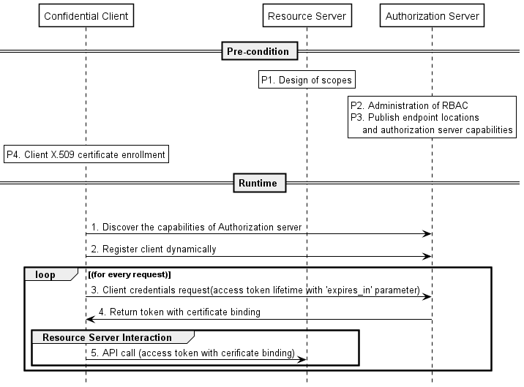
Figure 9.3.6-1 Profile for confidential client
9.3.6.3 Impacts on existing O-RAN architecture elements and interfaces
Impacts to be considered with respect to the following:
- Resource servers
O-RAN related APIs to define the scopes
- Authorization server
The OAuth servers should support the following capabilities
    - Token end points support
    - Introspection end point
    - Tokens with reference to access rules
    - Access token lifetime
    - Re-authenticate or refresh tokens
  - Solution options:
    - RBAC deployment
- Client (confidential client)
O-RAN related client credentials grant type clients (e.g., xApps) should be capable making a client credential grant request, processing of response and forwarding the access token in an API call.
- Security options
O-RAN related http interfaces should support mTLS with certificate binding in [i.6].

9.3.6.4 Solution evaluation
  - To accomplish the access control securely for the O-RAN related a machine-to-machine clients a combination of the existing RFCs has to be put together in order to maximise security and also ensure simplicity.

9.3.6.5 Potential security recommendations
Editor’s note: The security recommendation will be left for future study.

9.3.7 Solution #7: Resolution of authorization decision between authorization server and resource server
9.3.7.1 Background
- In typical operator deployments, RBAC requires that administration and execution of roles (coarse-grained authorization) and permissions (fine-grained authorization) are distributed between the authorization server and resource servers.
- Considering the size of a token and that various APIs have different levels of authorization, the permissions are part of the resource server and not part of the confidential client request.
- The authorization servers are typically centralized overseeing the administration and validation decision of coarse-grained authorization related roles which are part of the confidential client request. The examples of roles could be considered from Appendix I related to the function set group in [i.24].
- The resource servers are typically distributed overseeing the roles to permission mapping administration and validation decision of fine-grained authorization.
- Permissions are considered to be the operation (usually CRUD) on a particular object in the resource server as in [i.19] clause 7.
- In the solution below we consider examples of roles as rol1, rol2, rol3, etc. to be mapped to permissions per1, per2, per3, etc. for ease of understanding.

NOTE 1: The above discussion related to coarse-grained authorization and fine-grained authorization which is mentioned in the 9.3.7 needs further study.
NOTE 2: The above discussion related to roles in [i.24] which is mentioned in the 9.3.7.1 and 9.3.7.3 needs further study.

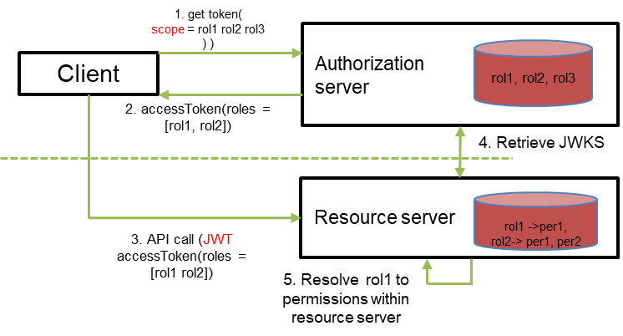
Figure 9.3.7-1 - Validation decision of roles and permissions
This solution elaborates on the possibilities to
- Split the administration of the roles and permissions between the authorization server and resource server.
- Validate the decision of the roles and permissions between the authorization server and resource server.

9.3.7.2 Solution description
Table 9.3.7-1 use case of authorization decision between authorization server and resource server
Use Case Stage | Evolution / Specification | <<Uses>>  Related use
Goal | Resolution of authorization related validation decision to achieve the principle of least privilege
Actors and Roles | Confidential client – making an API call on a resource server with the assigned role  Authorization server – Validating the scope and the roles of client  Resource server – Validating the fine-grained authorization after mapping them to the roles received in access token
Assumptions | Coarse-grained authorization roles are administered in the Authorization server (e.g.: rol1, rol2, rol3, etc)  Fine-grained authorization is administered in the resource server (e.g.: per1, per2, per3, etc.). permission defines the granular object in the resource server and operation (CRUD) that can be executed on it  Resource server to verify the token for every confidential client during the service initiation
Preconditions | n/a
Begins when | Confidential client makes a token request
Step 1 (M) | Send a token request with requested roles (e.g.: rol1, rol2, rol3) included in the 'scope' attribute
Step 2(M) | Validate the roles related to the ClientID
Step 3(M) | Return JWT access token with authorized roles (e.g.: rol1) included in the 'roles' attribute
Step 4(M) | API call (JWT access token with role (e.g.: rol1))
Step 5(M) | Check mapping of the role to permission (e.g.: rol1 -> per1)
Step 6(M) | Validate the permission of the fine-grained authorization operation in the API call
Ends when | Roles and permissions are resolved by respective entity and API call is executed with required authorization resolution
Exceptions | n/a
Post Conditions | n/a
Traceability | n/a

@startuml
hide footbox
skinparam sequenceActorBackgroundColor White
skinparam sequenceActorBorderColor Black
skinparam sequenceParticipantBackgroundColor White
skinparam sequenceParticipantBorderColor Black
skinparam sequenceArrowColor Black
skinparam sequenceLifeLineBackgroundColor White
skinparam sequenceLifeLineBorderColor Black
skinparam shadowing false
skinparam NoteBackgroundColor White
skinparam NoteBorderColor Black

Title Authorization resolution for fine-grained authorization
participant "Confidential Client" as C
participant "Resource Server" as RS
participant "Authorization Server" as AS

== Runtime ==
group Client Interaction
C -> AS: 1. Send a token request with requested roles (e.g.:rol1, rol2, rol3..) included in the ‘scope’ attribute
AS -> AS:2. Validate the roles related to the clientID
AS -> C: 3. Return JWT access token with authorized roles(e.g.: rol1) included in the ‘roles’ attribute

loop (for every request)

C -> RS: 4. API call (JWT access token with role(e.g.: rol1))

RS -> RS:5. Check mapping of the role to permission(e.g.: rol1 -> per1)
RS -> RS:6. Validate the permission of the fine-grained authorization operation in the API call

End
end
@enduml

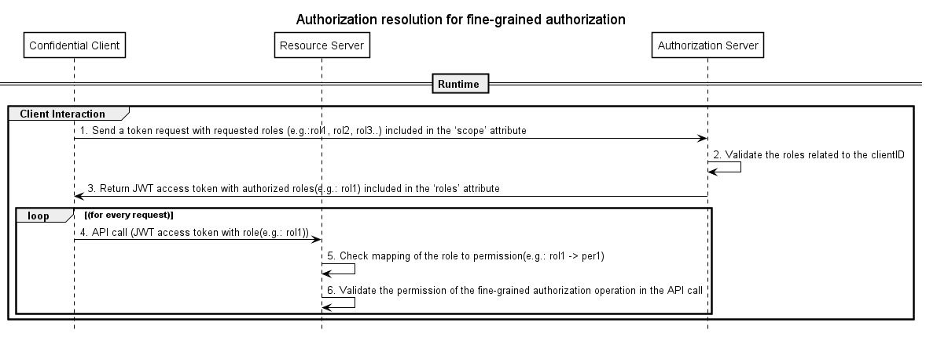
Figure 9.3.7-2 Roles and permission resolution between the authorization server and resource server
9.3.7.3 Impacts on existing O-RAN architecture elements and interfaces
    - O-RAN related confidential clients request access token with the roles as part of the claim. The authorization server administers and validates the roles to client token requests. Examples of roles are defined in function set groups in Appendix I for the network management layer in [i.24].
    - The O-RAN interfaces (APIs) may factor in the validation of permissions which are mapped to the roles the access token.

9.3.7.4 Solution evaluation
  - Roles have to be resolved and validated by the authorization server.
  - Roles to permission mapping may be administered and validated in the resource server for the various API calls.

9.3.7.5 Potential Security Recommendations
Editor’s note: The security recommendation will be left for future study.

9.3.8 Solution #8: rApp certificate enrolment
9.3.8.1 Background
The solution proposes to perform the initial certificate enrolment for the rApp instance based on authorization of rApp management SMOS as described in clause 9.3.3 and it is illustrated in Figure 9.3.8-1. The certificate enrolment is used for secured communication between rApp and SMO. The proposed solution is to align on RFC 8705 [i.29].
9.3.8.1 Solution description
Table 9.3.8-1: Initial certificate enrolment for rApp instance
Use case stage | Evolution / specification | <<Uses>> Related use
Goal | Initial configuration and certificate enrolment for rApp instance during rApp registration
Actors and Roles | - rApp management SMOS Consumer as a consumer of rApp management SMOS as described in clause 4.2.9 of SMO Architecture [i.26]  - rApp management SMOS as described in clause 4.2.9 of SMO Architecture [i.26]  - rApp instance as defined in clause 3 of Non-RT RIC: Architecture [i.27]
Assumptions | - The rApp management SMOS enrol the rApp certificate
Pre-conditions | - The rApp management SMOS Consumer is authorized to create and deploy a new rApp instance as described in the above clause 9.3.3 of OAuth 2.0TR.
Begins when | The rApp management SMOS Consumer initiates to deploy a new rApp instance.
Step 1 (M) | The rApp management SMOS Consumer requests the rApp management SMOS to create a new rApp instance.
Step 2(M) | The rApp management SMOS verifies the rApp SMOS management Consumer, which is authorized to create a new rApp instance as described in the above clause 9.3.3 of OAuth 2.0 TR.
Step 3 (M) | The rApp management SMOS creates the rApp instance identifier (rAppId) as described in clause 5.7.2.2 of R1GAP [i.13].
Step 4 (M) | The rApp management SMOS configures the rApp specific instance by assigning the certificate as per above assumption.
Step 5 (M) | The rApp management SMOS notifies the rApp management SMOS Consumer about the creation of the new rApp instance.
Step 6(M) | The rApp management SMOS Consumer requests the rApp management SMOS to deploys a new rApp instance.
Step 7 (M) | The rApp management SMOS deploys the rApp instance.
Step 8 (M) | The rApp management SMOS sends the status of the rApp instance deployment to the rApp management SMOS Consumer.
Ends when | The rApp instance deployment status is successful.
Exceptions | None identified
Post-conditions | Trust established between the rApp instance and SMO.

@startuml
!pragma teoz true
skinparam ParticipantPadding 5
skinparam BoxPadding 10
skinparam defaultFontSize 12
skinparam lifelineStrategy solid
autonumber
box "SMO" #Aquamarine
participant "rApp management SMOS Consumer" as RMSC
participant "rApp management SMOS " as RMS
participant "rApp" as rApp
end box
RMSC->RMS:Create new rApp Instance by sending access token as \n described in clause 9.3.3 of OAuth 2.0TR[i.26]
RMS-->RMS:Authz validation as described \n in clause 9.3.3 of OAuth 2.0TR[i.26]
RMS-->RMS: Create rApp instance identifier (rAppId)
RMS-->RMS: Configure rApp instance by assigning \n the certificate
RMS->RMSC: New rApp instance created
RMSC->RMS: Deploy new rApp instance
RMS<->rApp**: Deploy new rApp instance
RMS->RMSC: rApp instance deployed
@enduml

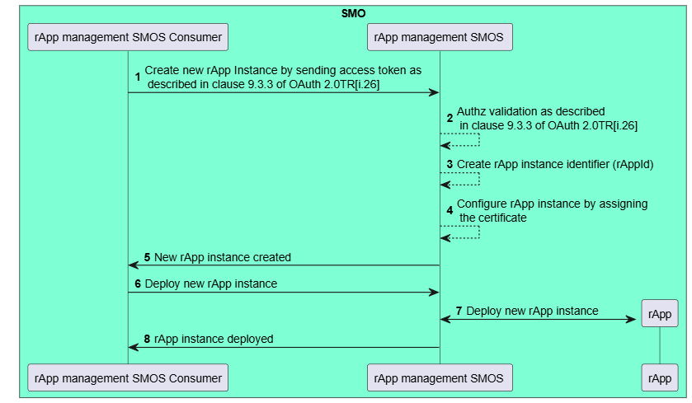
Figure 9.3.8-1 Initial certificate enrolment for rApp instance
9.3.8.3 Impacts on existing O-RAN architecture elements and interfaces
a) rApp Management SMOS description as specified in [i.26].
b) rApp instance as specified in [i.27].

9.3.8.4 Solution evaluation
The proposed solution addresses related key issue #3 & #13 in clause 9.2.
9.3.8.5 Potential security recommendations
The potential security recommendation as mentioned below,
- To enable rApp management SMOS to support certificate management for rApp instances

10 Study and recommendation on O-RAN Authorization Server architecture
Editor’s note: This section will do a study and recommendation on an authorization server architecture to overlay on the O-RAN architecture.

11 Conclusion
Editor’s note : This clause will provide the summary for the TR and mapping tables the key issues and solutions and it will submit the recommendations to WG1 for O-RAN authorization server.

Annex:Change history/Change request (history)
Date | Revision | Description
2023.05.10 | 00.00.01 | Initial TS skeleton
2023.08.23 | 00.00.02 | Updated the scope and reference for the TR
2023.10.16 | 00.00.03 | Updated the TR based on CR approved in OAuth 2.0 meeting for Nov train
2023.10.24 | 00.00.04 | Updated the TR based on CR approved during O-RAN F2F phoenix meeting
2023.11.21 | 01.00 | Final version 01.00
2024.02.07 | 01.00.01 | Updated the TR based on CR approved for OAuth 2.0 TR WI meeting in Dec 2023 and Jan 2024
2024.03.05 | 01.00.02 | Updated the TR based on CR approved for OAuth 2.0 TR WI meeting in Feb 2024
2024.06.26 | 02.00.01 | Updated the TR based on CR approved for OAuth 2.0 TR WI meeting from April to June 2024
2024.07.05 | 02.00.01 | Updated the TR based on the review comments during July 2024 plenary approvals
2024.10.30 | 03.00.01 | Updated the TR based CR approved before the WG11 F2F oct 2024 meeting
2024.11.12 | 03.00.02 | Updated the TR based CR approved after the WG11 F2F oct 2024 meeting
2024.11.26 | 03.00.03 | Updated the TR based on editorial comments during the WG11 plenary approval for Nov 2024 train
2024.11.27 | 03.00.04 | Updated the TR based on editorial comments (OAuthTR meeting update) during the WG11 plenary approval for Nov 2024 train
2025.03.04 | 04.01 | Updated the TR based on CR approved for OAuth 2.0 TR WI meeting in Dec 2024 Jan 2025 and Feb 2025
2025.03.04 | 04.02 | Updated the TR based on CR approved in OAuth 2.0 WI meeting on 04/03/2025
2025.03.18 | 04.03 | Updated the TR based on review comments received on or before OAuth 2.0 WI meeting on 18/03/2025
2025.03.25 | 05.00.01 | Updated the TR based on review comments received during voting of OAuth 2.0 march 2025 train
2025.05.27 | 05.01 | Updated the TR based on below CR approved for OAuth 2.0 TR WI meeting in April 2025 and May 2025  ERI-2025.03.25-WG11-CR-224-OAuth2.0-Clause2Considerationupdates-v02.docx  ERI-2025.01.04-WG11-CR0225-OAuth2.0-Clause7-Risk Assessment_Update(1)_v04.docx  ERI-2025.04.15-WG11-CR0233-OAuth2.0-Clause5.5SecurityControlsupdates-v03.docx  ERI-2025.04.15-WG11-CR0234-OAuth2.0-Clause5.1AssetsIDupdates-v01.docx  ERI-2025.04.29-WG11-CR0236-OAuth2.0-Clause7-Risk Assessment_Update(2)_v02.docx  ERI-2025.05.13-WG11-CR0240-OAuth2.0-Clause7.2-Risk Assessment_Update(3)_v01.docx  ERI-2025.05.27-WG11-CR0245-OAuth2.0-Clause7.2-Risk Assessment_Update(4)_v01.docx
2025.06.10 | 05.02 | Updated the TR based on review comments received during the OAuth2.0 TR meeting 60 on 10/06/2025
2025.11.04 | 06.01  06.02  06.03 | Updated the TR based on review comments received during the OAuth2.0 TR meeting on 05/11/2025  ERI-2025.08.05-WG11-CR0254-OAuth2.0-Clause9.2Key Issues_9.2.13_v04.docx  ERI-2025.08.19-WG11-CR0256-OAuth2.0-UpdatestoClause9.2_v02.docx  ERI.AO-2025.10.14-WG11-CR0269-OAuth2.0-Clause9.2-Updatestokeyissues_v01.docx  ERI-2025.10.14-WG11-CR0266-OAuth2.0-Solution9.3.8_rApp_certificate enrolment_v02.docx  NEC-2025.10.22-WG11-CR-0073-OAuth-ReferenceUpdate-v02.docx  ERI-2025.10.29-WG11-CR0268-OAuth2.0-Solution9.3.1_rApp_registrationwithcertificate_v01.docx

