
O-RAN.WG5.TS.D2-O&MRequirements.R005-v01.00
Technical Specification

O-RAN Work Group 5 ( Open F1/W1/E1/X2/Xn/D2 interfaces )
D2 Interface: O&M Requirements

Copyright © 2025 by the O-RAN ALLIANCE e.V.
The copying or incorporation into any other work of part or all of the material available in this specification in any form without the prior written permission of O-RAN ALLIANCE e.V. is prohibited, save that you may print or download extracts of the material of this specification for your personal use, or copy the material of this specification for the purpose of sending to individual third parties for their information provided that you acknowledge O-RAN ALLIANCE as the source of the material and that you inform the third party that these conditions apply to them and that they must comply with them.

O-RAN ALLIANCE e.V., Buschkauler Weg 27, 53347 Alfter, Germany
Register of Associations, Bonn VR 11238, VAT ID DE321720189

Contents
List of figures 3
List of tables 3
Foreword 4
Modal verbs terminology 4
Executive summary 4
Introduction 4
1 Scope 6
2 References 6
2.1 Normative references 6
2.2 Informative references 6
3 Definition of terms, symbols and abbreviations 7
3.1 Terms 7
3.2 Symbols 7
3.3 Abbreviations 7
4 Configuration Parameters 8
4.1 Parameter Name and Description 8
4.1.1 TimingList 8
4.1.5 Cell List 10
5 Performance Measurement 10
Annex A (informative): Flow Diagram for D2-c and D2-u 11
Annex (informative): Change history/Change request (history) 17

List of figures
Figure 1: D2 interface between O-DUs connected to same O-CU-CP and O-CU-UP 5
Figure 2: D2-c protocol architecture 5
Figure 3: D2-u protocol architecture 6
Figure 4: T1, T2, T3 Parameters relationship with respect to SCell OTA slot 9
Figure 5: D2CP Interface Management Function 13
Figure 6: D2CP UE management functions 15
Figure 7: D2UP messages 16

List of tables
Table 1: Counters for D2 interface 10

Foreword
This Technical Specification (TS) has been produced by WG5 of the O-RAN ALLIANCE.
The content of the present document is subject to continuing work within O-RAN and may change following formal O-RAN approval. Should the O-RAN ALLIANCE modify the contents of the present document, it will be re-released by O-RAN with an identifying change of version date and an increase in version number as follows:
version xx.yy.zz
where:
xx: the first digit-group is incremented for all changes of substance, i.e. technical enhancements, corrections, updates, etc. (the initial approved document will have xx=01). Always 2 digits with leading zero if needed.
yy: the second digit-group is incremented when editorial only changes have been incorporated in the document. Always 2 digits with leading zero if needed.
zz: the third digit-group included only in working versions of the document indicating incremental changes during the editing process. External versions never include the third digit-group. Always 2 digits with leading zero if needed.

Modal verbs terminology
In the present document "shall", "shall not", "should", "should not", "may", "need not", "will", "will not", "can" and "cannot" are to be interpreted as described in clause 3.2 of the O-RAN Drafting Rules (Verbal forms for the expression of provisions).
"must" and "must not" are NOT allowed in O-RAN deliverables except when used in direct citation.

Executive summary
D2 interface, defined by O-RAN Alliance, connects a pair of O-DUs (O-RAN Distributed Units). D2 interface plays an essential role in supporting various use cases for enhancing the user experience and efficient use of spectral resources such as inter O-DU carrier aggregation.
The present document outlines the configuration parameters required for establishment and functioning of D2 interface. Existing O1 interface towards O-DU shall be used by SMO to configure these parameters. SMO can define the counters and KPIs as mentioned in the present document for monitoring the D2 interface.

Introduction
D2 interface is introduced between the O-DUs to support control and user data exchange. Figure 5.1-2 in O-RAN WG1.OAD [1] shows the D2 interface in O-RAN architecture.
O-DUs connected via D2 interface can be connected to same or different O-CU-CPs and O-CU-UPs. Figure 1 adopted from O-RAN WG5.D2.GAP Figure 4.2-1, shows the cases where all the O-DUs are connected to same O-CU-CP and O-CU-UP. D2-c indicates the control part of D2 interface while D2-u is the user plane part.
O-CU-CP1
O-CU-UP1
O-DU1
O-DU2
O-RU1
O-DUn
O-RU2
O-RU3
F1-u
F1-u
F1-c
F1-c
Open FH
D2-c/ D2-u
D2-c/ D2-u
D2-c/ D2-u
Open FH
Open FH
E1
F1-c
F1-u

Figure 1: D2 interface between O-DUs connected to same O-CU-CP and O-CU-UP

Transport protocol for D2-c is SCTP over IP similar to the F1-c protocol architecture. Figure 2 shows the protocol architecture for D2-c part as defined in D2 GAP specification [2]. Application protocol for D2-c is named as D2CP which provides signalling aspects of D2 interface such as D2 interface setup, reconfiguration and other UE associated procedures.
D2CP
SCTP
IP
Data Link Layer
Physical Layer
Transport Network Layer
ApplicationLayer
Control Plane

Figure 2: D2-c protocol architecture
D2-u messages are transported by UDP over IP similar to F1-u protocol architecture (except GTP). The latency requirement for D2-u ( within 200us one way) is much lower compared to F1-u. Between a pair of O-DU nodes, one or more UDP ports may be used for D2-u. Figure 3 shows the D2-u protocol architecture as defined in D2 GAP specification [2]. D2UP is the application protocol defined for supporting D2-u functionality. It is used to exchange user level data and other critical control information for handling the user data such as PUCCH allocation information, transfer of CSI and HARQ feedback from UE etc.

Physical layer
Data link layer
IP
UDP
D2UP
Transport network layer
Application layer
Figure 3: D2-u protocol architecture

1 Scope
The present document specifies the counters and configuration parameters requirements for D2 interface. Parameters can be configured by SMO to O-DU via O1 interface for D2 interface functioning.

2 References

2.1 Normative references
References are either specific (identified by date of publication and/or edition number or version number) or non-specific. For specific references, only the cited version applies. For non-specific references, the latest version of the referenced document (including any amendments) applies. In the case of a reference to a 3GPP document, a non-specific reference implicitly refers to the latest version of that document in Release 18, or the latest 3GPP release prior to Release 18 that includes that document.
NOTE: While any hyperlinks included in this clause were valid at the time of publication, O-RAN cannot guarantee their long-term validity.
The following referenced documents are necessary for the application of the present document.
[1] O-RAN.WG1.TS.OAD: "O-RAN Architecture Description".
[2] O-RAN.WG5.TS.D2-GAP: "D2 Interface: General Aspects and Principles".

2.2 Informative references
References are either specific (identified by date of publication and/or edition number or version number) or nonspecific. For specific references, only the cited version applies. For non-specific references, the latest version of the referenced document (including any amendments) applies. In the case of a reference to a 3GPP document, a non-specific reference implicitly refers to the latest version of that document in Release 18, or the latest 3GPP release prior to Release 18 that includes that document.
NOTE: While any hyperlinks included in this clause were valid at the time of publication, O-RAN cannot guarantee their long-term validity.
The following referenced documents are not necessary for the application of the present document, but they assist the user with regard to a particular subject area.
[i.1] 3GPP TR 21.905: "Vocabulary for 3GPP Specifications".

3 Definition of terms, symbols and abbreviations

3.1 Terms
For the purposes of the present document, the terms [given in [i.1] and the following] apply:
beam: main lobe of a radiation pattern from an AAS BS
NOTE: For certain AAS BS antenna array, there may be more than one beam.
carrier aggregation: aggregation of two or more NR or E-UTRA component carriers in order to support wider transmission bandwidths
D2 interface: The inter O-DU interface to enable multi-vendor carrier aggregation in NR is named as D2 according to WG1 ATG definitions.
PCell O-DU: O-DU, where the PCell is configured for a UE to support inter O-DU carrier aggregation.
pO-DU: O-DU, where the PCell is configured for a UE to support inter O-DU carrier aggregation. This is same as PCell O-DU used in the D2 GAP specifications.
SCell O-DU: O-DU, where only SCell(s) are configured for a UE to support inter O-DU carrier aggregation.
sO-DU: O-DU, where only SCell(s) are configured for a UE to support inter O-DU carrier aggregation. This is same as SCell O-DU used in the D2 GAP specifications.

3.2 Symbols
For the purposes of the present document, the symbols [given in [i.1] and the following] apply:
N_{RB} Transmission bandwidth configuration, expressed in units of resource blocks (for E-UTRA)

3.3 Abbreviations
For the purposes of the present document, the abbreviations given in [i.1] and the following apply:
AAS Active Antenna System
CRNTI Cell Radio Network Temporary Identifier
CA Carrier Aggregation
D2-c D2 Control plane interface
D2CP D2 Control plane Protocol
D2-u D2 User Plane interface
D2UP D2 User Plane Protocol
DL Downlink
gNB g NodeB
MAC Medium Access Control
O-CU-CP O-RAN Central Unit – Control Plane
O-CU-UP O-RAN Central Unit – User Plane
O-DU O-RAN Distributed Unit
OTA Over-the-Air
O-RU O-RAN Radio Unit
PCell O-DU Primary cell O-DU
PCI Physical Cell Identity
PDCCH Physical downlink control channel
PUSCH Physical downlink shared channel
PUCCH Physical uplink control channel
RTT Round Trip Time
SCell O-DU Secondary cell O-DU
SCTP Stream Control Transmission Protocol
TB Transport block
UE User Equipment

4 Configuration Parameters

4.1 Parameter Name and Description

4.1.1 TimingList
This is a list of timing information for the self and peer O-DUs. First entry in the list contains information for the O-DU where configuration is done. All other entries shall be set as per the peer O-DUs information. Order in this list shall be same as the D2-c IP Address and SCTP port Num as defined in clause 4.1.5.

4.1.1.1 T1
This parameter as shown in Figure 4, with reference to a given OTA slot, indicates the minimum time required by SCell O-DU to process and transmit data to a UE once data is received from PCell O-DU on D2 interface. It is defined in microseconds. If the DL DATA TRANSFER and PUCCH RESOURCE TRANSFER for a given OTA slot arrives later than this time, SCell O-DU may not transmit the data to the UE in the OTA indicated.

4.1.1.2 T2
This parameter as shown in Figure 4, with reference to a given OTA slot in DL DATA REQUIRED message, indicates the minimum time required by PCell O-DU to process and respond to DL DATA REQUIRED message, and subsequent transmission of data in the OTA slot. It is defined in microseconds. If PCell O-DU receives the DL DATA REQUIRED message later than T2 time, it returns failure to SCell O-DU in PUCCH RESOURCE TRANSFER message.

4.1.1.3 T3
This parameter as shown in Figure 4, indicates the latest time by which pO-DU may send a DL SCHEDULING REQUEST message requesting scheduling for a given OTA slot. It is defined in microseconds. If DL SCHEDULING REQUEST message contains slot range lesser than T3, sO-DU shall ignore the received DL SCHEDULING REQUEST message. sO-DU shall consider the slots that are greater than T3 as valid slots for scheduling the UEs.

DL_SCHEDULING_REQUEST
DL DATA TRANSFER
DL DATA REQUIRED
T_{A}=0
On-air antenna transmission for the slot
T1 = Deadline for DL DATA TRANSFER/PUCCH RESOURCE TRANSFER to allow sO-DU time to transmit to UE
T3 = Deadline for DL SCHEDULING REQUEST to allow sO-DU budget for scheduling of scell carrier (PDCCH and PDSCH)
T1 + RTT/2 + xx + RTT/2 + yy
T2 = Deadline for DL DATA REQUIRED to allow pO-DU time to handle PUCCH, build TB and align with other carrier scheduling T1 + RTT/2 + xx
If DL DATA TRANSFER message arrives late, it cannot be processed.
PDCCH/PDSCH
$$|T1|<|T2|<|T3|$$

Figure 4: T1, T2, T3 Parameters relationship with respect to SCell OTA slot
NOTE 1: xx, yy in figure 4 indicates the processing time taken by pO-DU and sO-DU for the received messages respectively.
NOTE 2: TA =0 in the figure 4 indicates the Scell time where PDCCH/PDSCH is transmitted to UE by sO-DU.
    - Start CRNTI
This parameter defines the start CRNTI assigned to each O-DU that supports D2 interface. O-DU may allocate the CRNTI from Start CRNTI till CRNTI Range to the UEs attached to this O-DU.
NOTE: It is FFS if configuration of Start CRNTI is optional or mandatory.
    - CRNTI Range
This parameter defines the range of CRNTI assigned to each O-DU connected via D2 interface. O-DU may allocate the CRNTIs from this range starting from Start CRNTI, to the UEs attached to this O-DU.
NOTE: It is FFS if configuration of CRNTI Range is optional or mandatory.
    - D2-c IP Address and SCTP port Num
This is a configuration list defines the IP address and SCTP port number for the D2-c interface of local O-DU and its peer O-DUs. The first entry in the list indicates the IP address and SCTP port number for the O-DU where configuration is applied. All subsequent entries provide the corresponding details for peer O-DUs with which D2 connections can be established. These IP addresses and port numbers shall be used by local O-DU to establish the SCTP connection with peer O-DUs.
    - Self D2-u IP Address and port Num
These parameters define the configuration of the IP address and UDP port number used for establishing the D2-u interface. The specified IP address and UDP port number corresponds to the O-DU where configuration is applied. This information is conveyed to the peer O-DU in D2 SETUP REQUEST/RESPONSE message. This may be a list of IP addresses and port numbers to support multiple endpoints.

4.1.5 Cell List
This is a list of cells supported by an O-DU that can also support inter O-DU CA via D2 interface. For each entry in the list, the following parameters will be specified:
      - Cell ID
PCI for the cell that supports D2 interface for inter O-DU CA.
      - CA Type
For each cell that supports inter DU CA, it indicates whether cell supports DL_ONLY CA, NONE.

4.1.8 T_clearTB
This parameter specifies the maximum duration for which the SCell O-DU retains the transport Block (TB) for retransmission following a HARQ failure. The timer is reset when the SCell O-DU receives a DL SCHEDULING REQUEST message indicating retransmission request. Once the timer expires, the HARQ process becomes available for a new transmission, with the NDI bit toggled.

5 Performance Measurement
The Table 1 lists the O-RAN O1 defined performance measurements related to D2 Interface.
For complete measurement details, refer WG10 O1 PMeas specification [xx]
Table 1: Counters for D2 interface
Measurement Category | Measurements | Description
General Packet measurements | Transmitted D2-C messages | This counter provides the number of the transmitted D2-c messages.  The measurement is calculated per Cell basis.  It shall also be provided on per O-DU basis.
 | Received D2-C messages | This counter provides the number of the received D2-c messages.  The measurement is calculated per Cell basis.  It shall also be provided on per O-DU basis.
C-Plane procedure related measurements | Inter O-DU SCell addition | This counter provides the number of the SCell addition triggered in a O-DU.  The measurement is calculated per O-DU basis.
 | Inter O-DU SCell addition failure | This counter provides the number of the SCell addition failure in a O-DU.  The measurement is calculated per O-DU basis
U-Plane PDU related measurements | Transmitted DL User Data PDUs | This counter provides the total number of DL DATA TRANSFER message containing DL User data for new transmission.  The measurement is calculated per cell basis.
 | Received DL User Data PDUs | This counter provides the received total number DL DATA TRANSFER message that contains DL User data for new transmission.  The measurement is calculated per cell basis
 | Transmitted DL User Data Volume | This counter provides the total bytes (Only new transmission) that are transmitted by PCell O-DU over D2 interface.  The measurement is calculated per cell basis
 | Received DL User Data Volume | This counter provides the total bytes (Only new transmission) that are received by SCell O-DU over D2 interface.  The measurement is calculated per cell basis
 | Request for retransmission of DL User Data PDUs | This counter provides the total count of DL SCHEDULING REQUEST messages that are transmitted by PCell O-DU over D2 interface for requesting the retransmission of DL data by SCell O-DU.  The measurement is calculated per cell basis
 | Retransmitted DL User Data PDUs | This counter provides the total number of DL SCHEDULING REQUEST messages that successfully triggered the retransmission for the UE.  The measurement is calculated per cell basis
 | Retransmitted DL User Data volume | This counter provides the total bytes that are triggered by PCell O-DU over D2 interface that needs retransmission by SCell O-DU to UE?  The measurement is calculated per SCell basis
 | DL User PDUs discarded due to delayed reception | This counter provides the total count of all the D2 messages that did not satisfy the T1/T2/T3 timers criteria and hence discarded.  The measurement is calculated per cell basis

Annex A (informative):
Flow Diagram for D2-c and D2-u
Figure 5 indicates the D2CP global messages. These messages are exchanged between O-DUs irrespective of presence of any UE.

@startuml
Skinparam titleBorderRoundCorner 25
skinparam titleBorderThickness 2
skinparam titleBorderColor red
skinparam titleBackgroundColor Coral
skinparam titleFontSize 20
participant DU1 as "O-DU1"
participant DU2 as "O-DU2"
Note over DU1: O-DU1 is initiating the connection
DU1->DU2 : D2 SETUP REQUEST (\n O-DU1 Cell list, cell Capability etc)
group#Gold #LightBlue Success
DU2->DU1: D2 SETUP RESPONSE (\n O-DU2 Cell list, cell Capability etc)
Note over DU1 : If cells are locked, unlocked or overloaded \nor any other scenario causing update in Cell config.
DU1->DU2 : D2 CONFIGURATION UPDATE
DU2->DU1 : D2 CONFIGURATION UPDATE ACKNOWLEDGE
Note over DU2: Based on the received cause in Configuration Update,\n context for UEs in that cell can be released.
Note over DU1: Decides to bring down D2 connection gracefully
DU1->DU2: D2 RELEASE REQUEST
DU2->DU1: D2 RELEASE RESPONSE
Note over DU1, DU2: D2 connection is released. \nAll the D2 contexts is cleared. SCTP connection is released.\nNo further message exchange over D2 connection.
else #LightPink Failure
DU2->DU1: D2 SETUP FAILURE
End
@enduml
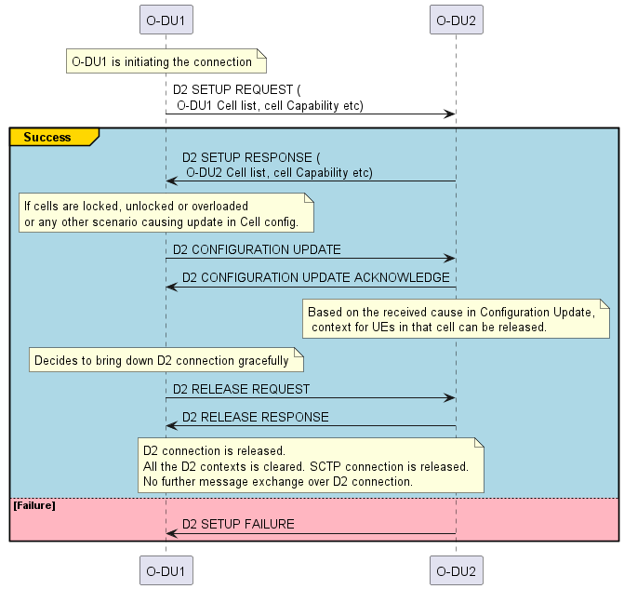
Figure 5: D2CP Interface Management Function
Figure 6 indicates the D2CP messages that are exchanged for establishing/releasing or modifying the D2 UE context in SCell O-DU.

@startuml
Skinparam titleBorderRoundCorner 25
skinparam titleBorderThickness 2
skinparam titleBorderColor red
skinparam titleBackgroundColor Coral
skinparam titleFontSize 20
participant CU as "O-CU-CP"
participant pDU as "PCell O-DU"
participant sDU as "SCell O-DU"
participant UE
Note over pDU, sDU: D2 connection is up and running
group #lightpink "First UE Addition from a SCell O-DU"
CU-> pDU: UE CONTEXT SETUP/MODIFICATION REQUEST
pDU ->sDU : UE ADDITION REQUEST
sDU-> pDU: UE ADDITION RESPONSE
pDU ->CU: UE CONTEXT SETUP/MODIFICATION RESPONSE
end
group #lightblue "Addition of more SCells or modification in existing SCells for a UE"
CU-> pDU: UE CONTEXT MODIFICATION REQUEST
pDU ->sDU : UE MODIFICATION REQUEST
sDU-> pDU: UE MODIFICATION RESPONSE
pDU ->CU: UE CONTEXT MODIFICATION RESPONSE (status)
end
CU->UE: RRC Reconfiguration Request (via F1 procedure)
UE->pDU: RRC Reconfiguration Complete
pDU->sDU: UE RECONFIGURATION COMPLETE
group #lightyellow SCell O-DU is unable to handle UE for a SCELL
sDU-> pDU: UE MODIFICATION INDICATION
end
group #lightgreen "Either CU decides to release Scell or UE is Released – UE release function"
CU-> pDU: UE CONTEXT MODIFICATION/RELEASE
pDU ->sDU: UE DELETION REQUEST
sDU-> pDU: UE DELETION RESPONSE
End
@enduml
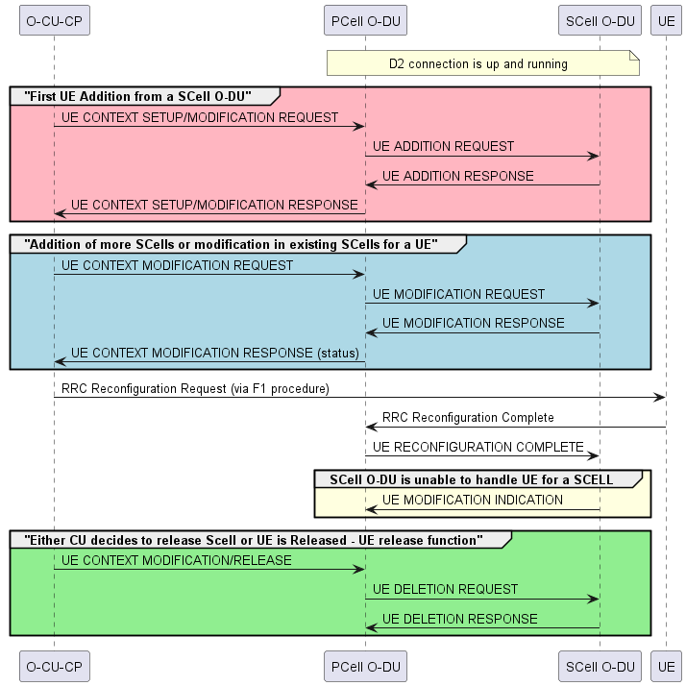
Figure 6: D2CP UE management functions

Figure 7 captures the messages that will be exchanged over D2 interface for transferring the user data. These messages are exchanged over UDP/IP transport protocols.
@startuml
Skinparam titleBorderRoundCorner 15
skinparam titleBorderThickness 2
skinparam titleBorderColor red
skinparam titleBackgroundColor Coral
skinparam titleFontSize 30
participant pDU as "PCell O-DU"
participant sDU as "SCell O-DU"
Note over pDU : DL Data Received from O-CU-UP
Group CSI report
Note over pDU : Receives CSI Indication \nfor the SCell from UE.
pDU->sDU : UCI TRANSFER (CSI, etc.)
end

Note over pDU: PCell O-DU determines the user data size. it requests \n the SCell O-DU to schedule the UE in a requested slot range.
Group User Data Transfer
Note over pDU: PCell O-DU may send asynchronously many DL SCHEDULE REQUEST messages \nwith different user data size and may also extend the slot range
pDU->sDU : DL SCHEDULING REQUEST (Requested User Data size, requested slot range, CSI, etc.)
Note over sDU: SCell O-DU determines the data size and slot it can schedule \n and sends that to the PCell O-DU
sDU->pDU: DL DATA REQUIRED (Scheduled user data size, selected slot)
Note over sDU: The SCell O-DU may send asynchronously many DL DATA REQUIRED \n messages for different selected slots
Note Over pDU: Allocates PUCCH resources for the selected slot
pDU->sDU : PUCCH RESOURCE TRANSFER(K1, DAI, etc.)
Note over pDU: PCell O-DU sends the user data TB matching \nthe scheduled size received from the SCell O-DU
pDU->sDU: DL DATA TRANSFER(User Data TB, etc.)
end

Group HARQ control, CSI report, TB Clearing
Note over pDU: UE has sent HARQ feedback or CSI report and/or PCell O-DU indicates clearing of a TB
pDU -> sDU : UCI TRANSFER (HARQ feedback,CSI,TB Clear-flag, etc.)
end
@enduml
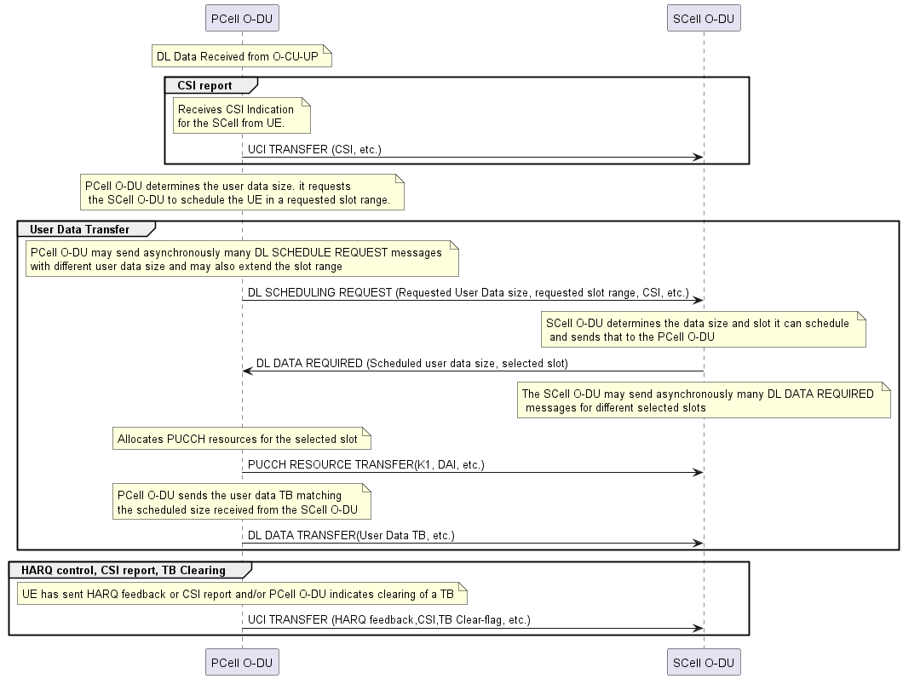
Figure 7: D2UP messages

Annex (informative):
Change history/Change request (history)

Date | Revision | Description
2025.07.22 | 01.00.00 | Initial Version
2025.10.15 | 00.00.01 | Incorporated CRs MAV-0021
2025.11.10 | 00.00.02 | Incorporated Review comments
2025.11.13 | 00.00.03 | Incorporated Review comments
2025.11.14 | 00.00.04 | Incorporated review comments
2025.11.17 | 00.00.05 | Spec renamed. Incorporated review comments
2025.11.18 | 00.00.06 | Editorial corrections. Some more clarification added for few of the fields

