
O-RAN.WG6.TS.O-Cloud-IM.0-R005-v06.00
Technical Specification

O-RAN Work Group 6 (Cloudification and Orchestration)
O-Cloud Information Model

Copyright © 2026 by the O-RAN ALLIANCE e.V.
The copying or incorporation into any other work of part or all of the material available in this specification in any form without the prior written permission of O-RAN ALLIANCE e.V. is prohibited, save that you may print or download extracts of the material of this specification for your personal use, or copy the material of this specification for the purpose of sending to individual third parties for their information provided that you acknowledge O-RAN ALLIANCE as the source of the material and that you inform the third party that these conditions apply to them and that they must comply with them.

O-RAN ALLIANCE e.V., Buschkauler Weg 27, 53347 Alfter, Germany
Register of Associations, Bonn VR 11238, VAT ID DE321720189

Contents
List of figures 3
List of tables 3
Foreword 5
Modal verbs terminology 5
Executive summary 5
Introduction 5
1 Scope 6
2 References 6
2.1 Normative references 6
2.2 Informative references 6
3 Definition of terms, symbols and abbreviations 7
3.1 Terms 7
3.2 Symbols 7
3.3 Abbreviations 7
4 O-Cloud Information Model 7
4.1 Information Modeling Conventions 7
4.1.1 Modeling approach, Unified Modeling Language (UML) 7
4.1.2 Namespaces in the Information Model 7
4.1.3 Namespace Relationships 8
4.2 Information Model Definitions 8
4.2.1 Namespace: ORAN.O2ims.Inventory 8
4.2.2 Namespace: ORAN.O2ims.Artifacts 65
4.2.3 Namespace: ORAN.O2ims.Cluster 70
4.2.4 Namespace: ORAN.O2ims.Provisioning 78
4.2.5 Namespace: ORAN.O2ims.Infrastructure 84
Annex (informative): Change History 97

List of figures
Figure 4.1.3-1 Relationship between Namespaces 8
Figure 4.2.1.3.1.2-1 O2ims Inventory Objects Relationship Views 10
Figure 4.2.1.3.1.2-2 O2ims Inventory Event Subscribe/Notify Relationship View 11
Figure 4.2.1.3.1.3.1-1 O2ims Alarm Relationship View 11
Figure 4.2.1.3.1.3.2-1 Performance Monitoring Information Flow 12
Figure 4.2.1.3.1.3.2-2 O2ims Performance Store Relationship View 13
Figure 4.2.1.3.1.3.2-3 O2ims Performance Measurement Job Relationship View 14
Figure 4.2.1.3.1.3.2-4 O2ims Performance Subscription Relationship View 15
Figure 4.2.1.3.1.3.2-5 O2ims Performance Report Relationship View 16
Figure 4.2.1.3.1.4.1-1 illustrates the O-Cloud networking-related Resource relationships between the Information Object Classes. 17
Figure 4.2.1.3.1.4.2.2-1 illustrates the Hardware Layer View and networking related Information Object Classes 18
Figure 4.2.1.3.1.4.2.3-1 illustrates the Execution Environment Layer View and networking related Information Object Classes 19
Figure 4.2.1.3.2.1-1 O2ims Inventory Intra-Namespace Inheritance 19
Figure 4.2.1.3.2.1-2 O2ims Inventory Inter-Namespace Inheritance 20
Figure 4.2.1.3.2.2-1 O2ims Alarm Inheritance 20
Figure 4.2.1.3.2.2-1 O2ims Performance Inheritance 20
Figure 4.2.1.4.16.4-1 State & Status Diagram for PerformanceMeasurementJob 44
Figure 4.2.2.3.1.2-1 ORAN.O2ims.Artifacts Intra-Namespace Relationships 66
Figure 4.2.2.3.1.3-1 ORAN.O2ims.Artifacts Inter-Namespace Relationships 67
Figure 4.2.2.3.2.1-1 ORAN.O2ims.Artifacts Inheritance 67
Figure 4.2.3.3.1.2-1 ORAN.O2ims.Cluster Intra-Namespace Relationships 71
Figure 4.2.3.3.1.3-1 ORAN.O2ims.Cluster Inter-Namespace Relationships 71
Figure 4.3.2.2.2.1-1 ORAN.O2ims.Cluster Inheritance 72
Figure 4.2.4.3.1.2-1 ORAN.O2ims.Provisioning Intra-Namespace Relationships 79
Figure 4.2.4.3.1.3-1 ORAN.O2ims.Provisioning Inter-Namespace Relationships 79
Figure 4.2.4.3.2.1-1 ORAN.O2ims.Provisioning Inheritance 80
Figure 4.2.5.3.1.2-1 O-Cloud Networking Overview 86
Figure 4.2.5.3.1.2-2 ORAN.O2ims.Infrastructure Intra-Namespace Relationships 87
Figure 4.2.5.3.1.3-1 ORAN.O2ims.Infrastructure Inter-Namespace Relationships 87
Figure 4.2.5.3.2.1-1 ORAN.O2ims.Infrastructure Inheritance 88

List of tables
Table 4.2.1.2.1-1 Imported Entities 8
Table 4.2.1.2.2-1 Associated Entities 9
Table 4.2.1.4.1.2-1 Attributes Properties for OCloud 21
Table 4.2.1.4.2.2-1 Attributes Properties for ResourceType 23
Table 4.2.1.4.3.2-1 Attributes Properties for ResourcePool 25
Table 4.2.1.4.4.2-1 Attributes Properties for Resource 26
Table 4.2.1.4.5.2-1 Attributes Properties for DeploymentManager 28
Table 4.2.1.4.6.2-1 Attributes Properties for InventorySubscription 29
Table 4.2.1.4.8.1-1 InfrastructureInventoryEvent Requirements 31
Table 4.2.1.4.8.2-1 Attributes Properties for InfrastructureInventoryEvent 31
Table 4.2.1.4.9.1-1 OCloudAvailableNotification Requirements 32
Table 4.2.1.4.9.2-1 Attributes Properties for OCloudAvailableNotification 32
Table 4.2.1.4.10.1-1 AlarmEventRecord Requirements 33
Table 4.2.1.4.10.2-1 Attributes Properties for AlarmEventRecord 33
Table 4.2.1.4.11.1-1 AlarmEvent Requirements 36
Table 4.2.1.4.11.2-1 Attributes Properties for AlarmEvent 36
Table 4.2.1.4.12.1-1 Subscription Requirements 37
Table 4.2.1.4.12.2-1 Attributes Properties for AlarmSubscription 37
Table 4.2.1.4.13.1-1 AlarmList Requirements 38
Table 4.2.1.4.13.2-1 Attributes Properties for AlarmList 38
Table 4.2.1.4.14.1-1 PerformanceMeasurementStore Requirements 39
Table 4.2.1.4.14.2-1 Attributes Properties for PerformanceMeasurementStore 39
Table 4.2.1.4.15.2-1 Attributes Properties for PerformanceMeasurementRecord 40
Table 4.2.1.4.16.1-1 PerformanceMeasurementJob Requirements 41
Table 4.2.1.4.16.2-1 Attributes Properties for PerformanceMeasurementJob 41
Table 4.2.1.4.16.3-1 Attributes Constraints for PerformanceMeasurementJob 43
Table 4.2.1.4.17.2-1 Attributes Properties for MeasuredResource 44
Table 4.2.1.4.18.2-1 Attributes Properties for CollectedMeasurement 45
Table 4.2.1.4.19.2-1 Attributes Properties for PerformanceMeasurementJobChangeSubscription 46
Table 4.2.1.4.20.2-1 Attributes Properties for PerformanceMeasurementJobChangeNotification 48
Table 4.2.1.4.21.1-1 PerformanceSubscription Requirements 50
Table 4.2.1.4.21.2-1 Attributes Properties for PerformanceSubscription 50
Table 4.2.1.4.22.2-1 Attributes Properties for PerformanceReportingFrequency 52
Table 4.2.1.4.23.2-1 Attributes Properties for PerformanceSubscriptionCriteria 53
Table 4.2.1.4.24.1-1 PerformanceMeasurementReport Requirements 54
Table 4.2.1.4.24.2-1 Attributes Properties for PerformanceMeasurementReport 54
Table 4.2.1.4.25.2-1 Attributes Properties for JobReport 56
Table 4.2.1.4.26.2-1 Attributes Properties for ResourceReport 56
Table 4.2.1.4.27.2-1 Attributes Properties for MeasurementValue 57
Table 4.2.1.4.28.2-1 Attributes Properties for NotifyFileReady 58
Table 4.2.1.4.29.2-1 Attributes Properties for FileInfo 59
Table 4.2.1.4.30.2-1 Attributes Properties for Location 61
Table 4.2.1.4.31.2-1 Attributes Properties for OCloudSite 62
Table 4.2.1.4.32.2-1 Attributes Properties for LogQuery 63
Table 4.2.1.4.33.2-1 Attributes Properties for DateRange 65
Table 4.2.1.4.33.3-2 Attributes Constraints for DateRange 65
Table 4.2.2.2.1-1 Imported Entities 66
Table 4.2.2.2.2-1 Associated Entities 66
Table 4.2.3.2.1-1 Imported Entities 70
Table 4.2.3.2.2-1 Associated Entities 70
Table 4.2.3.4.1.2-1 Attributes Properties for NodeClusterType 72
Table 4.2.3.4.2.2-1 Attributes Properties for NodeCluster 73
Table 4.2.3.4.3.2-1 Attributes Properties for ClusterResourceType 75
Table 4.2.3.4.4.2-1 Attributes Properties for ClusterResource 76
Table 4.2.3.4.5.2-1 Attributes Properties for ClusterResourceGroup 77
Table 4.2.4.2.1-1 Imported Entities 78
Table 4.2.4.2.2-1 Associated Entities 79
Table 4.2.4.4.1.2-1 Attributes Properties for ProvisioningRequest 80
Table 4.2.4.4.1.3-3 Attributes Constraints for ProvisioningRequest 81
Table 4.2.4.4.2.2-1 Attributes Properties for ProvisioningStatus 82
Table 4.2.4.4.2.2-1 Attributes Properties for ProvisionedResourceSet 84
Table 4.2.5.2.1-1 Imported Entities 85
Table 4.2.5.2.2-1 Associated Entities 85
Table 4.2.5.4.1.2-1 Attributes Properties for InfrastructureResourceType 88
Table 4.2.5.4.1.2-1 Attributes Properties for InfrastructureResource 89
Table 4.2.5.4.3.2-1 Attributes Properties for Gateway 91
Table 4.2.5.4.4.2-1 Attributes Properties for SiteNetwork 92
Table 4.2.5.4.5.2-1 Attributes Properties for AttachmentCircuit 94
Table 4.2.5.4.6.2-1 Attributes Properties for Port 94
Table 4.2.5.4.7.2-1 Attributes Properties for SegmentationElement 95
Table 4.2.5.4.8.2-1 Attributes Properties for NetworkAddress 96
Table 4.2.5.4.8.3-1 Attributes Constraints for EndPoint 96

Foreword
This Technical Specification (TS) has been produced by WG6 of the O-RAN ALLIANCE.
The content of the present document is subject to continuing work within O-RAN and may change following formal O-RAN approval. Should the O-RAN ALLIANCE modify the contents of the present document, it will be re-released by O-RAN with an identifying change of version date and an increase in version number as follows:
version xx.yy.zz
where:
xx: the first digit-group is incremented for all changes of substance, i.e. technical enhancements, corrections, updates, etc. (the initial approved document will have xx=01). Always 2 digits with leading zero if needed.
yy: the second digit-group is incremented when editorial only changes have been incorporated in the document. Always 2 digits with leading zero if needed.
zz: the third digit-group included only in working versions of the document indicating incremental changes during the editing process. External versions never include the third digit-group. Always 2 digits with leading zero if needed.

Modal verbs terminology
In the present document "shall", "shall not", "should", "should not", "may", "need not", "will", "will not", "can" and "cannot" are to be interpreted as described in clause 3.2 of the O-RAN Drafting Rules (Verbal forms for the expression of provisions).
"must" and "must not" are NOT allowed in O-RAN deliverables except when used in direct citation.

Executive summary
The O-Cloud Information Model provides the logical model of information elements and their relationships. This includes:
- Enumerations which provide a predefined list of choices.
- Information Object Classes intended to convey classes that can become an Information Object
- Data Types which provide structure to the elements of an Information Object Class
- Notifications which is the information conveyed in a message from a service publisher to a service consumer

Introduction
The O2 interface exposes information about the O-Cloud to external clients, presumably the SMO as the primary consumer. There are many relationships between elements of the model which need to be captured.
The O-Cloud Information Model is based on the 3GPP process defined to document a Network Resouce Model (NRM). The content contains all the salient elements of the NRM but does not follow the strict outline defined in 3GPP TS 32.160 [i.1]. The outline has been modified to align with other WG6 documents and to eliminate duplicative maintenance which leads to discord within the model.
UML provides a rich set of concepts, notations, and model elements to model distributive systems. 3GPP TS 32.156 [1] provides the necessary and sufficient set of UML notations and model elements, including the ones built by the UML extension mechanism <<stereotype>> to model network management systems and their managed nodes. These conventions are applied to the O-Cloud Information Model.
The Information model uses embedded PlantUML for diagraming. The information model relationships are modeled using UML Class diagram conventions.

1 Scope
The contents of the present document are subject to continuing work within O-RAN and may change following formal O-RAN approval. Should the O-RAN Alliance modify the contents of the present document, it will be re-released by O-RAN with an identifying change of version date and an increase in version number as follows:
version xx.yy.zz
where:
xx: the first digit-group is incremented for all changes of substance, i.e. technical enhancements, corrections, updates, etc. (the initial approved document will have xx=01). Always 2 digits with leading zero if needed.
yy: the second digit-group is incremented when editorial only changes have been incorporated in the document. Always 2 digits with leading zero if needed.
zz: the third digit-group included only in working versions of the document indicating incremental changes during the editing process. External versions never include the third digit-group. Always 2 digits with leading zero if needed.
This document is both a Specification and an Informational Report in that it specifies the Information Model that is foundational for O-RAN’s model-driven architecture for the O-Cloud information exposed over the O2 interface.
In addition, this document includes information about existing standards and industry work that serve as a basis for work items in O-RAN.
Lastly, this document describes the de facto methods and procedures with respect to a “modeling continuum” that aims to establish and evolve an O-Cloud Information Model from which O-RAN Data Models may be generated manually or with a set of tools.

2 References

2.1 Normative references
References are either specific (identified by date of publication and/or edition number or version number) or non-specific. For specific references, only the cited version applies. For non-specific references, the latest version of the referenced document (including any amendments) applies. In the case of a reference to a 3GPP document, a non-specific reference implicitly refers to the latest version of that document in Release 18, or the latest 3GPP release prior to Release 18 that includes that document.
NOTE: While any hyperlinks included in this clause were valid at the time of publication, O-RAN cannot guarantee their long-term validity.
The following referenced documents are necessary for the application of the present document.
[1] 3GPP TS 32.156: "Fixed Mobile Convergence repertoire ".
[2] O-RAN.WG10.TS. Information Model and Data Models: "O-RAN Information Model and Data Models Specification".
[3] O-RAN.WG6.TS.Orch-Use-Cases: “Cloudification and Orchestration Use Cases and Requirements for O-RAN Virtualized RAN”
[4] OMG: "Unified Modelling Language Specification, Version 2.5.1". https://www.omg.org/spec/UML/2.5.1.
[5] IETF RFC 5424 : "The Syslog Protocol”

2.2 Informative references
References are either specific (identified by date of publication and/or edition number or version number) or non-specific. For specific references, only the cited version applies. For non-specific references, the latest version of the referenced document (including any amendments) applies. In the case of a reference to a 3GPP document, a non-specific reference implicitly refers to the latest version of that document in Release 18, or the latest 3GPP release prior to Release 18 that includes that document.
NOTE: While any hyperlinks included in this clause were valid at the time of publication, O-RAN cannot guarantee their long-term validity.
The following referenced documents are not necessary for the application of the present document, but they assist the user with regard to a particular subject area.
[i.1] 3GPP TR 32.160: " Management service template".
[i.2] O-RAN.WG6.TS.O2-GA&P: “O2 Interface General Aspects and Principles”.
[i.3] O-RAN.WG6.TS.CADS: "Cloud Architecture and Deployment Scenarios".
[i.4] ITU-T Recommendation X.733 (02/92): "Information technology - Open Systems Interconnection - Systems Management: Alarm reporting function"
[i.5] ITU-T Recommendation X.736, "Information Technology - Open Systems Interconnection - System Management: Security Alarm Reporting Function', 1992"

3 Definition of terms, symbols and abbreviations

3.1 Terms
For the purposes of the present document, the following terms apply:
Generalized Object This is a kind of object whereby specialized objects can be derived from.
Specialized Object This is a kind of object which is derived from one or more Generalized Object(s).

3.2 Symbols
For the purposes of the present document, the following symbols apply:

3.3 Abbreviations
For the purposes of the present document, the [following] abbreviations [given in ... and the following] apply:
AAL Accelerator Abstraction Layer
OIM O-Cloud Information Model

4 O-Cloud Information Model

4.1 Information Modeling Conventions

4.1.1 Modeling approach, Unified Modeling Language (UML)
The Information Model within O-Cloud Infrastructure shall use the Unified Modeling Language™ (UML®) version 2.5.1 [4] from the Object Management Group (OMG).
The O-Cloud Infrastructure Information Model shall follow methodology documented in 3GPP TS 32.160 [i.1] Clause 5.2.

4.1.2 Namespaces in the Information Model
A Namespace provides a container for named elements, which are called its members. A Namespace may also import named elements from other specifications, in which case those elements become members of the importing Namespace.

4.1.3 Namespace Relationships
Figure 4.1.3-1 describes the relationship between each namespace defined in this specification.
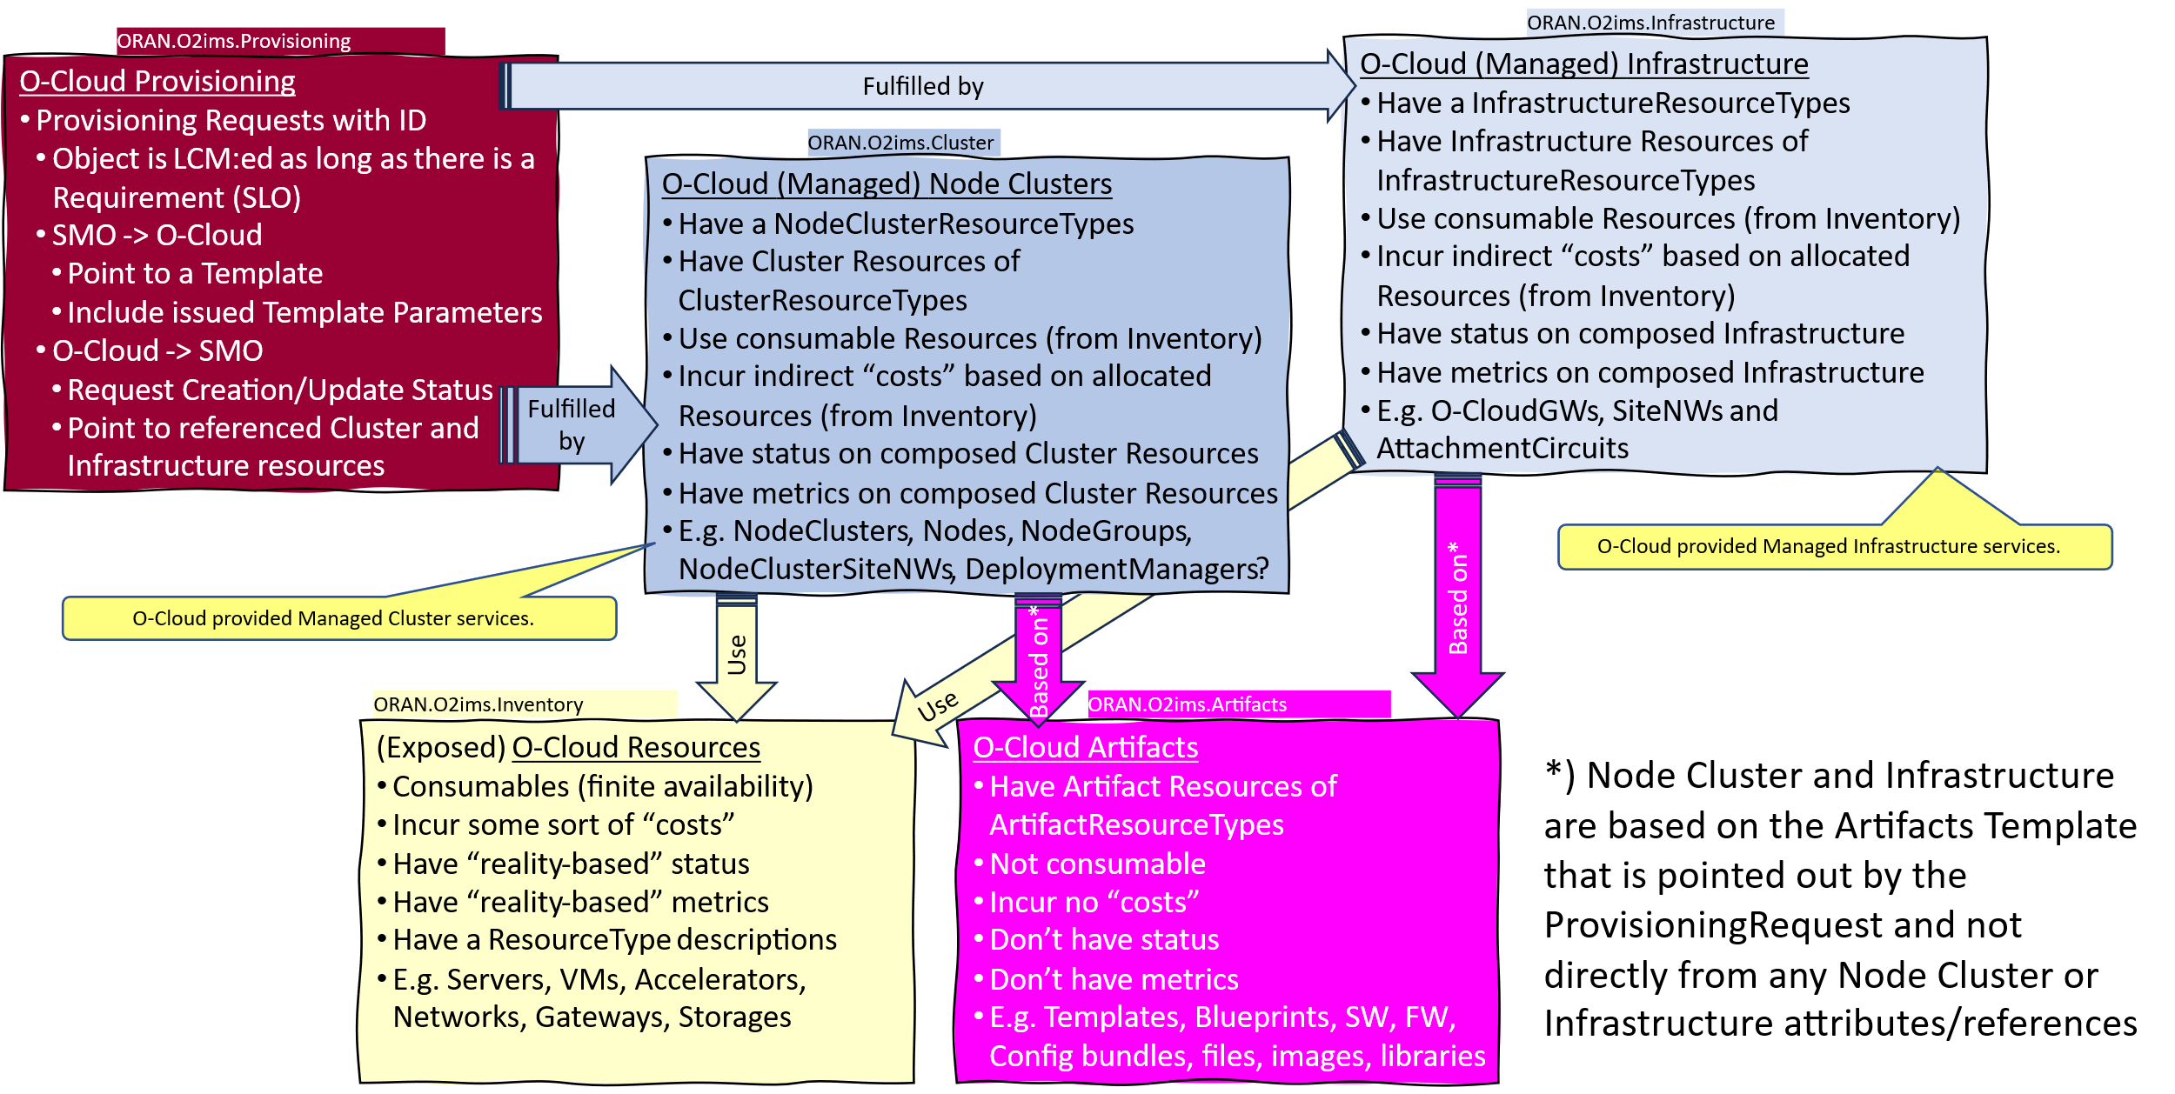
Figure 4.1.3-1 Relationship between Namespaces

4.2 Information Model Definitions

4.2.1 Namespace: ORAN.O2ims.Inventory

4.2.1.1 Namespace Overview
The O-RAN O2ims Inventory namespace defines the classes and their attributes which are directly exposed to the consumer (SMO) via its O2 IMS Interface.
This namespace is used for O-Cloud infrastructure Resources. That content is meant only to be internally consumable to the O-Cloud. The O2ims Inventory has status, metrics and types as well as its topologies. These resources can be used to build up the O-Cloud Node Clusters and their compute, networking and storage capabilities.

4.2.1.2 Imported and associated information entities

4.2.1.2.1 Imported information entities and local labels
Information entities imported into the model are also elements of the namespace and therefore shall remain unique within the namespace.
Table 4.2.1.2.1-1 Imported Entities
Label reference | Local label
TS 28.622 [6], information object class, Top | Top

4.2.1.2.2 Associated information entities and local labels
Information entities referenced in the model through an association which may be extended and overloaded with a new entity of the same name within the namespace are listed in the associated entities table.
Table 4.2.1.2.2-1 Associated Entities
Label reference | Local label
WG10 IM/DM [2], PerformanceMeasureDictionary | PerformanceMeasureDictionary
WG10 IM/DM [2], PerformanceMeasureDefinition_ | PerformanceMeasureDefinition
WG10 IM/DM [2], AlarmDictionary | AlarmDictionary
WG10 IM/DM [2], AlarmDefinition | AlarmDefinition
WG10 IM/DM [2], ProbableCause | ProbableCause
4.2.2.4.1, ArtifactResourceType | ArtifactResourceType
4.2.2.4.1, ArtifactResource | ArtifactResource
4.2.3.4.1, ClusterResourceType | ClusterResourceType
4.2.3.4.2, ClusterResource | ClusterResource
4.2.3.4.3, NodeClusterType | NodeClusterType
4.2.3.4.4, NodeCluster | NodeCluster
4.2.4.4.1, InfrastructureResourceType | InfrastructureResourceType
4.2.4.4.2, InfrastructureResource | InfrastructureResource

4.2.1.3 Class Diagram

4.2.1.3.1 Relationships

4.2.1.3.1.1 Description
This clause depicts the set of classes (e.g. IOCs) that encapsulates the information relevant for the O-RAN Cloud (O-Cloud). This clause provides an overview of the relationships between relevant classes in UML. Subsequent clauses provide more detailed specification of various aspects of these classes. The UML Class diagram depicts a view of the namespace maintaining a defined focus so as not to overcrowd a single diagram trying to depict all relationships within the namespace.

4.2.1.3.1.2 O2ims Inventory Object Relationships
The O2ims services have operations on the following managed service objects that are provided by the O-Cloud:
- OCloud,
- Location,
- OCloudSite,
- ResourceType,
- ResourcePool,
- Resource,
- DeploymentManager, and
- InventoryChangeSubscription

Figure 4.2.1.3.1.2-1 illustrates the relationships in between the information entities of the O2ims_InfrastructureInventory services. Figure 4.2.1.3.1.2-2 illustrates the relationship for the subscribe/notify pattern.

@startuml
skin rose
skinparam ClassStereotypeFontStyle normal
skinparam style strictuml
hide members

Namespace ORAN.O2ims.Inventory {
Class “O-Cloud” as OCloud

Class OCloudAvailableNotification <<notification>>
Class DeploymentManager

Class Location

Class “O-CloudSite” as OCloudSite

Class ResourcePool

Class Resource

Class ResourceType

Enum ResourceKind <<enumeration>>

Enum ResourceClass <<enumeration>>

OCloud .u.> OCloudAvailableNotification : SendsOnCreation
OCloud “1” *--> “+deploymentManagers\n1..*” DeploymentManager
OCloud “1” *--> “+oCloudSites\n1..*” OCloudSite
OCloud “1” *--> “+locations\n1..*” Location
Location “1” <--> “+oCloudSites\n0..*” OCloudSite : “\n”
OCloudSite “1” --> “+resourcePools\n1..*” ResourcePool
ResourcePool “1” *--> “+resources\n1..*” Resource
Resource “1” o--> “+elements\n0..*” Resource : IsComposedOf
Resource “0..*” --> “+resourceType\n1” ResourceType
OCloud “1” *--> “+resourceTypes\n1..*” ResourceType
ResourceType .. ResourceKind
ResourceType .. ResourceClass
ResourceType "1" -r-> "+alarmDictionary\n0..1" ORAN.ManagementArtifacts.AlarmDictionary
ResourceType "1" -r-> "+performanceDictionary\n0..1" ORAN.ManagementArtifacts.PerformanceDictionary

ORAN.ManagementArtifacts.AlarmDictionary –[hidden]- ORAN.ManagementArtifacts.PerformanceDictionary

}
@enduml
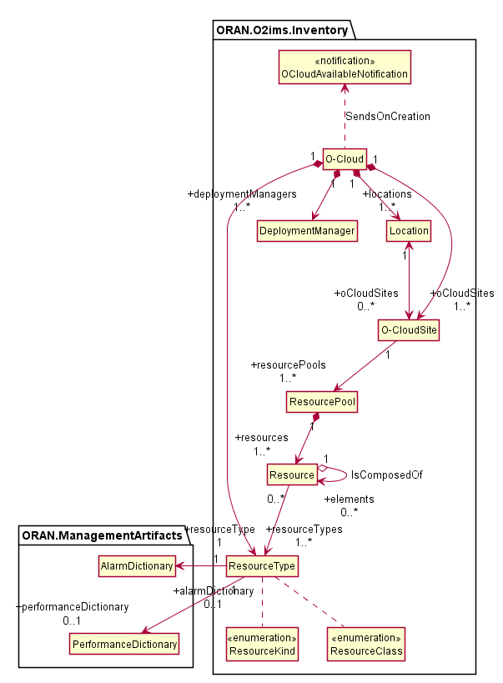
Figure 4.2.1.3.1.2-1 O2ims Inventory Objects Relationship Views
@startuml
skin rose
skinparam ClassStereotypeFontStyle normal
skinparam style strictuml
hide members

Namespace ORAN.O2ims.Inventory {
Class InventorySubscription

Abstract Class InfrastructureInventoryObject_
InfrastructureInventoryObject_ <|-- Resource
InfrastructureInventoryObject_ <|-- ResourceType
InfrastructureInventoryObject_ <|-- ResourcePool
InfrastructureInventoryObject_ <|-- DeploymentManager
InfrastructureInventoryObject_ <|-- “O-Cloud”
InfrastructureInventoryObject_ <|-- Location
InfrastructureInventoryObject_ <|-- “O-CloudSite”

Enum NotificationEventType <<enumeration>>

Class InfrastructureInventoryEvent <<notification>>

InfrastructureInventoryEvent .r. NotificationEventType
InfrastructureInventoryEvent “*” --> “+priorObjectState\n0..1” InfrastructureInventoryObject_
InfrastructureInventoryEvent “*” --> “+postObjectState\n0..1” InfrastructureInventoryObject_
InventorySubscription “1” --> “*” InfrastructureInventoryEvent : Subscription_Creates_Notification

}
@enduml
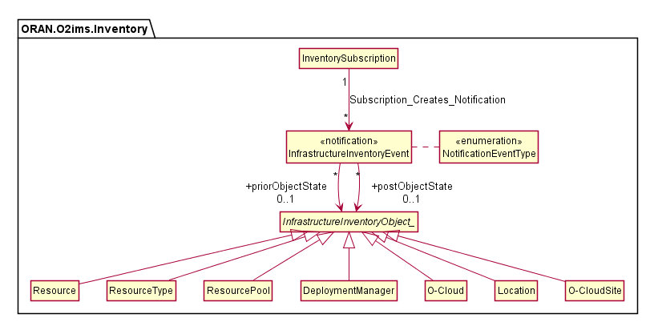
Figure 4.2.1.3.1.2-2 O2ims Inventory Event Subscribe/Notify Relationship View

4.2.1.3.1.3 Infrastructure Monitoring Relationships

4.2.1.3.1.3.1 Infrastructure Fault Relationships
The O2ims_InfrastructureMonitoring services has operations on the following managed service objects that are provided by the O-Cloud for faults:
- AlarmList
- AlarmSubscription
- LogQuery

Figure 4.2.1.3.1.3.1 -1 illustrates the relationships in between the information entities of the O2ims_InfrastructureMonitoring fault services.
@startuml
skin rose
skinparam ClassStereotypeFontStyle normal
skinparam style strictuml
hide members

Namespace ORAN.ManagementArtifacts {
Class AlarmDefinition

Class ProbableCause

}

Namespace ORAN.O2ims.Any {
Class ObjectType <<dataType>>

Class Object <<dataType>>

Object -u[hidden]-> ObjectType
Object -u[hidden]-> ORAN.ManagementArtifacts.AlarmDefinition
}

Namespace ORAN.O2ims.Inventory {

Class AlarmSubscription

Enum AlarmNotificationType <<enumeration>>

Enum PerceivedSeverity <<enumeration>>

Class AlarmEventRecord <<dataType>>

AlarmEventRecord --> ORAN.ManagementArtifacts.ProbableCause : IsDiagnosedAs
AlarmEventRecord --> PerceivedSeverity

Class AlarmEvent <<notification>>

AlarmEvent *-> AlarmEventRecord

AlarmEvent --> AlarmNotificationType
AlarmSubscription --> AlarmEvent : Creates

AlarmEventRecord -u-> ORAN.O2ims.Any.ObjectType : References
AlarmEventRecord -u-> ORAN.O2ims.Any.Object : References

AlarmEventRecord --> ORAN.ManagementArtifacts.AlarmDefinition : IsDefinedByA

Class AlarmList
AlarmList *-d-> AlarmEventRecord : HasMany

Class LogQuery
Class DateRange <<dataType>>
LogQuery “1” *--> “0..*\n+dateRanges” DateRange
Class NotifyFileReady <<notification>>
LogQuery --> NotifyFileReady : MayCreate

DateRange -l[hidden]- AlarmEvent
}
@enduml
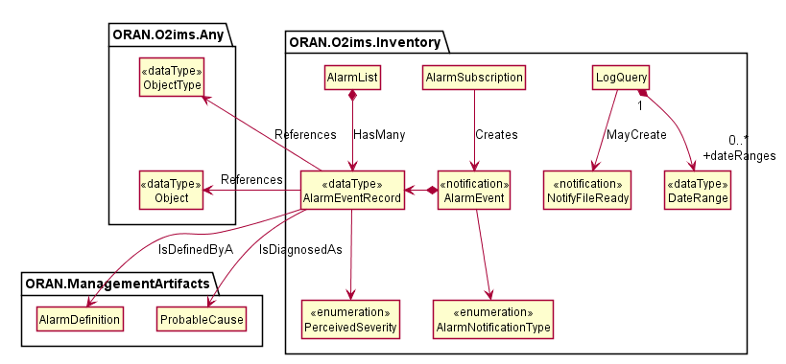
Figure 4.2.1.3.1.3.1-1 O2ims Alarm Relationship View

4.2.1.3.1.3.2 Infrastructure Performance Relationships
The O2ims_InfrastructureMonitoring services follow a flow described in the O2 GAP[i.2] clause 3.9.9. This primarily consists of:
- The Performance Measurement Store - used for storage and configuration of performance measurements.
- The Performance Measurement Job - used to collect performance measurements and insert them into the Performance Measurement Store.
- The Performance Subscription - used to identify what PerformanceMeasurementRecord(s) in the PeformanceMeasurementStore are reported, when they are reported, and how the report is to be delivered to the subscriber.
- The Performance Measurement Report - The notification payload used to convey measurement values identified by a Performance Subscription to the identified subscriber in a format selected by the subscriber.
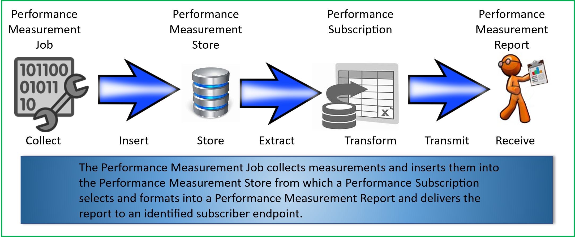
Figure 4.2.1.3.1.3.2-1 Performance Monitoring Information Flow
The O2ims_InfrastuctureMonitoring information model have sub-components as follows:
- Performance Store
  - PerformanceMeasurementStore
  - PerformanceMeasurementRecord
- Performance Jobs
  - PerformanceMeasurementJob
  - MeasuredResource
  - CollectedMeasurement
  - PerformanceMeasurementJobChangeSubscription
  - PerformanceMeasurementJobChangeNotification
- Performance Subscriptions
  - PerformanceSubscription
  - PerformanceReportingFrequency
  - PerformanceSubscriptionCriteria
- Performance Reports
  - PerformanceMeasurementReport
  - JobReport
  - ResourceReport
  - MeasurementValue
  - NotifyFileReady
  - FileInfo

Figure 4.2.1.3.1.3.2-2 illustrates the relationships in between the PerformanceMeasurementStore and PerformanceMeasurementRecord and other information entities.
@startuml
skin rose
skinparam ClassStereotypeFontStyle normal
skinparam style strictuml
hide members

Namespace ORAN.O2ims.Inventory {
Class Resource

Class PerformanceMeasurementRecord <<dataType>>

PerformanceMeasurementRecord "*" --> "1" PerformanceMeasurementJob : CollectedBy
PerformanceMeasurementRecord "*" --> "1" ORAN.O2ims.Inventory.Resource : MeasuredObject
PerformanceMeasurementRecord "*" --> "1" ORAN.ManagementArtifacts.PerformanceMeasurementDefinition : IsDefinedBy

Class PerformanceMeasurementStore << InformationObjectClass >>

PerformanceMeasurementStore "1" *--> "*" PerformanceMeasurementRecord : MayHaveMany

}

Namespace ORAN.ManagementArtifacts {
Class PerformanceMeasurementDefinition
}

@enduml
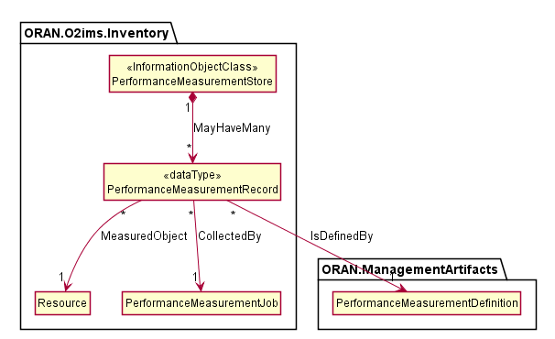

Figure 4.2.1.3.1.3.2-2 O2ims Performance Store Relationship View
Figure 4.2.1.3.1.3.2-3 illustrates the relationships in between the PerformanceMeasurementJob, MeasuredResource, CollectedMeasurement, PerformanceMeasurementJobChangeSubscription and other information entities.
@startuml
skin rose
skinparam ClassStereotypeFontStyle normal
skinparam style strictuml
hide members

Namespace ORAN.O2ims.Inventory {

Enum PerformanceMeasurementJobChangeSubscriptionType <<enumeration>>
Enum PerformanceMeasurementJobChangeSubscriptionDetailType <<enumeration>>

Class PerformanceMeasurementJobChangeSubscription << InformationObjectClass >>

PerformanceMeasurementJobChangeSubscription .. PerformanceMeasurementJobChangeSubscriptionType
PerformanceMeasurementJobChangeSubscription .u. PerformanceMeasurementJobChangeSubscriptionDetailType

Class PerformanceMeasurementJobChangeNotification << (N,orchid) Notification >>

PerformanceMeasurementJobChangeNotification .u. PerformanceMeasurementJobChangeSubscriptionType
PerformanceMeasurementJobChangeNotification --> MeasuredResource
PerformanceMeasurementJobChangeNotification --> CollectedMeasurement

PerformanceMeasurementJobChangeSubscription "1" --> "*" PerformanceMeasurementJobChangeNotification : Subscription_Creates_Notification

Enum PerformanceMeasurementJobState <<enumeration>>

Class MeasuredResource <<dataType>>
MeasuredResource --> Resource
MeasuredResource --> ResourceType
Class CollectedMeasurement <<dataType>>

Class PerformanceMeasurementJob <<InformationObjectClass>>

PerformanceMeasurementJob .. PerformanceMeasurementJobState
PerformanceMeasurementJob "1" *-u-> "*\nresource" MeasuredResource : Job_Measures_Resources
PerformanceMeasurementJob "1" *--> "*\nresource" CollectedMeasurement : Job_Collects_Measurements
PerformanceMeasurementJob "*" --> "*" ORAN.O2ims.Inventory.ResourceType : Job_Measures_ResourceTypes

CollectedMeasurement "*" --> "1" ORAN.ManagementArtifacts.PerformanceMeasurementDefinition : Measure_DefinedBy_Dictionary
CollectedMeasurement --> ResourceType : identifiesDictionary
Class PerformanceMeasurementRecord <<dataType>>

PerformanceMeasurementRecord "*" --> "1" PerformanceMeasurementJob : CollectedBy

}

Namespace ORAN.ManagementArtifacts {
Class PerformanceMeasurementDefinition
}

@enduml
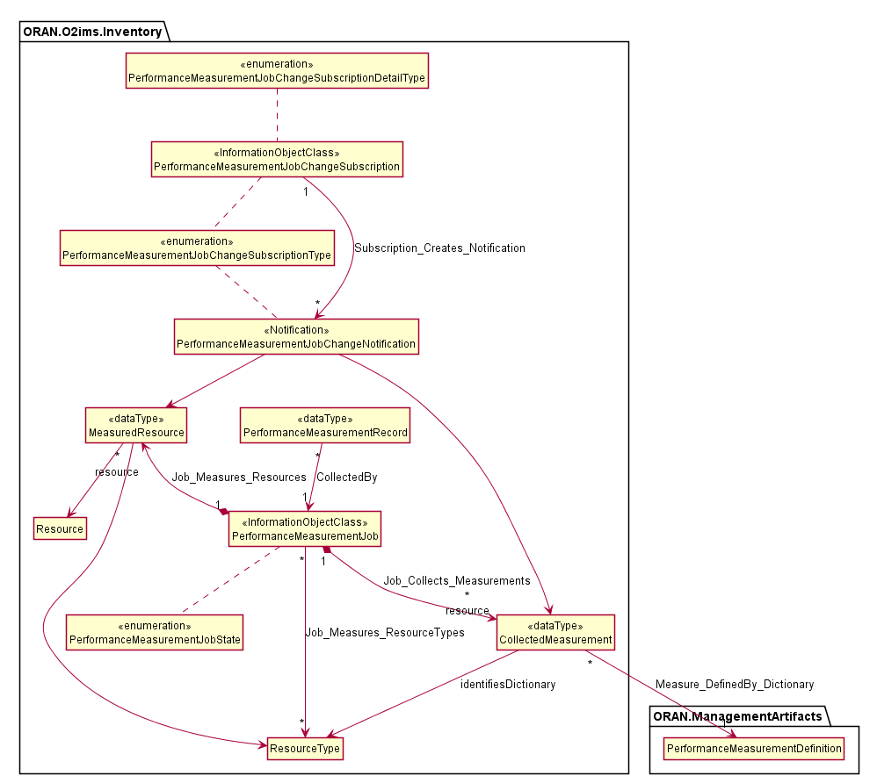
Figure 4.2.1.3.1.3.2-3 O2ims Performance Measurement Job Relationship View
Figure 4.2.1.3.1.3.2-4 illustrates the relationships in between the PerformanceSubscription, PerformanceReportingFrequency, PerformanceSubscriptionCriteria and other information entities.
@startuml
skin rose
skinparam ClassStereotypeFontStyle normal
skinparam style strictuml
hide members

Namespace ORAN.O2ims.Inventory {

Class PerformanceMeasurementStore << InformationObjectClass >>

Class PerformanceSubscriptionCriteria <<dataType>>

enum ReportDeliveryMechanism
enum SubscriptionMode

Class PerformanceReportingFrequency <<dataType>>

PerformanceReportingFrequency .r. SubscriptionMode

Class PerformanceSubscription <<InformationObjectClass>>

PerformanceSubscription .. ReportDeliveryMechanism
PerformanceSubscription *-> PerformanceReportingFrequency
PerformanceSubscription *--> PerformanceSubscriptionCriteria

PerformanceSubscription ..> PerformanceMeasurementStore : SelectsFrom

}

@enduml
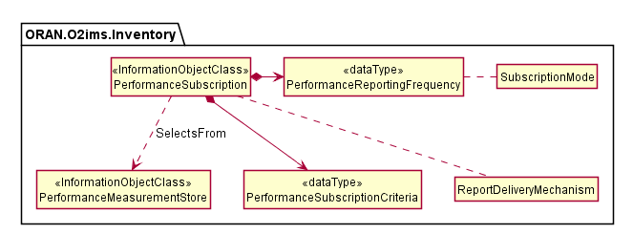

Figure 4.2.1.3.1.3.2-4 O2ims Performance Subscription Relationship View
Figure 4.2.1.3.1.3.2-5 illustrates the relationships in between the PerformanceMeasurementReport, JobReport, ResourceReport, MeasurementValue, NotifyFileReady, FileInfo and other information entities.
@startuml
skin rose
skinparam ClassStereotypeFontStyle normal
skinparam style strictuml
hide members

Namespace ORAN.O2ims.Inventory {

Class PerformanceSubscription << InformationObjectClass >>

Class MeasurementValue <<dataType>>

MeasurementValue "measureId" -d- ORAN.ManagementArtifacts.PerformanceMeasurementDefinition : identifies

Note left on link : measureId can be either:\n\t- performanceMeasurementName\n\t- performanceMeasureId.

Class ResourceReport <<dataType>>

ResourceReport "1" *--> "*" MeasurementValue : hasMany
ResourceReport "1" *--> "1" ORAN.O2ims.Inventory.Resource : MeasuredObject

Class JobReport <<dataType>>

JobReport "1" .. "1" PerformanceMeasurementJob : IsFor
JobReport "1" *--> "1..*" ResourceReport : hasMany

Class PerformanceMeasurementReport <<notification>>

PerformanceMeasurementReport .u. PerformanceSubscription: Subscription_Creates_Notification
PerformanceMeasurementReport "1" *--> "1..*" JobReport : hasMany

Enum FileDataType <<enumeration>>

Class FileInfo <<dataType>>

FileInfo .. FileDataType

Class NotifyFileReady <<notification>>

NotifyFileReady *--> FileInfo
NotifyFileReady .u. PerformanceSubscription: Subscription_Creates_Notification

}

@enduml
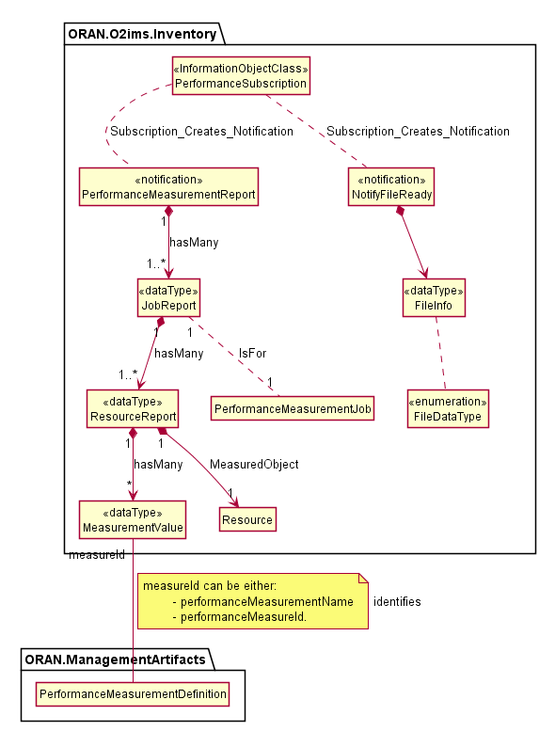
Figure 4.2.1.3.1.3.2-5 O2ims Performance Report Relationship View

4.2.1.3.1.4 O-Cloud Networking Relationships

4.2.1.3.1.4.1 O-Cloud Networking Relationships Overview
The O-Cloud Network provides seamless connectivity within an O-Cloud Site and facilitates external connectivity, such as transport network access, to various O-Cloud Resources. Clause 3.4.3 of the O-RAN.WG6.O2-GA&P [i.2] specification, outlines the fundamental concepts of the O-Cloud provisioning and defines these concepts at different layers. For instance, networking-related concepts such as O-Cloud Site Network Fabric (aka. SiteNWFabric) and O-Cloud Site Gateway (aka. SiteGW) can be defined at the hardware layer, which is related to that layers’ consumable constructs, and the networking-related concepts such as O-Cloud Site Network (aka. SiteNW), O-Cloud Gateway, and O-Cloud AttachmentCircuit can be defined at the execution environment layer as described in the O-RAN.WG6.O2-GA&P [i.2] spec. Also, there can be inter-namespace relationships for instance, Networking concept related to an O-Cloud Node Cluster such as, O-Cloud Node Cluster Site Network (aka. NodeClusterSiteNW) defined in ORAN.O2ims.Clusters namespace mapped to a SiteNW object and terminated by an O-Cloud Gateway object defined in ORAN.O2ims.Inventory namespace.
An O-Cloud AttachmentCircuit as defined in O-RAN.WG6.O2-GA&P [i.2], clause 3.4.3.5.10 has two possible associations — one with an O-Cloud Gateway and another with the SiteNW. This accommodates the two scenarios where a SiteNW connects to the transport network through an O-Cloud Gateway or where a SiteNW connects directly to the transport network. There can also be the case that SiteNWs are only used for internal connectivity within an O-Cloud Site, in which case, there is no need to associate (neither directly, nor via an O-Cloud Gateway) a SiteNW to an O-Cloud AttachmentCircuit.
Figure 4.2.1.3.1.4-1 illustrates the O-Cloud networking-related Resource relationships between the Information Objects Classes.
@startuml
skin rose
skinparam ClassStereotypeFontStyle normal
skinparam style strictuml
hide members

namespace ORAN.O2ims.Clusters {
Class NodeClusterSiteNW <<InformationObjectClass>>
}

namespace ORAN.O2ims.Inventory {
Class Gateway <<InformationObjectClass>>
Class SiteGW <<InformationObjectClass>>
Class SiteNW <<InformationObjectClass>>
Class SiteNWFabric <<InformationObjectClass>>
Class AttachmentCircuit <<InformationObjectClass>>
Class Compute <<InformationObjectClass>>

Gateway "*" --> "1" SiteGW : "RealizedBy"
Gateway "1" --> "*" AttachmentCircuit : "AttachTo"
SiteNW "1" --> "*" AttachmentCircuit : "AttachTo"
SiteNW "*" --> "*" Gateway : "TerminatedBy"
SiteNW “*” --> “1” SiteNWFabric : "RealizedBy"
SiteNW "*" --> "*" Compute : "TerminatedBy"
SiteGW "*" --> "*" SiteNWFabric : "ConnectedTo"
ORAN.O2ims.Clusters.NodeClusterSiteNW "*" --> "*" Gateway : "TerminatedBy"
ORAN.O2ims.Clusters.NodeClusterSiteNW "1" --> "1" SiteNW : "MappedTo"
Compute “*” --> “ *” SiteNWFabric : "ConnectedTo"
}

@enduml
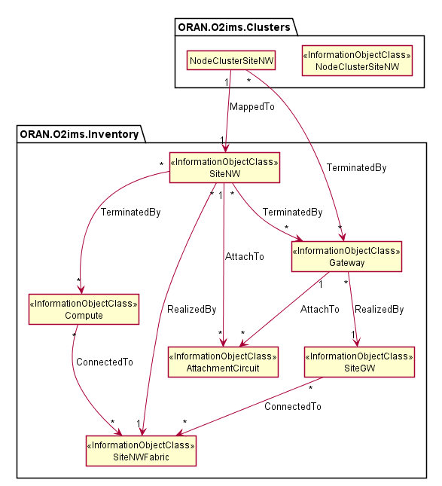
Figure 4.2.1.3.1.4.1-1 O-Cloud networking-related Resource relationships between the Information Object Classes.

4.2.1.3.1.4.2 O-Cloud Networking Relationships View

4.2.1.3.1.4.2.1 Overview
The O-RAN.WG6.O2-GA&P [i.2], clause 3.4.3.3 outlines fundamental concepts of the Resource View. For enabling separation of authority and operations, O-Cloud offers various types of resource views, in the form of different group of actors, some of them deals with hardware or more physical types of O-Cloud Resources whereas, others consume logical set of O-Cloud Resources.

4.2.1.3.1.4.2.2 Hardware Layer View
The O-RAN.WG6.O2-GA&P [i.2], clause 3.4.3.4 explains the Hardware Layer concept, which forms the foundation of a cloud, comprising physical computes that are inter-connected through network fabric and routers for external connectivity. According to O-RAN.WG6.CADS [i.3], a Cloud Site hosts Cloud Infrastructure equipment, abstracting O-Cloud Resources for leasing through the IMS. From the SMO perspective, understanding hardware concepts focuses on O-Cloud Resource locations, capabilities, capacity, availability, and potential disturbances, rather than physical realization.
@startuml
skin rose
skinparam ClassStereotypeFontStyle normal
skinparam style strictuml
hide members

namespace ORAN.O2ims.Inventory {

package "Hardware Layer" as HWL <<rectangle>> {
Class SiteNWFabric <<InformationObjectClass>>
Class SiteGW <<InformationObjectClass>>
Class Compute <<InformationObjectClass>>

SiteGW "*" --> "*" SiteNWFabric : "ConnectedTo"
Compute "*" --> "*" SiteNWFabric : "ConnectedTo"

}

}

@enduml
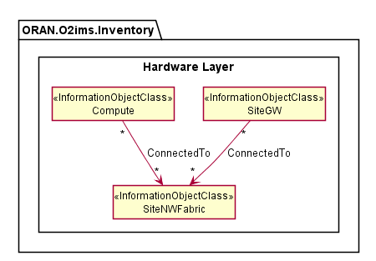
Figure 4.2.1.3.1.4.2.2-1 Hardware Layer View and networking related Information Object Classes

4.2.1.3.1.4.2.3 Execution Environment Layer View
The O-RAN.WG6.O2-GA&P [i.2], clause 3.4.3.5 explains the Execution Environment Layer concept, which transforms hardware layer constructs into consumable O-Cloud Node(s), Site Network(s), Gateway(s), and many more, as abstract O-Cloud Resources available for leasing through the IMS.
@startuml
skin rose
skinparam ClassStereotypeFontStyle normal
skinparam style strictuml
hide members

namespace ORAN.O2ims.Inventory {

package "Execution Environment Layer" as EEL<<rectangle>> {
Class Gateway <<InformationObjectClass>>
Class SiteNW <<InformationObjectClass>>
Class AttachmentCircuit <<InformationObjectClass>>

Gateway "1" --> "*" AttachmentCircuit : "AttachTo"
SiteNW "1" --> "*" AttachmentCircuit : "AttachTo"
SiteNW "*" --> "*" Gateway : "TerminatedBy"

}

}

@enduml
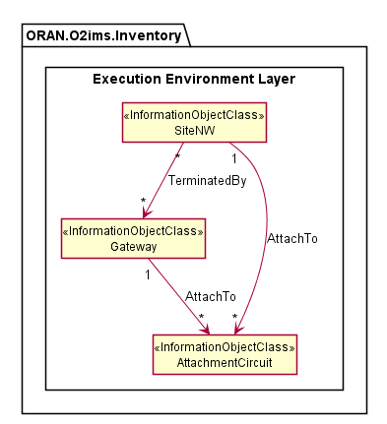
Figure 4.2.1.3.1.4.2.3-1 Execution Environment Layer View and networking related Information Object Classes

4.2.1.3.2 Inheritance

4.2.1.3.2.1 O2ims Inventory Inheritance
This subclause depicts the inheritance relationships of inventory object classes.

This subclause depicts the inheritance relationships.
@startuml
skinparam ClassStereotypeFontStyle normal
skinparam style strictuml
hide members

Abstract Class Top <<InformationObjectClass>>
Abstract Class InfrastructureInventoryObject_ <<InformationObjectClass>>
Top <|-- InfrastructureInventoryObject_
Top <|-r- InventorySubscription

Class InventorySubscription <<InformationObjectClass>>

Class Resource <<InformationObjectClass>>
Class ResourceType <<InformationObjectClass>>
Class ResourcePool <<InformationObjectClass>>
Class DeploymentManager <<InformationObjectClass>>
Class Location <<InformationObjectClass>>
Class “O-Cloud” <<InformationObjectClass>>
Class “O-CloudSite” <<InformationObjectClass>>

InfrastructureInventoryObject_ <|-- Resource
InfrastructureInventoryObject_ <|-l- ResourceType
InfrastructureInventoryObject_ <|-- ResourcePool
InfrastructureInventoryObject_ <|-r- DeploymentManager
InfrastructureInventoryObject_ <|-- “O-Cloud”
InfrastructureInventoryObject_ <|-- Location
InfrastructureInventoryObject_ <|-- “O-CloudSite”

@enduml
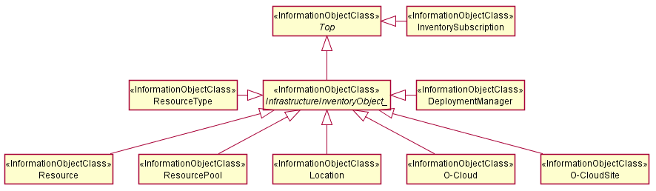
Figure 4.2.1.3.2.1-1 O2ims Inventory Intra-Namespace Inheritance
@startuml
skinparam ClassStereotypeFontStyle normal
skinparam style strictuml
hide members

Namespace ORAN.O2ims.Inventory {
Abstract Class InfrastructureInventoryObject_ <<InformationObjectClass>>
}

Namespace ORAN.O2ims.Artifacts {
Class ArtifactResourceType <<InformationObjectClass>>
Class ArtifactResource <<InformationObjectClass>>

ArtifactResourceType –d[hidden]- ArtifactResource
}

Namespace ORAN.O2ims.Cluster {
Class ClusterResourceType <<InformationObjectClass>>
Class ClusterResource <<InformationObjectClass>>
Class NodeCluster <<InformationObjectClass>>
Class NodeClusterType <<InformationObjectClass>>
}

Namespace ORAN.O2ims.Infrastructure {
Class InfrastructureResourceType <<InformationObjectClass>>
Class InfrastructureResource <<InformationObjectClass>>

InfrastructureResourceType –d[hidden]- InfrastructureResource

}

ORAN.O2ims.Inventory.InfrastructureInventoryObject_ <|-u- ORAN.O2ims.Artifacts.ArtifactResourceType

ORAN.O2ims.Inventory.InfrastructureInventoryObject_ <|-r- ORAN.O2ims.Artifacts.ArtifactResource

ORAN.O2ims.Inventory.InfrastructureInventoryObject_ <|-- ORAN.O2ims.Cluster.ClusterResourceType

ORAN.O2ims.Inventory.InfrastructureInventoryObject_ <|-- ORAN.O2ims.Cluster.ClusterResource

ORAN.O2ims.Inventory.InfrastructureInventoryObject_ <|-- ORAN.O2ims.Cluster.NodeClusterType

ORAN.O2ims.Inventory.InfrastructureInventoryObject_ <|-- ORAN.O2ims.Cluster.NodeCluster

ORAN.O2ims.Inventory.InfrastructureInventoryObject_ <|-u- ORAN.O2ims.Infrastructure.InfrastructureResourceType

ORAN.O2ims.Inventory.InfrastructureInventoryObject_ <|-l- ORAN.O2ims.Infrastructure.InfrastructureResource

@enduml
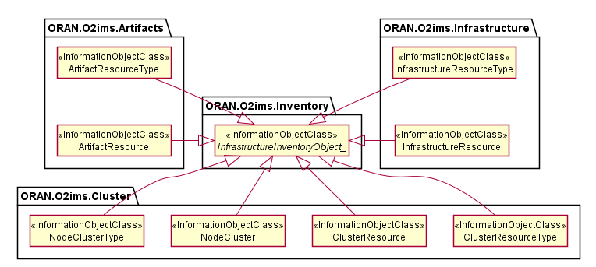
Figure 4.2.1.3.2.1-2 O2ims Inventory Inter-Namespace Inheritance

4.2.1.3.2.2 Infrastructure Monitoring Inheritance
This subclause depicts the inheritance relationships of alarm and performance.
@startuml
skin rose
skinparam ClassStereotypeFontStyle normal
skinparam style strictuml
hide members

Abstract Class Top

Top <|-- AlarmList
Top <|-- AlarmSubscription
Top <|-- LogQuery

@enduml
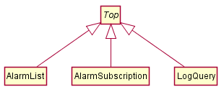
Figure 4.2.1.3.2.2-1 O2ims Alarm Inheritance
Figure 4.2.1.3.2.2-2 depicts the inheritance relationships of Performance.
@startuml
skin rose
skinparam ClassStereotypeFontStyle normal
skinparam style strictuml
hide members

Abstract Class Top

Top <|-r- PerformanceMeasurementStore
Top <|-l- PerformanceMeasurementJob
Top <|-u- PerformanceMeasurementJobChangeSubscription
Top <|-d- PerformanceSubscription

@enduml
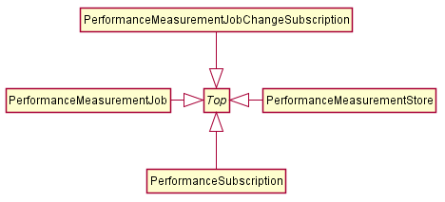
Figure 4.2.1.3.2.2-1 O2ims Performance Inheritance

4.2.1.4 Class Definitions

4.2.1.4.1 OCloud

4.2.1.4.1.1 Definition
The OCloud represents an instance of an O-Cloud. For more information about O-Cloud, refer to the "O-RAN O2 General Aspects and Principles Specification", clause 3.1 [i.2].

4.2.1.4.1.2 Attributes
Table 4.2.1.4.1.2-1 Attributes Properties for OCloud
Attribute name | Data Type/Description | Properties
oCloudId | Data Type: string  Description: Identifier of the O-Cloud instance. Internally generated within an O-Cloud instance. | x-support-qualifier: M  readOnly: True  x-isInvariant: True  x-inventoryNotification: False  x-stateChangeNotification: False  format: uuid
globalCloudId | Data Type: string  Description: Identifier of the O-Cloud instance assigned by the SMO. This identifier is globally unique across O-Cloud instances known to the SMO. This value was provided by the SMO at cloud genesis and is stored in the O-Cloud IMS Inventory. | x-support-qualifier: M  readOnly: True  x-isInvariant: True  x-inventoryNotification: False  x-stateChangeNotification: False  format: uuid
name | Data Type: string  Description: Human readable name of the O-Cloud as identified by the SMO at cloud genesis. | x-support-qualifier: M  x-isInvariant: False  x-inventoryNotification: True  x-stateChangeNotification: False
description | Data Type: string  Description: Human readable description of the O-Cloud as provided by the SMO at cloud genesis. | x-support-qualifier: M  x-isInvariant: False  x-inventoryNotification: True  x-stateChangeNotification: False
infrastructureManagementServicesEndPoint | Data Type: string  Description: The URI root to all services provided by the O2ims interface. Inventory is one of these services. | x-support-qualifier: M  x-isInvariant: False  x-inventoryNotification: True  x-stateChangeNotification: False
resourceTypes | Data Type: array  Description: List of Resource types. | x-support-qualifier: M  x-isInvariant: False  x-inventoryNotification: False  x-stateChangeNotification: False  x-isOrdered: False  minItems: 1  uniqueItems: True  items: ResourceType
locations | Data Type: array  Description: List of locations where O-Cloud Sites are deployed or can be deployed. | x-support-qualifier: M  x-isInvariant: False  x-inventoryNotification True  x-stateChangeNotification: False  x-isOrdered: False  minItems: 1  uniqueItems: True  items: Location
oCloudSites | Data Type: array  Description: List of O-Cloud Sites that are known by the IMS and need to be exposed to the SMO for Homing. | x-support-qualifier: M  x-isInvariant: False  x-inventoryNotification: True  x-stateChangeNotification: False  x-isOrdered: False  minItems: 1  uniqueItems: True  items: OCloudSite
deploymentManagers | Data Type: array  Description: List of Deployment managers. | x-support-qualifier: M  x-isInvariant: False  x-inventoryNotification: False  x-stateChangeNotification: False  x-isOrdered: False  minItems: 1  uniqueItems: True  items: DeploymentManager
smoRegistrationService | Data Type: string  Description: IP address endpoint or the URL of the SMO. | x-support-qualifier: M  x-isInvariant: False  x-inventoryNotification: True  x-stateChangeNotification: False  format: uri
extensions | Data Type: array  Description: These are unspecified (not standardized) properties (keys) which are tailored by the vendor to extend the information provided about the O-Cloud. | x-support-qualifier: M  x-isAlwaysPresent: False  readOnly: True  x-isInvariant: False  x-inventoryNotification: False  x-stateChangeNotification: False  x-isOrdered: False  minItems: 0  uniqueItems: True  items: AttributeValuePair

4.2.1.4.1.3 Attribute constraints
None.

4.2.1.4.1.4 State diagram
None.

4.2.1.4.2 ResourceType

4.2.1.4.2.1 Definition
The ResourceType represents a resource type in an O-Cloud.
Resource types provide the categorization of O-Cloud Nodes as described in the O-RAN Cloud Architecture and Deployment Scenarios [i.3] specification. The values for these types are used to build the inventory and enable an authorized consumer to track resource changes over time. The O-Cloud provides a mechanism to discover the resource types with respective operations on resource types.

4.2.1.4.2.2 Attributes
Table 4.2.1.4.2.2-1 Attributes Properties for ResourceType
Attribute name | Data Type/Description | Properties
resourceTypeId | Data Type: string  Description: Identifier of the resource type. | x-support-qualifier: M  readOnly: True  x-isInvariant: True  x-inventoryNotification: False  x-stateChangeNotification: False  format: uuid
name | Data Type: string  Description: Name of the resource type as identified by the cloud provider. | x-support-qualifier: M  readOnly: True  x-isInvariant: False  x-inventoryNotification: True  x-stateChangeNotification: False
description | Data Type: string  Description: Human readable description of the resource type. | x-support-qualifier: M  readOnly: True  x-isInvariant: False  x-inventoryNotification: True  x-stateChangeNotification: False
vendor | Data Type: string  Description: Name of the provider of the resource type. | x-support-qualifier: M  readOnly: True  x-isInvariant: True  x-inventoryNotification: False  x-stateChangeNotification: False
model | Data Type: string  Description: Information about the model of the resource type | x-support-qualifier: M  readOnly: True  x-isInvariant: True  x-inventoryNotification: False  x-stateChangeNotification: False
version | Data Type: string  Description: Version or generation of the resource type. | x-support-qualifier: M  readOnly: True  x-isInvariant: True  x-inventoryNotification: False  x-stateChangeNotification: False
alarmDictionaryId | Data Type: string  Description: Identifier of the associated dictionary of alarms that can be generated by the resource type. If no alarms are reported against a resource of this resourceType then the alarmDictionaryId is not present. | x-support-qualifier: M  x-isAlwaysPresent: False  readOnly: True  x-isInvariant: True  x-inventoryNotification: False  x-stateChangeNotification: False  format: uuid
performanceDictionaryId | Data Type: string  Description: Identifier of the associated dictionary of performance measurements that can be collected for the resource type. If the resource of this resourceType does not provide any measurements then the performanceDictionaryId is not present. | x-support-qualifier: M  x-isAlwaysPresent: False  readOnly: True  x-isInvariant: True  x-inventoryNotification: False  x-stateChangeNotification: False  format: uuid
resourceKind | Data Type: string  Description: A value describing the "physicality" of the resource type. | x-support-qualifier: M  readOnly: True  x-isInvariant: True  x-inventoryNotification: False  x-stateChangeNotification: False  enum:  - UNDEFINED  - PHYSICAL  - LOGICAL
resourceClass | Data Type: string  Description: A value describing the functional role within the cloud for the resource type.  The list of resource classes is not exhaustive, additional classes will be assessed on a case by case basis. | x-support-qualifier: M  readOnly: True  x-isInvariant: True  x-inventoryNotification: False  x-stateChangeNotification: False  enum:  - UNDEFINED  - COMPUTE  - NETWORKING  - STORAGE
extensions | Data Type: array  Description: These are unspecified (not standardized) properties (keys) which are tailored by the vendor to extend the information provided about the Resource Type. | x-support-qualifier: M  x-isAlwaysPresent: False  readOnly: True  x-isInvariant: True  x-inventoryNotification: False  x-stateChangeNotification: False  x-isOrdered: False  minItems: 0  uniqueItems: True  items: AttributeValuePair

4.2.1.4.2.3 Attribute constraints
None.

4.2.1.4.2.4 State diagram
None.

4.2.1.4.3 ResourcePool

4.2.1.4.3.1 Definition
The ResourcePool represents a resource pool instance in an O-Cloud.
The O-Cloud is a distributed cloud with resources placed in different locations. Those resources are organized into resource pools. There can be more than one resource pool for a given O-Cloud at the same physical location. However, each resource pool requires a different identity since the SMO will direct a deployment based on homing policies to a specific location. This is different than typical cloud deployments as location is key to meeting latency requirements, sometime to elements outside of the O-Cloud.
NOTE 1: The identity of a resource pool cannot be tied to a specific resource within the pool as that resource may be replaced as part of the O-Cloud lifecycle.
NOTE 2: The resource pool is described in the Cloud Architecture and Deployment Secnarios Technical Report [i.3] but may not be needed for exposure through the Information Model and subsequent O2 IMS interface.

4.2.1.4.3.2 Attributes
Table 4.2.1.4.3.2-1 Attributes Properties for ResourcePool
Attribute name | Data Type/Description | Properties
resourcePoolId | Data Type: string  Description: Identifier of the resource pool. Locally unique within the scope of an O-Cloud instance. | x-support-qualifier: M  readOnly: True  x-isInvariant: True  x-inventoryNotification: False  x-stateChangeNotification: False  format: uuid
name | Data Type: string  Description: Human readable name of the resource pool. | x-support-qualifier: M  readOnly: True  x-isInvariant: False  x-inventoryNotification: True  x-stateChangeNotification: False
oCloudSiteId | Data Type: string  Description: Identifier of the O-Cloud site the resource pool is a part of. | x-support-qualifier: M  readOnly: True  x-isInvariant: False  x-inventoryNotification: False  x-stateChangeNotification: False  format: uuid
description | Data Type: string  Description: Human readable description of the resource pool. | x-support-qualifier: M  readOnly: True  x-isInvariant: False  x-inventoryNotification: True  x-stateChangeNotification: False
resources | Data Type: array  Description: List of resource IDs that are part of the resource pool. | x-support-qualifier: M  readOnly: True  x-isInvariant: False  x-inventoryNotification: True  x-stateChangeNotification: False  x-isOrdered: False  minItems: 1  uniqueItems: True  items: string
extensions | Data Type: array  Description: These are unspecified (not standardized) properties (keys) which are tailored by the vendor to extend the information provided about the Resource Pool. | x-support-qualifier: M  x-isAlwaysPresent: False  readOnly: True  x-isInvariant: False  x-inventoryNotification: False  x-stateChangeNotification: False  x-isOrdered: False  minItems: 0  uniqueItems: True  items: AttributeValuePair

4.2.1.4.3.3 Attribute constraints
None.

4.2.1.4.3.4 State diagram
None.

4.2.1.4.4 Resource

4.2.1.4.4.1 Definition
The Resource represents an instance of a resource in the O-Cloud.
Resource pools are comprised of resources, wherein a specific instance of a resource can only be part of a single resource pool.
Resources are of a specific resource type. The resource type of a given resource instance does not change over the lifetime of such a resource instance.
The Resource is a Specialized Object that derives from a Generalized Object, the InfrastructureInventoryObject_. The Resource inherits the attributes from the InfrastructureInventoryObject_.

4.2.1.4.4.2 Attributes
Table 4.2.1.4.4.2-1 Attributes Properties for Resource
Attribute name | Data Type/Description | Properties
resourceId | Data Type: string  Description: Identifier of the resource. Locally unique within the scope of an O-Cloud instance. | x-support-qualifier: M  readOnly: True  x-isInvariant: True  x-inventoryNotification: False  x-stateChangeNotification: False  format: uuid
description | Data Type: string  Description: Human readable description of the resource. | x-support-qualifier: M  readOnly: True  x-isInvariant: False  x-inventoryNotification: True  x-stateChangeNotification: False
resourceTypeId | Data Type: string  Description: Reference to the resource type of the resource. | x-support-qualifier: M  readOnly: True  x-isInvariant: True  x-inventoryNotification: False  x-stateChangeNotification: False  format: uuid
globalAssetId | Data Type: string  Description: Identifier or serial number of the resource, if available. It is required only if the resource has been identified during its addition to the cloud as a reportable asset in the SMO inventory. | x-support-qualifier: M  x-isAlwaysPresent: False  readOnly: True  x-isInvariant: True  x-inventoryNotification: False  x-stateChangeNotification: False  x-nullable: True
resourcePoolId | Data Type: string  Description: Reference to the resource pool that the resource is part of. | support-qualifier: M  readOnly: True  x-isInvariant: True  x-inventoryNotification: False  x-stateChangeNotification: False  format: uuid
elements | Data Type: array  Description: The resource might be composed of smaller resources or other resource instances of a different type. | x-support-qualifier: M  x-isAlwaysPresent: False  readOnly: True  x-isInvariant: False  x-inventoryNotification: True  x-stateChangeNotification: False  x-isOrdered: False  minItems: 0  uniqueItems: True  items: Resource
tags | Data Type: array  Description: Keywords describing or classifying the resource instance. | x-support-qualifier: M  x-isAlwaysPresent: False  x-isInvariant: False  x-inventoryNotification: False  x-stateChangeNotification: False  x-isOrdered: False  minItems: 0  uniqueItems: True  items: string
groups | Data Type: array  Description: Keywords denoting groups a resource belongs to. | x-support-qualifier: M  x-isAlwaysPresent: False  x-isInvariant: False  x-inventoryNotification: False  x-stateChangeNotification: False  x-isOrdered: False  minItems: 0  uniqueItems: True  items: string
extensions | Data Type: array  Description: These are unspecified (not standardized) properties (keys) which are tailored by the vendor to extend the information provided about the Resource. | x-support-qualifier: M  x-isAlwaysPresent: False  readOnly: True  x-isInvariant: False  x-inventoryNotification: False  x-stateChangeNotification: False  x-isOrdered: False  minItems: 0  uniqueItems: True  items: AttributeValuePair

4.2.1.4.4.3 Attribute constraints
None.

4.2.1.4.4.4 State diagram
None.

4.2.1.4.5 DeploymentManager

4.2.1.4.5.1 Definition
The DeploymentManager represents an instance of a DMS in the O-Cloud. This class allows a client to discover the details about a DMS instance. This class provides a list of supported capabilities, and metrics for total capacity, current allocations, current reservations. For more information about DMS, refer to "O-RAN O2 General Aspects and Principles Specification, clause 1.3.1 "[i2].
The available capacity information supported by a DeploymentManager shall be calculated as Capacity - Allocated - Reserved.

4.2.1.4.5.2 Attributes
Table 4.2.1.4.5.2-1 Attributes Properties for DeploymentManager
Attribute name | Data Type/Description | Properties
deploymentManagerId | Data Type: string  Description: Identifier of the deployment manager. Locally unique within the scope of an O-Cloud instance. | x-support-qualifier: M  readOnly: True  x-isInvariant: True  x-inventoryNotification: False  x-stateChangeNotification: False  format: uuid
name | Data Type: string  Description: Human readable name of the deployment manager as identified by the cloud provider. | x-support-qualifier: M  readOnly: True  x-isInvariant: False  x-inventoryNotification: True  x-stateChangeNotification: False
description | Data Type: string  Description: Human readable description of the deployment manageras populated by the cloud provider. | x-support-qualifier: M  readOnly: True  x-isInvariant: False  x-inventoryNotification: True  x-stateChangeNotification: False
oCloudId | Data Type: string  Description: Reference to the O-Cloud associated to the deployment manager. | x-support-qualifier: M  readOnly: True  x-isInvariant: True  x-inventoryNotification: True  x-stateChangeNotification: False  format: uuid
deploymentManagementServiceEndpoint | Data Type: string  Description: Endpoint to access the management services of the deployment manager. | x-support-qualifier: M  readOnly: True  x-isInvariant: False  x-inventoryNotification: True  x-stateChangeNotification: False  format: uri
supportedLocations | Data Type: array  Description: List of globalLocationIDs that were assigned to resource pools that resources allocated to the service instance belong to. | x-support-qualifier: M  readOnly: True  x-isInvariant: False  x-inventoryNotification: True  x-stateChangeNotification: False  x-isOrdered: False  minItems: 1  uniqueItems: True  items: string
capabilities | Data Type: array  Description: Information about the capabilities supported by this set of deployment management services based on the resources allocated to the service instance. See Note. | x-support-qualifier: M  x-isAlwaysPresent: False  readOnly: True  x-isInvariant: False  x-inventoryNotification: True  x-stateChangeNotification: False  x-isOrdered: False  minItems: 0  uniqueItems: True  items: AttributeValuePair
capacity | Data Type: array  Description: Information about the available, allocated and reserved O-Cloud resources capacity allocated to the deployment manager. See Note. | x-support-qualifier: M  x-isAlwaysPresent: False  readOnly: True  x-isInvariant: False  x-inventoryNotification: True  x-stateChangeNotification: False  x-isOrdered: False  minItems: 0  uniqueItems: True  items: AttributeValuePair
extensions | Data Type: array  Description: These are unspecified (not standardized) properties (keys) which are tailored by the vendor to extend the information provided about the Resource Type. | x-support-qualifier: M  x-isAlwaysPresent: False  readOnly: True  x-isInvariant: False  x-inventoryNotification: False  x-stateChangeNotification: False  x-isOrdered: False  minItems: 0  uniqueItems: True  items: AttributeValuePair
NOTE: Values in the array shall be provided once these are known by the IMS.

4.2.1.4.5.3 Attribute constraints
None.

4.2.1.4.5.4 State diagram
None.

4.2.1.4.6 InventorySubscription

4.2.1.4.6.1 Definition
The InventorySubscription represents an instance of a subscription to infrastructure inventory notifications for when an InfrastructureInventoryObject_ within the inventory changes.
Subscriptions are required for a notification to be generated. Information about the change is provided to the consumer when the consumers specified criteria is met. The absence of a filter means all events are sent.

4.2.1.4.6.2 Attributes
Table 4.2.1.4.6.2-1 Attributes Properties for InventorySubscription
Attribute name | Data Type/Description | Properties
subscriptionId | Data Type: string  Description: Identifier of the subscription. Locally unique within the scope of an O-Cloud instance. | x-support-qualifier: M  readOnly: True  x-isInvariant: True  x-inventoryNotification: False  x-stateChangeNotification: False  format: uuid
callback | Data Type: string  Description: The URL of the callback to which notifications are delivered to. | x-support-qualifier: M  x-isInvariant: False  x-inventoryNotification: False  x-stateChangeNotification: False  format: uri
consumerSubscriptionId | Data Type: string  Description: The consumer may provide its identifier for tracking, routing, or identifying the subscription used to report the event. | x-support-qualifier: M  x-isAlwaysPresent: False  x-isInvariant: False  x-inventoryNotification: False  x-stateChangeNotification: False
filter | Data Type: string  Description: Criteria for events which do not need to be reported or will be filtered by the subscription notification service. Therefore, if a filter is not provided then all events are reported. | x-support-qualifier: M  x-isAlwaysPresent: False  x-isInvariant: False  x-inventoryNotification: False  x-stateChangeNotification: False

4.2.1.4.6.3 Attribute constraints
None.

4.2.1.4.6.4 State diagram
None.

4.2.1.4.7 InfrastructureInventoryObject_

4.2.1.4.7.1 Definition
The InfrastructureInventoryObject_ is an abstract class which shall be implemented by one of its specific sub-classes. The InfrastructureInventoryObject_ does not have any common attributes.
The InfrastructureInventoryObject_ is a Generalized Object for which specializations of this class, Specialized Object classes, can be included in a change notification.

4.2.1.4.7.2 Attributes
This class does not provide any attributes.

4.2.1.4.7.3 Attribute constraints
None.

4.2.1.4.7.4 State diagram
None.

4.2.1.4.8 InfrastructureInventoryEvent <<notification>>

4.2.1.4.8.1 Definition
The InfrastructureInventoryEvent is sent to consumers with an accepted subscription request and a filter criterion matching the content of the InfrastructureInventoryEvent attributes. This event can be triggered by change to an attribute in any subclass of the InfrastructureInventoryObject_ in which the property for x-inventoryNotification: or x-stateChangeNotification is “True”.
NOTE: It is up to the protocol and data model specification to determine the one or various protocol operations enabling the notification service to invoke the specified callback procedure.
Table 4.2.1.4.8.1-1 InfrastructureInventoryEvent Requirements
Referenced Specification | Requirement | Comment
O-RAN.WG6.ORCH-USE-CASES [3] | REQ-ORC-GEN13 | Optional clarification
O-RAN.WG6.ORCH-USE-CASES [3] | REQ-ORC-O2-08

The information representing InfrastructureInventoryEvent shall follow the provisions indicated in table 4.2.1.4.8.2-1.

4.2.1.4.8.2 Attributes
Table 4.2.1.4.8.2-1 Attributes Properties for InfrastructureInventoryEvent
Attribute name | Data Type/Description | Properties
consumerSubscriptionId | Data Type: string  Description: The consumer may provide its identifier for tracking, routing, or identifying the subscription used to report the event. | x-support-qualifier: M  x-isAlwaysPresent: False  readOnly: True  x-isInvariant: True  x-inventoryNotification: False  x-stateChangeNotification: False
notificationEventType | Data Type: string  Description: The type (CREATE, MODIFY, DELETE) of event being reported | x-support-qualifier: M  readOnly: True  x-isInvariant: False  x-inventoryNotification: False  x-stateChangeNotification: False  format: enum  enum:  - CREATE  - MODIFY  - DELETE
objectRef | Data Type: string  Description: The resultant reference to the object on which the action occurred. | x-support-qualifier: M  x-isAlwaysPresent: False  readOnly: True  x-isInvariant: False  x-inventoryNotification: False  x-stateChangeNotification: False  x-nullable: True  format: url
priorObjectState | Data Type: InfrastructureInventoryObject  Description: If the Event type is 'MODIFY' or 'DELETE' this this field will be populated with a copy of the object prior to the event. | x-support-qualifier: M  x-isAlwaysPresent: False  readOnly: True  x-isInvariant: True  x-inventoryNotification: False  x-stateChangeNotification: False  x-nullable: True
postObjectState | Data Type: InfrastructureInventoryObject  Description: If the Event type is 'CREATE' or 'MODIFY' this this field will be populated with a copy of the object after the event. | x-support-qualifier: M  x-isAlwaysPresent: False  readOnly: True  x-isInvariant: True  x-inventoryNotification: False  x-stateChangeNotification: False  x-nullable: True

4.2.1.4.8.3 Attribute constraints
None.

4.2.1.4.8.4 State diagram
None.

4.2.1.4.9 OCloudAvailableNotification <<notification>>

4.2.1.4.9.1 Definition
Although the Genesis lifecycle event precedes the existence of the O2ims in the O-Cloud there is a minimal set of data expected to be provided from the SMO to the process. This information is retained in the O-Cloud and is used to register the O-Cloud with the SMO once it becomes usable. Data expected to be included with the callback URI in the genesis data is the globalCloudId, each globalLocationId, and each globalAssetId for infrastructure at those locations. Once enough of the O-Cloud is discovered, provisioned and is available for additional provisioning or workload deployments, the O-Cloud shall send the O-CloudAvailableNotification to the consumer (SMO), thus registering its InfrastructureManagementServiceEndPoint with the SMO. After receiving the notification, the SMO will interogate the InfrastructureInventory APIs to account for corporate assets and discover the DMS service endpoints to allow workloads to be deployed.
NOTE: It is up to the protocol and data model specification to determine the one or various protocol operations enabling the notification service to invoke the specified callback procedure.
Table 4.2.1.4.9.1-1 OCloudAvailableNotification Requirements
Referenced Specification | Requirement | Comment
O-RAN.WG6.ORCH-USE-CASES [3] | REQ-ORC-GEN5 | Optional clarification

The information representing OCloudAvailableNotification shall follow the provisions indicated in table 4.2.1.4.9.2-1.

4.2.1.4.9.2 Attributes
Table 4.2.1.4.9.2-1 Attributes Properties for OCloudAvailableNotification
Attribute name | Data Type/Description | Properties
globalCloudId | Data Type: string  Description: Identifier of the O-Cloud instance assigned by the SMO. This identifier is globally unique across O-Cloud instances known to the SMO. This value was provided by the SMO at cloud genesis and is stored in the O-Cloud IMS Inventory. | x-support-qualifier: M  readOnly: True  x-isInvariant: True  x-inventoryNotification: False  x-stateChangeNotification: False  format: uuid
oCloudId | Data Type: string  Description: Identifier of the O-Cloud instance. Unique within an O-Cloud instance. | x-support-qualifier: M  readOnly: True  x-isInvariant: True  x-inventoryNotification: False  x-stateChangeNotification: False  format: uuid
IMS_EP | Data Type: string  Description: URL to the resource within the O-Cloud for other attributes. | x-support-qualifier: M  readOnly: True  x-isInvariant: True  x-inventoryNotification: False  x-stateChangeNotification: False  format: uri

4.2.1.4.9.3 Attribute constraints
None.

4.2.1.4.9.4 State diagram
None.

4.2.1.4.10 AlarmEventRecord <<dataType>>

4.2.1.4.10.1 Definition
The AlarmEventRecord represents a stored instance of an alarm detected within the O-Cloud Resources and stored by the IMS.
The AlarmEventRecord can represent either a current active alarm or one that occurred in the past. Retention of an AlarmEventRecord is dependent on IMS configuration which would be set through an IMS Provisioning service.
Table 4.2.1.4.10.1-1 AlarmEventRecord Requirements
Referenced Specification | Requirement | Comment
O-RAN.WG6.ORCH-USE-CASES [3] | REQ-ORC-O2-17 | Optional clarification
O-RAN.WG6.ORCH-USE-CASES [3] | REQ-ORC-O2-73

4.2.1.4.10.2 Attributes
Table 4.2.1.4.10.2-1 Attributes Properties for AlarmEventRecord
Attribute name | Data Type/Description | Properties
alarmEventRecordId | Data Type: string  Description: Identifier of an entry in the AlarmEventRecord. Locally unique within the scope of an O-Cloud instance. | x-support-qualifier: M  readOnly: True  x-isInvariant: True  x-inventoryNotification: False  x-stateChangeNotification: False  format: uuid
objectTypeId | Data Type: string  Description: A reference to the type of resource which caused the alarm. This could be from any namespace (e.g., a resourceTypeId in the inventory namespace, or a nodeClusterTypeId in the cluster namespace). The objectClass attribute identifies which class of object is being referenced. | x-support-qualifier: M  readOnly: True  x-isInvariant: True  x-inventoryNotification: False  x-stateChangeNotification: False  format: uuid
objectId | Data Type: string  Description: A reference to the resource instance which caused the alarm. This could be from any namespace (e.g., a resourceId in the inventory namespace, or a nodeClusterId in the cluster namespace). The objectClass attributes identifies which class of object is being referenced. | x-support-qualifier: M  readOnly: True  x-isInvariant: True  x-inventoryNotification: False  x-stateChangeNotification: False  format: uuid
‍objectClass | Data Type: string  Description: The name of the class of the object being referenced by the objectId attribute. This includes the namespace and class name of the object being referenced to disambiguate it from other objects in the same namespace as well as objects in other namespaces. From this a client can infer the type of objectType referenced by the objectTypeId attribute. | x-support-qualifier: M  readOnly: True  x-isInvariant: True  x-inventoryNotification: False  x-stateChangeNotification: False  example:  “oran.o2ims.cluster.ClusterResource”
alarmDefinitionId | Data Type: string  Description: A reference to the Alarm Definition record in the Alarm Dictionary associated with the referenced Object Type. | x-support-qualifier: M  readOnly: True  x-isInvariant: True  x-inventoryNotification: False  x-stateChangeNotification: False
probableCauseId | Data Type: string  Description: A reference to the ProbableCause of the Alarm. | x-support-qualifier: M  readOnly: True  x-isInvariant: True  x-inventoryNotification: False  x-stateChangeNotification: False
eventType | Data Type: string  Description: Type of event of the Alarm. Values are defined as an enumeration, and their meanings are as defined in ITU-T X.733 [i.4] and ITU-T X.736 [i.5]. | x-support-qualifier: M  readOnly: True  x-isInvariant: True  x-inventoryNotification: False  x-stateChangeNotification: False  enum:  - COMMUNICATIONS_ALARM  - PROCESSING_ERROR_ALARM  - ENVIRONMENTAL_ALARM  - QOS_ALARM  - EQUIPMENT_ALARM  - INTEGRITY_ALARM  - INTEGRITY_VIOLATION  - OPERATIONAL_VIOLATION  - PHYSICAL_VIOLATION  - SECURITY_SERVICE_OR_MECHANISM_  VIOLATION  - TIME_DOMAIN_VIOLATION  - OTHER  See NOTE.
alarmRaisedTime | Data Type: string  Description: This field is populated with a Date/Time stamp value when the AlarmEventRecord is created. | x-support-qualifier: M  readOnly: True  x-isInvariant: True  x-inventoryNotification: False  x-stateChangeNotification: False  format: date-time
alarmChangedTime | Data Type: string  Description: This field is populated with a Date/Time stamp value when any value of the AlarmEventRecord is modified. | x-support-qualifier: M  x-isAlwaysPresent: False  readOnly: True  x-isInvariant: False  x-inventoryNotification: True  x-stateChangeNotification: False  format: date-time
alarmClearedTime | Data Type: string  Description: This field is populated with a Date/Time stamp value when the alarm condition is cleared. | x-support-qualifier: M  x-isAlwaysPresent: False  readOnly: True  x-isInvariant: False  x-inventoryNotification: False  x-stateChangeNotification: True  format: date-time
alarmAcknowledgeTime | Data Type: string  Description: This field is populated with a Date/Time stamp value when the alarm condition is acknowledged. | x-support-qualifier: M  x-isAlwaysPresent: False  readOnly: True  x-isInvariant: False  x-inventoryNotification: False  x-stateChangeNotification: True  format: date-time
alarmAcklnowledged | Data Type: boolean  Description: This is a Boolean value defaulted to False. When a system acknowledges an alarm, it is then set to True. | x-support-qualifier: M  x-isInvariant: False  x-inventoryNotification: False  x-stateChangeNotification: True  default: False
perceivedSeverity | Data Type: string  Description: This is an enumerated set of values which identify the perceived severity of the alarm. | x-support-qualifier: M  x-isInvariant: False  x-inventoryNotification: True  x-stateChangeNotification: False  enum:  - CRITICAL  - MAJOR  - MINOR  - WARNING  - INDETERMINATE  - CLEARED
extensions | Data Type: array  Description: Unspecified (not standardized) properties (keys) which are tailored by the vendor or operator to extend the information provided about the O-Cloud Alarm. | x-support-qualifier: M  x-isAlwaysPresent: False  x-isInvariant: False  x-inventoryNotification: False  x-stateChangeNotification: False  x-isOrdered: False  minItems: 0  uniqueItems: True  items: AttributeValuePair
NOTE: The value of "OTHER" is for the case that the alarm cannot be assigned any other specifed value.

4.2.1.4.10.3 Attribute constraints
None.

4.2.1.4.10.4 State diagram
None.

4.2.1.4.11 AlarmEvent <<notification>>

4.2.1.4.11.1 Definition
The AlarmEvent represents a notification of an Alarm sent by the IMS to a registered Subcriber for a fault detected within an O-Cloud Resources.
The AlarmEvent can represent either a new alarm, a change of occurrence, or state change of an existing alarm.
Table 4.2.1.4.11.1-1 AlarmEvent Requirements
Referenced Specification | Requirement | Comment
O-RAN.WG6.ORCH-USE-CASES [3] | REQ-ORC-O2-16 | Optional clarification

4.2.1.4.11.2 Attributes
Table 4.2.1.4.11.2-1 Attributes Properties for AlarmEvent
Attribute name | Data Type/Description | Properties
globalCloudId | Data Type: string  Description: Identifier of the O-Cloud instance assigned by the SMO. This identifier is globally unique across O-Cloud instances known to the SMO. This value was provided by the SMO at cloud genesis and is stored in the O-Cloud IMS Inventory. | x-support-qualifier: M  readOnly: True  x-isInvariant: True  x-inventoryNotification: False  x-stateChangeNotification: False  format: uuid
consumerSubscriptionID | Data Type: string  Description: Identifier provided by the subscriber for event to subscription traceability within the consumer realm. | x-support-qualifier: M  x-isAlwaysPresent: False  readOnly: True  x-isInvariant: True  x-inventoryNotification: False  x-stateChangeNotification: False
alarmNotificationType | Data Type: string  Description: This is an enumerated set of values which identify the type of notification being sent to the subscriber. | x-support-qualifier: M  readOnly: True  x-isInvariant: True  x-inventoryNotification: False  x-stateChangeNotification: False  enum:  - NEW  - CHANGE  - CLEAR  - ACKNOWLEDGE
objectRef | Data Type: string  Description: This is a URL entry to the AlarmEventRecord for this notification within the AlarmList | x-support-qualifier: M  readOnly: True  x-isInvariant: True  x-inventoryNotification: False  x-stateChangeNotification: False  format: url
alarmEventRecord | Data Type: AlarmEventRecord  Description: This is a copy of the AlarmEventRecord associated with this event preventing the need for the alarm consumer to do a read after the notification is received. | x-support-qualifier: M  readOnly: True  x-isInvariant: True  x-inventoryNotification: False  x-stateChangeNotification: False

4.2.1.4.11.3 Attribute constraints
None.

4.2.1.4.11.4 State diagram
None.

4.2.1.4.12 AlarmSubscription

4.2.1.4.12.1 Definition
The AlarmSubscription represents a consumer wishing to be notified when specified alarm conditions occur.
The AlarmSubscription can be filtered by criteria based on the type of notification of fields of the AlarmEventRecord.
Table 4.2.1.4.12.1-1 Subscription Requirements
Referenced Specification | Requirement | Comment
O-RAN.WG6.ORCH-USE-CASES [3] | REQ-ORC-O2-14
O-RAN.WG6.ORCH-USE-CASES [3] | REQ-ORC-O2-15

4.2.1.4.12.2 Attributes
Table 4.2.1.4.12.2-1 Attributes Properties for AlarmSubscription
Attribute name | Data Type/Description | Properties
alarmSubscriptionId | Data Type: string  Description: Identifier of the subscription. Locally unique within the scope of an O-Cloud instance. | x-support-qualifier: M  readOnly: True  x-isInvariant: True  x-inventoryNotification: False  x-stateChangeNotification: False  format: uuid
consumerSubscriptionID | Data Type: string  Description: The consumer may provide its identifier for tracking, routing, or identifying the subscription used to report the event if a value was provided in the SubscriptionRequest. | x-support-qualifier: M  x-isAlwaysPresent: False  x-isInvariant: False  x-inventoryNotification: False  x-stateChangeNotification: False
filter | Data Type: string  Description: Criteria for events which do not need to be reported or will be filtered by the subscription notification service. Therefore, if a filter is not provided then all events are reported. | x-support-qualifier: M  x-isAlwaysPresent: False  x-isInvariant: False  x-inventoryNotification: False  x-stateChangeNotification: False  enum:  - NEW  - CHANGE  - CLEAR  - ACKNOWLEDGE
callback | Data Type: string  Description: The URI of the callback to which notifications are delivered to. | x-support-qualifier: M  x-isInvariant: True  x-inventoryNotification: False  x-stateChangeNotification: False  format: url

4.2.1.4.12.3 Attribute constraints
None.

4.2.1.4.12.4 State diagram
None.

4.2.1.4.13 AlarmList

4.2.1.4.13.1 Definition
The AlarmList represents the configuration parameters of the AlarmList and the list of AlarmEventRecords currently maintained in the O-Cloud.
Table 4.2.1.4.13.1-1 AlarmList Requirements
Referenced Specification | Requirement | Comment
O-RAN.WG6.ORCH-USE-CASES [3] | [REQ-ORC-O2-74]
O-RAN.WG6.ORCH-USE-CASES [3] | [REQ-ORC-O2-98]

4.2.1.4.13.2 Attributes
Table 4.2.1.4.13.2-1 Attributes Properties for AlarmList
Attribute name | Data Type/Description | Properties
retentionPeriod | Data Type: integer  Description: Specifies the number of days to retain cleared/acknowledge alarms in the AlarmList. Entries in the alarmEventRecords will be at least as long as the retentionPeriod but can be longer depending on the implementation of the purge feature. | x-support-qualifier: M  x-isInvariant: False  x-inventoryNotification: False  x-stateChangeNotification: False  x-units: Days  minimum: 0
alarmEventRecords | Data Type: array  Description: The alarmEventRecords provides the storage array for AlarmEventRecords that are active or have been cleared but not purged according to the implementation of the purge feature. | x-support-qualifier: M  readOnly: True  x-isInvariant: False  x-inventoryNotification: True  x-stateChangeNotification: True  minItems: 0  uniqueItems: True  items: AlarmEventRecord
extensions | Data Type: array  Description: These are unspecified properties (keys and values) which can be tailored to control the behaviour of the Alarm List. | x-support-qualifier: M  x-isAlwaysPresent: False  x-isInvariant: False  x-inventoryNotification: False  x-stateChangeNotification: False  x-isOrdered: False  minItems: 0  uniqueItems: True  items: AttributeValuePair

4.2.1.4.13.3 Attribute constraints
None.

4.2.1.4.13.4 State diagram
None.

4.2.1.4.14 PerformanceMeasurementStore

4.2.1.4.14.1 Definition
The PerformanceMeasurementStore represents the O-Cloud internal store where PerformanceMeasurementRecord(s) are retained according to the retention policy of the O-Cloud based on the configured retention period.
Table 4.2.1.4.14.1-1 PerformanceMeasurementStore Requirements
Referenced Specification | Requirement | Comment
O-RAN.WG6.ORCH-USE-CASES [3] | [REQ-ORC-O2-100]

The information representing the attributes of the PerformanceMeasurementStore follows the provisions indicated in table 4.2.1.4.14.2-1.

4.2.1.4.14.2 Attributes
Table 4.2.1.4.14.2-1 Attributes Properties for PerformanceMeasurementStore
Attribute name | Data Type/Description | Properties
retentionPeriod | Data Type: integer  Description: The number in days (24 hours) that measurements will be retained. The exact timing of when measurements are deleted are implementation dependent. | x-support-qualifier: M  x-isInvariant: False  x-inventoryNotification: False  x-stateChangeNotification: False  format: uInteger  x-units: days  minimum: 0
measurements | Data Type: array  Description: List of PerformanceMeasurementRecord(s) collected and stored in the performance measurement store. | x-support-qualifier: M  readOnly: True  x-isInvariant: True  x-inventoryNotification: False  x-stateChangeNotification: False  minItems: 0  uniqueItems: True  items: PerformanceMeasurementRecord
extensions | Data Type: array  Description: These are unspecified properties (keys and values) which can be tailored to control the behaviour of the Performance Service. | x-support-qualifier: M  x-isAlwaysPresent: False  x-isInvariant: False  x-inventoryNotification: False  x-stateChangeNotification: False  x-isOrdered: False  minItems: 0  uniqueItems: True  items: AttributeValuePair

4.2.1.4.14.3 Attribute constraints
None.

4.2.1.4.14.4 State diagram
None.

4.2.1.4.15 PerformanceMeasurementRecord <<dataType>>

4.2.1.4.15.1 Definition
The PerformanceMeasurementRecord represents a collected measurement in the PerformanceMeasurementStore.
The information representing the attributes of the PerformanceMeasurementRecord follows the provisions indicated in table 4.2.1.4.15.2-1.

4.2.1.4.15.2 Attributes
Table 4.2.1.4.15.2-1 Attributes Properties for PerformanceMeasurementRecord
Attribute name | Data Type/Description | Properties
performanceMeasurementJobId | Data Type: string  Description: The job identifier assigned by the O-Cloud when a performance measurement job is created. | x-support-qualifier: M  readOnly: True  x-isInvariant: True  x-inventoryNotification: False  x-stateChangeNotification: False  format: uuid
resourceId | Data Type: string  Description: The resource identifier for the resource for which the collected measurement is against. | x-support-qualifier: M  readOnly: True  x-isInvariant: True  x-inventoryNotification: False  x-stateChangeNotification: False  format: uuid
performanceMeasurementDefinitionId | Data Type: string  Description: The Performance Dictionary definition identifier for the collected measurement. | x-support-qualifier: M  readOnly: True  x-isInvariant: True  x-inventoryNotification: False  x-stateChangeNotification: False
timeStamp | Data Type: string  Description: The date and time in which the measurement was collected. | x-support-qualifier: M  readOnly: True  x-isInvariant: False  x-inventoryNotification: False  x-stateChangeNotification: False  format: date-time
measurementValue | Data Type: Any type  Description: The value of the measurement collected. The ValueType represents a variety of types depending on the measurement type. | x-support-qualifier: M  readOnly: True  x-isInvariant: True  x-inventoryNotification: False  x-stateChangeNotification: False
isSuspect | Data Type: boolean  Description: This flag is set to True if anomalous behaviour was detected on the resource during the last collection interval. | x-support-qualifier: M  x-isAlwaysPresent: False  readOnly: True  x-isInvariant: False  x-inventoryNotification: False  x-stateChangeNotification: False  default: False

4.2.1.4.15.3 Attribute constraints
None.

4.2.1.4.15.4 State diagram
None.

4.2.1.4.16 PerformanceMeasurementJob

4.2.1.4.16.1 Definition
The PerformanceMeasurementJob represents a process established to collect measurements and place them in the PerformanceMeasurementStore.
The information representing the attributes of the PerformanceMeasurementJob follows the provisions indicated in table 4.2.1.4.16.2-1.
For attributes with x-inventoryNotification: set to True or x-stateChangeNotification set to True, the notification to be sent will be the PerformanceMeasurementJobChangeNotification.
Table 4.2.1.4.16.1-1 PerformanceMeasurementJob Requirements
Referenced Specification | Requirement | Comment
O-RAN.WG6.ORCH-USE-CASES [3] | REQ-ORC-O2-31 | Optional clarification
O-RAN.WG6.ORCH-USE-CASES [3] | REQ-ORC-O2-32

4.2.1.4.16.2 Attributes
Table 4.2.1.4.16.2-1 Attributes Properties for PerformanceMeasurementJob
Attribute name | Data Type/Description | Properties
performanceMeasurementJobId | Data Type: string  Description: Identifier of the performance job instance within the IMS. This value is assigned by the IMS when the job is created | x-support-qualifier: M  readOnly: True  x-isInvariant: True  x-inventoryNotification: False  x-stateChangeNotification: False  format: uuid
consumerPerformanceJobId | Data Type: string  Description: Identifier optionally provided by the consumer for its purpose of managing performance jobs. This value could be the same across multiple instances of IMS performance job instances. | x-support-qualifier: M  x-isAlwaysPresent: False  x-isInvariant: False  x-inventoryNotification: True  x-stateChangeNotification: False
state | Data Type: string  Description: The current state of the PerformanceMeasurementJob. | x-support-qualifier: M  readOnly: True  x-isInvariant: False  x-inventoryNotification: False  x-stateChangeNotification: True  enum:  - ACTIVE  - SUSPENDED  - DEPRECATED
collectionInterval | Data Type: integer  Description: The interval at which performance measurements will be collected and stored. | x-support-qualifier: M  x-isInvariant: False  x-inventoryNotification: True  x-stateChangeNotification: False  x-units: Seconds  minimum: 0  default: 300
resourceScopeCriteria | Data Type: array  Description: Key value pairs of resource attributes which are used to select resources from which measures are to be collected.  This criterion determines, the value set for the Qualified Resource Types. | x-support-qualifier: M  x-isAlwaysPresent: False  x-isInvariant: False  x-inventoryNotification: True  x-stateChangeNotification: False  x-isOrdered: False  minItems: 0  uniqueItems: True  items: AttributeValuePair  example:  [  {"resourceTypeId","[  "7c491f8f-7207-4c00-9b67-3d2ee8b008f0",  "31040dec-8106-44db-83bc-62e1d618ea17"  ]"} ]
measurementSelectionCriteria | Data Type: array  Description: Key value pairs that identify the distinct set of measurements within the scope of a PerformanceMeasurementJob. | x-support-qualifier: M  x-isInvariant: False  x-inventoryNotification: True  x-stateChangeNotification: False  x-isOrdered: False  minItems: 1  uniqueItems: True  items: AttributeValuePair  example:  [  {"measurementGroup","MemoryUsage"},  {"measurementName","cpuAverageUtilization"}  ]
status | Data Type: string  Description: The current status within the state. | x-support-qualifier: M  readOnly: True  x-isInvariant: False  x-inventoryNotification: False  x-stateChangeNotification: True  enum:  - RUNNING  - FAILED  - DEGRADED  - IDLE  - PENDING_DELETE
preinstalledJob | Data Type: boolean  Description: This is an indicator if the performance job was created for the IMS (True) or as the result of an IMS consumer request (False) | x-support-qualifier: M  x-isAlwaysPresent: False  readOnly: True  x-isInvariant: True  x-inventoryNotification: False  x-stateChangeNotification: False
qualifiedResourceTypes | Data Type: array  Description: This list is computed from evaluation of the resourceScopeCriteria. The resulting qualifiedResourceTypes are the distinct set of ResourceTypes among those measuredResources.  This list of resource type UUIDs is used to qualify collectedMeasurements defined in the PM Dictionary of the qualified resource types. | x-support-qualifier: M  readOnly: True  x-isInvariant: False  x-inventoryNotification: True  x-stateChangeNotification: False  x-isOrdered: False  minItems: 0  uniqueItems: True  items: uuid  example:’[  "7c491f8f-7207-4c00-9b67-3d2ee8b008f0",  "31040dec-8106-44db-83bc-62e1d618ea17"  ]’
measuredResources | Data Type: array  Description: This is the historical list of resources measured by this job. Resources added and deleted are kept track of for the life of the job. | x-support-qualifier: M  readOnly: True  x-isInvariant: False  x-inventoryNotification: True  x-stateChangeNotification: False  x-isOrdered: False  minItems: 0  uniqueItems: True  items: MeasuredResource
collectedMeasurements | Data Type: array  Description: The historical list of measurements that are or have been collected by this job based on its resourceScopeCriteria and measurementSelectionCriteria over the life of the job. | x-support-qualifier: M  readOnly: True  x-isInvariant: False  x-inventoryNotification: True  x-stateChangeNotification: False  x-isOrdered: False  minItems: 0  uniqueItems: True  items: CollectedMeasurement
extensions | Data Type: array  Description: These are unspecified (not standardized) properties (key/value) which extend the information about the Performance Measurement Job. | x-support-qualifier: M  x-isAlwaysPresent: False  x-isInvariant: False  x-inventoryNotification: True  x-stateChangeNotification: False  x-isOrdered: False  minItems: 0  uniqueItems: True  items: AttributeValuePair

4.2.1.4.16.3 Attribute constraints
Table 4.2.1.4.16.3-1 Attributes Constraints for PerformanceMeasurementJob
Name | Definition
Status is RUNNING, FAILED, or DEGRADED | Condition: Job is in the ACTIVE state.
Status is IDLE | Condition: Job is in the SUSPENDED state.
Status is PENDING_DELETE | Condition: Job is in the DEPRECATED state.
WriteableExtensions | Condition: preInstalledJob is False then extensions can be created and updated.
ReadOnlyExtensions | Condition: preInstalledJob is True then extensions, if present are read only.

4.2.1.4.16.4 State diagram
@startuml
skin rose
skinparam ClassStereotypeFontStyle normal
skinparam style strictuml
hide members

[*] -> ACTIVE : Create
ACTIVE : status in (RUNNING, FAILED, DEGRADED)
ACTIVE -> SUSPENDED : Suspend
SUSPENDED : status = IDLE
Note right of SUSPENDED
isSuspect will be True for
first collected measure on
Resume
End note
DEPRECATED : status = PENDING_DELETE
Note left of DEPRECATED
Job will remain deprecated until
the last performance measurement
referring to it is deleted from
the PM Store
End note
SUSPENDED -> ACTIVE : Resume
SUSPENDED -d-> DEPRECATED : Delete
DEPRECATED -> [*]

@enduml
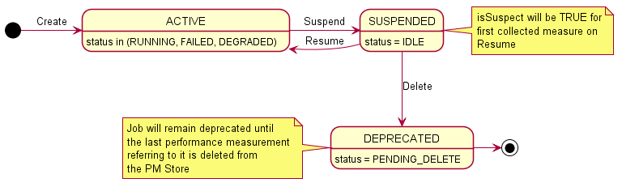
Figure 4.2.1.4.16.4-1 State & Status Diagram for PerformanceMeasurementJob

4.2.1.4.17 MeasuredResource <<datatype>>

4.2.1.4.17.1 Definition
The MeasuredResource represents a Resource that is or has been within the scope of a PerformanceMeasurementJob.
The information representing the attributes of the MeasuredResource follows the provisions indicated in table 4.2.1.4.17.2-1.

4.2.1.4.17.2 Attributes
Table 4.2.1.4.17.2-1 Attributes Properties for MeasuredResource
Attribute name | Data Type/Description | Properties
resourceTypeId | Data Type: string  Description: The resource identifier assigned by the O-Cloud when a performance measurement job is created. | x-support-qualifier: M  readOnly: True  x-isInvariant: True  x-inventoryNotification: False  x-stateChangeNotification:False  format: uuid
resourceId | Data Type: string  Description: The resource identifier for the resource for which the collected measurement is against. | x-support-qualifier: M  readOnly: True  x-isInvariant: True  x-inventoryNotification: False  x-stateChangeNotification: False  format: uuid
timeAdded | Data Type: array  Description: List of timestamps when the resource was added to the job. All resources shall have at least one timeAdded value. It could have multiple if changes caused a deletion and subsequent reinstatement to occur. | x-support-qualifier: M  readOnly: True  x-isInvariant: False  x-inventoryNotification: False  x-stateChangeNotification: False  minItems: 1  uniqueItems: True  items: date-time
timeDeleted | Data Type: array  Description: List of timestamps when the resource was deleted from a job. Multiple values may be present if deletion occurred at different times. The effective period of the measurement would be the times between a timeAdded and timeDeleted values. | x-support-qualifier: M  x-isAlwaysPresent: False  readOnly: True  x-isInvariant: False  x-inventoryNotification: False  x-stateChangeNotification: False  minItems: 0  uniqueItems: True  items: date-time
isCurrentlyMeasured | Data Type: boolean  Description: Indicates if the resource is currently being measured by the contained performance job. | x-support-qualifier: M  x-isAlwaysPresent: False  readOnly: True  x-isInvariant: False  x-inventoryNotification: False  x-stateChangeNotification: False  default: True

4.2.1.4.17.3 Attribute constraints
None.

4.2.1.4.17.4 State diagram
None.

4.2.1.4.18 CollectedMeasurement <<datatype>>

4.2.1.4.18.1 Definition
The CollectedMeasurement represents a measurement associated with a specific ResourceType that is or has been within the scope of a PerformanceMeasurementJob.
The information representing the attributes of the CollectedMeasurement follows the provisions indicated in table 4.2.1.4.18.2-1.

4.2.1.4.18.2 Attributes
Table 4.2.1.4.18.2-1 Attributes Properties for CollectedMeasurement
Attribute name | Data Type/Description | Properties
resourceTypeId | Data Type: string  Description: The resource identifier assigned by the O-Cloud when a performance measurement job is created. | x-support-qualifier: M  readOnly: True  x-isInvariant: True  x-inventoryNotification: False  x-stateChangeNotification: False  format: uuid
performanceMeasurementDefinitionId | Data Type: string  Description: Identifier of the measurement definition with the PM Dictionary for the specific device type identified by the resourceTypeId. | x-support-qualifier: M  readOnly: True  x-isInvariant: True  x-inventoryNotification: False  x-stateChangeNotification: False  format: uuid
timeAdded | Data Type: array  Description: List of timestamps when the resource was added to the job. All measurements shall have at least one timeAdded value. It could have multiple if changes caused a deletion and subsequent reinstatement to occur. | x-support-qualifier: M  readOnly: True  x-isInvariant: True  x-inventoryNotification: False  x-stateChangeNotification: False  minItems: 1  uniqueItems: True  items: date-time
timeDeleted | Data Type: array  Description: List of timestamps when the measurement was deleted from a job. Multiple values may be present if deletion occurred at different times. The effective period of the measurement would be the times between a timeAdded and timeDeleted values. | x-support-qualifier: M  x-isAlwaysPresent: False  readOnly: True  x-isInvariant: False  x-inventoryNotification: False  x-stateChangeNotification: False  minItems: 0  uniqueItems: True  items: date-time
isCurrentlyMeasured | Data Type: boolean  Description: Indicates if the resource is currently being measured by the contained performance job. | x-support-qualifier: M  x-isAlwaysPresent: False  readOnly: True  x-isInvariant: True  x-inventoryNotification: False  x-stateChangeNotification: False  default: True

4.2.1.4.18.3 Attribute constraints
None.

4.2.1.4.18.4 State diagram
None.

4.2.1.4.19 PerformanceMeasurementJobChangeSubscription

4.2.1.4.19.1 Definition
The PerformanceMeasurementJobChangeSubscription represents a subscription for events to be notified such as when the scope of a PerformanceMeasurementJob changes either due to an update to its criteria or a change in inventory, or updates to other attributes (e.g. collection interval, state, status).
The information representing the attributes of the PerformanceJobChangeSubscription follows the provisions indicated in table 4.2.1.4.19.2-1.

4.2.1.4.19.2 Attributes
Table 4.2.1.4.19.2-1 Attributes Properties for PerformanceMeasurementJobChangeSubscription
Attribute name | Data Type/Description | Properties
performanceMeasurementJobChangeSubscriptionId | Data Type: string  Description: Identifier of the PerformanceMeasurementJobChangeSubscription which will generate this notification. | x-support-qualifier: M  readOnly: True  x-isInvariant: True  x-inventoryNotification: False  x-stateChangeNotification: False  format: uuid
consumerPerformanceMeasurementJobChangeSubscriptionId | Data Type: string  Description: The consumer identification value if provided on the PerformanceMeasurementJobChangeSubscription which will generate this notification. | x-support-qualifier: M  x-isAlwaysPresent: False  x-isInvariant: False  x-inventoryNotification: True  x-stateChangeNotification: False
performanceChangesToNotify | Data Type: string  Description: The enumerated set of values representing the type(s) of changes to resources and/or measurements desired to be notified about (ADD, DELETE, BOTH). | x-support-qualifier: M  x-isInvariant: False  x-inventoryNotification: False  x-stateChangeNotification: False  enum:  - ADD  - DELETE  - BOTH
detailsToInclude | Data Type: string  Description: The enumerated set of values representing how much detail about the change to to resources and/or measurements include in the notification (NONE, DELTA, COMPLETE). | x-support-qualifier: M  x-isInvariant: False  x-inventoryNotification: False  x-stateChangeNotification: False  enum:  - NONE  - DELTA  - COMPLETE
subscriptionJobFilter | Data Type: array  Description: A key value set of criteria to select which jobs shall be reported on. | x-support-qualifier: M  x-isAlwaysPresent: False  x-isInvariant: False  x-inventoryNotification: False  x-stateChangeNotification: False  x-isOrdered: True  minItems: 0  uniqueItems: True  items: AttributeValuePair
callback | Data Type: string  Description: URL to which the PerformanceMeasurementJobChangeNotification will be sent. | x-support-qualifier: M  x-isInvariant: False  x-inventoryNotification: False  x-stateChangeNotification: False  format: uri

4.2.1.4.19.3 Attribute constraints
None.

4.2.1.4.19.4 State diagram
None.

4.2.1.4.20 PerformanceMeasurementJobChangeNotification <<notification>>

4.2.1.4.20.1 Definition
The PerformanceMeasurementJobChangeNotification notification represents the information about a change that occurred to a PerformanceMeasurementJob due to an update to its criteria or a change in inventory or updates to other attributes (e.g. collection interval, state, status) for which there is a PerformanceMeasurementJobChangeSubscription established.
The information representing the attributes of the PerformanceMeasurementJobChangeNotification follows the provisions indicated in table 4.2.1.4.20.2-1.

4.2.1.4.20.2 Attributes
Table 4.2.1.4.20.2-1 Attributes Properties for PerformanceMeasurementJobChangeNotification
Attribute name | Data Type/Description | Properties
performanceMeasurementJobChangeSubscriptionId | Data Type: string  Description: Identifier of the PerformanceMeasurementJobChangeSubscription. | x-support-qualifier: M  readOnly: True  x-isInvariant: True  x-inventoryNotification: False  x-stateChangeNotification: False  format: uuid
consumerPerformanceMeasurementJobChangeSubscriptionId | Data Type: string  Description: The consumer identification value if provided on the PerformanceMeasurementJobChangeSubscription. | x-support-qualifier: M  x-isAlwaysPresent: False  readOnly: True  x-isInvariant: True  x-inventoryNotification: False  x-stateChangeNotification: False
performanceMeasurementJobId | Data Type: string  Description: The UUID of the PerformanceMeasurementJob that incurred a change due to a change in scope criteria, a change to O-Cloud Infrastructure Inventory, a change to collection interval, a change to state and/or status, or a change to the extensions. | x-support-qualifier: M  readOnly: True  x-isInvariant: True  x-inventoryNotification: False  x-stateChangeNotification: False  format: uuid
objectRef | Data Type: string  Description: The URL of the service object which was modified. | x-support-qualifier: M  readOnly: True  x-isInvariant: False  x-inventoryNotification: False  x-stateChangeNotification: False  format: uri
typeOfChange | Data Type: string  Description: The enumerated value representing the type of changes to resources and/or measurements included in the notification. | x-support-qualifier: M  readOnly: True  x-isInvariant: False  x-inventoryNotification: False  x-stateChangeNotification: False  enum:  - ADD  - DELETE  - BOTH
resourceChangeDetails | Data Type: array  Description: If the subscription criteria indicates DELTA or COMPLETE extended information then all relevant added and/or deleted resources to the job are listed. | x-support-qualifier: M  x-isAlwaysPresent: False  readOnly: True  x-isInvariant: False  x-inventoryNotification: False  x-stateChangeNotification: False  minItems: 0  uniqueItems: True  x-isOrdered: True  items: MeasuredResource
measurementChangeDetails | Data Type: array  Description: If the subscription criteria indicates DELTA or COMPLETE extended information then all relevant added and/or deleted measurements of the performance measurement job are listed. | x-support-qualifier: M  x-isAlwaysPresent: False  readOnly: True  x-isInvariant: False  x-inventoryNotification: False  x-stateChangeNotification: False  minItems: 0  uniqueItems: True  x-isOrdered: True  items: CollectedMeasurement
consumerPerformanceJobId | Data Type: string  Description: Identifier provided by the consumer for its purpose of managing performance jobs. This value could be the same across multiple instances of IMS performance job instances. | x-support-qualifier: M  x-isAlwaysPresent: False  readOnly: True  x-isInvariant: False  x-inventoryNotification: False  x-stateChangeNotification: False
collectionInterval | Data Type: integer  Description: The interval at which performance measurement will be collected and stored. | x-support-qualifier: M  x-isAlwaysPresent: False  readOnly: True  x-isInvariant: False  x-inventoryNotification: False  x-stateChangeNotification: False  x-nullable: True  x-units: Seconds  minimum: 0  default: 300
state | Data Type: string  Description: The current state of the PerformanceMeasurementJob. | x-support-qualifier: M  x-isAlwaysPresent: False  readOnly: True  x-isInvariant: False  x-inventoryNotification: False  x-stateChangeNotification: False  enum:  - ACTIVE  - SUSPENDED  - DEPRECATED
status | Data Type: string  Description: The current status within the state. | x-support-qualifier: M  x-isAlwaysPresent: False  readOnly: True  x-isInvariant: False  x-inventoryNotification: False  x-stateChangeNotification: False  enum:  - RUNNING  - FAILED  - DEGRADED  - IDLE  - PENDING_DELETE
extensions | Data Type: array  Description: These are unspecified (not standardized) properties (key/value) which extend the information about the Performance Measurement Job | x-support-qualifier: M  x-isAlwaysPresent: False  readOnly: True  x-isInvariant: False  x-inventoryNotification: False  x-stateChangeNotification: False  x-isOrdered: False  minItems: 0  uniqueItems: True  items: AttributeValuePair

4.2.1.4.20.3 Attribute constraints
None.

4.2.1.4.20.4 State diagram
None.

4.2.1.4.21 PerformanceSubscription

4.2.1.4.21.1 Definition
The PerformanceSubscription represents the information required to establish the criteria by which a PerformanceMeasurementReport notification is to be generated and where to send that notification.
Table 4.2.1.4.21.1-1 PerformanceSubscription Requirements
Referenced Specification | Requirement | Comment
O-RAN.WG6.ORCH-USE-CASES [3] | REQ-ORC-O2-37 | Optional clarification
O-RAN.WG6.ORCH-USE-CASES [3] | REQ-ORC-O2-38

The information representing the attributes of the PerformanceSubscription follows the provisions indicated in table 4.2.1.4.21.2-1.

4.2.1.4.21.2 Attributes
Table 4.2.1.4.21.2-1 Attributes Properties for PerformanceSubscription
Attribute name | Data Type/Description | Properties
performanceSubscriptionId | Data Type: string  Description: Identifier of the performance subscription instance within the IMS. This value is assigned by the IMS when the subscription is created. | x-support-qualifier: M  readOnly: True  x-isInvariant: True  x-inventoryNotification: False  x-stateChangeNotification: False  format: uuid
consumerPerformanceSubscriptionId | Data Type: string  Description: Identifier optionally provided by the consumer for its purpose of managing performance data. This value could be the same across multiple instances of IMS subscription instances. | x-support-qualifier: M  x-isAlwaysPresent: False  x-isInvariant: False  x-inventoryNotification: False  x-stateChangeNotification: False
subscriptionCriteria | Data Type: PerformanceSubscriptionCriteria  Description: This is the criteria which will apply to this subscription. | x-support-qualifier: M  x-isAlwaysPresent: False  x-isInvariant: False  x-inventoryNotification: False  x-stateChangeNotification: False
reportDeliveryMechanism | Data Type: string  Description: Enumerated set of reporting mechanisms for delivery of the data identified by the PerformanceSubscription which are identified as:  NOTIFICATION: Call the callback with the data at the specified intervals providing the data, e.g., in JSON format  FILE: generate a file, e.g., formatted in XML to be collected and call the callback with the filename whenever one is generated.  STREAM: Session will remain open and continue to send the data in a streaming format, e.g., Google Protocol Buffers (GPB), at the specified intervals until the session or subscription is terminated. | x-support-qualifier: M  x-isInvariant: False  x-inventoryNotification: False  x-stateChangeNotification: False  enum:  - NOTIFICATION  - FILE  - STREAM
remoteFileLocation | Data Type: string  Description: When the reportFormat is FILE this field is populated with the URL to the remote directory where the service is expected to push the requested performance files to a remote files system. If the reportFormat is not FILE, the field is empty or not present. | x-support-qualifier: M  x-isAlwaysPresent: False  x-isInvariant: False  x-inventoryNotification: False  x-stateChangeNotification: False  Format: uri
callback | Data Type: string  Description: The callback to send responses for modes NOTIFICATION, or the file notification for FILE. The field is not required if mode is STREAM. | x-support-qualifier: M  x-isAlwaysPresent: False  x-isInvariant: False  x-inventoryNotification: False  x-stateChangeNotification: False  Format: uri
measurementReportingFrequency | Data Type: PerformanceReportingFrequency  Description: The frequency that specified measurements are to be reported. | x-support-qualifier: M  x-isInvariant: False  x-inventoryNotification: False  x-stateChangeNotification: False

4.2.1.4.21.3 Attribute constraints
None.

4.2.1.4.21.4 State diagram
None.

4.2.1.4.22 PerformanceReportingFrequency <<datatype>>

4.2.1.4.22.1 Definition
The PerformanceReportingFrequency represents the frequency that specified measurements are to be reported.
The information representing the attributes of the PerformanceReportingFrequency follows the provisions indicated in table 4.2.1.4.22.2-1.

4.2.1.4.22.2 Attributes
Table 4.2.1.4.22.2-1 Attributes Properties for PerformanceReportingFrequency
Attribute name | Data Type/Description | Properties
subscriptionMode | Data Type: string  Description: An enumerated set of values which will identify the mode in which data is reported. The valid values are as follows:  TARGET_DEFINED: Producer of the PM data decides if ON_CHANGE or SAMPLE is more optimal.  ON_CHANGE: Value is reported as soon as the PM Job collects it.  SAMPLE: Value is reported at the reportInterval period. | x-support-qualifier: M  x-isInvariant: False  x-inventoryNotification: False  x-stateChangeNotification: False  enum:  - TARGET_DEFINED  - ON_CHANGE  - SAMPLE
reportInterval | Data Type: integer  Description: This is the reporting interval for the data, it is an unsigned integer representing the number of milliseconds between reports. If the reportInterval is lower than the service can provide the subscription shall return an error indicating such. If the value is set to zero (0) then the service will use its lowest supported value for the reportInterval. | x-support-qualifier: M  x-isAlwaysPresent: False  x-isInvariant: False  x-inventoryNotification: False  x-stateChangeNotification: False  x-nullable: True  minimum: 0  default: 300  x-units: seconds
supressRedundant | Data Type: boolean  Description: This flag identifying if SAMPLE values that have not changed shall (False) or shall Not (True) be transmitted. | x-support-qualifier: M  x-isAlwaysPresent: False  x-isInvariant: False  x-inventoryNotification: False  x-stateChangeNotification: False  default: False
heartbeatInterval | Data Type: integer  Description: When the suppressRedundant is set to (True), if heartbeatInterval is a non-zero value then a duplicate value will be sent at least once per heatbeatInterval. The value shall be zero (0) or a value greater than or equal to the reportInterval. | x-support-qualifier: M  x-isAlwaysPresent: False  x-isInvariant: False  x-inventoryNotification: False  x-stateChangeNotification: False  minimum: 0  default: 0  x-units: seconds

4.2.1.4.22.3 Attribute constraints
None.

4.2.1.4.22.4 State diagram
None.

4.2.1.4.23 PerformanceSubscriptionCriteria <<datatype>>

4.2.1.4.23.1 Definition
The PerformanceSubscriptionCriteria represents the information required to establish which measurements for which resource shall be included in a PerformanceMeasurementReport.
The information representing the attributes of the PerformanceSubscriptionCriteria follows the provisions indicated in table 4.2.1.4.23.2-1.

4.2.1.4.23.2 Attributes
Table 4.2.1.4.23.2-1 Attributes Properties for PerformanceSubscriptionCriteria
Attribute name | Data Type/Description | Properties
jobCriteria | Data Type: array  Description: The list of performanceMeasurementJobId of interest.  See note. | x-support-qualifier: M  x-isAlwaysPresent: False  x-isInvariant: False  x-inventoryNotification: False  x-stateChangeNotification:False  minItems: 0  uniqueItems: True  items: string
resourceTypeCriteria | Data Type: array  Description: Key/Value list of criteria compared to Resource Type data. The Key shall correspond to the specified attribute names of the ResourceType (see clause 4.2.1.4.2.2), and the Value shall indicate the value of that attribute.  See note. | x-support-qualifier: M  x-isAlwaysPresent: False  x-isInvariant: False  x-inventoryNotification: False  x-stateChangeNotification: False  minItems: 0  uniqueItems: True  items: AttributeValuePair
resourceCriteria | Data Type: array  Description: Key/Value list of criteria compared to Resource data. The Key shall correspond to the specified attribute names of the Resource (see clause 4.2.1.4.4.2), and the Value shall indicate the value of that attribute.  See note. | x-isAlwaysPresent: False  x-support-qualifier: M  x-isInvariant: False  x-inventoryNotification: False  x-stateChangeNotification: False  minItems: 0  uniqueItems: True  items: AttributeValuePair
measurementCriteria | Data Type: array  Description: The list of performanceMeasureDefinitionId [2] of interest.  See note. | x-support-qualifier: M  x-isAlwaysPresent: False  x-isInvariant: False  x-inventoryNotification: False  x-stateChangeNotification:False  minItems: 0  uniqueItems: True  items: string
NOTE: At least one of the attributes shall be included. If more than one is included, the criteria selection
operates as an “inclusion” (i.e., AND-operator).

4.2.1.4.23.3 Attribute constraints
None.

4.2.1.4.23.4 State diagram
None.

4.2.1.4.24 PerformanceMeasurementReport <<notification>>

4.2.1.4.24.1 Definition
The PerformanceMeasurementReport notification represents the information required to define the scope of the JobReports being sent in the notification.
Table 4.2.1.4.24.1-1 PerformanceMeasurementReport Requirements
Referenced Specification | Requirement | Comment
O-RAN.WG6.ORCH-USE-CASES [3] | REQ-ORC-O2-39 | Optional clarification

The information representing the attributes of the PerformanceMeasurementReport follows the provisions indicated in table 4.2.1.4.24.2-1.

4.2.1.4.24.2 Attributes
Table 4.2.1.4.24.2-1 Attributes Properties for PerformanceMeasurementReport
Attribute name | Data Type/Description | Properties
globalCloudId | Data Type: string  Description: Identifier of the O-Cloud instance assigned by the SMO. This identifier is globally unique across O-Cloud instances known to the SMO. This value was provided by the SMO at cloud genesis and is stored in the O-Cloud IMS Inventory. | x-support-qualifier: M  readOnly: True  x-isInvariant: True  x-inventoryNotification: False  x-stateChangeNotification: False  format: uuid
notificationTime | Data Type: string  Description: The date and time that the notification was sent. | x-support-qualifier: M  readOnly: True  x-isInvariant: True  x-inventoryNotification: False  x-stateChangeNotification: False  format: date-time
performanceSubscriptionId | Data Type: string  Description: Identifier of the performance subscription instance within the IMS. This value is assigned by the IMS when the job is created. | x-support-qualifier: M  readOnly: True  x-isInvariant: True  x-inventoryNotification: False  x-stateChangeNotification: False  format: uuid
consumerPerformanceSubscriptionId | Data Type: string  Description: Identifier optionally provided by the consumer for its purpose of managing performance data. This value could be the same across multiple instances of IMS subscription instances. | x-support-qualifier: M  x-isAlwaysPresent: False  readOnly: True  x-isInvariant: False  x-inventoryNotification: False  x-stateChangeNotification: False
jobReports | Data Type: array  Description: The list of performance reports by jobId. A single subscription can subscribe to measurements collected by multiple jobs. | x-support-qualifier: M  readOnly: True  x-isInvariant: False  x-inventoryNotification: False  x-stateChangeNotification: False  x-isOrdered: False  minItems: 1  uniqueItems: True  items: JobReport

4.2.1.4.24.3 Attribute constraints
None.

4.2.1.4.24.4 State diagram
None.

4.2.1.4.25 JobReport <<datatype>>

4.2.1.4.25.1 Definition
The JobReport provides the list of performance reports generated from corresponding PerformanceMeasurementJobs. A single subscription can be used to subscribe to measurements collected by multiple PerformanceManagementJobs. The data from the PerformanceMeasurementJobs are aggregated into a single report per PerformanceSubscription.
The information representing the attributes of the JobReport follows the provisions indicated in table 4.2.1.4.25.2-1.

4.2.1.4.25.2 Attributes
Table 4.2.1.4.25.2-1 Attributes Properties for JobReport
Attribute name | Data Type/Description | Properties
performanceJobId | Data Type: string  Description: The UUID of the PerformanceMeasurementJob from which collected measurements are reported. | x-support-qualifier: M  readOnly: True  x-isInvariant: True  x-inventoryNotification: False  x-stateChangeNotification: False  format: uuid
consumerJobId | Data Type: string  Description: Identifier provided by the consumer for its purpose of managing performance jobs. This value could be the same across multiple instances of IMS performance job instances. | x-support-qualifier: M  readOnly: True  x-isInvariant: False  x-inventoryNotification: False  x-stateChangeNotification: False
measuredResources | Data Type: array  Description: The list of collected measurements for each Resource within the scope of the subscription to be included in this PerformanceMeasurementReport. | x-support-qualifier: M  readOnly: True  x-isInvariant: False  x-inventoryNotification: False  x-stateChangeNotification: False  minItems: 1  items: ResourceReport

4.2.1.4.25.3 Attribute constraints
None.

4.2.1.4.25.4 State diagram
None.

4.2.1.4.26 ResourceReport <<datatype>>

4.2.1.4.26.1 Definition
The ResourceReport dataType represents the information required to identify the resource for which a set of measurements are being reported in the notification.
The information representing the attributes of the ResourceReport follows the provisions indicated in table 4.2.1.4.26.2-1.

4.2.1.4.26.2 Attributes
Table 4.2.1.4.26.2-1 Attributes Properties for ResourceReport
Attribute name | Data Type/Description | Properties
resourceId | Data Type: string  Description: The UUID of the Resource as specified in Infrastructure Inventory. | x-support-qualifier: M  readOnly: True  x-isInvariant: False  x-inventoryNotification: False  x-stateChangeNotification: False  format: uuid
measurementValues | Data Type: array  Description: The list of collected measurements for the Resource within the subscription included in this PerformanceMeasurementReport. | x-support-qualifier: M  readOnly: True  x-isInvariant: False  x-inventoryNotification: False  x-stateChangeNotification: False  minItems: 1  uniqueItems: True  items: MeasurementValue

4.2.1.4.26.3 Attribute constraints
None.

4.2.1.4.26.4 State diagram
None.

4.2.1.4.27 MeasurementValue <<datatype>>

4.2.1.4.27.1 Definition
The MeasurementValue dataType represents the information about a collected measurement and its value to be included in a notification.
The information representing the attributes of the MeasurementValue follows the provisions indicated in table 4.2.1.4.27.2-1.

4.2.1.4.27.2 Attributes
Table 4.2.1.4.27.2-1 Attributes Properties for MeasurementValue
Attribute name | Data Type/Description | Properties
performanceMeasurementId | Data Type: string  Description: Based on encoding this value can be either a string consisting of the performanceMeasureName of the MeasurementDefinition in the Performance Dictionary for the Resource Type or an unsigned integer consisting of the performanceMeasurementId of the MeasurementDefinition. | x-support-qualifier: M  readOnly: True  x-isInvariant: False  x-inventoryNotification: False  x-stateChangeNotification: False
measurementCollectionTime | Data Type: string  Description: If present, this is the value that is added to the PerformanceMeasurementStore. When omitted then the notificationTime is assumed to the time the value was added to the PerformanceMeasurementStore as would be the case if the subscriptionMode equated to ON_CHANGE. | x-support-qualifier: M  readOnly: True  x-isInvariant: False  x-inventoryNotification: False  x-stateChangeNotification: False  format: date-time
measurementValue | Data Type: Any type  Description: This is the actual value of the measurement which varies in type from measurement to measurement. | x-support-qualifier: M  readOnly: True  x-isInvariant: False  x-inventoryNotification: False  x-stateChangeNotification: False
isSuspect | Data Type: boolean  Description: This flag is set to True if anomalous behavior was detected on the resource between this measurement value and a prior measurement value. | x-support-qualifier: M  x-isAlwaysPresent: False  readOnly: True  x-isInvariant: False  x-inventoryNotification: False  x-stateChangeNotification: False  default: False

4.2.1.4.27.3 Attribute constraints
None.

4.2.1.4.27.4 State diagram
None.

4.2.1.4.28 NotifyFileReady <<notification>>

4.2.1.4.28.1 Definition
The NotifyFileReady notification represents the information about one (1) or more files to be made available to a subscriber when the reportFormat of a PerformanceSubscription is FILE or a LogQuery when a callback is supplied. This notification only makes the consumer aware of the file and does not predicate delivery of the file (push or pull).
The information representing the attributes of the NotifyFileReady follows the provisions indicated in table 4.2.1.4.28.2-1.

4.2.1.4.28.2 Attributes
Table 4.2.1.4.28.2-1 Attributes Properties for NotifyFileReady
Attribute name | Data Type/Description | Properties
globalCloudId | Data Type: string  Description: Identifier of the O-Cloud instance assigned by the SMO. This identifier is globally unique across O-Cloud instances known to the SMO. This value was provided by the SMO at cloud genesis and is stored in the O-Cloud IMS Inventory. | x-support-qualifier: M  readOnly: True  x-isInvariant: True  x-inventoryNotification: False  x-stateChangeNotification: False  format: uuid
subscriptionId | Data Type: string  Description: When the notification is created due to a PerformanceSubscription this attribute will contain the identifier of the performanceSubscriptionId for this notification. | x-support-qualifier: M  x-isAlwaysPresent: False  readOnly: True  x-isInvariant: True  x-inventoryNotification: False  x-stateChangeNotification: False  format: uuid
consumerSubscriptionId | Data Type: string  Description: When the notification is created due to a PerformanceSubscription this attribute will contain the identifier provided by the consumer for its purpose of managing performance data and may be included in the PerformanceSubscription.  If the notification is due to a logQuery request this attribute shall provide the consumerLogRequestId when provided on the request to allow the consumer to correlate it to the original request. | x-support-qualifier: M  x-isAlwaysPresent: False  readOnly: True  x-isInvariant: False  x-inventoryNotification: False  x-stateChangeNotification: False
eventTime | Data Type: string  Description: The date and time that the notification was issued. | x-support-qualifier: M  readOnly: True  x-isInvariant: False  x-inventoryNotification: False  x-stateChangeNotification: False  format: date-time
fileInfoList | Data Type: array  Description: The list of information about one or more files included in this notification. | x-support-qualifier: M  readOnly: True  x-isInvariant: False  x-inventoryNotification: False  x-stateChangeNotification: False  minItems: 1  uniqueItems: True  items: FileInfo

4.2.1.4.28.3 Attribute constraints
None.

4.2.1.4.28.4 State diagram
None.

4.2.1.4.29 FileInfo <<datatype>>

4.2.1.4.29.1 Definition
The FileInfo dataType represents information about one or more generated files collected by a producer and which are now available to a consumer.
The information representing the attributes of the FileInfo follows the provisions indicated in table 4.2.1.4.29.2-1.

4.2.1.4.29.2 Attributes
Table 4.2.1.4.29.2-1 Attributes Properties for FileInfo
Attribute name | Data Type/Description | Properties
fileLocation | Data Type: string  Description: Location of the file | x-support-qualifier: M  readOnly: True  x-isInvariant: False  x-inventoryNotification: False  x-stateChangeNotification: False  format: uri
fileSize | Data Type: integer  Description: Size of the file, unit is byte | x-support-qualifier: M  readOnly: True  x-isInvariant: False  x-inventoryNotification: False  x-stateChangeNotification: False  format: int32  minimum: 0  x-units: bytes
fileReadyTime | Data Type: string  Description: Date and time when the file was last closed and made available by the producer. The file content will not be changed any more | x-support-qualifier: M  readOnly: True  x-isInvariant: False  x-inventoryNotification: False  x-stateChangeNotification: False  format: date-time
fileExpirationTime | Data Type: string  Description: Date and time after which the file may be deleted. | x-support-qualifier: M  readOnly: True  x-isInvariant: False  x-inventoryNotification: False  x-stateChangeNotification: False  format: date-time
fileCompression | Data Type: string  Description: If compression is applied to the file, the name of the compression algorithm used for compressing the file. | x-support-qualifier: M  x-isAlwaysPresent: False  readOnly: True  x-isInvariant: True  x-inventoryNotification: False  x-stateChangeNotification: False
fileDataType | Data Type: string  Description: An enumerated set of values identifying the type of data contained in the file. The valid set of values are described as follows:  PERFORMANCE: The file contains a PerformanceMeasurementReport.  ANALYTIC: The file contains analytic data.  LOG: The file contains log entries identified in a logQuery request. | x-support-qualifier: M  readOnly: True  x-isInvariant: True  x-inventoryNotification: False  x-stateChangeNotification: False  enum:  - PERFORMANCE  - ANALYTIC  - LOG

4.2.1.4.29.3 Attribute constraints
None.

4.2.1.4.29.4 State diagram
None.

4.2.1.4.30 Location

4.2.1.4.30.1 Definition
The Location represents an instance of a Location where an O-Cloud Site may be available.

4.2.1.4.30.2 Attributes
Table 4.2.1.4.30.2-1 Attributes Properties for Location
Attribute name | Data Type/Description | Properties
globalLocationId | Data Type: string  Description: Identifier of the location as defined by the SMO. | x-support-qualifier: M  readOnly: True  x-isInvariant: True  x-inventoryNotification: False  x-stateChangeNotification: False
name | Data Type: string  Description: Human readable name of the location as defined by the SMO. | x-support-qualifier: M  readOnly: True  x-isInvariant: False  x-inventoryNotification: True  x-stateChangeNotification: False
description | Data Type: string  Description: Human readable description of the location as defined by the SMO. | x-support-qualifier: M  readOnly: True  x-isInvariant: False  x-inventoryNotification: True  x-stateChangeNotification: False
oCloudId | Data Type: string  Description: Reference to the O-Cloud available at the location. | support-qualifier: M  readOnly: True  x-isInvariant: True  x-inventoryNotification: False  x-stateChangeNotification: False  format: uuid
oCloudSiteIds | Data Type: array  Description: List of O-Cloud Site identifiers referencing the O-Cloud Sites available at the location. | x-support-qualifier: M  x-isAlwaysPresent: False  readOnly: True  x-isInvariant: False  x-inventoryNotification True  x-stateChangeNotification: False  x-isOrdered: False  minItems: 0  uniqueItems: True  items: string
coordinate | Data Type: string  Description: The latitude and longitude of the location (shall be supplied if a postal address not provided). | support-qualifier: M  x-isAlwaysPresent: False  readOnly: True  x-isInvariant: True  x-inventoryNotification: False  x-stateChangeNotification: False
address | Data Type: string  Description: Postal address of the facility (shall be supplied if a coordinate is not provided). | support-qualifier: M  x-isAlwaysPresent: False  readOnly: True  x-isInvariant: True  x-inventoryNotification: False  x-stateChangeNotification: False
extensions | Data Type: array  Description: These are unspecified (not standardized) properties (keys) which are tailored by the vendor to extend the information provided about the location. | x-support-qualifier: M  x-isAlwaysPresent: False  readOnly: True  x-isInvariant: False  x-inventoryNotification: False  x-stateChangeNotification: False  x-isOrdered: False  minItems: 0  uniqueItems: True  items: AttributeValuePair

4.2.1.4.30.3 Attribute constraints
None.

4.2.1.4.30.4 State diagram
None.

4.2.1.4.31 OCloudSite

4.2.1.4.31.1 Definition
The OCloudSite represents an O-Cloud Site instance in an O-Cloud, as described in the O-RAN Cloud Architecture and Deployment Scenarios specification [i.3].

4.2.1.4.31.2 Attributes
Table 4.2.1.4.31.2-1 Attributes Properties for OCloudSite
Attribute name | Data Type/Description | Properties
oCloudSiteId | Data Type: string  Description: Identifier of the O-Cloud site. Locally unique within the scope of an O-Cloud instance. | x-support-qualifier: M  readOnly: True  x-isInvariant: True  x-inventoryNotification: False  x-stateChangeNotification: False  format: uuid
locationId | Data Type: string  Description: Reference to location where the O-Cloud site is deployed at. | x-support-qualifier: M  readOnly: True  x-isInvariant: True  x-inventoryNotification: False  x-stateChangeNotification: False  format: uuid
name | Data Type: string  Description: Human readable name of the O-Cloud site as identified by the cloud provider. | x-support-qualifier: M  readOnly: True  x-isInvariant: False  x-inventoryNotification: True  x-stateChangeNotification: False
description | Data Type: string  Description: Human readable description of the O-Cloud site as provided by the cloud provider. | x-support-qualifier: M  readOnly: True  x-isInvariant: False  x-inventoryNotification: True  x-stateChangeNotification: False
oCloudId | Data Type: string  Description: Reference to the O-Cloud of which the O-Cloud site is part. | support-qualifier: M  readOnly: True  x-isInvariant: True  x-inventoryNotification: False  x-stateChangeNotification: False  format: uuid
resourcePools | Data Type: array  Description: List of resource pools that are part of the O-Cloud site. | x-support-qualifier: M  readOnly: True  x-isInvariant: False  x-inventoryNotification: True  x-stateChangeNotification: False  x-isOrdered: False  minItems: 1  uniqueItems: True  items: ResourcePool
extensions | Data Type: array  Description: These are unspecified (not standardized) properties (keys) which are tailored by the vendor to extend the information provided about the O-Cloud site. | x-support-qualifier: M  x-isAlwaysPresent: False  readOnly: True  x-isInvariant: False  x-inventoryNotification: False  x-stateChangeNotification: False  x-isOrdered: False  minItems: 0  uniqueItems: True  items: AttributeValuePair

4.2.1.4.31.3 Attribute constraints
None.

4.2.1.4.31.4 State diagram
None.

4.2.1.4.32 LogQuery

4.2.1.4.32.1 Definition
The LogQuery represents a request for O-Cloud log files for specific resources or resource of specific ResourceTypes to be collected and made available to the requestor.

4.2.1.4.32.2 Attributes
Table 4.2.1.4.32.2-1 Attributes Properties for LogQuery
Attribute name | Data Type/Description | Properties
logType | Data Type: string  Description: This identifies the type of log(s) to be collected. The exact list of valid log types to be discovered via a log capability discovery. | x-support-qualifier: M  x-isInvariant: False  x-inventoryNotification: False  x-stateChangeNotification: False
dateRanges | Data Type: array  Description: list of date ranges that log data is to be extracted and placed into the log file for collection. | x-support-qualifier: M  x-isInvariant: False  x-inventoryNotification: False  x-stateChangeNotification: False  minItems: 1  items: DateRange
eventTypes | Data Type: array  Description: List of event types that are to be extracted and placed in the log file for collection. If the attribute is not provided, all event types are selected.  The exact list of valid event types are to be discovered via a log capability discovery. | x-support-qualifier: M  x-isAlwaysPresent: False  x-isInvariant: False  x-inventoryNotification: True  x-stateChangeNotification: False  minItems: 0  items: string
resources | Data Type: array  Description: list of resource selection criteria to identify which resources are in scope for the query. If the attribute is not provided, all resources are selected. | x-support-qualifier: M  x-isAlwaysPresent: False  x-isInvariant: False  x-inventoryNotification: False  x-stateChangeNotification: False  minItems: 0  items: AttributeValuePair
resourceTypes | Data Type: array  Description: list of resourceType selection criteria to identify which resources matching the resourceTypes are in scope for the query. If the attribute is not provided, all resourceTypes are selected. | x-support-qualifier: M  x-isAlwaysPresent: False  x-isInvariant: False  x-inventoryNotification: False  x-stateChangeNotification: False  minItems: 0  items: AttributeValuePair
logLevels | Data Type: array  Description: List of logging levels that are to be extracted and placed in the log file for collection. If the attribute is not provided, all logging levels are selected.  The log levels specified in Clause 6.2.1, Table 2 of IETF RFC 5424 [5] shall be supported by the O-Cloud instance. | x-support-qualifier: M  x-isAlwaysPresent: False  x-isInvariant: False  x-inventoryNotification: True  x-stateChangeNotification: False  minItems: 0  items: string
remoteFileLocation | Data Type: string  Description: When the service is expected to push to a remote file system, this field is populated with the URL to the remote directory, otherwise the field is empty or not present. | support-qualifier: M  x-isAlwaysPresent: False  x-isInvariant: False  x-inventoryNotification: False  x-stateChangeNotification: False  format: uri
callback | Data Type: string  Description: The URL of the callback to which asynchronous notifications are delivered to. | x-support-qualifier: M  x-isAlwaysPresent: False  x-isInvariant: False  x-inventoryNotification: False  x-stateChangeNotification: False  format: uri
consumerLogRequestId | Data Type: string  Description: Identifier optionally provided by the consumer for its purpose of tracking a request for log data. | x-support-qualifier: M  x-isAlwaysPresent: False  x-isInvariant: False  x-inventoryNotification: False  x-stateChangeNotification: False

4.2.1.4.32.3 Attribute constraints
None.

4.2.1.4.32.4 State diagram
None.

4.2.1.4.33 DateRange <<dataType>>

4.2.1.4.33.1 Definition
The DateRange represent a start and end date and time value to indicate a span of time.

4.2.1.4.33.2 Attributes
Table 4.2.1.4.33.2-1 Attributes Properties for DateRange
Attribute name | Data Type/Description | Properties
startDateTime | Data Type: string  Description: This identifies the start of a time range. | x-support-qualifier: M  x-isInvariant: False  x-inventoryNotification: False  x-stateChangeNotification: False  format: date-time
endDateTime | Data Type: string  Description: This identifies the end of a time range. | x-support-qualifier: M  x-isInvariant: False  x-inventoryNotification: False  x-stateChangeNotification: False  format: date-time

4.2.1.4.33.3 Attribute constraints
Table 4.2.1.4.33.3-2 Attributes Constraints for DateRange
Name | Definition
START_PRECEDES_END | Condition: startDateTime shall chronologically precede the endDateTime.
.

4.2.1.4.33.4 State diagram
None.

4.2.2 Namespace: ORAN.O2ims.Artifacts

4.2.2.1 Namespace Overview
The O-RAN O2ims Artifacts namespace defines the classes and their attributes which are directly exposed to the consumer (SMO) via its O2 IMS Interface.
This namespace is used for the O-Cloud artifacts e.g. Cluster Templates, Initial Configuration Sets, OS/SW/FW, etc. that e.g. The O-Cloud artifacts can be used for configuring O-Cloud Resources from the Inventory and Cluster namespaces. The artifacts are not consumed when they are used and can be referenced in the Inventory, Cluster and Provisioning structures.

4.2.2.2 Imported and associated information entities

4.2.2.2.1 Imported information entities and local labels
Information entities imported into the model are also elements of the namespace and therefore shall remain unique within the namespace.
Table 4.2.2.2.1-1 Imported Entities
Label reference | Local label

4.2.2.2.2 Associated information entities and local labels
Information entities referenced in the model through an association which may be extended and overloaded with a new entity of the same name within the namespace are listed in the associated entities table.
Table 4.2.2.2.2-1 Associated Entities
Label reference | Local label
4.2.1.2.1 Top | Top
4.2.1.4.7, InfrastructureInventoryObject_ | InfrastructureInventoryObject_

4.2.2.3 Class Diagram

4.2.2.3.1 Relationships

4.2.2.3.1.1 Description
This clause depicts the set of classes (e.g. IOCs) that encapsulates the information relevant for the O-RAN Cloud (O-Cloud). This clause provides an overview of the relationships between relevant classes in UML. Subsequent clauses provide more detailed specification of various aspects of these classes. The UML Class diagram depicts a view of the namespace maintaining a defined focus so as not to overcrowd a single diagram trying to depict all relationships within the namespace.

4.2.2.3.1.2 ORAN.O2ims.Artifacts Intra-Namespace Relationships
@startuml
Namespace ORAN.O2ims.Artifacts #Magenta {
Skinparam BorderColor Red
Skinparam ArrowColor Black
Hide Members
Hide Circle

Class ArtifactResourceType <<InformationObjectClass>> {
artifactResourceTypeId UUID
name String
resource String
description String
extensions[] KeyValuePair
}

Class ArtifactResource <<InformationObjectClass>> {
artifactResourceId UUID
name String
description String
}

ArtifactResource --> ArtifactResourceType : isOfType
ArtifactResource --> ArtifactResource : ReferenceOrUse

@enduml
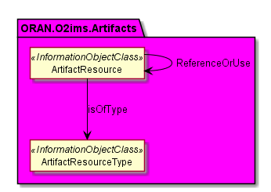
Figure 4.2.2.3.1.2-1 ORAN.O2ims.Artifacts Intra-Namespace Relationships

4.2.2.3.1.3 ORAN.O2ims.Artifacts Inter-Namespace Relationships
@startuml
Hide Members
Hide Circle

Namespace ORAN.O2ims.Cluster #LightSteelBlue {
Class NodeCluster
Class ClusterResource
}

Namespace ORAN.O2ims.Infrastructure #Lavender {
Abstract Class InfrastructureResource
Class InfrastructureResource
}

Namespace ORAN.O2ims.Artifacts #Magenta {

Class ArtifactResource <<InformationObjectClass>>

}

ORAN.O2ims.Cluster.NodeCluster --> ORAN.O2ims.Artifacts.ArtifactResource : BasedOn

ORAN.O2ims.Cluster.ClusterResource --> ORAN.O2ims.Artifacts.ArtifactResource : BasedOn

ORAN.O2ims.Infrastructure.InfrastructureResource --> ORAN.O2ims.Artifacts.ArtifactResource : BasedOn

@enduml
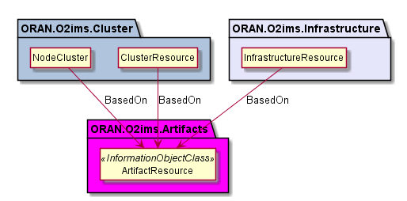
Figure 4.2.2.3.1.3-1 ORAN.O2ims.Artifacts Inter-Namespace Relationships

4.2.2.3.2 Inheritance

4.2.2.3.2.1 ORAN.O2ims.Artifacts Inheritance
@startuml
skin rose
skinparam ClassStereotypeFontStyle normal
skinparam style strictuml
hide members

Namespace ORAN.O2ims.Inventory {
Abstract Class Top <<InformationObjectClass>>

Abstract Class InfrastructureInventoryObject_ <<InformationObjectClass>>

Top <|-d- InfrastructureInventoryObject_
}

Namespace ORAN.O2ims.Artifacts {

Class ArtifactResource <<InformationObjectClass>>
ArtifactResource -u-|> ORAN.O2ims.Inventory.InfrastructureInventoryObject_

Class ArtifactResourceType <<InformationObjectClass>>
ArtifactResourceType -u-|> ORAN.O2ims.Inventory.InfrastructureInventoryObject_

}

@enduml
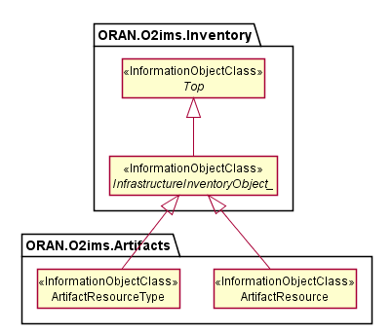
Figure 4.2.2.3.2.1-1 ORAN.O2ims.Artifacts Inheritance

4.2.2.4 Class Definitions

4.2.2.4.1 ArtifactResourceType

4.2.2.4.1.1 Definition
The ArtifactResourceType represents a resource type for a stored artifact resource in an O-Cloud.
Artifact resource types provide the categorization of O-Cloud artifacts used as declarative templates or binary images for provisioning or deployment. The values for these types are used to build the inventory with provisioning enablers. The O-Cloud provides a mechanism to discover data about artifacts with respective operations on artifact resource types.
The ArtifactResourceType is a Specialized Object that derives from a Generalized Object, the InfrastructureInventoryObject_. The ArtifactResourceType inherits the attributes from the InfrastructureInventoryObject_ and allows it and all specializations of this class to be included in a change notification.

4.2.2.4.1.2 Attributes
Table 4.2.2.4.1.2-1 Attributes Properties for ArtifactResourceType
Attribute name | Data Type/Description | Properties
artifactResourceTypeId | Data Type: string  Description: Cloud unique identifier for the artifact type. | x-support-qualifier: M  x-isInvariant: True  x-inventoryNotification: True  x-stateChangeNotification: False  format: uuid
name | Data Type: string  Description: Human readable name for the artifact type. | x-support-qualifier: M  x-isInvariant: True  x-inventoryNotification: False  x-stateChangeNotification: False
description | Data Type: string  Description: Description of the artifact type. | x-support-qualifier: M  x-isInvariant: True  x-inventoryNotification: False  x-stateChangeNotification: False
extensions | Data Type: array  Description: These are unspecified (not standardized) properties (keys) which are tailored by the vendor to extend the information provided about the artifact resource type. | x-support-qualifier: M  x-isAlwaysPresent: False  x-isInvariant: False  x-inventoryNotification: False  x-stateChangeNotification: False  x-isOrdered: False  minItems: 0  uniqueItems: True  items: AttributeValuePair

4.2.2.4.1.3 Attribute constraints
None.

4.2.2.4.1.4 State diagram
None.

4.2.2.4.2 ArtifactResource

4.2.2.4.2.1 Definition
The ArtifactResource represents a stored artifact resource in an O-Cloud.
ArtifactResource provides the ability to expose information about the artifact that is needed by consumers without the need of parsing the artifact itself by the consumer. The O-Cloud provides a mechanism to discover new artifacts with respective operations on artifact resources.
The ArtifactResource is a Specialized Object that derives from a Generalized Object, the InfrastructureInventoryObject_. The ArtifactResource inherits the attributes from the InfrastructureInventoryObject_ and allows it and all specializations of this class to be included in a change notification.

4.2.2.4.2.2 Attributes
Table 4.2.2.4.2.2-1 Attributes Properties for ArtifactResource
Attribute name | Data Type/Description | Properties
artifactResourceId | Data Type: string  Description: O-Cloud unique identifier for the artifact. | x-support-qualifier: M  x-isInvariant: True  x-inventoryNotification: True  x-stateChangeNotification: False  format: uuid
name | Data Type: string  Description: Human readable name of the artifact. | x-support-qualifier: M  x-isInvariant: True  x-inventoryNotification: False  x-stateChangeNotification: False
version | Data Type: string  Description: Version of the artifact. | x-support-qualifier: M  x-isInvariant: True  x-inventoryNotification: False  x-stateChangeNotification: False
description | Data Type: string  Description: Description of the artifact. | x-support-qualifier: M  x-isInvariant: True  x-inventoryNotification: False  x-stateChangeNotification: False
parameterSchema | Data Type: array  Description: Properties (keys) which are tailored by the artifact composition when it is to be used as a parameterized template. See NOTE. | x-support-qualifier: M  x-isAlwaysPresent: False  readOnly: True  x-isInvariant: False  x-inventoryNotification: False  x-stateChangeNotification: False  x-isOrdered: False  minItems: 0  uniqueItems: True  items: AttributeValuePair
NOTE: Since the ArtifactResource is generic for any kind of artifact at an information model level, no keys are specified since this would have dependency on the kind of resource to which the artifact applies.

4.2.2.4.2.3 Attribute constraints
None.

4.2.2.4.2.4 State diagram
None.

4.2.3 Namespace: ORAN.O2ims.Cluster

4.2.3.1 Namespace Overview
The O-RAN O2ims Cluster namespace defines the classes and their attributes which are directly exposed to the consumer (SMO) via its O2 IMS Interface.
This namespace is used for the provisioned O-Cloud Node Clusters with status and metrics as well as its internal topologies. The O-Coud Node Clusters are assembled based on the ORAN.O2ims.Inventory objects and configured through ORAN.O2ims.Artifacts.

4.2.3.2 Imported and associated information entities

4.2.3.2.1 Imported information entities and local labels
Information entities imported into the model are also elements of the namespace and therefore shall remain unique within the namespace.
Table 4.2.3.2.1-1 Imported Entities
Label reference | Local label

4.2.3.2.2 Associated information entities and local labels
Information entities referenced in the model through an association which may be extended and overloaded with a new entity of the same name within the namespace are listed in the associated entities table.
Table 4.2.3.2.2-1 Associated Entities
Label reference | Local label
4.2.1.4.7 InfrastructureInventoryObject_ | InfrastructureInventoryObject_

4.2.3.3 Class Diagram

4.2.3.3.1 Relationships

4.2.3.3.1.1 Description
This clause depicts the set of classes (e.g. IOCs) that encapsulates the information relevant for the O-RAN Cloud (O-Cloud). This clause provides an overview of the relationships between relevant classes in UML. Subsequent clauses provide more detailed specification of various aspects of these classes. The UML Class diagram depicts a view of the namespace maintaining a defined focus so as not to overcrowd a single diagram trying to depict all relationships within the namespace.

4.2.3.3.1.2 ORAN.O2ims.Cluster Intra-Namespace Relationships
@startuml
Hide Members
Hide Circle

Namespace ORAN.O2ims.Cluster #LightSteelBlue {
Class NodeCluster <<InformationObjectClass>>
Class NodeClusterType <<InformationObjectClass>>
Class ClusterResourceGroup <<InformationObjectClass>>
Class ClusterResource <<InformationObjectClass>>
Class ClusterResourceType <<InformationObjectClass>>

NodeCluster "1" --> "0..N\n+clusterResourceGroups" ClusterResourceGroup
NodeCluster --> NodeClusterType : Has
ClusterResourceGroup "1" -r-> "1..N\n+clusterResources" ClusterResource : "\t\t\t"
NodeCluster "1" --> "1..N\n+clusterResourceIds" ClusterResource
ClusterResource --> ClusterResourceType : Has
ClusterResource "1" --> "0..N\n+memberOf" ClusterResource
}

@enduml
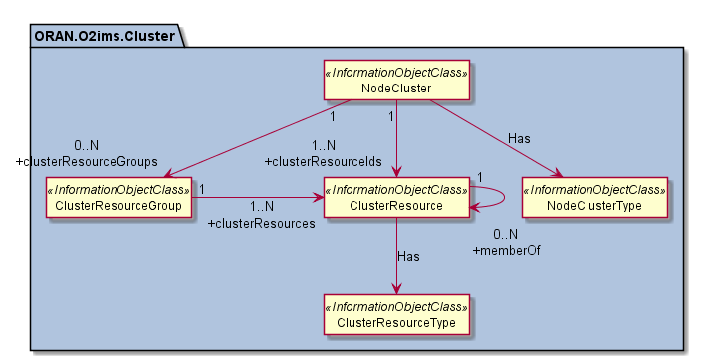
Figure 4.2.3.3.1.2-1 ORAN.O2ims.Cluster Intra-Namespace Relationships

4.2.3.3.1.3 ORAN.O2ims.Cluster Inter-Namespace Relationships
@startuml
Hide Members
Hide Circle

Namespace ORAN.O2ims.Cluster #LightSteelBlue {
Class NodeCluster <<InformationObjectClass>>
Class ClusterResource <<InformationObjectClass>>

}

Namespace ORAN.O2ims.Inventory #LightYellow {
Class Resource <<InformationObjectClass>>
}

Namespace ORAN.O2ims.Infrastructure #Lavender {
Class InfrastructureResource <<InformationObjectClass>>
}

Namespace ORAN.O2ims.Artifacts #Magenta {
Class ArtifactResource <<InformationObjectClass>>
}
Namespace ORAN.02ims.Provisioning #FireBrick {
Class ProvisioningRequest <<InformationObjectClass>>
}

ORAN.02ims.Provisioning.ProvisioningRequest --> ORAN.O2ims.Cluster.NodeCluster : Fulfill

ORAN.O2ims.Cluster.NodeCluster --> ORAN.O2ims.Artifacts.ArtifactResource : BasedOn

ORAN.O2ims.Cluster.ClusterResource -l-> ORAN.O2ims.Inventory.Resource : "\tMappedTo\t"
ORAN.O2ims.Cluster.ClusterResource .u. ORAN.O2ims.Infrastructure.InfrastructureResource
Note Left on Link
This relation will exist but its exact definitions
are dependent on the definition of specialized
classes within each namespace.
End note

ORAN.O2ims.Cluster.ClusterResource "\n0..N" --> "0..N\n+artifactResourceIds\t\t\t\n" ORAN.O2ims.Artifacts.ArtifactResource : "\n"
@enduml
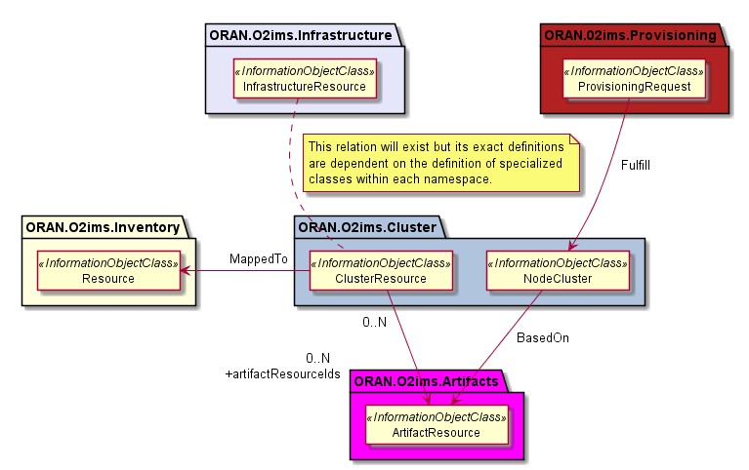
Figure 4.2.3.3.1.3-1 ORAN.O2ims.Cluster Inter-Namespace Relationships

4.2.3.3.2 Inheritance

4.2.3.3.2.1 ORAN.O2ims.Cluster Inheritance
@startuml
skin rose
skinparam ClassStereotypeFontStyle normal
skinparam style strictuml
hide members

Namespace ORAN.O2ims.Inventory {
Abstract Class InfrastructureInventoryObject_ <<InformationObjectClass>>
}

Namespace ORAN.O2ims.Cluster {

Abstract Class Top <<InformationObjectClass>>

Class NodeCluster <<InformationObjectClass>>
NodeCluster -r-|> ORAN.O2ims.Inventory.InfrastructureInventoryObject_

Class NodeClusterType <<InformationObjectClass>>
NodeClusterType -u-|> ORAN.O2ims.Inventory.InfrastructureInventoryObject_

Class ClusterResourceGroup <<InformationObjectClass>>
ClusterResourceGroup -d-|> Top

Class ClusterResource <<InformationObjectClass>>
ClusterResource -u-|> ORAN.O2ims.Inventory.InfrastructureInventoryObject_

Class ClusterResourceType <<InformationObjectClass>>
ClusterResourceType -l-|> ORAN.O2ims.Inventory.InfrastructureInventoryObject_

}

@enduml
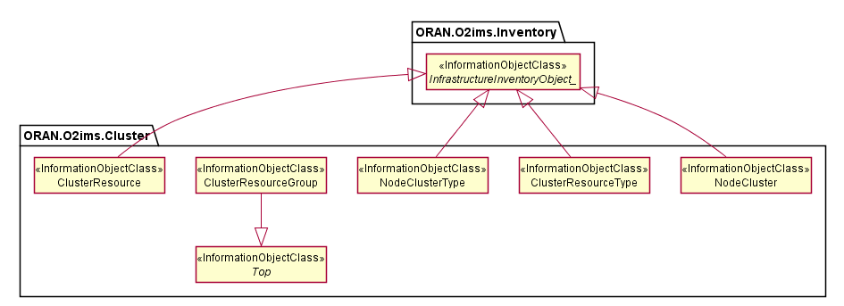
Figure 4.3.2.2.2.1-1 ORAN.O2ims.Cluster Inheritance

4.2.3.4 Class Definitions

4.2.3.4.1 NodeClusterType

4.2.3.4.1.1 Definition
The NodeClusterType represents a resource type for a NodeCluster in an O-Cloud.
Node cluster types provide the categorization of O-Cloud resource types used to create a node cluster. The O-Cloud provides a mechanism to discover the node cluster types with respective operations on node cluster types.
The NodeClusterType is a Specialized Object that derives from a Generalized Object, the InfrastructureInventoryObject_. The NodeClusterType inherits the attributes from the InfrastructureInventoryObject_ and allows it and all specializations of this class to be included in a change notification.

4.2.3.4.1.2 Attributes
Table 4.2.3.4.1.2-1 Attributes Properties for NodeClusterType
Attribute name | Data Type/Description | Properties
NodeClusterTypeId | Data Type: string  Description: Unique identifier for the NodeClusterType instance. | x-support-qualifier: M  x-isInvariant: True  x-inventoryNotification: True  x-stateChangeNotification: False  format: uuid
name | Data Type: string  Description: Name of the Node Cluster Type. | x-support-qualifier: M  x-isInvariant: False  x-inventoryNotification: True  x-stateChangeNotification: False
description | Data Type: string  Description: Human readable description of the Node Cluster Type. | x-support-qualifier: M  x-isInvariant: False  x-inventoryNotification: True  x-stateChangeNotification: False
extensions | Data Type: array  Description: These are unspecified (not standardized) properties (keys) which are tailored extend the information provided about the Node Cluster Type. | x-support-qualifier: M  x-isAlwaysPresent: False  x-isInvariant: False  x-inventoryNotification: False  x-stateChangeNotification: False  x-isOrdered: False  minItems: 0  uniqueItems: True  items: AttributeValuePair

4.2.3.4.1.3 Attribute constraints
None.

4.2.3.4.1.4 State diagram
None.

4.2.3.4.2 NodeCluster

4.2.3.4.2.1 Definition
The NodeCluster represents a set if resource used to deploy workloads in an O-Cloud.
Node cluster provides inventory of the resources used in a NodeCluster. The O-Cloud provides a mechanism to discover the node cluster with respective operations on node clusters.
The NodeCluster is a Specialized Object that derives from a Generalized Object, the InfrastructureInventoryObject_. The NodeCluster inherits the attributes from the InfrastructureInventoryObject_ and allows it and all specializations of this class to be included in a change notification.

4.2.3.4.2.2 Attributes
Table 4.2.3.4.2.2-1 Attributes Properties for NodeCluster
Attribute name | Data Type/Description | Properties
nodeClusterId | Data Type: string  Description: Unique identifier for the NodeCluster instance assigned by the O-Cloud. | x-support-qualifier: M  readOnly: True  x-isInvariant: True  x-inventoryNotification: True  x-stateChangeNotification: False  format: uuid
clientNodeClusterId | Data Type: string  Description: Unique identifier for the NodeCluster instance assigned by the consumer who requested its creation. | x-support-qualifier: M  x-isAlwaysPresent: False  x-isInvariant: True  x-inventoryNotification: True  x-stateChangeNotification: False
name | Data Type: string  Description: Name of the NodeCluster. | x-support-qualifier: M  x-isInvariant: False  x-inventoryNotification: True  x-stateChangeNotification: False
description | Data Type: string  Description: Human readable description of the NodeCluster. | x-support-qualifier: M  x-isInvariant: False  x-inventoryNotification: True  x-stateChangeNotification: False
extensions | Data Type: array  Description: These are unspecified (not standardized) properties (keys) which are tailored extend the information provided about the NodeCluster. | x-support-qualifier: M  x-isAlwaysPresent: False  x-isInvariant: False  x-inventoryNotification: False  x-stateChangeNotification: False  x-isOrdered: False  minItems: 0  uniqueItems: True  items: AttributeValuePair
clusterDistributionDescription | Data Type: string  Description: Human readable text identifying the method of distribution of ClusterResources over O-Cloud Sites. | x-support-qualifier: M  readOnly: True  x-isInvariant: False  x-inventoryNotification: True  x-stateChangeNotification: False
NodeClusterTypeId | Data Type: string  Description: Identifier for the NodeClusterType that this NodeCluster is. | x-support-qualifier: M  x-isInvariant: True  x-inventoryNotification: True  x-stateChangeNotification: False  format: uuid
artifactResourceId | Data Type: string  Description: Identifier for the template artifact which this NodeCluster is based on. | x-support-qualifier: M  readOnly: True  x-isInvariant: True  x-inventoryNotification: True  x-stateChangeNotification: False  format: uuid
clusterResourceIds | Data Type: array  Description: The list of cluster resource identifiers that are used to construct this NodeCluster. | x-support-qualifier: M  x-isInvariant: False  x-inventoryNotification: True  x-stateChangeNotification: False  x-isOrdered: False  minItems: 1  uniqueItems: True  items: string  format: uuid
clusterResourceGroups | Data Type: array  Description: Optional list node groups that comprise the cluster resources which compose the NodeCluster. | x-support-qualifier: M  x-isAlwaysPresent: False  x-isInvariant: False  x-inventoryNotification: True  x-stateChangeNotification: False  x-isOrdered: False  minItems: 0  uniqueItems: True  items: string  format: uuid

4.2.3.4.2.3 Attribute constraints
None.

4.2.3.4.2.4 State diagram
None.

4.2.3.4.3 ClusterResourceType

4.2.3.4.3.1 Definition
The ClusterResourceType represents a resource type for a ClusterResource in an O-Cloud.
Cluster resource types provide the categorization of O-Cloud resource types used to create a node cluster. The O-Cloud provides a mechanism to discover the cluster resource types with respective operations on cluster resource types.
The ClusterResourceType is a Specialized Object that derives from a Generalized Object, the InfrastructureInventoryObject_. The ClusterResourceType inherits the attributes from the InfrastructureInventoryObject_ and allows it and all specializations of this class to be included in a change notification.

4.2.3.4.3.2 Attributes
Table 4.2.3.4.3.2-1 Attributes Properties for ClusterResourceType
Attribute name | Data Type/Description | Properties
clusterResourceTypeId | Data Type: string  Description: Unique identifier for the ClusterResourceType instance. | x-support-qualifier: M  x-isInvariant: True  x-inventoryNotification: True  x-stateChangeNotification: False  format: uuid
name | Data Type: string  Description: Name of the Cluster Resource Type. | x-support-qualifier: M  x-isInvariant: False  x-inventoryNotification: True  x-stateChangeNotification: False
description | Data Type: string  Description: Human readable description of the Cluster Resource Type. | x-support-qualifier: M  x-isInvariant: False  x-inventoryNotification: True  x-stateChangeNotification: False
extensions | Data Type: array  Description: These are unspecified (not standardized) properties (keys) which are tailored extend the information provided about the Cluster Resource Type. | x-support-qualifier: M  x-isAlwaysPresent: False  x-isInvariant: False  x-inventoryNotification: False  x-stateChangeNotification: False  x-isOrdered: False  minItems: 0  uniqueItems: True  items: AttributeValuePair

4.2.3.4.3.3 Attribute constraints
None.

4.2.3.4.3.4 State diagram
None.

4.2.3.4.4 ClusterResource

4.2.3.4.4.1 Definition
The ClusterResource represents a resource used to construct a NodeCluster in an O-Cloud.
Node cluster resource provides inventory of the resources used in a NodeCluster. The O-Cloud provides a mechanism to discover the node cluster resources with respective operations on node cluster resources.
The ClusterResource is a Specialized Object that derives from a Generalized Object, the InfrastructureInventoryObject_. The ClusterResource inherits the attributes from the InfrastructureInventoryObject_ and allows it and all specializations of this class to be included in a change notification.

4.2.3.4.4.2 Attributes
Table 4.2.3.4.4.2-1 Attributes Properties for ClusterResource
Attribute name | Data Type/Description | Properties
clusterResourceId | Data Type: string  Description: Unique identifier for the ClusterResource instance. | x-support-qualifier: M  x-isInvariant: True  x-inventoryNotification: True  x-stateChangeNotification: False  format: uuid
name | Data Type: string  Description: Name of the cluster resource. | x-support-qualifier: M  x-isInvariant: False  x-inventoryNotification: True  x-stateChangeNotification: False
description | Data Type: string  Description: Human readable description of the cluster resource. | x-support-qualifier: M  x-isInvariant: False  x-inventoryNotification: True  x-stateChangeNotification: False
extensions | Data Type: array  Description: These are unspecified (not standardized) properties (keys) which are tailored extend the information provided about the Cluster Resource. | x-support-qualifier: M  x-isAlwaysPresent: False  x-isInvariant: False  x-inventoryNotification: False  x-stateChangeNotification: False  x-isOrdered: False  minItems: 0  uniqueItems: True  items: AttributeValuePair
clusterResourceTypeId | Data Type: string  Description: Identifier for the ClusterResourceType for this resource. | x-support-qualifier: M  readOnly: True  x-isInvariant: True  x-inventoryNotification: True  x-stateChangeNotification: False  format: uuid
memberOf | Data Type: array  Description: list of other ClusterResources which are linked together. | x-support-qualifier: M  x-isAlwaysPresent: False  readOnly: True  x-isInvariant: False  x-inventoryNotification: True  x-stateChangeNotification: False  x-isOrdered: False  minItems: 0  uniqueItems: True  items: string
artifactResourceIds | Data Type: array  Description: Identifiers for the artifact(s) which this resource is based on. | x-support-qualifier: M  x-isAlwaysPresent: False  x-isInvariant: False  x-inventoryNotification: True  x-stateChangeNotification: False  x-isOrdered: False  minItems: 0  uniqueItems: True  items: string  format: uuid
resourceId | Data Type: string  Description: Identifier for the inventory resource which this resource is mapped to. | x-support-qualifier: M  readOnly: True  x-isInvariant: True  x-inventoryNotification: True  x-stateChangeNotification: False  format: uuid

4.2.3.4.4.3 Attribute constraints
None.

4.2.3.4.4.4 State diagram
None.

4.2.3.4.5 ClusterResourceGroup

4.2.3.4.5.1 Definition
The ClusterResourceGroup represents a collection of ClusterResources as a named set.

4.2.3.4.5.2 Attributes
Table 4.2.3.4.5.2-1 Attributes Properties for ClusterResourceGroup
Attribute name | Data Type/Description | Properties
clusterResourceGroupId | Data Type: string  Description: Unique identifier for the ClusterResourceGroup. | x-support-qualifier: M  x-isInvariant: True  x-inventoryNotification: True  x-stateChangeNotification: False  format: uuid
name | Data Type: string  Description: Name of the Node Group. | x-support-qualifier: M  x-isInvariant: False  x-inventoryNotification: True  x-stateChangeNotification: False
description | Data Type: string  Description: Human readable description of the ClusterResourceGroup. | x-support-qualifier: M  x-isInvariant: False  x-inventoryNotification: True  x-stateChangeNotification: False
extensions | Data Type: array  Description: These are unspecified (not standardized) properties (keys) which are tailored extend the information provided about the ClusterResourceGroup. | x-support-qualifier: M  x-isAlwaysPresent: False  x-isInvariant: False  x-inventoryNotification: False  x-stateChangeNotification: False  x-isOrdered: False  minItems: 0  uniqueItems: True  items: AttributeValuePair
clusterResources | Data Type: array  Description: The list of Cluster Resources belonging to this ClusterResourceGroup. | x-support-qualifier: M  readOnly: True  x-isInvariant: False  x-inventoryNotification: True  x-stateChangeNotification: False  x-isOrdered: False  minItems: 1  uniqueItems: True  items: string  format: uuid

4.2.3.4.5.3 Attribute constraints
None.

4.2.3.4.5.4 State diagram
None.

4.2.4 Namespace: ORAN.O2ims.Provisioning

4.2.4.1 Namespace Overview
The O-RAN O2ims Provisioning namespace defines the classes and their attributes which are directly exposed to the consumer (SMO) via its O2 IMS Interface.
This namespace is used for provisioning requests and fulfillments, e.g. of O-Cloud Node Clusters, representing the requested and agreed service levels and their current identifiers.

4.2.4.2 Imported and associated information entities

4.2.4.2.1 Imported information entities and local labels
Information entities imported into the model are also elements of the namespace and therefore shall remain unique within the namespace.
Table 4.2.4.2.1-1 Imported Entities
Label reference | Local label
TS 28.622 [6], information object class, Top | Top

4.2.4.2.2 Associated information entities and local labels
Information entities referenced in the model through an association which may be extended and overloaded with a new entity of the same name within the namespace are listed in the associated entities table.
Table 4.2.4.2.2-1 Associated Entities
Label reference | Local label

4.2.4.3 Class Diagram

4.2.4.3.1 Relationships

4.2.4.3.1.1 Description
This clause depicts the set of classes (e.g. IOCs) that encapsulates the information relevant for the O-RAN Cloud (O-Cloud). This clause provides an overview of the relationships between relevant classes in UML. Subsequent clauses provide more detailed specification of various aspects of these classes. The UML Class diagram depicts a view of the namespace maintaining a defined focus so as not to overcrowd a single diagram trying to depict all relationships within the namespace.

4.2.4.3.1.2 ORAN.O2ims.Provisioning Intra-Namespace Relationships
@startuml
Namespace ORAN.O2ims.Provisioning #FireBrick {
Skinparam BorderColor Red
Skinparam ArrowColor Yellow
Hide Empty Members
Hide Circle

Class ProvisioningRequest <<InformationObjectClass>>

Class ProvisioningStatus <<dataType>>

ENUM ProvisioningPhase <<enumeration>>

ProvisioningRequest --> ProvisioningStatus
ProvisioningStatus -r- ProvisioningPhase

}
@enduml
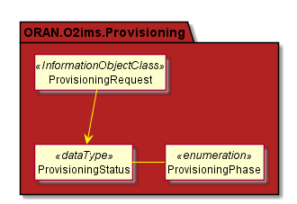
Figure 4.2.4.3.1.2-1 ORAN.O2ims.Provisioning Intra-Namespace Relationships

4.2.4.3.1.3 ORAN.O2ims.Provisioning Inter-Namespace Relationships
@startuml
Hide Members
Hide Circle

Skinparam ArrowColor MediumSeaGreen

Namespace ORAN.O2ims.Provisioning #FireBrick {
Class ProvisioningRequest <<InformationObectClass>>
}

Namespace ORAN.O2ims.Artifacts #Magenta {
Abstract Class Template <<InformationObectClass>>
}

Namespace ORAN.O2ims.Cluster #LightSteelBlue {
Class NodeCluster <<InformationObectClass>>
}

Namespace ORAN.O2ims.Infrastructure #Lavender {
Abstract Class InfrastructureResource <<InformationObectClass>>
}

ORAN.O2ims.Provisioning.ProvisioningRequest : “\n\n”

ORAN.O2ims.Provisioning.ProvisioningRequest -l-> ORAN.O2ims.Artifacts.Template : “ accordingTo “

ORAN.O2ims.Provisioning.ProvisioningRequest “\n\n1\n+provisioningRequestId” <-r-> “0..N\n+nodeClusterId” ORAN.O2ims.Cluster.NodeCluster : “\t\t\t\t\t\t\t“

ORAN.O2ims.Provisioning.ProvisioningRequest “1\n+provisioningRequestId\n\n” <-u-> “\n0..N\n+infrastructureResourceIds” ORAN.O2ims.Infrastructure.InfrastructureResource : “\n\n\n”

@enduml
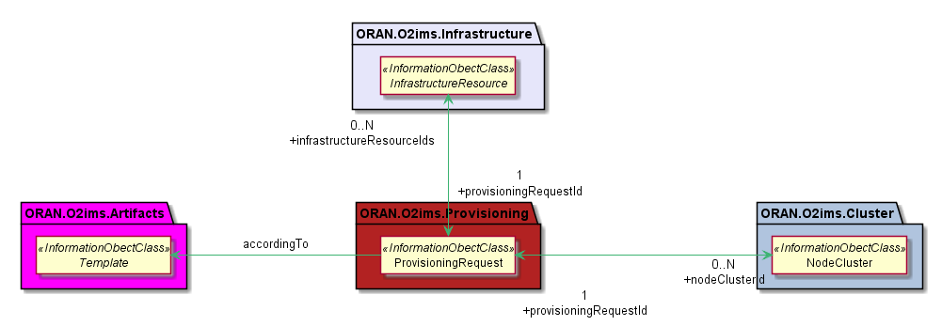
Figure 4.2.4.3.1.3-1 ORAN.O2ims.Provisioning Inter-Namespace Relationships

4.2.4.3.2 Inheritance

4.2.4.3.2.1 ORAN.O2ims.Provisioning Inheritance
@startuml
skin rose
skinparam ClassStereotypeFontStyle normal
skinparam style strictuml
hide members

Abstract Class Top <<InformationObectClass>>
Class ProvisioningRequest <<InformationObectClass>>

Top <|-- ProvisioningRequest

@enduml
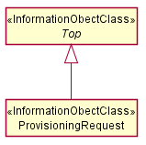
Figure 4.2.4.3.2.1-1 ORAN.O2ims.Provisioning Inheritance

4.2.4.4 Class Definitions

4.2.4.4.1 ProvisioningRequest

4.2.4.4.1.1 Definition
The ProvisioningRequest represents a request for item(s) to be provisioned in the O-Cloud. The SMO makes the declarative request to the O-Cloud through the O2ims.

4.2.4.4.1.2 Attributes
Table 4.2.4.4.1.2-1 Attributes Properties for ProvisioningRequest
Attribute name | Data Type/Description | Properties
provisioningRequestId | Data Type: string  Description: Identifier of the provisioning request instance assigned by the SMO. | x-support-qualifier: M  x-isInvariant: True  x-inventoryNotification: False  x-stateChangeNotification: False  format: uuid
name | Data Type: string  Description: Human readable name of the provisioning request instance as assigned by the SMO. | x-support-qualifier: M  x-isInvariant: False  x-inventoryNotification: False  x-stateChangeNotification: False
description | Data Type: string  Description: Human readable description of the provisioning request instance as assigned by the SMO. | x-support-qualifier: M  x-isInvariant: False  x-inventoryNotification: False  x-stateChangeNotification: False
templateName | Data Type: string  Description: Name of the template to be used as the basis for the declarative model for the provisioning request instance. When combined with the templateVersion it shall resolve to a templateId. | x-support-qualifier: M  x-isInvariant: False  x-inventoryNotification: False  x-stateChangeNotification: False
templateVersion | Data Type: string  Description: Version of the template used as the basis for the declarative model for the provisioning request instance. When combined with the templateName it shall resolve to a templateId. | x-support-qualifier: M  x-isInvariant: False  x-inventoryNotification: False  x-stateChangeNotification: False
templateParameters | Data Type: array  Description: List of variables/value pairs used within the template to tailor the template to this request instance. | x-support-qualifier: M  x-isAlwaysPresent: False  x-isInvariant: False  x-inventoryNotification: False  x-stateChangeNotification: False  x-isOrdered: False  minItems: 0  uniqueItems: True  items: AttributeValuePair
provisioningRequestReference | Data Type: string  Description: A unique reference of this ProvisioningRequest assigned by the service producer at the time of request creation. | x-support-qualifier: M  readOnly: True  x-isInvariant: True  x-inventoryNotification: False  x-stateChangeNotification: False
status | Data Type: ProvisioningStatus  Description: The time of the last message and the current provisioningPhase of the ProvisioningRequest. | x-support-qualifier: M  readOnly: True  x-isInvariant: False  x-inventoryNotification: False  x-stateChangeNotification: True
provisionedResourceSet | Data Type: provisionedResourceSet  Description: The resources that have been successfully provisioned as part of the provisioningRequest. | x-support-qualifier: M  x-isAlwaysPresent: False  readOnly: True  x-isInvariant: False  x-inventoryNotification: True  x-stateChangeNotification: False

4.2.4.4.1.3 Attribute constraints
Table 4.2.4.4.1.3-3 Attributes Constraints for ProvisioningRequest
Name | Definition
ReadOnlyAfterCreate | The following attributes are provided by the SMO on the create request but are readOnly aftwards: provisioningRequestId

4.2.4.4.1.4 State diagram
None.

4.2.4.4.2 ProvisioningStatus <<dataType>>

4.2.4.4.2.1 Definition
The ProvisioningStatus represents the status of a ProvisioningRequest indicating the time of the last message and the current provisioningPhase and the provisioning status of the NodeCluster and/or individual InfrastructureResource(s) being provisioned by the ProvisioningRequest. The provisioningPhase is an enumerated set of values – PENDING, PROGRESSING, FULFILLED, FAILED, DELETING, that reflect the current phase of the provisioning request. The high-level definition of each provisioningPhase, are:
- PENDING: The ProvisioningRequest is waiting to be processed by the O-Cloud (IMS).
- PROGRESSING: The O-Cloud (IMS) is processing the ProvisioningRequest and executing the actions to fulfill it.
- FULFILLED: The ProvisioningRequest has been successfully processed and completed by the O-Cloud (IMS).
- FAILED: The ProvisioningRequest could not be fully processed by the O-Cloud (IMS).
- DELETING: The ProvisioningRequest is in the process of being deleted by the O-Cloud (IMS).

4.2.4.4.2.2 Attributes
Table 4.2.4.4.2.2-1 Attributes Properties for ProvisioningStatus
Attribute name | Data Type/Description | Properties
updateTime | Data Type: string  Description: The last date and time that the provisioningPhase attribute was modified. | x-support-qualifier: M  readOnly: True  x-isInvariant: False  x-inventoryNotification: False  x-stateChangeNotification: True  format: date-time
message | Data Type: string  Description: Human readable text about the provisioningPhase at the last updateTime. | x-support-qualifier: M  readOnly: True  x-isInvariant: False  x-inventoryNotification: False  x-stateChangeNotification: True
provisioningPhase | Data Type: string  Description: This is an enumerated set of values which reflects the current phase of the provisioning request. | x-support-qualifier: M  readOnly: True  x-isInvariant: False  x-inventoryNotification: False  x-stateChangeNotification: True  enum:  - PENDING  - PROGRESSING  - FULFILLED  - FAILED  - DELETING
nodeClusterProvisioningStatus | Data Type: ResourceProvisionigStatus  Description: The current provisioning status of the NodeCluster. | x-support-qualifier: M  x-isAlwaysPresent: False  readOnly: True  x-isInvariant: False  x-inventoryNotification: False  x-stateChangeNotification: True
infrastructureResourceProvisioningStatus | Data Type: array  Description: The current provisioning status of individual InfrastructureResource(s). | x-support-qualifier: M  x-isAlwaysPresent: False  readOnly: True  x-isInvariant: False  x-inventoryNotification: False  x-stateChangeNotification: True  x-isOrdered: False  minItems: 0  uniqueItems: True  items: ResourceProvisionigStatus

4.2.4.4.2.3 Attribute constraints
None.

4.2.4.4.2.4 State diagram
@startuml
skinparam NoteFontColor white
[*] -[#green]-> PENDING : Create
PENDING -[#blue]-> PROGRESSING : Accepted
PENDING -[#blue]--> FAILED : Failed
PENDING -[#green]--> DELETING : Delete
PROGRESSING -[#blue]-> FULFILLED : Completed
PROGRESSING -[#green]-> PENDING : Update
PROGRESSING -[#blue]--> FAILED : Failed
PROGRESSING -[#green]--> DELETING : Delete
FAILED -[#green]--> PENDING : Update
FAILED -[#green]--> DELETING : Delete
FULFILLED -[#green]-> PENDING : Update
FULFILLED -[#green]--> DELETING : Delete
DELETING -[#blue]->[*] : Deletion\nCompleted
note "O-Cloud Internal Transitions" as N1 #blue
note "Service Operation Request" as N2 #green
@enduml
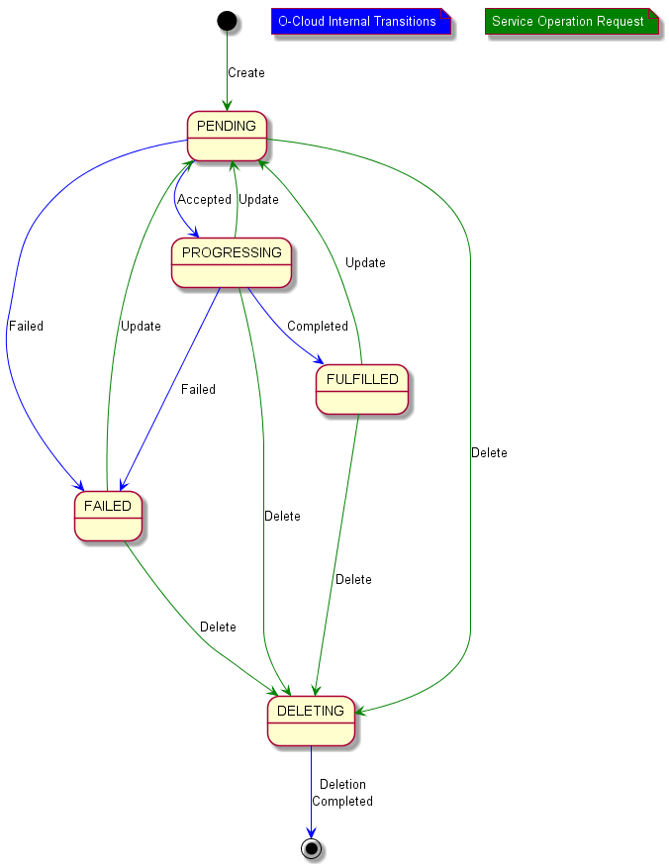Figure 4.2.4.4.2.4-1 State Diagram for Provisioning Request (provisioningPhase) Phase Transition

4.2.4.4.3 ProvisionedResourceSet <<dataType>>

4.2.4.4.3.1 Definition
The ProvisionedResourceSet represents the resources that have been successfully provisioned as part of the ProvisioningRequest.

4.2.4.4.3.2 Attributes
Table 4.2.4.4.3.2-1 Attributes Properties for ProvisionedResourceSet
Attribute name | Data Type/Description | Properties
nodeClusterId | Data Type: String  Description: If the request is fulfilled by a NodeCluster this field will contain its Id. | x-support-qualifier: M  x-isAlwaysPresent: False  readOnly: True  x-isInvariant: False  x-inventoryNotification: True  x-stateChangeNotification: False  x-nullable: True  format: uuid
infrastructureResourceIds | Data Type: array  Description: If the request is fulfilled by InfrastructureResource(s) this list will contain the Id(s) of all resources used to fulfil it. | x-support-qualifier: M  x-isAlwaysPresent: False  readOnly: True  x-isInvariant: False  x-inventoryNotification: True  x-stateChangeNotification: False  x-isOrdered: False  minItems: 0  uniqueItems: True  items: string

4.2.4.4.3.3 Attribute constraints
None.

4.2.4.4.3.4 State diagram
None.

4.2.4.4.4 ResourceProvisioningStatus <<dataType>>

4.2.4.4.4.1 Definition
The ResourceProvisioningStatus represents the provisioning status of a resource indicating the ‘name’, ‘resourceId’ and ‘resourceProvisioningPhase’ of the NodeCluster or the InfrastructureResource. The ‘resourceProvisioningPhase’ is an enumerated set of values – PROCESSING, PROVISIONED, AWAITING_FREE_RESOURCES and FAILED, that reflect the current provisioning phase of the NodeCluster or an InfrastructureResource. The meanings of the possible values for resourceProvisioningPhase are as follows:
- PROCESSING: The resource provisioning is under processing.
- PROVISIONED: The resource has been provisioned successfully.
- AWAITING_FREE_RESOURCES: IMS is waiting for free O-Cloud Resources to be available to fulfill the provisioning of the requested resource. IMS continues to attempt to acquire required resources. This situation can be resolved if required O-Cloud Resources are made available by O-Cloud, or by SMO (FOCOM) updating the Provisioning Request to suit the available O-Cloud resources.
- FAILED: O-Cloud has experienced some internal failures for the provisioining of the resource. IMS at O-Cloud stops further processing for provisioning of corresponding resource until further intervention from consumer SMO (FOCOM).

4.2.4.4.4.2 Attributes
Table 4.2.4.4.4.2-1 Attributes Properties for ResourceProvisioningStatus
Attribute name | Data Type/Description | Properties
resourceName | Data Type: string  Description: Name of the resource as given in ProvisioningRequest parameters. | x-support-qualifier: M  readOnly: True  x-isInvariant: True  x-inventoryNotification: False  x-stateChangeNotification: False
resourceId | Data Type: string  Description: Identifier of the resource, as assigned by the O-Cloud. | x-support-qualifier: M  x-isAlwaysPresent: False  readOnly: True  x-isInvariant: True  x-inventoryNotification: False  x-stateChangeNotification: False  format: uuid
resourceProvisioningPhase | Data Type: string  Description: Current provisioning phase of the resource. | x-support-qualifier: M  readOnly: True  x-isInvariant: False  x-inventoryNotification: False  x-stateChangeNotification: True  enum:  - PROCESSING  - PROVISIONED  - AWAITING_FREE_RESOURCES  - FAILED

4.2.4.4.4.3 Attribute constraints
None

4.2.4.4.4.4 State diagram
@startuml
skin rose
skinparam ClassStereotypeFontStyle normal
skinparam style strictuml
hide members

state PROCESSING
state FAILED
state PROVISIONED
state "AWAITING_FREE_RESOURCES" as WAITING

PROCESSING --> FAILED : O-Cloud\nInternal failure
FAILED -l-> PROCESSING : ProvisioningRequest\nupdate request
PROCESSING -d-> PROVISIONED : ProvisioningRequest\nupdate request
PROVISIONED -> PROCESSING
PROCESSING -d-> WAITING : O-Cloud could not\nacquire enough\nresources
WAITING -> PROCESSING : O-Cloud adds\nrequired resources
WAITING -> PROCESSING : ProvisioningRequest\nupdate request
FAILED -d[hidden]-> PROVISIONED
FAILED -r[hidden]-> WAITING
WAITING -d[hidden]-> PROVISIONED

@enduml
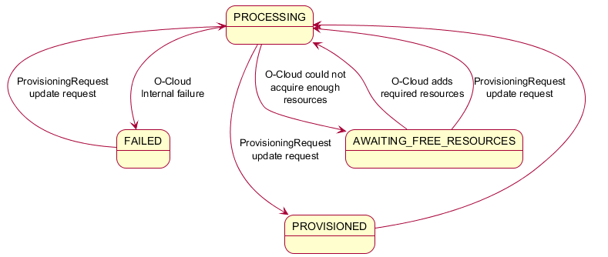
Figure 4.2.4.4.4.4-1 State Diagram for ResourceProvisioningPhase transitions

4.2.5 Namespace: ORAN.O2ims.Infrastructure

4.2.5.1 Namespace Overview
The O-RAN O2ims Infrastructure namespace defines the classes and their attributes which are directly exposed to the consumer (SMO) via its O2 IMS Interface.
This namespace is used for fulfillment of provisioning requests which produce configured resources for later provisioning requests.

4.2.5.2 Imported and associated information entities

4.2.5.2.1 Imported information entities and local labels
Information entities imported into the model are also elements of the namespace and therefore shall remain unique within the namespace.
Table 4.2.5.2.1-1 Imported Entities
Label reference | Local label

4.2.5.2.2 Associated information entities and local labels
Information entities referenced in the model through an association which may be extended and overloaded with a new entity of the same name within the namespace are listed in the associated entities table.
Table 4.2.5.2.2-1 Associated Entities
Label reference | Local label
4.2.1.4.7, InfrastructureInventoryObject_ | InfrastructureInventoryObject_

4.2.5.3 Class Diagram

4.2.5.3.1 Relationships

4.2.5.3.1.1 Description
This clause depicts the set of classes (e.g. IOCs) that encapsulates the information relevant for the O-RAN Cloud (O-Cloud). This clause provides an overview of the relationships between relevant classes in UML. Subsequent clauses provide more detailed specification of various aspects of these classes. The UML Class diagram depicts a view of the namespace maintaining a defined focus so as not to overcrowd a single diagram trying to depict all relationships within the namespace.

4.2.5.3.1.2 ORAN.O2ims.Infrastructure Intra-Namespace Relationships
The O-Cloud Networking consists of both intra- and inter-namespace relationships, which are complex in nature. The overview diagram (Figure 4.2.5.3.1.2-1) which simplifies the relationships has been drawn to help build a high-level understanding of the various object classes and their relationships. For example, a “Node” of type VM, BareMetal, and/or IaaS, which is a cluster resource type, terminates one or more site networks, which is an infrastructure resource type. Similarly, a gateway can terminate one or more site networks, forming an intra-namespace relationship since both the gateway and site networks belong to the infrastructure namespace.
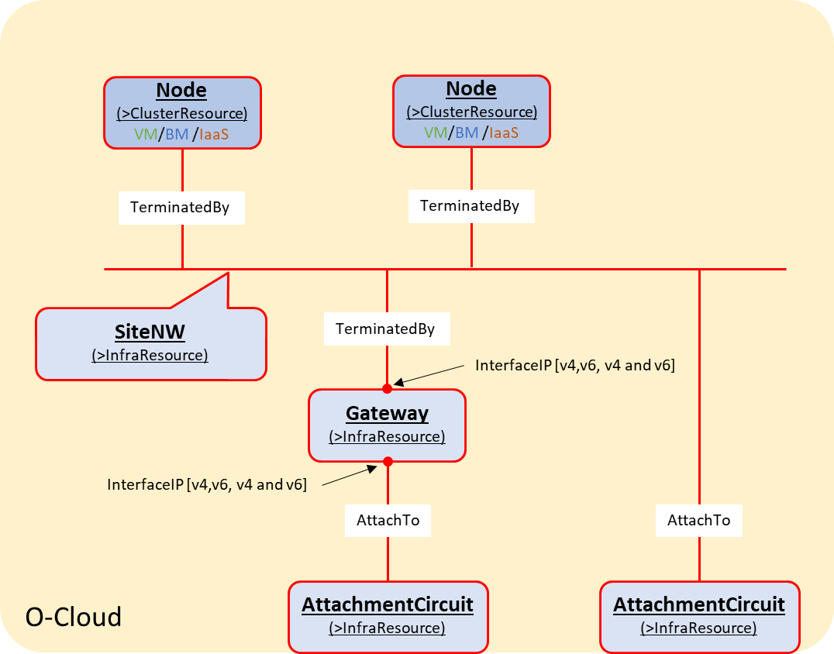
Figure 4.2.5.3.1.2-1 O-Cloud Networking Overview
These relationships, however, involve various elements and endpoints to support multiplicity, which introduces several implicit data types such as Port, NetworkAddress, and SegmentationElement. Each of these elements can include multiple endpoints representing a termination or an external connectivity attachment. These implicit data types and their relationships with O-Cloud Networking objects are captured in Figure 4.2.5.3.1.2-2, which illustrates the intra-namespace relationships between specialized infrastructure namespace objects.
There is a relationship between “Port” and “AttachmentCircuit” to represent the endpoint connectivity provided by “Port” for O-Cloud Site connectivity, using two possible associations to the transport network described in Clause 4.2.1.3.1.4.1.
Note: This document version represents the relationship with a dotted line, as the O-Cloud Networking Information Model is still in development.

@startuml
Hide members
Hide circle

Namespace ORAN.O2ims.Infrastructure #Lavender {

Class InfrastructureResource <<InformationObjectClass>>

InfrastructureResource “1” o--> “0..N\n+linkedInfrastructureResources” InfrastructureResource

Class InfrastructureResourceType <<InformationObjectClass>>

InfrastructureResource -u-> InfrastructureResourceType : isOfType

Class Gateway <<InformationObjectClass>>
Class Port <<dataType>>
Class NetworkAddress <<dataType>>

Class SiteNetwork <<InformationObjectClass>>
Class SegmentationElement <<dataType>>
Class AttachmentCircuit <<InformationObjectClass>>

SiteNetwork “1” *--> “1..N\n+segmentation” SegmentationElement : “\n\n\n”
SiteNetwork “1” o-r-> “0..N\n+attachedTo” Port : “\t\t\t”
AttachmentCircuit “1” *-u-> “1..N\n+segmentation” SegmentationElement
Gateway “1” *-u-> “1..N\n+connectedNetworks” Port : "\n\n\n"
Gateway “1” *-u-> “0..N\n+attachedTo” Port
Port “1” *-r-> “1..N\n+endPoints” NetworkAddress : "\t\t\t"

AttachmentCircuit .l. Port

}

@enduml
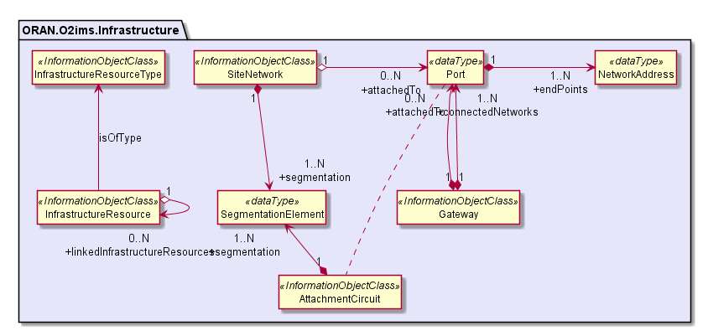
Figure 4.2.5.3.1.2-2 ORAN.O2ims.Infrastructure Intra-Namespace Relationships

4.2.5.3.1.3 ORAN.O2ims.Infrastructure Inter-Namespace Relationships
@startuml
Hide Members
Hide Circle

Namespace ORAN.O2ims.Inventory #LightYellow {
Class Resource <<InformationObjectClass>>
}

Namespace ORAN.O2ims.Cluster #LightSteelBlue {
Class ClusterResource <<InformationObjectClass>>
}

Namespace ORAN.O2ims.Infrastructure #Lavender {
Class InfrastructureResource <<InformationObjectClass>>
}

Namespace ORAN.O2ims.Artifacts #Magenta {
Class ArtifactResource <<InformationObjectClass>>
}

ORAN.O2ims.Infrastructure.InfrastructureResource “1” -l-> “\n1..N\n+inventoryResourceIds” ORAN.O2ims.Inventory.Resource : “\t\trealizedBy\t\t”

ORAN.O2ims.Infrastructure.InfrastructureResource .d. ORAN.O2ims.Cluster.ClusterResource
Note Left on Link
This relation will exist but its exact definitions
are dependent on the definition of specialized
classes within each namespace.
End note

ORAN.O2ims.Infrastructure.InfrastructureResource “1” -r-> “\n1\n+artifactResourceId” ORAN.O2ims.Artifacts.ArtifactResource : “\t\tBasedOn\t\t”

@enduml
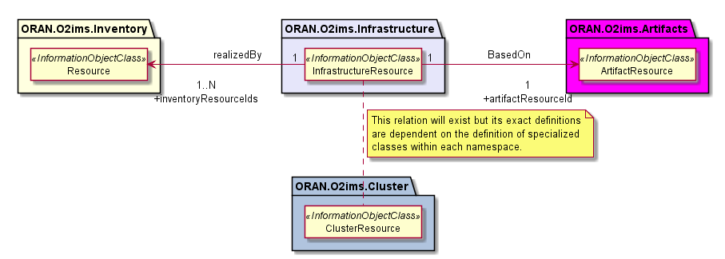
Figure 4.2.5.3.1.3-1 ORAN.O2ims.Infrastructure Inter-Namespace Relationships

4.2.5.3.2 Inheritance

4.2.5.3.2.1 ORAN.O2ims.Infrastructure Inheritance
@startuml
skin rose
skinparam ClassStereotypeFontStyle normal
skinparam style strictuml
hide members

Namespace ORAN.O2IMS.Inventory {
Abstract Class InfrastructureInventoryObject_ <<InformationObjectClass>>

}

Namespace ORAN.O2IMS.Infrastructure {
Class InfrastructureResource <<InformationObjectClass>>
InfrastructureResource -u-|> ORAN.O2IMS.Inventory.InfrastructureInventoryObject_

Class InfrastructureResourceType <<InformationObjectClass>>
InfrastructureResourceType -u-|> ORAN.O2IMS.Inventory.InfrastructureInventoryObject_
}

@enduml
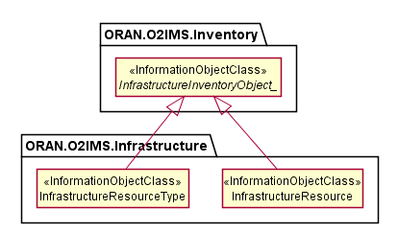
Figure 4.2.5.3.2.1-1 ORAN.O2ims.Infrastructure Inheritance

4.2.5.4 Class Definitions

4.2.5.4.1 InfrastructureResourceType

4.2.5.4.1.1 Definition
The InfrastructureResourceType represents a resource type in an O-Cloud.
Infrastructure resource types provide the categorization of O-Cloud resources used to connect the O-Cloud resources and to build components of the Cluster namespace. The values for these types are used to build the configured inventory and enable an authorized consumer to track infrastructure resource changes over time. The O-Cloud provides a mechanism to discover the infrastructure resource types with respective operations on infrastructure resource types.
The InfrastructureResourceType is a Specialized Object that derives from a Generalized Object, the InfrastructureInventoryObject_. The InfrastructureResourceType inherits the attributes from the InfrastructureInventoryObject_ and allows it and all specializations of this class to be included in a change notification.

4.2.5.4.1.2 Attributes
Table 4.2.5.4.1.2-1 Attributes Properties for InfrastructureResourceType
Attribute name | Data Type/Description | Properties
infrastructureResourceTypeId | Data Type: string  Description: Identifier of the infrastructure resource type. | x-support-qualifier: M  readOnly: True  x-isInvariant: True  x-inventoryNotification: True  x-stateChangeNotification: False  format: uuid
name | Data Type: string  Description: Name of the infrastructure resource type as identified by the cloud provider. | x-support-qualifier: M  readOnly: True  x-isInvariant: False  x-inventoryNotification: True  x-stateChangeNotification: False
description | Data Type: string  Description: Human readable description of the infrastructure resource type. | x-support-qualifier: M  readOnly: True  x-isInvariant: False  x-inventoryNotification: True  x-stateChangeNotification: False
extensions | Data Type: array  Description: These are unspecified (not standardized) properties (keys) which are tailored by the vendor to extend the information provided about the Infrastructure Resource Type. | x-support-qualifier: M  x-isAlwaysPresent: False  readOnly: True  x-isInvariant: True  x-inventoryNotification: False  x-stateChangeNotification: False  x-isOrdered: False  minItems: 0  uniqueItems: True  items: AttributeValuePair

4.2.5.4.1.3 Attribute constraints
None.

4.2.5.4.1.4 State diagram
None.

4.2.5.4.2 InfrastructureResource

4.2.5.4.2.1 Definition
The InfrastructureResource is a Specialized Object that derives from a Generalized Object, the InfrastructureInventoryObject_. The InfrastructureResource inherits the attributes from the InfrastructureInventoryObject_ and allows it and all specializations of this class to be included in a change notification.

4.2.5.4.2.2 Attributes
Table 4.2.5.4.1.2-1 Attributes Properties for InfrastructureResource
Attribute name | Data Type/Description | Properties
infrastructureResourceId | Data Type: string  Description: Identifier of the resource. Locally unique within the scope of an O-Cloud instance. | x-support-qualifier: M  readOnly: True  x-isInvariant: True  x-inventoryNotification: True  x-stateChangeNotification: False  format: uuid
name | Data Type: string  Description: Human readable name of the infrastructure resource instance. | x-support-qualifier: M  readOnly: True  x-isInvariant: False  x-inventoryNotification: True  x-stateChangeNotification: False
description | Data Type: string  Description: Human readable description of the infrastructure resource. | x-support-qualifier: M  readOnly: True  x-isInvariant: False  x-inventoryNotification: True  x-stateChangeNotification: False
infrastructureResourceTypeId | Data Type: string  Description: Identifier of infrastructure resource type that this instance is a type of. | x-support-qualifier: M  readOnly: True  x-isInvariant: True  x-inventoryNotification: True  x-stateChangeNotification: False  format: uuid
linkedInfrastructureResourceIds | Data Type: array  Description: List of infrastructure resource IDs that are used to realize this infrastructure resource instance. | x-support-qualifier: M  x-isAlwaysPresent: False  readOnly: True  x-isInvariant: False  x-inventoryNotification: True  x-stateChangeNotification: False  x-isOrdered: False  minItems: 0  uniqueItems: True  items: string
inventoryResourceIds | Data Type: array  Description: List of inventory resource IDs that are used to realize this infrastructure resource instance. | x-support-qualifier: M  readOnly: True  x-isInvariant: False  x-inventoryNotification: True  x-stateChangeNotification: False  x-isOrdered: False  minItems: 1  uniqueItems: True  items: string
artifactResourceId | Data Type: string  Description: Identifier of artifact resource Id that the instance was configured with. | x-support-qualifier: M  readOnly: True  x-isInvariant: True  x-inventoryNotification: True  x-stateChangeNotification: False  format: uuid
extensions | Data Type: array  Description: These are unspecified (not standardized) properties (keys) which are tailored by the vendor to extend the information provided about the Resource Pool. | x-support-qualifier: M  x-isAlwaysPresent: False  readOnly: True  x-isInvariant: False  x-inventoryNotification: False  x-stateChangeNotification: False  x-isOrdered: False  minItems: 0  uniqueItems: True  items: AttributeValuePair

4.2.5.4.2.3 Attribute constraints
None.

4.2.5.4.2.4 State diagram
None.

4.2.5.4.3 Gateway

4.2.5.4.3.1 Definition
The Gateway infrastructure resource is a specialization of the InfrastructureResource. As such in addition to the attributes below, all attributes of the InfrastructureResource are also a member of this class.
NOTE 1: The present document version does not specify QoS related attributes/classes.
NOTE 2: The present document version does not specify complete L2/L3 related attributes/classes associated to the Gateway.
The Gateway is a Specialized Object that derives from a Generalized Object, the InfrastructureResource. The Gateway inherits the attributes from the InfrastructureResource.

4.2.5.4.3.2 Attributes
Table 4.2.5.4.3.2-1 Attributes Properties for Gateway
Attribute name | Data Type/Description | Properties
tags | Data Type: array  Description: The list of tags/labels on the Gateway resource. | x-support-qualifier: M  x-isAlwaysPresent: False  readOnly: True  x-isInvariant: False  x-inventoryNotification: True  x-stateChangeNotification: False  minItems: 0  items: AttributeValuePair
status | Data Type: string  Description: The Gateway status. For instance, ACTIVE, DOWN, BUILD or ERROR. | x-support-qualifier: M  readOnly: True  x-isInvariant: False  x-inventoryNotification: False  x-stateChangeNotification: True
connectedNetworks | Data Type: array  Description: The list of port(s) to support one or multiple Site Networks termination. A port is a list of Gateway interfaceIPs e.g. IPv4 and IPv6 for a Site Network. | x-support-qualifier: M  x-isAlwaysPresent: False  readOnly: True  x-isInvariant: False  x-inventoryNotification: True  x-stateChangeNotification: False  minItems: 0  items: Port
realizedBy | Data Type: string  Description: Where this gateway is implemented/realized (e.g. SiteGW). | x-support-qualifier: M  readOnly: True  x-isInvariant: True  x-inventoryNotification: True  x-stateChangeNotification: False  format: uuid
attachedTo | Data Type: array  Description: The list of port(s) to support one or multiple Attachment Circuits. A port is a list of Gateway interfaceIPs e.g. IPv4 and IPv6 for an Attachment Circuit. | x-support-qualifier: M  x-isAlwaysPresent: False  readOnly: True  x-isInvariant: False  x-inventoryNotification: True  x-stateChangeNotification: False  minItems: 0  items: Port

4.2.5.4.3.3 Attribute constraints
None.

4.2.5.4.3.4 State diagram
None.

4.2.5.4.4 SiteNetwork

4.2.5.4.4.1 Definition
The SiteNetwork infrastructure resource is a specialization of the InfrastructureResource. As such in addition to the attributes below, all attributes of the InfrastructureResource are also a member of this class.
NOTE: The present document version does not specify QoS related attributes/classes.
The SiteNetwork is a Specialized Object that derives from a Generalized Object, the InfrastructureResource. The SiteNetwork inherits the attributes from the InfrastructureResource.

4.2.5.4.4.2 Attributes
Table 4.2.5.4.4.2-1 Attributes Properties for SiteNetwork
Attribute name | Data Type/Description | Properties
tags | Data Type: array  Description: The list of tags/labels on the SiteNetwork resource. | x-support-qualifier: M  x-isAlwaysPresent: False  readOnly: True  x-isInvariant: False  x-inventoryNotification: True  x-stateChangeNotification: False  items: AttributeValuePair
mtu | Data Type: integer  Description: The maximum transmission unit (MTU) value to address fragmentation. Minimum value is 68 for IPv4, and 1280 for IPv6. | x-support-qualifier: M  x-isAlwaysPresent: False  readOnly: True  x-isInvariant: False  x-inventoryNotification: True  x-stateChangeNotification: False
segmentation | Data Type: array  Description: The list of segmentationElement(s) to support one or multiple segments where, a segmentationElement is a list of segmentationID (e.g. 100, 200) and segmentationType (e.g. flat, vlan, vxlan, or gre) | x-support-qualifier: M  readOnly: True  x-isInvariant: False  x-inventoryNotification: True  x-stateChangeNotification: False  minItems: 1  items: SegmentationElement
realizedBy | Data Type: string  Description: Where this network/segment is implemented/realized (e.g. SiteNWFabric). | x-support-qualifier: M  readOnly: True  x-isInvariant: False  x-inventoryNotification: True  x-stateChangeNotification: False
shared | Data Type: boolean  Description: Indicates if the network is shared (True). | x-support-qualifier: M  readOnly: True  x-isInvariant: False  x-inventoryNotification: True  x-stateChangeNotification: False
status | Data Type: string  Description: The SiteNetwork status. For instance, ACTIVE, DOWN, BUILD or ERROR. | x-support-qualifier: M  readOnly: True  x-isInvariant: False  x-inventoryNotification: False  x-stateChangeNotification: True
subnets | Data Type: array  Description: The list of associated subnets. | x-support-qualifier: M  readOnly: True  x-isInvariant: False  x-inventoryNotification: True  x-stateChangeNotification: False  minItems: 1  items: KeyValuePair
externalSiteNW | Data Type: boolean  Description: Indicates if the network is also external (True) or not (False) to the O-Cloud Site. | x-support-qualifier: M  x-isAlwaysPresent: False  readOnly: True  x-isInvariant: False  x-inventoryNotification: True  x-stateChangeNotification: False  default: False
attachedTo | Data Type: array  Description: The list of port(s) to support one or multiple Attachment Circuits. A port is a list of interfaceIPs e.g. IPv4 and IPv6 for an Attachment Circuit. | x-support-qualifier: M  x-isAlwaysPresent: False  readOnly: True  x-isInvariant: False  x-inventoryNotification: True  x-stateChangeNotification: False  minItems: 0  items: Port

4.2.5.4.4.3 Attribute constraints
None.

4.2.5.4.4.4 State diagram
None.

4.2.5.4.5 AttachmentCircuit

4.2.5.4.5.1 Definition
The AttachmentCircuit infrastructure resource is a specialization of the InfrastructureResource. As such in addition to the attributes below, all attributes of the InfrastructureResource are also a member of this class.
NOTE: The present document version does not specify QoS related attributes/classes.
The AttachmentCircuit is a Specialized Object that derives from a Generalized Object, the InfrastructureResource. The AttachmentCircuit inherits the attributes from the InfrastructureResource.

4.2.5.4.5.2 Attributes
Table 4.2.5.4.5.2-1 Attributes Properties for AttachmentCircuit
Attribute name | Data Type/Description | Properties
tags | Data Type: array  Description: The list of tags/labels on the AttachmentCircuit resource. | x-support-qualifier: M  x-isAlwaysPresent: False  readOnly: True  x-isInvariant: False  x-inventoryNotification: True  x-stateChangeNotification: False  minItems: 0  items: AttributeValuePair
segmentation | Data Type: array  Description: The list of segmentationElement(s) to support one or multiple segments where, a segmentationElement is a list of segmentationID (e.g. 100, 200) and segmentationType (e.g. flat, vlan, vxlan, or gre) | x-support-qualifier: M  readOnly: True  x-isInvariant: False  x-inventoryNotification: True  x-stateChangeNotification: False  minItems: 1  items: SegmentationElement
bearer | Data Type: string  Description: A physical or logical link that establishes connectivity between the O-Cloud Site and external networks. | x-support-qualifier: M  readOnly: True  x-isInvariant: False  x-inventoryNotification: True  x-stateChangeNotification: False

4.2.5.4.5.3 Attribute constraints
None.

4.2.5.4.5.4 State diagram
None.

4.2.5.4.6 Port <<dataType>>

4.2.5.4.6.1 Definition
The Port is a list of network addresses (IPv4, IPv6, or IPv4 and IPv6) which a network device is connected to.

4.2.5.4.6.2 Attributes
Table 4.2.5.4.6.2-1 Attributes Properties for Port
Attribute name | Data Type/Description | Properties
endPoints | Data Type: array  Description: The list of addresses to support one or multiple network connections. | x-support-qualifier: M  readOnly: True  x-isInvariant: False  x-inventoryNotification: True  x-stateChangeNotification: False  minItems: 1  items: NetworkAddress

4.2.5.4.6.3 Attribute constraints
None.

4.2.5.4.6.4 State diagram
None.

4.2.5.4.7 SegmentationElement <<dataType>>

4.2.5.4.7.1 Definition
The SegmentationElement represents one segment of a SiteNetwork. A SiteNetwork may have more than one segment.

4.2.5.4.7.2 Attributes
Table 4.2.5.4.7.2-1 Attributes Properties for SegmentationElement
Attribute name | Data Type/Description | Properties
segmentationType | Data Type: string  Description: The description of the type of segmentation. | x-support-qualifier: M  x-isInvariant: False  x-inventoryNotification: False  x-stateChangeNotification: False
Segments | Data Type: array  Description: list of segmentIds for a given SiteNetwork segment. | x-support-qualifier: M  x-isInvariant: False  x-inventoryNotification: False  x-stateChangeNotification: False  minItems: 1  items: string

4.2.5.4.7.3 Attribute constraints
None.

4.2.5.4.7.4 State diagram
None.

4.2.5.4.8 NetworkAddress <<dataType>>

4.2.5.4.8.1 Definition
The NetworkAddress is an IP address (IPv4, IPv6, or IPv4 & IPv6) which identifies a network address.

4.2.5.4.8.2 Attributes
Table 4.2.5.4.8.2-1 Attributes Properties for NetworkAddress
Attribute name | Data Type/Description | Properties
ipv4Addr | Data Type: Ipv4Addr  Description: IPv4 address as defined in 3GPP TS 28.623 | x-support-qualifier: M  x-isAlwaysPresent: False  x-isInvariant: False  x-inventoryNotification: False  x-stateChangeNotification: False
ipv6Addr | Data Type: Ipv6Addr  Description: IPv6 address as defined in 3GPP TS 28.623 | x-support-qualifier: M  x-isAlwaysPresent: False  x-isInvariant: False  x-inventoryNotification: False  x-stateChangeNotification: False

4.2.5.4.8.3 Attribute constraints
Table 4.2.5.4.8.3-1 Attributes Constraints for EndPoint
Name | Definition
ATLEAST_ONE_ADDRESS_EXISTS | Condition: if ipv4Addr exists then ipv6Addr is optional. Likewise, if ipv6Addr exists then ipv4Addr is optional.

4.2.5.4.8.4 State diagram
None.

Annex (informative):
Change History
Date | Revision | Description
2023.03.21 | 00.01.00 | Create initial O-RAN version, from template with modifications for 3GPP TS 32.160
2023.04.28 | 00.01.01 | Modified Scope, Introduction, References, and Annex Formatinng CR: ATT-2023.03.15-WG6-CR-001-O2IM Introduction and Scope Changes - v02.
2023.04.28 | 00.01.02 | Modified Section 4 Outline with examples CR: ATT-2023.04.04-CR-003-02IM Section 4 new Outline-v04.
2023.06.02 | 00.01.03 | Incorporated the following CRs:  ATT-2023.05.02-WG6-CR-004-ORIM Template Cleanup-v01  ATT-2023.05.03-WG6-CR-005-O2IM IMS Diagrams-v03  ATT-2023.05.23-WG6-CR-006-O2IM Imported and Associated Entities-v03  ATT-2023.05.23-WG6-CR-007-O2IM Fault Monitoring-v04
2023.07.10 | 00.02.00 | Initial internal release based on the current O2IMS Specification.  Incorporated the following CRs:  ATT-2023.05.30-WG6-CR-008-O2IM Infrastructure Inventory-v05  ATT-2023.05.23-WG6-CR-009-O2IM LCM-v03  ATT-2023.05.31-WG6-CR-010-O2IM Performance Store-v03  ATT-2023.05.31-WG6-CR-011-O2IM Performance Job-v04  ATT-2023.06.01-WG6-CR-012-O2IM Performance Subscription-v04  ATT-2023.06.01-WG6-CR-013-O2IM Performance Report-v03
2024.03.12 | 01.00.00 | Initial release  Incorporated the following CRs:  ATT-2024.03.01-WG6-CR-019-O2IM CR Merge Corrections-v03  DELL.AO-2023.09.26-WG6-CR-0002-O2IM_Site_v07  ATT-2024.01.26-WG6-CR-017-O2IM Namespace alignment-V02  ATT-2024.01.26-WG6-CR-018-O2IM Measurement Job Corrections-V04  ATT-2023.09.15-WG6-CR-016-O2IM Deferred Comment Corrections-V04  DELL.AO-2023.02.21-WG6-CR-0001-O2IM Extensions to infrastructure service objects-v03  ATT-2023.08.25-WG6-CR-015-O2IM New PM Use Case Support-v03  ATT-2023.06.01-WG6-CR-014-O2IM New Alarm Use Case Support-v06  Editorial, missing clauses for new section 4.3.3.5.3, 4.3.3.5.4
2024.07.01 | 01.00.04 | Incorporated the following CRs:  ERI.AO-2024.04.09-WG6-CR-0029-Namespace-Updates-v03  ATT-2024.04.15-WG6-CR-0020-New Namespace Skeletons-v03  ATT-2024.04.23-CR-021-Remove Performance Measurement Subscription-v01  ERI.AO-2023.07.25-WG6-CR-0024-OCloud_Networking_Information_Model-v21
2024.07.05 | 01.00.05 | Incorporated the following CRs:  ATT-2024.05.28-WG6-CR-0022-Performance Subscription Correction-v02  ATT-2024.05.28-WG6-CR-0023-log Query Enhancements-v05
2024.07.19 | 01.00.06 | Incorporated Release review Comments
2024.07.30. | 02.00.00 | Release 2.0
2024.11.12 | 02.00.01 | Incorporated the following CRs:  DELL.AO-2024.08.27-WG6-CR-0010-O2IM_DictionaryId_v01  NOK.AO-2024.09.10-WG6-CR0131-GenSpclResource_Guidelines_v01.01  ATT-2024.07.30-WG6-CR-0024-Provisioning Relationship Modeling-v06  ATT.AO-2024.07.31-WG6-CR-0025-Networking Infrastructure Attribution-v09  ATT.AO-2024.09.11-WG6-CR-0026-Infrastructure Specialized Classes-v09  ATT-2024.09.11-WG6-CR-0027-PM Job Writeable Extensions-v02  ATT-2024.09.11-WG6-CR-0028-InfrastructureInventoryObject Name Correction-v03  ATT-2024.10.02-WG6-CR-0030-Cluster Classes and Attribution-v05  ATT-2024.10.02-WG6-CR-0031-Artifact Classes and Attribution-v04  ATT-2024.10.02-WG6-CR-0032-Provisioning Classes and Attribution-v08  ATT.AO-2024.10.15-WG6-CR-0033-3GPP Alignment to Release 18-v02  The following Editorial changes were made to make the document cohesive  Boiler plate text required for the Infrastructure Namespace which was not included in ATT-CR-0025 or ATT-CR-0026. This included the clause 4.2.5 itself and clauses 4.2.5.1, 4.2.5.2, and 4.2.5.3
2024.11.26 | 03.00.00 | Release 3.0
2025.03.11 | 03.00.01 | Incorporated the following CR:  DTAG-2025.01.24-WG6-CR-0002-O2IM_extensions attribute_v02.00  DELL.AO-2025.01.28-WG6-CR-0012-O2IM_Location_v03.00  ERI.AO-2025.01.13-WG6-CR-0056-O2IM-Update-ProvisioningRequest-InfoObjectClass-CR-v05
2025.03.18 | 03.00.02 | Incorporated Release comments from Information Modeling Team. Many Font changes, especially to tables for consistency and lignment to the O-RAN template.
2025.03.21 | 03.00.03 | Incorporated Release review Comments
2025.03.27 | 04.00.00 | Release 4.0
2025.06.23 | 04.00.01 | Incorporated the following CR:  DTAG-29.04.2025-WG6-CR-0003_Update to NotifyFileReady and LogQuery_v02.00  DTAG.AO-23.05.2025-WG6-CR-0004 PM Job Change Notification_v01.00  DTAG.AO-23.05.2025-WG6-CR-0006 Consumer provided identifier format IM-v01.00  ERI.AO-2025.04.10-WG6-CR-0074-O2IM-ProvisioningRequest-InfoObjectClass-CR-v04
2025.06.24 | 04.00.02 | Incorporated the following CR:  RHT.2025.04.07-WG6-CR-0002-O2IM_Generic_Object_References_For_Alarms_v04.00
2025.07.07 | 04.00.03 | Formatting changes to align with new O-RAN Template
2025.07.07 | 05.00 | Release 5.0
2025.11.07 | 05.00.01 | Incorporated the following CRs:  ATT-2025.04.01-WG6-CR-0034-Collection and report interval alignment-v02  DCM-2025.10.02-O-RAN.WG6.O2IM-CR-001-addition_of_eventType-v02  DTAG.AO-29.07.2025-WG6-CR-0007 Introduce x-isAlwaysPresent and x-nullable properties-v03.00  DTAG.AO-29.07.2025-WG6-CR-0008 Clarification for PerformanceSubscription-v02.00  ERI.AO-2025.10.4-WG6-CR-0089-O2IM-ProvisioningRequest-API-ProvisioningStatus-CR-v06
2025.11.19 | 05.00.05 | Corrections to CR incorporation.

