1. Open MS Word –
2. Start + Word + click
3. Run + winword + Enter/OK

**File**

1. **Info:** Show information (word, line, page, author, modification date, locked, password etc.) about document.

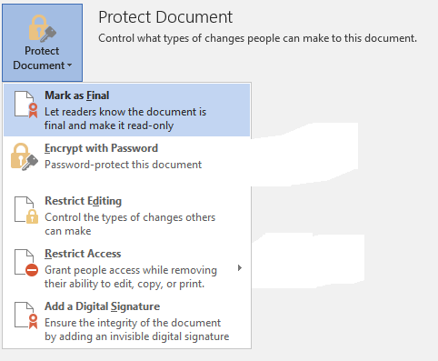

1. **New –** To create new document.
2. **Open –** To open existing document.
3. **Save –** To save document.
4. **Save As –** To save document with different name.
5. **Print –** To print the document.
6. **Share –** To share document with other people.
7. **Export –** To export the document as pdf/notepad/xps etc.
8. **Close –** To close document.
9. **Account –** User’s Microsoft office account.
10. **Options –** AdvanceMS office setting options.

**Home**

**Paste –** Paste the copied content from clipboard. (Ctrl + v)

1. Keep source 2. Merge formatting 3. Keep text only

**Cut –** Cut the content and copy into clipboard. (Ctrl + x)

**Copy –** Copy the contents into clipboard. (Ctrl + c)

**Format Painter –** To paint text format.

**Font –** apply different font style on text.

**Font Size –** Increase or decrease the font size.

**Increase Font Size –** To increase size of fonts.

**Decrease Font Size –** To decrease size of fonts.

**Bold –** To make text bold. (Ctrl + b)

**Italic –** To make text italic. (Ctrl + i)

**Underline –** To make text underline. (Ctrl + u)

**Strike Through –** To strike text.

**Subscript –** Type small letters at bottom.

**Superscript -** Type small letters at top.

fdsf

(234)4dfghgdhjser343

***My name is Sudhir.***