**1. PROJECT DESCRIPTION : "ART GALLERY"**

On line art gallery. In this we have added the details of artists.

We can upload and download the new arts. Payment gate way added to receive the payments.

We have added the blogs so that user can comments on the pictures and share the ideas about the title.

In this we have collected various arts of the artists from internet and other sources. We have also designed the template that represent the overall flow of the gallery maintained at the run time. We have added the uploading feature of the php that uploads the images and arts of the artists on line .

This site integrates the two parts first part is admin section that allow addition and deletion of the users who can view the arts and download them. Admin section have also added features to upload images and list the arts that can be modified or deleted.

Customer can also register online and they can browse art works that are arranged in different categories scientifically. Each Customer can create their own gallery to see his favorite art works with out much difficult. And each user has the right to purchase an art work using the integrated payment gateway and participate in auction by submitting their bids.Qualified bidder should remit the amount using payment gateway and after each valid payment the art work will be shipped within some days.

This application helps the end-users to search their arts and paintings and they can place order for the selected pieces. The end-user can also get the information about the art exhibition and the respective address, so, that they can visit to those exhibitions.

Art Gallery brings you an opportunity to view online art exhibitions at our [Online Art Gallery](http://www.paletteartgallery.com/contact-palette-art-gallery-india.asp) we bring you details of all art exhibitions held in the past and the forthcoming show. The Online Art Gallery is updated daily, so the user can view and buy the latest collection of contemporary art online from anywhere in the world. You can view and buy the latest Indian contemporary art collection available at their exhibitions and also at their online gallery.

**2. COMPONENTS OF THE PROJECTS**

**2.1 How to Login**

In this module, the user will enter his username and password to view and give some comments on specific blogs and also reply can be made. There will be 3 types of users

Administrator/Students/Customer

**2.2 How to be a member of blog site**

In this site, the candidate can join the site ,if he is not a member yet by pressing new user link .User should provide some details that are asked to join.

**2.3 How to search the blogs**

Any blog can be searched by giving and selecting the topic and the title of the blog

**2.4 How to give the comments**

Select the given blog and then go the the comment option and give the comment.

**2.5** **To give the reply on a blog**

Select the blog and go to the reply option and do the reply

**3.** **REQUIREMENT ANALYSIS**

**3.1 Hardware Requirements**

|  |  |
| --- | --- |
| **Number** | **Description** |
| 1 | Pentium 4 ,WIN xp/Linux |
| 2 | 256 MB RAM |

**3.2 Software Requirements**

|  |  |
| --- | --- |
| **Number** | **Description** |
| 1 | Windows XP –SP2 |
| 2 | Php 5.1 |
| 3 | MySql |
| 4 | IIS server/ WAMP |
| 5 | HTML/Dhtml/Ajax/JavaScript |

**4. MODULES**

**4.1 Login Module** –In this module user can enter the site by providing username and password and start blogging.

**4.2 Admin Module** – Can upload new arts of the artists.

**4.3 Join Module** – In this module user can become a part of the site by providing some necessary information for example firstname , lastname ,password ,confirmation password ,email and other details .

**4.4 Blog Module** – In this User can create his own blog using the various topic options eg. Sports , politics etc .User also provides the title of the blog.

**4.5 Search** – In this user can search for the existing blog created already by the others.User chooses the category and enters the title . Then he presses the search blog button .All the matched enteries from the database are displayed.

**4.6 Reply** –User views the already existing blogs and then replies it to the corresponding sender.

**4.7 Administrator** –Can add modify delete the users employee.

**5. INTRODUCTION TO TOOLS**

**FRONT-END/BACK-END**

**Front-End:** Web Pages using PHP, HTML ,JavaScript and Net Beans

**Back-End:** MYSQL

**5.1** **Front End:**

* **HTML/CSS** –The are used to generate web page . HTML, an [initialism](http://en.wikipedia.org/wiki/Initialism) of Hypertext Markup Language, and CSS, Cascading stylesheet is the predominant [markup language](http://en.wikipedia.org/wiki/Markup_language) and style sheets for [web pages](http://en.wikipedia.org/wiki/Web_page). They provide a means to describe the structure of text-based information in a document — by denoting certain text as headings, paragraphs, lists, styles and so on.
* **JAVASCRIPT** – It is used for checking User information before sending to server .JavaScript is a scripting language most often used for client-side web development. It is a dynamic, weakly typed, prototype-based language with first-class functions. Currently, "JavaScript" is an implementation of the ECMAScript standard.

**5.2 Backend:**

* **PHP:-** Php is a technology that lets you mix regular, static HTML with dynamically-generated HTML. Many Web pages that are built by CGI programs are mostly static, with the dynamic part limited to a few small locations. But most CGI variations, including servlets, make you generate the entire page via your program, even though most of it is always the same.
* **IIS SERVER** /WAMP- Apache is a [web container](http://en.wikipedia.org/wiki/Web_container), or [application server](http://en.wikipedia.org/wiki/Application_server) developed at the [Apache Software Foundation](http://en.wikipedia.org/wiki/Apache_Software_Foundation) (ASF).It adds tools for configuration and management but can also be configured by editing configuration files that are normally [XML](http://en.wikipedia.org/wiki/XML)-formatted. Appache includes its own internal [HTTP](http://en.wikipedia.org/wiki/Hypertext_Transfer_Protocol) server.

**5.3 Platform**

The Blog everything is targeted at Microsoft Windows platform .It can be used with other platforms but not is yet tested on other platform such as linux and Vista.

**6. Why PHP?**

**PHP** is a widely used, general-purpose [scripting language](http://en.wikipedia.org/wiki/Scripting_language) that was originally designed for [web development](http://en.wikipedia.org/wiki/Web_development), to produce [dynamic web pages](http://en.wikipedia.org/wiki/Dynamic_web_page). It can be embedded into [HTML](http://en.wikipedia.org/wiki/HTML) and generally runs on a [web server](http://en.wikipedia.org/wiki/Web_server), which needs to be configured to process PHP code and create [web page](http://en.wikipedia.org/wiki/Web_page) content from it. It can be deployed on most web servers and on almost every [operating system](http://en.wikipedia.org/wiki/Operating_system) and [platform](http://en.wikipedia.org/wiki/Platform_%28computing%29) free of charge. PHP is installed on over 20 million websites and 1 million [web servers](http://en.wikipedia.org/wiki/Web_server). PHP was originally created by [Rasmus Lerdorf](http://en.wikipedia.org/wiki/Rasmus_Lerdorf) in [1995](http://en.wikipedia.org/wiki/1995) and has been in continuous development ever since. The main implementation of PHP is now produced by **The PHP Group** and serves as the [de facto standard](http://en.wikipedia.org/wiki/De_facto_standard) for PHP as there is no [formal specification](http://en.wikipedia.org/wiki/Formal_specification). PHP is [free software](http://en.wikipedia.org/wiki/Free_software) released under the [PHP License](http://en.wikipedia.org/wiki/PHP_License), which is incompatible with the [GNU General Public License](http://en.wikipedia.org/wiki/GNU_General_Public_License) (GPL) because of restrictions on the use of the term PHP.

PHP has evolved to include a [command line interface](http://en.wikipedia.org/wiki/Command_line_interface) capability and can also be used in [standalone](http://en.wikipedia.org/wiki/Standalone_software) [graphical applications](http://en.wikipedia.org/wiki/Graphical_user_interface).

|  |  |  |  |  |
| --- | --- | --- | --- | --- |
| **6.1 History** |  |  |  |  |
| [Rasmus Lerdorf](http://en.wikipedia.org/wiki/Rasmus_Lerdorf), who wrote the original [Common Gateway Interface](http://en.wikipedia.org/wiki/Common_Gateway_Interface) binaries, [Zeev Suraski](http://en.wikipedia.org/wiki/Zeev_Suraski), who rewrote the [parser](http://en.wikipedia.org/wiki/Parser) that formed PHP 3 |

PHP originally stood for Personal Home Page. It began in 1994 as a set of [Common Gateway Interface](http://en.wikipedia.org/wiki/Common_Gateway_Interface) [binaries](http://en.wikipedia.org/wiki/Binary_file) written in the [C programming language](http://en.wikipedia.org/wiki/C_programming_language) by the [Danish](http://en.wikipedia.org/wiki/Danish_people)/[Greenlandic](http://en.wikipedia.org/wiki/Greenland) programmer [Rasmus Lerdorf](http://en.wikipedia.org/wiki/Rasmus_Lerdorf). Lerdorf initially created these Personal Home Page Tools to replace a small set of [Perl](http://en.wikipedia.org/wiki/Perl) scripts he had been using to maintain his [personal homepage](http://en.wikipedia.org/wiki/Personal_homepage). The tools were used to perform tasks such as displaying his résumé and recording how much [traffic](http://en.wikipedia.org/wiki/Web_traffic) his page was receiving. He combined these binaries with his Form Interpreter to create PHP/FI, which had more functionality. PHP/FI included a larger implementation for the C programming language and could communicate with [databases](http://en.wikipedia.org/wiki/Database), enabling the building of simple, dynamic [web applications](http://en.wikipedia.org/wiki/Web_application). Lerdorf released PHP publicly on June 8, 1995 to accelerate [bug](http://en.wikipedia.org/wiki/Software_bug) location and improve the code. This release was named PHP version 2 and already had the basic functionality that PHP has today. This included Perl-like variables, form handling, and the ability to embed HTML. The syntax was similar to Perl but was more limited, simpler, and less consistent.

[Zeev Suraski](http://en.wikipedia.org/wiki/Zeev_Suraski) and [Andi Gutmans](http://en.wikipedia.org/wiki/Andi_Gutmans), two developers at the [Technion IIT](http://en.wikipedia.org/wiki/Technion_IIT), rewrote the [parser](http://en.wikipedia.org/wiki/Parser) in 1997 and formed the base of PHP 3, changing the language's name to the [recursive initialism](http://en.wikipedia.org/wiki/Recursive_initialism) PHP: Hypertext Preprocessor. The development team officially released PHP/FI 2 in November 1997 after months of [beta](http://en.wikipedia.org/wiki/Development_stage#beta) testing. Afterwards, public testing of PHP 3 began, and the official launch came in June 1998. Suraski and Gutmans then started a new [rewrite](http://en.wikipedia.org/wiki/Rewrite_%28programming%29) of PHP's core, producing the [Zend Engine](http://en.wikipedia.org/wiki/Zend_Engine) in 1999. They also founded [Zend Technologies](http://en.wikipedia.org/wiki/Zend_Technologies) in [Ramat Gan](http://en.wikipedia.org/wiki/Ramat_Gan), Israel

On May 22, 2000, PHP 4, powered by the Zend Engine 1.0, was released. As of August, 2008 this branch is up to version 4.4.9. PHP 4 is no longer under development nor will any security updates be released. On July 13, 2004, PHP 5 was released, powered by the new Zend Engine II. PHP 5 included new features such as improved support for [object-oriented programming](http://en.wikipedia.org/wiki/Object-oriented_programming), the PHP Data Objects extension (which defines a lightweight and consistent interface for accessing databases), and numerous performance enhancements. In 2008, PHP 5 became the only stable version under development. [Late static binding](http://en.wikipedia.org/wiki/Late_static_binding) has been missing from PHP and has been added in version 5.3. PHP 6 is under development alongside PHP 5. Major changes include the removal of register_globals, [magic quotes](http://en.wikipedia.org/wiki/Magic_quotes), and [safe mode](http://en.wikipedia.org/wiki/Safe_mode#Application_software_safe_mode). The reason for the removals was that register_globals had given way to security holes, and magic quotes had an unpredictable nature, and was best avoided. Instead, to escape characters, magic quotes may be substituted with the addslashes() function, or more appropriately an escape mechanism specific to the database vendor itself like mysql_real_escape_string() for [MySQL](http://en.wikipedia.org/wiki/MySQL). Functions that will be removed in PHP 6 have been deprecated in PHP 5.3 and will produce a warning if used.

Many high-profile open-source projects ceased to support PHP 4 in new code as of February 5, 2008, because of the GoPHP5 initiative, provided by a consortium of PHP developers promoting the transition from PHP 4 to PHP 5.

PHP currently does not have native support for [Unicode](http://en.wikipedia.org/wiki/Unicode) or multibyte strings; Unicode support will be included in PHP 6 and will allow strings as well as class, method and function names to contain non-[ASCII](http://en.wikipedia.org/wiki/ASCII) characters.

It runs in both [32-bit](http://en.wikipedia.org/wiki/32-bit) and [64-bit](http://en.wikipedia.org/wiki/64-bit) environments, but on Windows the only official distribution is 32-bit, requiring Windows 32-bit compatibility mode to be enabled while using [IIS](http://en.wikipedia.org/wiki/Internet_Information_Services) in a 64-bit Windows environment. As of PHP 5.3.0, experimental x64 bit versions are available.

6.2

**Usage**

PHP is a general-purpose scripting language that is especially suited for [web development](http://en.wikipedia.org/wiki/Web_development). PHP generally runs on a [web server](http://en.wikipedia.org/wiki/Web_server). Any PHP code in a requested file is [executed](http://en.wikipedia.org/wiki/Execution_%28computing%29) by the PHP runtime, usually to create [dynamic web page](http://en.wikipedia.org/wiki/Dynamic_web_page) content. It can also be used for [command-line](http://en.wikipedia.org/wiki/Command-line) scripting and [client-side](http://en.wikipedia.org/wiki/Client-side) [GUI](http://en.wikipedia.org/wiki/Graphical_user_interface) applications. PHP can be deployed on most [web servers](http://en.wikipedia.org/wiki/Web_server), many [operating systems](http://en.wikipedia.org/wiki/Operating_system) and [platforms](http://en.wikipedia.org/wiki/Platform_%28computing%29), and can be used with many [relational database management systems](http://en.wikipedia.org/wiki/Relational_database_management_system). It is available free of charge, and the PHP Group provides the complete source code for users to build, customize and extend for their own use.

PHP primarily acts as a [filter](http://en.wikipedia.org/wiki/Filter_%28software%29),[]](http://en.wikipedia.org/wiki/PHP#cite_note-30) taking input from a file or stream containing text and/or PHP instructions and outputs another stream of data; most commonly the output will be HTML. Since PHP 4, the PHP [parser](http://en.wikipedia.org/wiki/Parser) [compiles](http://en.wikipedia.org/wiki/Compiler) input to produce [bytecode](http://en.wikipedia.org/wiki/Bytecode) for processing by the [Zend Engine](http://en.wikipedia.org/wiki/Zend_Engine), giving improved performance over its [interpreter](http://en.wikipedia.org/wiki/Interpreter_%28computing%29) predecessor. Originally designed to create dynamic web pages, PHP now focuses mainly on [server-side scripting](http://en.wikipedia.org/wiki/Server-side_scripting),[[33]](http://en.wikipedia.org/wiki/PHP#cite_note-32) and it is similar to other server-side scripting languages that provide dynamic content from a web server to a [client](http://en.wikipedia.org/wiki/Client_%28computing%29), such as [Microsoft](http://en.wikipedia.org/wiki/Microsoft)'s [Active Server Pages](http://en.wikipedia.org/wiki/Active_Server_Pages), [Sun Microsystems](http://en.wikipedia.org/wiki/Sun_Microsystems)' [JavaServer Pages](http://en.wikipedia.org/wiki/JavaServer_Pages), and [mod_perl](http://en.wikipedia.org/wiki/Mod_perl). PHP has also attracted the development of many [frameworks](http://en.wikipedia.org/wiki/Software_framework) that provide building blocks and a design structure to promote [rapid application development](http://en.wikipedia.org/wiki/Rapid_application_development) (RAD). Some of these include [CakePHP](http://en.wikipedia.org/wiki/CakePHP), [Symfony](http://en.wikipedia.org/wiki/Symfony), [CodeIgniter](http://en.wikipedia.org/wiki/CodeIgniter), and [Zend Framework](http://en.wikipedia.org/wiki/Zend_Framework), offering features similar to other [web application frameworks](http://en.wikipedia.org/wiki/List_of_web_application_frameworks).

The [LAMP](http://en.wikipedia.org/wiki/LAMP_%28software_bundle%29) and [WAMP](http://en.wikipedia.org/wiki/WAMP) architectures have become popular in the web industry as a way of deploying web applications. PHP is commonly used as the P in this bundle alongside [Linux](http://en.wikipedia.org/wiki/Linux), [Apache](http://en.wikipedia.org/wiki/Apache_HTTP_Server) and [MySQL](http://en.wikipedia.org/wiki/MySQL), although the P may also refer to [Python](http://en.wikipedia.org/wiki/Python_%28programming_language%29) or [Perl](http://en.wikipedia.org/wiki/Perl).

As of April 2007, over 20 million Internet domains were hosted on servers with PHP installed, and mod_php was recorded as the most popular Apache module. Significant websites are written in PHP including the user-facing portion of [Facebook](http://en.wikipedia.org/wiki/Facebook), [Wikipedia](http://en.wikipedia.org/wiki/Wikipedia) ([MediaWiki](http://en.wikipedia.org/wiki/MediaWiki" \o "MediaWiki)), [Yahoo!](http://en.wikipedia.org/wiki/Yahoo%21), [MyYearbook](http://en.wikipedia.org/wiki/MyYearbook),[]](http://en.wikipedia.org/wiki/PHP#cite_note-38) [Digg](http://en.wikipedia.org/wiki/Digg), [Joomla](http://en.wikipedia.org/wiki/Joomla), [WordPress](http://en.wikipedia.org/wiki/WordPress), [YouTube](http://en.wikipedia.org/wiki/YouTube), [Drupal](http://en.wikipedia.org/wiki/Drupal) and [Tagged](http://en.wikipedia.org/wiki/Tagged).

**6.3 Speed optimization**

As with many scripting languages, PHP scripts are normally kept as human-readable source code, even on production web servers.[[41]](http://en.wikipedia.org/wiki/PHP#cite_note-40) In this case, PHP scripts will be [compiled](http://en.wikipedia.org/wiki/Compiler) at runtime by the PHP engine, which increases their execution speed. PHP scripts are able to be compiled before runtime using PHP compilers as with other programming languages such as [C](http://en.wikipedia.org/wiki/C_%28programming_language%29) (the language PHP and its extensions are written in).

Code optimizers aim to reduce the computational complexity of the compiled code by reducing its size and making other changes that can reduce the execution time with the overall goal of improving performance. The nature of the PHP [compiler](http://en.wikipedia.org/wiki/Compiler) is such that there are often opportunities for [code optimization](http://en.wikipedia.org/wiki/Optimization_%28computer_science%29), and an example of a code optimizer is the [Zend Optimizer](http://en.wikipedia.org/wiki/PHP_accelerator#Zend_Optimizer) PHP extension.

Another approach for reducing overhead for high load PHP servers is using [PHP accelerators](http://en.wikipedia.org/wiki/PHP_accelerator). These can offer significant performance gains by [caching](http://en.wikipedia.org/wiki/Caching) the compiled form of a PHP script in [shared memory](http://en.wikipedia.org/wiki/Shared_memory) to avoid the overhead of [parsing](http://en.wikipedia.org/wiki/Parsing) and [compiling](http://en.wikipedia.org/wiki/Compiling) the code every time the script runs. A PHP accelerator will be built into PHP 6.

**6.4 Security**

The [National Vulnerability Database](http://en.wikipedia.org/wiki/National_Vulnerability_Database) stores all vulnerabilities found in computer software. The overall proportion of PHP-related vulnerabilities on the database amounted to: 20% in 2004, 28% in 2005, 43% in 2006, 36% in 2007, and 35% in 2008.[[44]](http://en.wikipedia.org/wiki/PHP#cite_note-43) Most of these PHP-related vulnerabilities can be [exploited](http://en.wikipedia.org/wiki/Exploit_%28computer_security%29) remotely: they allow [hackers](http://en.wikipedia.org/wiki/Hacker_%28computer_security%29#Black_hat) to [steal or destroy](http://en.wikipedia.org/wiki/Computer_crime) data from data sources linked to the webserver (such as an [SQL](http://en.wikipedia.org/wiki/SQL) [database](http://en.wikipedia.org/wiki/Database)), send [spam](http://en.wikipedia.org/wiki/E-mail_spam) or contribute to [DOS attacks](http://en.wikipedia.org/wiki/Denial_of_service) using [malware](http://en.wikipedia.org/wiki/Malware), which itself can be installed on the vulnerable servers.

These vulnerabilities are caused mostly by not following best practice programming rules: technical security flaws of the language itself or of its core libraries are not frequent (23 in 2008, about 1% of the total). Recognizing that programmers cannot be trusted, some languages include [taint checking](http://en.wikipedia.org/wiki/Taint_checking) to detect automatically the lack of [input validation](http://en.wikipedia.org/wiki/Data_validation) which induces many issues. Such a feature is being developed for PHP, but its inclusion in a release has been rejected several times in the past.

Hosting PHP applications on a server requires a careful and constant attention to deal with these security risks. There are advanced protection patches such as [Suhosin](http://en.wikipedia.org/w/index.php?title=Suhosin&action=edit&redlink=1) and [Hardening](http://en.wikipedia.org/wiki/Hardening_%28computing%29)-Patch, especially designed for web hosting environments. Installing PHP as a CGI binary rather than as an Apache module is the preferred method for added security.

**6.5 Syntax**

[Syntax-highlighted](http://en.wikipedia.org/wiki/Syntax_highlighting) PHP code embedded within [HTML](http://en.wikipedia.org/wiki/HTML)

PHP only parses code within its [delimiters](http://en.wikipedia.org/wiki/Delimiter). Anything outside its delimiters is sent directly to the output and is not processed by PHP. The most common delimiters are <?php to open and ?> to close PHP sections. <script language="php"> and </script> delimiters are also available, as are the shortened forms <? or <?= (which is used to echo back a [string](http://en.wikipedia.org/wiki/String_%28computer_science%29) or [variable](http://en.wikipedia.org/wiki/Variable_%28programming%29)) and ?> as well as [ASP](http://en.wikipedia.org/wiki/Active_Server_Pages)-style short forms <% or <%= and %>. While short delimiters are used, they make script files less portable as their purpose can be disabled in the [PHP configuration](http://wiki.php.net/rfc/shortags), and so they are discouraged. The purpose of all these delimiters is to separate PHP code from non-PHP code, including HTML.

The first form of delimiters, <?php and ?>, in [XHTML](http://en.wikipedia.org/wiki/XHTML) and other [XML](http://en.wikipedia.org/wiki/XML) documents, creates correctly formed XML 'processing instructions' This means that the resulting mixture of PHP code and other markup in the server-side file is well-formed XML.

Variables are prefixed with a [dollar symbol](http://en.wikipedia.org/wiki/Dollar_sign) and a [type](http://en.wikipedia.org/wiki/Primitive_type) does not need to be specified in advance. Unlike function and class names, variable names are case sensitive. Both double-quoted ("") and [heredoc](http://en.wikipedia.org/wiki/Heredoc) strings allow the ability to embed a variable's value into the string. PHP treats [newlines](http://en.wikipedia.org/wiki/Newline) as [whitespace](http://en.wikipedia.org/wiki/Whitespace_%28computer_science%29) in the manner of a [free-form language](http://en.wikipedia.org/wiki/Free-form_language) (except when inside string quotes), and statements are terminated by a semicolon. PHP has three types of [comment syntax](http://en.wikipedia.org/wiki/Comparison_of_programming_languages_%28syntax%29#Comments): /* */ marks block and inline comments; // as well as # are used for one-line comments The echo statement is one of several facilities PHP provides to output text (e.g. to a web browser).

In terms of keywords and language syntax, PHP is similar to most high level languages that follow the C style syntax. If conditions, for and while loops, and function returns are similar in syntax to languages such as C, C++, Java and Perl.

**6.6 Data types**

PHP stores whole numbers in a platform-dependent range. This range is typically that of 32-bit [signed](http://en.wikipedia.org/wiki/Signed_number_representations) [integers](http://en.wikipedia.org/wiki/Integer_%28computer_science%29). Unsigned integers are converted to signed values in certain situations; this behavior is different from other programming languages. Integer variables can be assigned using decimal (positive and negative), [octal](http://en.wikipedia.org/wiki/Octal), and [hexadecimal](http://en.wikipedia.org/wiki/Hexadecimal) notations. [Floating point](http://en.wikipedia.org/wiki/Floating_point) numbers are also stored in a platform-specific range. They can be specified using [floating point](http://en.wikipedia.org/wiki/Floating_point) notation, or two forms of [scientific notation](http://en.wikipedia.org/wiki/Scientific_notation). PHP has a native [Boolean](http://en.wikipedia.org/wiki/Boolean_datatype) type that is similar to the native Boolean types in [Java](http://en.wikipedia.org/wiki/Java_%28programming_language%29) and [C++](http://en.wikipedia.org/wiki/C%2B%2B). Using the Boolean type conversion rules, non-zero values are interpreted as true and zero as false, as in Perl and C++. The null data type represents a variable that has no value. The only value in the null data type is NULL. Variables of the "resource" type represent references to resources from external sources. These are typically created by functions from a particular extension, and can only be processed by functions from the same extension; examples include file, image, and database resources. Arrays can contain elements of any type that PHP can handle, including resources, objects, and even other arrays. Order is preserved in lists of values and in [hashes](http://en.wikipedia.org/wiki/Hash_table) with both keys and values, and the two can be intermingled. PHP also supports [strings](http://en.wikipedia.org/wiki/String_%28computing%29), which can be used with single quotes, double quotes, or [heredoc syntax](http://en.wikipedia.org/wiki/Heredoc).

The Standard PHP Library (SPL) attempts to solve standard problems and implements efficient data access interfaces and classes.

**6.7 Functions**

PHP has hundreds of base functions and thousands more via extensions. These functions are well documented on the PHP site, however, the built-in library has a wide variety of naming conventions and inconsistencies. PHP currently has no functions for [thread](http://en.wikipedia.org/wiki/Thread_%28computer_science%29) programming, although it does support multiprocess programming on POSIX systems.

**Version 5.2 and Earlier**

Functions are not [first-class functions](http://en.wikipedia.org/wiki/First-class_function) and can only be referenced by their name, directly or dynamically by a variable containing the name of the function. User-defined functions can be created at any time without being prototyped. Functions can be defined inside code blocks, permitting a [run-time decision](http://en.wikipedia.org/wiki/Dynamic_dispatch) as to whether or not a function should be defined. Function calls must use parentheses, with the exception of zero argument class [constructor](http://en.wikipedia.org/wiki/Constructor_%28computer_science%29) functions called with the PHP new operator, where parentheses are optional. PHP supports quasi-[anonymous functions](http://en.wikipedia.org/wiki/Anonymous_function) through the create_function() function, although they are not true anonymous functions because anonymous functions are nameless, but functions can only be referenced by name, or indirectly through a variable $function_name();, in PHP.

**Version 5.3 And Newer**

PHP gained support for [closures](http://en.wikipedia.org/wiki/Closure_%28computer_science%29). True [anonymous functions](http://en.wikipedia.org/wiki/Anonymous_function) are supported using the following syntax:

function getAdder($x)

{

return function ($y) use ($x) {

return $x + $y;

};

}

$adder = getAdder(8);

echo $adder(2); // prints "10"

Here, getAdder() function creates a closure using parameter $x (keyword "use" forces getting variable from context), which takes additional argument $y and returns it to the caller. Such a function can be stored, given as the parameter to other functions, etc. For more details see [Lambda functions and closures RFC](http://wiki.php.net/rfc/closures).

**6.8 Objects**

Basic [object-oriented programming](http://en.wikipedia.org/wiki/Object-oriented_programming) functionality was added in PHP 3 and improved in PHP 4. Object handling was completely rewritten for PHP 5, expanding the feature set and enhancing performance.[]](http://en.wikipedia.org/wiki/PHP#cite_note-php_5_objects-63) In previous versions of PHP, objects were handled like [primitive types](http://en.wikipedia.org/wiki/Primitive_type). The drawback of this method was that the whole object was copied when a variable was assigned or passed as a parameter to a method. In the new approach, objects are referenced by [handle](http://en.wikipedia.org/wiki/Smart_pointer#Handles), and not by value. PHP 5 introduced private and protected [member variables](http://en.wikipedia.org/wiki/Member_variable) and methods, along with [abstract classes](http://en.wikipedia.org/wiki/Abstract_type) and [final classes](http://en.wikipedia.org/wiki/Final_type) as well as [abstract methods](http://en.wikipedia.org/wiki/Abstract_method) and [final methods](http://en.wikipedia.org/wiki/Final_method). It also introduced a standard way of declaring [constructors](http://en.wikipedia.org/wiki/Constructor_%28computer_science%29) and [destructors](http://en.wikipedia.org/wiki/Destructor_%28computer_science%29), similar to that of other object-oriented languages such as [C++](http://en.wikipedia.org/wiki/C%2B%2B), and a standard [exception handling](http://en.wikipedia.org/wiki/Exception_handling) model. Furthermore, PHP 5 added [interfaces](http://en.wikipedia.org/wiki/Interface_%28computer_science%29) and allowed for multiple interfaces to be implemented. There are special interfaces that allow objects to interact with the runtime system. [Objects](http://en.wikipedia.org/wiki/Object_%28computer_science%29) implementing ArrayAccess can be used with [array](http://en.wikipedia.org/wiki/Array_data_type) syntax and [objects](http://en.wikipedia.org/wiki/Object_%28computer_science%29) implementing [Iterator](http://en.wikipedia.org/wiki/Iterator) or [IteratorAggregate](http://en.wikipedia.org/wiki/IteratorAggregate) can be used with the foreach language construct. There is no [virtual table](http://en.wikipedia.org/wiki/Virtual_table) feature in the engine, so [static variables](http://en.wikipedia.org/wiki/Static_variable) are bound with a name instead of a reference at compile time.

If the developer creates a copy of an object using the reserved word clone, the Zend engine will check if a __clone() method has been defined or not. If not, it will call a default __clone() which will copy the object's properties. If a __clone() method is defined, then it will be responsible for setting the necessary properties in the created object. For convenience, the engine will supply a function that imports the properties of the source object, so that the programmer can start with a by-value [replica](http://en.wiktionary.org/wiki/replica) of the source object and only override properties that need to be changed.

**6.9 Resources**

PHP includes [free and open source libraries](http://en.wikipedia.org/wiki/List_of_PHP_libraries) with the core build. PHP is a fundamentally [Internet](http://en.wikipedia.org/wiki/Internet)-aware system with modules built in for accessing [FTP](http://en.wikipedia.org/wiki/File_transfer_protocol) servers, many database servers, embedded SQL libraries such as embedded [PostgreSQL](http://en.wikipedia.org/wiki/PostgreSQL), [MySQL](http://en.wikipedia.org/wiki/MySQL) and [SQLite](http://en.wikipedia.org/wiki/SQLite), [LDAP](http://en.wikipedia.org/wiki/Lightweight_Directory_Access_Protocol) servers, and others. Many functions familiar to C programmers such as those in the [stdio](http://en.wikipedia.org/wiki/Stdio.h) family are available in the standard PHP build. PHP has traditionally used features such as "[magic_quotes_gpc](http://en.wikipedia.org/wiki/Magic_quotes" \o "Magic quotes)" and "magic_quotes_runtime" which attempt to escape apostrophes (') and quotes (") in strings in the assumption that they will be used in databases, to prevent [SQL injection](http://en.wikipedia.org/wiki/SQL_injection) attacks. This leads to confusion over which data is escaped and which is not, and to problems when data is not in fact used as input to a database and when the escaping used is not completely correct. To make code portable between servers which do and do not use magic quotes, developers can preface their code with a script to reverse the effect of magic quotes when it is applied.

PHP allows developers to write [extensions](http://en.wikipedia.org/wiki/Extension_%28computing%29) in [C](http://en.wikipedia.org/wiki/C_%28programming_language%29) to add functionality to the PHP language. These can then be compiled into PHP or loaded dynamically at runtime. Extensions have been written to add support for the [Windows API](http://en.wikipedia.org/wiki/Windows_API), process management on [Unix-like](http://en.wikipedia.org/wiki/Unix-like) [operating systems](http://en.wikipedia.org/wiki/Operating_system), multibyte strings ([Unicode](http://en.wikipedia.org/wiki/Unicode)), [cURL](http://en.wikipedia.org/wiki/CURL), and several popular [compression formats](http://en.wikipedia.org/wiki/Archive_format). Some more unusual features include integration with [Internet Relay Chat](http://en.wikipedia.org/wiki/Internet_Relay_Chat), dynamic generation of images and

**7. MYSQL**

**MySQL** (pronounced [/maɪˌɛskjuːˈɛl/](http://en.wikipedia.org/wiki/Wikipedia:IPA_for_English)My S-Q-L, or "My sequel" /maɪˈsiːkwəl/) is a [relational database management system](http://en.wikipedia.org/wiki/Relational_database_management_system) (RDBMS) which has more than 6 million installations. MySQL stands for "My Structured Query Language". The program runs as a server providing multi-user access to a number of databases.

The project's [source code](http://en.wikipedia.org/wiki/Source_code) is available under terms of the [GNU General Public License](http://en.wikipedia.org/wiki/GNU_General_Public_License), as well as under a variety of [proprietary](http://en.wikipedia.org/wiki/Proprietary_software) agreements. MySQL is owned and sponsored by a single [for-profit](http://en.wikipedia.org/wiki/Business) firm, the [Swedish](http://en.wikipedia.org/wiki/Sweden) company [MySQL AB](http://en.wikipedia.org/wiki/MySQL_AB), now a [subsidiary](http://en.wikipedia.org/wiki/Subsidiary) of [Sun Microsystems](http://en.wikipedia.org/wiki/Sun_Microsystems), which holds the copyright to most of the codebase.

MySQL is commonly used by [free software](http://en.wikipedia.org/wiki/Free_software) projects which require a full-featured database management system, such as [WordPress](http://en.wikipedia.org/wiki/WordPress), [phpBB](http://en.wikipedia.org/wiki/PhpBB) and other software built on the [LAMP](http://en.wikipedia.org/wiki/LAMP_%28software_bundle%29) software stack. It is also used in very high-scale [World Wide Web](http://en.wikipedia.org/wiki/World_Wide_Web) products including [Google](http://en.wikipedia.org/wiki/Google) and [Facebook](http://en.wikipedia.org/wiki/Facebook).

**7.1 Uses**

MySQL is used in [web applications](http://en.wikipedia.org/wiki/Web_application) and acts as the database component of the [LAMP](http://en.wikipedia.org/wiki/LAMP_%28software_bundle%29) software stack. Its popularity for use with web applications is closely tied to the popularity of [PHP](http://en.wikipedia.org/wiki/PHP), which is often combined with MySQL. Several high-traffic web sites (including [Flickr](http://en.wikipedia.org/wiki/Flickr), [Facebook](http://en.wikipedia.org/wiki/Facebook), [Wikipedia](http://en.wikipedia.org/wiki/Wikipedia), [Google](http://en.wikipedia.org/wiki/Google) (though not for searches), [Nokia](http://en.wikipedia.org/wiki/Nokia), Auctionmarts and [YouTube](http://en.wikipedia.org/wiki/YouTube)) use MySQL for data storage and logging of user data.

**7.2 Platforms and interfaces**

The MySQL Administrator in Linux

MySQL is written in [C](http://en.wikipedia.org/wiki/C_%28programming_language%29) and [C++](http://en.wikipedia.org/wiki/C%2B%2B). The [SQL](http://en.wikipedia.org/wiki/SQL) parser uses [yacc](http://en.wikipedia.org/wiki/Yacc) and a home-brewed [lexer](http://en.wikipedia.org/wiki/Lex_programming_tool), sql_lex.cc

MySQL works on many different [system platforms](http://en.wikipedia.org/wiki/System_platform), including [AIX](http://en.wikipedia.org/wiki/AIX_operating_system), [BSDi](http://en.wikipedia.org/wiki/BSD/OS), [FreeBSD](http://en.wikipedia.org/wiki/FreeBSD), [HP-UX](http://en.wikipedia.org/wiki/HP-UX), [i5/OS](http://en.wikipedia.org/wiki/IBM_i5/OS), [Linux](http://en.wikipedia.org/wiki/Linux), [Mac OS X](http://en.wikipedia.org/wiki/Mac_OS_X), [NetBSD](http://en.wikipedia.org/wiki/NetBSD), [Novell NetWare](http://en.wikipedia.org/wiki/Novell_NetWare), [OpenBSD](http://en.wikipedia.org/wiki/OpenBSD), [OpenSolaris](http://en.wikipedia.org/wiki/OpenSolaris), [eComStation](http://en.wikipedia.org/wiki/EComStation), [OS/2](http://en.wikipedia.org/wiki/OS/2) Warp, [QNX](http://en.wikipedia.org/wiki/QNX), [IRIX](http://en.wikipedia.org/wiki/IRIX), [Solaris](http://en.wikipedia.org/wiki/Solaris_%28operating_system%29), [Symbian](http://en.wikipedia.org/wiki/Symbian), [SunOS](http://en.wikipedia.org/wiki/SunOS), [SCO OpenServer](http://en.wikipedia.org/wiki/SCO_OpenServer), SCO [UnixWare](http://en.wikipedia.org/wiki/UnixWare), [Sanos](http://en.wikipedia.org/wiki/Sanos), [Tru64](http://en.wikipedia.org/wiki/Tru64) and [Microsoft Windows](http://en.wikipedia.org/wiki/Microsoft_Windows). A port of MySQL to [OpenVMS](http://en.wikipedia.org/wiki/OpenVMS) is also available.

[Libraries](http://en.wikipedia.org/wiki/Library_%28computing%29) for accessing MySQL databases are available in all major [programming languages](http://en.wikipedia.org/wiki/Programming_language) with language-specific [APIs](http://en.wikipedia.org/wiki/Application_programming_interface). In addition, an [ODBC](http://en.wikipedia.org/wiki/ODBC) interface called [MyODBC](http://en.wikipedia.org/wiki/MyODBC) allows additional programming languages that support the ODBC interface to communicate with a MySQL database, such as [ASP](http://en.wikipedia.org/wiki/Active_Server_Pages) or [ColdFusion](http://en.wikipedia.org/wiki/Adobe_ColdFusion). The MySQL server and official libraries are mostly implemented in [ANSI C](http://en.wikipedia.org/wiki/ANSI_C)/[ANSI C++](http://en.wikipedia.org/wiki/ANSI_C%2B%2B).

To administer MySQL databases one can use the included [command-line](http://en.wikipedia.org/wiki/Command_line) tool (commands: mysql and mysqladmin). Also downloadable from the MySQL site are [GUI](http://en.wikipedia.org/wiki/Graphical_user_interface) administration tools: [MySQL Administrator](http://en.wikipedia.org/wiki/MySQL_GUI_Tools#MySQL_Administrator), [MySQL Migration Toolkit](http://en.wikipedia.org/wiki/MySQL_GUI_Tools#MySQL_Migration_Toolkit) and [MySQL Query Browser](http://en.wikipedia.org/wiki/MySQL_GUI_Tools#MySQL_Query_Browser). The GUI tools are now included in one package called [MySQL GUI Tools](http://en.wikipedia.org/wiki/MySQL_GUI_Tools).

In addition to the above-mentioned tools developed by MySQL AB, there are several other commercial and [non-commercial](http://en.wikipedia.org/wiki/Non-commercial) tools available. Examples include [Navicat](http://en.wikipedia.org/wiki/Navicat) Free Lite Edition or [SQLyog](http://en.wikipedia.org/wiki/SQLyog) Community Edition, they are free desktop based GUI tools, and [phpMyAdmin](http://en.wikipedia.org/wiki/PhpMyAdmin), a free [Web](http://en.wikipedia.org/wiki/World_Wide_Web)-based administration interface implemented in [PHP](http://en.wikipedia.org/wiki/PHP).

**7.3 Features**

As of April 2009[[update]](http://en.wikipedia.org/w/index.php?title=MySQL&action=edit), MySQL offers MySQL 5.1 in two different variants: the MySQL Community Server and [Enterprise Server](http://en.wikipedia.org/wiki/MySQL_Enterprise). They have a common code base and include the following features:

* A broad subset of [ANSI SQL 99](http://en.wikipedia.org/wiki/SQL:1999), as well as extensions
* Cross-platform support
* [Stored procedures](http://en.wikipedia.org/wiki/Stored_procedure)
* [Triggers](http://en.wikipedia.org/wiki/Database_trigger)
* [Cursors](http://en.wikipedia.org/wiki/Cursor_%28databases%29)
* Updatable [Views](http://en.wikipedia.org/wiki/View_%28database%29)
* True [Varchar](http://en.wikipedia.org/wiki/Varchar) support
* INFORMATION_SCHEMA
* Strict mode
* [X/Open XA](http://en.wikipedia.org/wiki/X/Open_XA) [distributed transaction processing](http://en.wikipedia.org/wiki/Distributed_transaction_processing) (DTP) support; [two phase commit](http://en.wikipedia.org/wiki/Two-phase-commit_protocol) as part of this, using Oracle's [InnoDB](http://en.wikipedia.org/wiki/InnoDB) engine
* Independent [storage engines](http://en.wikipedia.org/wiki/Storage_engine) ([MyISAM](http://en.wikipedia.org/wiki/MyISAM" \o "MyISAM) for read speed, InnoDB for transactions and [referential integrity](http://en.wikipedia.org/wiki/Referential_integrity), [MySQL Archive](http://en.wikipedia.org/wiki/MySQL_Archive) for storing historical data in little space)
* Transactions with the InnoDB, BDB and Cluster storage engines; savepoints with InnoDB
* [SSL](http://en.wikipedia.org/wiki/Secure_Sockets_Layer) support
* Query [caching](http://en.wikipedia.org/wiki/Caching)
* Sub-[SELECTs](http://en.wikipedia.org/wiki/Select_%28SQL%29) (i.e. nested SELECTs)
* Replication with one master per slave, many slaves per master, no automatic support for multiple masters per slave.
* Full-text [indexing](http://en.wikipedia.org/wiki/Indexing) and searching using MyISAM engine
* Embedded database library
* Partial [Unicode](http://en.wikipedia.org/wiki/Unicode) support ([UTF-8](http://en.wikipedia.org/wiki/UTF-8) sequences longer than 3 bytes are not supported; [UCS-2](http://en.wikipedia.org/wiki/UTF-16/UCS-2) encoded strings are also limited to the [BMP](http://en.wikipedia.org/wiki/Basic_Multilingual_Plane))
* Partial [ACID](http://en.wikipedia.org/wiki/ACID) compliance (only full compliance when using the non-default storage engines InnoDB, [BDB](http://en.wikipedia.org/wiki/Berkeley_DB) and Cluster.

The MySQL Enterprise Server is released once per month and the sources can be obtained either from MySQL's customer-only Enterprise site or from MySQL's [Bazaar](http://en.wikipedia.org/wiki/Bazaar_%28software%29) repository, both under the GPL license. The MySQL Community Server is published on an unspecified schedule under the GPL and contains all bug fixes that were shipped with the last MySQL Enterprise Server release. Binaries are no longer provided by MySQL for every release of the Community Server.

* Replication support (i.e. Master-Master Replication & Master-Slave Replication)

**7.4 Distinguishing features**

The following features are implemented by MySQL but not by some other [RDBMS](http://en.wikipedia.org/wiki/RDBMS) software:

* Multiple storage engines, allowing one to choose the one that is most effective for each table in the application (in MySQL 5.0, storage engines must be compiled in; in MySQL 5.1, storage engines can be dynamically loaded at [run time](http://en.wikipedia.org/wiki/Run_time_%28computing%29)):
  + Native storage engines ([MyISAM](http://en.wikipedia.org/wiki/MyISAM" \o "MyISAM), [Falcon](http://en.wikipedia.org/wiki/Falcon_%28storage_engine%29), Merge, Memory (heap), [Federated](http://en.wikipedia.org/wiki/MySQL_Federated), [Archive](http://en.wikipedia.org/wiki/MySQL_Archive), [CSV](http://en.wikipedia.org/wiki/Comma-separated_values), Blackhole, [Cluster](http://en.wikipedia.org/wiki/MySQL_Cluster), [Berkeley DB](http://en.wikipedia.org/wiki/Berkeley_DB), EXAMPLE, and [Maria](http://en.wikipedia.org/wiki/Maria_%28storage_engine%29))
  + Partner-developed storage engines ([InnoDB](http://en.wikipedia.org/wiki/InnoDB" \o "InnoDB), [solidDB](http://en.wikipedia.org/wiki/SolidDB), NitroEDB, [Infobright](http://en.wikipedia.org/wiki/Infobright) (formerly Brighthouse), [Infobright (Open Source)](http://www.infobright.org))
  + Community-developed storage engines ([memcached](http://en.wikipedia.org/wiki/Memcached" \o "Memcached), [httpd](http://en.wikipedia.org/wiki/Web_server), PBXT, [Revision Engine](http://en.wikipedia.org/w/index.php?title=Revision_Engine&action=edit&redlink=1))
  + Custom storage engines
* Commit grouping, gathering multiple transactions from multiple connections together to increase the number of commits per second.

**7.5 Server compilation type**

There are 3 types of MySQL Server Compilations for Enterprise and Community users:

* Standard: The MySQL-Standard binaries are recommended for most users, and include the InnoDB storage engine.
* Max: (not [MaxDB](http://en.wikipedia.org/wiki/MaxDB), which is a cooperation with [SAP AG](http://en.wikipedia.org/wiki/SAP_AG)) is mysqld-max Extended MySQL Server. The MySQL-Max binaries include additional features that may not have been as extensively tested or are not required for general usage.
* The MySQL-Debug binaries have been compiled with extra debug information, and are not intended for [production use](http://en.wikipedia.org/w/index.php?title=Production_use&action=edit&redlink=1), because the included debugging code may cause reduced performance.

Beginning with MySQL 5.1, MySQL AB has stopped providing these different package variants. There will only be one MySQL server package, which includes a mysqld binary with all functionality and storage engines enabled. Instead of providing a separate debug package, a server binary with extended debugging information is also included in the standard package.

**7.6 History**

Milestones in MySQL development include:

* MySQL was originally developed by [Michael Widenius](http://en.wikipedia.org/wiki/Michael_Widenius) and [David Axmark](http://en.wikipedia.org/wiki/David_Axmark) beginning in 1994
* MySQL was first released internally on 23 May 1995
* Windows version was released on 8 January 1998 for Windows 95 and NT
* Version 3.23: beta from June 2000, production release January 2001
* Version 4.0: beta from August 2002, production release March 2003 ([unions](http://en.wikipedia.org/wiki/Union_%28SQL%29))
* Version 4.01: beta from August 2003, Jyoti adopts MySQL for database tracking
* Version 4.1: beta from June 2004, production release October 2004 ([R-trees](http://en.wikipedia.org/wiki/R-tree) and [B-trees](http://en.wikipedia.org/wiki/B-tree), subqueries, [prepared statements](http://en.wikipedia.org/w/index.php?title=Prepared_statement&action=edit&redlink=1))
* Version 5.0: beta from March 2005, production release October 2005 ([cursors](http://en.wikipedia.org/wiki/Cursor_%28databases%29), [stored procedures](http://en.wikipedia.org/wiki/Stored_procedure), [triggers](http://en.wikipedia.org/wiki/Database_trigger), [views](http://en.wikipedia.org/wiki/View_%28database%29), [XA transactions](http://en.wikipedia.org/wiki/Database_transaction))
* Sun Microsystems acquired [MySQL AB](http://en.wikipedia.org/wiki/MySQL_AB) on 26 February 2008.
* Version 5.1: production release 27 November 2008 (event scheduler, [partitioning](http://en.wikipedia.org/wiki/Partition_%28database%29), plugin API, row-based replication, [server log](http://en.wikipedia.org/wiki/Server_log) tables)

**7.7 Future releases**

The MySQL 6 roadmap outlines support for:

* [Referential integrity](http://en.wikipedia.org/wiki/Referential_integrity) and [Foreign key](http://en.wikipedia.org/wiki/Foreign_key) support for all storage engines is targeted for release in MySQL 6.1 (although it has been present since version 3.23.44 for [InnoDB](http://en.wikipedia.org/wiki/InnoDB)).
* Support for supplementary [Unicode](http://en.wikipedia.org/wiki/Unicode) characters, beyond the 65,536 characters of the [Basic Multilingual Plane](http://en.wikipedia.org/wiki/Basic_Multilingual_Plane) (BMP) is announced for MySQL 6.0.
* A new storage engine is also in the works, called [Falcon](http://en.wikipedia.org/wiki/Falcon_%28storage_engine%29). A preview of Falcon is available on MySQL's website.

Support for [parallelization](http://en.wikipedia.org/wiki/Parallel_computing) is also part of the roadmap for future versions.

**7.8 Support and licensing**

Via MySQL Enterprise MySQL AB offers support itself, including a [24/7](http://en.wikipedia.org/wiki/24/7) service with 30-minute response time, the support team has [direct access](http://en.wikipedia.org/wiki/Direct_access) to the developers as necessary to handle problems. In addition it hosts forums and [mailing lists](http://en.wikipedia.org/wiki/Mailing_list), employees and other users are often available in several [IRC channels](http://en.wikipedia.org/wiki/Internet_Relay_Chat) providing assistance.

Buyers of MySQL Enterprise have access to binaries and software that is certified for their particular operating system, and access to monthly binary updates with the latest bug fixes. Several levels of Enterprise membership are available, with varying response times and features ranging from how to and emergency support through server [performance tuning](http://en.wikipedia.org/wiki/Performance_tuning) and [system architecture](http://en.wikipedia.org/wiki/Systems_architecture) advice. The MySQL [Network Monitoring](http://en.wikipedia.org/wiki/Network_monitoring) and Advisory Service monitoring tool for [database servers](http://en.wikipedia.org/wiki/Database_server) is available only to MySQL Enterprise customers.

MySQL Server is available as [free software](http://en.wikipedia.org/wiki/Free_software) under the [GNU General Public License](http://en.wikipedia.org/wiki/GNU_General_Public_License) (GPL), and the [MySQL Enterprise](http://en.wikipedia.org/wiki/MySQL_Enterprise) subscriptions include a GPL version of the server, with a traditional [proprietary](http://en.wikipedia.org/wiki/Proprietary_software) version available on request at no additional cost for cases where the intended use is incompatible with the GPL.

Both the MySQL server software itself and the client libraries are distributed under a [dual-licensing](http://en.wikipedia.org/wiki/Dual_license) format. Users may choose the GPL, which MySQL has extended with a [FLOSS](http://en.wikipedia.org/wiki/Alternative_terms_for_free_software) License Exception. It allows Software licensed under other [OSI](http://en.wikipedia.org/wiki/Open_Source_Initiative)-compliant [Open Source licenses](http://en.wikipedia.org/wiki/Open-source_license), which are not compatible to the GPL, to link against the MySQL client libraries.

Customers that do not wish to be bound to the terms of the GPL may choose to purchase a proprietary license.

[Like many open-source programs](http://en.wikipedia.org/wiki/List_of_trademarked_open_source_software), the name "MySQL" is [trademarked](http://en.wikipedia.org/wiki/Trademark) and may only be used [with the trademark holder's permission](http://www.mysql.com/company/legal/trademark.html).

MySQL recently (2008) released version 5.1 with 20 known crashing and wrong result bugs in addition to the 35 present in version 5.0. Critical bugs sometimes do not get fixed for long periods of time. An example was a critical bug which was reported in 2003 and eventually patched six years later in an alpha release.

MySQL shows poor performance when used for [data warehousing](http://en.wikipedia.org/wiki/Data_warehousing); this is partly due to inability to utilize multiple CPU cores for processing a single query.

MySQL does not offer a single table type ("storage engine") offering all features; the two most common types, [MyISAM](http://en.wikipedia.org/wiki/MyISAM) and [InnoDB](http://en.wikipedia.org/wiki/InnoDB), do not completely overlap in their feature sets.

Previous versions of MySQL did not support many standard SQL features, with the manual claiming that they were unnecessary or would hurt performance. Even now, MySQL has many limitations that other RDBMS software (e.g. [PostgreSQL](http://en.wikipedia.org/wiki/PostgreSQL)) do not, such as the inability to refer to a temporary table twice in one query and extremely poor subselect performance.

The developer of the Federated Storage Engine states that "The Federated Storage Engine is a [proof-of-concept](http://en.wikipedia.org/wiki/Proof_of_concept) storage engine", though it was included and turned on by default in the main distributions of MySQL version 5.0. Some of the short-comings are documented in the ["MySQL Federated Tables: The Missing Manual"](http://www.oreillynet.com/pub/a/databases/2006/08/10/mysql-federated-tables.html).

**7.9 Competition**

In October 2005, [Oracle Corporation](http://en.wikipedia.org/wiki/Oracle_Corporation) acquired Innobase OY, the [Finnish](http://en.wikipedia.org/wiki/Finland) company that developed the [InnoDB](http://en.wikipedia.org/wiki/InnoDB) storage engine that allows MySQL to provide such functionality as transactions and [foreign keys](http://en.wikipedia.org/wiki/Foreign_key). A [press release](http://en.wikipedia.org/wiki/News_release) by Oracle that was issued after the acquisition, mentioned that the contracts that make the company's software available to [MySQL AB](http://en.wikipedia.org/wiki/MySQL_AB) would be due for renewal (and presumably renegotiation) some time in 2006. During the MySQL Users Conference in April 2006, MySQL issued a press release which confirmed that MySQL and Innobase OY agreed to a "multi-year" extension of their licensing agreement.

In February 2006, Oracle Corporation acquired [Sleepycat Software](http://en.wikipedia.org/wiki/Sleepycat_Software),[[31]](http://en.wikipedia.org/wiki/MySQL#cite_note-30) makers of the [Berkeley DB](http://en.wikipedia.org/wiki/Berkeley_DB), a database engine onto which another MySQL storage engine was built.

In April 2009, Oracle Corporation entered into an agreement to purchase Sun Microsystems, current owners of the MySQL intellectual property. Although the deal was unanimously approved by Sun's board of directors, it is anticipated to close this summer, subject to Sun stockholder approval, certain regulatory approvals and customary closing conditions.

**8. SYSTEM DEVELPOMENT LIFE CYCLE (SDLC)**

The Systems Development Life Cycle **(SDLC)** is a conceptual model used in project management that describes the stages involved in an information system development project from an initial feasibility study through maintenance of the completed application. Various SDLC methodologies have been developed to guide the processes involved including the waterfall model (the original SDLC method). Documentation is crucial regardless of the type of model chosen or devised for any application, and is usually done in parallel with the development process. Some methods work better for specific types of projects, but in the final analysis, the most important factor for the success of a project may be how closely particular plan was followed.

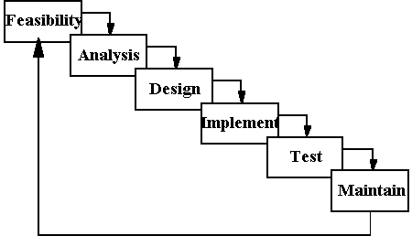

**8.1 FEASIBILTY STUDY**

From the inception of ideas for software system, until it is implemented and delivered to customer and even after that the system undergoes gradual developments and evaluations. The software is said to have life cycle composed of several phases.

At the feasibility stage, it is desirable that two or three different configuration will be pursed that satisfy the key technical requirement but which represent different level of ambition and cost.

Feasibility is the determination of whether or not a project is worth doing. A feasibility study is carried out select a best system that mate performance requirements.

The data collected during primary investigation examines system feasibilities that is likelihood that the system will be beneficial to the organization. Feasibility study is done so that an ill-conceived system is recognized early in definition phase. During system engineering, however, we concentrate our attention on four primary areas of interest. This phase is really important as before starting with the real work of building the system it was very important to find out whether the idea thought is possible or not.

**Types of Feasibility--**

* **Economic Feasibility:** An evaluation of development cost weighted against the ultimate income or benefit derived from the developed system.
* **Technical Feasibility:** A study of function, performance and constraints that may affect the ability to achieve an acceptable system.
* **Operational Feasibility:** A study about the operational aspects of the system.

**Economic Analysis :**

Among the most important information contained in feasibility study is Cost Benefit Analysis and assessment of the economic justification for a computer based system project. Cost Benefit Analysis delineates costs for the project development and weighs them against tangible and intangible benefits of a system. Although this system eliminates paper work considerably yet we should consider various costs associated with this. Cost Benefits Analysis is complicated by the criteria that vary with the characteristics of the system to be developed, the relative size of the project and the expected return on investment desired as part of company’s strategic plan. In addition, many benefits derived from a computer-based system are intangible (e.g. better design quality through iterative optimization, increased customer satisfaction through programmable control etc.)

**Cost Benefit Analysis :**

The various costs evaluated include:

* Equipment Costs.

This includes capital and leasing costs of

* Computer and peripherals.
* The initial systems supplies. (E.g. disks, tapes, etc.)
* Additional hardware.
* UPS and Voltage Regulators.
* Development Costs.
* The purchasing of software. (Programming, DB and OS’s)
* Consulting work.
* System analysis and programming.
* Installation Costs.
* Preparation of the computer room.

(E.g. wiring, air-conditioning, etc.)

* Accommodation (e.g. new building or building alteration,

Etc.)

* Personal Costs.
* Staff training. (Assumption: we will be incurring the cost to train the employees in the Proposed Leave System)
* Staff recruitment or relocations.
* Staff salaries.
* Redundancy payments.
* Operating Costs.
* Consumable (e.g.- tapes, disks, stationery)
* Accommodation costs.
* Power.
* Insurance.

**Technical Analysis :**

During technical analysis, the technical merits of the system are studied and at the same time collecting additional information about performance, reliability, maintainability and predictability.

Technical analysis begins with an assessment of the technical viability of the proposed system.

* What technologies are required to accomplished system function and performance?
* What new materials, methods, algorithms or processes are required and what is their development risk?
* How will these obtained from technical analysis form the basis for another go/no-go decision on the test system? If the technical risk is severe, if models indicate that the desired function can not be achieved, if the pieces just won’t fit together smoothly-it’s back to the drawing board.

As the software is vary much economically feasible, then it is really important for it to be technically sound. The software will be build among:

* Front-End: ASP.NET 3.5
* Back-End: MS SQL SERVER 2000

**Operational Feasibility :**

The project is operationally feasible. This project is being made for the convenience of the managers and employees only. This system will greatly reduce a huge burden of managers and employees. So because of the above stated advantages the users of the system will not be reluctant at all.

**8.2 Software Requirement Specification**

The software requirement specification is produced at the culmination of the analysis task.

**Purpose**

The purpose of this Software Requirement Specification (SRS) is to

fully describe the behavior of the “ SYSTEM” being developed. It also describes the nonfunctional requirements, design constraints and other factors necessary to provide a complete and comprehensive description of the requirements.

**User Characteristics**

**Administrator :** Deep knowledge of computers as well as company policies.

**Employees :** Basic knowledge of handling computers is required.

This software has been designed keeping in view the requirements and ease of the user who is finally going to use it. After all the effort put on analysis phase, I ended up with the following requirements:

* Easy storage, updation, deletion and retrieval of data.
* No redundancy of data.
* Minimal traversal time.
* User friendly interface.
* Proper validations and checks for the data to be entered.
* Generation of certain automatic values.
* Compatibility with other Microsoft based softwares.

**General Constraints**

The Online Trading System shall execute online. The said application is a server-side application and the product code shall be written in ASP.NET using C#.NET and VB.NET. The database will be managed in SQL Server. A standard QWERTY keyboard is associated with each workstation.

The application is allocated the responsibility for ensuring that only authorized data-entry operators, employees can access the records and availability to anyone who has a computer and an internet connection.

**Assumptions**

This application is released with an implicit assumption that it is made to work online for applying of Equities and viewing customers records with the broker.

**Functional Requirements**

The function and performance specification for the system is divided into two major roles: Admin and customer. These functions can be accessed after going through the Login Screen which is a welcome page.

**Introduction:** It deals with the administrator’s login that has complete access to all files and records there in.

**Inputs:** The main data that is inputted is the Customer Code of the administrator to keep track of authorization and authentication.

**Processing:** The input is processed with the help of a cookie or a query string. An admin can create new records, edit old ones and delete the unnecessary.

**Outputs:** Maximum output is generated through this section. The Admin is responsible for adding all the basic information and codes which are used further while entering employee related information and equipment related information too.

**8.3 SYSTEM ANALYSIS**

The Analysis model:

The analysis model must achieve three primary objectives:

* To describe what the customer requires.
* To establish the basis for the enhancement of a software design.
* To define a set of requirements that can be validated once the software is completely enhanced. The main elements of the analysis model are briefly described below.

**Entity Relationship**

**Diagram**

**Data Object Description**

**Process Specification**

**Data Flow Diagram**

**State Transition Diagram**

**Control Specification**

* At the core of the model lies the **data dictionary**, which is a repository that contains descriptions of all the data objects consumed or produced by the software .Three different diagrams surround the core.
* The **entity relation diagram** depicts relationships between data objects.
* The **data flow diagram** provides an indication of how the data is transformed as they move through the system.
* The **state transition diagram** indicates how the system behaves as a consequence of external events.

**8.4 REQUIREMENT ANALYSIS**

**Goal of Thesis**

The goal of our thesis is to develop a website that can be used as an enrollment website with the features of interaction and problem solving. The whole project will be based on PHP with MYSQL as the database with certain security constraints added to it.

Our aim is also to implement the Administrator part in to the project so that the server or administrator himself can view, add, delete and modify.

1. **Administrator**

He has to see whether the website is working properly and whether the details available in the system are relevant and correct. He can view, add, modify, delete details.

1. **Database**

The database keeps all the records of all the users i.e. name,course, phone no.,dob, city, country,etc. For creating such records it takes the help of tables which is created in the MYSQL. The tables can have infinite entries of all the registered users as well as administrators.

1. **Clients**

Our aim will also to provide efficient way by which client can enter to see his profile, ask questions to his teacher and download softwares.

1. **Security Constraints**

There need to be certain constraints which have to be implemented on the database as well as on the administrator in order to work properly the whole system, such as declaring the primary key, or such constraints in order to keep the database work properly.

**Some of such constraints are as follows :**

1.Each user has a field called username which can be used to differentiate between different users.

2.The administrator has his own password known to no one else to access a unique page.

3. Only the administrator has the right to delete, modify users and questions.

4. Administrator has to first login to get access to myaccount part and modify some data available in the website.

5. A new user cannot have same username and password as of some already registered user.

6.When user or administrator click on logout the session of the user ends and he has to again login using his/her username and password to access the same functionality.

7. Checks are implemented so that the mandatory fields are filled by users when the user is entering some information in the system.

8. Latest firewalls and other antivirus and anti hacking modules are to be used with the website so as to protect the website from external attacks.

**8.5 PROBLEM ANALYSIS :**

**APPLICATIONS**

The main applications of the On Line Placement System is the ability of the website to properly show enroll the artists and manage information about them. The administrator has the ability to change ,modify, view and delete the various details regarding the users and arts. The users have the ability to log in and post their queries and download arts.

**CHALLENGES**

The challenges mainly lie in detecting attacks like viruses, hacking and also in the implementation of firewall. A virus can enter the system and can disrupt the working of the website. Hacking can be done by some people who want to access some restricted sections of the website (e.g. administrator’s area) and to modify or taper some aspects of the website.

Scanning attacks may yield:

(i) The method used by viruses to enter the system.

(ii) The types of database allowed through a firewall.

(iii) The paths or ways used by hackers to enter the system

(iv) The loopholes remaining in the system (or website) which are used by attackers.

(v) The server from where the viruses or hackers are gaining access to the system.

(vi) The types of viruses able to affect the website.

And with the implementation of firewall and other security mechanisms that are designed for it, the On Line Placement System Website safe and secure.

**FEASIBILTY STUDY**

From the inception of ideas for software system, until it is implemented and delivered to customer and even after that the system undergoes gradual developments and evaluations.

The software is said to have life cycle composed of several phases.

At the feasibility stage, it is desirable that two or three different configuration will be pursed that satisfy the key technical requirement but which represent different level of ambition and cost.

Feasibility is the determination of whether or not a project is worth doing. A feasibility study is carried out select a best system that mate performance requirements.

The data collected during primary investigation examines system feasibilities that is likelihood that the system will be beneficial to the organization. Four tests for feasibility study are as follows:-

**Technical Feasibility:** This is concerned with specifying equipment and software that will successfully satisfy the use considerably, but might includeThe feasibility to produce output in a given time because system is fast enough to handle multiple users.Response time under certain circumstances and ability to process a certain volume of transaction of a particular speed.

**Economical Feasibility:** Economic analysis is the most frequently used technique used for evaluating the effectiveness of a proposed system. More commonly known as cost/benefit analysis the procedure is to determine the benefits and savings that are expected from a proposed system and compared them with cost. Though the cost of installing the system may appear high, it is one time investment. The resulting benefits is that automation results in turnaround time. The resulting cost/benefit ratio is favorable.

**Operational Feasibility:** It is mainly related to human organizational as social aspects. The points to be considered are - The system interface is standard, user friendly and provides extensive help. Hence no special training is not required.

**Social Feasibility:** Social feasibility is determination of whether a proposed project will be acceptable to people or not, So this project is totally Social and Feasible

**SYSTEM ANALYSIS :**

The Analysis model:

The analysis model must achieve three primary objectives:

* To describe what the customer requires.
* To establish the basis for the enhancement of a software design.
* To define a set of requirements that can be validated once the software is completely enhanced. The main elements of the analysis model are briefly described below.
* At the core of the model lies the **data dictionary**, which is a repository that contains descriptions of all the data objects consumed or produced by the software .Three different diagrams surround the core.
* The **entity relation diagram** depicts relationships between data objects.
* The **data flow diagram** provides an indication of how the data is transformed as they move through the system.

**8.6 SYSTEM DESIGN PHASE**

The design phase involves converting the informational, functional, and network requirements identified during the initiation and planning phases into unified design specifications that developers use to script programs during the development phase. Program designs are constructed in various ways. Using a top-down approach, designers first identify and link major program components and interfaces, then expand design layouts as they identify and link smaller subsystems and connections. Using a bottom-up approach, designers first identify and link minor program components and interfaces, then expand design layouts as they identify and link larger systems   
Contemporary design techniques often use prototyping tools that build mock-up designs of items such as application screens, database layouts, and system architectures. End users, designers, developers, database managers, and network administrators should review and refine the prototyped designs in an iterative process until they agree on an acceptable design.

Designers should carefully document completed designs. Detailed documentation enhances a programmer’s ability to develop programs and modify them after they are placed in production. The documentation also helps management ensure final programs are consistent with original goals and specifications. Organizations should create initial testing, conversion, implementation, and training plans during the design phase. Additionally, they should draft user, operator, and maintenance manuals.

For design of the website project:

1. First Database has to be designed which can be used to handle all the requirements of the users.
2. The basic structure of the website has to be designed.
3. The main template to be used for the website is designed.

**8.6.1 Introduction**

System design is the process of developing specifications for a candidate system that meet the criteria established in the system analysis. Major step in system design is the preparation of the input forms and the output reports in a form applicable to the user.

The main objective of the system design is to make the system user friendly. System design involves various stages as:

## Data Entry

* **Data Correction**
* **Data Deletion**
* **Processing**
* **Sorting and Indexing**

System design is the creative act of invention, developing new inputs, a database, offline files, procedures and output for processing business to meet an organization objective. System design builds information gathered during the system analysis.

**8.6.2 CHARACTERSTICS OF A WELL DEFINED SYSTEM**

In design an efficient and effective system is of great importance to consider the human factor and equipment that these will require to use. System analyst must evaluate the capabilities and limitations of the personal and corresponding factors of the equipment itself.

The characteristics associated with effective system operations are:

* Accessibility

## Decision Making Ability

* Economy
* Flexibility
* Reliability

**Personnel:** If the operating system is convinced that the new system will not benefit them, it appears one, and the system is in serious trouble. To overcome this resistance participation by operating personal during all phases of the changeover is necessary because they constitute the organization, which must use alive in with newly design system. An effective system produces not only information at the lowest cost pertinent and timely for making decision.

The main objective of the system design is to make the system user friendly. After discussing with some of the technical persons, friends, guide; it was concluded that the design of the application should be 3 tier which means that the system will be developed in orientation to three things:

**Data:** It includes Database, Stored Procedures, and Cursors etc.

**Business:** It includes the logic that will actually process the data but it should be in the form of objects and classes that will help in providing the application components reusability, abstraction and other Object Oriented features.

**Presentation:** It includes the front end that links the user to the whole system.

Generally, it is said that if the design is made well, the whole system will work well. So, I have tried my best to put my effort on this phase properly.

**Benefits of the System**

The system provides the following benefits:

**Menu Driven Package:**

The system consists of various menus through which we can choose various options.

These menus are self explanatory and allow the user to browse through the various forms.

**Easy Retrieval of Data:**

Operations like add, update, delete, save and cancel etc. have been accomplished with the

help of various buttons and list boxes. The user can easily view or retrieve information.

**Validations:**

There are proper validations for the information to be filled at the relevant places. So, the

chances of wrong entry are minimal.

**Security and Access:**

The system is fully secured by a password facility so that nobody can use the system or

view information without the right and the permission. Only the correct password allows

further navigation in the project.

**User friendly:**

The system is completely user friendly so that the end user who may have very little

knowledge of using computers can easily use the system.

**9. Data Flow Diagram**

In our DFD, we give names to data flows, processes, and data stores. Although the names are descriptive of the data, they do not give details. So the following the DFD, our interest is to build some structured place to keep details of the contents of data flow, processes, and data store. A data dictionary is a structured repository of data about data. It is a set of rigorous definition of all DFD data element and data structure

**9.1 DFD Symbols**

In the DFD, there are four symbols,

1. **A Square** defines a source (originator) or destination of system data.
2. **An Arrow** identifies data flow- data in motion .It is pipeline through which information flows.
3. **A circle** or a **bubble** (or a oval bubble) represents a process that transforms incoming data flow(s) into outgoing data flow(s)
4. **An open rectangle** is a data store-data at rest , or temporary repository of data

**9.2 DFD Rules and Tips**

1. Each process should have at least one input and an output.
2. Each data store should have at least one data flow in and one data flow out.
3. Data stored in a system must go through a process
4. All processes in a DFD go to another process or a data store.

.

**9.3 DATA FLOW DIAGRAM :**

Client 3

Client 2

Client 1

Main System Representing Art Gallery

Database server for valid user

View

Save to folder

DownLoad at client side

Arts

Database

Search

Arts

Client

Database

About Us

Home

Contact

us

**DFD level 0:**

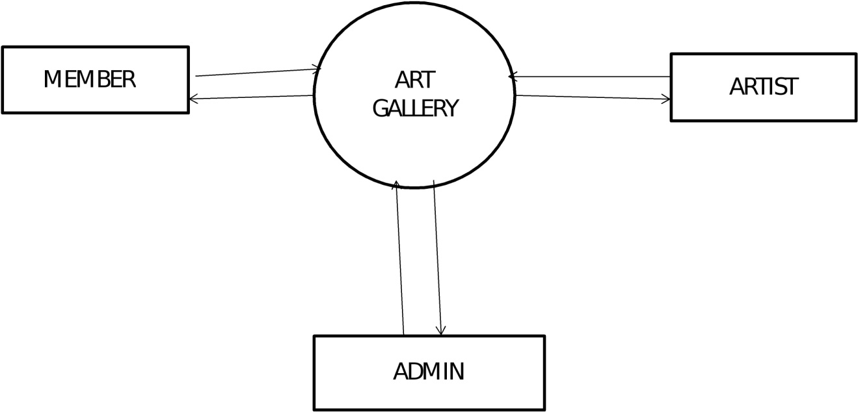

**DFD level 1 member:**

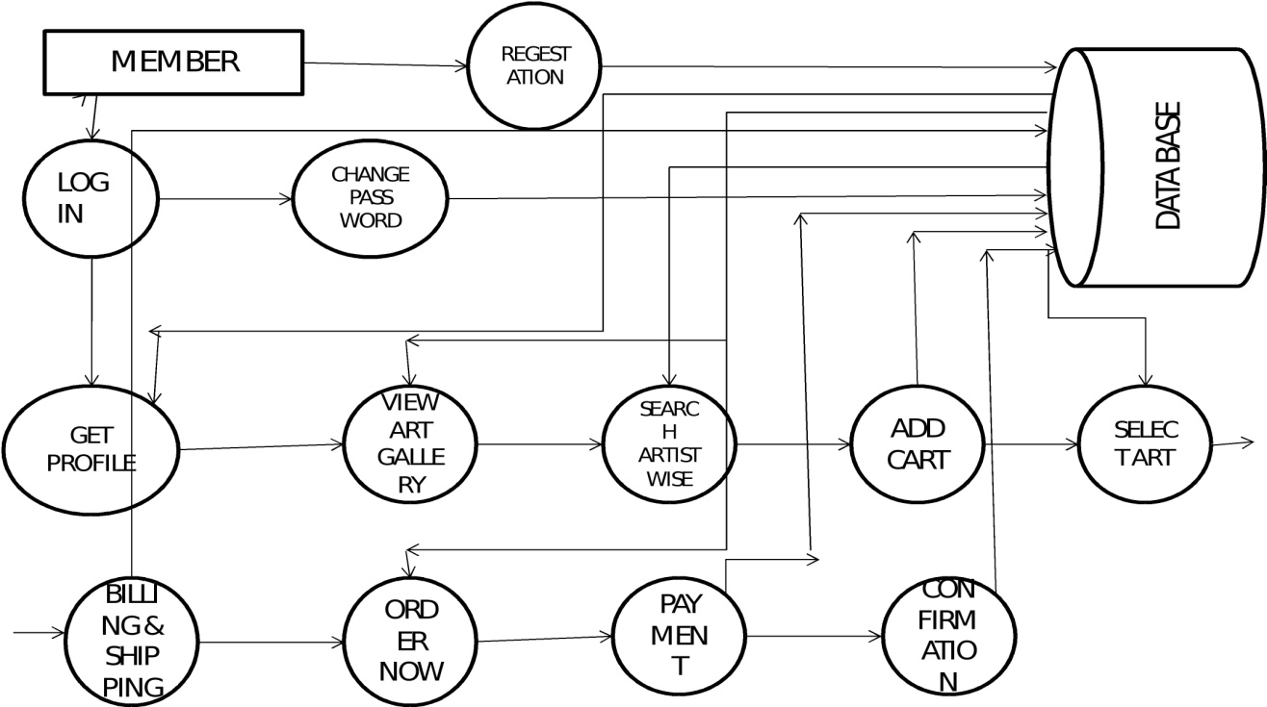

**DFD Level 1 Artist:**

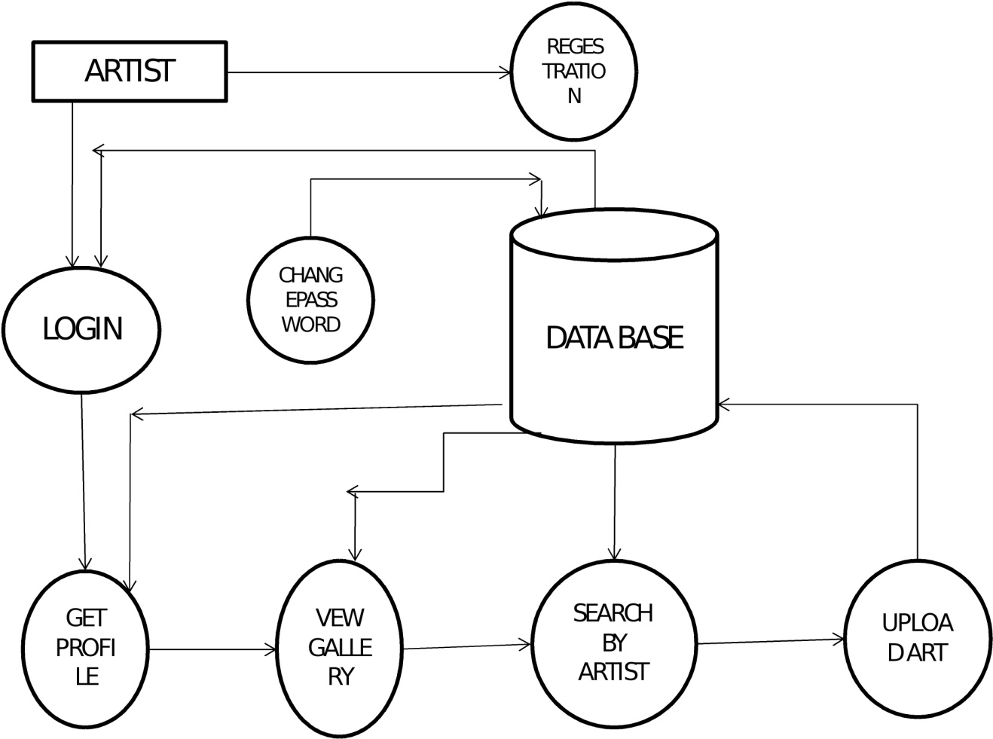

**DFD Level 1 Admin:**

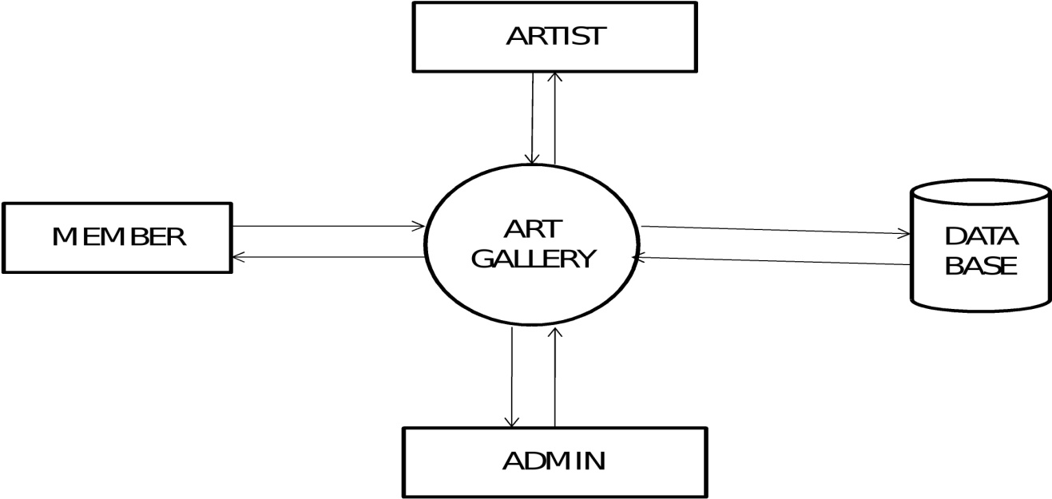

**Context Diagram:**

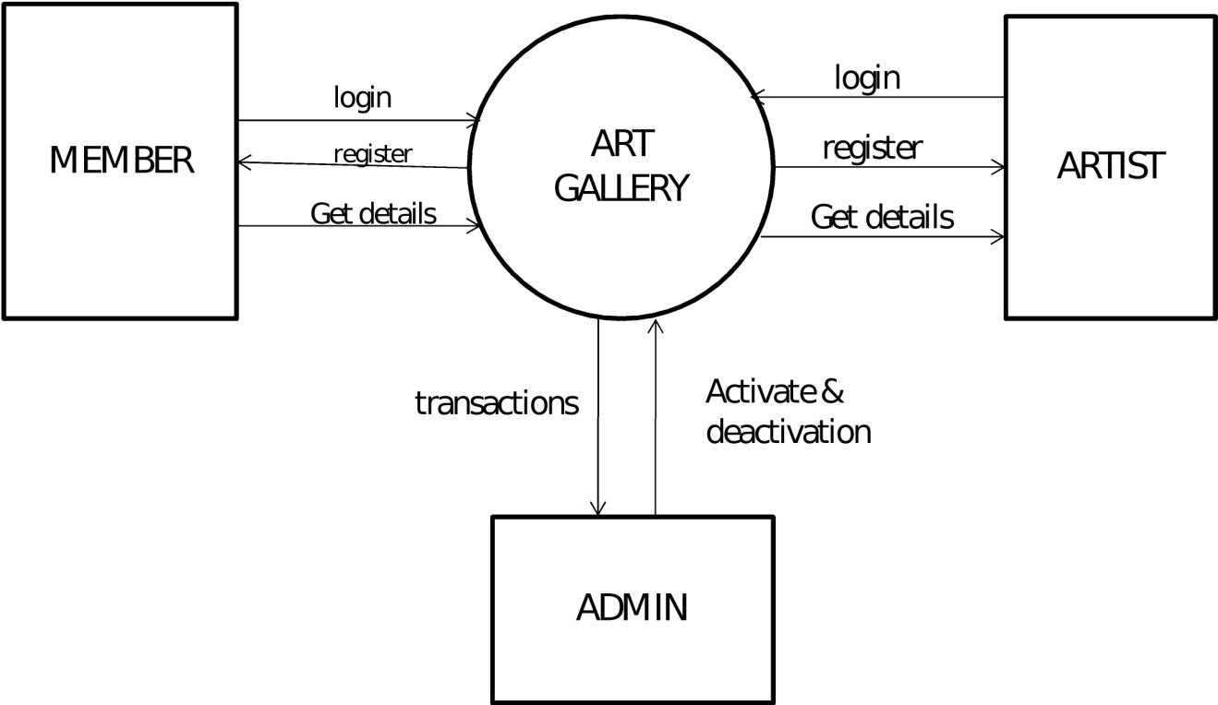

**10. SNAPSHOTS**

**Admin Login:**

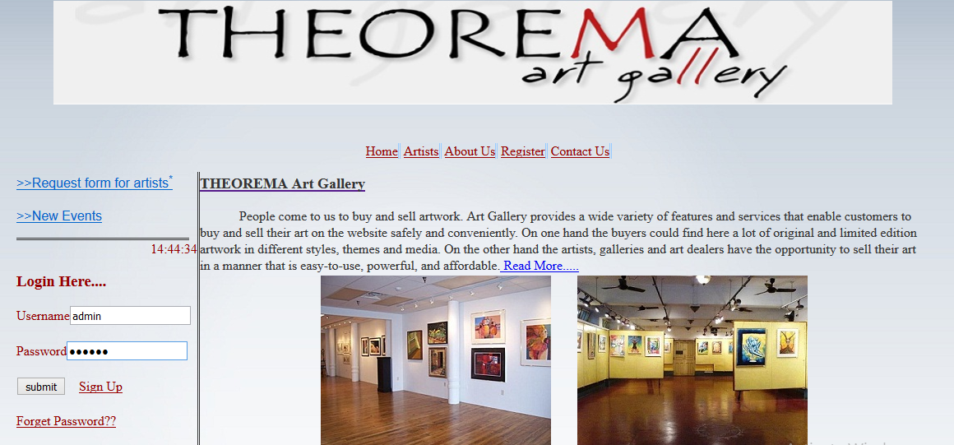

**Admin Homepage:**

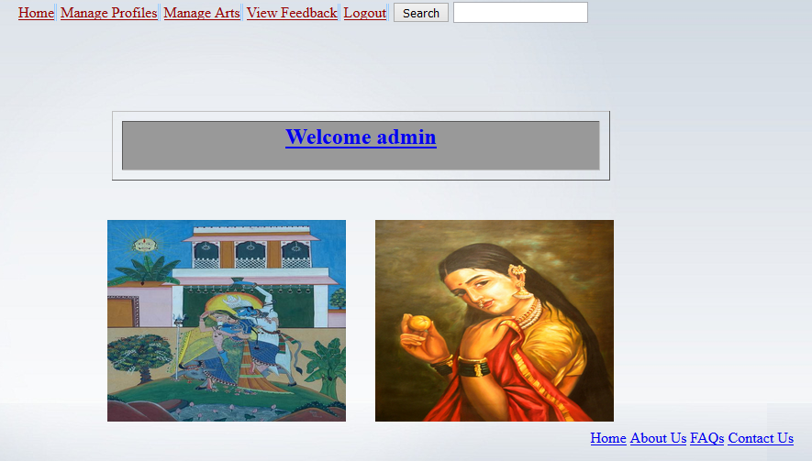

**Functions of Admin:**

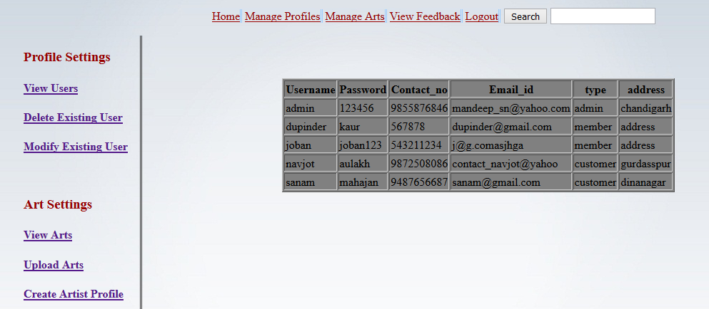

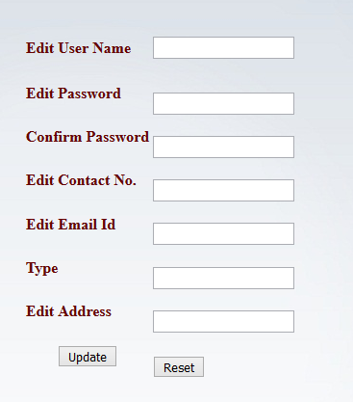

**Member Homepage:**

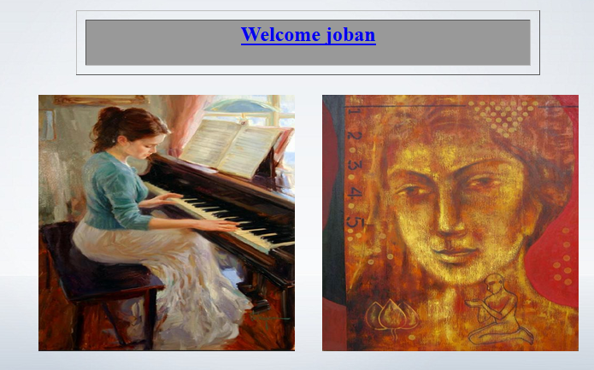

**Member Change Password:**

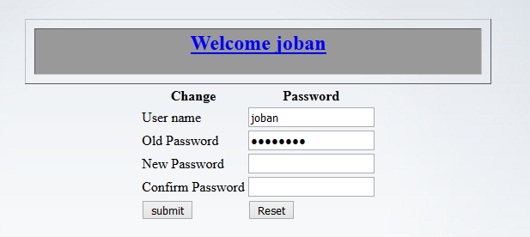

**Tables:**

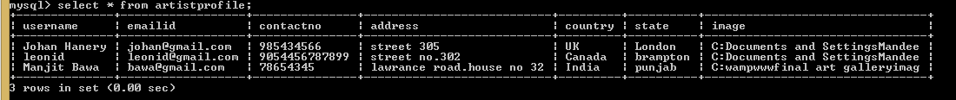

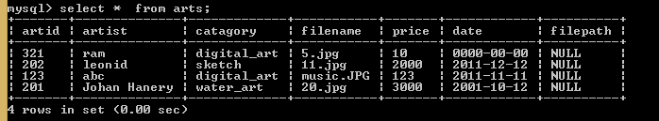

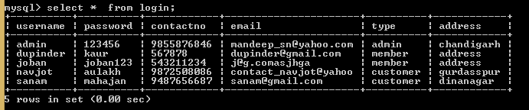

**BIBLIOGRAPHY**

1. [**www.google.com**](http://www.google.com)
2. [**www.w3schools.com**](http://www.w3schools.com)
3. [**www.phpbuddy.com**](http://www.phpbuddy.com)
4. [**www.mysql.com**](http://www.mysql.com)
5. **www.phpeasystep.com**