**Assignment Submission Sheet**

|  |  |  |
| --- | --- | --- |
| **Term: 321221** | **Submission Date: 05-10-2021** |  |
|  | **Assignment Number: 03** |
| **Course Code: ECE290** | **Section: E1901** | **Group: A** |
| **Registration Number: 11904463** | **Student Name: Mohit Rawat** | **Roll No: 09** |

### Concept Learned

### I have learn about how to make 2x1, 4x1 and 16x1 (using 4x1 and 2x1) Multiplexer in verilog code and how to simulate its output in waveform.

1. **Key Observations &Insights**

Key observation is the output waveform of 16x1 using 4x1 and 2x1 multiplexer and how we connect each other in verilog code.

1. **Application Areas**

Multiplexer is used in many area like in processor to reduce number of pin.

1. **A)**
2. **2x1 Multiplexer using conditional operator.**

**2. 4x1 Multiplexer using conditional operator.**

**B)**

**16x1 multiplexer using 2x1 and 4x1 multiplexer in data flow model.**

**2x1 Multiplexer**

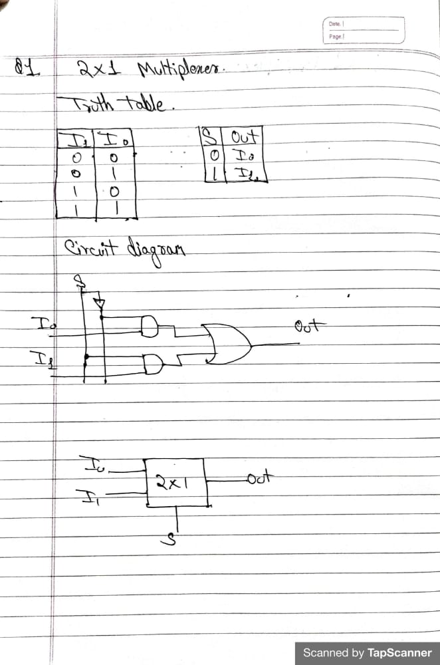

**Verilog Code**

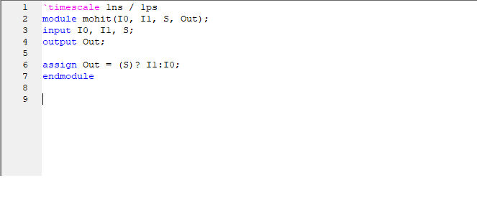

**Test bench code**

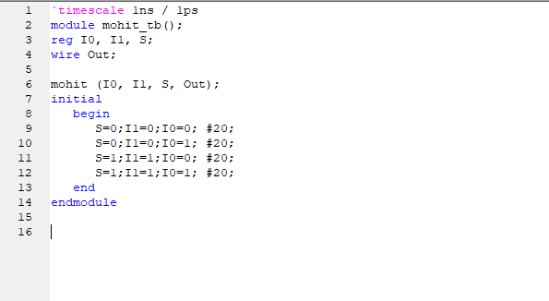

**Circuit design**

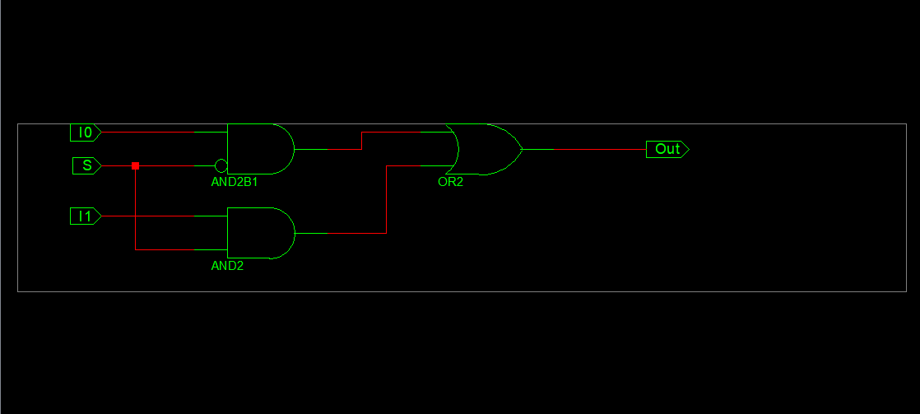

**Wave form**

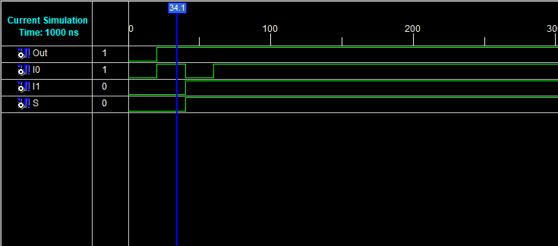

**4x1 Multiplexer**

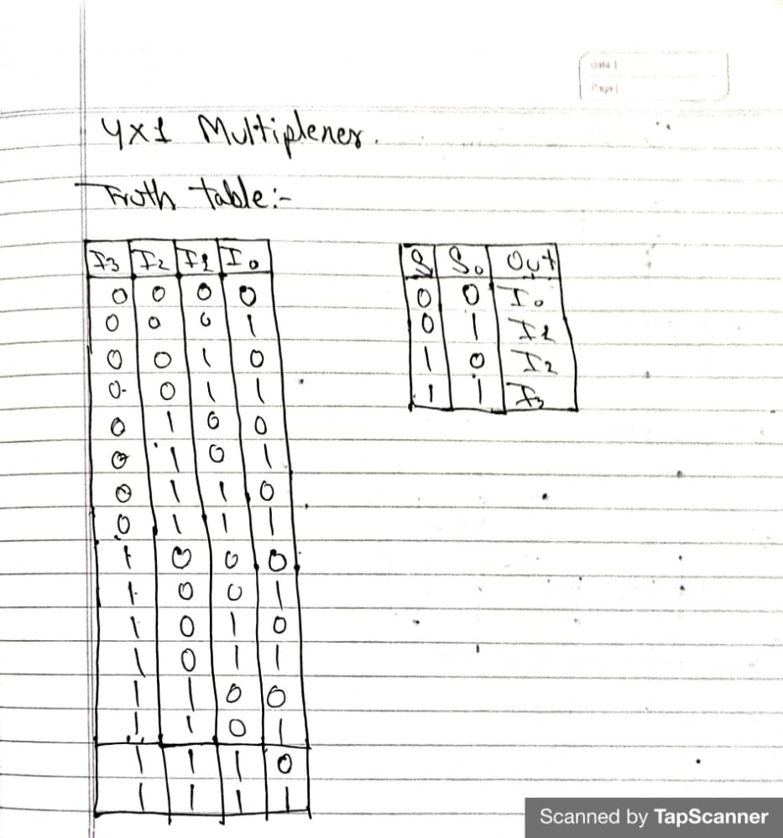

**Verilog Code**

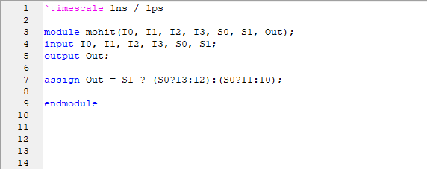

**Test bench code**

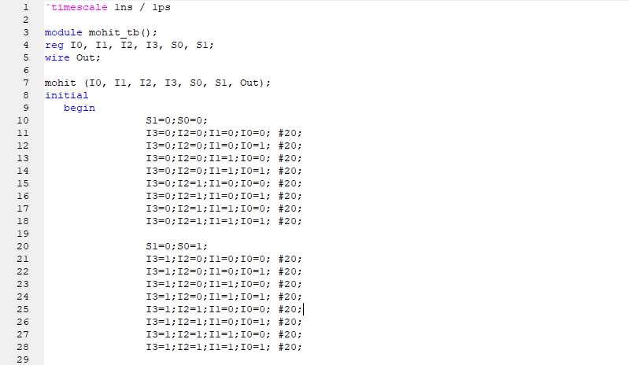

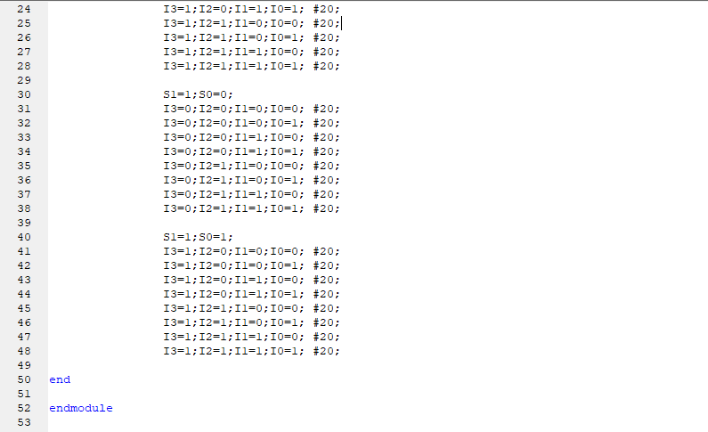

**Circuit**

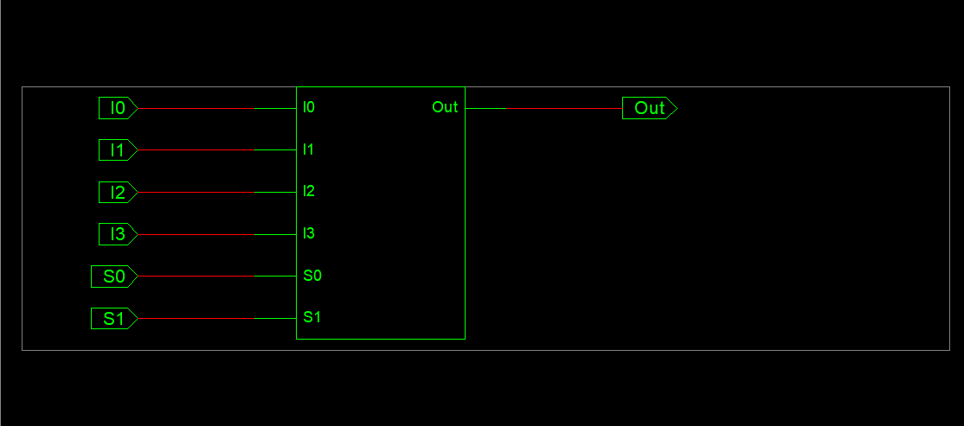

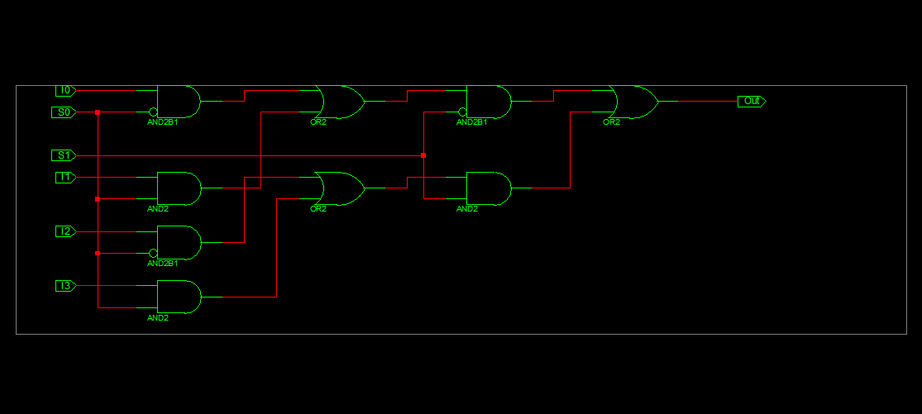

**Waveform**

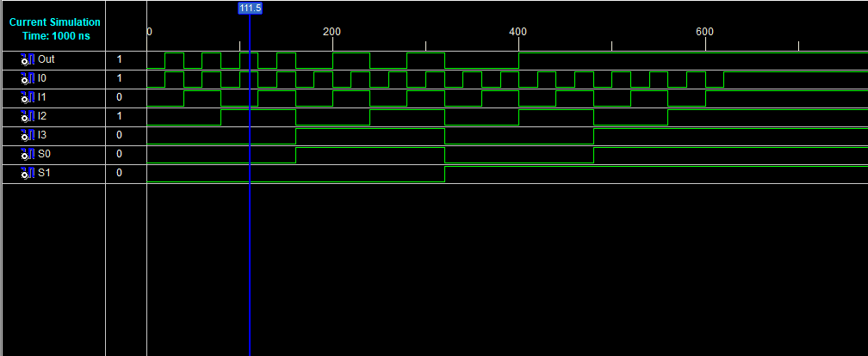

**16x1 Multiplexer using 2x1 & 4x1 Multiplexer**

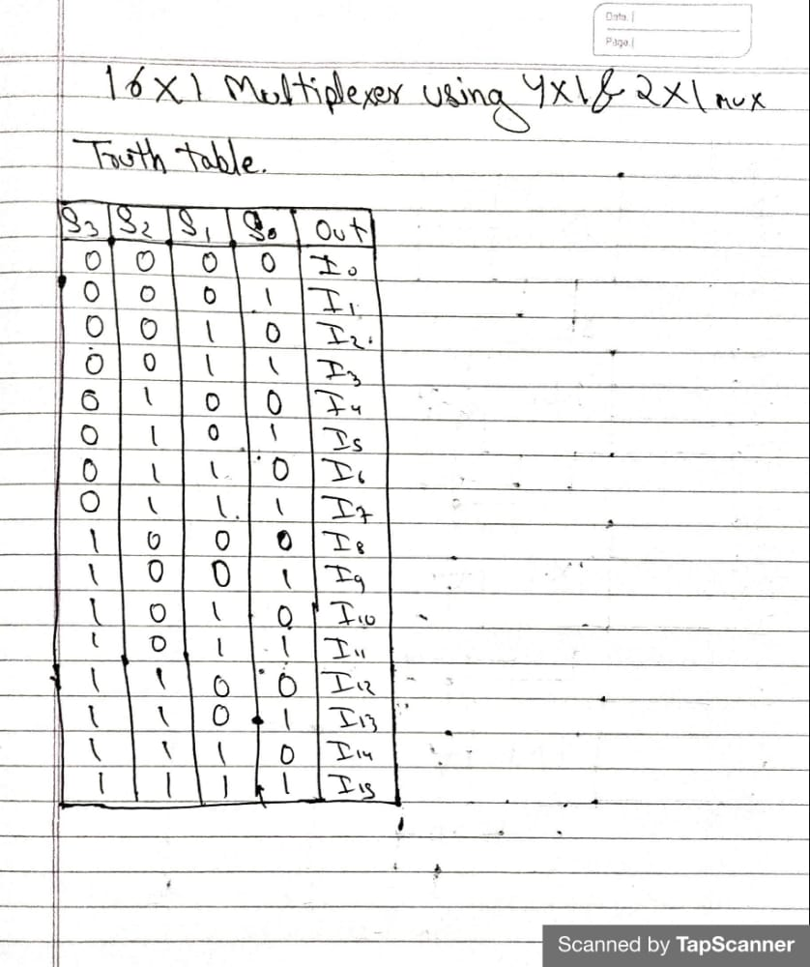

**Diagram of 16x1 using 2x1 & 4x1**

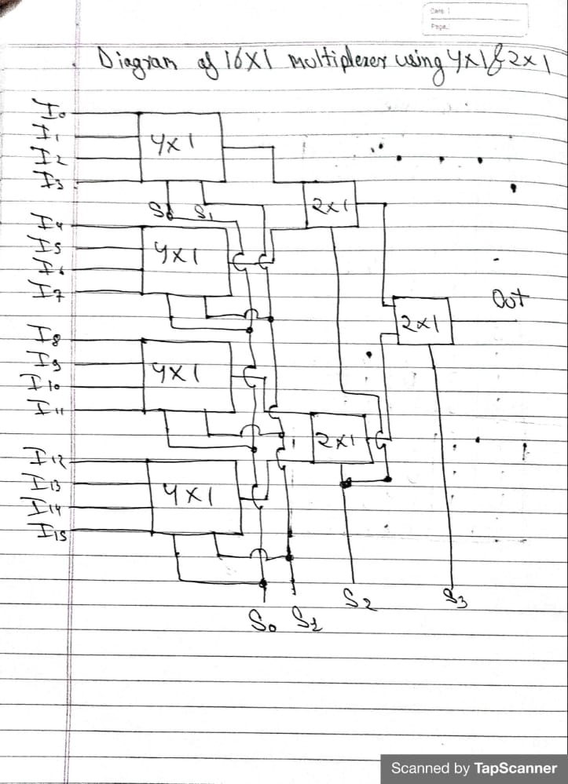

**Verilog Code**

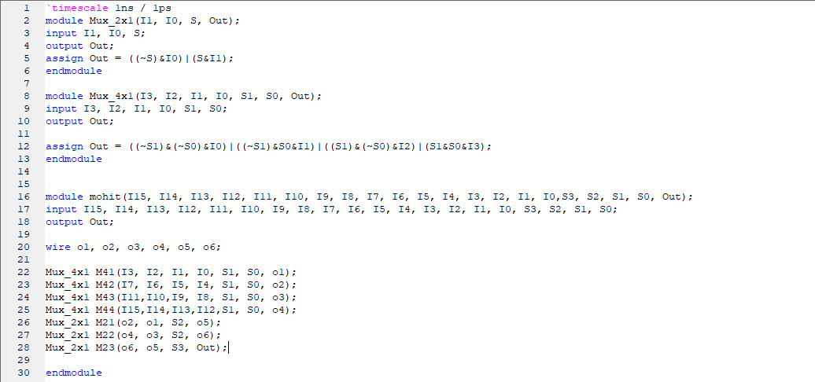

**Test bench Program**

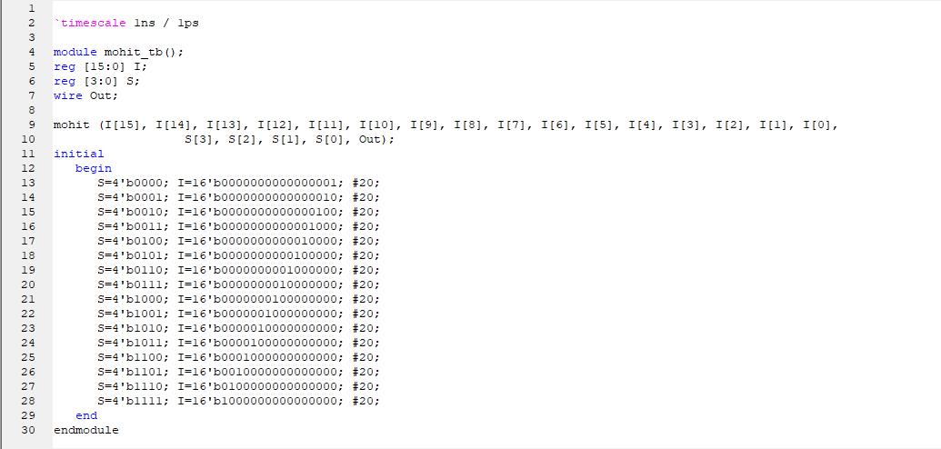

**Circuit Diagram**

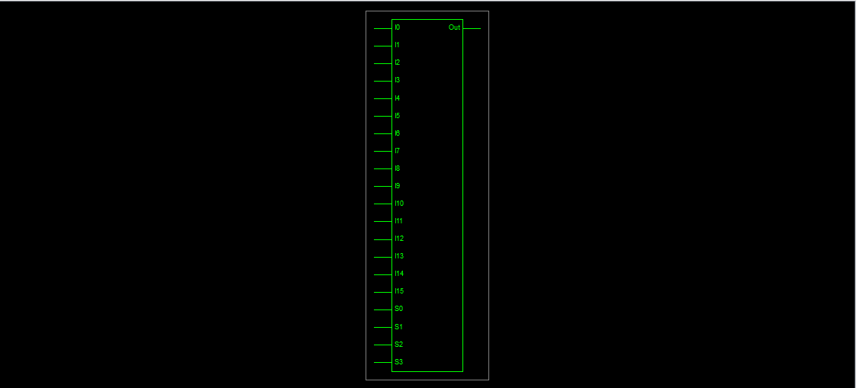

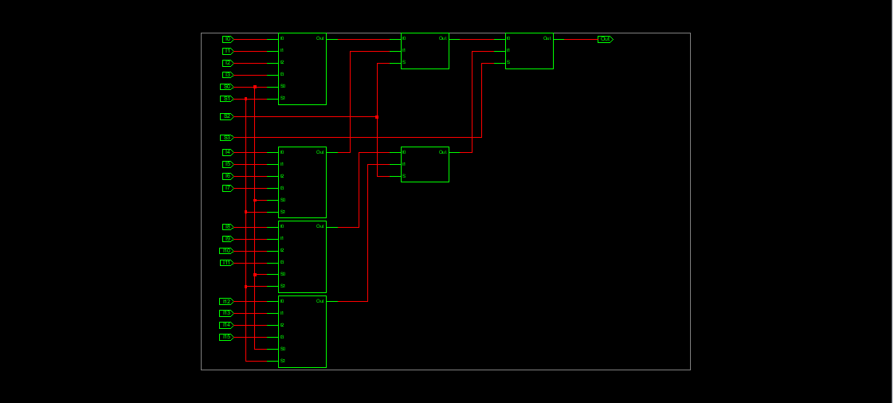

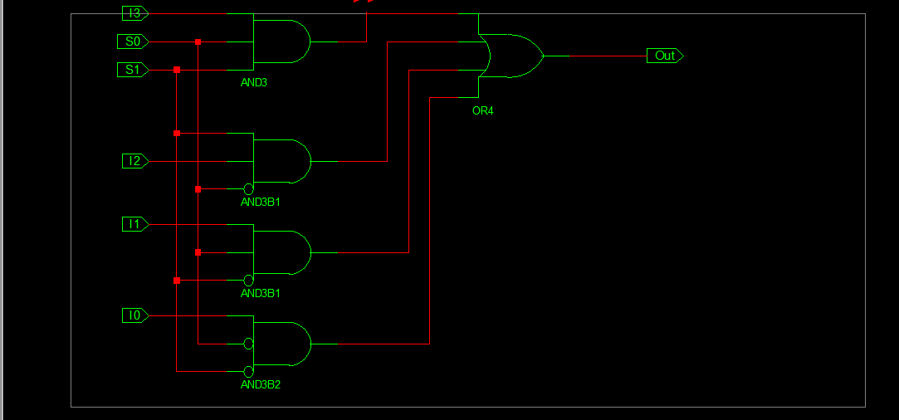

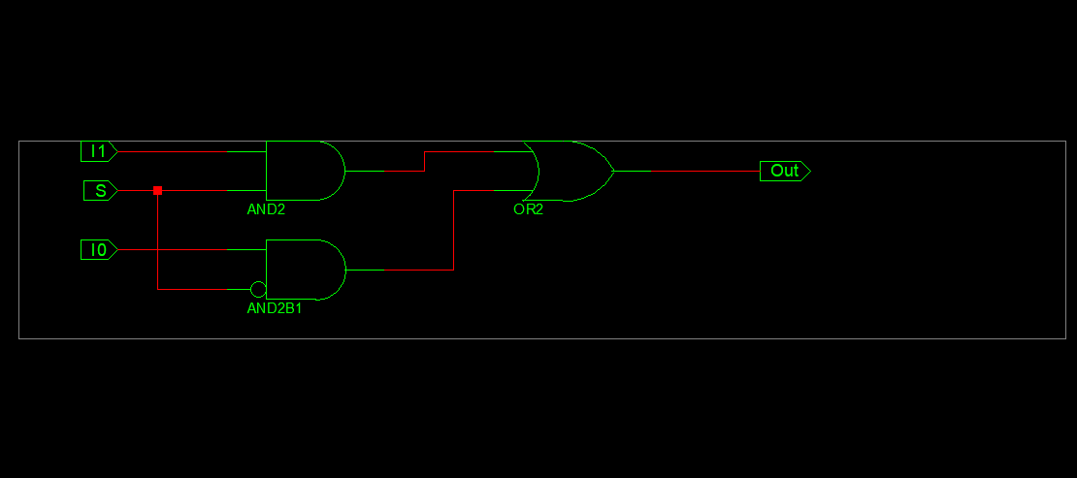

**Waveform**

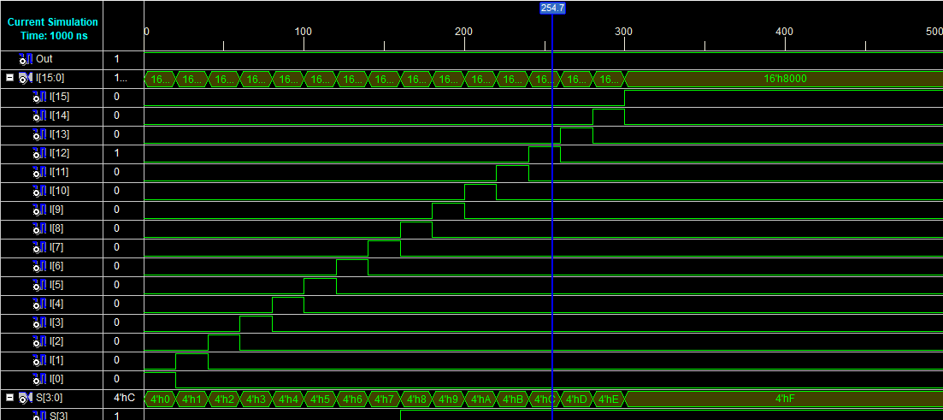

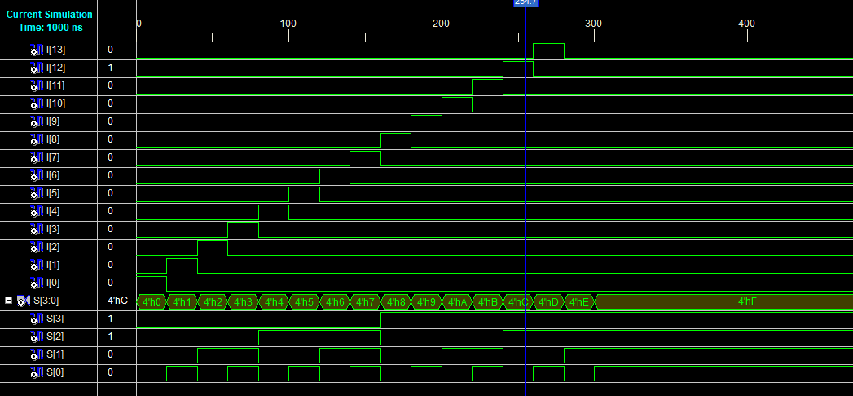

**END**