**Assignment Submission Sheet**

|  |  |  |
| --- | --- | --- |
| **Term: 321221** | **Submission Date: 02-11-2021** |  |
|  | **Assignment Number: 04** |
| **Course Code: ECE290** | **Section: E1901** | **Group: A** |
| **Registration Number: 11904463** | **Student Name: Mohit Rawat** | **Roll No: 09** |

### Concept Learned

### I have learn about how to make 4 bit up counter using verilog and how to make testbench and give clock in circuit.

1. **Key Observations &Insights**

Key observation is the output waveform was that it start from 0000 and count up to 1111 and again starting from 0000.

1. **Application Areas**

Application of counter is in many digital machine like washing machine, micro owner, program counter in computer.

1. A verilog Program to implement 4 bit synchronous Up counter using D- Flip Flop.

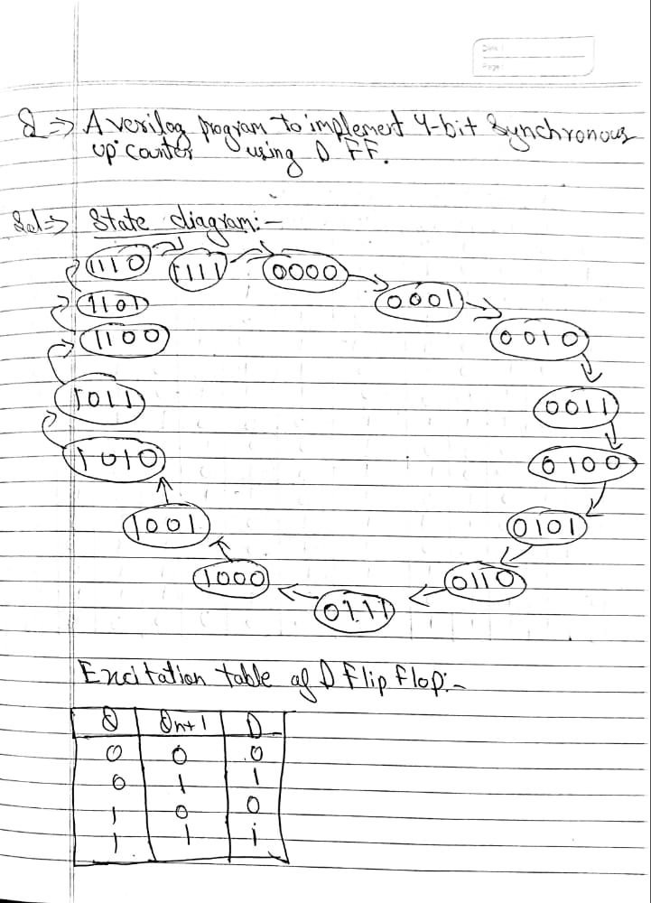

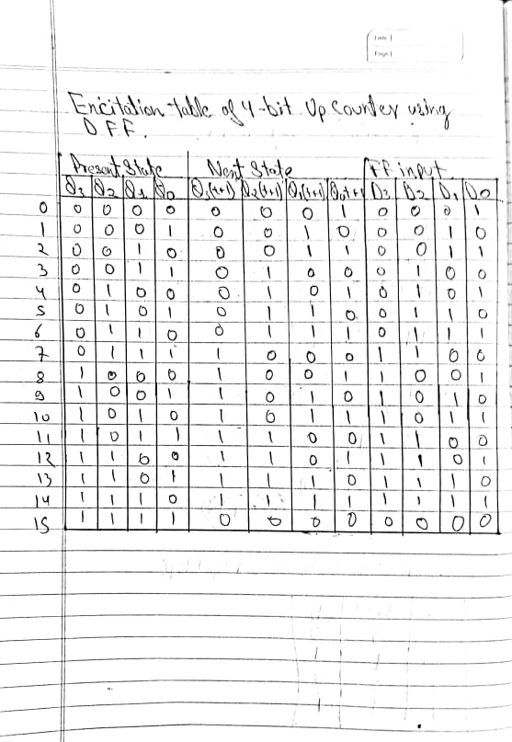

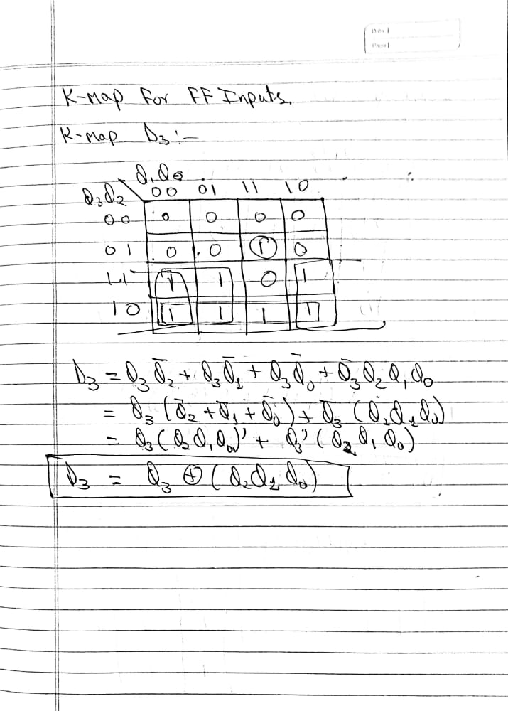

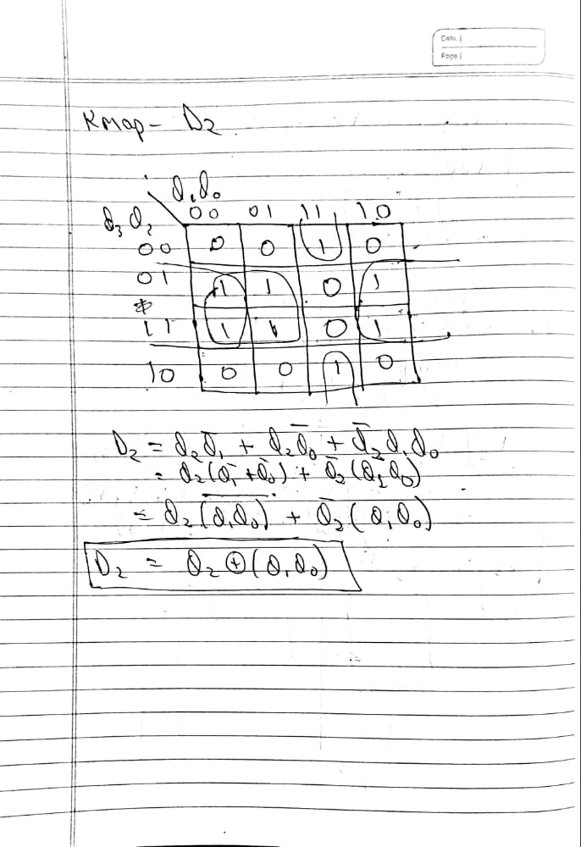

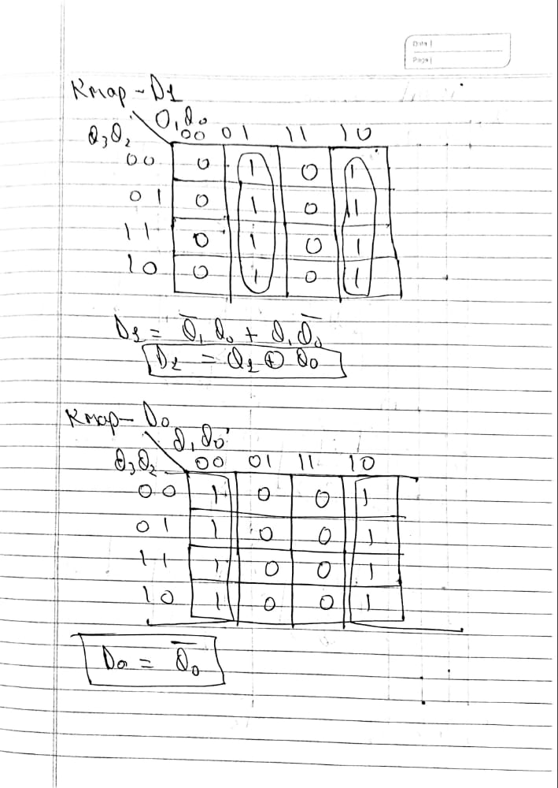

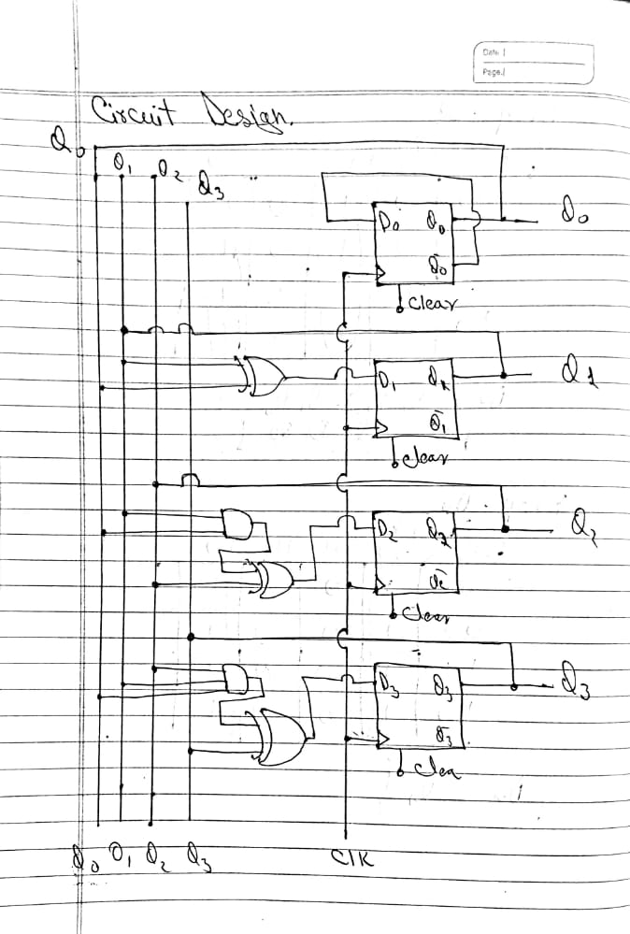

Verilog Code

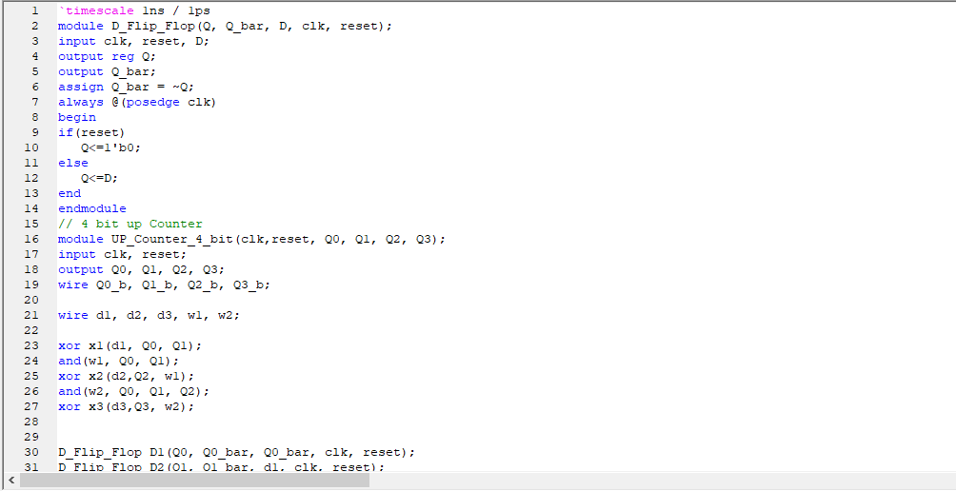

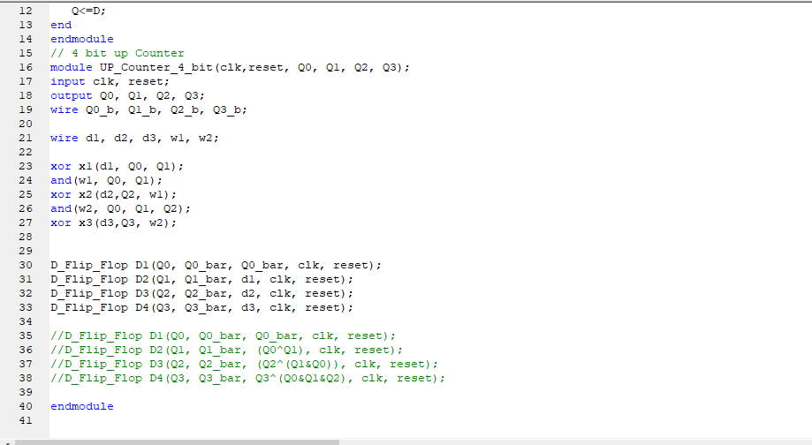

Test Bench For Verilog Code

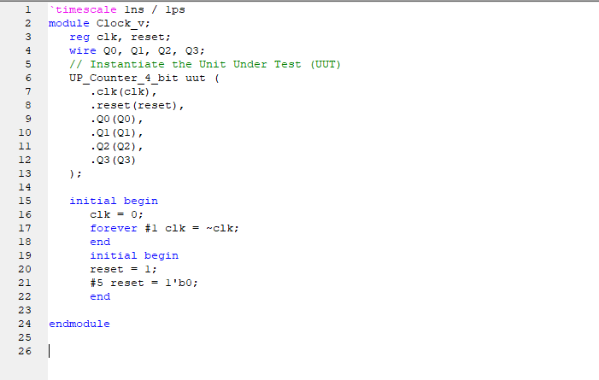

Schematic Diagram

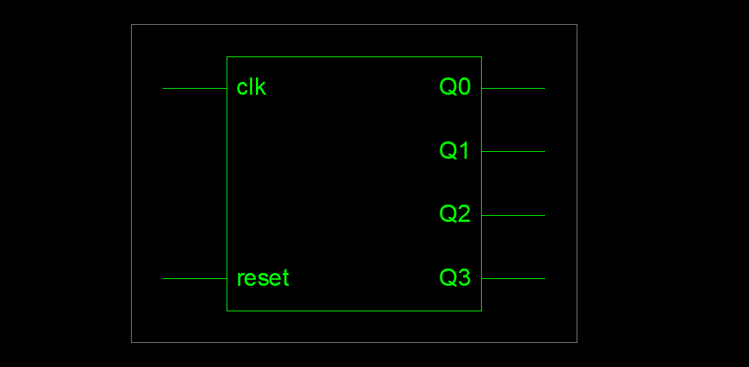

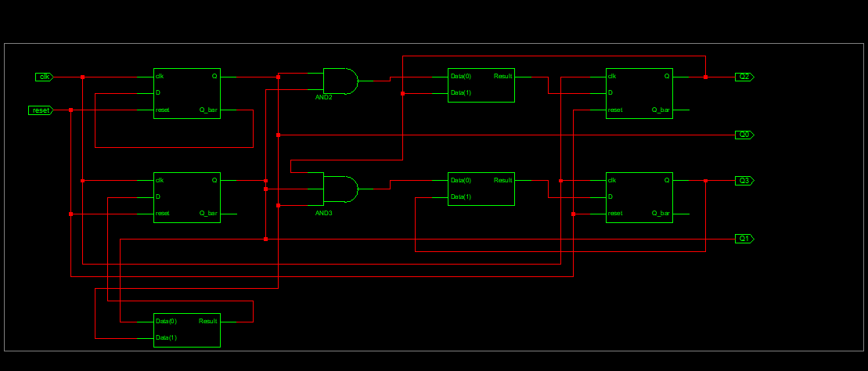

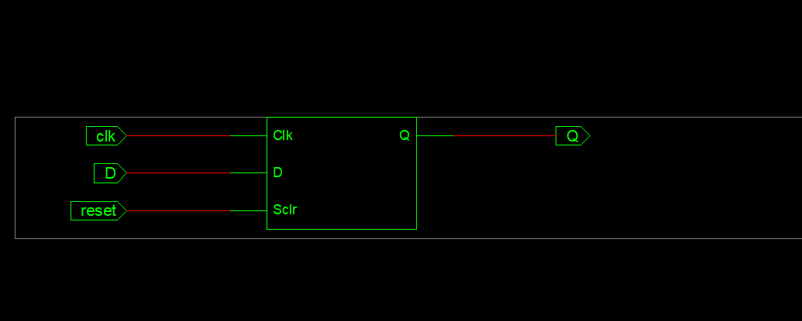

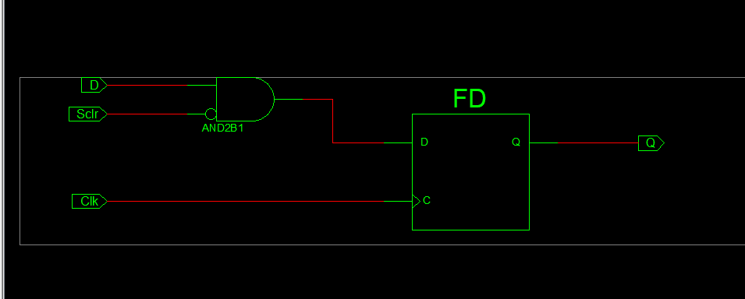

Wave Form (Output Counter)

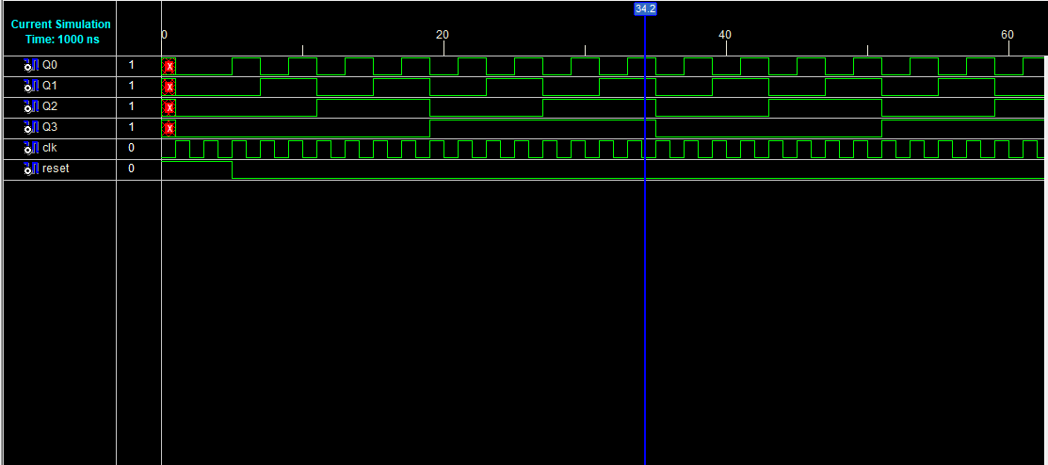

**END**