**Assignment Submission Sheet**

|  |  |  |
| --- | --- | --- |
| **Term: 321221** | **Submission Date: 22-11-2021** |  |
|  | **Assignment Number: 05** |
| **Course Code: ECE290** | **Section: E1901** | **Group: A** |
| **Registration Number: 11904463** | **Student Name: Mohit Rawat** | **Roll No: 09** |

### Concept Learned

### I have learn about how to make 16 x 1 Multiplexer using 4 x 1 multiplexer and how to code in Verilog and make simulation of it.

1. **Key Observations &Insights**

Key observation is the output waveform was the multiplexer’s output according to select line and the input given throw testbench.

1. **Application Areas**

Application of Multiplexer is in modern devices like microprocessor inside ALU.

1. A Verilog Program to implement 16 x 1 Multiplexer using 4 x 1 Multiplexers.

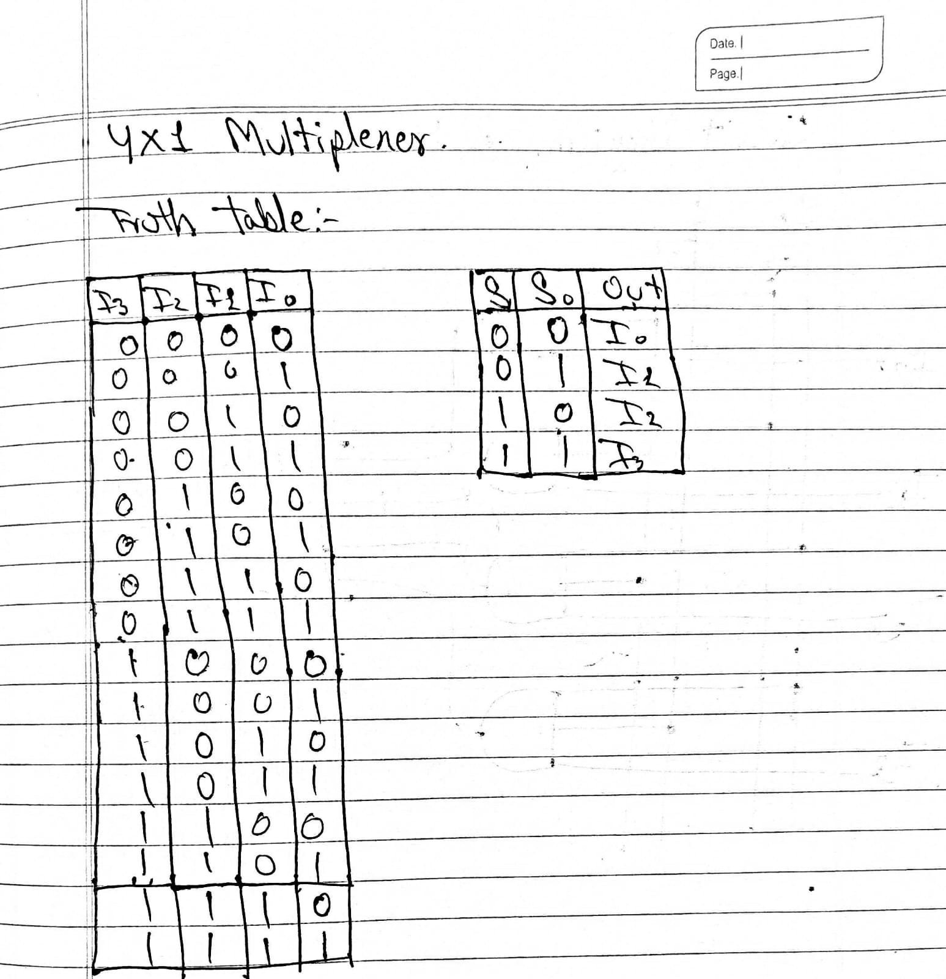

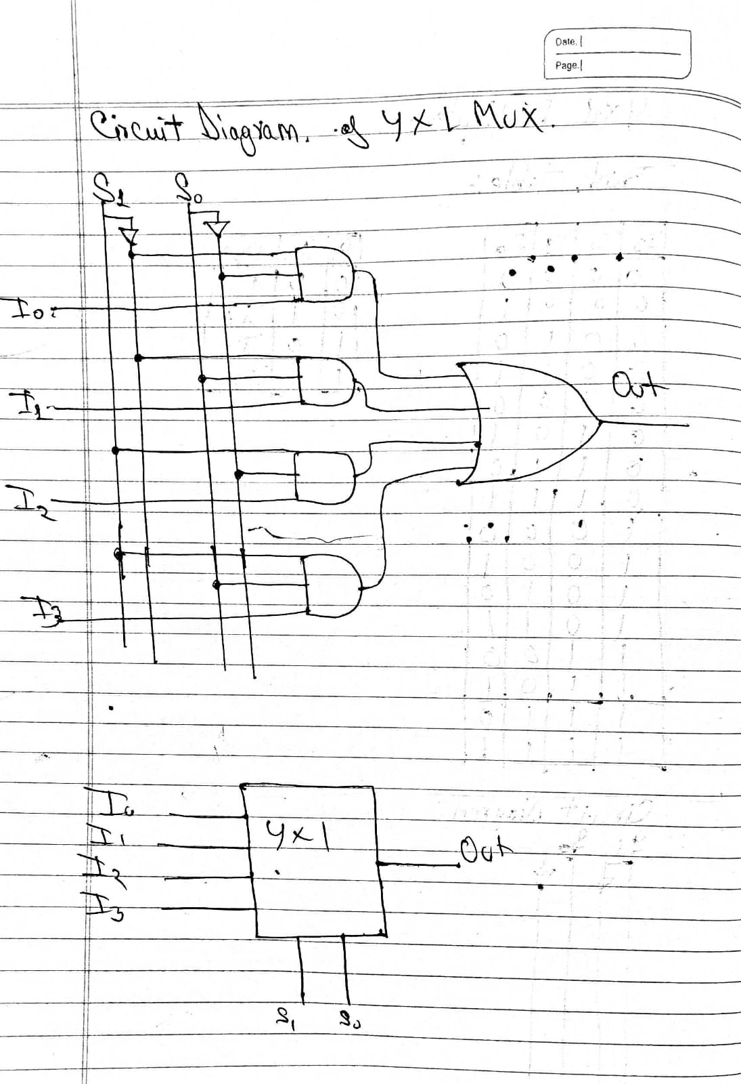

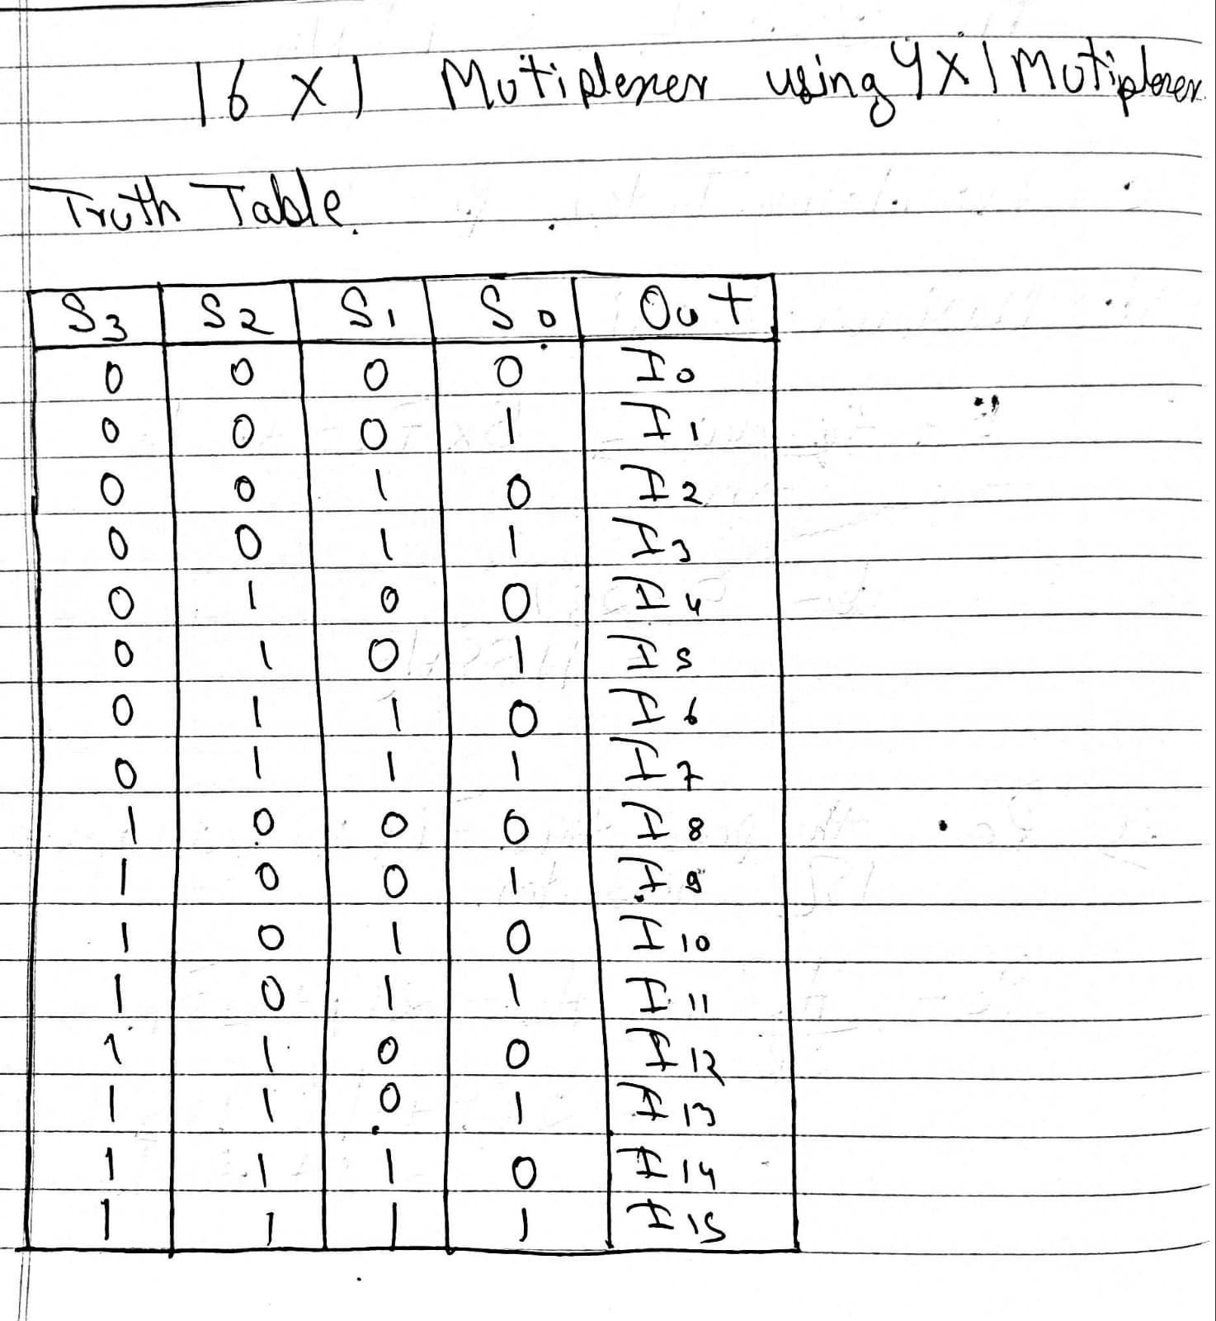

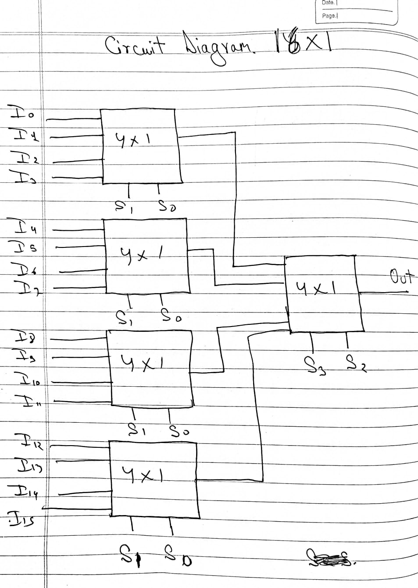

Verilog Code

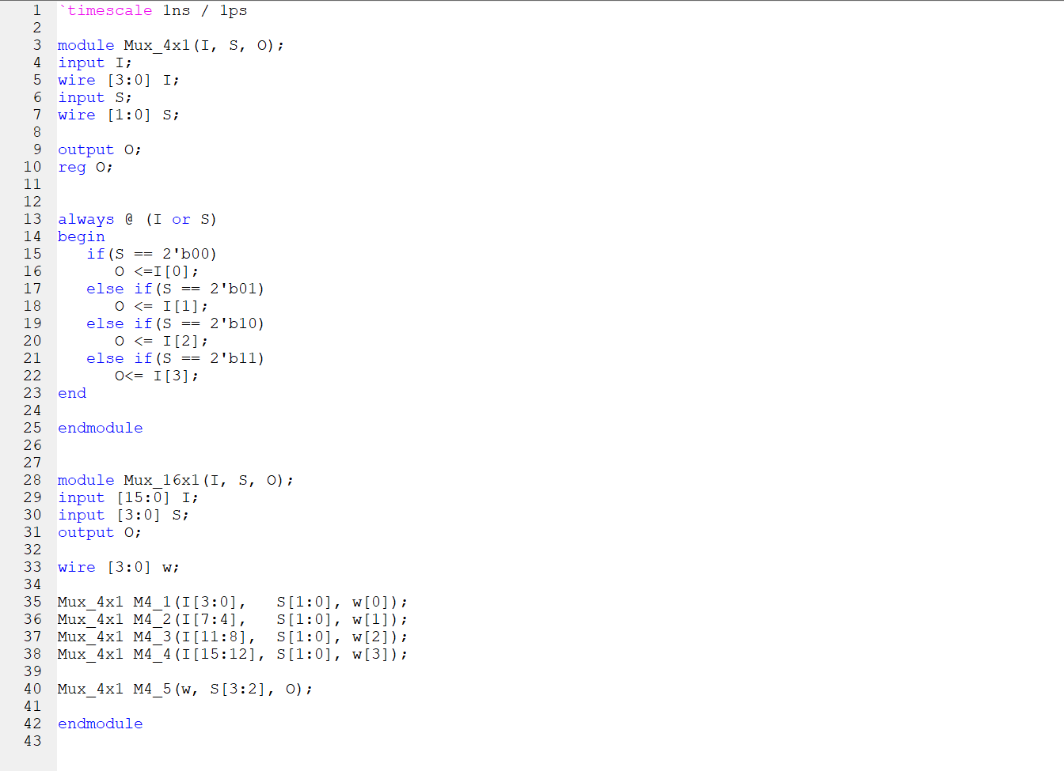

Test Bench For Verilog Code

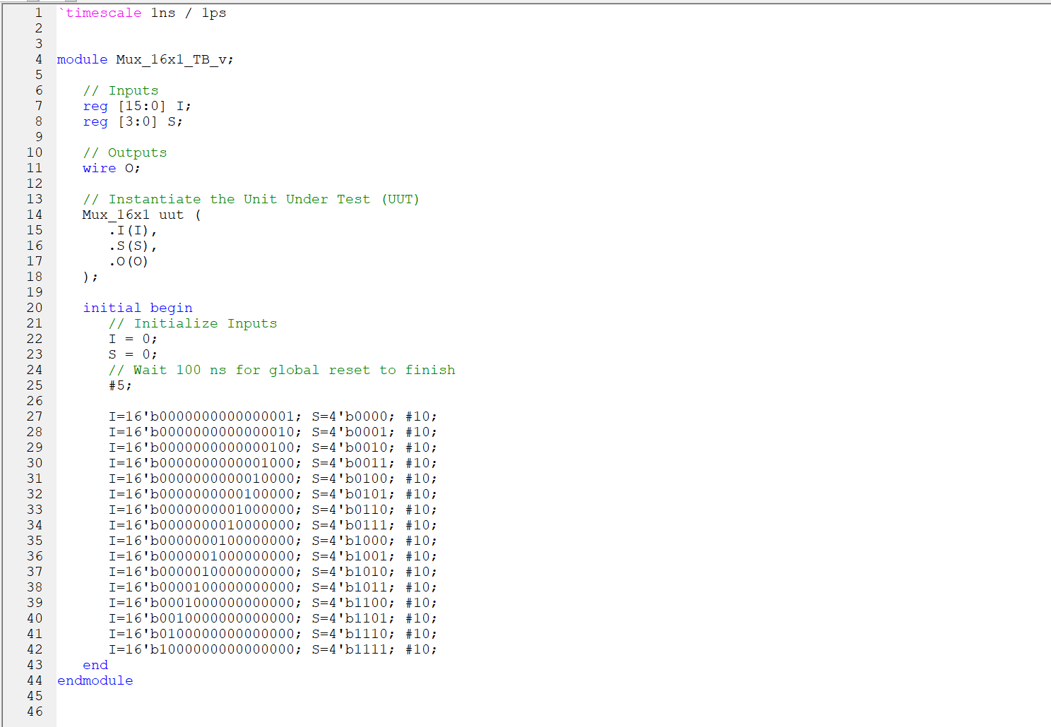

Schematic Diagram

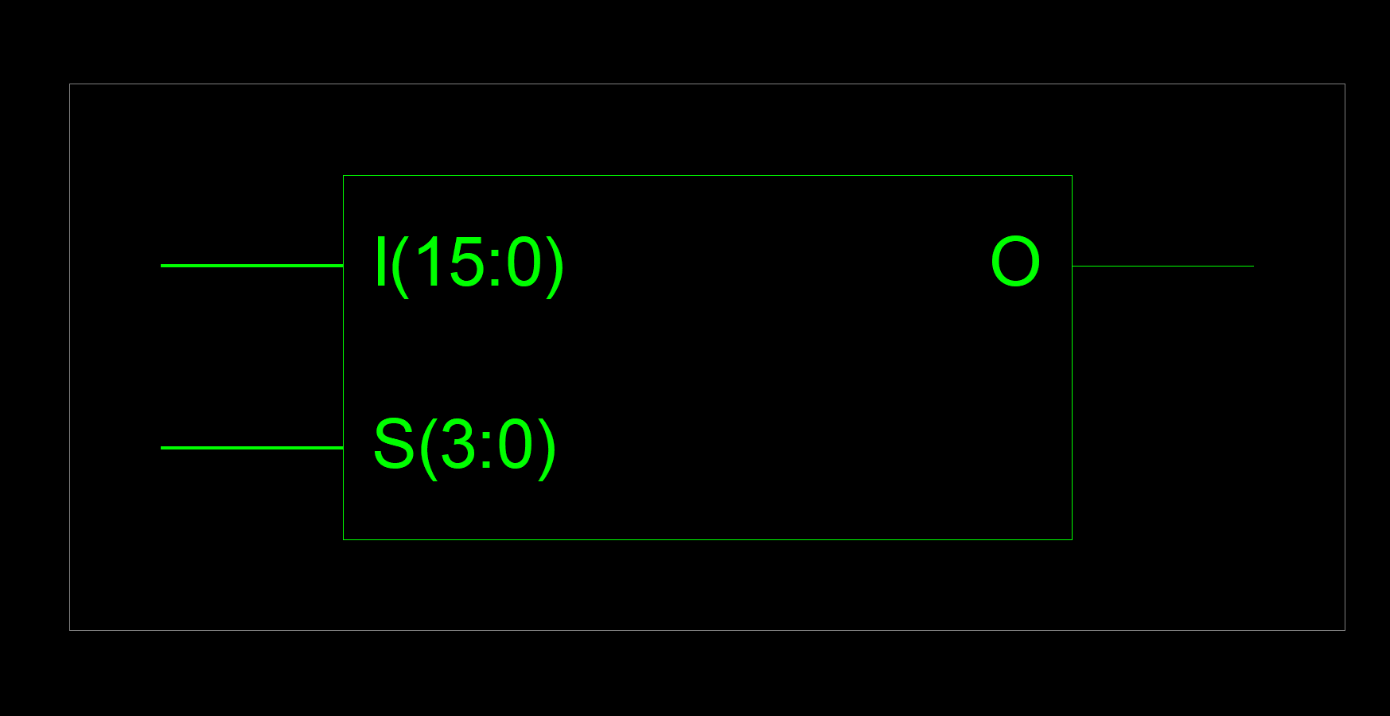

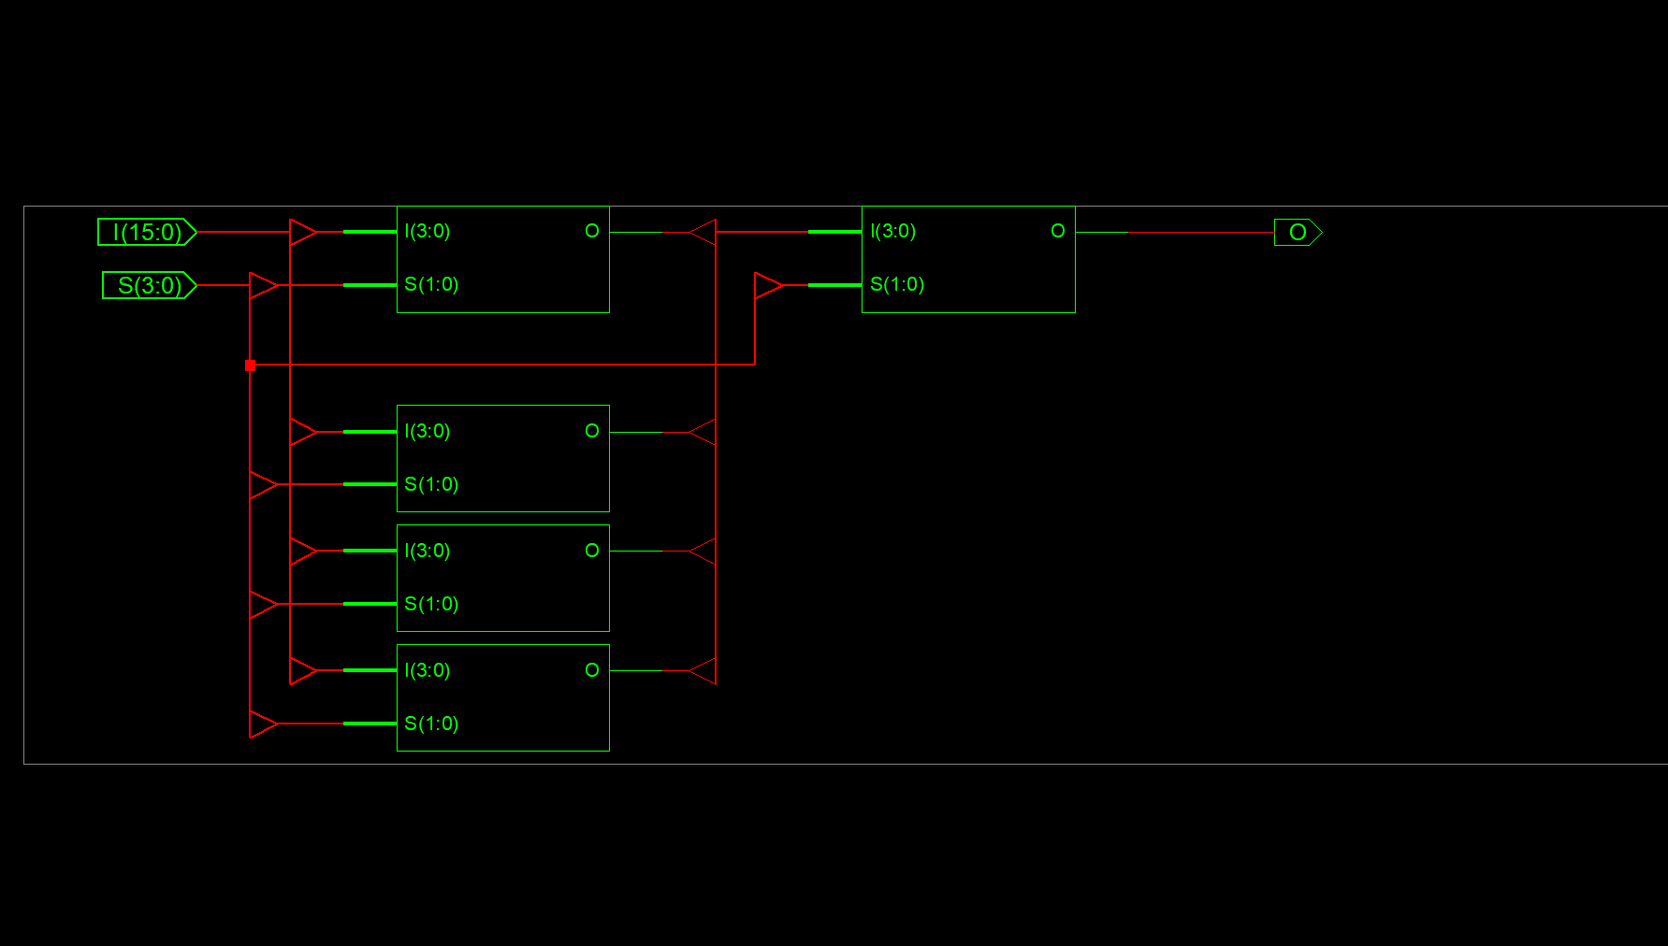

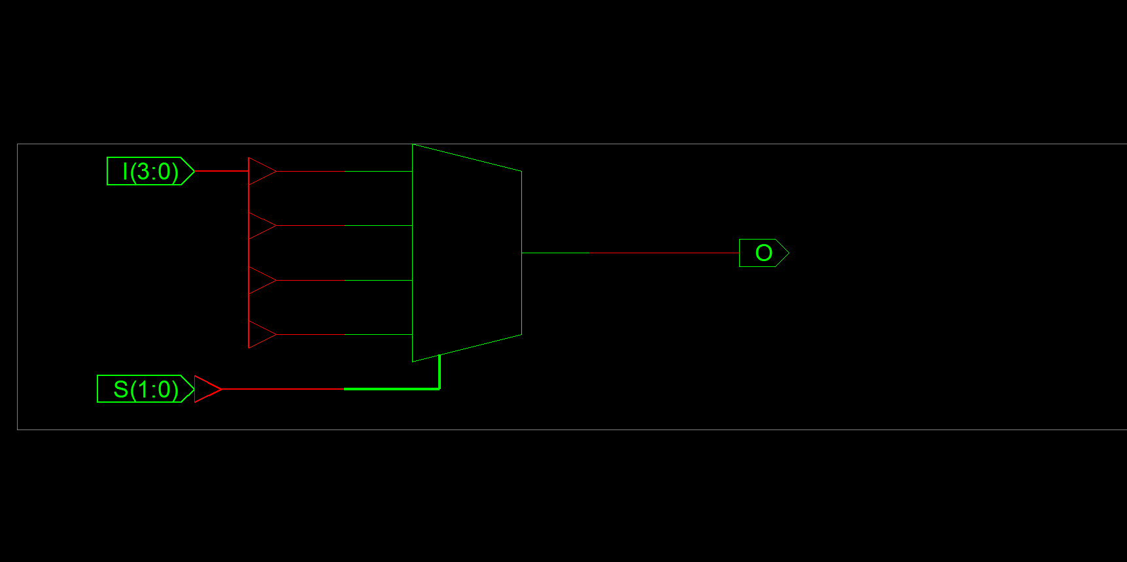

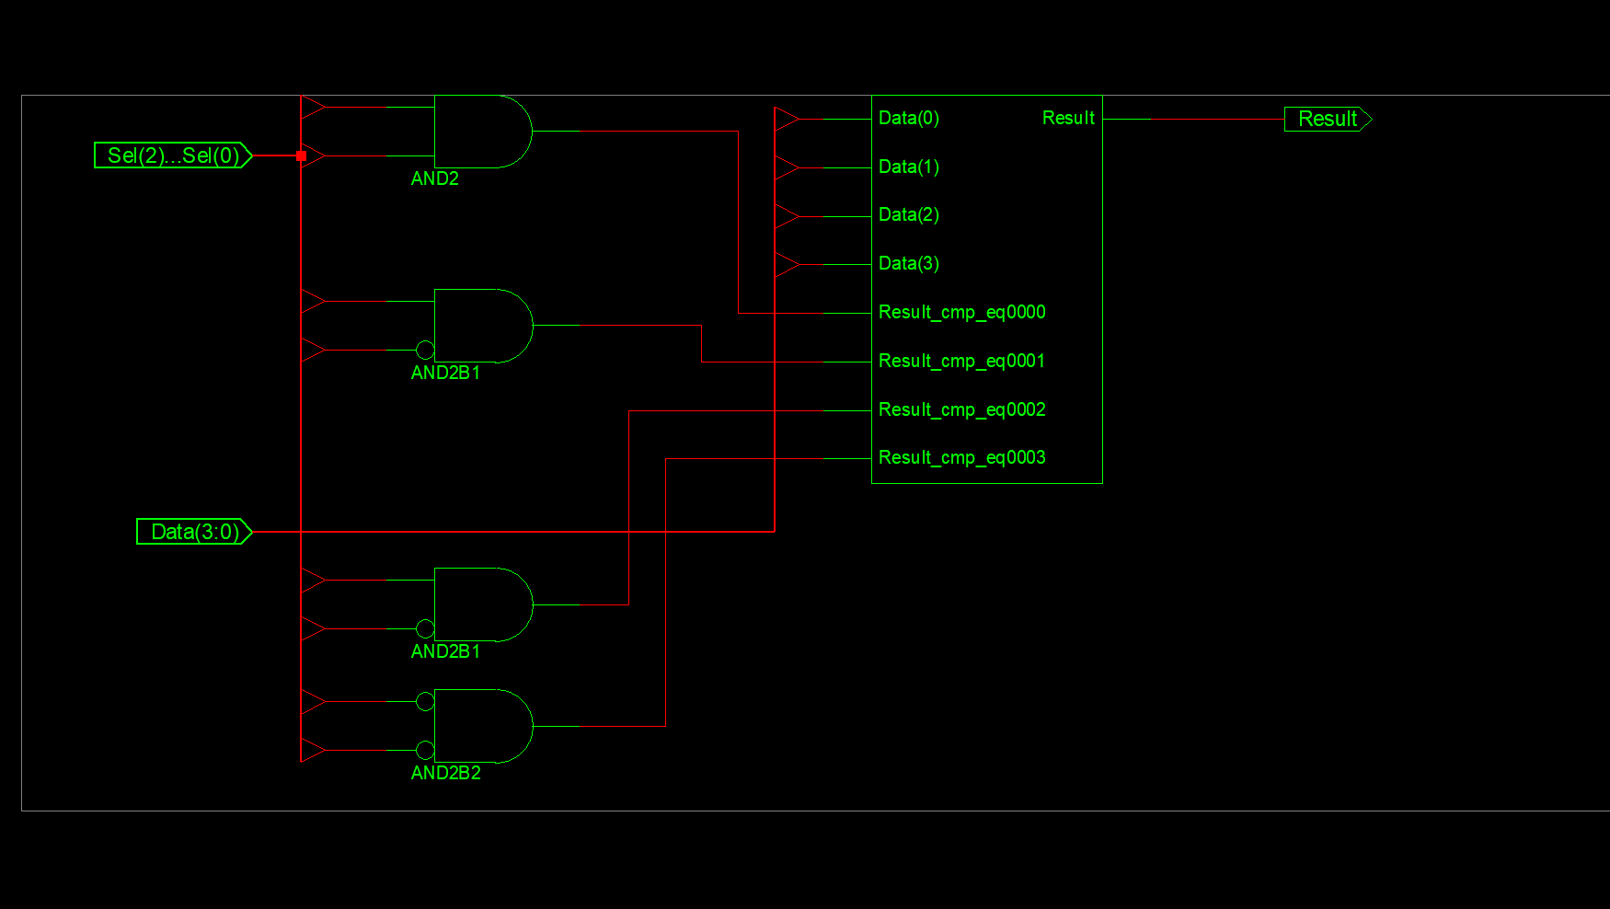

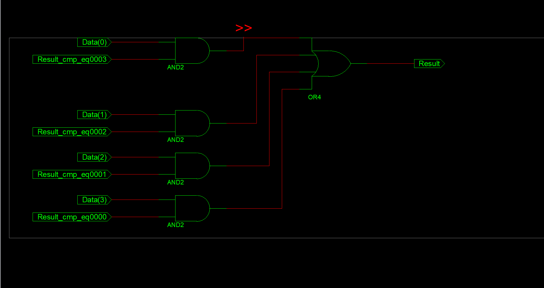

Wave Form

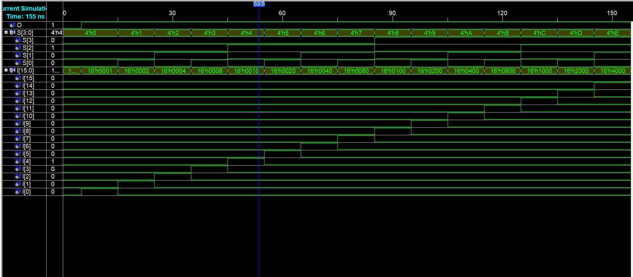

**END**