**Assignment Submission Sheet**

|  |  |  |
| --- | --- | --- |
| **Term: 321221** | **Submission Date: 11-12-2021** |  |
|  | **Assignment Number: 06** |
| **Course Code: ECE290** | **Section: E1901** | **Group: A** |
| **Registration Number: 11904463** | **Student Name: Mohit Rawat** | **Roll No: 09** |

### Concept Learned

### I have learned how to make Logical gates using cmos technology and how we combine pmos and nmos to make

### cmos and building the logical gates. After that I have learned how to make switch level program to make cmos gates.

1. **Key Observations &Insights**

Key observation is the working of pull-up and pull-down networks and how we make all gates using this circuits.

1. **Application Areas**

Application of CMOS technology is in many place like designing gates for ICs and for other embedded systems.

We makes processor and other microcontrollers using CMOS technology.

1. Draw and explain CMOS 3-input AND gate and write a Verilog code using Switch level model.
2. 2. Write a Verilog code of OR gate and NOR gate using UDP.

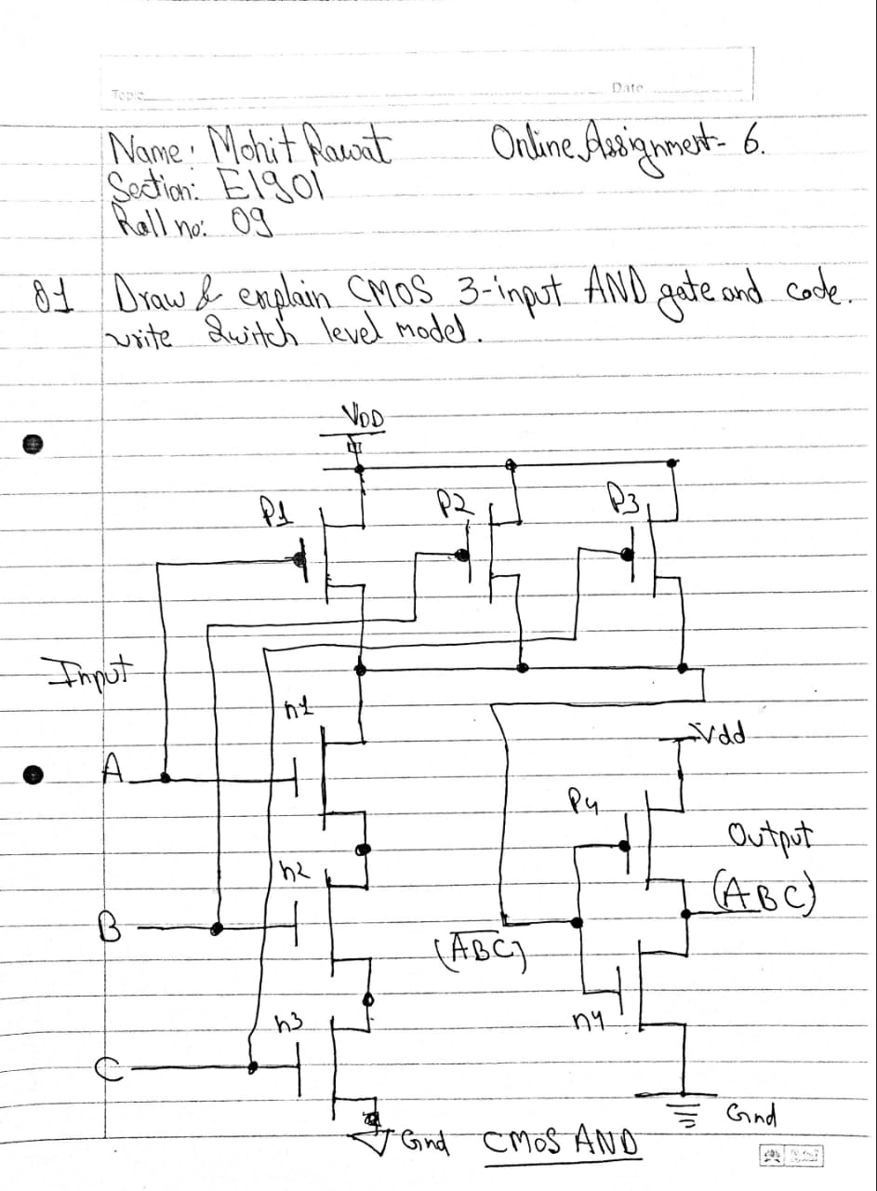

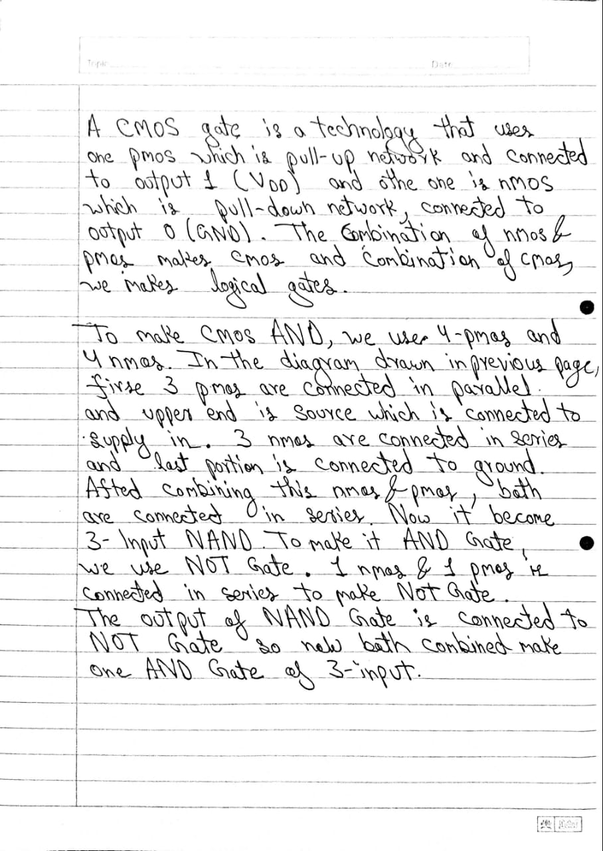

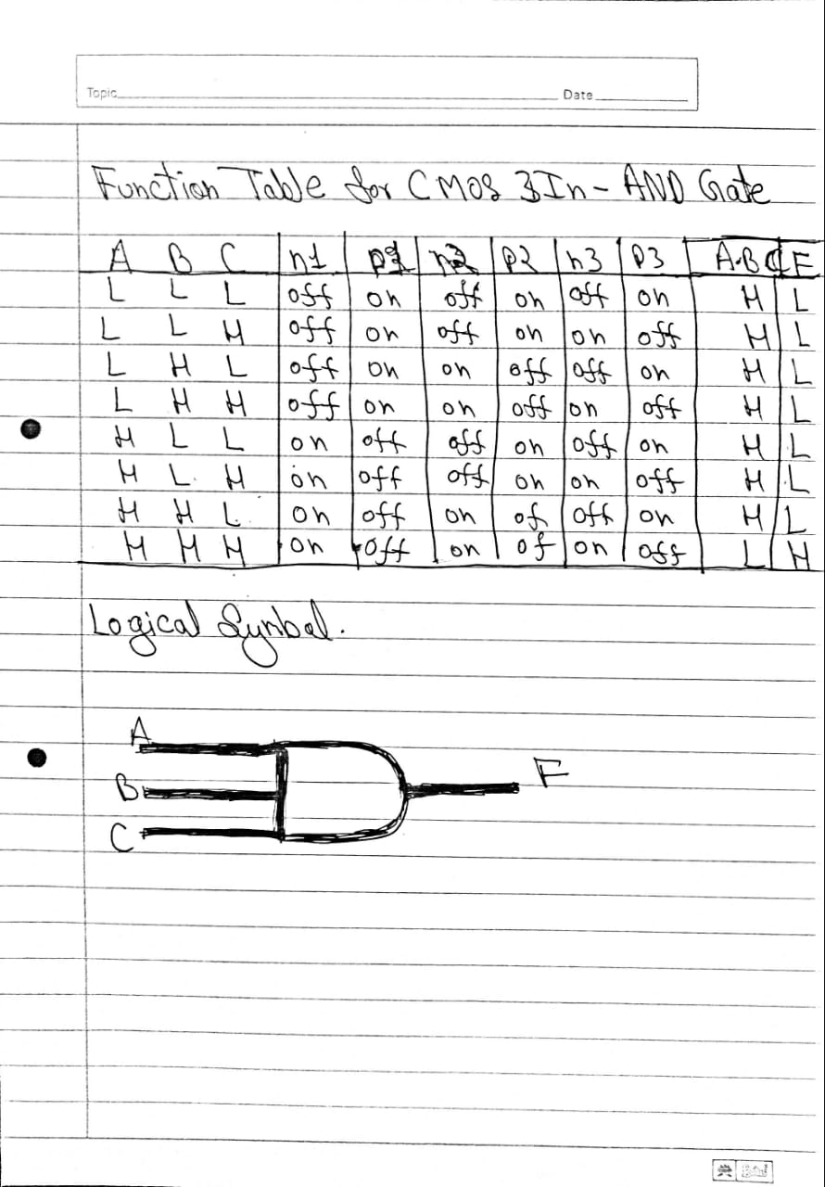

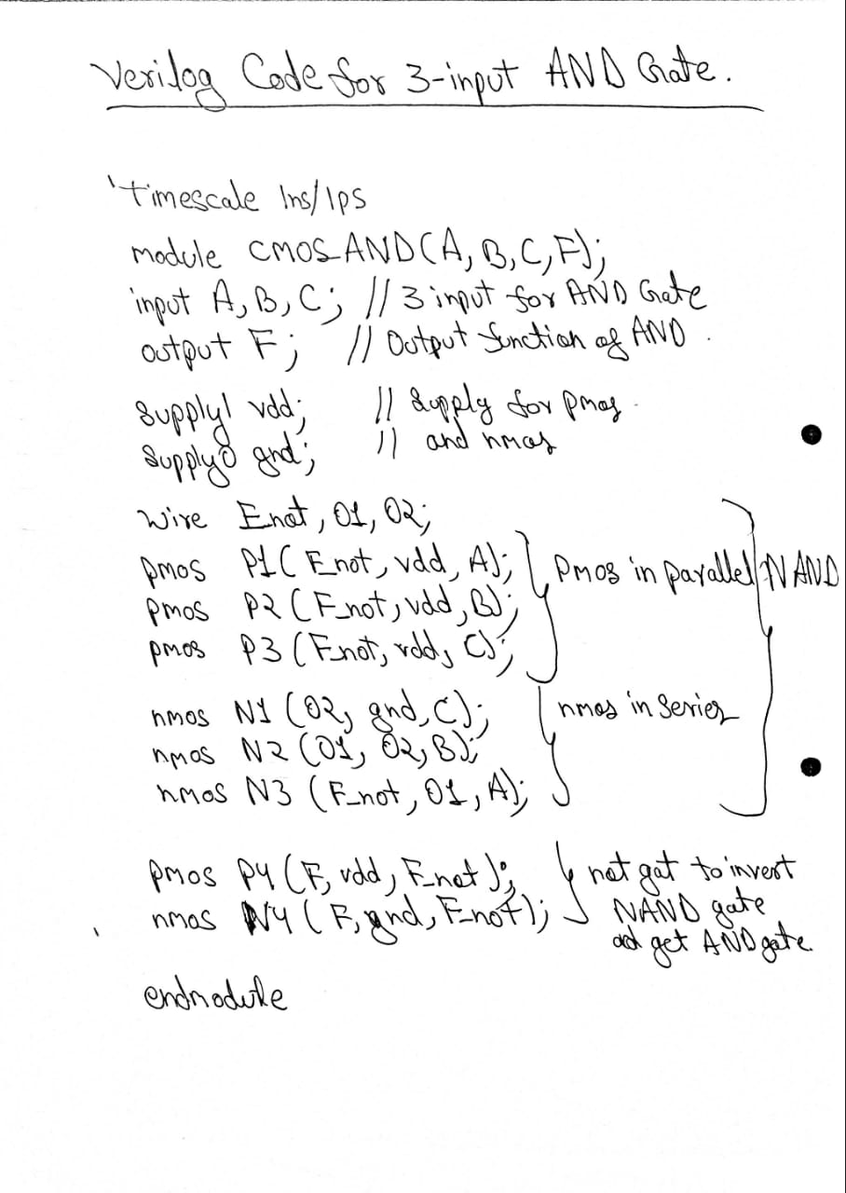

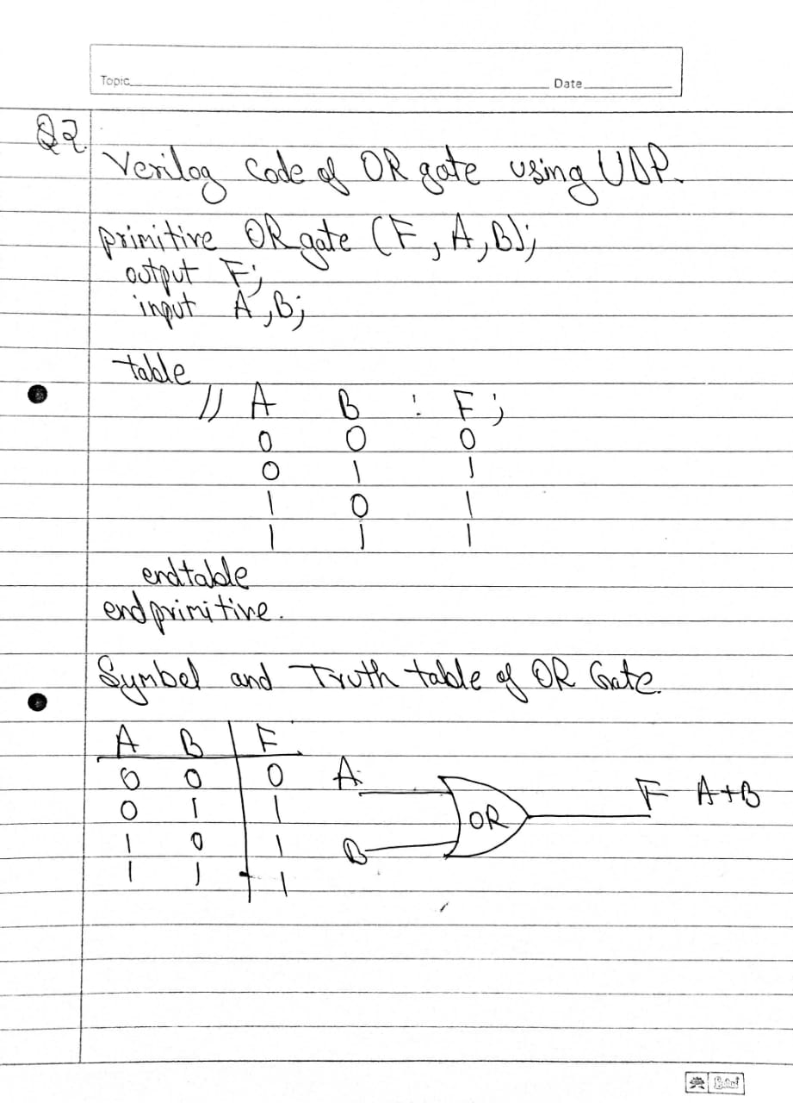

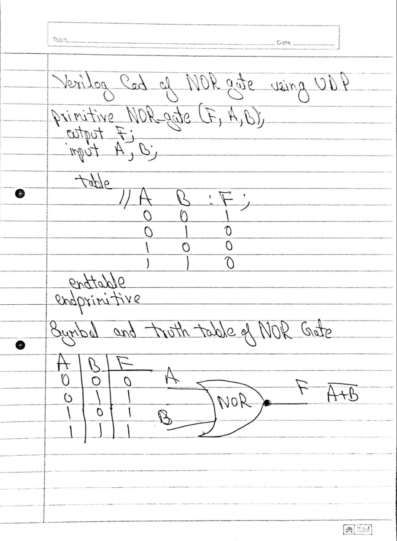

**END**