Set3

# ECE 390: WORKSHOP ON ANALOG DESIGN USING CADENCE VIRTUOSO

Name: Mohit Rawat

Section: E1901 Roll No: 09 Registration No: 11904463

Max Marks: 30

Q1. Design a CMOS inverter using tanner tool and create a symbol named NOT gate of the same.

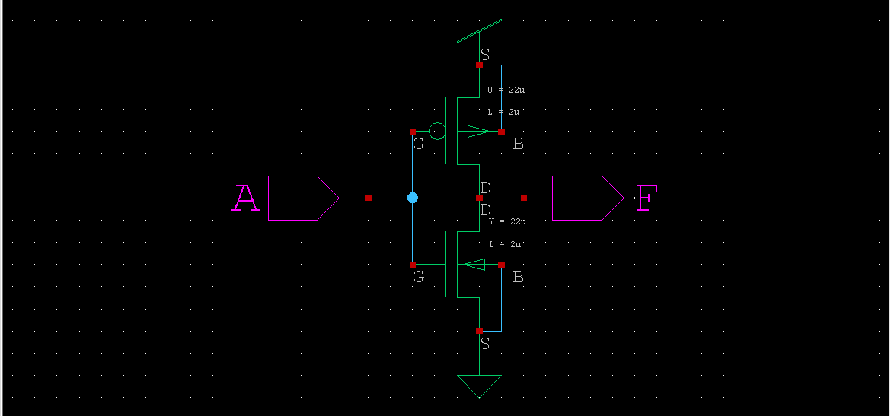

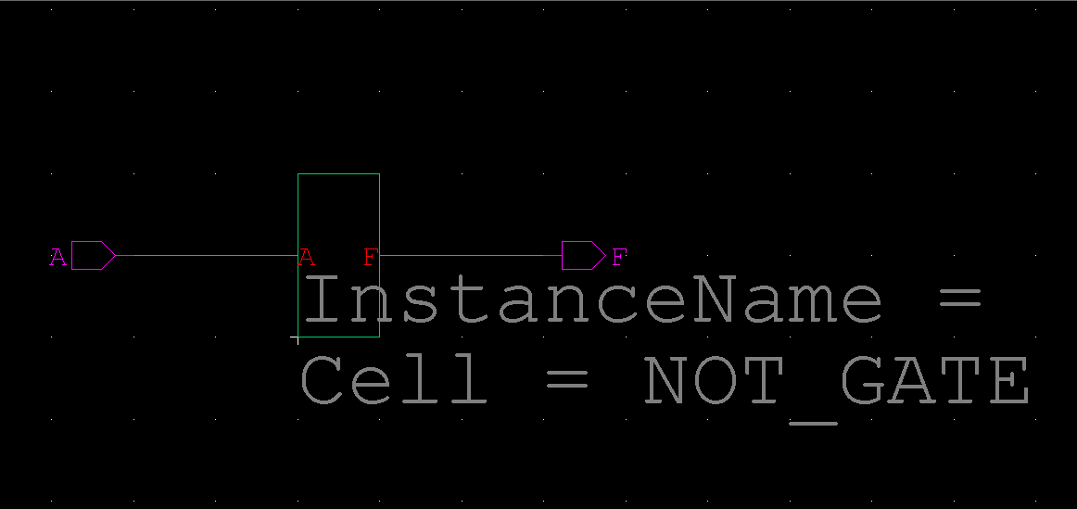

(5)

Q2. Implement NAND gate using CMOS technology and simulate on tanner tool using level 1 model file. Attach the screenshots of S-edit, T-spice and W-Edit of the same.

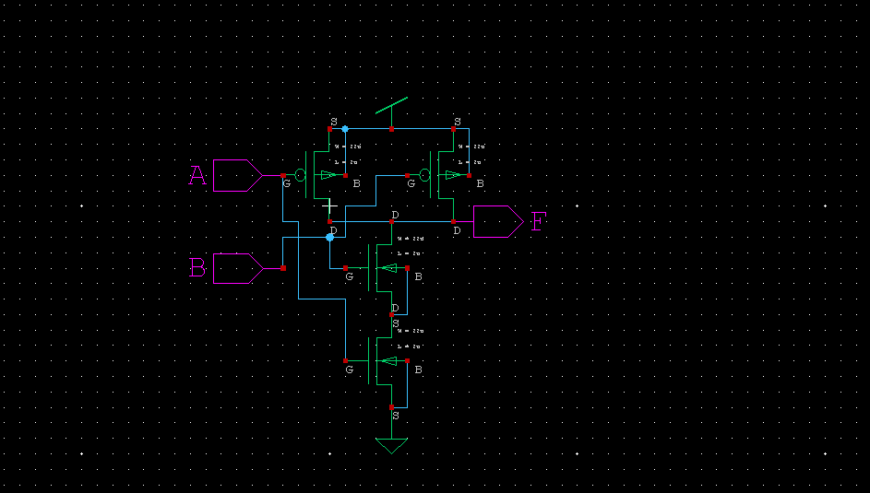

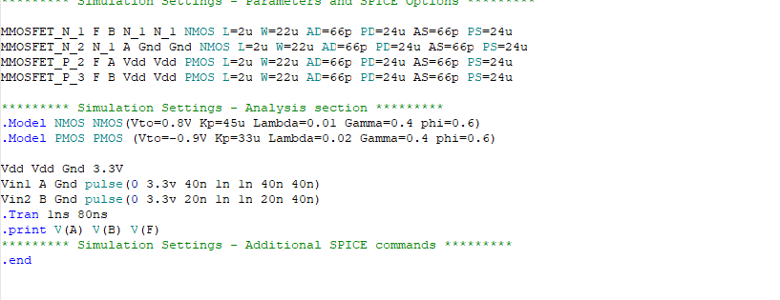

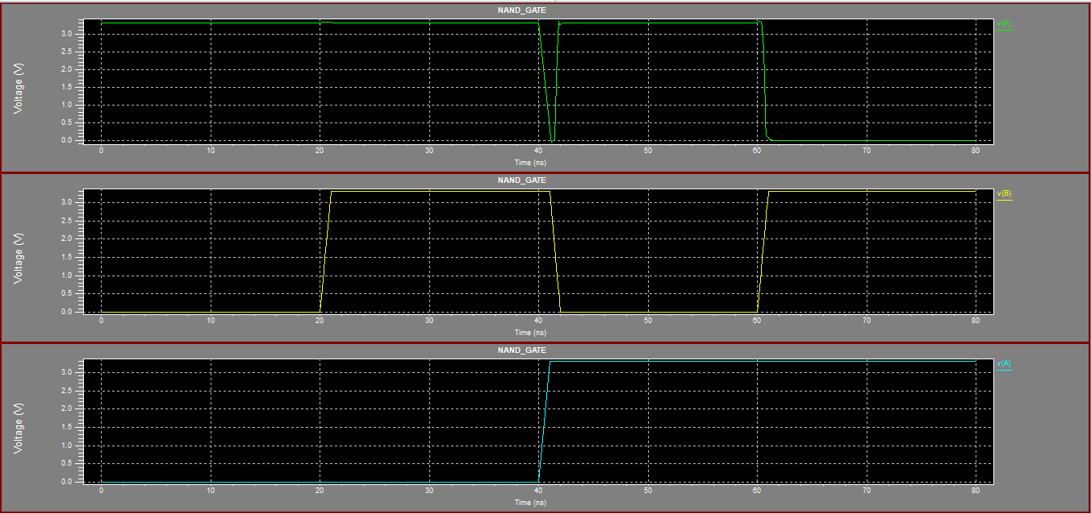

(5)

Q3. Design CMOS inverter in S-edit, simulate for transient analysis in T-spice. Calculate propagation delay using the generated waveform.

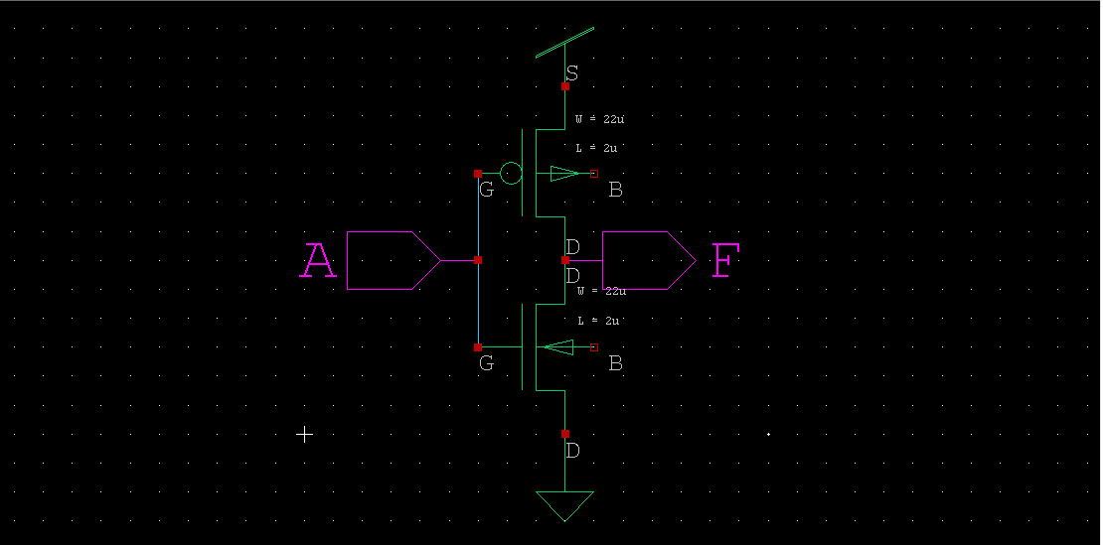

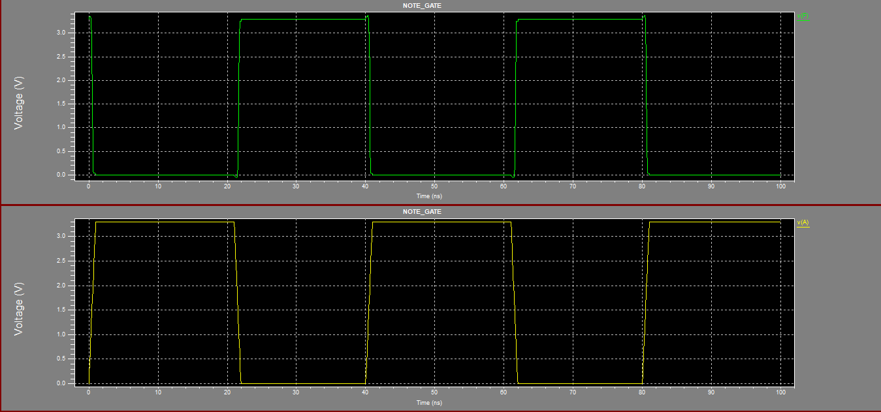

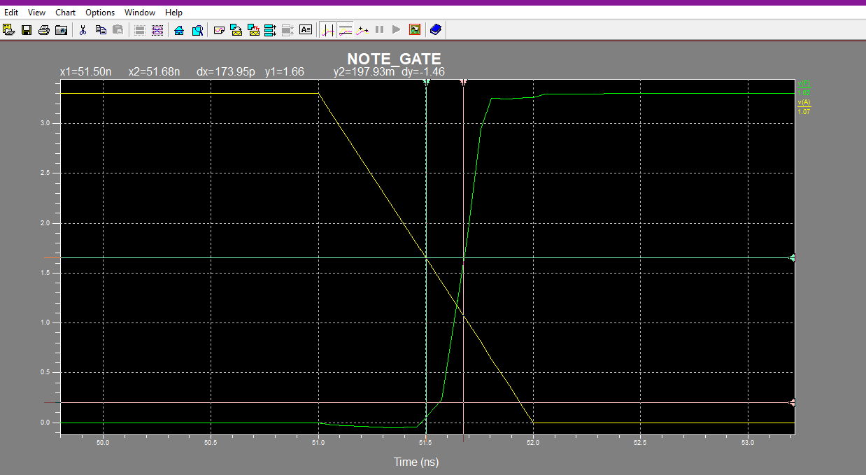

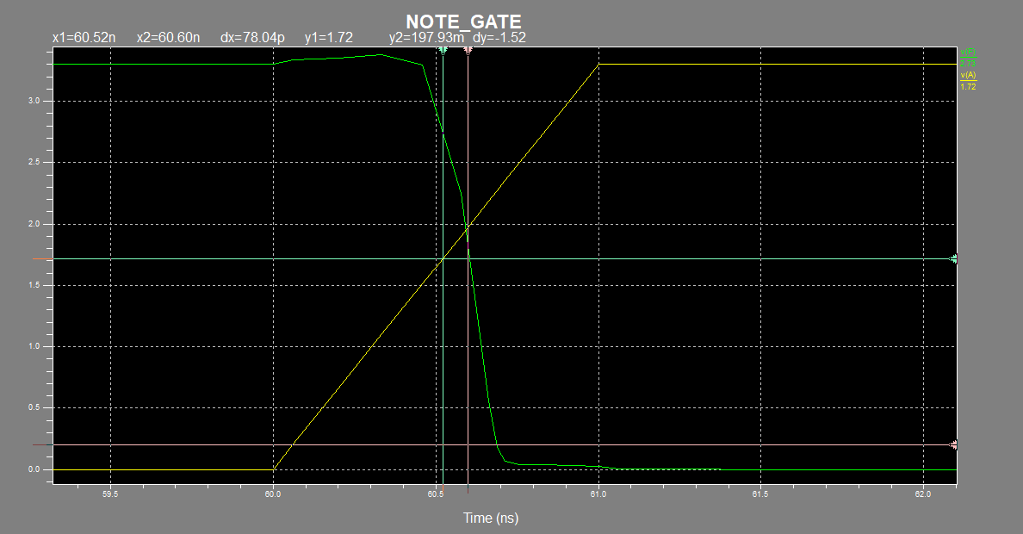

(5)

Q4. Implement Full-adder circuit in S-edit, simulate for transient analysis in T-spice. Choose the ON time and time period wisely to verify the truth table in the generated waveform.

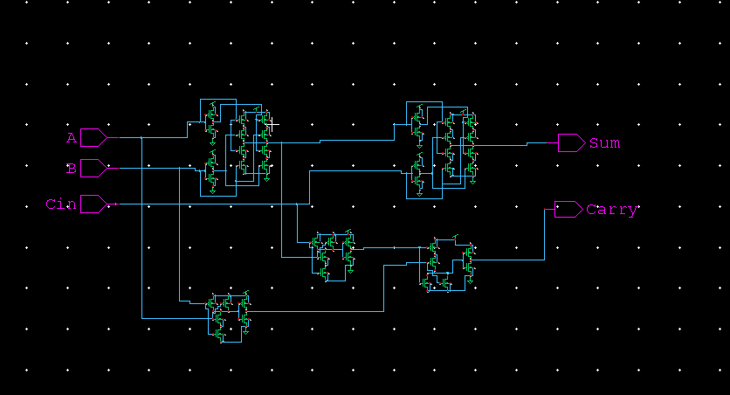

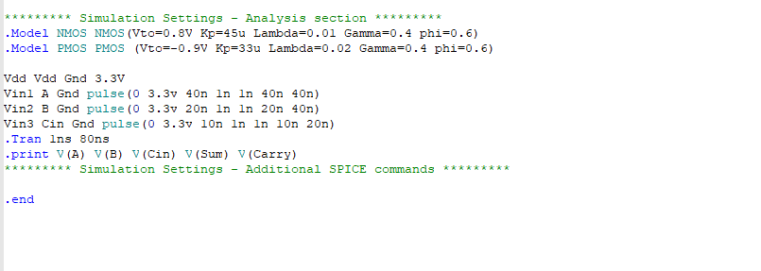

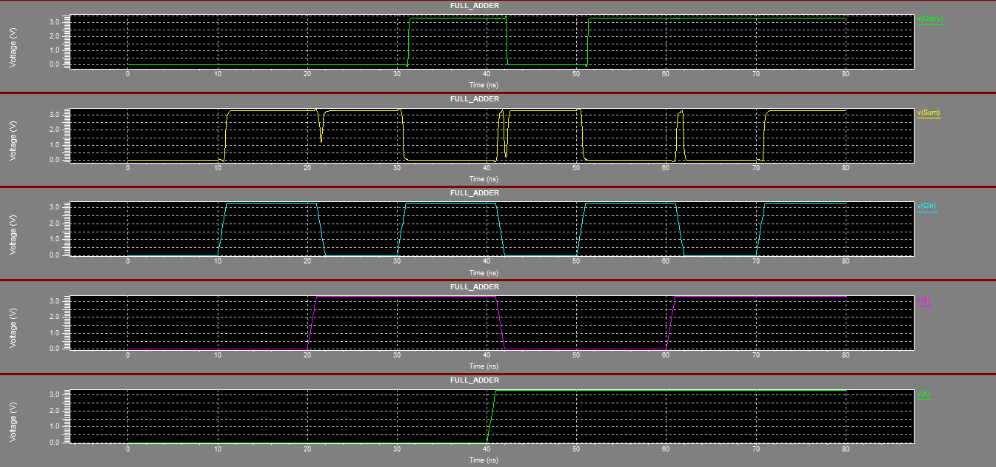

(5)

Q5. Design J-K flip-flop in S-edit using instances of earlier designed NAND and Not gates as symbols, simulate for transient analysis in T-spice. Calculate propagation delay using the generated waveform.

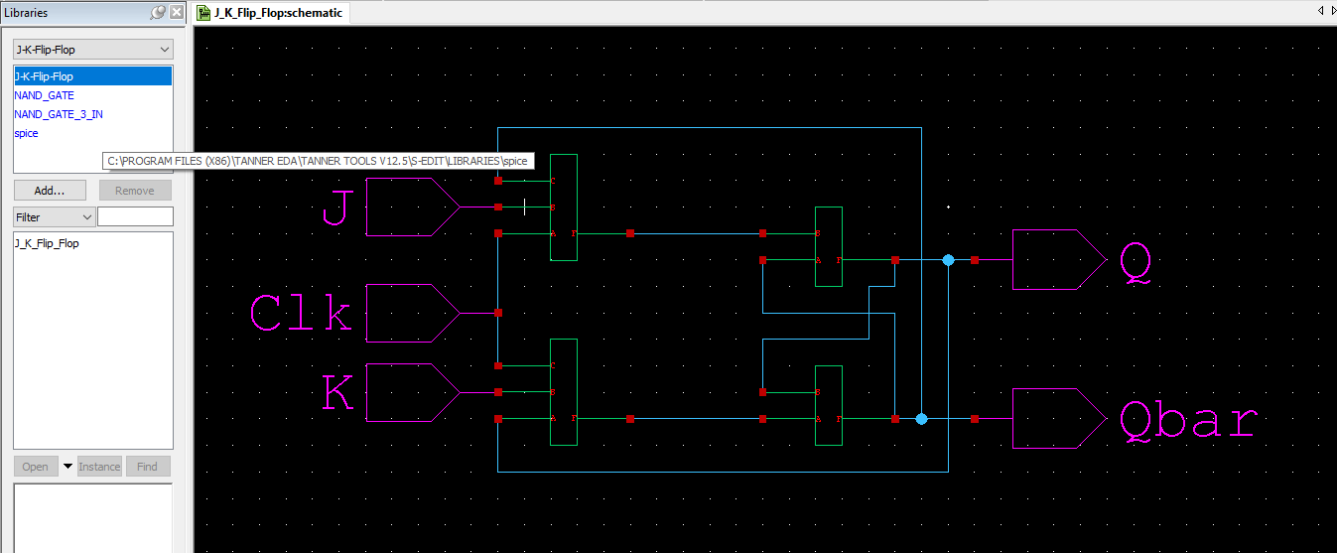

(5)

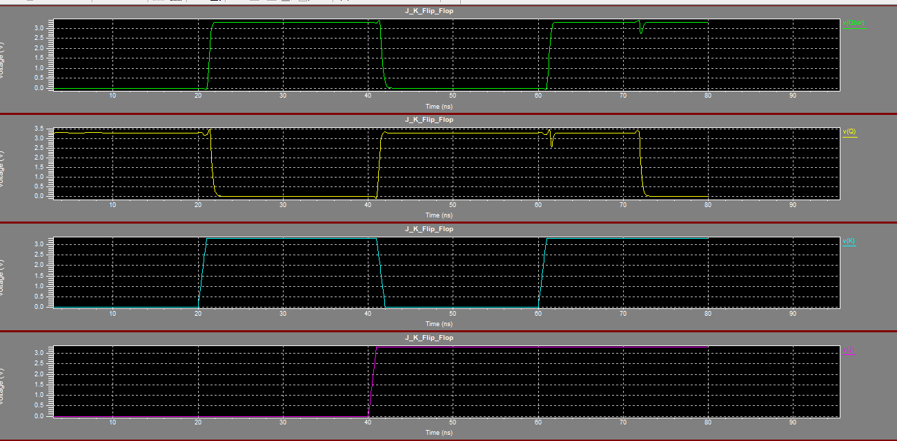

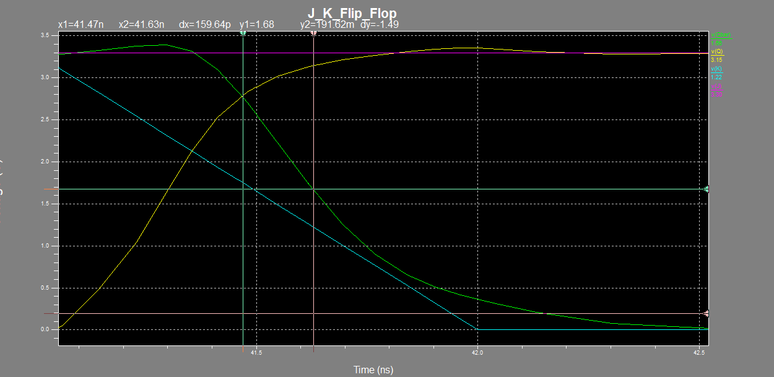

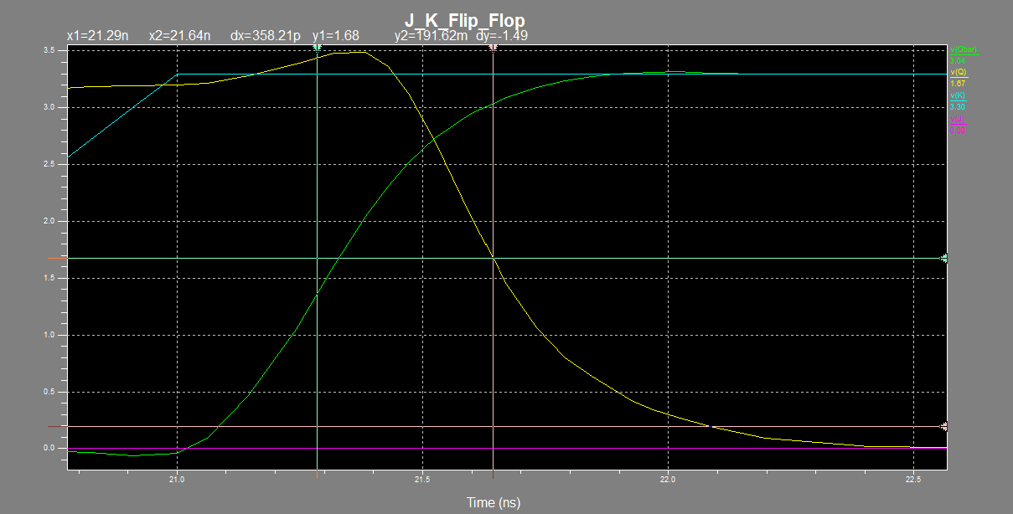

Q6. Design 4 bit Shift register using D flip-flop in S-edit, simulate for transient analysis in Tspice. Verify the functionality by giving input pattern 1101 in serial fashion.

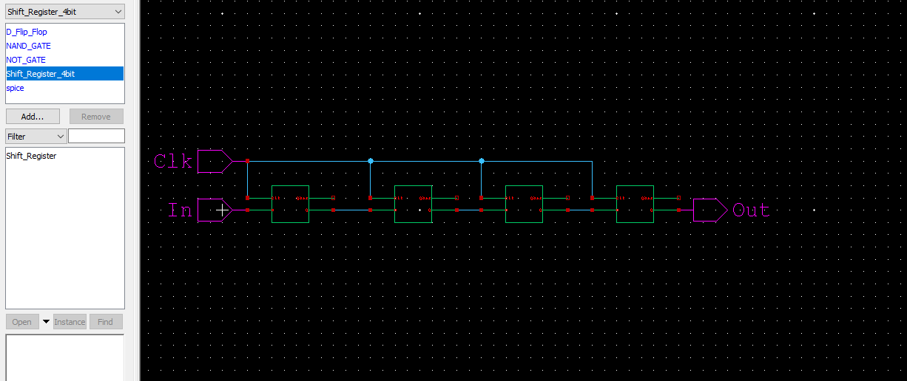

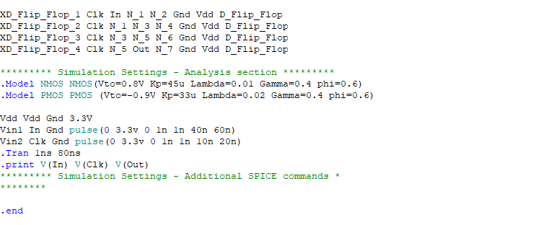

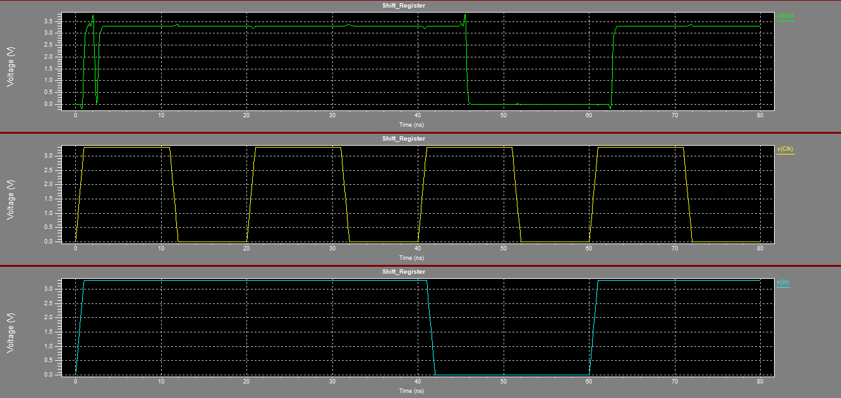 (5)