CA-2

ECE 390: **WORKSHOP ON ANALOG DESIGN USING CADENCE**

**VIRTUOSO**

Name: Kulwant Singh Rathore

Section:_ E1901A Registration No: 11917313

Q1. Design a 4-bit adder using tanner tool using created symbol of full adder circuit. Verify the

operation using spice simulation for A=1010 and B=0111.

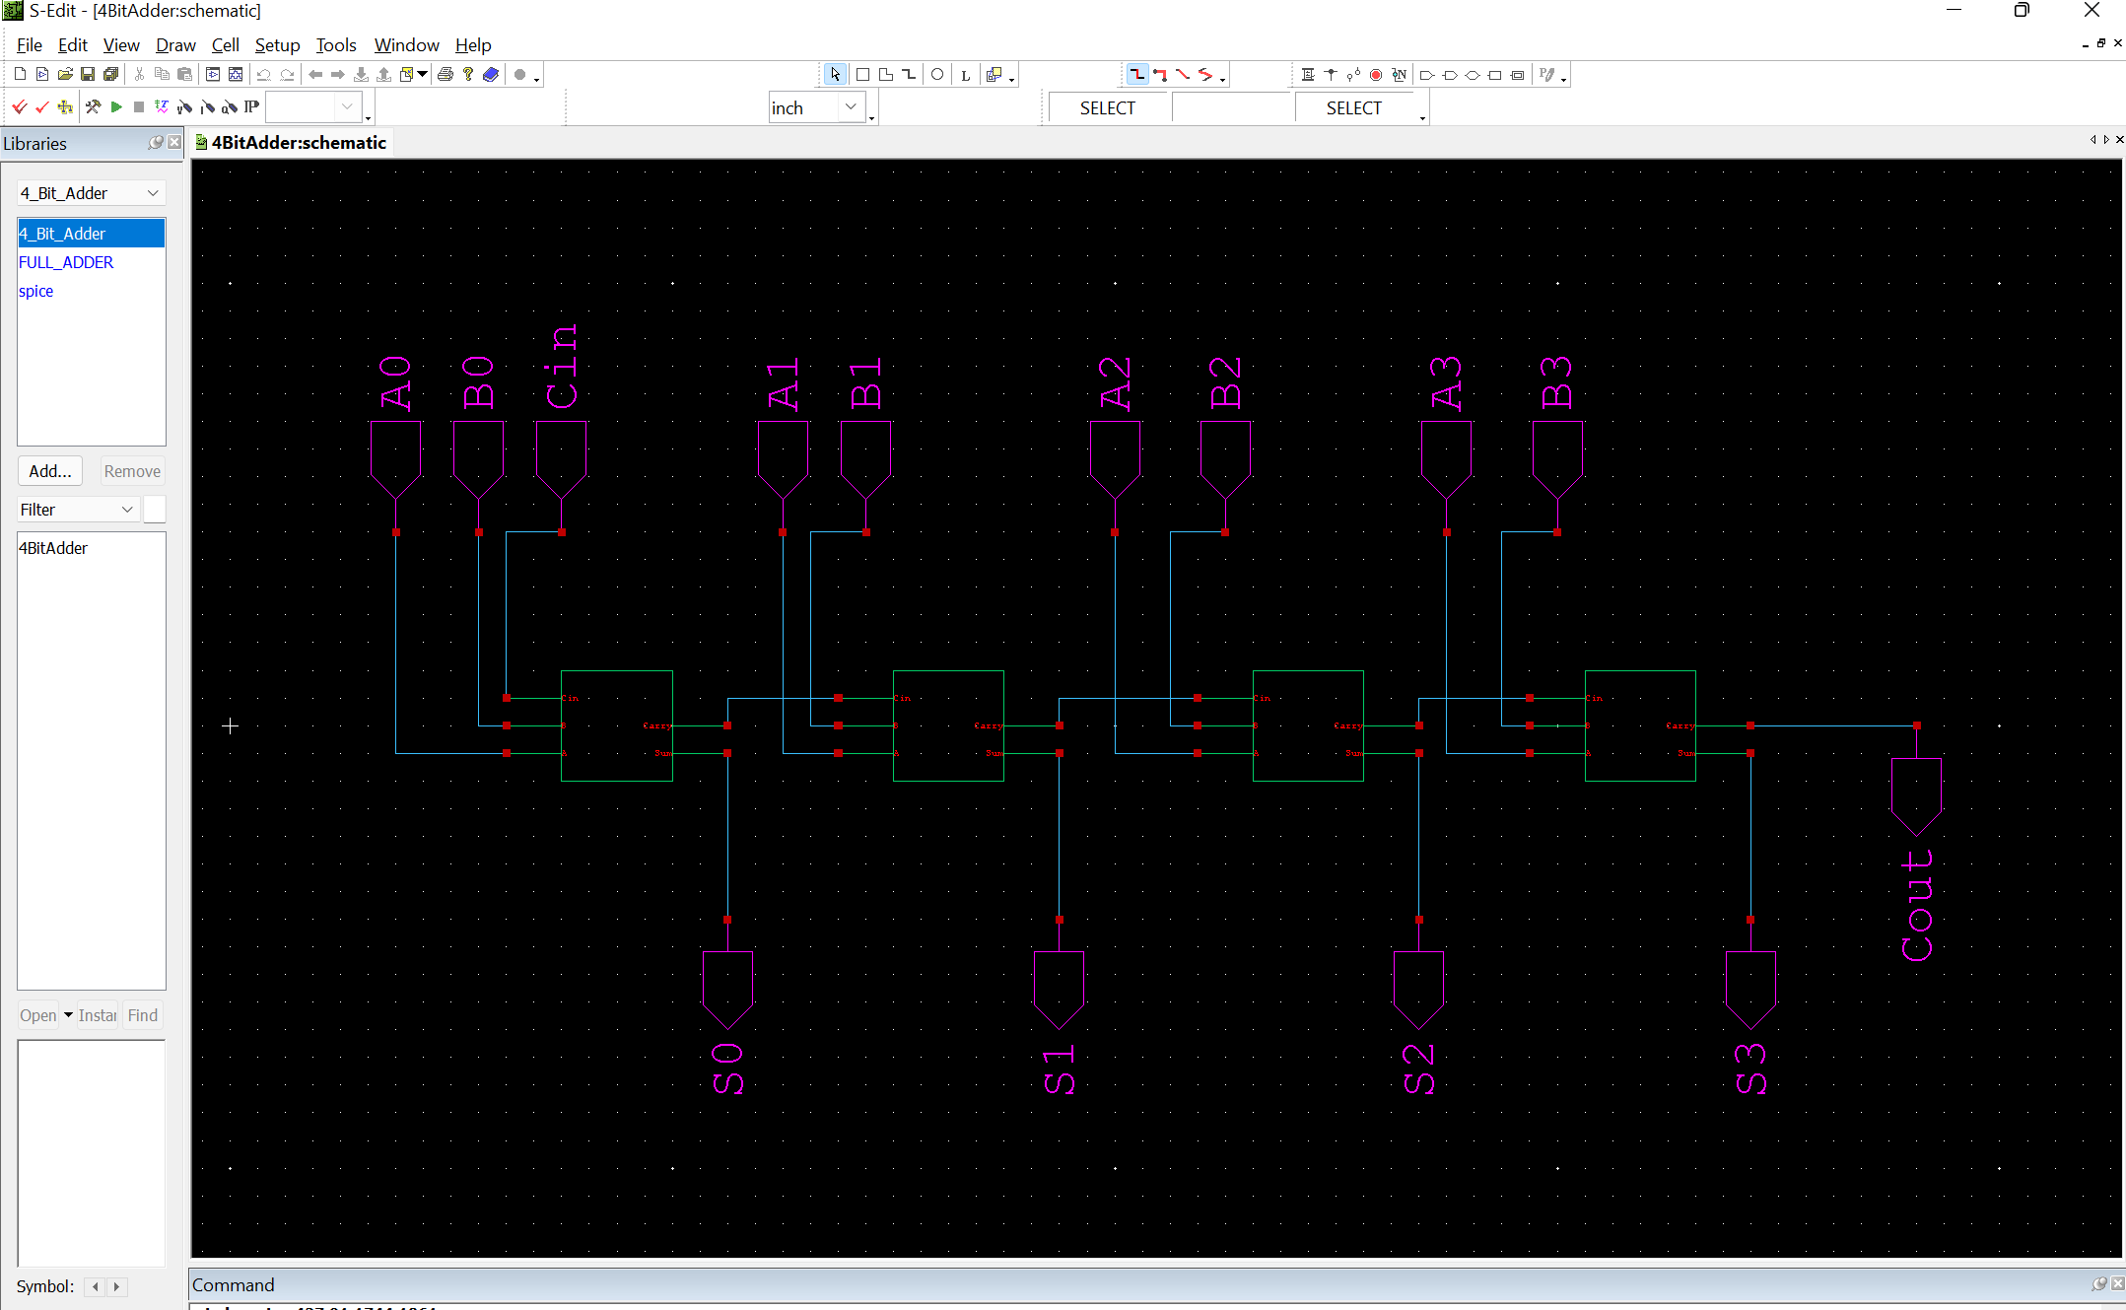

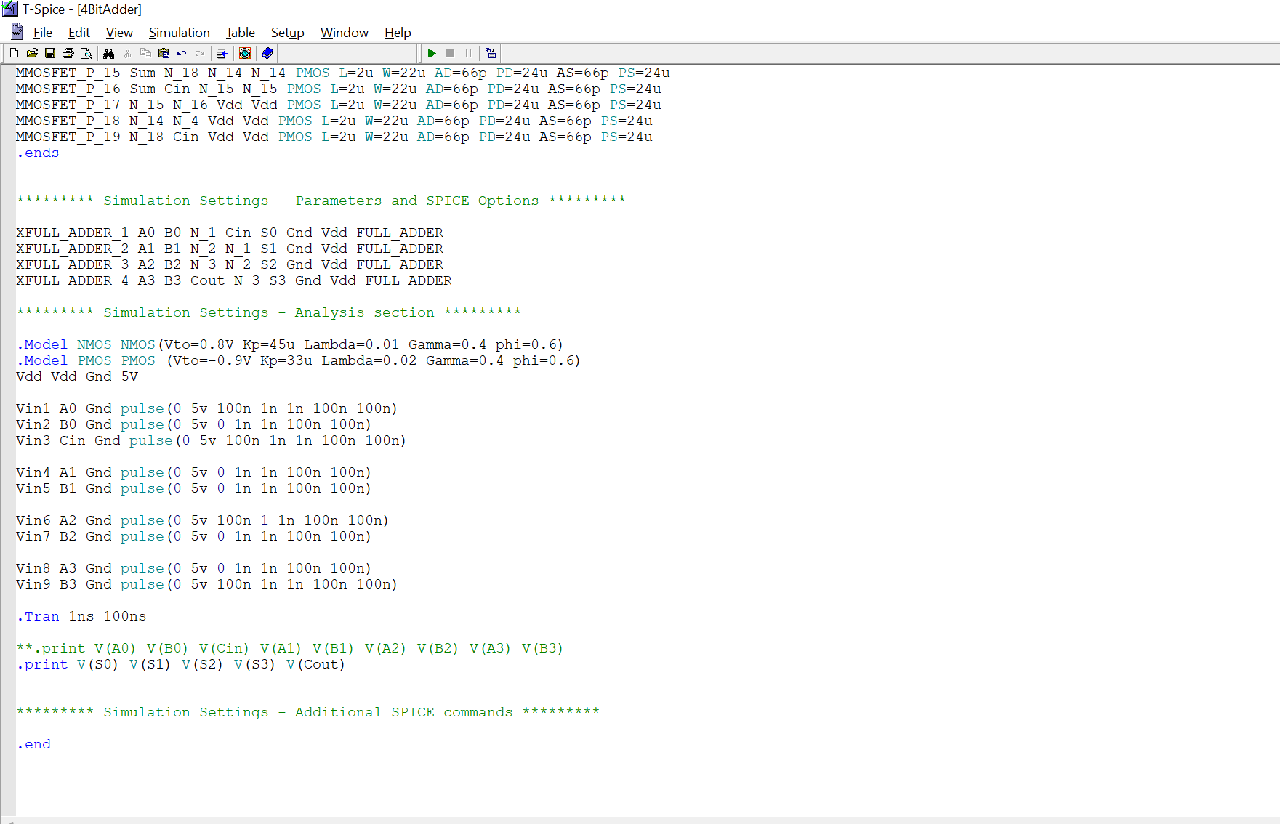

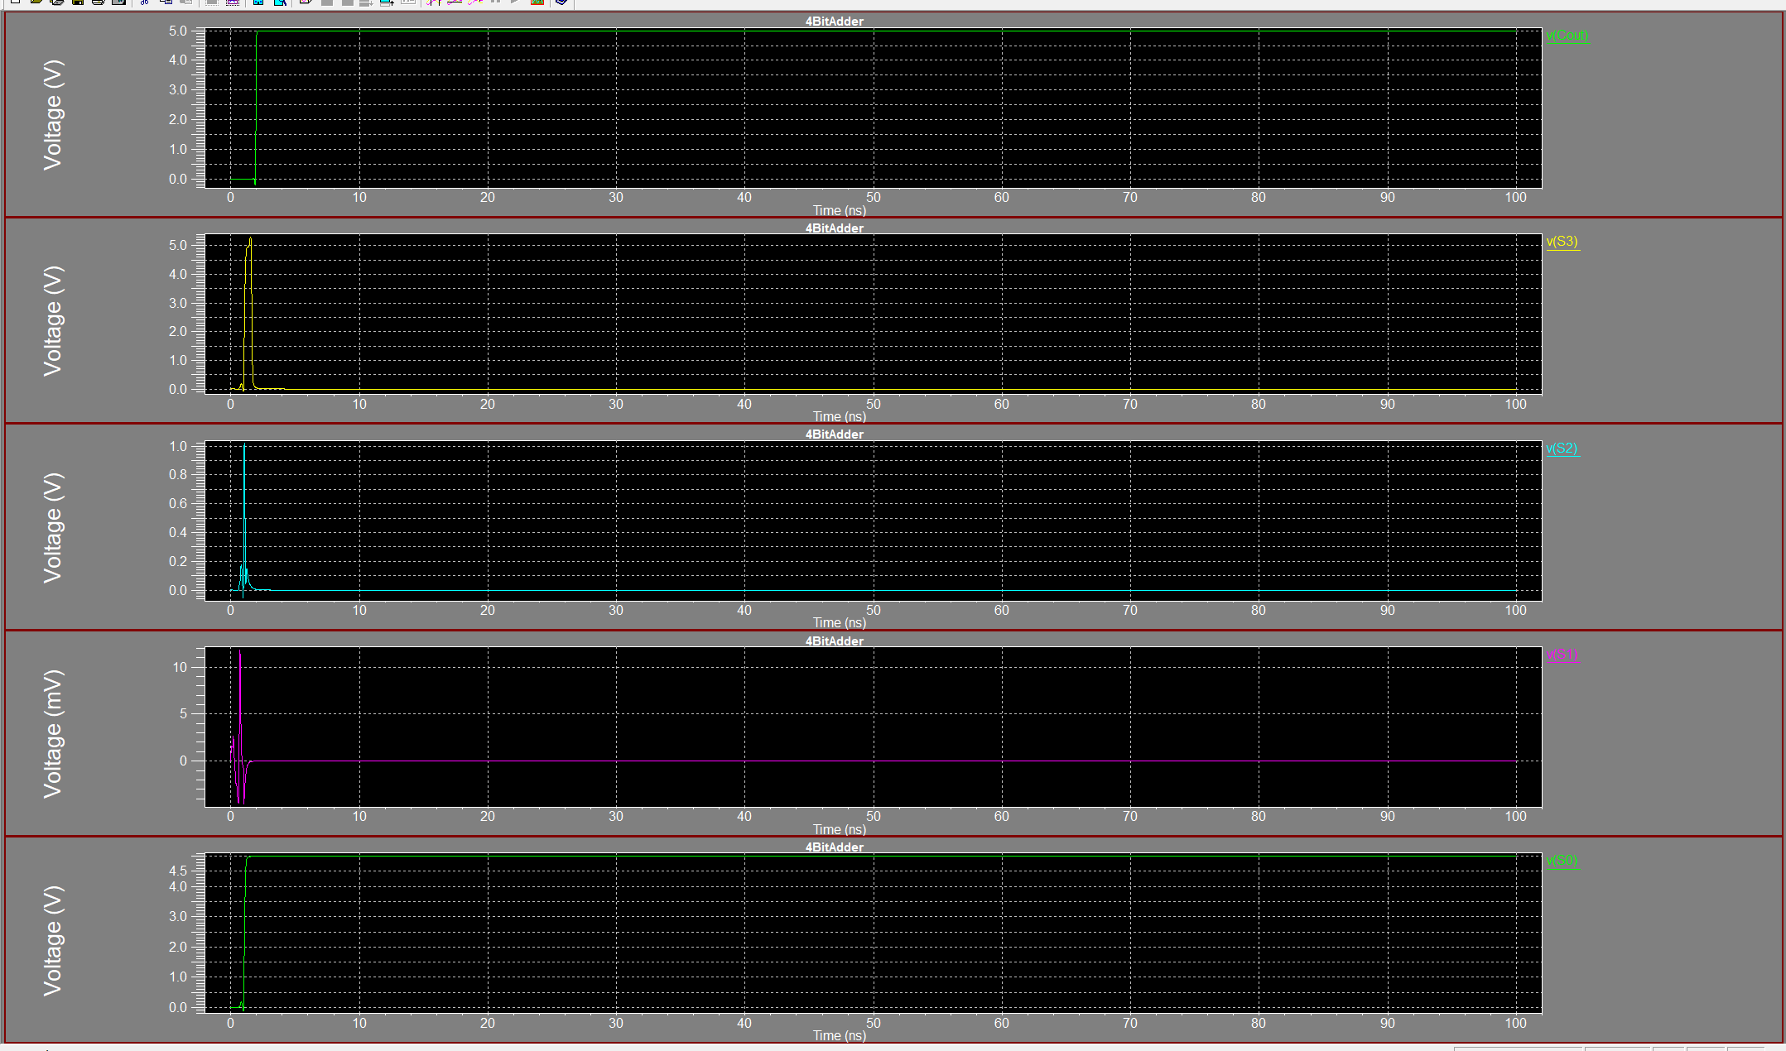

Q2. Implement 2x1 Mux using transmission gate technology and simulate on tanner tool. Attach the

screenshots of S-edit, T-spice and W-Edit of the same.

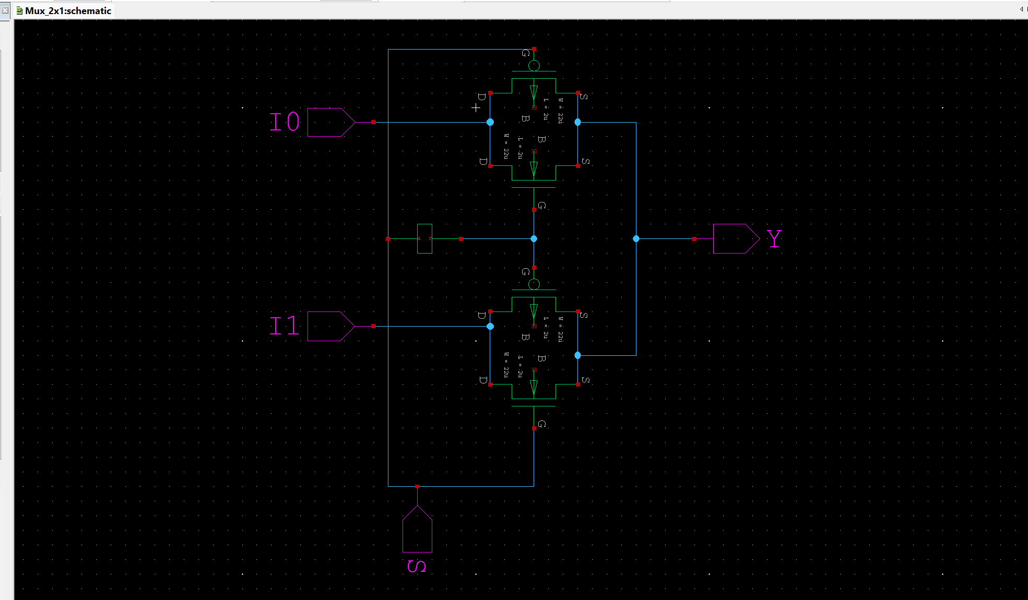

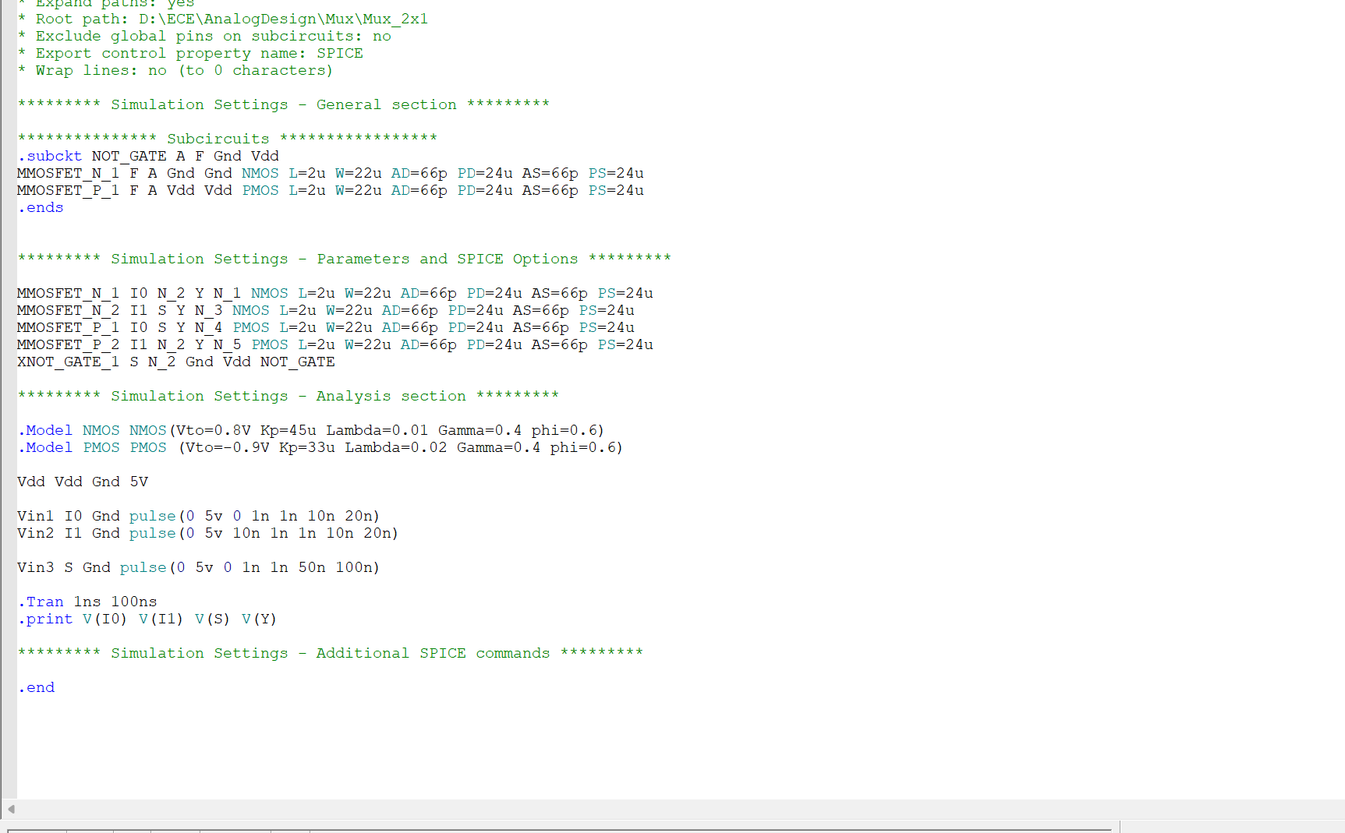

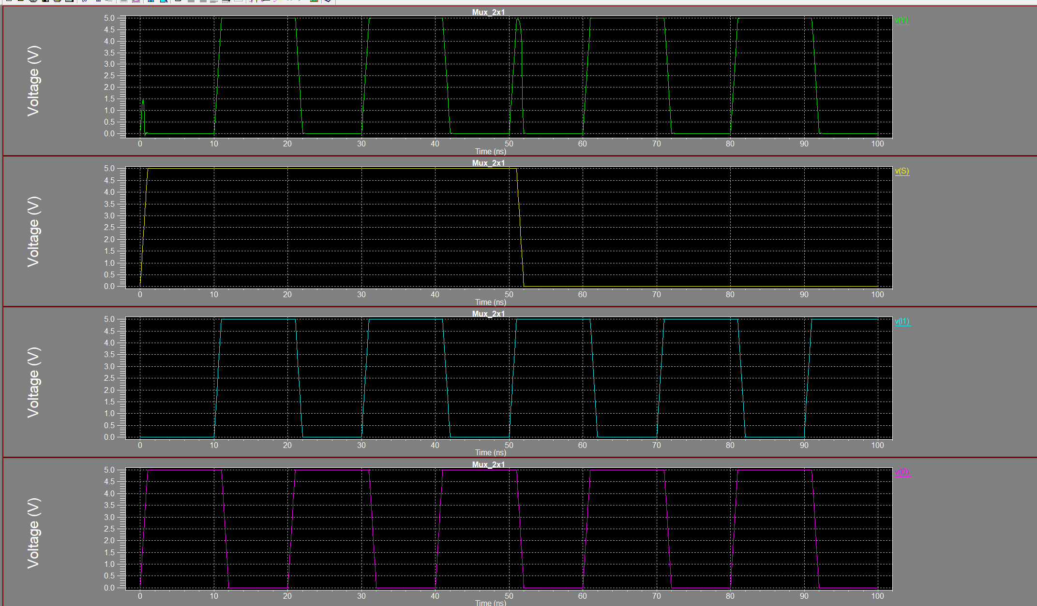

Q3. Design ALU capable to perform addition, subtraction, multiplication and division operations on two 2-bit numbers in S-edit, simulate for transient analysis in T-spice. Indicate each operation

separately in the wave-form using vertical bars.

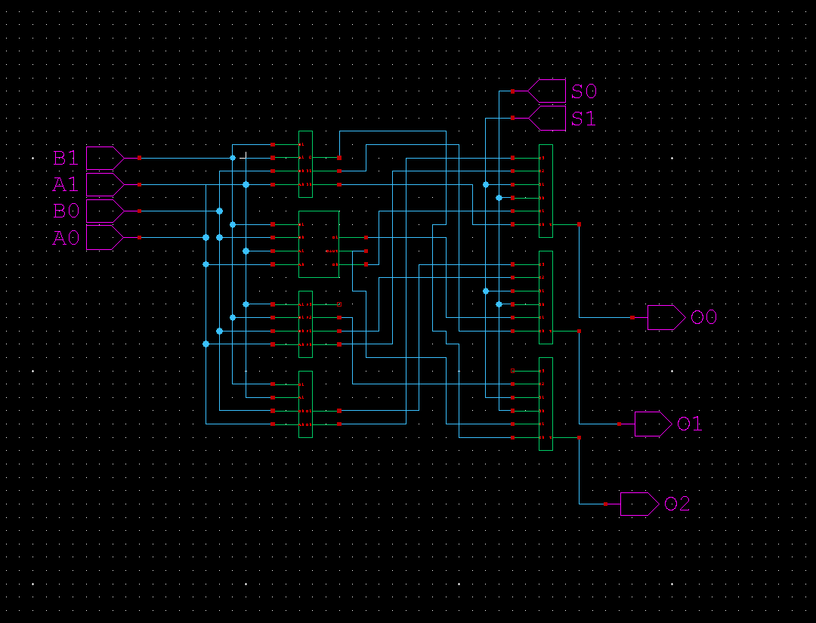

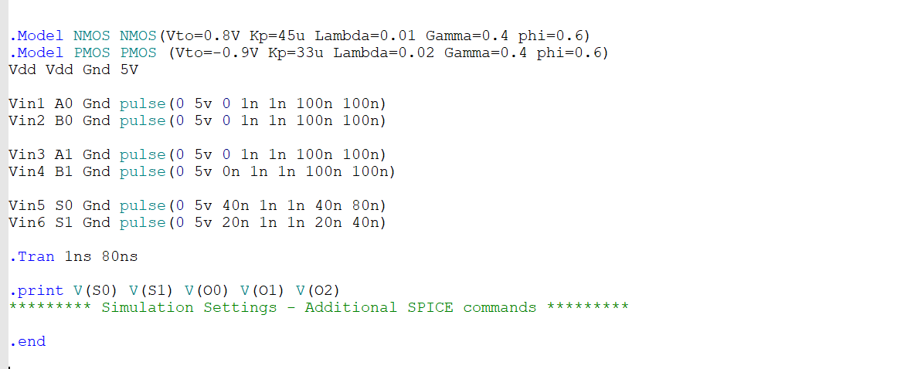

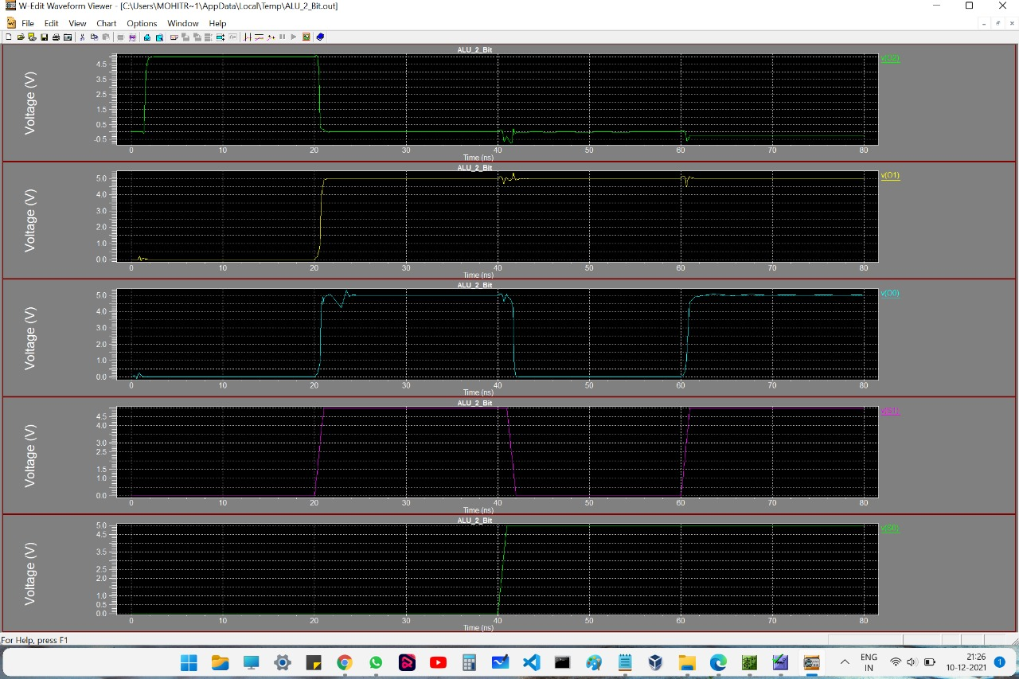

Q4. Implement 4-bit LFSR circuit with characteristic equation 1+ x + x4 in S-edit using D-flip-flops and Ex-OR gate. Simulate the same and identify number of non-identical patterns generated in the

waveform.

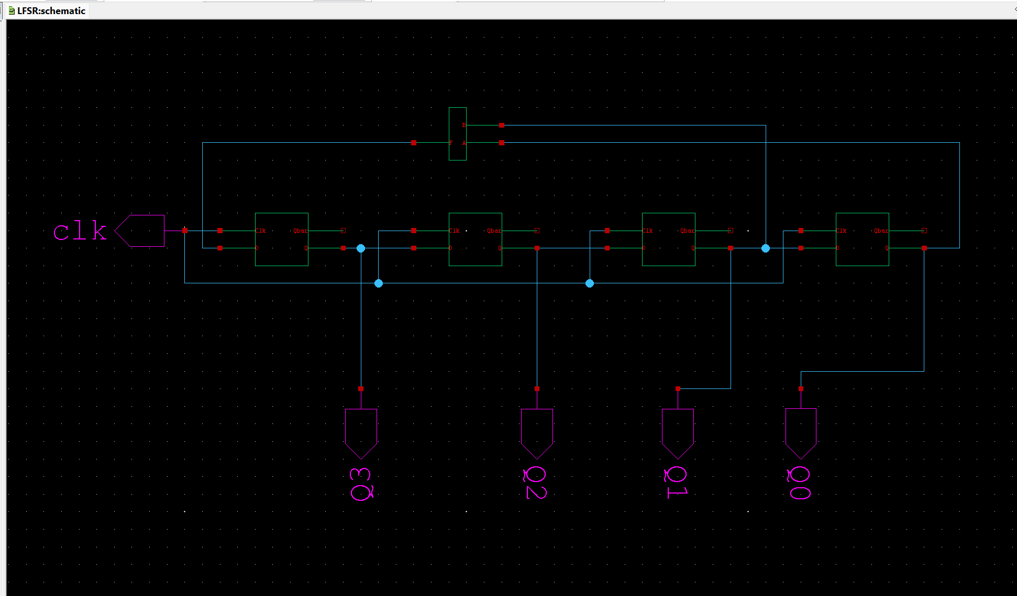

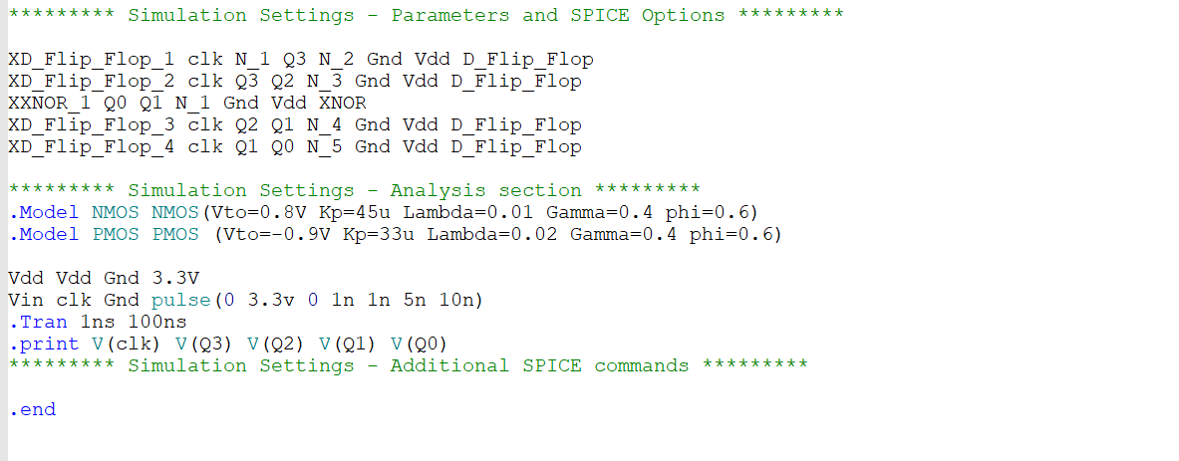

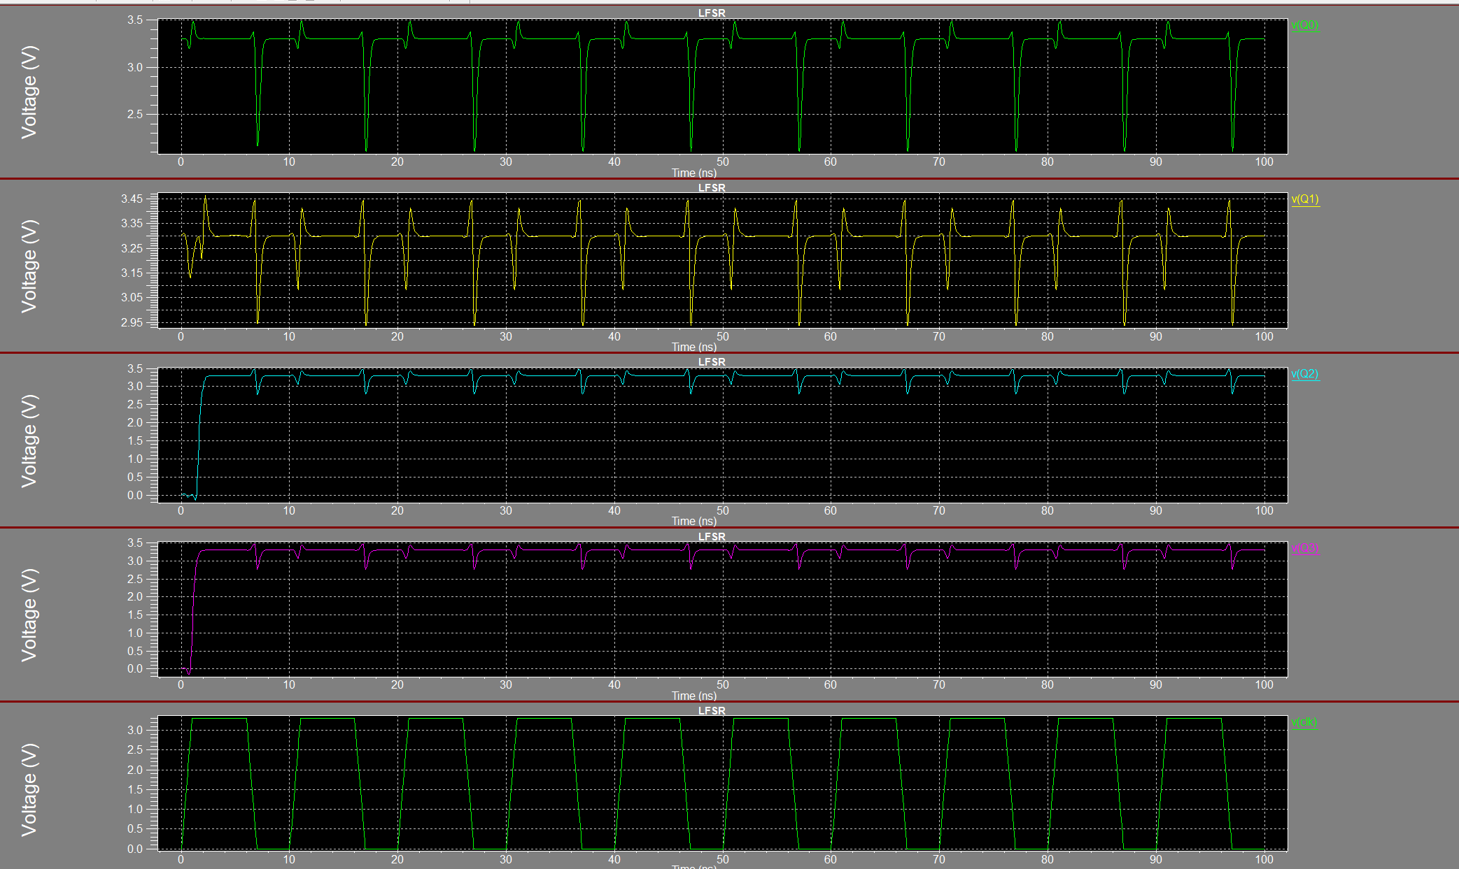

Q5. Design 1-bit 6T-SRAM cell in S-edit. Choose the timings wisely to show storage of logic 0 and logic 1 in the waveform. Also verify the Read/Write operation using vertical bars

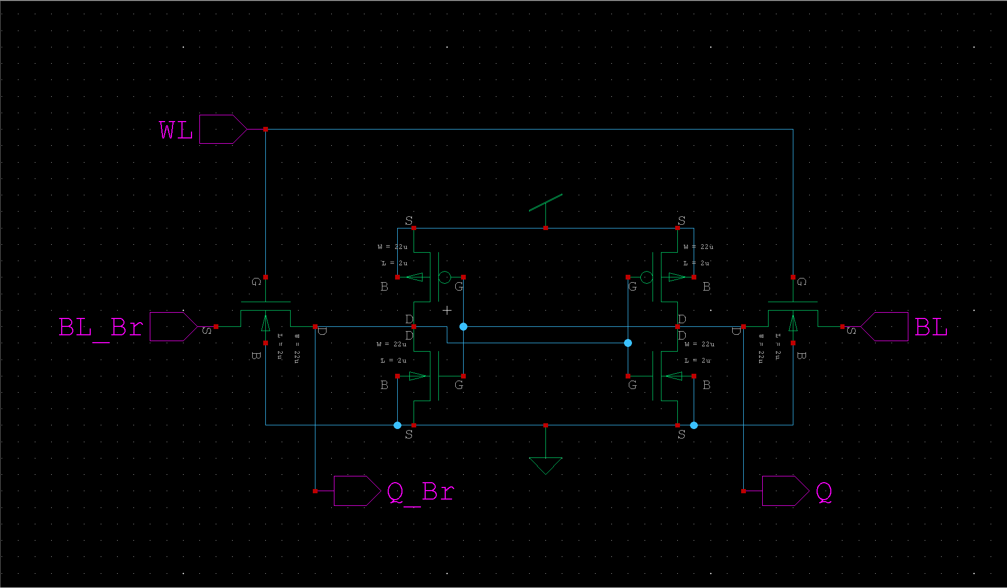

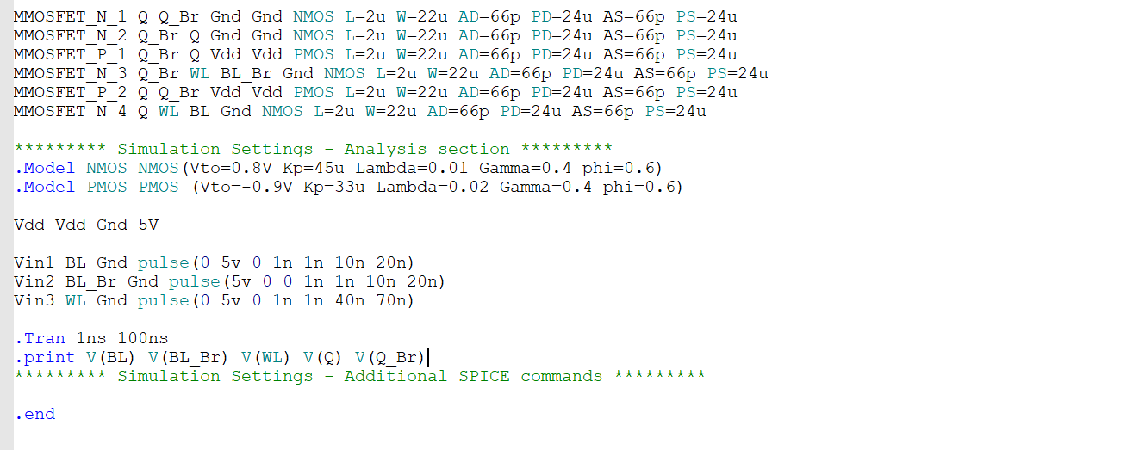

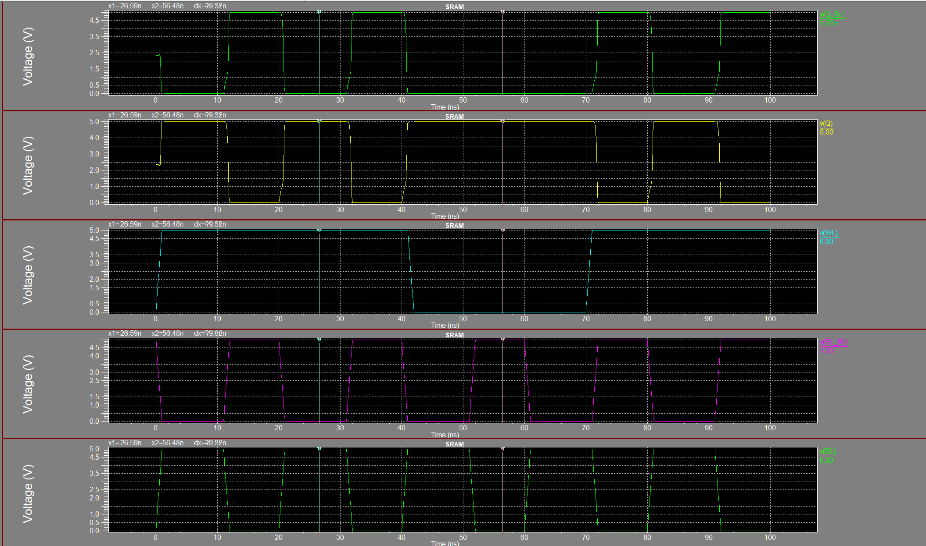

Q6. Design 4X4 ROM using NMOS and perform the read operation using 2x4 address decoder. Verify the functionality after storing data “1000”, “0100”, “0010”, “0001”.

