Box on a Slope
1. How do the normal reaction R and weight W acting on the box change as the inclination θ of the slope increases?

2. A box of mass 2 kg stays at rest on a slope of inclination 30° with a ‘very rough’ surface.
(a) Using the tip-to-tail method, add up the normal reaction R, the weight W and the friction f to find the net force F.

net force F = ___________ N
(b) State a condition for the box to stay at rest on the slope.

3. A box of mass 2 kg accelerates down a slope of inclination 60° with a ‘very rough’ surface.
(a) Using the tip-to-tail method, add up the normal reaction R, the weight W and the friction f to find the net force F.
net force F = ___________ N
(b) Resolve the weight W along the directions parallel and perpendicular to the slope and calculate the magnitudes of the components. Hence, calculate the magnitude of the net force F.

Box on a Slope (Answers)
1. How do the normal reaction R and weight W acting on the box change as the inclination θ of the slope increases?
The normal reaction R decreases while the weight W remains unchanged.

2. A box of mass 2 kg stays at rest on a slope of inclination 30° with a ‘very rough’ surface.
(a) Using the tip-to-tail method, add up the normal reaction R, the weight W and the friction f to find the net force F.
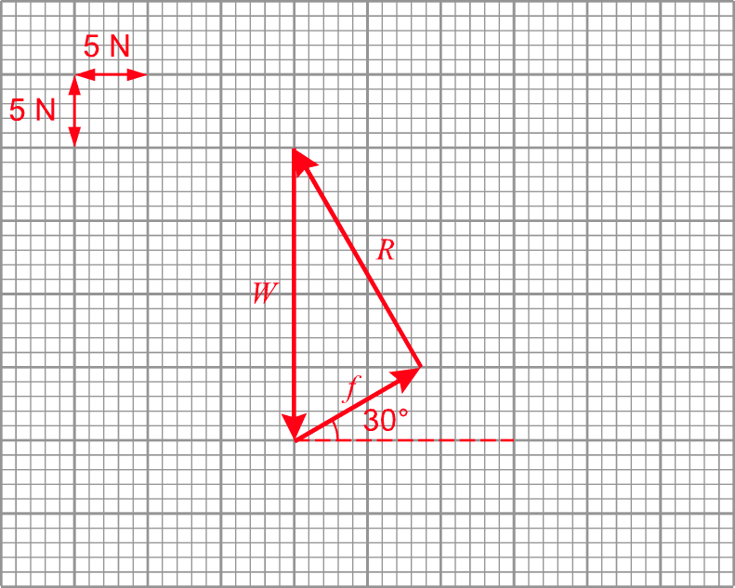
0
net force F = ___________ N
(b) State a condition for the box to stay at rest on the slope.
The net force acting on the box is zero.

3. A box of mass 2 kg accelerates down a slope of inclination 60° with a ‘very rough’ surface.
(a) Using the tip-to-tail method, add up the normal reaction R, the weight W and the friction f to find the net force F.
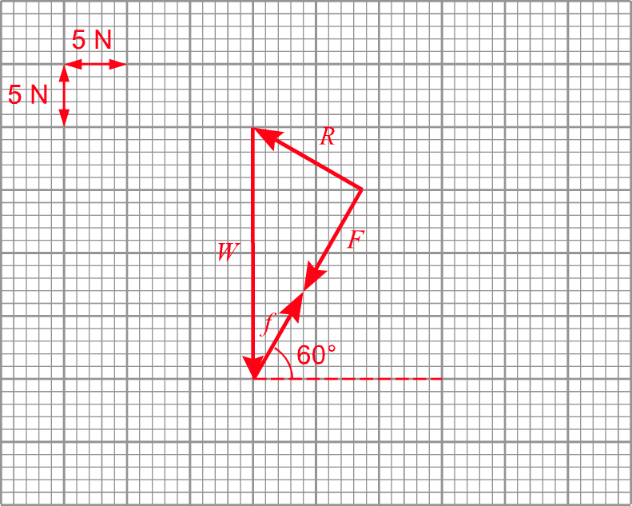
9.3
net force F = ___________ N
(b) Resolve the weight W along the directions parallel and perpendicular to the slope and calculate the magnitudes of the components. Hence, calculate the magnitude of the net force F.
Resolve the weight W into two components:
component parallel to the slope = W sin θ = 20 sin 60° N = 17.32 N
component perpendicular to the slope = W cos θ = 20 cos 60° N = 10 N
Consider the forces parallel to the slope, we have
W sin θ – f = F
F = 17.32 – 8.00 = 9.32 N
The magnitude of the net force F is 9.32 N.

