NavApp

Google Map API Project

**( A mapping and navigation application for desktop )**

* Features:
* User Authentication.
* Google map in home page.
* Searching button (Search any place).
* Navigation to any place.
* Show best possible routes.
* Technology required.
* Django
* REST api framework
* Google map api
* PostgreSQL
* Html/CSS
* Python

1. User sign in:

* User need to first sign up / sign in for authentication.

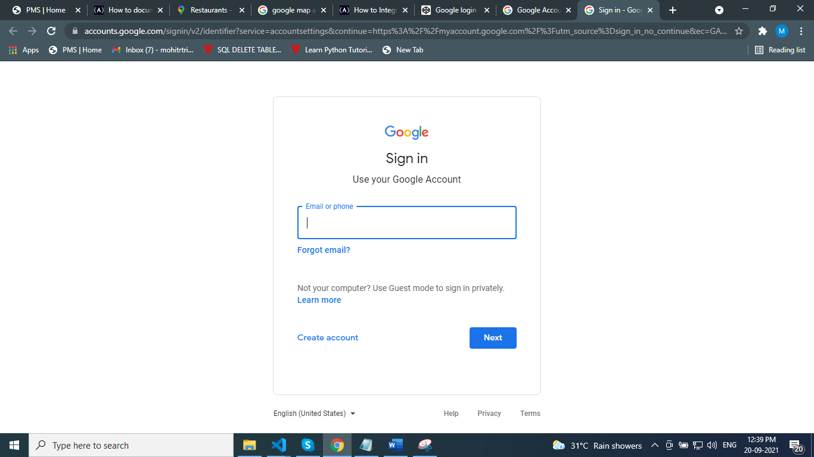

1. Home page:

* After successfully login user redirected to home page.
* Home page contains google map and search bar.

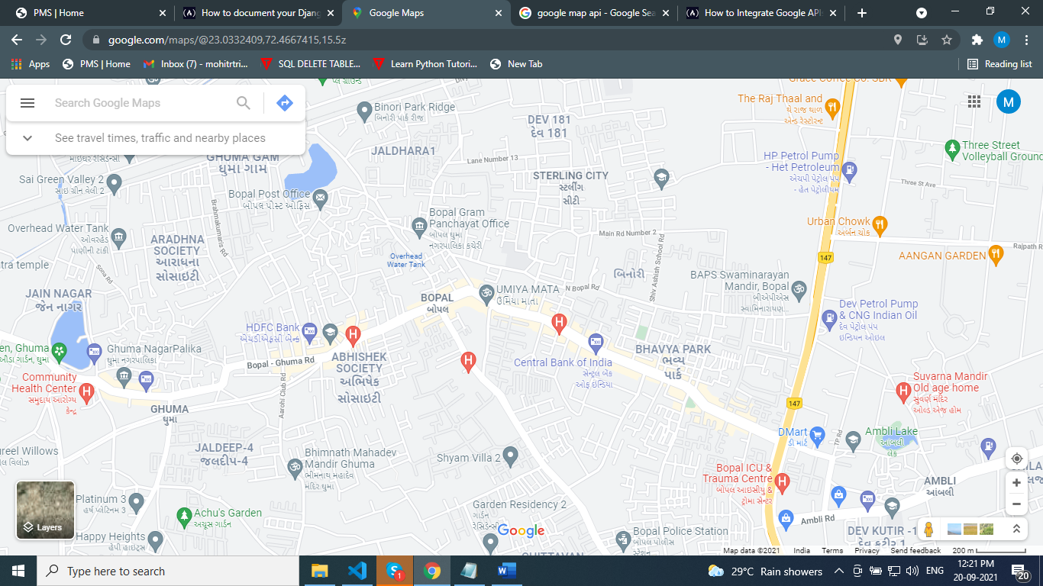

1. Search bar:

* User can search any place in search bar.

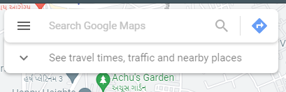

1. Searched results:

* Searched results can be displayed as shown in below image.

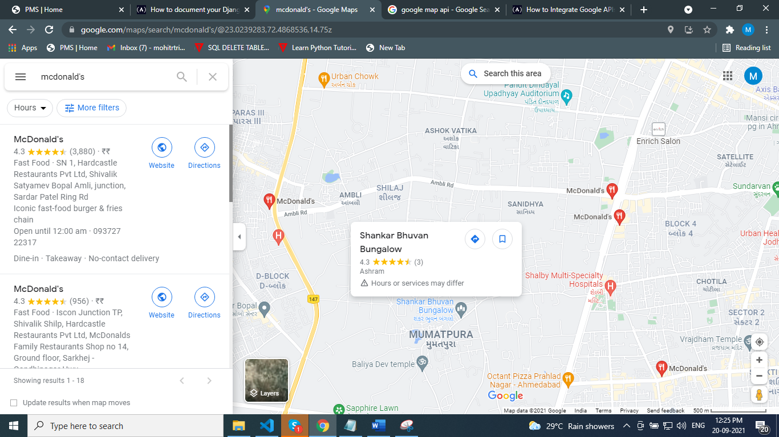

1. Place info:

* User can also see place information.
* And user can also choose navigate to that place.

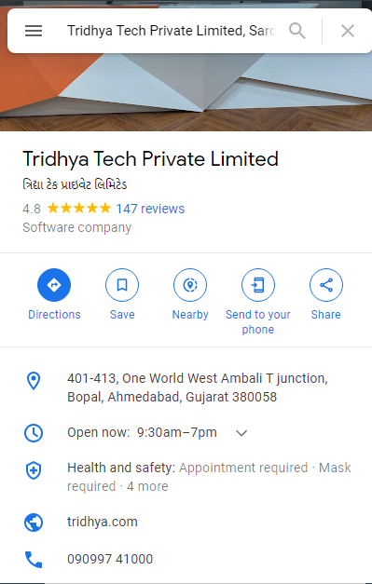

1. Navigation:

* User can see multiple routes and their respective travel timing.
* After selecting best route user get directed to that place.

