SIMATS ENGINEERING
Co3-ASSESSMENT TOOL 2 Case study

COURSE NAME: Computer Networks COURSE CODE: CSA07

COURSE OUTCOME COVERED

CO3: Analyze the performance of core network protocols such as TCP, UDP, HTTP, and DNS under varying conditions

Assessment Tool Weightage: 40%

Dr.V.Parthipan

QUESTIONS:4 Total Marks:40

Code of Conduct:

I S.MOHIT(192312508) (Name / Reg No) certify that this submission is my original work and that I have adhered to the guidelines specified for this assessment. I understand that any violation of academic integrity rules will result in disciplinary action.

Signature of the student:MOHIT S
Criteria | Understandi ng the case  2.5 | Application of Concepts  2.5 | Analysis 2 | Solution  Design 2 | Clarity 1 | Total  (10)
Q1
Q2
Q3
Q4
Faculty Signature

QUESTIONS:4 Total Marks:40

1. A multinational IT company uses a cloud-based video conferencing platform for daily client meetings. During peak business hours, employees experience frequent voice distortion, frozen video frames, and delayed communication. Network monitoring reports indicate an 8% packet loss, 180 ms jitter, and fluctuating bandwidth utilization. The IT administrator suspects that the issue is related to the transport protocol or application-level buffering strategy.

Questions
- Analyze whether the problem is primarily caused by the transport protocol (TCP/UDP) or the application layer.
- Justify your answer based on the communication requirements of real-time multimedia applications.
- Recommend suitable protocol-level or application-level improvements to enhance conferencing quality.
CASE STUDY 1
The problem is mainly related to the transport protocol and its interaction with the application layer. For real-time video conferencing, using TCP can cause delays because TCP retransmits lost packets and waits for acknowledgements. With 8% packet loss and 180 ms jitter, these retransmissions can increase delay and cause frozen video and distorted audio.
However, the application layer also plays an important role. If the conferencing application uses a large buffer, it may wait too long for missing packets, increasing communication delay. If the buffer is too small, packet loss and jitter may directly affect audio and video quality.
- Why real-time multimedia applications are different
Video conferencing requires low delay, low jitter, and continuous delivery rather than perfect delivery of every packet.
  - TCP provides reliable delivery, but retransmission and congestion control can introduce delays.
  - UDP is commonly preferred for real-time audio and video because it does not wait for lost packets to be retransmitted.
  - A small amount of packet loss is often better than waiting for delayed packets.
  - 180 ms jitter can cause audio/video synchronization problems.
  - 8% packet loss is high enough to cause noticeable voice distortion and frozen frames.
  - Fluctuating bandwidth can make the problem worse if the application does not adapt its video quality.
Therefore, UDP with suitable application-level mechanisms is generally more appropriate for real-time conferencing.
- Recommended improvements

Protocol-level improvements
- Use UDP-based real-time transport instead of TCP where appropriate.
- Use RTP/RTCP over UDP for audio/video delivery and quality monitoring.
- Apply congestion control to reduce traffic during peak periods.
- Use packet-loss recovery techniques, such as Forward Error Correction (FEC), when suitable.
- Use QoS (Quality of Service) to prioritize voice and video traffic over less time-sensitive traffic.

Application-level improvements
- Use an adaptive jitter buffer to handle variations in packet arrival time.
- Use adaptive bitrate (ABR) so video resolution and bitrate automatically decrease when bandwidth becomes limited.
- Prioritize audio over video because audio is more important for maintaining communication.
- Use packet-loss concealment to reduce the effect of missing audio/video packets.
- Avoid excessively large buffers because they can create additional delay.
- Monitor network conditions continuously and dynamically adjust video quality.

Conclusion
The 8% packet loss, 180 ms jitter, and fluctuating bandwidth strongly indicate that the conferencing system is experiencing network and transport-related problems, but the application’s buffering and adaptation strategy can significantly affect the final user experience. For real-time conferencing, UDP-based transport combined with RTP/RTCP, adaptive buffering, adaptive bitrate, QoS, and packet-loss recovery would provide better performance than relying on TCP's retransmission-based reliability.

2. A multinational software company hosts its web services across multiple continents. Employees frequently report long delays before the application homepage loads. Network analysis shows that the average DNS lookup time is approximately 800 ms, significantly affecting user experience. The organization plans to redesign its DNS infrastructure while ensuring continuous service availability during server failures.

Questions
- Analyze the reasons behind the high DNS resolution time.
- Propose a suitable DNS architecture using techniques such as Anycast DNS, DNS pre-fetching, and TTL optimization to reduce the lookup time below 50 ms.
- Evaluate the advantages and limitations of your proposed architecture in terms of performance, scalability, and availability.
CASE STUDY 2

1. Reasons for the high DNS resolution time
The 800 ms average DNS lookup time is very high and can be caused by several factors:
- Long geographical distance: Users may be contacting DNS servers located far away.
- DNS recursion delays: A recursive DNS server may need to contact multiple DNS servers before finding the required IP address.
- High DNS server load: Heavy traffic can increase processing and response time.
- Poor DNS caching: If DNS records are not cached effectively, repeated queries require fresh resolution.
- High network latency: Congestion and unstable network connections can delay DNS requests.
- Improper TTL values: Very short TTL values cause DNS records to expire frequently, increasing the number of DNS lookups.
- Single-server dependency: If one DNS server is overloaded or unavailable, users may experience additional delays.

2. Proposed DNS architecture
The company can use a distributed Anycast DNS architecture combined with DNS caching, pre-fetching, and optimized TTL values.
Architecture:
User → Nearest Anycast DNS Server → Cached DNS Response → Web Server
5

a) Anycast DNS
Deploy DNS servers at multiple geographical locations such as Asia, Europe, North America, and Australia.
All DNS servers advertise the same IP address using routing protocols such as BGP. The network automatically directs users to a nearby or optimal DNS server.
Example:
- User in India → Asian DNS server
- User in Europe → European DNS server
- User in USA → North American DNS server
This reduces network round-trip time and improves availability. b) DNS pre-fetching
Frequently accessed domain records can be pre-fetched before their TTL expires.
For example, if a DNS record has a TTL of 300 seconds, the DNS resolver can refresh it before expiration. This ensures that users usually receive the answer directly from the cache instead of waiting for a complete recursive lookup. c) TTL optimization
Use suitable TTL values for different DNS records.
- Frequently changing records → shorter TTL
- Stable records → longer TTL
For example, stable web-service records could use a TTL of 300–3600 seconds, depending on how quickly changes need to propagate.
Longer TTLs reduce repeated DNS queries and improve response time.

d) Multiple DNS servers and failover
Deploy several authoritative DNS servers across different regions. If one server fails, DNS traffic can automatically be redirected to another available server.
This prevents a single point of failure and provides continuous service availability.

Target performance
With users directed to nearby Anycast servers and frequently requested records available in cache, DNS responses can often be reduced to well below 50 ms for cached queries.
However, 50 ms cannot be guaranteed for every uncached recursive lookup, because Internet distance and upstream DNS response times can vary.

3. Advantages and limitations
Feature | Advantages Limitations
Anycast DNS | Reduces latency, improves More complex routing availability, distributes traffic and management
DNS  Pre-fetching | Keeps popular records ready in Uses additional DNS cache and reduces lookup delays queries and resources
TTL  Optimization | Reduces unnecessary DNS lookups Long TTL can delay and improves cache efficiency DNS changes

Conclusion
The company's 800 ms DNS lookup time is mainly caused by geographical latency, inefficient caching, overloaded DNS infrastructure, and repeated recursive lookups. A globally distributed Anycast DNS architecture, supported by DNS pre-fetching, optimized TTL values, effective caching, and multiple redundant DNS servers, can significantly reduce DNS response time and improve availability.

3.A cloud service provider delivers applications to millions of users worldwide. During promotional events, users experience intermittent delays in accessing cloud-hosted services. Investigation reveals that DNS queries are taking nearly 800 ms because all requests are directed to a single primary DNS server. The company wants a highly available DNS solution capable of handling global traffic efficiently.

Questions
- Examine the impact of centralized DNS architecture on application performance.
- Design a distributed DNS solution that minimizes lookup latency while maintaining high availability.
- Analyze how TTL values, Anycast routing, and DNS caching influence system performance and fault tolerance.
CASE STUDY 3

1. Impact of centralized DNS architecture on application performance
In the given situation, all DNS requests are sent to a single primary DNS server.
This creates a major performance bottleneck and single point of failure.
The 800 ms DNS lookup time causes users to wait before their browsers can even connect to the cloud application. During promotional events, millions of users generate a large number of DNS queries, which can overload the server and increase response time.
The main problems are:
- High latency: Every user must contact the same DNS server, even when the server is geographically far away.
- Server overload: A large number of simultaneous queries can exceed the server's processing capacity.
- Single point of failure: If the primary DNS server fails, users may be unable to resolve the application domain.
- Poor scalability: Adding more users increases the load on the same server.
- Increased application delay: DNS resolution occurs before the user can establish a connection with the cloud service.
Therefore, the centralized architecture is unsuitable for a global service with millions of users.

2. Proposed distributed DNS solution
The company should implement a globally distributed DNS architecture using Anycast routing, multiple authoritative DNS servers, and DNS caching.
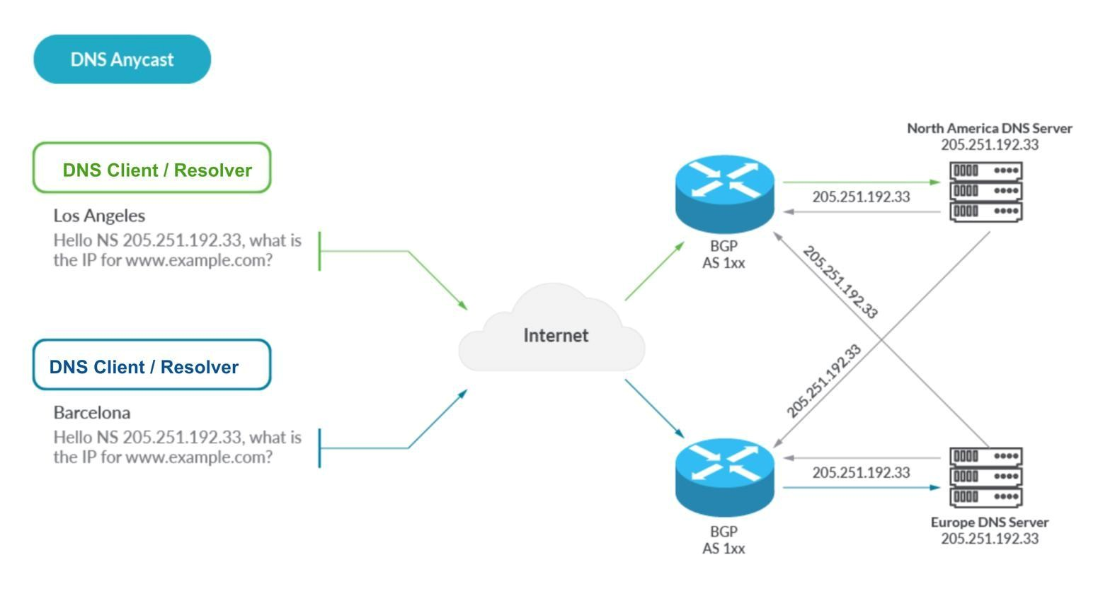

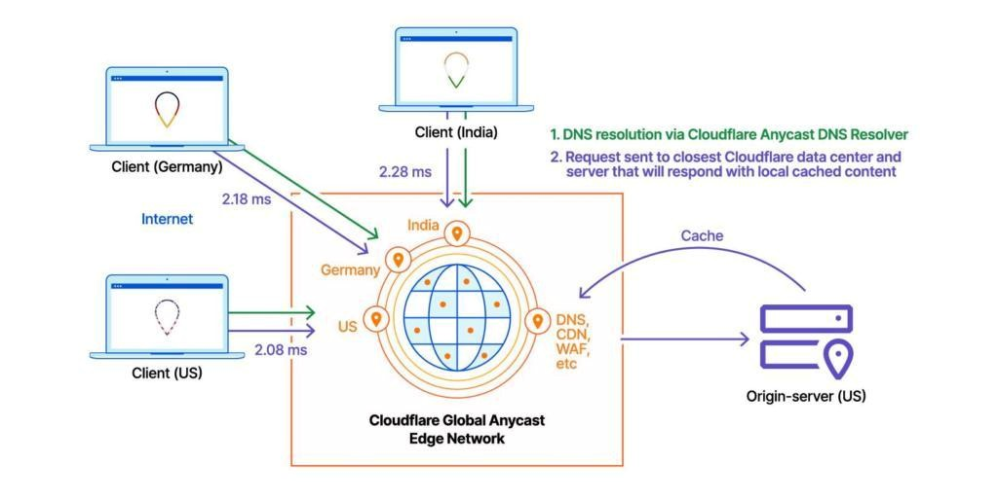
6

Proposed architecture
Users worldwide → Nearest Anycast DNS node → DNS cache →
Authoritative DNS server → Cloud application
Step 1: Deploy DNS servers globally
Place multiple DNS servers in different geographical regions:
- Asia
- Europe
- North America ● South America
- Australia
This allows users to obtain DNS responses from servers closer to their location.

Step 2: Use Anycast routing
All DNS servers can advertise the same IP address using Anycast routing.
For example:
- User in India → Asian DNS node
- User in Germany → European DNS node
- User in USA → North American DNS node
The routing system directs the query to an appropriate nearby/optimal DNS instance.
This significantly reduces network round-trip time.

Step 3: Use DNS caching
Frequently requested DNS records should be stored in caches.
For example, if thousands of users request the same cloud application's IP address, the DNS resolver can return the cached answer instead of performing a new lookup every time.
This reduces:
- DNS traffic
- Server workload
- Lookup latency

Step 4: Provide redundant DNS servers
Each region should have multiple DNS servers. If one server fails, traffic can be redirected to another available server.
This provides high availability and fault tolerance.

3. Effect of TTL, Anycast routing, and DNS caching
Technique | Effect on Performance Effect on Fault Tolerance
TTL  values | Appropriate TTL reduces Longer TTL can allow cached records repeated DNS lookups to continue working during temporary DNS failures
Anycast routing | Sends users to nearby DNS If one Anycast node fails, routing can servers, reducing latency direct traffic to another node
DNS Provides fast responses Cached records may remain usable caching without repeated recursive even if the authoritative server is
lookups temporarily unavailable

TTL values
TTL (Time To Live) determines how long a DNS record can remain in a cache.
- Very short TTL: Changes propagate quickly, but DNS queries increase.
- Very long TTL: Reduces DNS queries and improves performance, but changes take longer to propagate.
- Balanced TTL: Provides a good compromise between performance and flexibility.
For stable cloud services, a moderate TTL such as 300–3600 seconds can be considered, depending on how frequently the records change.

Anycast routing
Anycast allows multiple DNS servers to use the same IP address. Internet routing directs users toward an appropriate DNS location.
Benefits:
- Lower latency
- Global traffic distribution
- Better scalability
- Automatic routing around failed nodes

DNS caching
Caching is one of the most important methods for reducing DNS load. Once a domain's IP address is cached, subsequent requests can be answered quickly without contacting the authoritative server.
For example:
Without caching:
User → DNS server → Recursive lookup → Authoritative server → Response With caching:
User → Cache → Response
This can reduce DNS lookup time dramatically.

Conclusion
The centralized DNS architecture is responsible for much of the 800 ms delay because it creates a bottleneck and forces global users to depend on one server.
A better solution is a distributed Anycast DNS architecture with multiple redundant DNS servers, optimized TTL values, and effective DNS caching. Anycast reduces geographical latency, caching reduces repeated queries, and suitable TTL values balance performance with the need for DNS updates.

4.A financial institution operates an electronic stock trading platform where thousands of buy and sell orders are submitted every second. During market opening hours, the average order acknowledgment latency increases from 1 ms to 40 ms, resulting in delayed trade confirmations and customer dissatisfaction. Network engineers observe increased TCP retransmissions, longer connection establishment times, and excessive buffering.

Questions
- Analyze three possible TCP-related factors responsible for the latency increase, considering flow control, Nagle's algorithm, and SYN queue limitations.
- Explain how each factor affects transaction processing in high-frequency systems
- Recommend appropriate TCP configuration changes to reduce latency and improve transaction reliability.
CASE STUDY 4
TCP-Related Causes of Increased Latency in High-Frequency Trading
1. Three TCP-Related Factors Responsible for Latency Increase
The increase in order acknowledgment latency from 1 ms to 40 ms during market opening can be influenced by several TCP mechanisms. The three important factors are:
- TCP Flow Control
- Nagle's Algorithm
- SYN Queue Limitations
A. TCP Flow Control
TCP uses flow control to prevent a sender from transmitting more data than the receiver can process. The receiver advertises a receive window (rwnd) indicating the amount of data it can accept without acknowledgment.
During market opening hours, thousands of transactions may generate a sudden burst of traffic. If the receiving application processes data slowly, its TCP receive buffer may become full. The advertised receive window can then become smaller, forcing the sender to reduce its transmission rate.
Effect on Trading
- Reduces the amount of data that can be transmitted at once.
- Causes packets to wait in buffers.
- Slows the delivery of order messages.
- Delays acknowledgments and application responses.
- Excessive buffering can increase end-to-end latency.
Therefore, poorly tuned receive buffers or slow application processing can contribute significantly to increased transaction latency.

B. Nagle's Algorithm
Nagle's algorithm is designed to improve network efficiency by combining small TCP segments instead of sending many small packets individually.
This mechanism is useful for reducing network overhead, but it can be undesirable in high-frequency trading (HFT) because trading messages are often small and time-sensitive.
When Nagle's algorithm is enabled, a small outgoing message may temporarily wait for either additional data or acknowledgment of previously transmitted data before being sent.
Effect on Trading
- Small order messages may experience additional delay.
- Time-sensitive trading instructions may not be transmitted immediately.
- Application responses can be delayed.
- The accumulated delay becomes significant when transactions must be completed within milliseconds.
For latency-sensitive trading applications, Nagle's algorithm is therefore commonly disabled using:
TCP_NODELAY = ON
This allows small TCP segments to be transmitted immediately.

C. SYN Queue Limitations
TCP establishes a connection using the three-way handshake:
SYN → SYN-ACK → ACK
During periods of extremely high traffic, many clients may attempt to establish TCP connections simultaneously. The server maintains queues for connections that are in the connection-establishment stage.
If the SYN backlog becomes overloaded:
- New connection requests may be delayed or dropped.
- Clients may retransmit SYN packets.
- TCP connection establishment takes longer.
- Applications waiting for a new connection experience additional delay.
This problem is particularly important when the trading application repeatedly creates new TCP connections during market opening.
However, SYN queue limitations primarily affect connection establishment, not the latency of transactions that are already using established TCP connections. For HFT systems, persistent connections are therefore preferred.

2. Effect on High-Frequency Transaction Processing
TCP Factor | What Happens | Effect on Trading
TCP Flow Control | Receive window becomes smaller when receiver buffers fill | Slower order transmission and delayed responses
Nagle's Algorithm | Small TCP packets may be temporarily delayed or combined | Increases latency of small trading messages
SYN Queue Limitations | Large numbers of connection requests overload the SYN backlog | Slows establishment of new trading connections
In a high-frequency trading system, even a few milliseconds can be important. An increase from 1 ms to 40 ms represents a 39 ms additional delay, which can cause order acknowledgments to arrive much later than expected.
This may result in:
- Delayed trade confirmations.
- Slower order processing.
- Missed short-lived trading opportunities.
- Reduced system responsiveness.
- Poorer customer experience.
Therefore, minimizing TCP processing and network delays is critical for HFT applications.

3. Recommended TCP Configuration Changes
A. Disable Nagle's Algorithm
For latency-sensitive trading connections, disable Nagle's algorithm using:
TCP_NODELAY = ON
This allows small TCP messages to be transmitted immediately rather than waiting for additional data.
Advantages
- Reduces delay for small packets.
- Improves responsiveness.
- Suitable for latency-sensitive trading applications.
- Reduces application-level waiting time.
This is one of the most direct TCP configuration changes for reducing unnecessary latency.

B. Optimize TCP Send and Receive Buffers
TCP send and receive buffers should be properly configured according to the application's traffic pattern.
Recommended parameters include:
- SO_RCVBUF – receive buffer size.
- SO_SNDBUF – send buffer size.
- Appropriate application-level queue sizes.
Buffers should be large enough to handle sudden traffic bursts but should not be unnecessarily large.
Very large buffers can result in excessive queuing and bufferbloat, which can increase latency.
Therefore, buffer sizes should be tuned based on:
- Transaction rate.
- Network bandwidth.
- Round-trip time.
- Application processing speed.

C. Increase SYN Backlog Capacity
If the trading server receives a large number of new connection requests, the TCP SYN backlog should be configured appropriately.
Possible measures include:
- Increase the TCP SYN backlog/queue capacity.
- Enable SYN cookies where appropriate for protection against SYN-flood conditions.
- Monitor connection-establishment failures.
- Use persistent connections to reduce repeated handshakes.
This prevents connection-establishment delays during sudden traffic bursts.

D. Use Persistent TCP Connections
Creating a new TCP connection for every transaction introduces unnecessary handshake overhead.
Less Efficient
Order → TCP Handshake → Send Order → Close Connection
More Efficient
TCP Connection Established Once → Order 1 → Order 2 → Order 3 → Order 4 → ...
Persistent connections or connection pooling allow multiple transactions to use an already established TCP connection.
Benefits
- Eliminates repeated three-way handshakes.
- Reduces connection-establishment latency.
- Reduces SYN queue pressure.
- Improves transaction throughput.
- Provides more consistent latency.
For high-frequency trading, maintaining long-lived connections is generally preferable to repeatedly opening and closing connections.

E. Monitor Retransmissions and Network Congestion
The observation of increased TCP retransmissions is an important indication that the problem may not be caused by TCP configuration alone.
Network engineers should investigate:
- Packet loss
- Network congestion
- TCP retransmissions
- Receive-window limitations
- Interface errors
- High round-trip time (RTT)
- TCP retransmission timeout (RTO)
- Bandwidth saturation
TCP retransmission occurs when transmitted data is lost or not acknowledged within the expected period. Retransmissions can introduce substantial additional latency.
Therefore, simply changing TCP parameters will not completely solve the problem if the underlying network is experiencing packet loss or congestion.

4. Recommended Overall Approach
The trading system should adopt a combination of TCP and application-level optimizations:
Disable Nagle's Algorithm
↓
Tune TCP Send/Receive Buffers
↓
Increase SYN Backlog Capacity
↓
Use Persistent TCP Connections
↓
Monitor Packet Loss and Retransmissions
↓
Optimize Network Bandwidth and Congestion
This approach addresses both TCP-level delays and the underlying network conditions responsible for increased latency.

Conclusion
The increase in order acknowledgment latency from 1 ms to 40 ms can be influenced by TCP flow-control behavior, Nagle's algorithm, and connection-establishment limitations such as SYN queue congestion.
Among these factors, Nagle's algorithm and flow-control/buffering effects directly influence data transmission latency, while SYN queue limitations mainly affect the establishment of new TCP connections.
For a high-frequency trading environment, the recommended solution is to:
- Enable TCP_NODELAY.
- Properly tune TCP send and receive buffers.
- Increase and monitor the SYN backlog.
- Use persistent TCP connections or connection pooling.
- Monitor packet loss, congestion, RTT, and retransmissions.
These measures can reduce unnecessary delays and help maintain reliable, low-latency transaction processing during periods of extremely high market activity.

