**ASSIGNMENT_1**

1. In the below elements which of them are values or an expression? eg:- values can be integer or string and expressions will be mathematical operators.

ANS- *🡪expression

'hello'🡪values

-87.8🡪values

- 🡪expression

/🡪expression

+🡪expression

6🡪values

1. What is the difference between string and variable?

ANS. String is written in double or single quotes eg- "Apple",'Apple'.

variable is a container which stores values or character or any data.

1. Describe three different data types.

ANS. Integer-integer can store only numerical values. eg- 64,75

Float- Float can store only numerical values having deciaml places or Floating values eg-22.6,56.5

bool- boolean is having values either True or False

1. What is an expression made up of? What do all expressions do?

ANS. Expression is a combination of mathematical operator, numerical values and variables and to get a desired result.

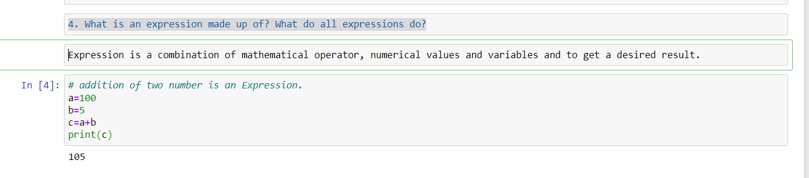

1. This assignment statements, like spam = 10. What is the difference between an expression and a statement?

ANS. Expression is a combination of mathematical operator, numerical values and variables and to get a desired result.

Statement is a command which interprets through python compiler eg-print()

1. After running the following code, what does the variable bacon contain?

bacon = 22

bacon + 1

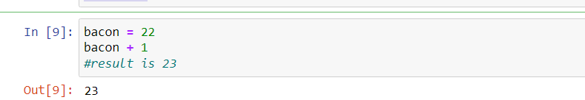

1. What should the values of the following two terms be?

'spam'+'spamspam'

'spam'* 3

ANS. 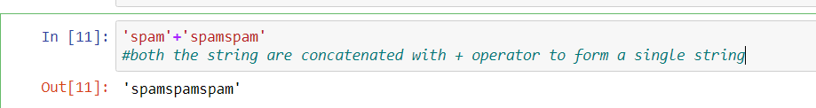

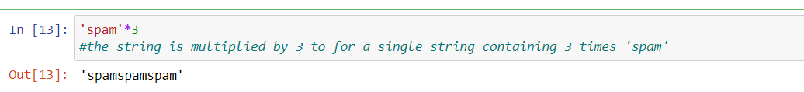

1. Why is eggs a valid variable name while 100 is invalid?

ANS. we can't start variable name with integer or numerical values. if we do it will throw an error. Variable name must start with alphabets eg- eggs is a valid varaible, 100 is not a valid variable beacause it is starting from numerical values.

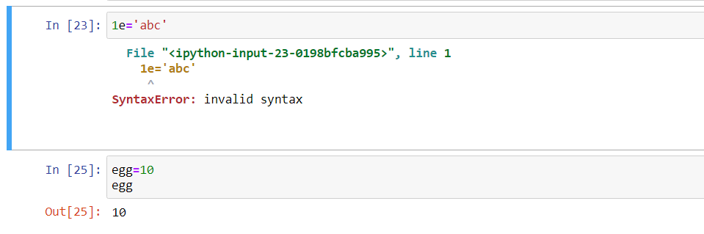

1. What three functions can be used to get the integer, floating-point number, or string version of a value?

ANS. str(), int(), float()

1. Why does this expression cause an error? How can you fix it?

'I have eaten' + 99 + 'burritos.'

ANS. 'I have eaten ' + str(99) + ' burritos.'

