**ASSIGNMENT_2**

1. What are the two values of the Boolean data type? How do you write them?

ANS. There are two values of Boolean:

1. True
2. False

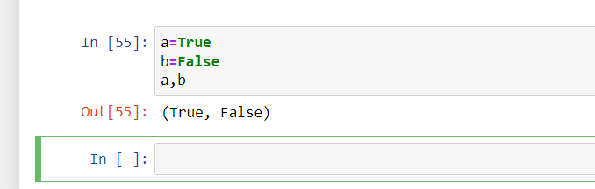

1. What are the three different types of Boolean operators?

ANS. AND, OR and NOT

1. Make a list of each Boolean operator truth tables (i.e. every possible combination of Boolean values for the operator and what it evaluate ).

ANS. True and True is True

False and True is False

True and False is False

False and False is False

True or True is True

False or True is True

True or False is True

False or False is False

not True is False

not False is True

Truth Table for AND  
A B output  
0 0 0  
0 1 0  
1 0 0  
1 1 1

Truth Table for OR  
A B output  
0 0 0  
0 1 1  
1 0 1  
1 1 1

Truth Table for NOT  
A output  
0 1  
1 0

1. 4. What are the values of the following expressions?

(5>4) and (3 == 5)

not (5 > 4)

(5 > 4) or (3 == 5)

not ((5 >4) or (3 == 5))

(True and True) and (True == False)

(not False) or (not True)

ANS. 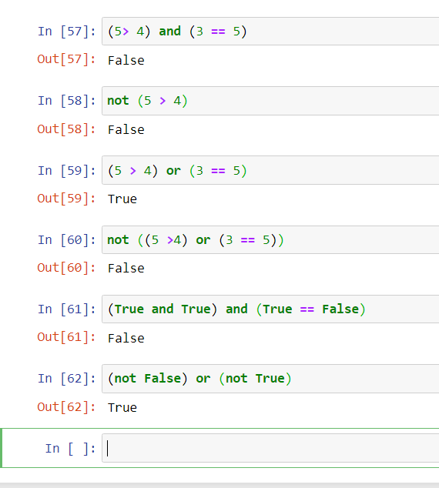

1. What are the six comparison operators?

ANS. >, <, ==, <=, >= and !=

1. How do you tell the difference between the equal to and assignment operators?Describe a

condition and when you would use one.

ANS. 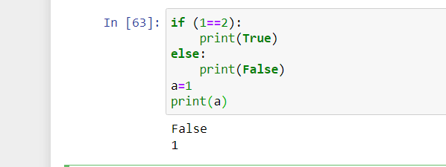

1. Identify the three blocks in this code:

spam = 0

if spam == 10:

print(‘eggs’)

if spam >5:

print(‘bacon’)

else:

print(‘ham’)

print(‘spam’)

print(‘spam’)

ANS. 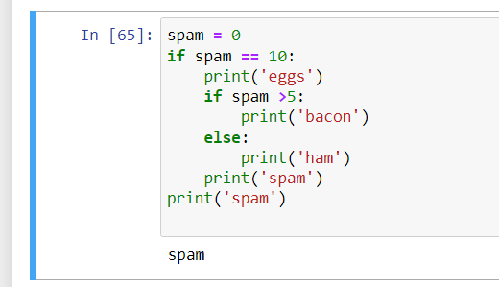

1. Write code that prints Hello if 1 is stored in spam, prints Howdy if 2 is stored in spam, and prints Greetings! if anything else is stored in spam.

ANS. 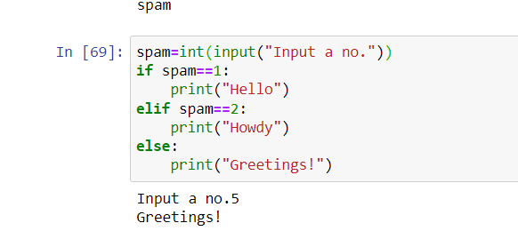

1. If your programme is stuck in an endless loop, what keys you’ll press?

ANS. press ctrl+c.

1. How can you tell the difference between break and continue?

ANS. 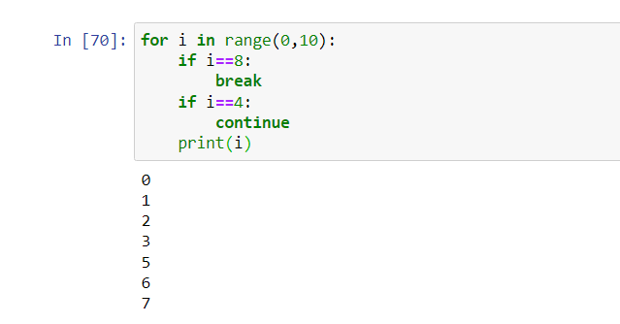

1. In a for loop, what is the difference between range(10), range(0, 10), and range(0, 10, 1)?

ANS. They all perform same operation but the method to write the command is different, range(10) will select the values starting from 0 to 9. range(0,10) here we specify the starting number will be 0 and iterate till 9. range(0,10,1) here 1 will perform the skipping operation as the value is one it will iterate from 0 to 9.

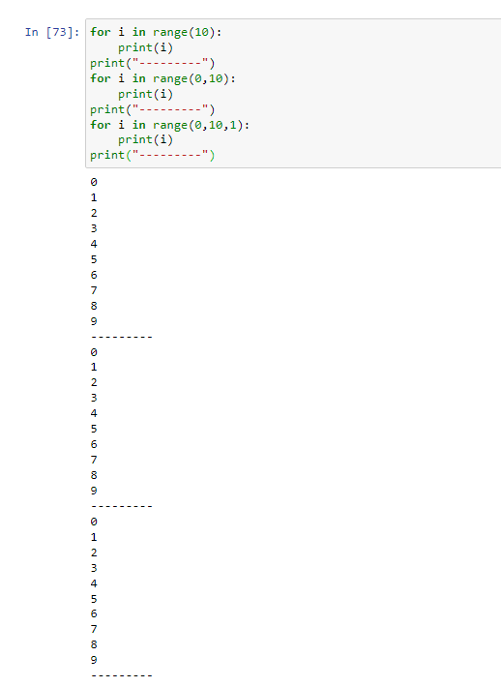

1. Write a short program that prints the numbers 1 to 10 using a for loop. Then write an equivalent program that prints the numbers 1 to 10 using a while loop.

ANS. 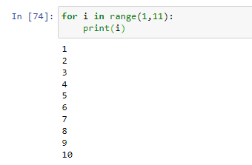

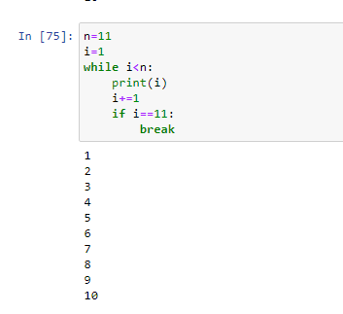

1. If you had a function named bacon() inside a module named spam, how would you call it after importing spam?

ANS. this bacon() function can be called using two methods:



import spam

spam.bacon()



from spam import bacon