CSC 555 Social Computing

S-D Report

Name: Mohit Satarkar

Unity Id: mmsatar2

The assignment was carried out using the VIKOR evaluation method applied on the sharing policy id. While I got the suggested policy of the classifier by querying the URL, I used user feedbacks to assign payoffs to the specific user sharing policy preference. After that, a VIKOR evaluated sharing policy was determined for use in a checkin along with the classifier suggested policy.

Sanctions were sent to the person who tagged me by making my own VIKOR calculation for the scenario in which the primary stakeholder had tagged me, and also the classifier suggested policy for me. An evaluation was decided to send a payoff based on how different the tagged sharing policy was from my VIKOR calculations. Sharing policies were kept in a hierarchy for this decision. If the tagged sharing policy tier was completely different than the VIKOR evaluated sharing policy, then the secondary stakeholder received a very negative sanction. If the policies matched, then the user received a very positive sanction.

**VIKOR algorithm**

The VIKOR total was kept as 1. Initially every payoff is assigned as 0.25. Based on user’s feedback, these get reassigned based on the user’s preference. Once we have the final Q values to determine the best policy for the user, we send the VIKOR suggested policy to our checkin function.

The application keeps and updates the data received from the sanctions on runtime. It stores the data in a volatile way. Once the execution of the application is terminated, the application data will be initial data.

**Program work:**

Checkin option work.

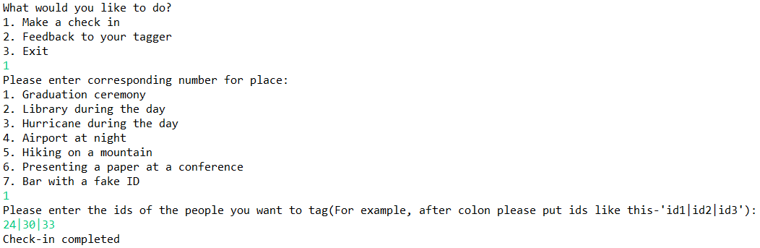

Feedback work:

