Testcase 1:

Test case 2:

Testcase 3

Testcase 4:

Inout :

Hello, This is the first line of the file for testing and would you get this

Hello, this is second line

please find the details on different scenarios covered-

**Testcase 5 :**

**Input:**

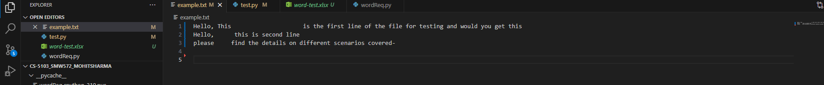

**Result Screenshot**

**Testcase 6: The string with large size should pass too and the string should give correct word count.**

**Test Results:**

Testcase 7: Special characters in a string will be considered as a characters and will print separate words.

Testcase 8: String with alphanumeric words are considered as unique words such as abc123 6abc789

Input :

Output:  
**Test_Result:**

