Project Name -: MAKE MY TRIP 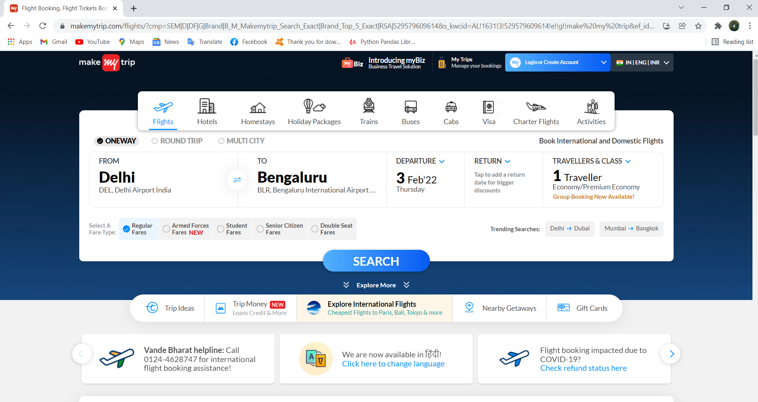

Overview:

MakeMyTrip is an Indian online travel company founded in 2000. Headquartered in Gurugram, Haryana, the company provides online travel services including airline tickets, domestic and international holiday packages, hotel reservations, rail, and bus tickets.

MOHIT SHARMA

Edureka Presents

Profile Live Link -: https://mohitsharma4402.github.io/myprofile1/

PAGES -:

1. Login page and logout page

2. Booking page

* Flights

* Hotels

* Trains

* Holiday Packages

3. Payment page

4. Offers page

Technologies used in MakeMyTrip -:

Front-End:

1. Html

2. Css

3. Bootstrap

4. React

Dynamic:

1. Javascript

2. Ci/cd with AWS

3. Login and Logout (oauth and jwt)

Database:

1. Mongodb

2. Json

Data Code compilers:

1. Visual studio code

2. Git bash

3. Git hub

4. Node js.

PRODUCT OFFERING -:

Flights, International Flights, Hotels, International Hotels, Activities, Holidays In India, International Holidays,Book Online Cabs, Book Bus Tickets, Book Train Tickets, Vande Bharat Mission Flights, Cheap Tickets to India, Book Flights From US, Trip Planner, Gift Cards, Trip Money, Trip Ideas, Travel Blog.

Navigation bar

* Company name
* Avatar button (login/create account)
* Search bar
* Location selection
* Login/Logout

Basic Features

**Login page:**

1. Login id/username
2. Password
3. Login button

**Sign up page:**

Form 🡪 takes personal details as input

1. Name
2. Mobile number
3. Mail id
4. Address

* Sign up button

Filters

* Sort by price
* User rating
* Price ranges
* Discount

HEADER

SEARCH

BAR

QUICK

SEARCH

EVENTS

FOOTER