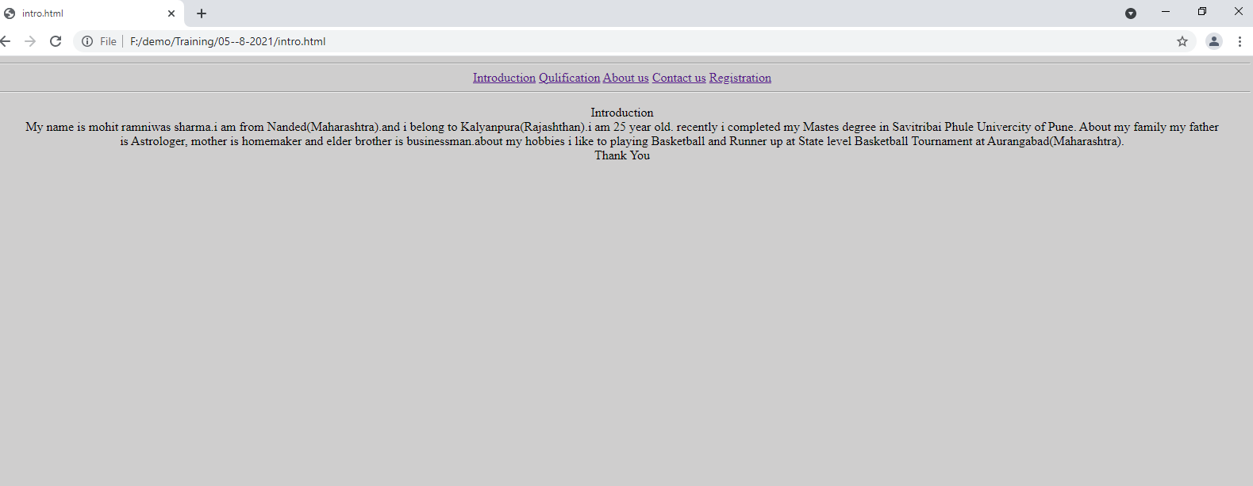

In this webpage I used many tag like <blockqoute>,<bgcolor>,<hr>,<a>,<div>,<hr>.

I set align CENTER . and used hyperlink also which is help us to travels another page .

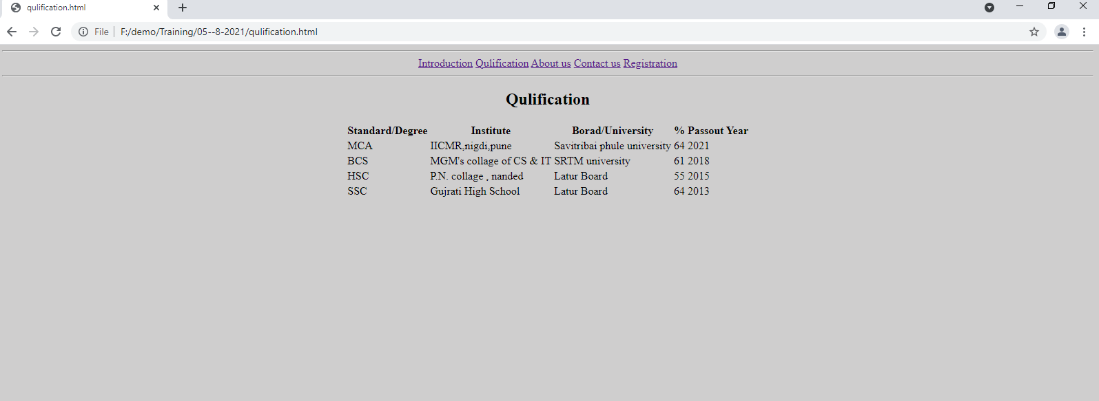

Here I used <Table>,<TD>,<TR> and mention all my Standard/degree , Institute,University , %(percentage) and passout year

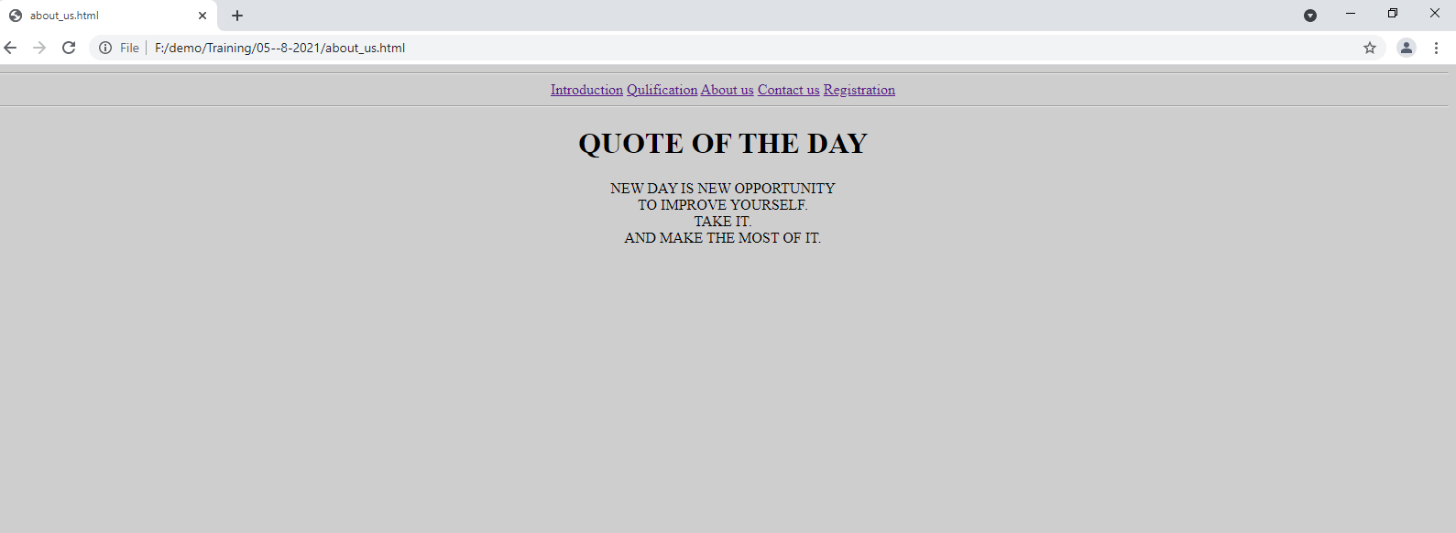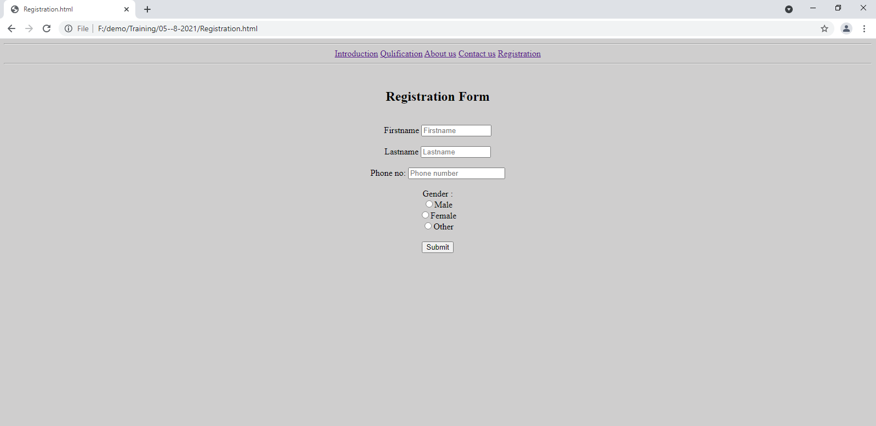

Here I used <label>,<input>,<h2>

Bgcolor, align,required

Used radio button , submit button

