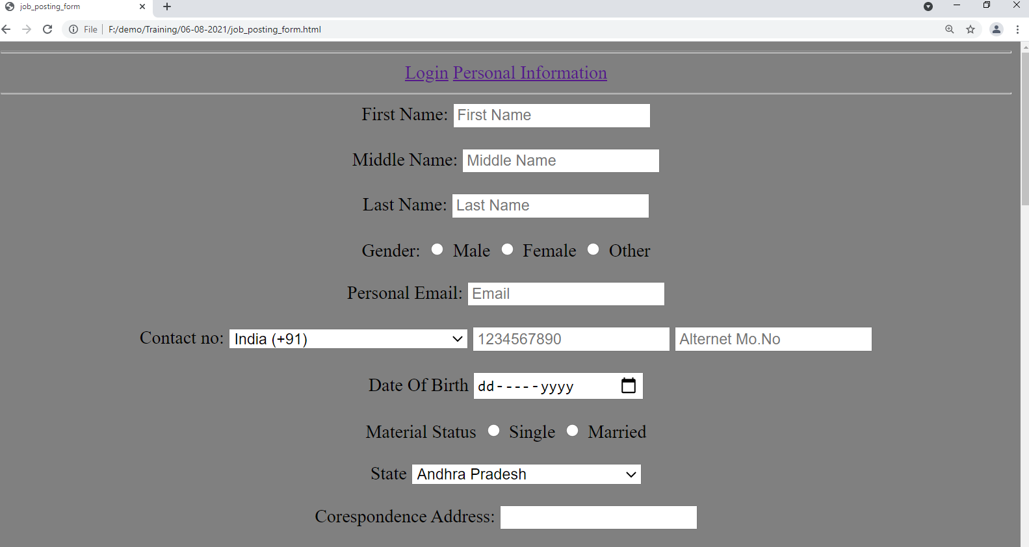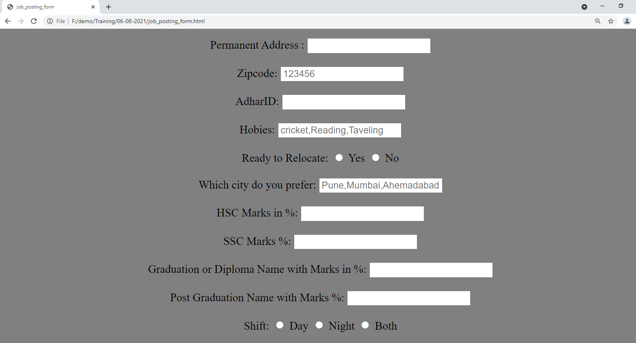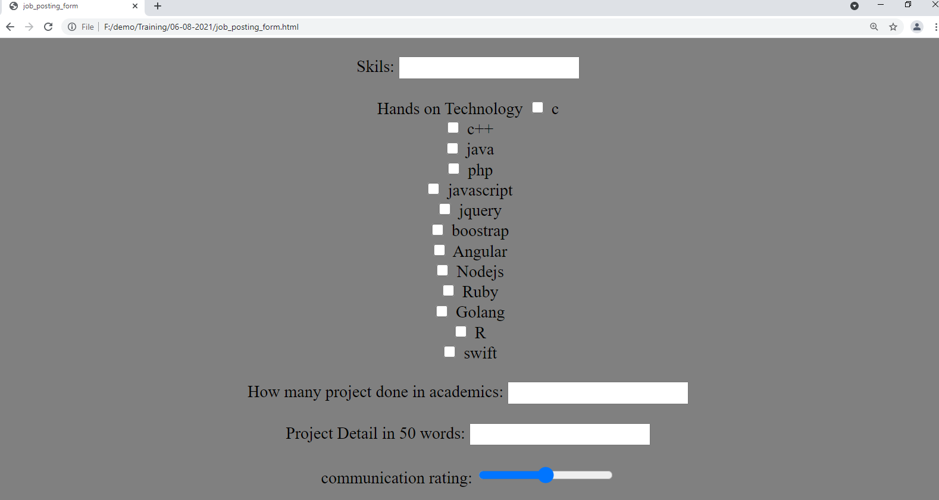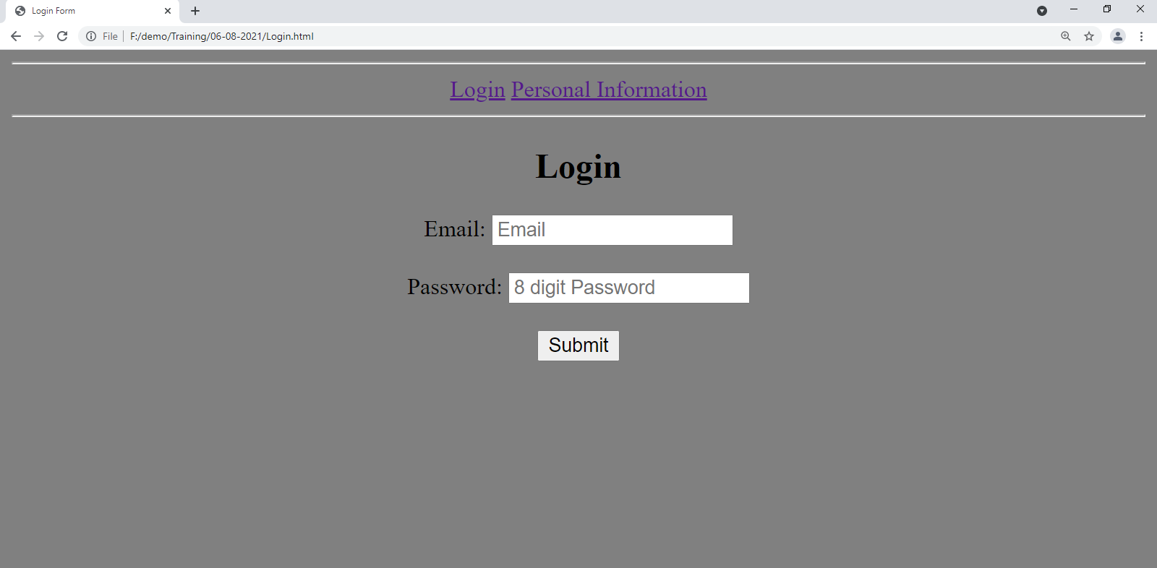

create login page using 2 field

email and password.

create job post form in this 28 field created using many tag.

-First name

-Middle name

-Last name

-Gender

-Email

-Number

-Alternate number

-Select state

-Date of Birth

-Material status

-Correspondence address

-Permanent Address

-Adhar ID

-Hobbies

-Ready to relocate

-which city do you prefer

-experience

-HSC marks

-SSC marks

-Degree/Diploma name with Marks

-Post graduation name with marks

-Shift(day/night/both)

-Skills

-How many project

-Project Description

-communication Rating

-Zip code

-Passport photo

-Hands on technology

-select state

-select country