MIAE Copilot NextGen
Manufacturing Impact Analysis Engine

1. Overview
MIAE Copilot NextGen is the next-generation conversational intelligence layer for the Manufacturing Impact Analysis Engine (MIAE).
It extends the existing Copilot from a primarily single-agent/prompt-driven interaction model into a multi-agent collective intelligence architecture. NextGen can combine information from multiple MIAE capabilities—such as Asset Intelligence, MES Execution Intelligence, Digital Twin, Impact Analysis, and RAG/Document Intelligence—to answer complex manufacturing questions that cross operational and business domains.
The objective is not to create another source of manufacturing data. Instead, Copilot NextGen orchestrates existing intelligence capabilities and combines their results into a coherent, contextual response.

2. Objective
Copilot NextGen is intended to answer questions that cannot be adequately answered from a single manufacturing perspective.
Example: " What’s happening with EQ-101, and what are the downstream business impacts?"
- Asset Intelligence to understand the equipment condition.
- MES Execution Intelligence to determine what is currently executing.
- Digital Twin to provide operational context.
- Impact Analysis to determine affected Work Orders and downstream business entities.
- RAG to provide relevant information from maintenance, shift, or production documents.

3. Core Capabilities

3.1 Multi-Agent Intelligence
NextGen introduces specialized intelligence agents, each responsible for a specific manufacturing domain.
- Asset Intelligence Agent
The Asset Intelligence Agent provides an asset-centric view of manufacturing equipment and resources. It retrieves and reasons over asset information to understand the current state and condition of an asset, its relationships within the manufacturing environment, and the potential impact of an asset-related issue.
It is responsible for:
- Asset state & condition — understand the current reported state of equipment.
- Asset relationships — identify relevant relationships between equipment and manufacturing entities such as Work Centers and Work Orders/WO-Operations.
- Asset impact — determine the manufacturing and business entities potentially affected by an asset condition or issue.

- MES Execution Intelligence Agent
The MES Execution Intelligence Agent provides the shop-floor execution view of manufacturing. It determines what is currently or historically being executed for a Work Order/WO-Operation and provides the associated execution context.
It is responsible for:
- Execution context — identify operation executions associated with a Work Order and WO-Operation.
- Execution status & progress — understand execution status and reported quantities.
- Operator and resource assignments — identify operators, equipment/resources, and assignment changes explicitly provided by MES.
- Work Center & Shift context — identify where and under which shift the execution is taking place.
- Downtime & exceptions — identify execution downtime and open/relevant execution exceptions.
- Execution history — retrieve execution information for a requested time period.

- Impact Analysis Agent
The Impact Analysis Agent determines the manufacturing and business consequences of an identified asset, execution, or manufacturing issue. It uses MIAE's deterministic graph-based impact analysis capabilities to traverse established relationships and identify affected entities.
It is responsible for:
- Impact traversal — determine entities affected by a given issue or entity.
- Manufacturing impact — identify affected Work Orders, WO-Operations, components, suppliers, or other relevant manufacturing entities.
- Business impact — identify affected Sales Orders, customers, and potential revenue exposure supported by the graph.
- What-if analysis — evaluate potential impact scenarios supported by MIAE.

- Digital Twin Agent
The Digital Twin Agent provides the operational and contextual view of physical manufacturing assets. It uses Digital Twin data to understand the asset's current operational context and associated telemetry, anomalies, and diagnoses.

- RAG / Document Intelligence Agent
The RAG / Document Intelligence Agent provides intelligence from unstructured manufacturing information that is not necessarily represented in the MIAE knowledge graph or operational APIs.
It is responsible for:
- Document retrieval — find relevant manufacturing documents based on the user's question and established context.
- Maintenance information — retrieve relevant maintenance reports and records.
- Shift and production information — retrieve shift reports, production reports, and related operational documents.
- Procedures and reference information — retrieve SOPs, manuals, and other manufacturing reference documents.
- Contextual evidence — provide relevant document-derived information to complement structured MIAE intelligence.

The agents are specialized rather than being independent general-purpose chatbots.

3.2 Intelligent Orchestration
A central Copilot NextGen Orchestrator determines which capabilities are required for a user's question.
Not every question requires every agent. A question about what an operator is doing may only require MES Execution Intelligence, while a question about why equipment is affecting production and which customers are exposed may require Asset Intelligence, MES Execution, and Impact Analysis.

4. Context Engineering
A key capability of NextGen is context engineering. Rather than providing every agent with the entire manufacturing knowledge graph or a large static prompt, NextGen dynamically builds the relevant context required for each capability.
Context Engineering is the connective tissue of Copilot NextGen.
It carries relevant entities, relationships, facts, source information, and results from one intelligence capability to another, progressively enriching the understanding of the user's question while keeping each agent focused on its domain.
- User intent
- Identified manufacturing entities
- Operation Executions
- Operator/resource assignments
- Shifts
- Downtime and exceptions
- Asset intelligence
- Impact analysis results
- Digital Twin context
- Relevant document evidence
- Results produced by previous agents
Context can be progressively enriched as agents discover additional information.
EQ-101
↓
Work Center WC-10
↓
WO-1001 / OP-20
↓
EXEC-101
↓
Sales Order SO-5001

5. Agent-to-Agent Context Flow
The output of one intelligence capability can become input context for another.
Asset Intelligence
|
| EQ-101 / WC-10 / degraded
v
MES Execution Intelligence
|
| WO-1001 / OP-20 / EXEC-101
v
Impact Analysis
|
| affected WO / SO / Customer
v
Response Composition
This allows NextGen to progressively build an understanding of the user's question rather than requiring every agent to independently rediscover the same information.

6. Collective Intelligence
NextGen provides a collective view of manufacturing intelligence. Each capability contributes a different perspective.
Capability | Perspective
Asset Intelligence | Asset state, relationships and asset impact
MES Execution Intelligence | Current and historical shop-floor execution
Digital Twin | Operational and manufacturing context
Impact Analysis | Manufacturing and business consequences
RAG / Document Intelligence | Unstructured manufacturing knowledge and evidence

7. Deterministic Intelligence + AI Reasoning
NextGen maintains a clear boundary between deterministic MIAE capabilities and LLM-based reasoning. MIAE's existing APIs, knowledge graph, MES, Digital Twin, and other domain systems provide authoritative facts and calculated results. LLM can reason across domains without becoming the source of manufacturing truth.

Deterministic capabilities
- Which Work Order is associated with an execution.
- Which equipment is assigned to an execution.
- Which Work Center performs a WO-Operation.
- Which Sales Orders are affected.
- What quantity was reported.
- What unresolved exception was reported.
- What asset condition, anomaly, or diagnosis is available.

AI capabilities
- Question interpretation
- Capability selection
- Context orchestration
- Cross-domain reasoning
- Correlation of results
- Natural-language explanation
- Response composition
The Copilot should not invent manufacturing relationships or runtime states that are not supported by the underlying MIAE capabilities.

8. Source-Aware Intelligence
Each participating capability remains authoritative for its own domain.
MES → Execution state
Asset Intelligence → Asset intelligence
Digital Twin → Operational context
Impact Analysis → Deterministic impact relationships
RAG → Document-derived evidence
Copilot NextGen combines these sources but does not replace them.
This is particularly important for runtime information such as execution status, quantities, timestamps, operator/resource assignments, replacements, downtime, and exceptions. NextGen should use the state provided by the authoritative source rather than infer a stronger state from indirect evidence.

9. Follow-up and Conversational Context
NextGen should maintain conversational context so that users can progressively explore a manufacturing situation.
User: What's happening on WO-1001?
NextGen discovers:
WO-1001
OP-20
EXEC-101
OPR-300
EQ-101
User: What is OPR-300 doing?
User: Is EQ-101 affected?
User: Which customers could be impacted?
NextGen can use the context already established in the conversation and invoke additional intelligence only when required.

10. Response Composition
The final response is composed from the results of the participating intelligence capabilities. The user should receive one coherent manufacturing answer, rather than separate responses from Asset, MES, Impact Analysis, and RAG agents.
Sample Response “EQ-101 is currently degraded and is associated with an active execution at Work Center WC-10. MES shows EQ-101 assigned to execution EXEC-101 for WO-1001 / OP-20, with the operation currently in progress and an active execution exception. The Digital Twin reports an anomaly of abnormal torque behavior, with a diagnosis of torque output instability. The associated Work Order is linked to Sales Order SO-5001 for Acme Corp, with $50,000 revenue at risk if the equipment issue affects fulfillment.”
The response can therefore combine current execution + asset condition + business impact + supporting documents.

11. New API Boundary
Copilot NextGen will be exposed through a dedicated endpoint rather than extending the existing Copilot interface.
POST /api/v2/nextgen/chat
Initial interaction can remain simple:
{
"query": "EQ-101 has a problem. What is happening on the shop floor and what business is affected?"
}
The complexity of agent selection, context construction, capability invocation, and response composition remains internal to NextGen.

12. High-Level Architecture
MIAE Copilot NextGen is a multi-agent architecture that brings together multiple manufacturing intelligence capabilities to support cross-domain user queries. It includes a Copilot NextGen orchestration layer, a Context Engineering layer, and specialized intelligence capabilities covering Asset Intelligence, MES Execution Intelligence, Impact Analysis, Digital Twin, and RAG/Document Intelligence. These capabilities use information from their respective authoritative systems and data sources, while context can be carried across the intelligence capabilities to support a broader understanding of the user's query. The architecture brings together the resulting information to provide a unified response, while maintaining the principle that deterministic intelligence establishes the facts and AI reasoning connects those facts to answer the user's question.
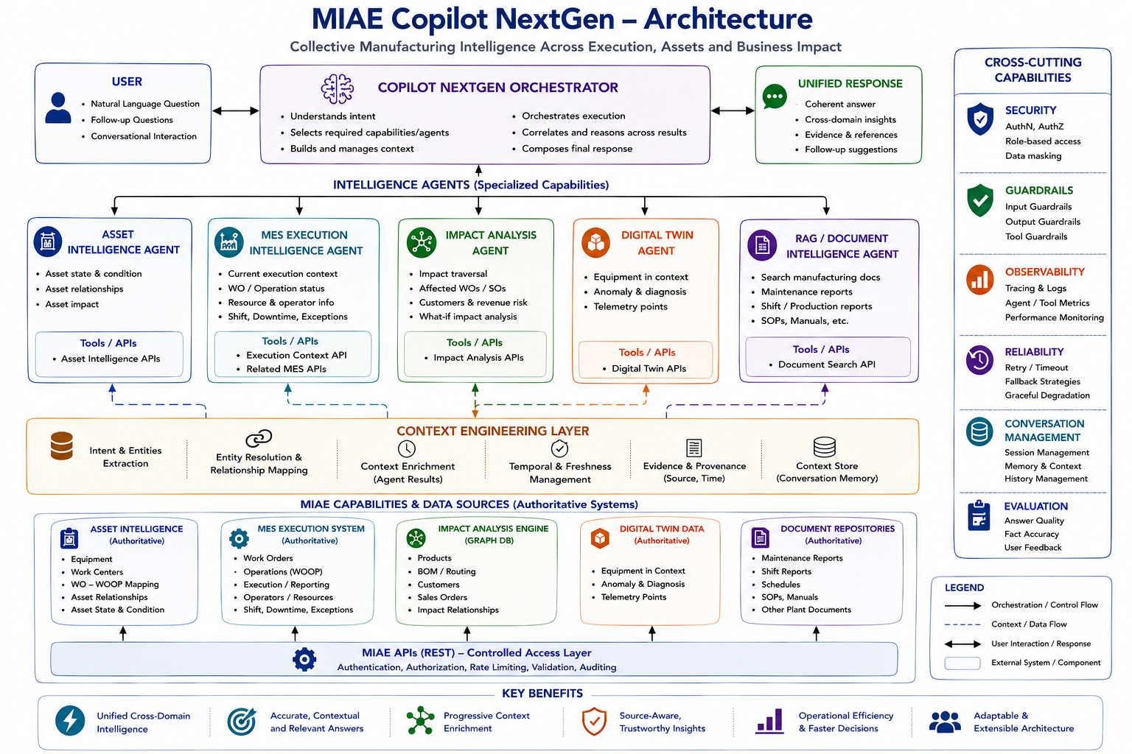

13. Guiding Principle
MIAE Copilot NextGen transforms MIAE from a collection of individual intelligence capabilities into a collective manufacturing intelligence platform, where specialized agents can be orchestrated, contextualized, and composed to answer complex operational and business questions.
