MIAE Authentication with Keycloak 26.7
Installation and Configuration Guide
End-to-end guide for installing, configuring, and integrating Keycloak 26.7 with MIAE using Spring Security and JWT/JWKS authentication.

1. Introduction
Purpose:
- Configure Keycloak as the Identity Provider for MIAE.
- Support Developer API Key, JWT Public Key, and JWKS authentication.
- Secure all MIAE APIs with Spring Security.

2. Prerequisites
Java 21+, Spring Boot 3.x, Keycloak 26.7, Postman/curl, Windows or Linux.

3. Download and Start Keycloak
Download: https://www.keycloak.org/downloads
Windows:
bin\kc.bat start-dev --http-port=8081
Verify:
http://localhost:8081

4. Create Realm
Create a realm named 'MIAE'. Use a dedicated realm instead of the master realm.
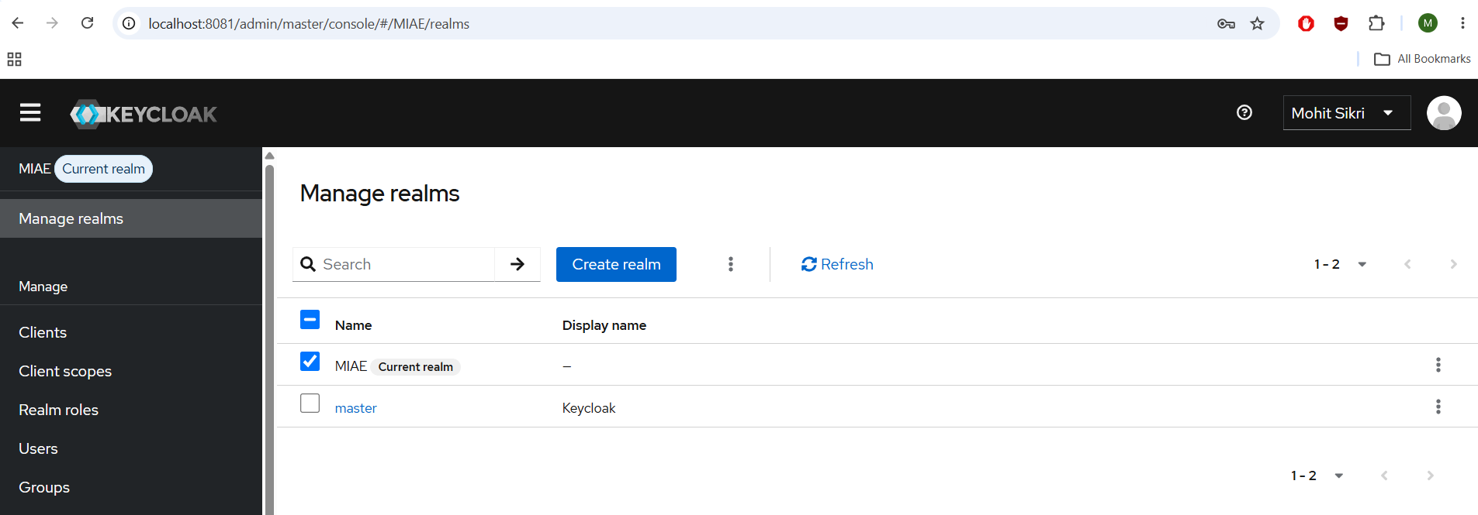

5. Create Client
Client ID: miae-api
Protocol: OpenID Connect
Client Authentication: Enabled
Direct Access Grants: Enabled
Retrieve the client secret from the Credentials tab.
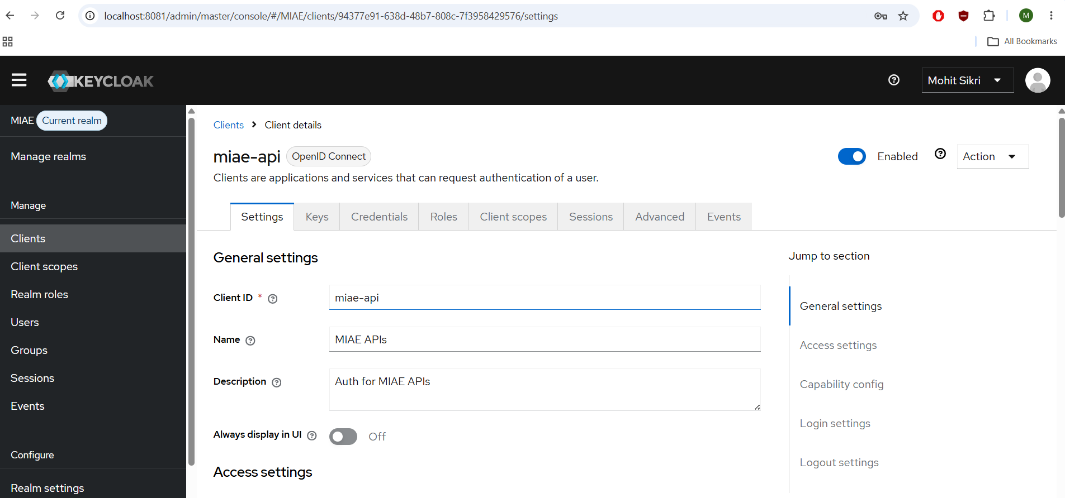

6. Create User
Example:
Username: sikri.mohit
Temporary Password: OFF
Assign a permanent password.
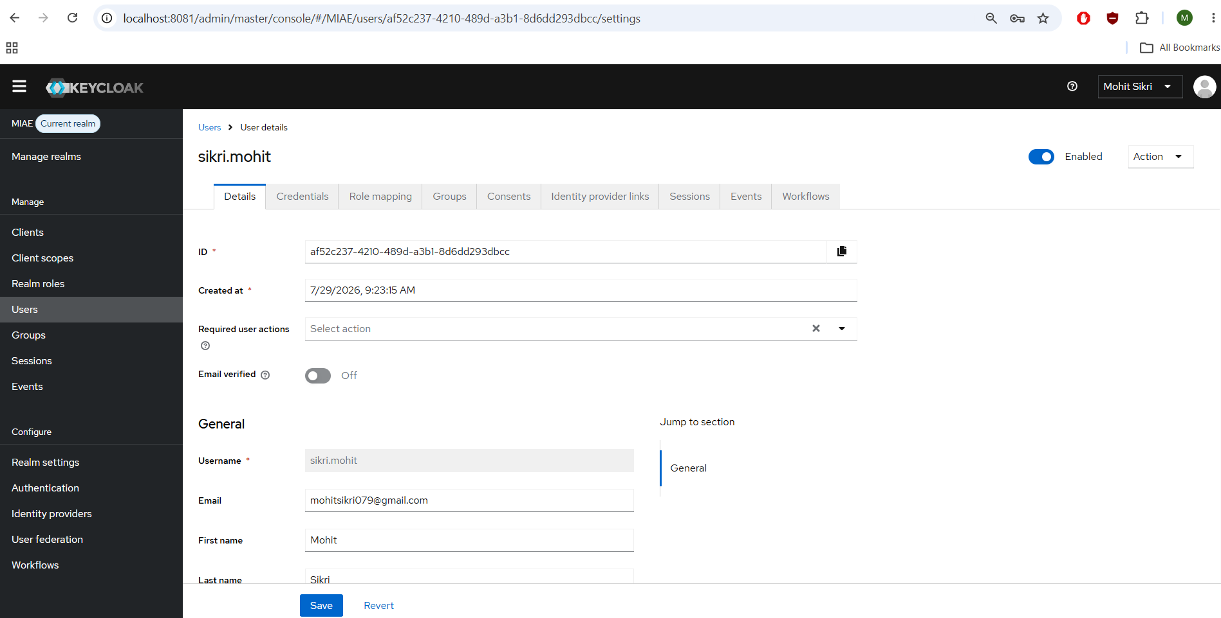

7. Audience Mapper
Create an Audience mapper in assigned client scope ('miae-api-dedicated').
Mapper Type: Audience
Included Client Audience: miae-api
Included Custom Audience: leave empty
Add to access token: ON
Add to ID token: OFF
Add to lightweight access token: OFF
If the token contains:
aud = account
azp = miae-api
MIAE should reject the token because the audience is incorrect.
If 'Included Client Audience' is blank, the mapper does not add any audience.
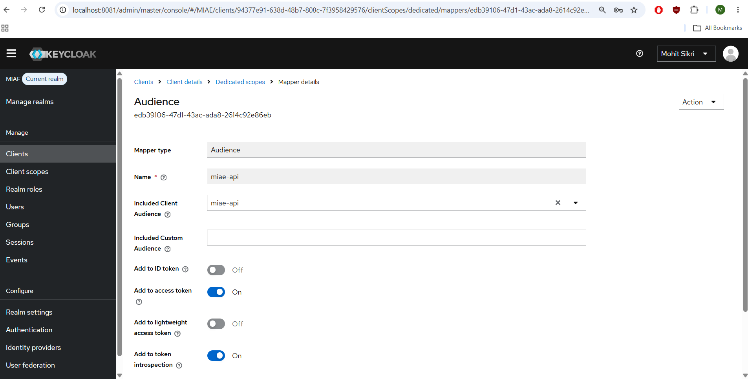

8. Generate Bearer Token
POST /realms/MIAE/protocol/openid-connect/token
grant_type=password
client_id=miae-api
client_secret=<secret>
username=<user>
password=<password>
curl --location 'http://localhost:8081/realms/MIAE/protocol/openid-connect/token'
--header 'Content-Type: application/x-www-form-urlencoded'
--data-urlencode 'grant_type=password'
--data-urlencode 'client_id=miae-api'
--data-urlencode 'client_secret=GXSsDwKjYXfIdiIFVIFri5jsrccSxed7EIQUL70FSdOyikLAURgFXVVxCzDXOgkoEZgimxmoGFH1NcjdL' \
--data-urlencode 'username=test.user'
--data-urlencode 'password=Password@123'

9. JWT Claims
Important claims:
iss, aud, azp, exp, preferred_username.
aud = intended recipient (resource server).
azp = client that requested the token.
MIAE validates aud, not azp.

10. Keycloak 26.7 Notes
The automatically created 'miae-api-dedicated' client scope:
- is special,
- cannot be manually assigned like a normal client scope.

11. Configure Spring Security
authentication-type:
- JWKS
Security validates signature, issuer, audience, expiration, and clock skew.
miae:
security:
authentication-type: JWKS
jwks:
uri: http://localhost:8081/realms/MIAE/protocol/openid-connect/certs
issuer: http://localhost:8081/realms/MIAE
audience: miae-api

