MIAE Digital Twin & Operational Context
Requirements
Manufacturing Impact Analysis Engine (MIAE)

1. Objective
Extend MIAE with a vendor-neutral Digital Twin capability for manufacturing asset or equipment that provides the Copilot with current operational context without persisting telemetry, anomalies, diagnoses, or other volatile equipment state in the MIAE graph.
The capability shall allow MIAE to answer questions that require knowledge of:
- current equipment state
- current equipment health
- active anomaly
- current/latest diagnosis
- current /latest telemetry measurements
- observation freshness
- operational source
MIAE retains responsibility for equipment identity, manufacturing relationships, operations, work orders, products/revisions, sales orders, customers, impact analysis, and business consequences.
The Digital Twin capability shall be provider-neutral and must not depend specifically on operational intelligence platform, a particular MES, IoT platform, SCADA product, EAM/CMMS platform, or vendor.
User query
“What is the current status of Equipment EQ-101, and what manufacturing impact would we have if it remains unavailable?”
Example MIAE Copilot response
EQ-101 is currently DOWN, based on the latest Digital Twin state. The equipment is associated with Work Center WC-10 and is required by Operation OP-20.
A high-severity vibration anomaly has been detected. Diagnostic analysis indicates possible bearing degradation with 87% confidence. The latest observed telemetry shows a temperature of 82.4°C, vibration of 4.1 mm/s, and motor speed of 100 RPM.
MIAE identifies 4 open Work Orders dependent on this execution path, with 220 units of Production Quantity at Risk.
These Work Orders are linked to 3 open Sales Orders across 2 customers.

2. What MIAE Digital Twin Means
For this proposal, a Digital Twin is:
A runtime, current-state representation of a physical manufacturing asset, composed on demand from one or more operational data providers and enriched with MIAE's manufacturing context when required.
It is NOT:
- an IoT platform
- a telemetry historian
- an MES replacement
- an EAM/CMMS replacement
- a persistent copy of equipment state
- an archive of anomaly/diagnosis history

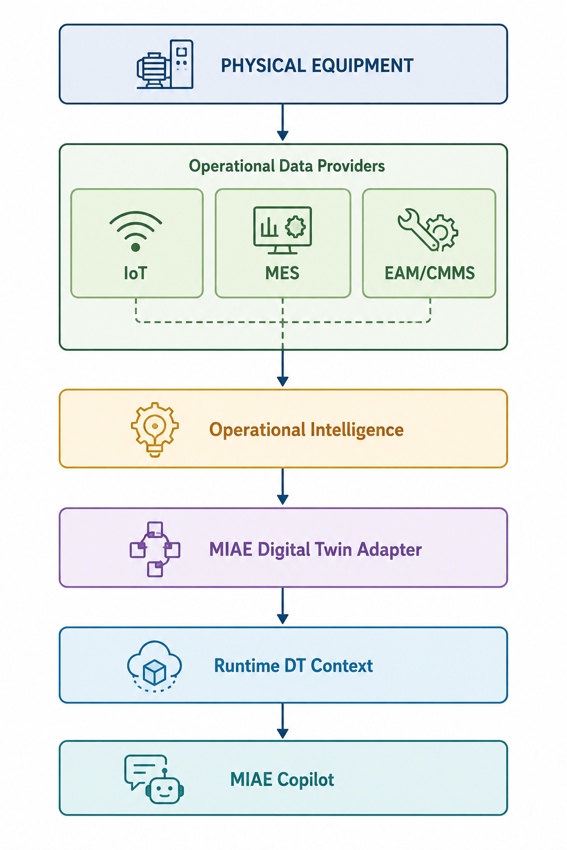

3. Vendor-Neutral Architecture
MIAE defines an Equipment Digital Twin Provider abstraction.
EquipmentDigitalTwinProvider
|
+-- Digital Twin Platform
+-- MES
+-- IoT Platform
+-- SCADA
+-- EAM / CMMS
+-- Custom Implementation of Industrial Automation Control, IACF
+-- IOT + Operational Intelligence
Eclipse Ditto, Things Board, Siemens Insights Hub could be one implementation of the provider interface. The Copilot should not need to know which vendor supplies the information.
The MIAE Digital Twin Adapter provides the integration boundary between MIAE and external Digital Twin, IoT, IIoT, MES, EAM/CMMS, or Operational Intelligence platforms that provide Digital Twin state and/or telemetry.
Its primary responsibility is to obtain external operational data and transform it into the established MIAE Digital Twin Contract and Telemetry Contract.
MIAE should provide a generic HTTP adapter capability for providers that expose REST APIs but do not require a dedicated vendor-specific adapter.
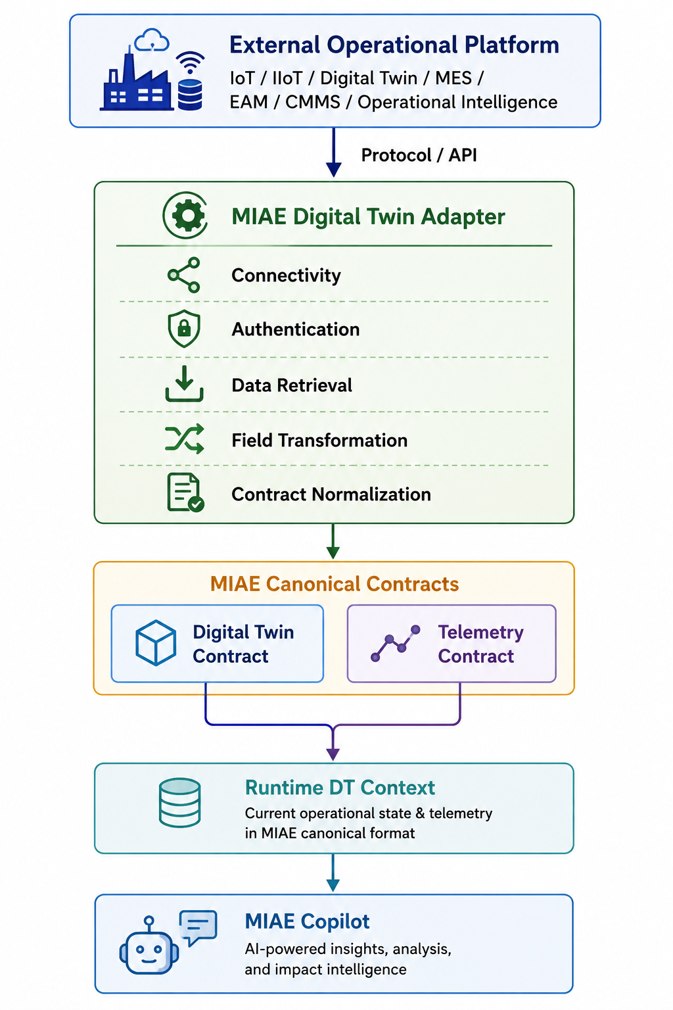

4. Responsibilities and System Boundaries
Capability | MIAE
Current equipment state | Consumes from external provider, does not own the data
Current health
Current anomaly
Current diagnosis
Current telemetry

Fundamental boundary: MIAE owns relationships and consequences; the operational provider owns real-time equipment observations and operational intelligence.
MIAE treats Digital Twin state as volatile operational context, retrieved from the authoritative provider when required. MIAE's persistent Knowledge Graph stores the relatively stable manufacturing entities and relationships required for impact reasoning.
If the configured Digital Twin provider is unavailable, MIAE will not infer or fabricate the current operational state. MIAE may still provide analysis based on persisted graph data.
External platforms provide Digital Twin and/or Telemetry capabilities; the MIAE Adapter Layer normalizes those capabilities into canonical MIAE contracts; MIAE intelligence operates on the canonical representation.

5. Digital Twin State Contract
The Digital Twin State Contract defines the canonical representation of the current operational state of a physical manufacturing entity made available to MIAE at runtime. The contract represents runtime state rather than historical data. MIAE retrieves the latest available state when operational context is required.
MIAE consumes the resulting anomaly and diagnosis as provider-generated operational intelligence through the established contract
{
"dtId": "EQ-101",
"equipmentId": "EQ-101",
"state": "RUNNING",
"health": "DEGRADED",
"anomaly": {
"type": "HIGH_VIBRATION",
"severity": "HIGH",
"description": "Vibration level is significantly above the normal operating range."
"observations": [
{
"metric": "vibration",
"value": 4.1,
"unit": "mm/s",
"threshold": 3.0,
"condition": "ABOVE_NORMAL_RANGE"
}
]
"detectedAt": "2026-08-17T14:00:00Z"
},
"diagnosis": {
"condition": "BEARING_DEGRADATION",
"confidence": 0.87,
"description": "Vibration pattern indicates possible bearing degradation."
"diagnosedAt": "2026-08-17T14:30:00Z",
},
"observedAt": "2026-08-14T18:36:00Z",
"source": "DTP"
}

Field definitions:
Field | Required | Meaning
dtId | Yes | Digital Twin identifier; normally mapped to MIAE equipmentId
equipmentId | Yes | MIAE equipment identifier
state | Yes | Current operational state
health | Yes | Current normalized health state
anomaly | No | Currently active abnormal condition
diagnosis | No | Current diagnostic conclusion
observedAt | Yes | Time at which the state was observed
source | Yes | Provider supplying the state

Suggested normalized state values: RUNNING, IDLE, STOPPED, STARTING, STOPPING, FAULT, MAINTENANCE, UNKNOWN.
Suggested normalized health values: NORMAL, DEGRADED, CRITICAL, UNKNOWN.
An Anomaly represents an abnormal operational condition determined or inferred by the configured provider based on its evaluation of current telemetry, Digital Twin state, configured thresholds, rules, and/or provider-specific analytical intelligence. MIAE treats the reported anomaly as provider-determined operational intelligence.
Field | Required | Definition | Example
type | Yes | Classification of the detected abnormal condition. | HIGH_VIBRATION
severity | Yes | Severity of the reported anomaly. | HIGH
description | Yes | Human-readable description explaining the abnormal condition. | Vibration level is significantly above the normal operating range.
observations | Optional | Observed telemetry values that provide evidence for the anomaly. Multiple observations may be provided when the anomaly is based on multiple metrics. | [...]
detectedAt | Optional | When the anomaly was detected. UTC time format | 2026-08-17T14:00:00Z

The observations object contains the specific measurements and associated operating references that the provider used as evidence when determining an anomaly. Multiple observations may contribute to a single anomaly.
Field | Required | Definition | Example
metric | Yes | Name of the operational measurement or metric associated with the anomaly. | VIBRATION
value | Yes | Observed value of the measurement or metric. | 8.7
unit | Optional | Unit associated with the observed value. | mm/s
condition | Optional | Provider's assessment of the measurement relative to its applicable operating condition/range. | OUT_OF_RANGE
threshold | Optional | Reference threshold used by the provider when determining the anomaly, when applicable. | 6.0
normalRange | Optional | Normal/expected operating range used by the provider, when applicable. | 0–6.0 mm/s

A Diagnosis provides an interpreted assessment of the equipment or operational condition or likely cause identified and determined by the configured provider based on anomalies, telemetry, Digital Twin state, diagnostics, or provider-provided diagnostic information. MIAE treats the reported diagnosis as provider-determined diagnostic intelligence.
Field | Required | Definition | Example
condition | Yes | The diagnosed or suspected equipment/operational condition indicated by the available evidence. | BEARING_DEGRADATION
confidence | Optional | Confidence associated with the diagnosis, represented as a value between 0 and 1. | 0.87
description | Yes | Human-readable explanation of the diagnostic assessment and the condition indicated by the available evidence. | Vibration pattern indicates possible bearing degradation.
diagnosedAt | Optional | When the diagnosis was provided, inferred. UTC time format. | 2026-08-17T14:30:00Z

Telemetry vs. Anomaly Observations
Telemetry represents the operational measurements themselves:
EQ-101
temperature = 82.4 °C
vibration = 4.1 mm/s
motorSpeed = 100 RPM

Anomaly observations represent the subset of those measurements or derived(computed) metrics that were relevant for detecting a particular anomaly:
Anomaly: HIGH_VIBRATION  observations:  vibration = 4.1 mm/s  temperature = 82.4 °C | Anomaly: HIGH_VIBRATION  observations:  Thermal-Vibration Risk Score = 91

From the Telemetry data. Copilot should be able to answer:
"What is the latest motor speed of EQ-101?"
Telemetry provides the measurements; anomaly observations identify which measurements or derived metrics are relevant to an anomaly; diagnosis interprets the anomaly and its supporting observations.
Anomaly observations are available they are the primary evidence for the reported anomaly; they can only explain the anomaly. When anomaly observations are not available, but telemetry is then latest telemetry is just supporting operational evidence but not a claim that an anomaly exists.

6. Current-Only Semantics
The DT contract represents only the current condition. If an equipment issue is resolved, the anomaly and diagnosis fields disappear or become null. MIAE shall not maintain historical anomaly or diagnosis records as part of the Digital Twin state.
Before resolution:
health = DEGRADED
anomaly = HIGH_VIBRATION
diagnosis = BEARING_DEGRADATION
After resolution:
health = NORMAL
anomaly = absent
diagnosis = absent
Historical information remains the responsibility or feature of the operational source.

7. Telemetry Contract
The Telemetry Contract defines the canonical representation of operational measurements reported by an external Digital Twin, IoT, MES, EAM/CMMS, or Operational Intelligence provider. It provides MIAE with a vendor-neutral representation of the latest observed measurements for an entity.
{
"entityId": "EQ-101",
"observedAt": "2026-08-14T18:36:00Z",
"source": "DTP",
"measurements": [
{
"name": "VIBRATION",
"value": 8.7,
"unit": "mm/s",
"condition": "OUT_OF_RANGE"
},
{
"name": "TEMPERATURE",
"value": 92.4,
"unit": "°C",
"condition": "IN_RANGE"
},
{
"name": "SPINDLE_SPEED",
"value": 4200,
"unit": "rpm",
"condition": "IN_RANGE"
}
]
}

Field definitions:
Field | Required | Definition | Example
entityId | Yes | Unique identifier of the entity equipment for which the telemetry was observed. | EQ-101
observedAt | Yes | Timestamp indicating when the telemetry measurements were observed/captured. | 2026-08-14T18:36:00Z
source | Yes | Identifier of the Digital Twin/telemetry provider that supplied the measurements. | DTP
measurements | Yes | Collection of operational measurements captured for the equipment. | [...]

Measurement fields. Each item in measurements represents an individual telemetry measurement.
Field | Required | Definition | Example
name | Yes | Name of the measured equipment parameter. | VIBRATION
value | Yes | Observed value of the measurement. | 8.7
unit | Optional | Unit associated with the measurement value. | mm/s
condition | Optional | Condition of the measurement relative to the applicable normal/expected range. | OUT_OF_RANGE

8. Data Acquisition Model
The Data Acquisition Model defines how MIAE obtains Digital Twin state and telemetry data from configured operational data providers. The DT shall be invoked on demand, not continuously replicated into MIAE.
User
|
v
MIAE Copilot
|
| Query requires equipment state?
v
Digital Twin Provider
|
v
Operational Provider
+-- IACF
+-- MES
+-- IoT
+-- Other
|
v
Current DT State
|
v
Copilot Context

9. MIAE Digital Twin Configuration
MIAE shall provide configuration for enabling Digital Twin capabilities and defining one or more operational data provider connections. Each connection shall identify the provider and the Digital Twin capabilities it exposes, including Digital Twin State and/or Telemetry. The configuration shall be exposed through the application's configuration mechanism (e.g., Spring configuration).
Configuration establishes how runtime Digital Twin and telemetry capabilities are made available to MIAE, Copilot while keeping provider-specific connectivity and data representations outside the core Copilot and impact-intelligence model.
miae:
digital-twin:
enabled: true
connections:
- id: dtp-01
provider: DTP
capabilities:
digital-twin-state: true
telemetry: true

The Copilot optionally can be made configurable with knowledge of the available providers, while remaining provider-neutral. This defines what runtime DT information Copilot is permitted/configured to use. Copilot should interact through stable MIAE provider interfaces.
miae.copilot.digital-twin
├── enabled
└── context
├── digital-twin-state
├── telemetry
├── anomaly
└── diagnosis

10. Query-Driven Data Retrieval
Query-Driven Data Retrieval defines how MIAE determines the minimum runtime Digital Twin and Telemetry context required to answer a Copilot query.
The user's query is analyzed to identify the operational context needed, and MIAE requests only the relevant data from the configured Digital Twin/Telemetry providers through the Adapter Layer.
User Query | Context Retrieved
What is the current health of EQ-101? | DT State
Why is EQ-101 unhealthy? | DT State + Telemetry
“What is the latest temperature or telemetry of EQ-101?” | Telemetry
What happens if EQ-101 stops? | DT State + MIAE Impact Analysis
What is wrong with EQ-101 and what is the business impact? | DT State + Telemetry + MIAE Impact Analysis

11. Capability Expansion

11.1 Equipment Awareness
Previously, MIAE could identify equipment structurally. With Digital Twin integration it can state the current condition, for example: EQ-101 is currently running but its health is degraded due to high vibration.

11.2 Condition-Aware Impact Analysis
MIAE can combine an operational provider's current health/anomaly/diagnosis with its manufacturing dependency graph to determine affected WOs, sales orders, customers, and revenue exposure.

11.3 Business Question → Operational Cause
Example: Why is sales order SO-100 delayed?
SO-100 → WO-1001 → OP-40 → WC-10 → EQ-101
DT State:
Health = DEGRADED
Anomaly = HIGH_VIBRATION
Diagnosis = BEARING_DEGRADATION
Copilot response: SO-100 is at risk because its manufacturing order, WO-1001, depends on Operation OP-40, which is performed at Work Center WC-10 using Equipment EQ-101. EQ-101 is currently degraded due to high vibration, with the diagnosis indicating probable bearing degradation.

12. Expanded Copilot Classes
- Equipment state: What is the current state of EQ-101? Is EQ-101 healthy?
- Diagnosis: Why is EQ-101 unhealthy? What is causing the current issue?
- Telemetry: What is EQ-101's current vibration? Which readings are outside the normal range?
- Manufacturing context: What operation is EQ-101 currently performing? Which WO is currently using EQ-101?
- Impact: What happens if EQ-101 goes down? Which WOs, customers, and revenue are affected?
- Condition + impact: What is the impact of EQ-101's current condition? Should we take EQ-101 offline?

13. Copilot Runtime Context
Runtime context is temporary context for reasoning. Operational context should be session-scoped and discarded when the Copilot session ends. A new Copilot session therefore starts without assuming the previous session's operational state is still current.
- Once DT/telemetry context is acquired for asset EQ-101, it remains available for relevant follow-up questions.
- A follow-up such as “What WOs are affected?” can reuse the existing EQ-101 context without reacquiring it.
- If the user explicitly asks for fresh/current data, MIAE should reacquire it.
- If the context changes—for example, the user asks “What about EQ-102?”—MIAE should acquire the required context for EQ-102.
- The retained context should not be treated as permanently current; it represents the previously acquired runtime context and should be refreshed when freshness is required.

14. Functional Requirements Summary
Requirement | Description
Equipment DT identification | Support an equipment Digital Twin identified by dtId mapped to MIAE equipmentId.
Runtime retrieval | Retrieve Digital Twin state on demand; do not persist it as MIAE graph state.
Provider neutrality | Do not depend on a specific MES, IoT, SCADA, EAM, or another vendor.
Current-state semantics | Represent only the latest known state.
Resolved condition removal | Remove resolved anomaly and diagnosis information from current state.
Telemetry separation | Represent telemetry through a separate contract.
Provider adapter | Translate provider-specific data into MIAE contracts.
Copilot integration | Retrieve DT information selectively based on query intent.
runtime conversation context retention | Once DT/telemetry context is acquired, that remains available for relevant follow-up questions, unless explicitly ask to reacquire or context changes.
Impact enrichment | Combine runtime DT state with MIAE impact analysis.
Source and freshness | Include source and observedAt.

15. Non-Functional Requirements Summary
- Vendor independence: Provider/Vendor concepts must not leak into the MIAE core domain model.
- Loose coupling: a provider can be replaced without changing the MIAE graph model, Impact Engine, Copilot query model, or business logic.
- Fault tolerance: if the operational provider is unavailable, MIAE should still perform graph-based impact analysis while explicitly indicating that current equipment state could not be retrieved.
- Security: provider credentials and authentication remain outside the DT contract.

16. Target Architecture
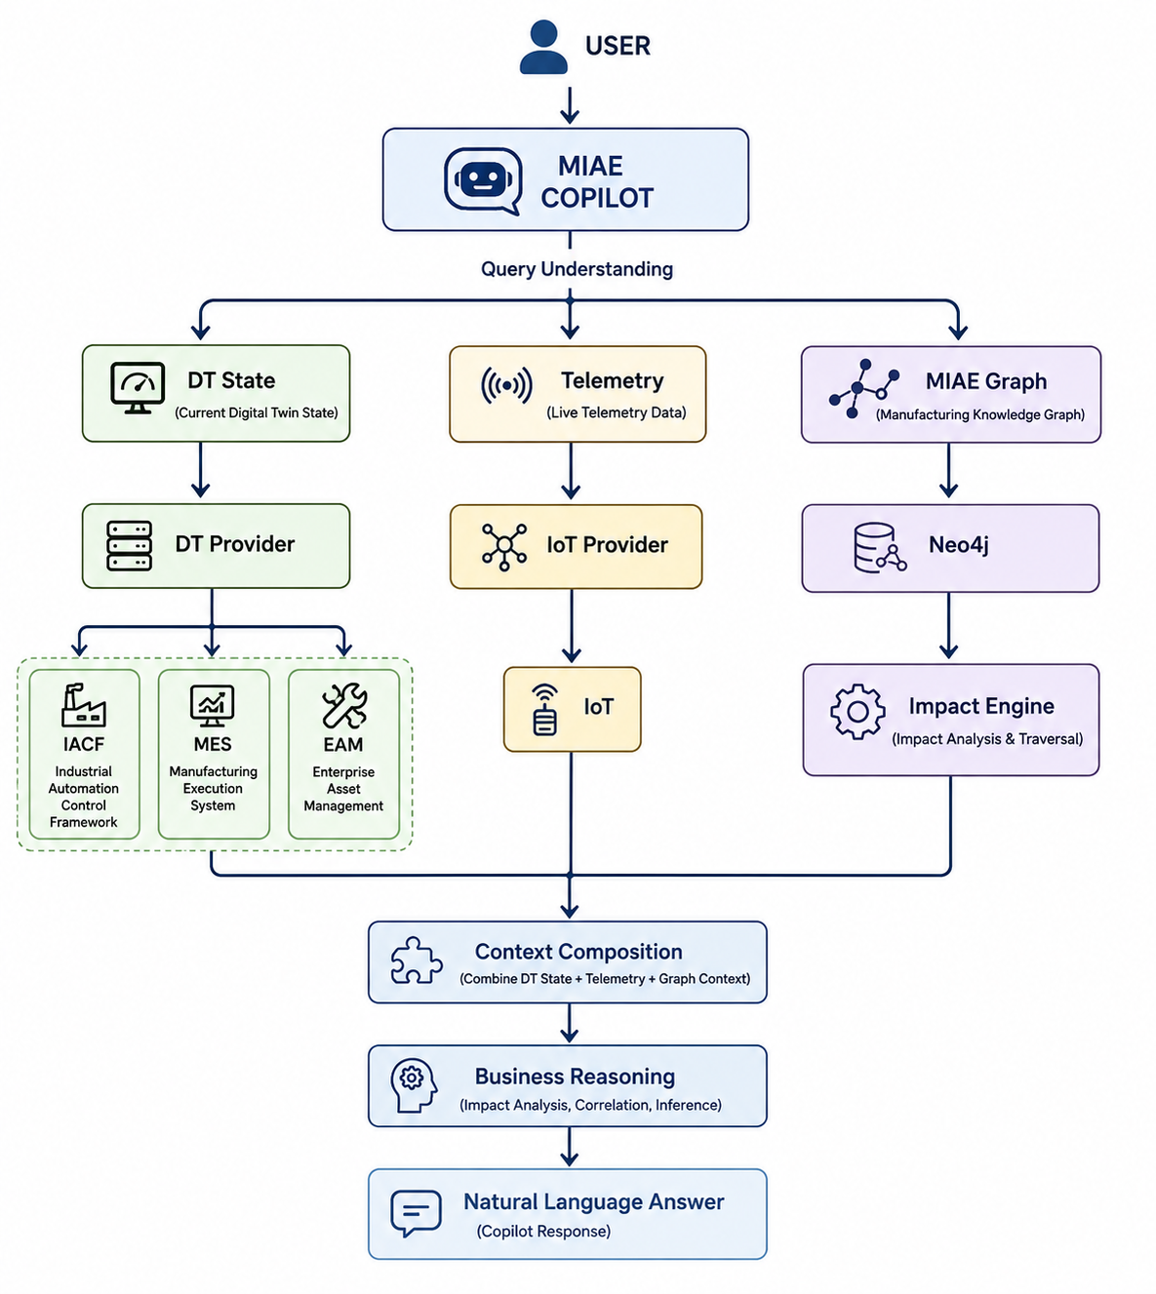

MIAE Digital Twin does not attempt to become an IoT, MES, SCADA, or EAM platform. It establishes a vendor-neutral runtime contract through which MIAE can obtain the current operational condition of a manufacturing asset from an external operational intelligence provider. MIAE then combines that transient operational state with its persistent manufacturing dependency graph to reason about operational impact and business consequences.

17. Capability Positioning
System / Layer | Primary Question Answered
IoT / SCADA | What is the machine measuring?
Operational Intelligence | What is happening to the machine?
MES | What is the machine doing in production?
MIAE | What does the machine's condition mean to manufacturing and the business?
MIAE Copilot | What combined operational and business context is needed to answer the user's question?

