MIAE Release – Manufacturing Asset Impact Intelligence

1. Objective
Manufacturing Asset Impact Intelligence extends the Manufacturing Impact Analysis Engine (MIAE) from engineering and supply-chain impact analysis to manufacturing execution impact analysis. This release introduces Operations, Work Centers and Equipment into the existing manufacturing knowledge graph, enabling MIAE to determine how manufacturing assets influence Work Orders, Products, Sales Orders, Customers and Revenue.

2. Business Objectives
- Extend impact analysis beyond engineering and supply-chain entities into manufacturing execution.
- Model manufacturing execution using Operations, Work Centers and Equipment.
- Provide dependency analysis between manufacturing assets and business entities.
- Preserve backward compatibility by retaining the existing Impact Analysis API.
- Provide a foundation for future Engineering Change Intelligence and Digital Twin capabilities.

3. Product Definition
This section describes the new entities introduced. Business purpose and detailed descriptions can be completed during detailed design.
Operation represents an individual manufacturing step or routing activity required to produce a product revision as part of a Work Order. Each Operation defines a specific stage in the manufacturing process, such as assembly, machining, inspection, testing, or packaging, and is performed at a designated Work Center. Operations are executed sequentially according to the manufacturing routing and provide the link between engineering definitions and shop-floor execution.
Work Center represents a logical manufacturing area or production resource where one or more Operations are executed. It defines the execution location within the manufacturing process and groups the equipment required to perform specific manufacturing activities. A Work Center serves as the bridge between manufacturing Operations and physical Equipment.

Equipment represents a physical manufacturing asset, such as a machine or production equipment, that is assigned to a Work Center and used to execute manufacturing Operations. Equipment forms the execution layer of the manufacturing knowledge graph, linking shop-floor resources to engineering and business processes.

4. Manufacturing Knowledge Graph Extension

New Nodes
Node | Fields | Description
OPERATION | operationId, operationSequence, name, status, workCenterId,  workOrderId | operationId Unique identifier of the manufacturing operation within MIAE.  operationSequence Execution order of the operation within the manufacturing routing.  name Business name of the manufacturing operation  workOrderId(Lookup) Identifier of the Work Order to which the operation belongs.  workCenterId(Lookup) Identifier of the Work Center where the operation is performed.  status Current execution status of the operation (e.g., NOT_STARTED, IN_PROGRESS, COMPLETED).
WORK_CENTER | workCenterId, code, name, status, capacity | workCenterId Unique identifier of the manufacturing work center.  code Business code used to uniquely identify the work center  name Descriptive name of the work center  status Operational status of the work center (e.g., ACTIVE, INACTIVE, MAINTENANCE).  capacity Configured production capacity of the work center for planning purposes.
EQUIPMENT | equipmentId, code, name, status, workCenterId | equipmentId Unique identifier of the manufacturing equipment.  code Business code used to uniquely identify the equipment.  name Descriptive name of the manufacturing equipment or machine.  workCenterId (Lookup) Identifier of the Work Center to which the equipment is assigned.  status Current operational status of the equipment (e.g., AVAILABLE, UNAVAILABLE, MAINTENANCE).

Addition to existing graph:
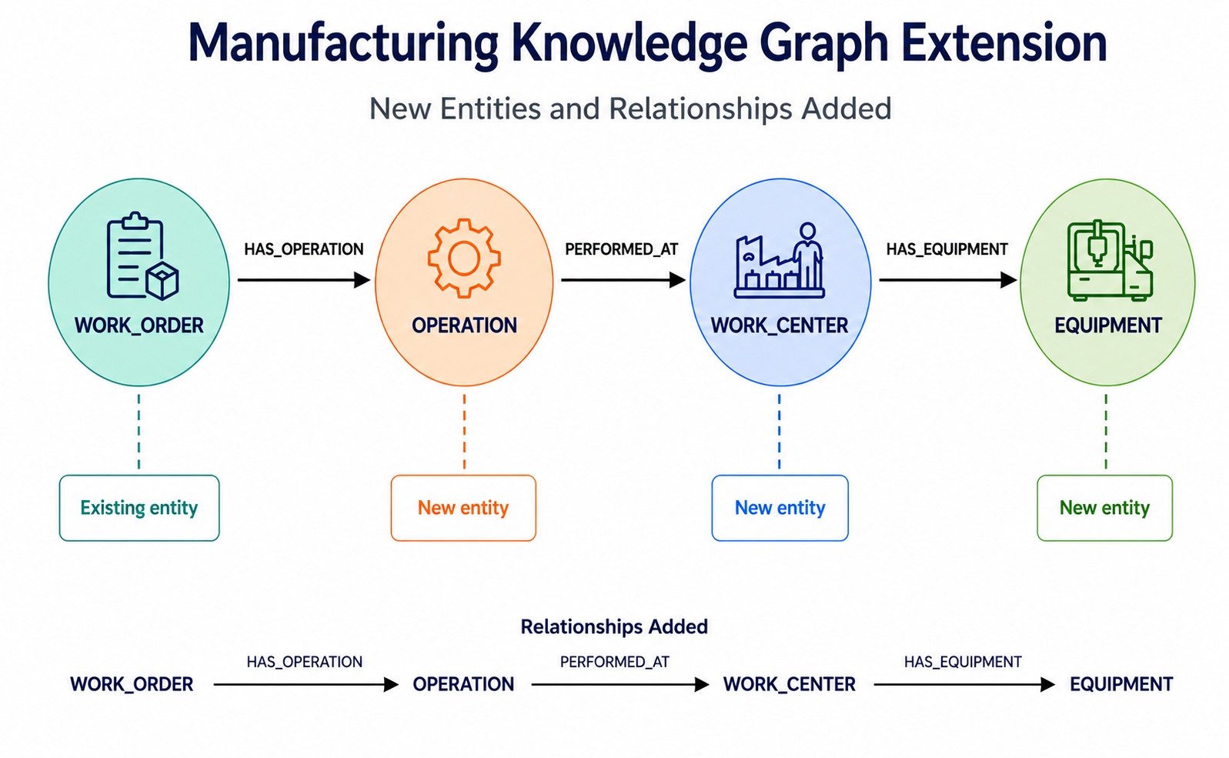

5. New Relationships Types
- WORK_ORDER -[:HAS_OPERATION]-> OPERATION
- OPERATION -[:PERFORMED_AT]-> WORK_CENTER
- WORK_CENTER -[:HAS_EQUIPMENT]-> EQUIPMENT

6. Ingestion Model
Master Data APIs (ingested first)
- POST /api/v1/work-centers
- POST /api/v1/equipment
Transactional APIs
- POST /api/v1/work-orders

7. REST Payload Changes

7.1 Work Center Ingestion
Work Center Ingestion introduces manufacturing Work Centers into the MIAE knowledge graph as master data
POST /api/v1/work-centers
{
"workCenterId":"WC-100",
"code":"WC-SMT",
"name":"SMT Assembly",
"status":"ACTIVE",
"capacity":8
}

7.2 Equipment Ingestion
Equipment Ingestion introduces physical manufacturing assets into the MIAE knowledge graph as master data
POST /api/v1/equipment
{
"equipmentId":"EQ-101",
"code":"SMT-01",
"name":"SMT Machine 01",
"workCenterId":"WC-100",
"status":"AVAILABLE"
}

7.3 Work Order Payload Extension
Work Order Payload Extension enhances the existing Work Order ingestion API by introducing an optional collection of manufacturing Operations associated with the Work Order. Each Operation captures the execution sequence, operation name, status, and the Work Center where it is performed.
POST /api/v1/work-orders
{
"workOrderId":"WO-1001",
"revisionId":"P100-REV-B",
"status":"RELEASED",
"remainingQty":50,
"priority":"HIGH",
"plannedCompletionDate":"2026-02-20",
"operations":[
{
"operationSequence ":10,
"operationId":10,
"name":"SMT Assembly",
"status":"NOT_STARTED",
"workCenterId ":"WC-SMT"
},
{
"operationSequence ":20,
"operationId":20,
"name":"AOI Inspection",
"status":"NOT_STARTED",
"workCenterId ":"WC-AOI"
}
]
}

8. Equipment Impact Analysis
Equipment Impact Analysis enables MIAE to assess the business impact of a manufacturing equipment by tracing its dependencies across the manufacturing knowledge graph. Starting from an Equipment entity, MIAE identifies the associated Work Center, Operations, Work Orders, Products, Sales Orders, and Customers that depend on the equipment, providing a consolidated view of operational and business impact. This analysis helps manufacturing organizations understand the downstream effects of equipment-related changes or disruptions and supports informed decision-making through a single, business-oriented impact analysis API.
Traversal:
EQUIPMENT → WORK_CENTER → OPERATION → WORK_ORDER → REVISION → PRODUCT → SALES_ORDER → CUSTOMER
Business outputs:
• Affected Operations
• Affected Work Orders
• Affected Products
• Affected Sales Orders
• Affected Customers
• Revenue Exposure
Request Payload:
POST /api/v1/impact-analysis
Content-Type: application/json
{
"entityType": "EQUIPMENT",
"entityId": "EQ-101"
}
Response Payload:
{
"entityType": "EQUIPMENT",
"entityId": "EQ-101",
"entityName": "SMT Machine 01",
"summary": {
"affectedOperations": 6,
"affectedWorkOrders": 12,
"affectedProducts": 5,
"affectedSalesOrders": 18,
"affectedCustomers": 7,
"revenueAtRisk": 1250000
},
"workCenter": {
"workCenterId": "WC-100",
"code": "WC-SMT",
"name": "SMT Assembly"
},
"operations": [
{
"operationNumber": 10,
"name": "SMT Assembly",
"status": "NOT_STARTED"
},
{
"operationNumber": 20,
"name": "AOI Inspection",
"status": "IN_PROGRESS"
}
],
"affectedWorkOrders": [
{
"workOrderId": "WO-1001",
"priority": "HIGH",
"status": "RELEASED",
"remainingQty": 50
},
{
"workOrderId": "WO-1005",
"priority": "MEDIUM",
"status": "IN_PROGRESS",
"remainingQty": 120
}
],
"affectedProducts": [
{
"productId": "P100",
"code": "SENSOR-100",
"name": "Industrial Sensor"
},
{
"productId": "P200",
"code": "CTRL-200",
"name": "Industrial Controller"
}
],
"affectedSalesOrders": [
{
"salesOrderId": "SO-101",
"customer": "Acme Manufacturing",
"orderValue": 450000
},
{
"salesOrderId": "SO-102",
"customer": "Global Industries",
"orderValue": 800000
}
],
"affectedCustomers": [
{
"customerId": "CUST-100",
"name": "Acme Manufacturing"
},
{
"customerId": "CUST-200",
"name": "Global Industries"
}
]
}

9. Personas and Representative Questions

Persona | Representative Questions | Business Value
Manufacturing Engineer | Which products use Equipment EQ-101? Which Work Center owns Equipment EQ-101? | Engineering dependency analysis
Maintenance Engineer | If Equipment EQ-101 is unavailable, which Work Orders and Customers are affected? | Maintenance planning
Production Planner | Which high-priority Work Orders execute on Equipment EQ-101? | Production prioritization
Plant Manager | Which equipment is business critical? Which equipment supports the highest revenue? | Operational visibility
Executive | Which manufacturing assets represent the highest revenue exposure? | Strategic decisions
Manufacturing Impact Copilot | Explain why Equipment EQ-101 is business critical. | Natural-language explanation

